|  |
| --- |
| **Page 1** |

solar power

equity

consumption:

New opportunities

for multi-family

houses and areas

|  |
| --- |
| **Page 2** |

Overbuilding Balberstrasse

© Suntechnics Fabrisolar AG

«The overbuilding

produces more electricity,

as she consumes. »

reto rope,

project manager energy

and ecology, abz

|  |
| --- |
| **Page 3** |

CONTENTS

FOREWORD OF ENERGY SWITZERLAND ............................................... .................................................. ......... 5

EXPERIENCE FROM PRACTICE .............................................. .................................................. ............. 6

THE OWN CONSUMPTION MODEL ................................................ .................................................. .......... 8th

OPPORTUNITIES IN THE NEW ENERGY LAW .............................................. .................................................. ..... 9

THE MOST IMPORTANT PLAYERS ............................................... .................................................. .................... 10

INTERVIEW: TENANT ............................................... .................................................. .............................. 12

IN THREE STEPS FOR YOUR OWN CONSUMPTION ............................................. ............................................. 15

CONFIGURATION FOR OWN CONSUMPTION (ZEV) REASONS ........................................... ................. 16

MEASUREMENT AND ACCOUNTING ............................................... .................................................. ............. 18

EXAMPLES FROM PRACTICE .............................................. .................................................. ..................... 20

BENEFITS OF SOLAR POWER ............................................... .................................................. ............... 24

INTERVIEW: REAL ESTATE DEVELOPER ............................................... .................................................. .. 27

EXAMPLE CALCULATION ................................................. .................................................. ............................ 30

SHORT AND BUNDLY ............................................... .................................................. .............................. 32

*Cover photo:*

*© ABZ Zurich*

|  |
| --- |
| **Page 4** |

«THE OWN CONSUMPTION

FROM SOLAR STREAM IS ON

CENTRAL COB OF THE

NEW ENERGY LAW. »

|  |
| --- |
| **Page 5** |

5

Thanks to the rapid development of solar technologies, the costs of solar

In many cases electricity from one's own roof is lower than the cost of electricity

from the net. So the one who invests in solar energy, not just one

Contribute to environmental protection, but at the same time saves money.

With the new Energy Act, which has been in force since 2018, the framework

conditions for self-consumption of solar power once again improved what

brings new opportunities for real estate owners and tenants. As 60% of the residents

living in an apartment building in Switzerland, the promotion of self-reliance

consumption of solar power in multi-family houses is a central pillar of the new

Energy Act. The self-consumption concept has proven itself and is now

a well - established way to reduce electricity costs while at the same time being a sign of

to set sustainability. This possibility does not exist only for single-family

houses, but also for rental properties or for condominiums.

The number of inhabitants or consumers of electricity does not matter - one

profitable investment is almost always possible today.

Are you planning a solar system? In this brochure by SwissEnergy and Energy

Future Switzerland will find the information you need to have a solar system in

to plan and realize an apartment building. As a next step

we recommend you to choose a certified solar professional. We wish

We wish you every success in the realization of your solar system and thank you for your contribution.

ken in the expansion of renewable energies.

Patrick Kutschera

*Managing Director of SwissEnergy*

FOREWORD

|  |
| --- |
| **Page 6** |

6

EXPERIENCES FROM PRACTICE

**THOMAS LAUX, CTO, ESTATES TRAIN**

**(IMMOBILIENFONDS)**

It's time. Become with the new energy law

innovative projects such as areal networks or electricity procurement

Medium voltage level possible, for new buildings as well as for

existing properties. This is an important step in

Towards a sustainable future.

**KATIA ARM, HEAD**

**MANAGEMENT REGIO EAST,**

**Wincasa**

Sustainability aspects in value preservation and value

Increases are central to our customers. Solar power systems

can make an important contribution to sustainable development

real estate portfolio.

**LEA GREHN, PROPERTY OWNER**

**OUT OF BLOW**

Solar systems have been significantly improved in recent years.

tiger and today are economically viable in many cases

meaningful. An own solar system is an effective one

Contribution to a sustainable future.

|  |
| --- |
| **Page 7** |

7

**LETINA WELDERGERGIS,**

**RENTER IN ZURICH**

In addition to a good connection to public transport

belongs to the modern house also a thoughtful Nach-

haltigkeitskonzept. The exciting thing is that the electricity is cheaper

as previously!

**ANDREAS APPENZELLER,**

**SOLAR PIONEER, ADEV**

Where a lot of pioneering work and idealism were needed in the past,

Solar energy today reaches large parts of the population.

The prices for solar systems have dropped so far in the meantime

that the self-generated electricity from the roof is cheaper than the

Electricity from the grid.

**KARL VIRIDÉN, ARCHITECT,**

**VIRIDÉN + PARTNER AG**

The topic of solar power is also with the architects

arrived. I am particularly interested in the creative

Possibilities, the modern solar modules for the roof

and to provide for the facade. Integrate modern PV systems

unobtrusively in the existing building.

|  |
| --- |
| **Page 8** |

THE OWN CONSUMPTION MODEL

8th

**1 OWN CONSUMPTION**

When the sun is shining, the solar power becomes

consumed directly in the building. All residents

benefit!

**2 INJECTION**

Excess solar power gets into the grid

fed and remunerated by the utility.

**3 NETWORKING**

The energy provider supplies the addition to

Solar power needed electricity.

ownconsumption

in a nutshell

**OWN CONSUMPTION PAYS**

Self-consumption means that the solar power produced is re-used at the same time in the same place. need. Since there are no network fees and charges for "self-consumed" electricity, this is Solar power from your own roof usually cheaper than the grid-related electricity. The more solar power consumed in the building itself, the better the investment returns. A win-win situation for owners and tenants!

|  |
| --- |
| **Page 9** |

9

OPPORTUNITIES IN THE NEW ENERGY LAW

the merger

for own consumption (zev)

brings new opportunities

**BETTER POSITION OF OWN CONSUMPTION COMMUNITIES**

A ZEV is new in the law. This will make multiple consumers a single customer

at the power company.

**MEASURE CURRENT ELECTRICITY**

ZEV can now decide whether to carry out the current measurement itself or whether to order it

Third is awarded.

**STROME BUYING ON THE OPEN MARKET**

If you come as a ZEV over the limit of 100 MWh of electricity consumption per year (from about 30 apartments),

you can buy the mains electricity on the open market. This often results in high costs

savings possible.

**OWN CONSUMPTION IN AREALS**

In a ZEV can not only apartments in apartment buildings, but also buildings on

several adjoining land together to solar power together

consume.

**PROMOTION**

Up to 30% of the investment costs are paid by the Federal Government via the so-called one-off payment

taken over, new also for larger systems (from 30 kWp).

|  |
| --- |
| **Page 10** |

10

who

makes

What?

**OWNER / INTERIOR \***

• You are responsible for the **operation of** the

Solar system, the **power supply** of network

and solar power to the users and the

**Feed** in surplus production.

• You are responsible for the **settlement of** the

Power consumption of the users.

• You can provide a **ZEV** for the users

provide.

• You receive compensation for the

fed electricity.

**USER / INTERIOR**

• The **users of** the solar power are

either for rent or own the property

bilie. In the second case are owner / in and

User identical.

• In a ZEV, users relate

both the mains power and the solar

electricity from the owner / owner.

• By founding the ZEV remain for the

User / indoor **energy costs** equal to or

decline.

|  |
| --- |
| **Page 11** |

11

THE MOST IMPORTANT PLAYER

**FOR A CONSUMPTION FOR OWN CONSUMPTION (ZEV)**

**THE MOST IMPORTANT PLAYERS HAVE DIFFERENT RIGHTS AND**

**OBLIGATIONS.**

*\* For simplification, it is assumed here*

*that the landowner also the building*

*owner and the operator of the solar power*

*plant is.* *Other cases are in the guide of*

*Energy Switzerland treated.*

*(www.energieschweiz.ch/eigenverbrauch).*

**UTILITIES**

• The local utility **supplies the ZEV**

**Electricity** for the times in which the solar

electricity does not meet the electricity needs of the users

covers.

• When the solar system produces more

than is consumed in the property will

the solar power fed into the grid. The

Energy supplier **pays** the owner / the

Owner of the solar system for this.

• The **cost** of mains electricity is usually

higher than the cost of solar power.

solar power

AC power

|  |
| --- |
| **Page 12** |

12

«BEFORE 10 YEARS

SOLAR PLANTS STILL VERY HIGH

EXPENSIVE. TODAY PAY

they are for renters like

FOR OWNERS. »

marcel rhyner,

tenants and

projektmitinitiator

|  |
| --- |
| **Page 13** |

13

**AT THE WESTSTRASSE HAS THE GENERAL BUILDING COOPERATION**

**WINTERTHUR SEVEN MULTI-FAMILY HOUSES WITH PHOTOVOLTAIC**

**EQUIPMENT EQUIPPED.** **ALL RESIDENTS AND RESIDENTS**

**CAN RELATE SOLAR POWER TO CHEAP PRICES.** **THESE**

**ECOLOGICAL RETROFITTING WAS ALSO FROM RENTERS**

**AND RENTALS INITIATED.** **MARCEL RHYNER, RESIDENTIAL**

**BUILDING WEST, TELLS, WHY.**

**Why did you choose to build one**

**Solar system on your residential property**

**used?**

Renewable energies and decentralized electricity

care are topics that have been with me for a long time

employ. When our roof was renovated in 2005,

one has tested the installation of a solar system.

However, at that time the photovoltaic was still

very expensive, and it was abandoned by a construction

seen. In the meantime, prices have changed.

why, a project group is technically

interested renter for the retest

used this option.

**What came out?**

A preliminary clarification has shown that a solar

plant on our premises profitable operated

can be. We tenants today purchase solar

electricity, which is cheaper than electricity from the grid.

In addition, inefficient electric boilers have gone through

Heat pump boiler replaced.

**You live in a house from the centenary**

**changed turn.** **Was the construction expensive?**

**Were the residents affected?**

Not at all. For the construction, a building

set up, but only on one

Side of the house. So the balconies could always

be used. Anyway, the construction did not last

long: After two weeks everything was over.

Additionally, the residents were upfront

asked how they stand for the project, and the

Feedback was positive. Also during construction

There were no complaints.

**What has changed since then?**

Not much. The electricity bill we receive as

until now from Stadtwerk Winterthur, which the

Measurement and billing takes over. On

The electricity bill is new, the solar power individually

expelled. The inhabitants, the solar power

have a power supply

contract with Stadtwerk.

**Are you up to date with the situation**

**satisfied?**

Yes. I am happy today ecological, decentralized

to draw electricity produced. That the

Solar power is cheaper than the mains electricity is a

nice side effect.

INTERVIEW: MARCEL RHYNER

**The project:**

Number of buildings:

7

Usage concept: own consumption

for apartments and

heat pump boiler

Owner:

General

cooperative

Winterthur

Location:

Winterthur

Configuration:

SOLARVILLE AG

www.solarville.ch

13

|  |
| --- |
| **Page 14** |

14

«Thanks to our solar system

do we have solar power,

the cheaper than the

mains current. "

marcel rhyner,

tenants and

projektmitinitiator

|  |
| --- |
| **Page 15** |

15

IN THREE STEPS FOR YOUR OWN CONSUMPTION

How do I organize one?

Merger with

Own consumption (ZEV)?

**1**

**PURPOSE CLAIMABILITY**

• Online suitability check at www.quick-check.ch

• Inclusion of a solar professional

• Obtain recommended information

• Optimize self-consumption if possible

• Estimate economic efficiency

**3**

**BUILD SOLAR PLANT**

• Obtaining at least three offers from solar professionals for the construction of the facility

• Free comparison of the offers on www.energieschweiz.ch/solar-offerte-check

• Procurement to a solar professional

• Set up the required meters for billing

**2**

**ZEV REASONS**

• ZEV among tenants: In case of existing buildings inform the tenants early, in one

New construction can be provided for the ZEV from the beginning

• ZEV under owners: agree on merger

• Contractual regulation of electricity collection with the users

• Estimate tariff for solar power and calculate economy

• Report to the utility that a ZEV is planned

*The topic "founding ZEV" will be discussed in detail on the next page.*

|  |
| --- |
| **Page 16** |

16

which questions

should for

the foundation

a zev clarified

become?

**DETAILED INFORMATION**

**IN ORDER TO SET A ZEV**

**AND CONTRACTUAL TEMPLATES**

**FIND IN THE GUIDE**

**OWN CONSUMPTION OF**

**ENERGY SWITZERLAND (SEE**

**WWW.ENERGIESCHWEIZ.CH/**

**OWNCONSUMPTION).**

*\* Other regulations such as electricity supply*

*Contracts are possible in principle.*

|  |
| --- |
| **Page 1** |

ZEV REASONS

17

**ZEV UNDER OWNER**

ZEV UNDER OWNER

The self-consumption of solar power is suitable both for rental properties as well as for condominiums and buildings on neighboring properties. A ZEV under owners can be easily regulated by private law. So everyone can benefit from sustainable and cheap solar power from their own roof..

**rent control**

rent control

If a ZEV is provided for tenants in an existing tenancy, they can pay for their participation in the ZEV.

After the ZEV has been set up, tenants can only get out in special cases. Therefore, the electricity in the ZEV may not be more expensive than without the ZEV

**WHO MAKES THE BILLING?**

WHO MAKES THE BILLING?

The owner is responsible for the measurement and billing of the users. However, he / she can also hire a specialized company. In many cases the measurement and billing can also be taken over by the local energy supplier (see next page).

**AS IS**

**SETTLED?**

HOW IS BILLING settled?

In tenancies, the used grid and solar power

normally charged over the additional costs. It is also possible that the tenants and owners receive a separate bill for the used grid and solar power.

**WHICH CONTRACTS MUST COMPLETED**

WHICH CONTRACTS MUST BE CONCLUDED?

In general, the owner adjusts the leases to the tenants and notes that they are purchasing solar power. * A merger agreement can be concluded for owners. The local utility must also be informed.

**WHAT CAN BE MISSED**

**BECOME?**

WHAT CAN BE MIXED?

The owner may charge the user for the cost of the electricity consumed.

In particular:

• Investment and capital costs

• running costs for operation and maintenance

• Administrative effort for measurement and billing

• Costs for grid connection

|  |
| --- |
| **Page 2** |

18

MEASUREMENT AND ACCOUNTING

**IN ADDITION TO THE ESTABLISHMENT OF A ZEV, IT IS ALSO POSSIBLE TO LEAVE THE MEASUREMENT AND BILLING TO THE ENERGY SUPPLIER, IF SUCH THAT PROVIDES THIS**

**COMMON OWN CONSUMPTION** **FROM SOLAR STREAM**

|  |  |  |
| --- | --- | --- |
|  | ZEV | PRACTICE MODEL VNB |
|  | Self-consumption as a regulated merger independently of the energy supplier | The local energy supplier continues to supply electricity,  measurement and billing |
| Measurement and  accounting | The ZEV is a single end user. The required mains current is purchased together. The owner is responsible for the measurement and billing within the ZEV. The electricity can be settled via the additional costs. | The tenants continue to be end users of the energy supplier. This takes care of the measurement and billing of grid and solar power. The owner receives the energy from the self-consumed and fed solar power from the utility |
| Price solar power | The electricity price may not be higher than for users without ZEV. | The owner is free in the pricing, as the tenants can decide at any time against the purchase of solar power. |
| Access to the free electricity market | With a total consumption of the ZEV of more than 100 MWh per year (about 30 apartments), the ZEV has access to the free  electricity market, which can significantly reduce the cost of grid electricity. | The tenants have no access to the free electricity market |
| Site network | The ZEV can extend over several plots of land. | Own consumption is limited to individual houses. |

|  |
| --- |
| **Page 3** |

19

BILLING SOLUTIONS

**ALWAYS MORE ENERGY SUPPLIERS AND SPECIALIZED**

**COMPANIES OFFER SIMPLE SOLUTIONS FOR THE BILLING**

**OF OWN CONSUMPTION.**

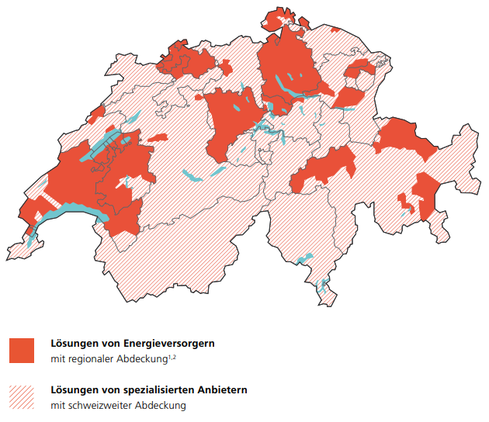

ZURICH: EWZ can take over the billing

On the map you can see in which areas the local energy supplier can take over the billing of self-consumption for you (orange). In addition, there are also specialized companies offering billing solutions that can be used throughout Switzerland. A detailed and up-to-date overview can be found at www.ezs.ch/brechnung.

**Solutions from energy suppliers**

with regional coverage 1,2

**Solutions from specialized providers**

with Swiss wide cover

*1 as of spring 2018, not exhaustive.*

*2 Some energy providers also offer solutions that can be used throughout Switzerland.*

|  |
| --- |
| **Page 4** |

20

**project description**

The apartment house in La Sagne consists of five rental apartments whose

Residents of the solar power produced on the roof

share. The landlord is also the owner of the

Solar system. He charged his tenants the electricity costs on the

Incidental costs, thereby reducing the additional administrative burden

can keep low.

**Location**

Sagne NE

**property**

Bestandesbau

**Area of ​​the plant**

**(Power)**

90 m 2 (18 kWp)

**measurement concept**

The building has a building entrance counter. In addition, for

the appropriate settlement of the consumption of each tenant individually

measured.

**billing model**

The billing is done by a specialized company: Planair

settles the bill together with the property management.

**electricity price**

The solar power is sold at the same price as the mains electricity.

**Configuration**

PLANAIR SA, www.planair.ch

**SMALL MULTI-FAMILY HOUSE**

|  |
| --- |
| **Page 5** |

21

PRACTICAL EXAMPLES

**project description**

Aqua Horw is a modern new building with 54 apartments. The solar power,

The tenants do not consume at the same time, will be the first in Europe

installed TESLA Powerpack cached. As a result, 90%

of the solar power produced in the building itself. In the

Garage can be connected to electric cars.

**Location**

Horw LU

**property**

new

**Area of ​​the plant**

**(Power)**

678 m 2 (94 kWp)

**measurement concept**

The central Swiss power plants measure the flow of electricity within

of the building via smart metering.

**billing model**

The billing is carried out by the property management.

The electricity is charged on the additional costs.

**electricity price**

The solar power is charged at 23 Rp./kWh.

**Configuration**

SOLVATEC AG, www.solvatec.ch

**GREAT MULTI-FAMILY HOUSE**

|  |
| --- |
| **Page 6** |

22

**project description**

The modern co-operative rooftop was built by the

Allgemeine Baugenossenschaft Zürich after ecological considerations

designed. During construction in 2007, a solar system with a capacity of

108 kWp installed. In 2015, the system was expanded by 90 kWp. thanks

A battery can today 95 - 99% of the solar power in self-consumption

be used.

**Location**

Zurich ZH

**property**

new

**Area of ​​the plant**

**(Power)**

1270 m 2 (198 kWp)

**measurement concept**

The tenants remain end users with the energy supplier, which also

continues to make the current measurements.

**billing model**

The tenants receive as before the electricity bill from

Electricity plant of the city of Zurich. The solar power (also saved from the

Battery) and the mains current are shown separately.

**electricity price**

The solar power is sold at the same price as the mains electricity.

**Configuration**

Amena AG, www.amena.ch

**AREA OVERVIEW OF THE GENERAL BUILDING COOPERATION ZURICH**

|  |
| --- |
| **Page 7** |

23

PRACTICAL EXAMPLES

**project description**

The "Azur" complex in Kreuzlingen is a modern Minergie eco-friendly

Overbuilding of the pension fund Basel-Stadt, which consists of twelve buildings

consists of a total of 122 apartments. The self-consumption planned here

Project is an example of how energy providers are delivering through

of attractive billing solutions the implementation of self-consumption

massive projects.

**Location**

Kreuzlingen TG

**property**

Bestandesbau

**Area of ​​the plant**

**(Power)**

1400 m 2 (168 kWp)

**measurement concept**

The tenants remain end users with the energy supplier, which also

continues to make the current measurements.

**billing model**

Billing is carried out by the energy supplier, who

owner both the fed and the tenants

consumed solar power tempered.

**electricity price**

The solar power is sold at the same price as the mains electricity.

**Configuration**

Energy Future Switzerland, www.ezs.ch/Eigenverbrauch

**AREA OVERVIEW OF THE PENSIONSKASSE BASEL CITY**

|  |
| --- |
| **Page 8** |

24

ADVANTAGES OF SOLAR POWER

Everyone benefits from the self-consumption of solar power

Annual electricity costs of an average 4-person household

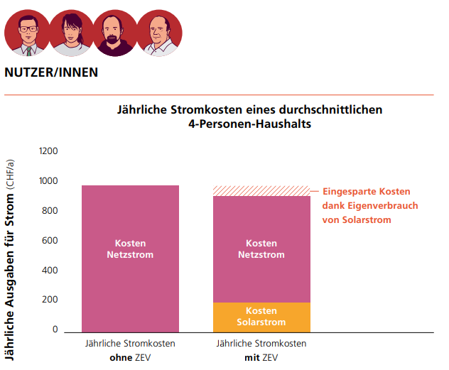

Since the solar electricity for the users generally costs less than the electricity from the grid, the annual electricity costs fall for them. With the founding of a ZEV, the grid power can also be purchased much more cheaply in larger buildings (from approx. 30 apartments) than if each user receives individual grid power. The rules governing tariffs are set out in the Guide. (Www.energieschweiz.ch/eigenverbrauch)

|  |
| --- |
| **Page 9** |

25

**INVESTING IN YOURSELF OR RENTING THE ROOF (CONTRACTING)?**

INVESTING IN YOURSELF OR RENTING THE ROOF (CONTRACTING)?

If you do not want to invest in a solar system yourself as the owner of a property, you can make your property available to an investor. This then installs a solar system and sells you and your tenants the maximum electricity at the same rate that you pay for mains electricity. So you can easily obtain solar power without investing yourself.

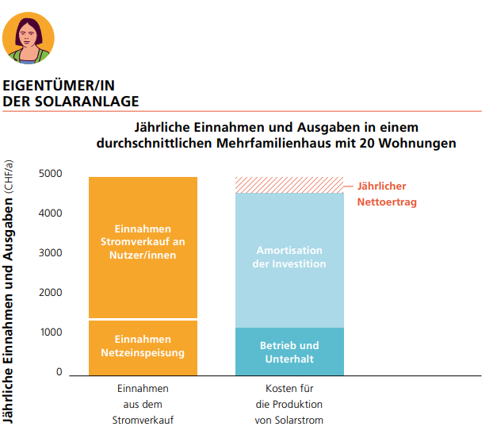

Annual revenue and expenditure in an average apartment building with 20 apartments

Costs for the prodn of solar power

Revenue from electricity sales

Yearly net income

Operation and maintenance

Amortization of the investment

Earnings Power sales to users

Revenue network feed

**In most regions of Switzerland, you receive a very low tariff for the solar power fed into the grid. However, if you sell a large part of the solar power produced to your tenants, you can achieve an average tariff for solar power that is well above the production costs. Nevertheless, the electricity price for the tenants decreases.**

|  |
| --- |
| **Page 10** |

26

«A big part of the

consume solar power

we on the areal itself. »

urs buomberger,

Project developer of the foundation habitat

|  |
| --- |
| **Page 11** |

27

INTERVIEW: URS BUOMBERGER

27

**ON THE AREAL ERLENMATT EAST IN BASEL, A LIVING**

**DIGER TOWN PART WITH HIGH LIVING AND WORK QUALITY.**

**THE FOUNDATION HABITAT PLANTS, BUILDS AND OPERATES THE BUILDINGS**

**AND EQUIPMENT RESOURCE.** **HEAT FROM THE BASIC**

**WATER AND ELECTRICITY FROM SOLAR PLANTS ON THE ROOF**

**ARE COMBINED THAT THE AREA WITH AS POSSIBLE MUCH**

**DIRECTLY ON-SITE PRODUCED POWER CAN BE SUPPLIED.**

**TOGETHER, ALL 13 BUILDINGS MAKE A SITE NETWORK.** **URS BUOMBERGER,**

**HEAD OF PROJECT OFFICE ERLENMATT OST, EXPLAINED, WHY.**

**Why did the Habitat Foundation work for the**

**Construction of a solar system decided?**

Ecological topics lie in the DNA of the

Habitat Foundation. That's why it was clear to us that

as much as possible of the electricity required in the area

to be produced on their own roofs.

For this we have built an area network.

**What does that mean?**

The power supplier only supplies the mains power

a place in the area, which is why all residents

and residents part of a merger to

Self-consumption are. The current distribution and

Measurement is taken over by our partner.

This was made possible by the new energy law.

**What are the benefits for you?**

**Internal consumption community?**

A concern of Erlenmatt Ost is the "small parts"

ligkeit ". Individual plots of our area were

assigned in construction law. To this "small piece"

also fits a decentralized power generation

on their own roofs. The tenants

and tenants on Erlenmatt East will be contracted

Guaranteed that the decentralized solution is not

more expensive than a classic solution.

**You have decided on an area network.**

**Was the implementation complex?**

The administrative setup of the area network

we have regulated the building lease contracts.

For the technical implementation was the foundation

Habitat quickly realized that we are operating the

Solar system and billing of solar power

can not take over themselves. We have

therefore decided for the ADEV as contractor.

The implementation of the area network has so easily

is working.

**How does the current measurement and**

**-distribution?**

The current measurement and distribution takes over

the ADEV. After the adoption of the new Energy

law in 2017, we were able to

install counter. This worked effortlessly.

So far we had little problems with the power

supply and heating. And they could

be remedied quickly.

**How big is the administrative effort?**

Since the ADEV to the entire enterprise

cares, we have no effort for

the operation of the solar systems. The billing

takes place via the service charge settlement

individual leaseholders

the parcels.

|  |
| --- |
| **Page 12** |

28

«The new possibility of one

areal network allows us

our power on the

free market. »

urs buomberger,

Project developer of the foundation habitat

© vistadoc

|  |
| --- |
| **Page 13** |

29

**High self-consumption increases the**

**Profitability of the solar system.** **Do you have**

**Measures have been taken to**

**optimize consumption?**

The available roof areas on the area are

rather small compared to the expected electricity

consumption, which is why a large part of it automatically

solar power is consumed on the area.

In addition, we have heat and hot water

memories that are filled automatically then

if there is excess solar energy.

Mobility is also an issue.

**How does the mobility behavior of the**

**Residents the consumption of solar power?**

On Erlenmatt east we deliberately narrow

the offer of parking spaces. In addition, currently running

a research project with carsharing and

Electric cars. It is trying to excess

To store solar power in the car batteries

and then in the evening at power reference peaks

to use again on the area. Naturally

so that the cars are used at all times

can. So we want the self-consumption of

Increase solar power.

**The project:**

Number of buildings:

Form 13 buildings

an area network

Usage concept: own consumption for

Apartments,

Heat pumps and

E-charging stations

Owner:

Habitat Foundation

Location:

Basel

Configuration:

ADEV

www.adev.ch

|  |
| --- |
| **Page 14** |

Is own consumption of solar power economically? expect for yourself!

A: How many apartments does your property have?

B: How big should the solar system be? Here, the system is designed with a rule of thumb that a self-consumption of 60% is possible. Multiply the number of apartments by nine to get the area occupied by solar panels

C:How much does your investment cost? Multiply The area **(B)** with the factor 330, because on average, one solar system costs per installed square meter (m 2 ) approximately 330 CHF.

D: The federal government promotes the construction of a solar system

with a one-off fee of the amount of 20 - 30% of the investment costs **(C).**

E: The cost of installation **(C)** minus the costs Medium **(D)** gives the investment amount.

F: They sell the solar power to the Residents. This example is about half of the solar power (60%) directly in the House consumed. You earn about CHF 20 per m 2 per year. The annual Revenue from own consumption thus result by multiplication the area **(B)** with the factor 20.

Basis of calculation: Plant size B

(180 m 2 ) × electricity price (0.2 CHF / kWh)

× Own consumption share (60%)

× Annual electricity yield per area (170 kWh / m 2 ).

G: Excess solar power (40%) is going into Network fed in and from the energy provider Remunerated: Depending on the tariff of the energy supplier

this results in revenues of about 5 CHF per m 2 per year. The annual revenue

from the feed of solar power therefore calculate by multiplication

the area **(B)** by a factor of 5.

Basis of calculation: Plant size B

(180 m 2 ) × Entry tariff (0.07 CHF / kWh)

× Grid feed-in share (40%)

× Annual electricity yield per area (170 kWh / m 2 ).

H: The operating and measuring costs of Plant including the administration costs

According to experience, about 8 CHF per m 2 and year.

I: The annual net income arises from the revenues from electricity sales **(F und G)** less the operating and the Measuring costs **(H).**

J: You calculate the amortization period, by the investment costs **(E)** by dividing the annual revenue **(I)** .

**Please note: This is a simplified example calculation.** **The optimal**

**The size of the system in relation to the power requirement depends on many factors and can differ significantly from the example shown here.**

|  |
| --- |
| **Page 15** |

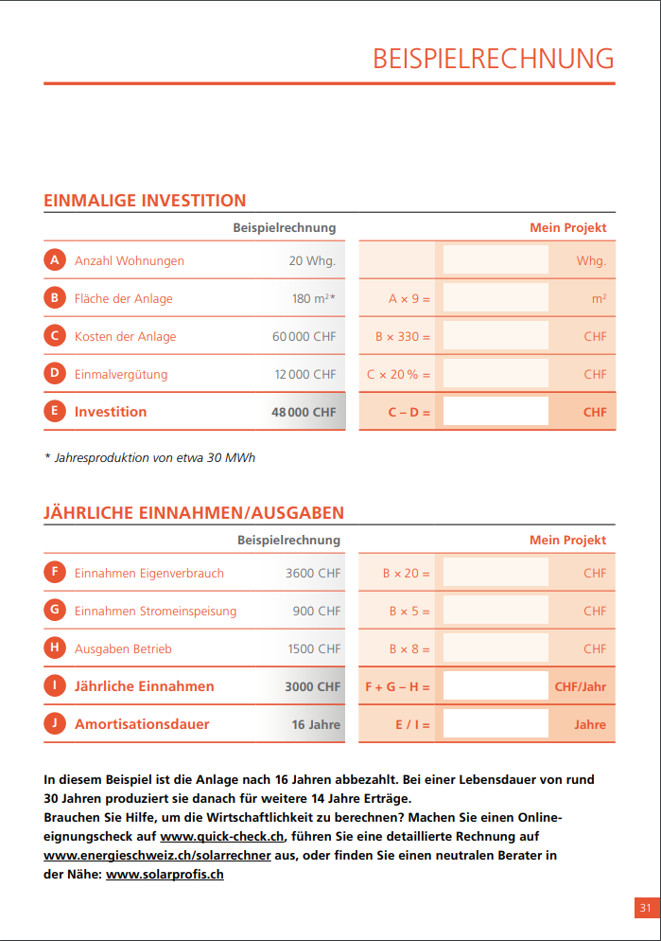

**example calculation**

**My project**

number of apartments

20 Whg.

Curr.

Area of ​​the plant

180 m 2 *

A × 9 =

m 2

Cost of the plant

CHF 60,000

B × 330 =

CHF

time payment

12,000 CHF

C × 20% =

CHF

**investment**

**48,000 CHF**

**C - D =**

**CHF**

**example calculation**

**My project**

Revenue self-consumption

3600 CHF

B × 20 =

CHF

Revenue power feed

900 CHF

B × 5 =

CHF

Spending operation

1500 CHF

B × 8 =

CHF

**Annual revenue**

**3000 CHF**

**F + G - H =**

**CHF / year**

**payback period**

**16 years**

**E / I =**

**years**

EXAMPLE CALCULATION

**A**

**F**

**B**

**G**

**C**

**H**

**D**

**I**

**e**

**J**

**ONE-TIME INVESTMENT**

**ANNUAL REVENUE / EXPENDITURE**

**In this example, the system is paid off after 16 years.** **With a service life of around**

**30 years later, she produces yields for another 14 years.**

**Need help to calculate the profitability?** **Make an online**

**Check your fitness on www.quick-check.ch, list a detailed invoice**

**www.energieschweiz.ch/solarrechner or find a neutral consultant in**

**near: www.solarprofis.ch**

31

*\* Annual production of about 30 MWh*

|  |
| --- |
| **Page 16** |

SwissEnergy, Swiss Federal Office of Energy SFOE

Mühlestrasse 4, CH-3063 Ittigen. Postal address: CH-3003 Bern

Infoline 0848 444 444, www.infoline.energieschweiz.ch

energieschweiz@bfe.admin.ch, www.energieschweiz.ch

twitter.com/energieschweiz

Sales: www.bundespublikationen.admin.ch

Item number 805.527.D

The use of solar power is ideal for multi-family houses.

The new Energy Act, which has been in force since 2018, is opening up

new opportunities for property owners and tenants. But how are you?

me before? Is the effort worth it? Implementation for real estate

Owners is easy: By the own solar system you become the

ecological electricity provider. This brochure is intended to assist you

a guide, and show you how to test the power of

availability of your own system.

SHORT AND BUNDLY

**THE NEXT STEPS?**

• Make an online suitability check: www.quick-check.ch

• Contact a solar professional: www.solarprofis.ch

**FOR FURTHER INFORMATION**

• Guide to self-consumption, SwissEnergy: www.energieschweiz.ch/en/conditions

• Overview of Billing Solutions: www.ezs.ch/billing

• Instructions for a successful implementation: https://www.energieschweiz.ch/my-solaranlage

The contents were from

Energy Future Switzerland

(www.ezs.ch).

08.18 1000 8604

2

67

8th

5