1) Frontend, Backend, and Full-Stack Development
Frontend development focuses on the part of a website that users actually see and interact with — things like layout, buttons, and design — using languages such as HTML, CSS, and JavaScript.
Backend development works behind the scenes, handling the server, database, and application logic using technologies like Node.js, Python, or Java.
Full-stack development combines both, meaning the developer can create an entire web application — from the user interface to the data processing.
Example: In Zomato, the restaurant listings and interface are managed by the frontend, while the login system and data handling are managed by the backend. A full-stack developer can work on both parts together.

3) How a Browser Requests and Displays a Web Page
When a user enters a website URL, the browser sends an HTTP request to the web server. The server receives this request, processes it, and sends back an HTML response.
The browser then downloads additional files like CSS, JavaScript, and images, interprets them using its rendering engine, and finally displays a properly formatted web page to the user.

4) Tools Required for a Web Development Environment
To start web development, you need a proper setup that helps in writing, testing, and managing code efficiently:
- Code Editor (VS Code): Used to write and organize code. It supports HTML, CSS, and JavaScript and provides features like syntax highlighting, extensions, and live preview.
- Web Browser (Chrome or Firefox): Used to test and view web pages. Developer tools inside browsers help debug errors and analyze performance.
- Version Control (Git and GitHub): Helps track changes in code and collaborate with others. Git works locally, while GitHub hosts the project online.
- Package Manager (npm): Makes it easy to install and manage frameworks or libraries like React and Tailwind CSS.
- Local Server (XAMPP or Node.js): Allows testing dynamic websites on a local computer before deploying them online.

5) What Is a Web Server?
A web server is software that delivers web pages to users when requested through the internet. It handles incoming HTTP requests from clients (browsers) and sends back the correct web pages or data as responses.
Examples: Apache, Nginx, Microsoft IIS, and Node.js.

7)
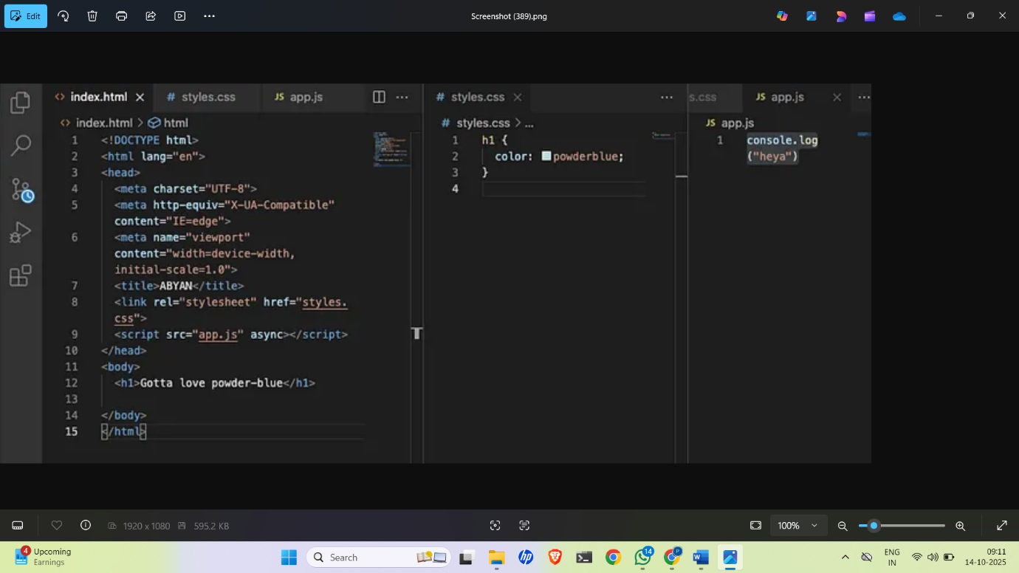

6) Roles in a Web Project
- Frontend Developer: Creates and designs the visual interface of the website using HTML, CSS, and JavaScript.
- Backend Developer: Manages the logic, database, and APIs that power the website’s functionality.
- Database Administrator (DBA): Maintains the database, ensuring security, efficiency, and reliability.

8) Static vs Dynamic Websites
A static website displays the same fixed content to all users and only changes when the developer manually edits the code.
Example: A personal portfolio website.
A dynamic website, on the other hand, changes content in real time based on user actions or data from a database.
Example: Social media platforms like Facebook.

9) Web Browsers and Rendering Engines
Some of the most popular web browsers are:
- Google Chrome: Fast, secure, and user-friendly — developed by Google.
- Mozilla Firefox: Open-source and privacy-focused with strong customization options.
- Microsoft Edge: Built on Chromium, integrated well with Windows.
- Safari: Default browser for Apple devices, optimized for speed and battery life.
- Opera: Lightweight browser known for its built-in VPN and ad blocker.
Difference: Each browser uses a different rendering engine to interpret HTML, CSS, and JavaScript. For example, Chrome uses Blink, while Safari uses WebKit, which can cause small differences in how web pages appear across browsers.

10) The client sends a request → the server processes it → through APIs it connects to the database → gets or updates the data → and finally sends the response back to the client.

