ASSIGNMENT 1

1. Difference Between Frontend, Backend, and Full-stack Development
- Frontend Development:
  - Refers to the part of the web that users interact with. It is the visual aspect and the user interface of the website or application.
  - Technologies used: HTML, CSS, JavaScript, React, Angular, Vue.js.
  - Example: The layout of a website, buttons, forms, and navigation bars you see on a webpage.
- Backend Development:
  - Refers to the server side of the application, where data is processed, and requests from the frontend are handled.
  - Technologies used: Node.js, Python, Ruby, PHP, Java, C#, databases like MySQL, PostgreSQL.
  - Example: When you log into a website, the backend handles the verification of your credentials and retrieves your data.
- Full-stack Development:
  - A full-stack developer works on both the frontend and the backend of an application, handling everything from the user interface to the database and server-side logic.
  - Example: Building a website like Facebook where the frontend (UI) and backend (data processing, authentication) are both managed by one developer or team.

2. Client-Server Model Diagram
The client-server model involves the client (typically a browser) sending requests to a server, which processes the requests and sends back a response.

The Client-Server Model is the foundational concept of the web:
● Client: Usually a web browser that sends requests for data or content.
● Server: Responds to client requests by sending requested data (HTML pages, JSON,
files).
● Internet/Network: Acts as the communication channel between client and server.

Diagram Example:
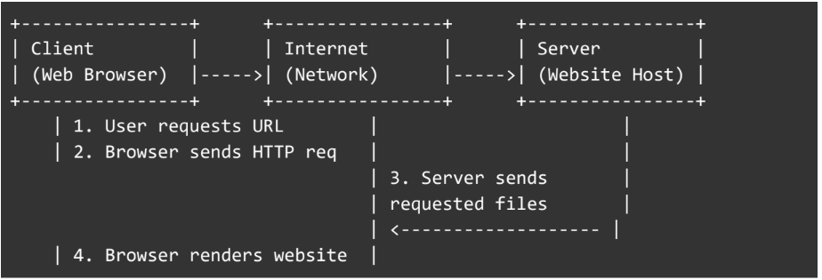

3. Browser Requesting and Displaying a Web Page
- Step 1: The browser sends a request to the server via the URL entered in the address bar (HTTP request).
- Step 2: The web server processes the request and sends the required HTML, CSS, and JavaScript files back to the browser.
- Step 3: The browser renders the page. It first parses the HTML, applies the CSS for styling, and then executes the JavaScript to add interactivity.
- Step 4: The page is displayed to the user.

4. Tools Required to Set Up a Web Development Environment
- Text Editor (e.g., VS Code): To write and edit code.
- Web Browser (e.g., Chrome, Firefox): For testing and rendering websites.
- Local Web Server (e.g., XAMPP, WAMP, or Live Server extension in VS Code): To run server-side code locally.
- Version Control (e.g., Git, GitHub): To manage and track code changes.
- Command Line (e.g., Terminal on Mac or Command Prompt on Windows): For running scripts and managing projects.
- Package Manager (e.g., npm, yarn): To manage JavaScript libraries and dependencies.

5. Web Server and Examples
- Web Server: A web server is software that serves web pages to users by accepting HTTP requests and sending back responses.
- Examples of Web Servers:
  - Apache HTTP Server: Open-source, commonly used in Linux environments.
  - NGINX: Known for high performance and scalability, used as a reverse proxy.
  - Microsoft IIS: A web server for hosting web applications in Windows environments.
  - Node.js (Express.js): JavaScript runtime that can act as a web server.

6. Roles of Frontend Developer, Backend Developer, and Database Administrator
- Frontend Developer:
  - Responsible for creating the visual aspects and user interfaces of a website.
  - Works with HTML, CSS, JavaScript, and UI/UX design tools.
- Backend Developer:
  - Handles the server-side logic, APIs, databases, and application logic.
  - Works with server-side programming languages like Node.js, PHP, Python, Ruby, and frameworks like Django, Express.
- Database Administrator (DBA):

  - Manages the database, ensuring data integrity, security, and performance.
  - Works with SQL or NoSQL databases and performs tasks like database design, backups, and query optimization.

7. Install VS Code and Configure it for HTML, CSS, and JavaScript Development
- Install VS Code: Download from here.
- Configure for HTML, CSS, and JavaScript:
  - Install the "Live Server" extension for real-time preview of HTML files.
  - Install the "Prettier" extension for automatic code formatting.
  - Install "ESLint" for JavaScript linting.
- Screenshot: You can take a screenshot after opening VS Code with a project setup containing index.html, styles.css, and app.js.

8. Difference Between Static and Dynamic Websites
- Static Websites:
  - Consist of fixed content that doesn’t change unless manually edited.
  - Technologies: HTML, CSS, JavaScript.
  - Example: A personal portfolio website with fixed information.
- Dynamic Websites:
  - Content is generated on the fly, based on user interactions or server-side logic.
  - Technologies: PHP, Node.js, Python (Flask, Django).
  - Example: A blog where posts are dynamically loaded from a database.

9. Research and List Five Web Browsers
- Google Chrome
- Mozilla Firefox
- Safari
- Microsoft Edge
- Opera
Rendering Engines:
- Google Chrome: Uses Blink rendering engine.
- Mozilla Firefox: Uses Gecko rendering engine.
- Safari: Uses WebKit rendering engine.
- Microsoft Edge: Uses Blink rendering engine (after switching from EdgeHTML).
- Opera: Also uses Blink (same as Chrome).

10. Basic Web Architecture Flow Diagram
- Diagram Example:
