Student Setu — Design Document
Student Setu is one free platform that guides Indian students from school, through college, to a job. Team YuvaNex · Hack for Social Cause · HSC|MP|00172 · Madhya Pradesh.

Problem and users
Students in small towns and government colleges lack one trusted guide from school to a job. They lose months on scattered, unverified websites, and their syllabus often does not teach what employers ask for.
- Career confusion: Class 12 students don't know every course and entrance exam open to them.
- Skills gap: university syllabi cover only part of what a job role needs, and students can't prove the skills they learn on their own.
- Overloaded teachers: teachers in local colleges have little time or support to plan lessons, set papers and track who is falling behind.
- Life in a new city: students who move for college struggle to find safe stays and affordable food.
- Exam pressure: when NEET or JEE doesn't go well, students see no alternatives and face stress alone.
User | What they come for
School student (Class 11–12) | Courses open after their subjects, entrance exams, a preparation roadmap
College student | Gap between syllabus and job, a learning plan, verified skill badges, study material
Graduate | Jobs matched to their degree and skills
Teacher | AI lesson plans, question papers, class quizzes and weak-topic insights
Hostel owner, tiffin provider | List verified stays and meals near colleges
Mentor, admin | Guide students; verify teachers and approve listings

Solution at a glance
Student Setu replaces many scattered websites with one free platform that follows the student through three stages.
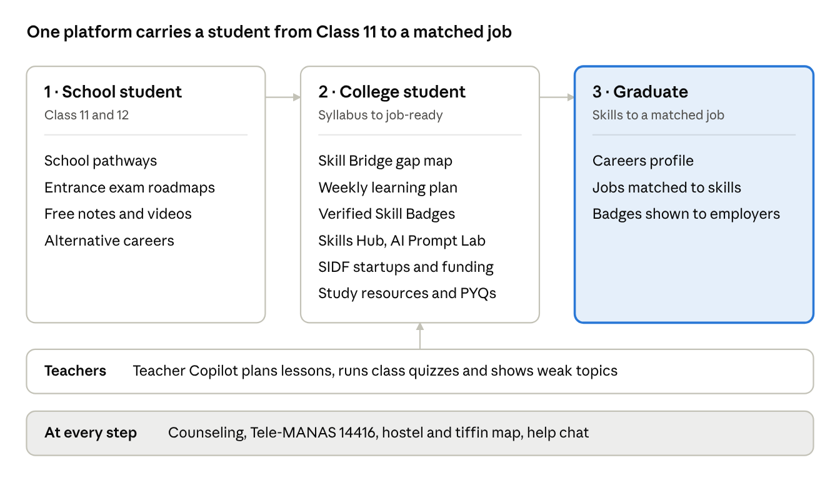
student journey · 3 stages and the modules at each
Teacher Copilot works alongside the college stage, and support tools stay open at every step.

Modules
Student Setu has 11 learning and career modules, plus optional student-life tools, all in one React app with role-based logins.
Module | Page | Main users | What it does
School pathways | /pathways | School students | Pick Class 12 subjects and see every public and private course open to them, its entrance exam with official links, a step-by-step roadmap, and free notes and videos
Skill Bridge | /skill-bridge | College students | Compares the real syllabus (course, university, semester) with 13 job roles across 45 skills, shows coverage by graduation, and builds a week-by-week plan from free courses
Verified Skill Badges | /skill-bridge, /verify/:token | Students, employers | 5-question tests graded on the server (4 of 5 to pass) for 15 skills; the signed badge can be checked by anyone in one click
Skills Hub | /skills | Students | Free AI courses, a hands-on AI Prompt Lab, and a leaderboard showing the next step to a job
Careers | /careers | Graduates | Profile with degree and skills; shows only jobs matched to them, with verified badges counted automatically
Teacher Copilot | /teacher | Teachers | AI lesson plans and question papers in English or Hindi, a quiz builder, class codes, auto-graded quizzes, a weak-topic heatmap and one-click re-teach lessons
Class page | /class/:code | Students | Join a class with a 6-character code; no login or app needed
Counseling | /counseling | Students under pressure | Alternative careers if NEET, JEE, CLAT or CA doesn't go well, a drop-year self-check, Talk to an Expert, and the Tele-MANAS helpline 14416
SIDF | /sidf | College innovators | Startup events in government colleges, mentors, hackathon prep, government funding schemes and an idea form with instant feedback
Vocational | /vocational | Trade learners | 7 trade tracks in Hindi with tests and links to Skill India, Apprenticeship India and ITI
Study resources | /resources, /library, /exams, /scholarships | All students | University-wise notes, previous-year papers and syllabus, free quizzes, an e-library, and scholarships
Student life (optional) | /hostels, /tiffin, /connect, /colleges | Students moving cities | Verified hostels, PGs and tiffin centres on one map around each college, local-student connect and a college directory
Setu Saathi | every page | Everyone | Help chat powered by Gemini, with built-in FAQ answers as a fallback
Owners, tiffin providers, mentors and admins each get their own dashboard. Admins verify teachers and approve listings before they go live.

System architecture
Student Setu is a serverless web app: a React progressive web app on Netlify's CDN, four Netlify Functions for anything that needs trust or AI, Google Gemini for AI, and Netlify Blobs for shared class data.
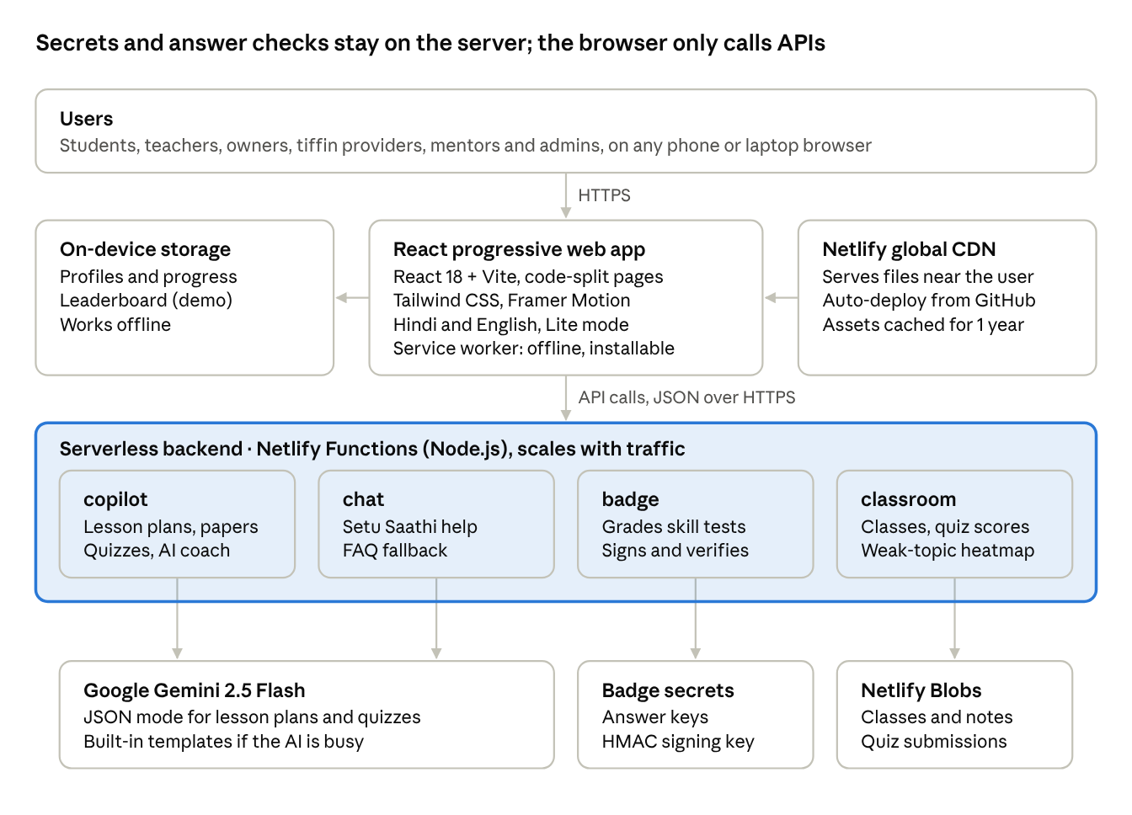
system architecture · browser, 4 serverless functions, AI and storage
The browser never holds an API key, a badge answer key or the signing key. If Gemini is not reachable, Copilot falls back to built-in templates and the chat to FAQ answers, so the app keeps working.

Key flows
The two flows that need the most trust, earning a skill badge and running a class quiz, are both decided on the server.

Earning and verifying a skill badge
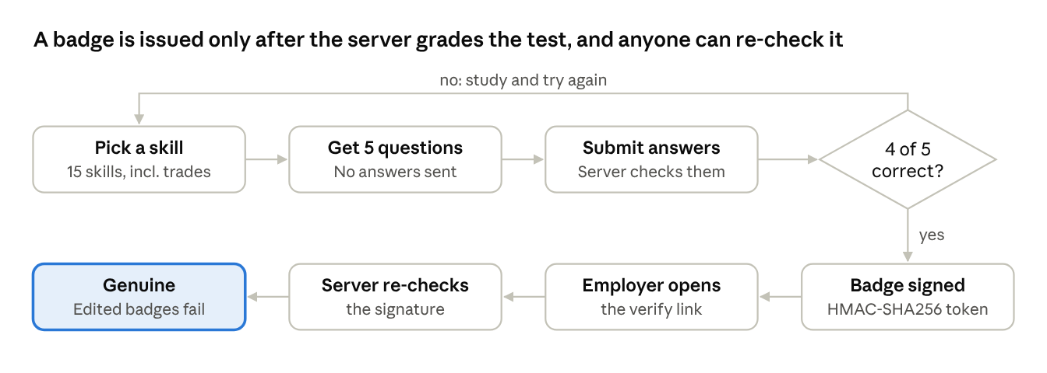
skill badge flow · test, sign, verify
The badge is a signed token, so checking it needs no database. Changing even one letter of a badge makes the check fail.

Running a class quiz
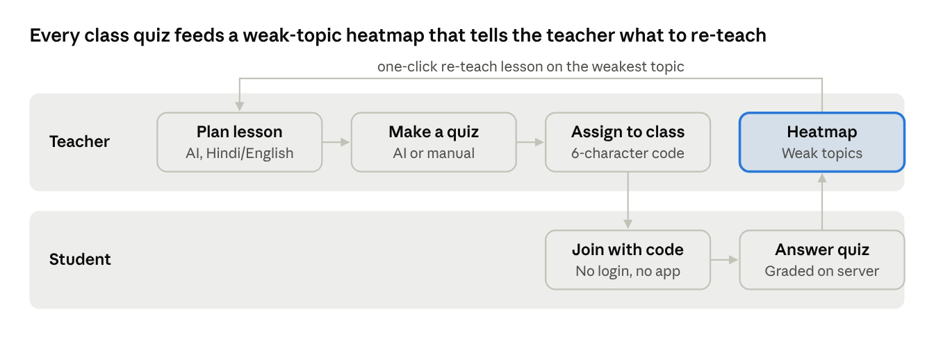
class quiz flow · teacher and student
Students never receive the answers. The server grades each attempt, and the heatmap groups results by topic so the teacher sees which topic most of the class missed.

Data design
Data lives in three places: shared class data on the server, secret material only in server code, and each user's own progress on their device.
Data | Stored in | Key or shape | Why there
Class (subject, teacher, college, quizzes with answers, notes) | Netlify Blobs | class/<CODE> | Shared between a teacher and every student who joins with the code
Quiz submission (name, answers, score, per-question results) | Netlify Blobs | subs/<CODE>/<id> | One record per attempt; the teacher's heatmap is computed from these
Badge question bank and answer key | Server code only | 15 skills × 5 questions | Answers never reach the browser, so tests can't be cheated
Skill badge | A signed token the student keeps | <payload>.<signature> (base64url) | Needs no database; the signature proves it is genuine
Profiles, progress, leaderboard, listings | Browser (localStorage) | One record per user | Prototype only; works offline
Courses, syllabi, job roles, exams, scholarships, hostels, tiffins | Static data files in the app | src/data/*.js | Fast to load and cached for offline use
A class record has two keys. The 6-character class code lets students view and join; a separate 32-character teacher key is needed to add quizzes or see results. Students only ever receive the class with answers removed.
The grading and heatmap logic is one shared file (src/shared/classroom.js) used by both the server and the browser, so results match online and offline.

Security and privacy
Every secret stays on the server, and every trust decision (grading, signing, class access) is made there, not in the browser.
Risk | How it is handled
Leaked API keys | The Gemini key and badge signing key live only in Netlify environment variables, read by server functions. Nothing named VITE_* holds a secret, so no key is bundled into public JavaScript.
Cheating on skill tests | The browser gets questions and options only. Answers are checked on the server; a pass needs 4 of 5.
Fake or edited badges | Each badge is signed with HMAC-SHA256. The verify page recomputes the signature with a timing-safe comparison, so any edited badge is rejected.
Strangers changing a class | Adding quizzes, adding notes and viewing results all need the class's secret teacher key. Without it the server answers "forbidden".
Fake teachers | New teachers give their college, employee ID and subjects and start as "Verification pending". Only an admin can verify them, and only verified teachers can run classes.
Bad or oversized input | The server trims and length-limits every field and checks quiz shape (2–6 options, one valid answer, at most 30 questions, 50 quizzes per class). Note links must start with http:// or https://.
Student privacy | Students join a class with a name only: no phone number, email or app login. Phone numbers in listings are masked.
AI mistakes | AI output is labelled "Generated by Gemini — review before use", and the prompt tells the model never to invent statistics.
Open item: accounts are a browser-only demo today. Production needs real sign-in (for example OTP login) with teacher verification stored on the server.

Design for Bharat
The design target is a budget Android phone on a slow, expensive connection, used by someone more comfortable in Hindi than English.
Need | Design choice
Slow or costly data | Lite mode turns off photos and animations for 2G/3G. Pages are code-split, so each loads only its own code. Static files are cached for a year.
Patchy internet | A service worker keeps the app working offline. It installs like an app from the browser, with no app store download.
Language | The whole interface switches between English and Hindi. Teacher Copilot writes lesson plans and papers in either language, and vocational modules are in Hindi.
Low reading confidence | Listen-aloud (text to speech) reads plans, lessons and notes.
How students already share | One-tap WhatsApp sharing for class codes, plans and badges.
No logins for students | Students join a class by typing a 6-character code. Codes skip look-alike characters (0, O, 1, I).
Trust | Verified badges on hostels, listings and teachers. Real programmes, scholarships and books link to their official sites.
Missing images | Hero and city artwork is inline SVG, so it always renders; a failed photo shows a styled placeholder.
Comfort | Light and dark themes, a global search palette, and a help chat on every page.
The visual language uses navy for trust and saffron for action, with large tap targets and card layouts that read well on a 360-pixel-wide screen.

Scaling plan
The serverless core already scales with traffic and costs nothing when idle; growing to national scale means replacing the browser-only demo parts with managed services.
Area | Prototype today | At national scale
Accounts | Demo logins saved in the browser | Managed sign-in (for example Supabase or Firebase) with OTP login
Main data | Browser storage and static files | PostgreSQL for profiles, progress, listings and teacher verification, with geo-search for hostels and tiffins
Lectures and notes | Links and static files | Object storage behind a CDN for university lecture videos and notes
Job and course matching | Computed in the browser | Computed on the server from verified skills
Classes and quizzes | Netlify Blobs | Stays on Blobs or moves into the central database
AI | Gemini 2.5 Flash with template fallback | Same, with per-user limits and caching of common lesson plans
Coverage | Sample cities, colleges and the RGPV syllabus | More universities, cities and Hindi translations of listing content
The order: real accounts first (they unlock trusted teacher verification), then the central database, then content storage and server-side matching.

Team and links
Team YuvaNex built and deployed Student Setu; it is live and free to try.
Member | Role
Divyansh Dubey | Team Lead · Architecture
Khushi Dubey | Frontend & UI/UX
Prakhar Porwal | AI & Backend
- Live website — demo logins on the Login page, password demo123
- Source code on GitHub
- Submission video (4:57)
- Presentation (PDF) · PowerPoint
- Architecture page on the site

