SNS
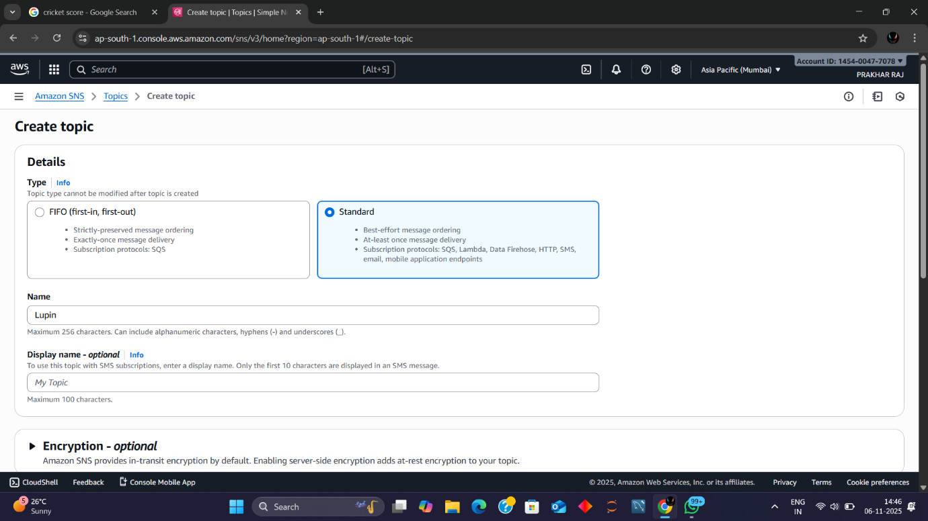
Amazon SNS Topic Creation Summary
Topic Name: Lupin
Topic Type: Standard (selected)
- Message Ordering: Best-effort
- Delivery Guarantee: At-least-once
- Supported Protocols: SQS, Lambda, Data Firehose, HTTP, SMS, Email, Mobile App Endpoints
Optional Display Name: My Topic
- Used for SMS subscriptions (first 10 characters shown in SMS)
Encryption Settings:
- In-transit encryption enabled by default
- Optional server-side encryption for at-rest protection
Region: Asia Pacific (Mumbai)
Account Info: Visible in console header
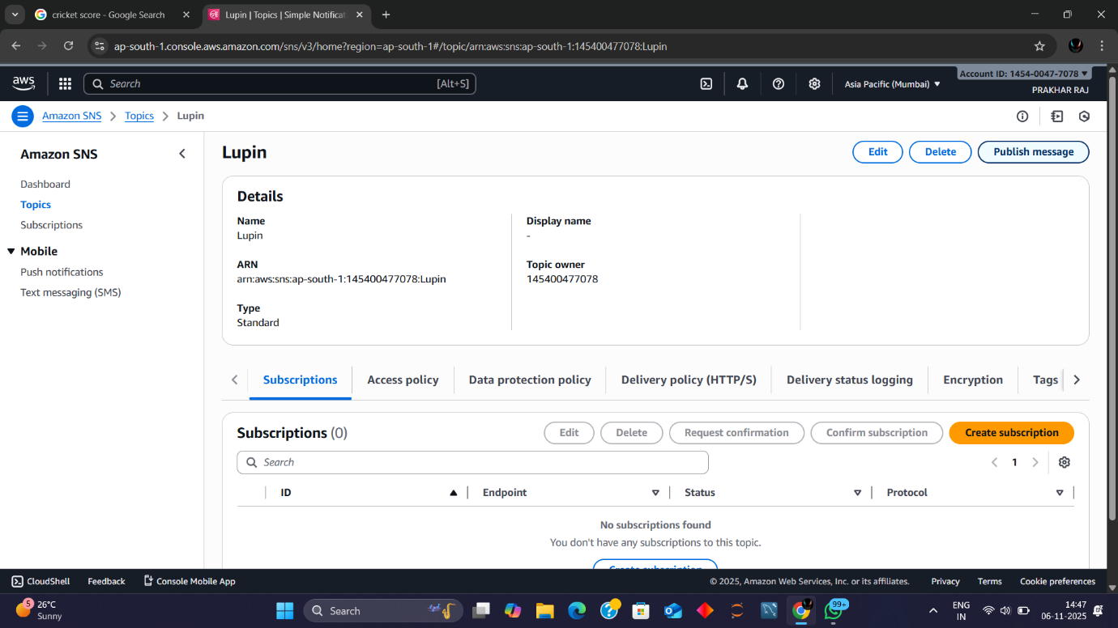
Amazon SNS Topic Overview – Lupin
Topic Name: Lupin
Topic ARN: arn:aws:sns:ap-south-1:145400477078:Lupin
Topic Type: Standard
Display Name: (not set)
Topic Owner: 145400477078
Region: Asia Pacific (Mumbai)
Subscriptions Tab:
- No subscriptions currently configured
- Options available: Create, Edit, Delete, Confirm, Request Confirmation
Other Configuration Tabs:
- Access Policy
- Data Protection Policy
- Delivery Policy (HTTP/S)
- Delivery Status Logging
- Encryption
- Tags
- 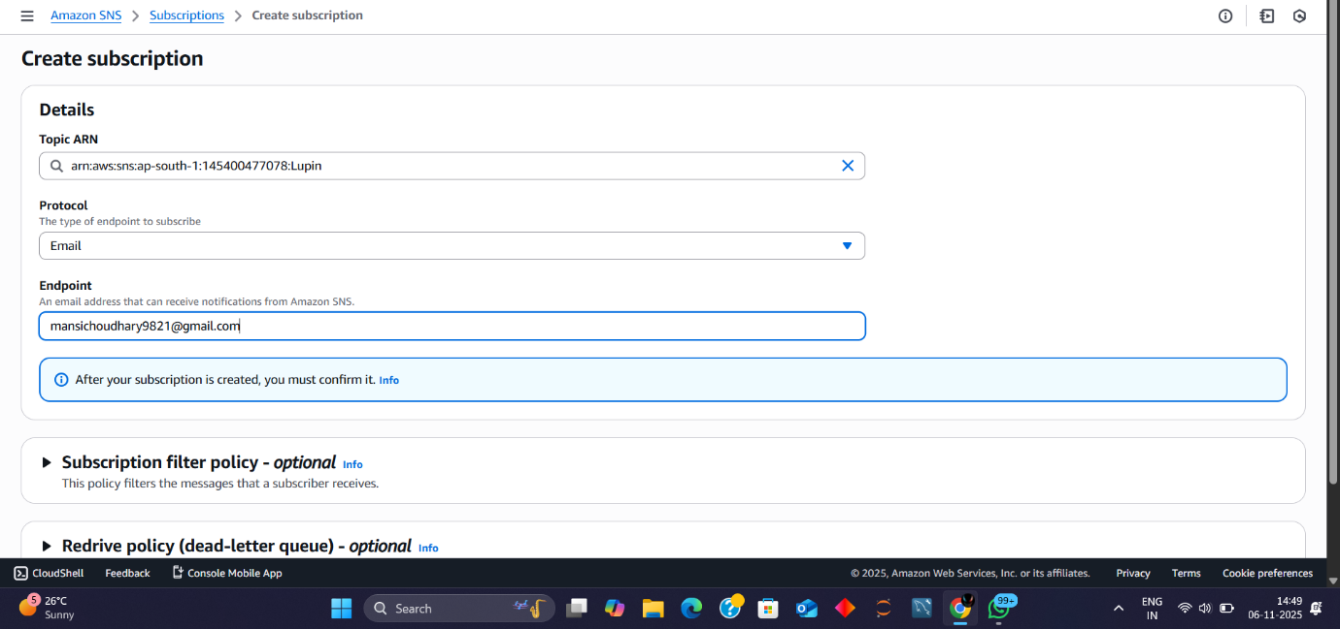
Amazon SNS – Create Subscription for Topic Lupin
Topic ARN: arn:aws:sns:ap-south-1:145400477078:Lupin
Protocol Selected: Email
Endpoint: mansichoudhary9821@gmail.com
- The recipient must confirm the subscription after creation
Optional Settings Available:
- Subscription Filter Policy: Filters messages based on attributes
- Redrive Policy (Dead-letter Queue): Handles failed message deliveries
Region: Asia Pacific (Mumbai)
Timestamp: 06-Nov-2025, 14:49 IST
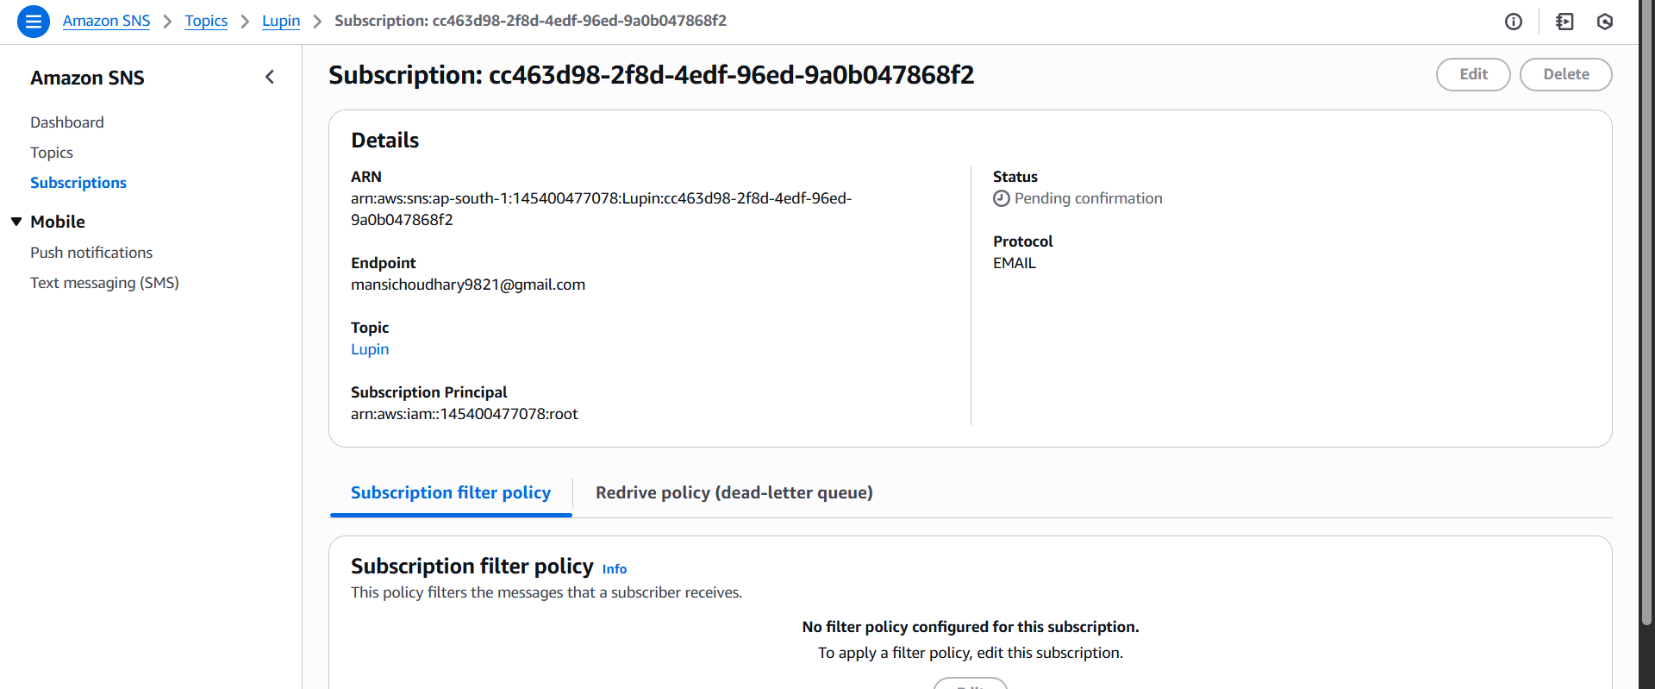
Amazon SNS Subscription Details – Lupin
Subscription ID: cc463d98-2f8d-4edf-96ed-9a0b047868f2
Subscription ARN: arn:aws:sns:ap-south-1:145400477078:Lupin:cc463d98-2f8d-4edf-96ed-9a0b047868f2
Protocol: EMAIL
Endpoint: mansichoudhary9821@gmail.com
Status: Pending confirmation
Topic Name: Lupin
Subscription Principal: arn:aws:iam::145400477078:root
Subscription Filter Policy:
- No filter policy configured
- Option available to edit and apply filters
Navigation Context:
- Located under SNS > Subscriptions
- Other sections visible: Dashboard, Topics, Mobile (Push & SMS)
- 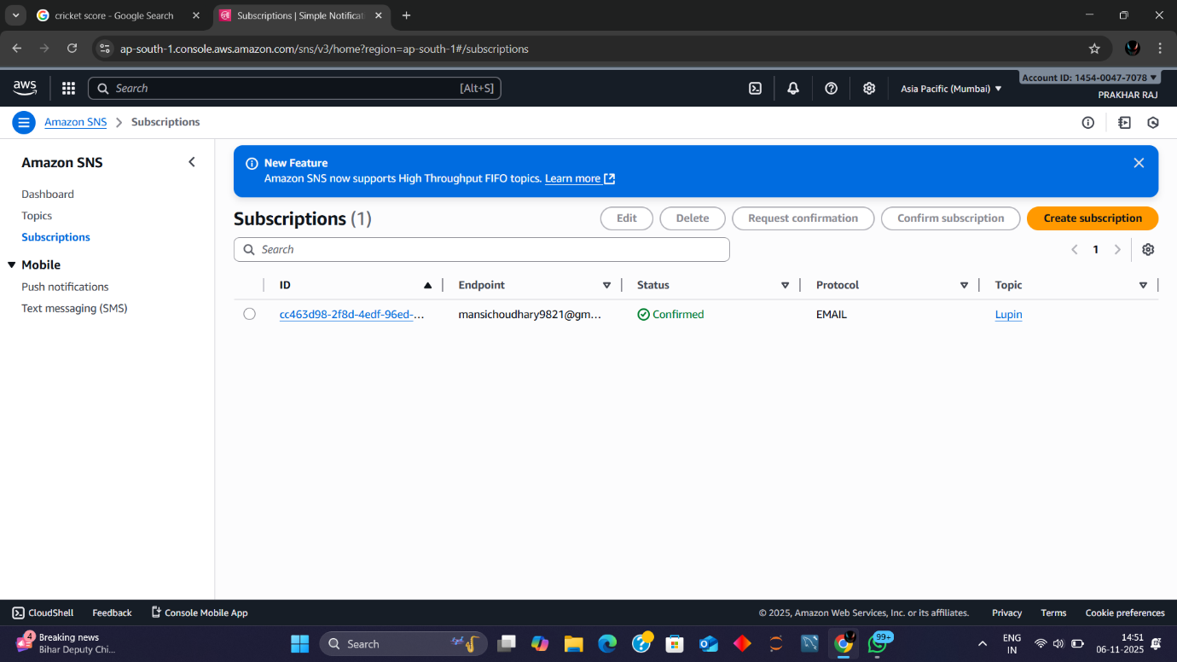
Amazon SNS Subscription Status – Lupin
Subscription ID: cc463d98-2f8d-4edf-96ed-...
Endpoint: mansichoudhary9821@gmail.com
Status: Confirmed
Protocol: EMAIL
Topic: Lupin
Available Actions:
- Edit
- Delete
- Request Confirmation
- Confirm Subscription
- Create New Subscription
Navigation Context:
- Located under SNS > Subscriptions
- Sidebar includes: Dashboard, Topics, Subscriptions, Mobile (Push & SMS)
Console Update Banner:
- Highlights support for High Throughput FIFO topics
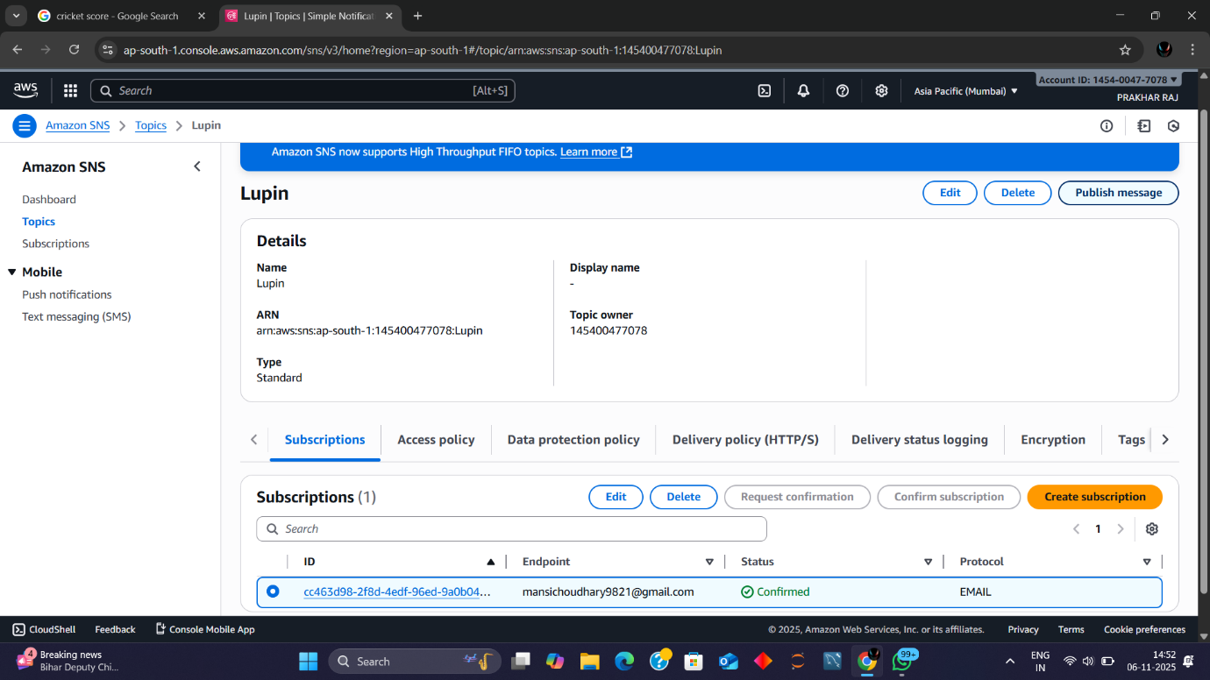
Amazon SNS Topic & Subscription Summary – Lupin
Topic Details:
- Name: Lupin
- ARN: arn:aws:sns:ap-south-1:145400477078:Lupin
- Type: Standard
- Display Name: (not set)
- Topic Owner: 145400477078
- Region: Asia Pacific (Mumbai)
Subscription Details (under Subscriptions tab):
- ID: cc463d98-2f8d-4edf-96ed-9a0b04...
- Endpoint: mansichoudhary9821@gmail.com
- Status: ✅ Confirmed
- Protocol: EMAIL
Available Actions:
- Edit
- Delete
- Request Confirmation
- Confirm Subscription
- Create New Subscription
Other Configuration Tabs:
- Access Policy
- Data Protection Policy
- Delivery Policy (HTTP/S)
- Delivery Status Logging
- Encryption
- Tags
Timestamp: 06-Nov-2025, 14:52 IST
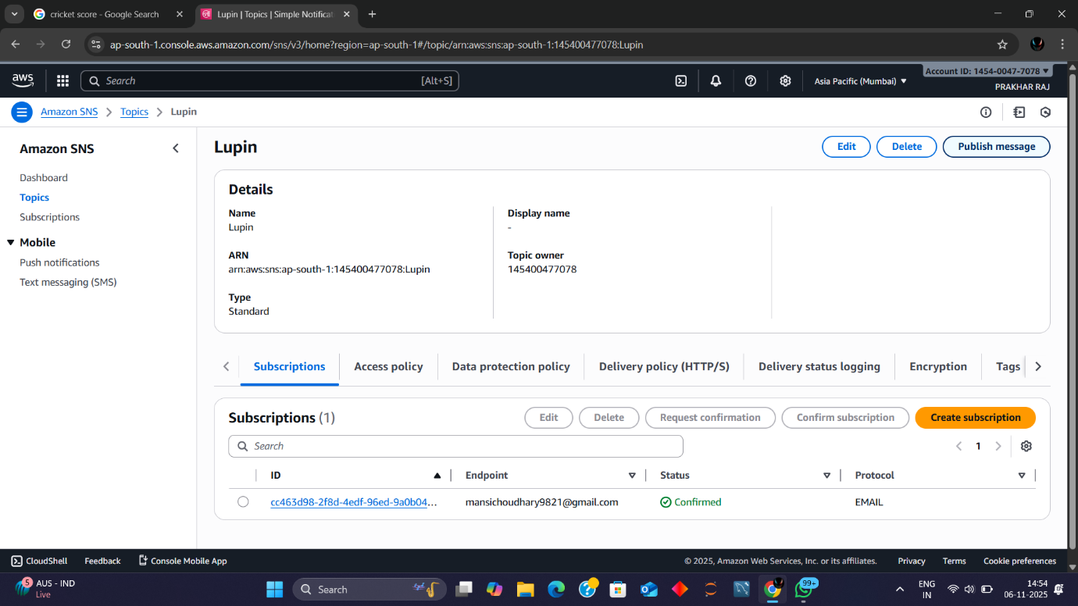
Amazon SNS Topic Overview – Lupin
Topic Details:
- Name: Lupin
- ARN: arn:aws:sns:ap-south-1:145400477078:Lupin
- Type: Standard
- Display Name: (not set)
- Topic Owner: 145400477078
- Region: Asia Pacific (Mumbai)
Subscription Summary:
- Total Subscriptions: 1
- ID: cc463d98-2f8d-4edf-96ed-9a0b04...
- Endpoint: mansichoudhary9821@gmail.com
- Status: ✅ Confirmed
- Protocol: EMAIL
Available Actions:
- Edit
- Delete
- Publish Message
- Request Confirmation
- Confirm Subscription
- Create Subscription
Configuration Tabs:
- Subscriptions
- Access Policy
- Data Protection Policy
- Delivery Policy (HTTP/S)
- Delivery Status Logging
- Encryption
- Tags

