Lamda
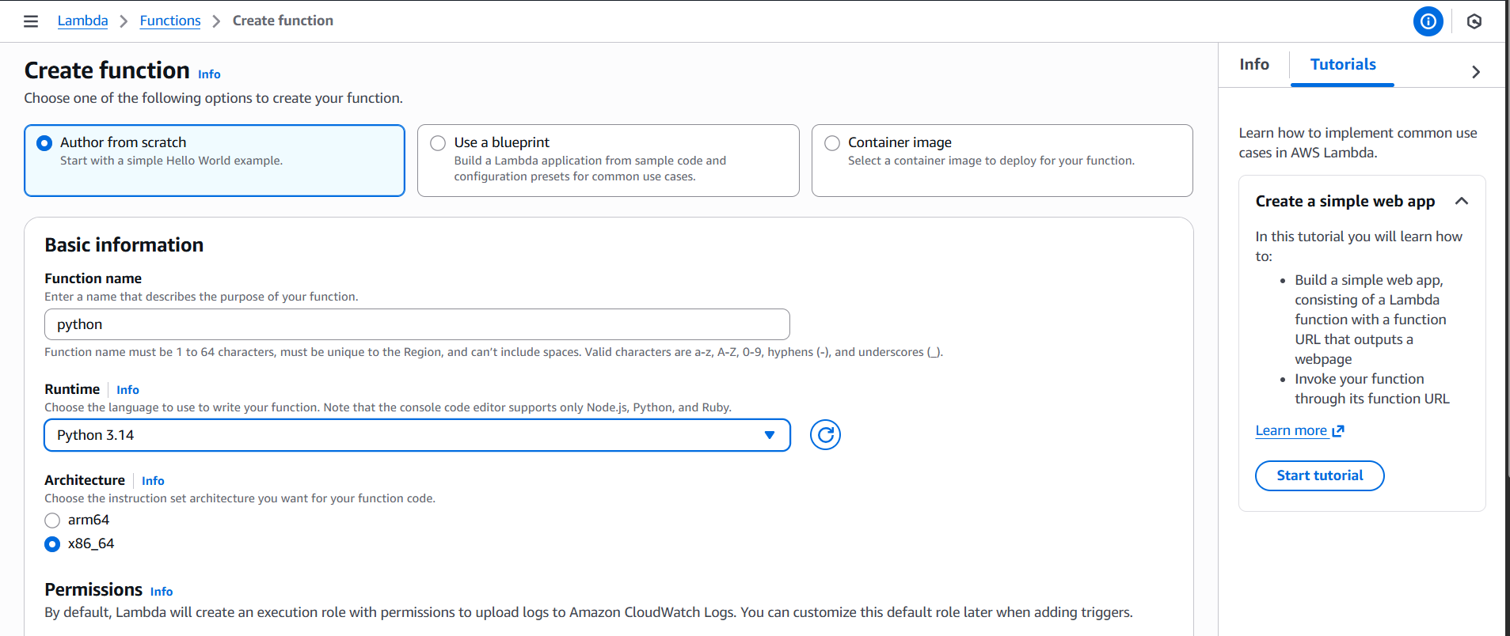
AWS Lambda – Create Function Overview
Creation Method Selected: Author from scratch
- Starts with a basic Hello World example
- Alternative options: Use a blueprint, Container image
Basic Configuration:
- Function Name: python
- Runtime: Python 3.14
- Architecture: x86_64
- Permissions:
- Default execution role created
- Grants permission to upload logs to Amazon CloudWatch Logs
Tutorial Sidebar:
- Title: Create a simple web app
- Guides users to:
  - Build a Lambda function with a function URL
  - Output a webpage
  - Invoke via function URL
- Options: Start tutorial, Learn more
Region Context: Asia Pacific (Mumbai)
Would you like this integrated with your SNS summaries into a unified AWS workflow guide or onboarding deck? I can also help you annotate the Lambda setup for client-facing documentation.
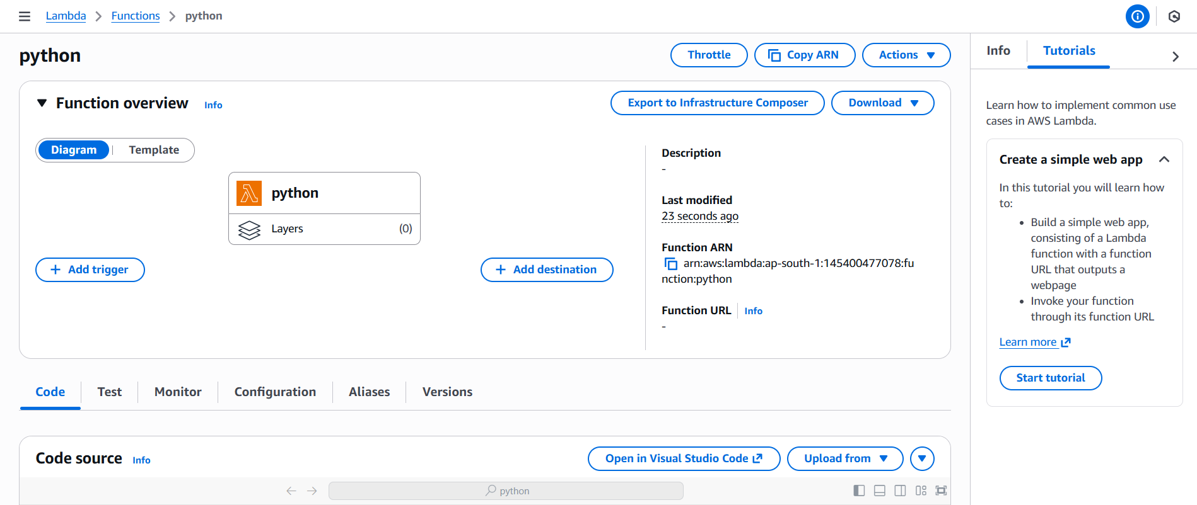
AWS Lambda Function Summary – python
Function Name: python
Function ARN: arn:aws:lambda:ap-south-1:145400477078:function:python
Runtime: Python 3.14
Architecture: x86_64
Description: (not set)
Last Modified: 23 seconds ago
Function URL: (not configured)
Function Overview Panel:
- View options: Diagram or Template
- Actions available: Add Trigger, Add Destination
Console Tabs:
- Code
- Test
- Monitor
- Configuration
- Aliases
- Versions
Code Source Options:
- Open in Visual Studio Code
- Upload from file
Tutorial Sidebar:
- Create a simple web app
- Build a Lambda function with a function URL
- Output a webpage
- Invoke via URL
Region Context: Asia Pacific (Mumbai)
Would you like me to combine this with the previous Lambda and SNS summaries into a unified AWS resource guide or onboarding document? I can also help you structure it for client presentations or internal training.
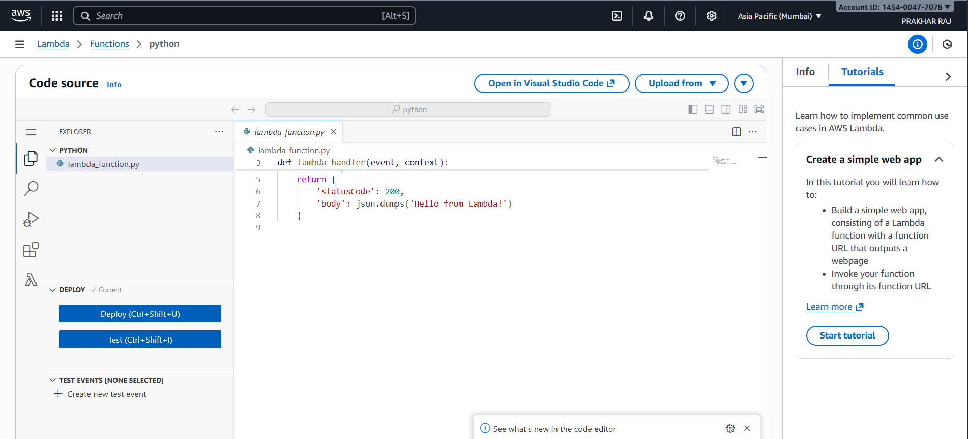
AWS Lambda Code Editor – python
Function File: lambda_function.py
Handler Function: lambda_handler(event, context)
Code Behavior:
- Returns a JSON response with:
- statusCode: 200
- body: "Hello from Lambda!" (via json.dumps)
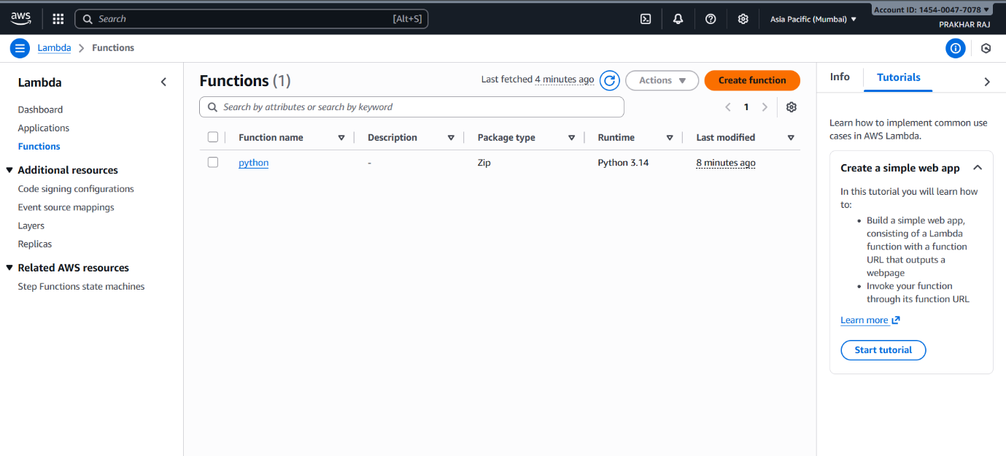
AWS Lambda Functions Dashboard – python
Function Listed:
- Name: python
- Description: (not set)
- Package Type: Zip
- Runtime: Python 3.14
- Last Modified: 8 minutes ago
Navigation Sidebar Includes:
- Dashboard
- Applications
- Functions
- Code Signing Configurations
- Event Source Mappings
- Layers
- Replicas
Tutorial Sidebar:
- Create a simple web app
- Build a Lambda function with a function URL
- Output a webpage
- Invoke via URL
Region & Account Info:
- Region: Asia Pacific (Mumbai)
- Account ID: 1454-0047-7078
- Logged-in User: PRAKHAR RAJ

