EC2
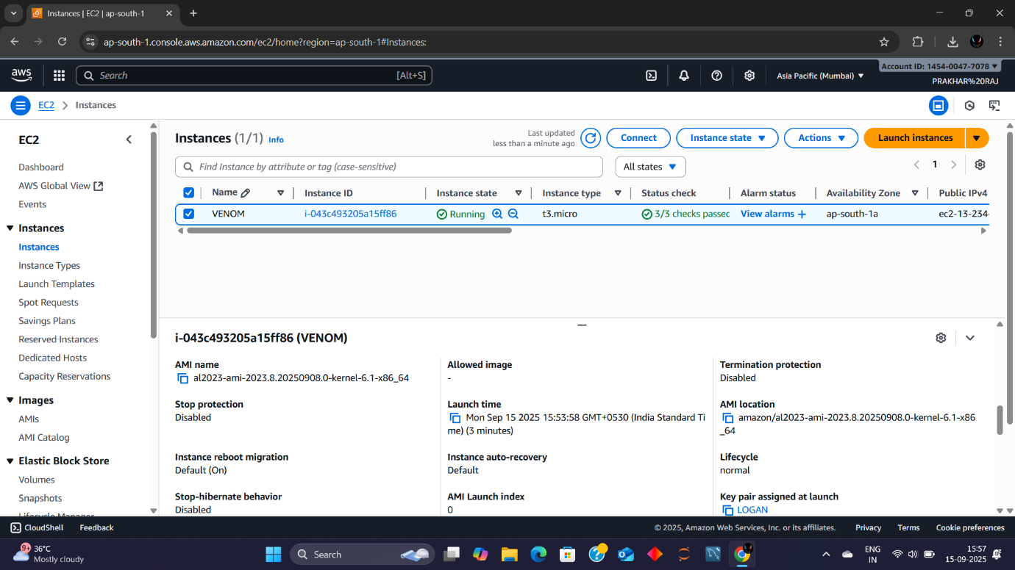
EC2 Instance Summary: "VENOM"
- Instance Name: VENOM
- Instance ID: i-04c543205a15f1f6b
- State: Running ✅ (2/2 status checks passed)
- Type: t2.micro
- Platform: Linux/UNIX
- Availability Zone: ap-south-1a
- Launch Time: August 30, 2023, 6:35 PM IST
- Public IPv4: 13.233.240.122
- Private IPv4: 172.31.38.214
- AMI Name & ID: VENOM (ami-0f5eea9c2f3f7f4b7)
- Key Pair: venomkey
- Monitoring: Disabled
- Termination Protection: Disabled
- Elastic IPs: None associated
- 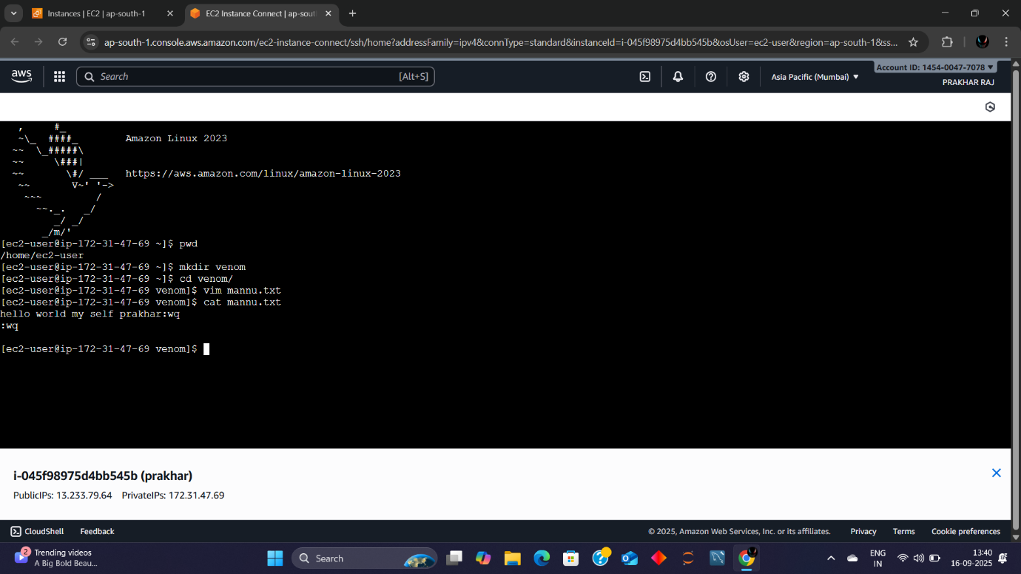
Environment Details
- OS: Amazon Linux 2023
- Instance ID: i-0458975d4bb45b45b (Name: prakhar)
- Public IP: 13.233.154.96
- Private IP: 172.31.7.91
📂 Command Line Activity
- User: ec2-user
- Navigated to Directory: venam
- Listed Files:
- amazon.txt
- venam.txt

