S3
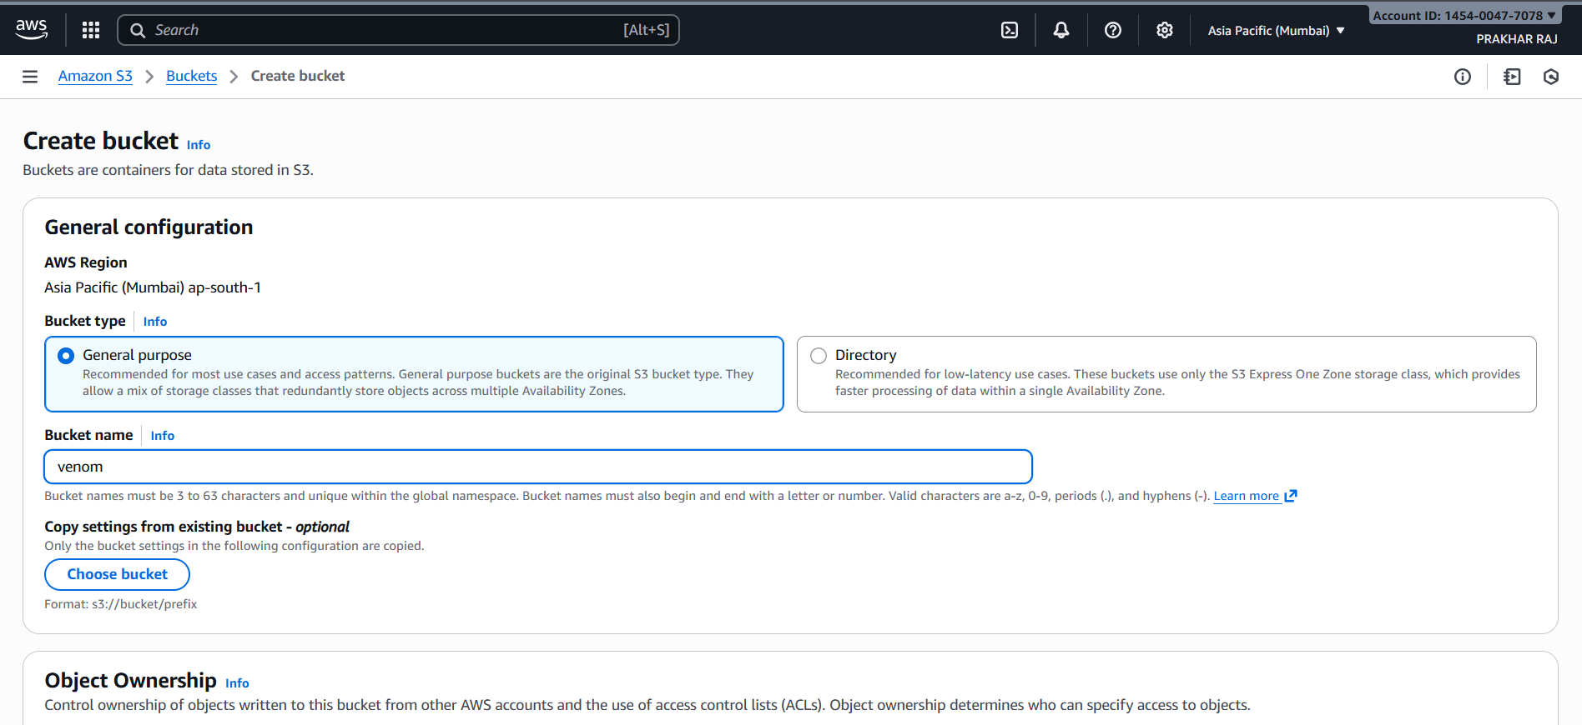
The screenshot shows the AWS S3 Create Bucket interface, where a new storage bucket is being configured.
- AWS Region:
The bucket is being created in the Asia Pacific (Mumbai) – ap-south-1 region.
- Bucket Type:
The General Purpose bucket type is selected.
This type is recommended for most use cases and supports redundant storage across multiple Availability Zones.
- Bucket Name:
The chosen bucket name is “venom.”
AWS requires bucket names to be globally unique and between 3 to 63 characters, using only lowercase letters, numbers, periods, or hyphens.
- Copy Settings (Optional):
There is an option to copy settings from an existing bucket, but no bucket is selected for copying.
- Object Ownership Section:
The page proceeds to the “Object Ownership” settings, where users can control object permissions and ACL usage (not fully shown in the screenshot).
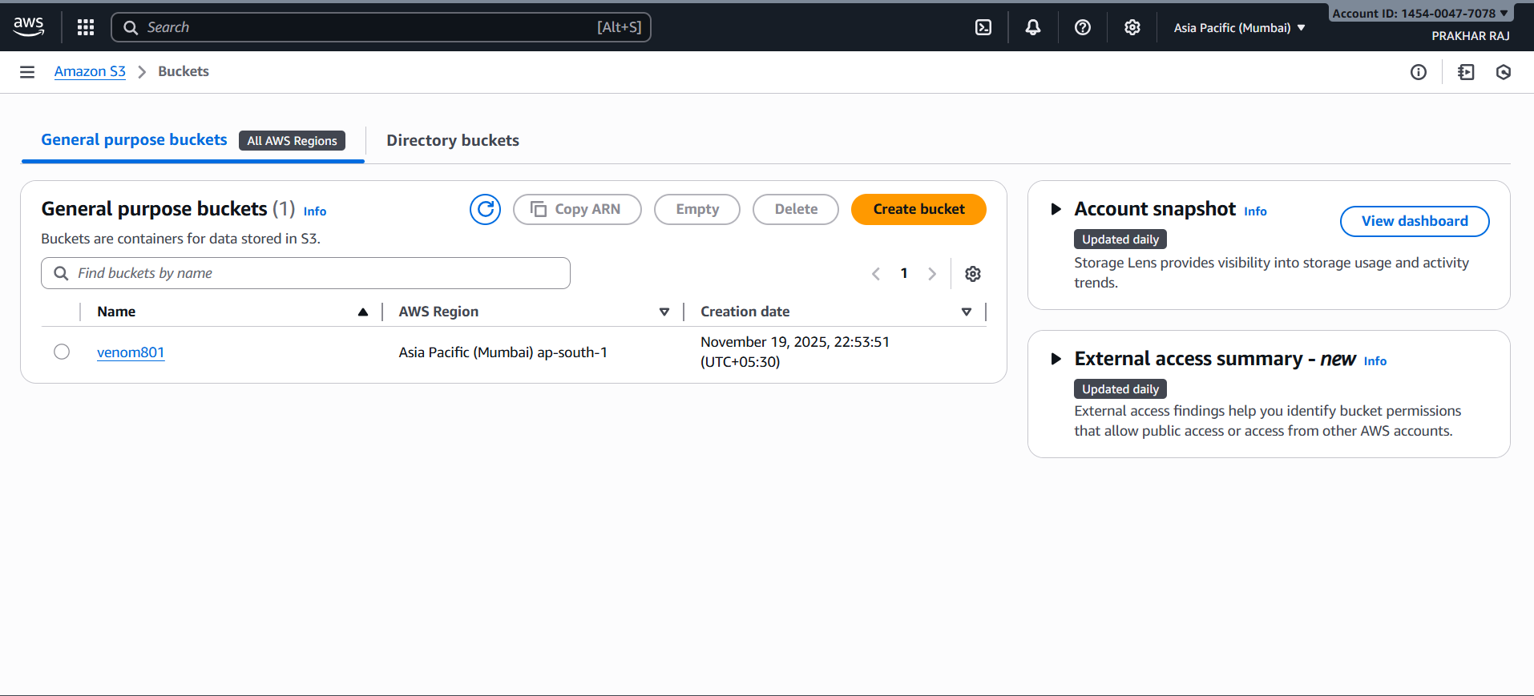
The screenshot displays the AWS S3 Buckets Dashboard, showing an overview of all existing S3 buckets in the account.
- Bucket List:
There is one General Purpose S3 bucket currently created in the account.
- Bucket Details:
  - Bucket Name: venom801
  - AWS Region: Asia Pacific (Mumbai) – ap-south-1
  - Creation Date: November 19, 2025, 22:53:51 (UTC+05:30)
- Dashboard Options:
The page provides options such as Copy ARN, Empty, Delete, and Create Bucket for bucket management.
- Account Snapshot:
A panel on the right side shows Storage Lens insights, which provide daily updates on storage usage and activity trends.
- External Access Summary:
Another panel displays external access findings, helping identify buckets that might allow public access or cross-account access.
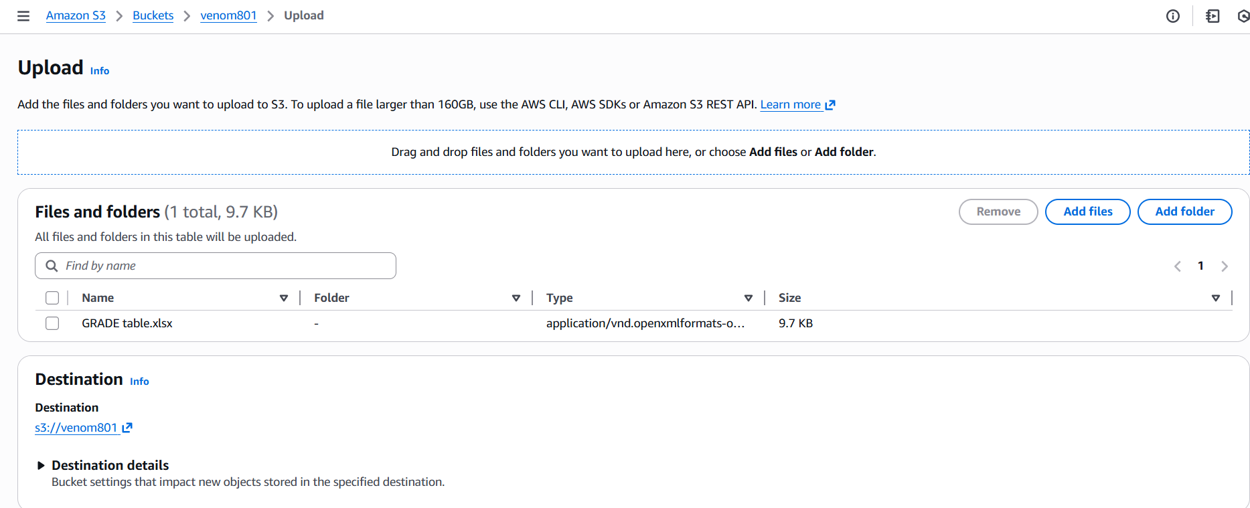
1. Upload Section:
- The interface allows users to add files or folders manually or drag-and-drop them for upload.
- It also provides a note that files larger than 160GB should be uploaded via AWS CLI, AWS SDKs, or REST API.
2. Files and Folders Table:
- One file has been added for upload:
  - File Name: GRADE table.xlsx
  - Folder: Not placed inside any folder (root of bucket).
  - Type: application/vnd.openxmlformats-officedocument.spreadsheetml.sheet
  - Size: 9.7 KB
- Options such as Remove, Add files, and Add folder are provided for managing upload items.
3. Destination Section:
- The selected upload destination is the S3 bucket at:
s3://venom801
- A "Destination Details" dropdown is also available to view bucket-level settings that may affect new objects.
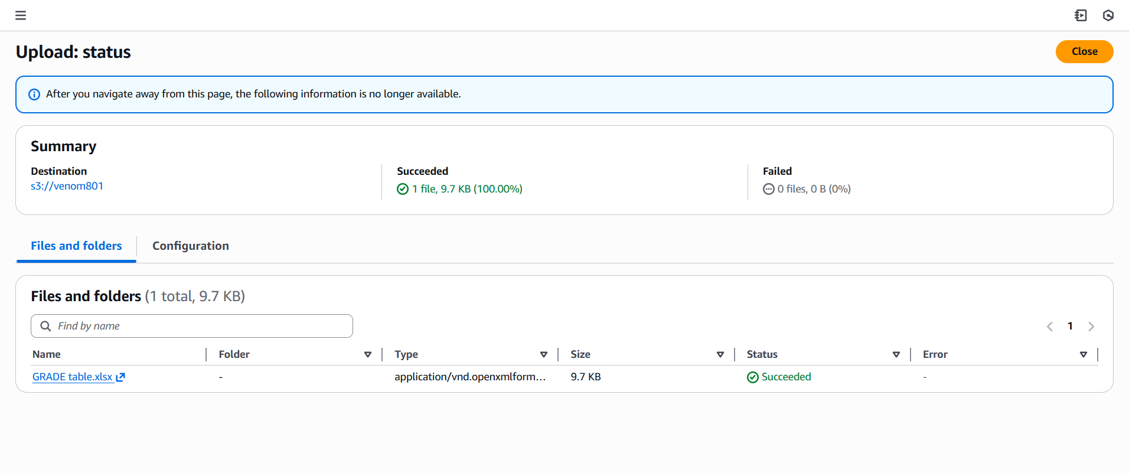
1. Upload Summary:
- Destination:
The uploaded file was sent to the bucket path: s3://venom801
- Succeeded:
✔ 1 file uploaded successfully, totaling 9.7 KB (100%).
- Failed:
✖ 0 files failed to upload (0%).
2. Files and Folders Section:
- The uploaded file listed is:
  - Name: GRADE table.xlsx
  - Folder: Stored in the root directory of the bucket
  - Type: application/vnd.openxmlformats-officedocument.spreadsheetml.sheet
  - Size: 9.7 KB
  - Status: ✔ Succeeded
  - Error: None
3. Dashboard Note:
- The page displays a note stating that once the user leaves this screen, upload status information will no longer be viewable.

