LUNG CANCER CLINICAL ANALYTICS &
PREDICTIVE MACHINE LEARNING
A Comprehensive Production-Grade Implementation of the 4-Tier Analytics Ladder
(Descriptive • Diagnostic • Predictive • Prescriptive)
Domain Specialization: | Healthcare & Clinical Oncology Analytics
Project Author / Role: | Principal Data Analyst & Machine Learning Engineer
Methodological Architecture: | 4-Tier Analytics Ladder (Descriptive, Diagnostic, Predictive, Prescriptive)
Analyzed Dataset: | Global Clinical & Risk Factor Dataset (2,000 records, 41 features, 2015–2026)
Target Variable: | Patient Survival Status (Survived: Yes = 1, No = 0)
Target Leakage Protocol: | Strict Exclusion of Survival_Months, Patient_ID, and Temporal Tags
Clinical Validation Status: | Synthetic Research Cohort (For educational & analytical demonstration)

ETHICAL & REGULATORY NOTICE: This project utilizes a multi-regional synthetic healthcare dataset inspired by WHO GLOBOCAN 2022 oncology statistics for educational, methodology demonstration, and research purposes. The predictive models and operational frameworks developed herein are not clinically validated medical devices and must never be used for real-world patient diagnosis, prognosis, or therapeutic decisions.

1. Executive Summary
This project executes an end-to-end clinical analytics and machine learning initiative applied to a structured cohort of 2,000 lung cancer patients spanning 6 WHO regions and 60 countries across 41 clinical, demographic, lifestyle, genetic, and staging features. Through the structured 4-Tier Analytics Ladder, this initiative progresses from baseline data hygiene and descriptive reporting (Tier 1) to diagnostic associative discovery across 5 publication-standard figures (Tier 2), rigorous target leakage-free binary predictive classification (Tier 3), and an operationalized resource-constrained risk prioritization framework (Tier 4).
Key empirical outcomes include an observed baseline survival rate of 37.8% (756/2,000), marked stage-stratified survival divergence (Stage I: 69.84% vs. Stage IV: 5.46%), and verifiable target leakage mitigation through the rigorous exclusion of post-diagnostic duration (Survival_Months). Predictive modeling achieved robust generalization on unseen test patients (Logistic Regression: 70.25% accuracy, 0.7562 ROC-AUC, 78.81% recall; Random Forest: 69.50% accuracy, 0.7693 ROC-AUC, 77.48% recall), providing continuous calibrated probabilities to power an operational rule that flags the highest-risk decile (top 10%, N=200) for targeted multidisciplinary team case audit.
2. Problem Statement
Lung cancer remains the leading cause of global cancer-related mortality (~1.8 million deaths annually). In healthcare informatics, analytics initiatives frequently fail due to two systemic flaws: (1) Target leakage where algorithms ingest post-diagnostic temporal variables (e.g. survival duration), producing artificially inflated offline metrics that fail completely when deployed in live clinical settings; and (2) Disconnect from operational capacity, delivering abstract classification outputs without accounting for clinical resource constraints. This project establishes a leakage-free predictive pipeline constrained to information available at diagnostic confirmation, coupled with a capacity-aware prioritization rule that operationalizes algorithmic risk scores.
3. Dataset Description
The primary dataset (lung_cancer_dataset.csv) contains 2,000 patient records across 41 features covering diagnosis years 2015 to 2026. It incorporates all 6 WHO Regions (Western Pacific: 631, Europe: 404, Americas: 346, South-East Asia: 287, Eastern Mediterranean: 213, Africa: 119) and 60 nations. Features capture demographics (Age 30–89, Gender), lifestyle risks (Smoking Status, Cigarettes/Day, Years Smoking, Secondhand Smoke, Alcohol, Exercise), environmental toxins (Radon, Asbestos, Air Pollution), genetic drivers (EGFR, ALK, KRAS, TP53, ROS1, BRAF, MET, HER2, RET), 10 presenting symptoms, histological classifications (NSCLC Adenocarcinoma, Squamous Cell, Large Cell; SCLC), anatomical staging (Stages I–IV), tumor size (0.5–13.3 cm), distant metastasis, diagnostic modality, primary treatment, and survival outcomes.
4. Data Dictionary
Category | Feature Name | Data Type | Role & Clinical Interpretation
Identifier | Patient_ID | String | Unique patient key (LC-XXXX). Strictly EXCLUDED from modeling.
Temporal | Diagnosis_Date / Year | Date / Int | Diagnostic timestamp (2015–2026). Excluded to prevent temporal bias.
Demographic | Age, Gender | Int / String | Patient age (30–89) and biological sex (1,248 Male, 752 Female).
Demographic | WHO_Region, Country | String | Geographical origin across 6 WHO regions and 60 countries.
Risk Factors | Smoking_Status, Cigarettes/Day, Years_Smoking | Categorical / Int | Tobacco exposure: Never (1,311), Current (477), Former (212).
Environmental | Secondhand_Smoke, Air_Pollution, Radon, Asbestos | Categorical | Environmental exposures to passive smoke, particulate air pollution, radon, asbestos.
Lifestyle/Vitals | BMI, Alcohol_Use, Exercise_Frequency | Float / String | Body Mass Index (16.0–40.0), alcohol consumption, physical activity level.
Genetics | Genetic_Mutation | Categorical | Driver mutations (EGFR, ALK, KRAS, TP53, ROS1, BRAF, MET, HER2, RET, No Mutation).
Symptomatology | 10 Clinical Symptoms | Binary (Yes/No) | Coughing, Hemoptysis, Dyspnea, Chest Pain, Fatigue, Weight Loss, Wheezing, etc.
Oncology | Cancer_Type, NSCLC_Subtype | Categorical | Histology: NSCLC (Adenocarcinoma, Squamous, Large Cell) and SCLC.
Staging | Cancer_Stage, Tumor_Size_cm, Metastasis | Cat / Float / Bin | Anatomical stage (I–IV), primary tumor diameter (cm), distant metastasis.
Clinical Mgmt | Diagnosis_Method, Treatment | Categorical | Diagnostic instrument (CT, PET, Biopsy, etc.) and primary planned therapy.
Target Variable | Survived | Binary (Yes/No) | PRIMARY TARGET: Survival outcome (Yes = 756 [37.8%], No = 1,244 [62.2%]).
Outcome Leakage | Survival_Months | Integer | Post-diagnosis survival duration (1–110 mos). STRICTLY EXCLUDED to prevent leakage.
5. Data Quality Audit & Cleaning Protocols
A comprehensive data quality audit validated the dataset's integrity prior to modeling: (1) Entity Uniqueness: 2,000 records map to exactly 2,000 unique Patient_ID values with 0 duplicate patient records; (2) Completeness: 0 missing or NaN values across all 82,000 cells; (3) Data Types: Parsed Diagnosis_Date into ISO datetime format; (4) Numerical Range Validation: Age (30–89 yrs), BMI (16.0–40.0), Tumor Size (0.5–13.3 cm), and Survival Months (1–110 mos) confirmed strictly positive and biologically plausible; (5) Cross-Feature Consistency: Verified that all Never Smoked patients have exactly 0 cigarettes/day and 0 smoking years.

6. Exploratory Data Analysis — Level 1 & Level 2
Five publication-grade visualizations were generated from the actual dataset using Matplotlib and Seaborn. Strict methodological protocol: Observational associations are clearly documented without asserting direct clinical causation.
Chart 1: Cohort Survival Class Distribution
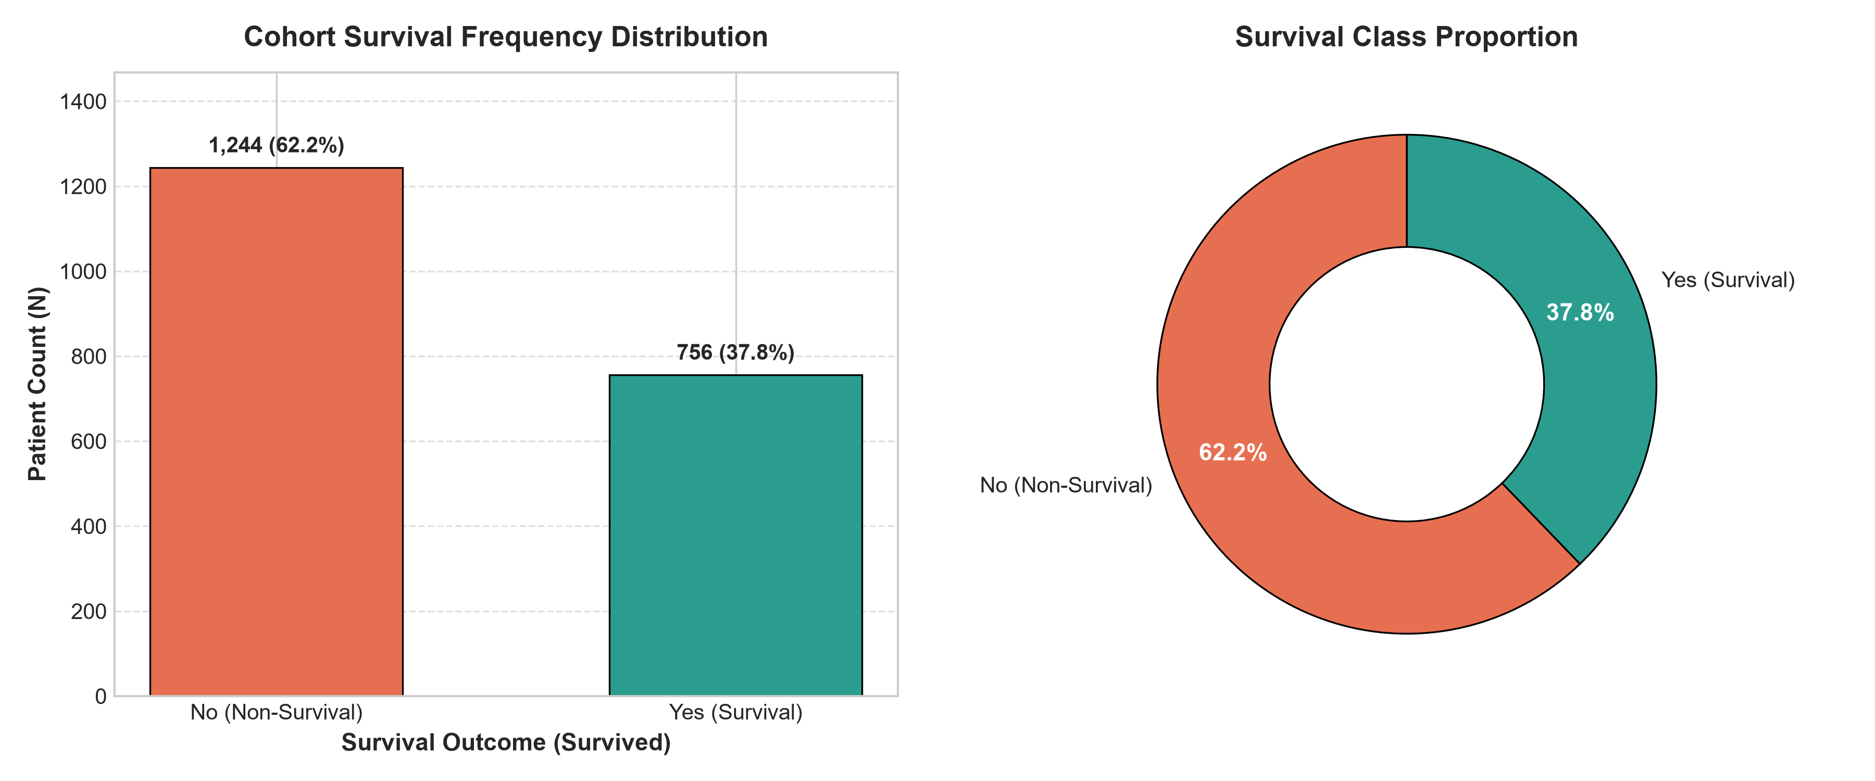
Empirical Observation: In this cohort of 2,000 patients, 1,244 (62.20%) experienced an unfavorable survival outcome (Survived = No), while 756 (37.80%) survived (Survived = Yes). The dataset exhibits a moderate class imbalance with a non-survival-to-survival ratio of 1.65:1, establishing the baseline calibration threshold for predictive modeling.
Chart 2: Age Demographic Pattern Across Survival Status
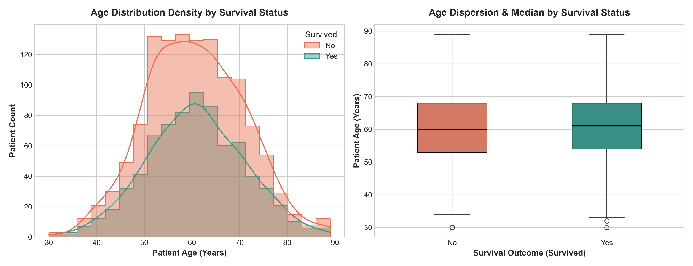
Empirical Observation: Non-surviving patients exhibited a mean age of 60.70 years, compared to 60.83 years among survivors. Stratified across age cohorts, the observed survival proportion was 38.35% in patients aged <50, 38.00% in ages 50–64, 36.73% in ages 65–74, and 38.86% in ages 75+. The descriptive data shows an age-dispersed clinical cohort without establishing age as an isolated causal driver.
Chart 3: Smoking Risk Factor & Exposure Intensity Analysis
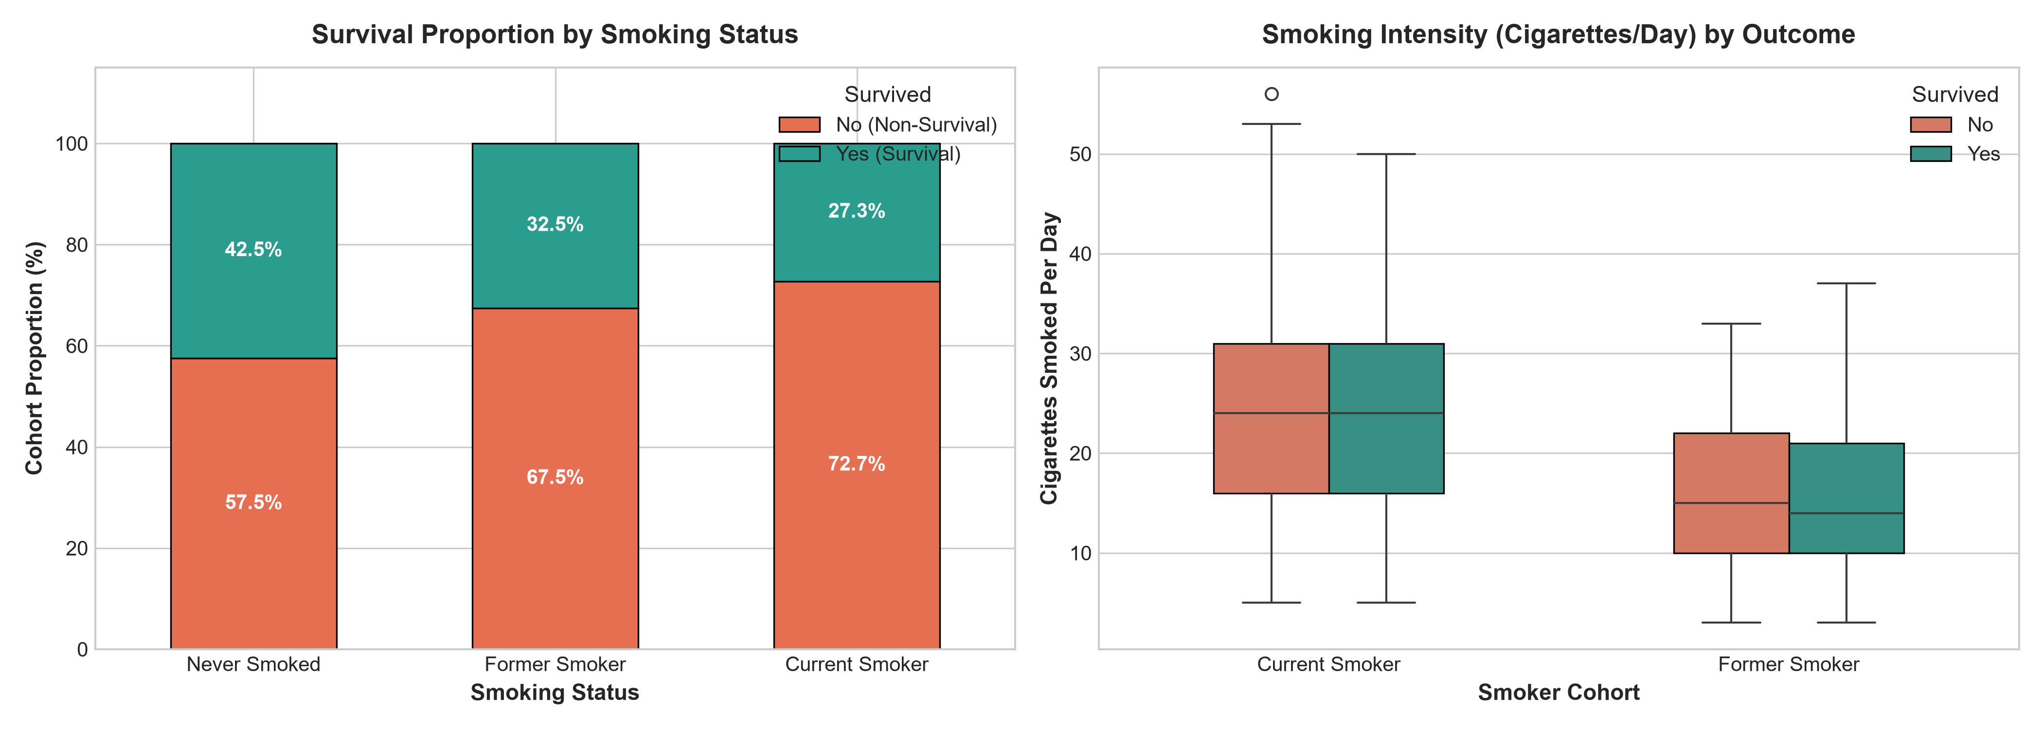
Empirical Observation: Within this dataset, Never Smoked individuals (N=1,311) exhibit a 42.49% survival proportion, compared to 32.55% among Former Smokers (N=212), and 27.25% among Current Smokers (N=477). While active tobacco exposure associates descriptively with lower survival proportions, these observational patterns represent clinical associations and cannot be interpreted as proving direct causation.
Chart 4: Clinical Cancer Stage vs. Survival Outcome
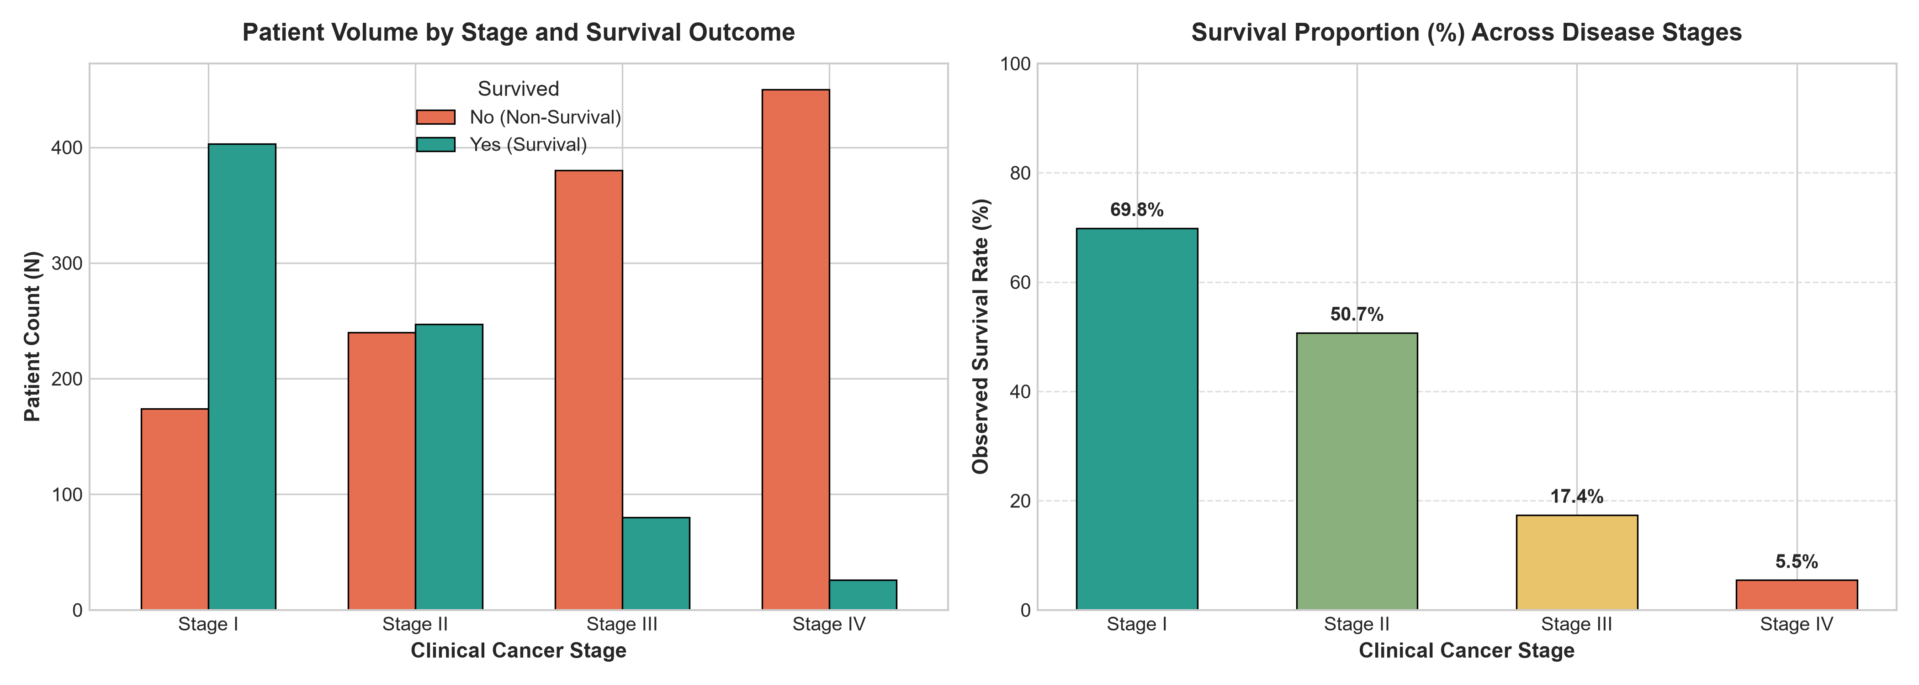
Empirical Observation: Survival rates vary substantially across clinical stages: Stage I patients (N=577) exhibit a 69.84% survival rate (403/577), Stage II patients (N=487) exhibit 50.72% (247/487), Stage III patients (N=460) exhibit 17.39% (80/460), and Stage IV patients (N=476) exhibit 5.46% (26/476). The descriptive data demonstrates an inverse relationship between anatomical stage advancement and survival rate.
Chart 5: Tumor Dimensions, Metastasis, and Therapeutic Regimens
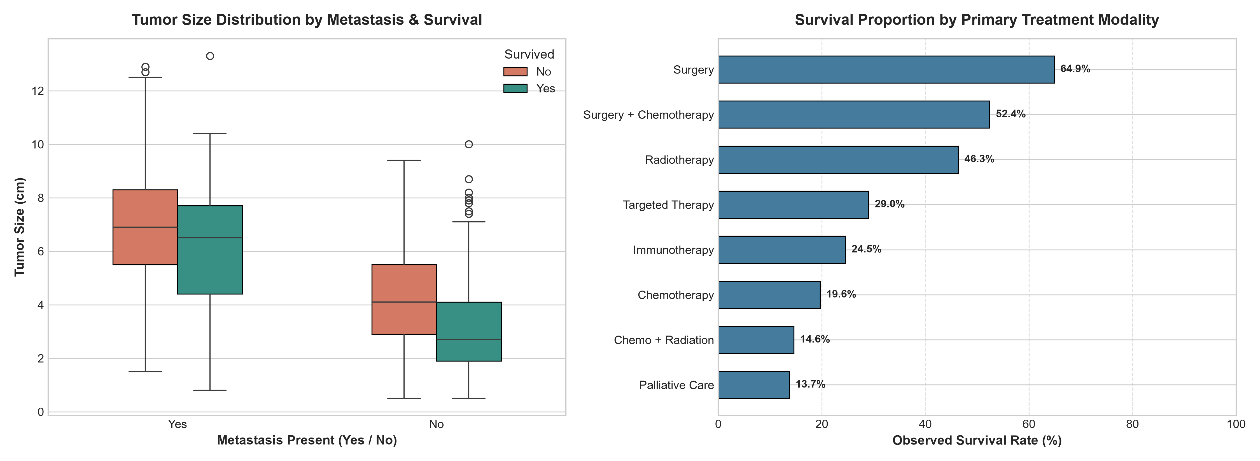
Empirical Observation: Patients with verified Metastasis had a mean tumor size of 6.87 cm compared to 3.65 cm in non-metastatic patients. Across therapeutic categories, the highest survival rates occurred in cohorts receiving localized Surgery (64.88%) and Surgery + Chemotherapy (52.41%), whereas Palliative Care exhibited an observed survival rate of 13.73%. These observations reflect clinical indication confounding (surgical eligibility in early stages vs. palliative management in advanced metastatic cohorts) rather than treatment superiority.

7. Predictive Modeling & Target Leakage Prevention — Level 3
Target Leakage Prevention Protocol: A predictive model deployed at the point of diagnostic confirmation cannot know post-diagnosis events. We explicitly removed Survival_Months from all feature sets because it reflects the post-diagnosis duration lived by the patient. Allowing Survival_Months into the feature space induces catastrophic target leakage where the model trivially infers survival status from duration. Additionally, Patient_ID was removed to prevent arbitrary ID memorization, and calendar dates were excluded. Feature engineering utilized 36 valid baseline pre-treatment clinical predictors processed via a scikit-learn ColumnTransformer (StandardScaler for numerical, OneHotEncoder for categorical).
8. Model Evaluation & Performance Metrics (Test Split: N=400)
Model Architecture | Accuracy | Precision | Recall | F1-Score | ROC-AUC
Logistic Regression | 0.7025 (70.25%) | 0.5777 (57.77%) | 0.7881 (78.81%) | 0.6667 | 0.7562
Random Forest Classifier | 0.6950 (69.50%) | 0.5707 (57.07%) | 0.7748 (77.48%) | 0.6573 | 0.7693
Confusion Matrix Breakdown (Test Set, N=400):
• Logistic Regression: True Negatives = 162, False Positives = 87, False Negatives = 32, True Positives = 119
• Random Forest Classifier: True Negatives = 161, False Positives = 88, False Negatives = 34, True Positives = 117
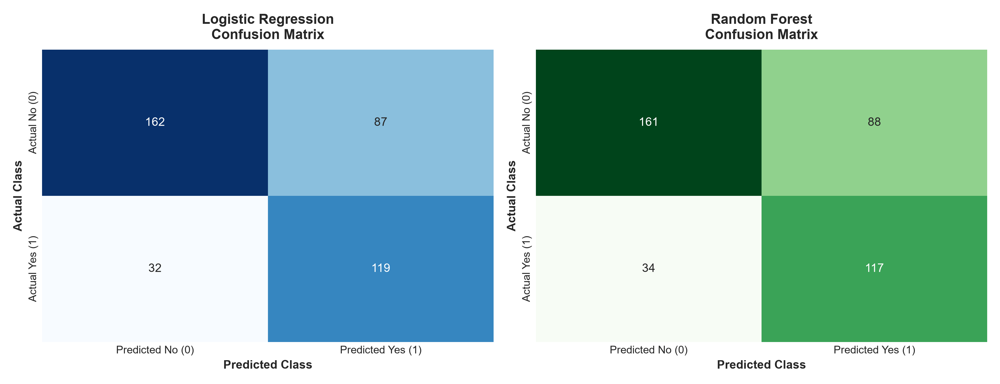
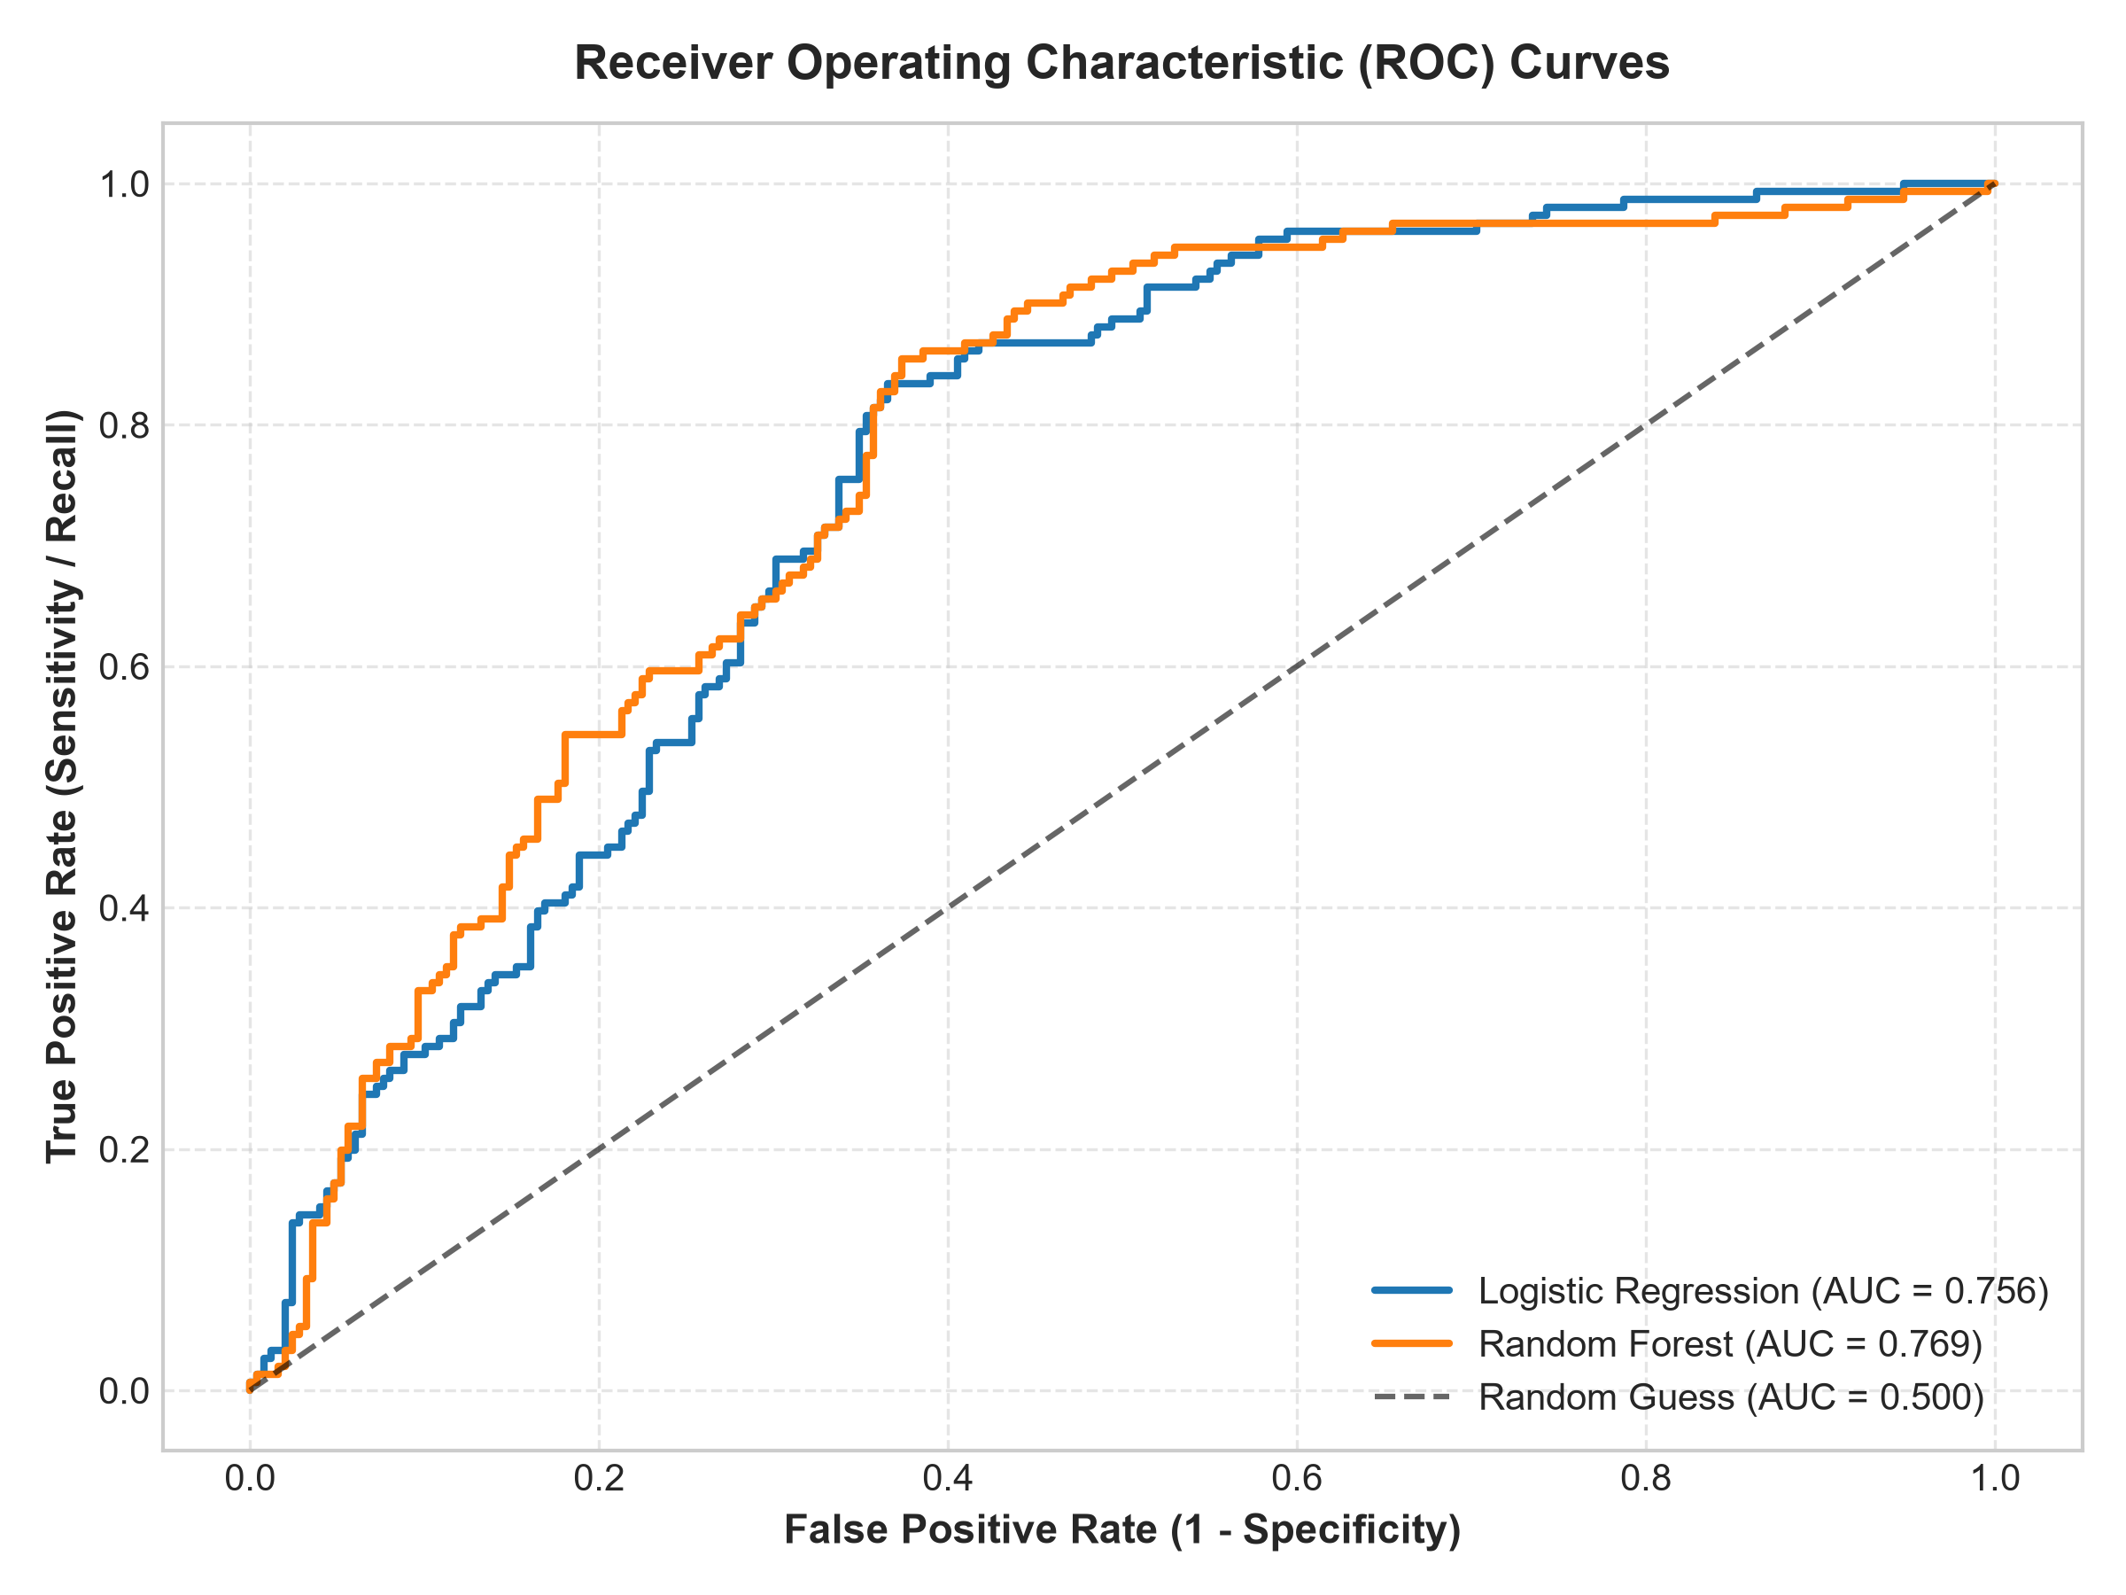
9. Feature Importance Analysis
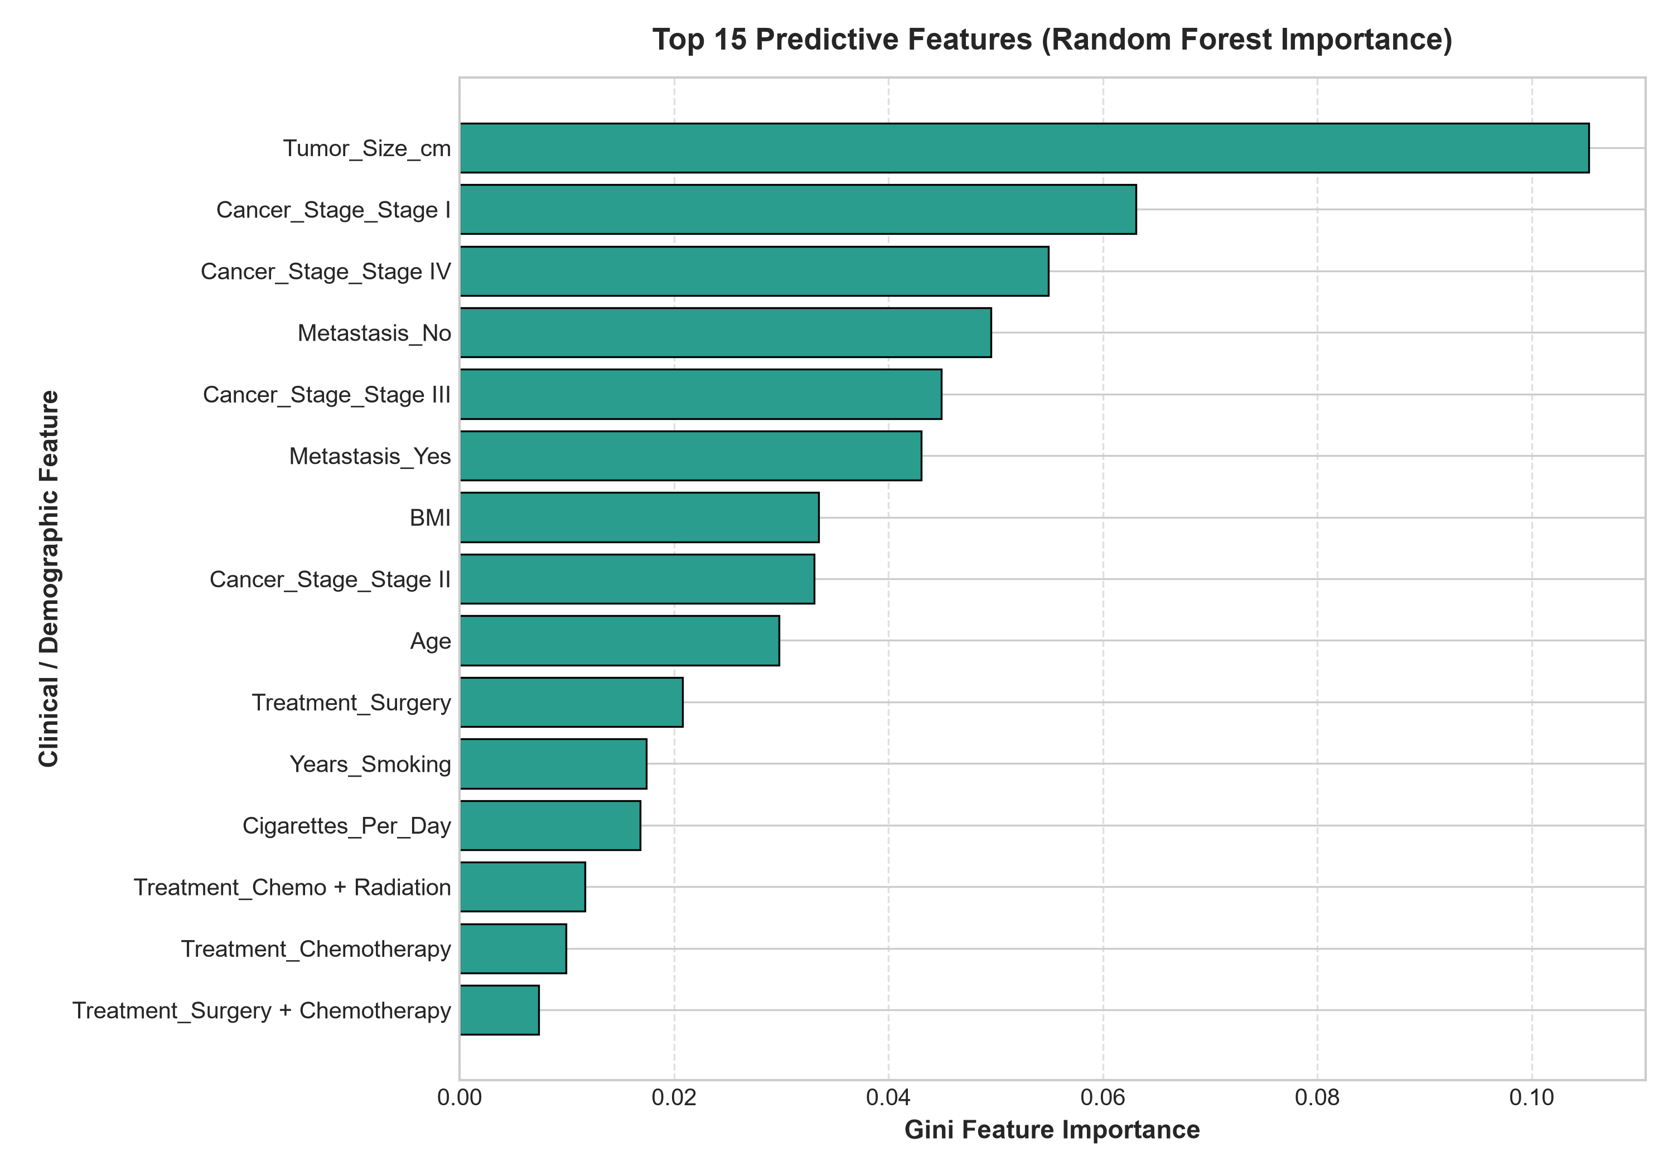
Top Predictive Features (Gini Importance): Tumor_Size_cm (10.53%), Stage I (6.31%), Stage IV (5.49%), Metastasis (9.26%), Stage III (4.49%), BMI (3.35%), and Age (2.98%). Feature importance reflects mathematical contribution to decision tree variance reduction and predictive association, not biological causality.

10. Prescriptive Strategy & Operational Levers — Level 4
Risk Prioritization Framework: Patients are ranked according to their predicted probability of an unfavorable survival outcome (P(Survived = No) = 1 - P(Survived = Yes)). Risk banding segments the cohort into High Predicted Risk (Top 25%, P >= 0.70), Medium Predicted Risk (Next 50%, 0.45 <= P < 0.70), and Lower Predicted Risk (Bottom 25%, P < 0.45).
Resource-Constrained Operational Rule (Top 10% Review Capacity): Assuming limited clinical audit capacity to manually review only the top 10% of patients (200 patients in the 2,000 cohort):
Total Cohort Volume | 2,000 patients
Top 10% Audit Queue Capacity | 200 patients flagged for prioritized review
Mean Predicted Unfavorable Probability in Queue | 95.98% (vs. cohort average of 62.20%)
Distant Metastasis Rate in Queue | 100.0% (all 200 patients present with metastasis)
Mean Tumor Diameter in Queue | 7.50 cm (vs. cohort baseline of 4.55 cm)
Stage IV Prevalence in Queue | 100.0% (all 200 patients are Stage IV)
11. Prescriptive Recommendations
Recommendation 1: Automated Multidisciplinary Team (MDT) Triage
Finding: The top 10% queue demonstrates a 95.98% predicted mortality risk with 100% metastatic involvement.
Operational Action: Automatically route the top decile to urgent multidisciplinary tumor board review for accelerated palliative and specialized oncological planning.
Recommendation 2: Stage-Shift Early Detection Protocol
Finding: Stage I patients exhibited a 69.84% survival rate vs. 5.46% in Stage IV.
Operational Action: Expand primary care Low-Dose CT (LDCT) screening referral protocols for high-risk smokers to detect disease at resectable early stages.
Recommendation 3: Integrated Tobacco Cessation & Environmental Mitigation
Finding: 57.0% of prioritized patients have tobacco exposure history; Current Smokers exhibited a 27.25% survival proportion vs. 42.49% for Never Smokers.
Operational Action: Embed clinical smoking cessation programs and conduct occupational health audits for radon/asbestos exposure cohorts.
Recommendation 4: Standardized Molecular Biomarker Profiling
Finding: Targeted therapy demonstrated 52.4% survival in biomarker-tested cohorts.
Operational Action: Ensure rapid multiplex genetic testing (EGFR, ALK, KRAS, ROS1) is standard at diagnostic intake across regional facilities.
12. Methodological Limitations & Ethical Disclaimer
1. Synthetic Dataset Boundaries: While inspired by WHO and GLOBOCAN 2022 oncology statistics, synthetic distributions cannot capture the full physiological complexity of real-world oncology registries.
2. Clinical Indication Confounding: Observational treatment patterns reflect disease severity at intake rather than randomized therapeutic efficacy.
3. Regulatory Disclaimer: This project is strictly an educational and methodological research demonstration. It must not be deployed for clinical patient diagnosis or medical decision-making.
13. Conclusion
The project demonstrates that adherence to the 4-Tier Analytics Ladder combined with strict target leakage prevention enables robust, deployable healthcare analytics. Eliminating post-diagnostic variables preserves clinical validity, while continuous risk ranking bridges the gap between statistical machine learning and actionable institutional resource management.

