**Q2. Does the sex of an individual affect educational attainment? Is there any evidence that the educational attainment of males is different from that of females?**

**Answer:** In this question, we wish to find out whether the educational attainment of an individual is affected by their sex, hence, we wish to find out whether there is any relationship between the sex of an individual and the number of years of schooling. We will be using the following variables to model the relationship.

Variable Definitions

**S –** Number of years of schooling

**ASVABC –** measure of cognitive ability of a person

**SM –** years of schooling of the respondent’s mother

**SF –** years of schooling of the respondent’s father

**MALE –** dummy variable which is 1 for male respondents and 0 for female respondents

We take these variables in our regression analysis to account for the differences in the background of the people, hence, we hold these other variables constant in our regression analysis.

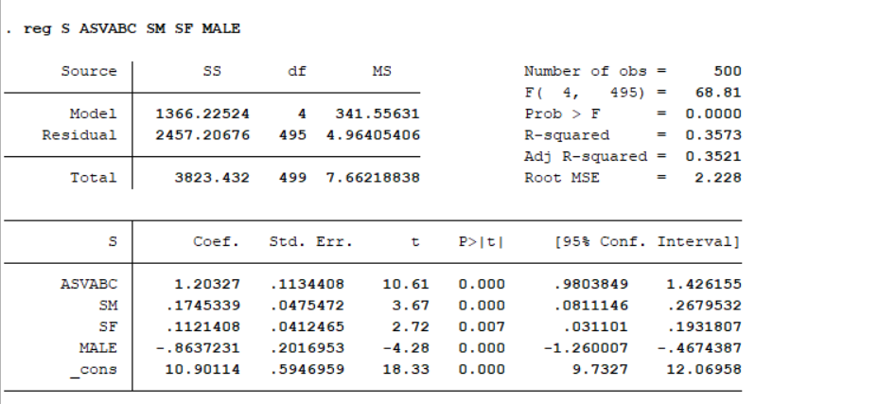

**Using your EAWE data set, define a slope dummy variable MALEASVC as the product of MALE and ASVABC: MALEASVC = MALE*ASVABC. Regress S on ASVABC, SM, SF, ETHBLACK, ETHHISP, MALE, and MALEASVC, interpret the equation and perform appropriate statistical tests to comment on the use of the interaction variable in this regression, and whether that improves model specification.**

