**Due Date: November 25, 2020 (10 pm)**

**Guidelines**

* This assignment aims to make the students familiar with socket programming in computer networks.
* **This assignment is to be completed individually.**
* **Programming Language to be used: Java**
* Use either UDP or TCP sockets for this assignment.
* Code should be easy to understand (make proper use of comments, don’t overuse them).
* Assignment submitted after due date and time will not be evaluated and a score of zero will be awarded for this assignment.
* Materials copied from the Internet or otherwise will attract penalty.

**Grading:** This term paper has a **weightage of 10%** in your overall 100 points.

**Submission**

Each student must upload the following files on Blackboard:

1. Client.java file - The java file must contain your name and roll no (as comments).
2. Server.java file - The java file must contain your name and roll no (as comments).
3. Paste your code and screenshots of input and output screens (paste them in this file) - Name the document as Socket_CN2020_FirstName_LastName.pdf. [**You are required to strictly follow the naming convention**.]

**Question**

Write a program that involves a client and a server. The client sends server 4 values, for example *X, n, B, C* where,  X is the adjacency matrix of a directed graph with 5 nodes A B C D E, and n is the length of the path from node B to node C.

The server responds back with two responses:

(a)    positive Y response (or negative N response) if there exists (or doesn't exist) a path of length n from B to C.

(b)    the image of the directed graph with nodes A B C D E proving the validity of the response.

For simplicity, assume a 5-node graph with nodes named A, B, C, D, E.

For example: Let’s take a 3-node directed graph:

**Case 1:** Client sends the following to the server:

*Input:*

|  |  |  |  |  |  |  |  |  |  |  |  |  |
| --- | --- | --- | --- | --- | --- | --- | --- | --- | --- | --- | --- | --- |
| |  |  |  | | --- | --- | --- | | *0* | *1* | *0* | | *1* | *0* | *1* | | *0* | *0* | *0* | | *, 2, A, C* |  |  |

where, there is an adjacency matrix, 2 is the length of the path from node A to node C – that server has to check whether it exists or not.

Server should return the following:

*Output 1: Yes, there exists a path of length 2 from node A to node C.*

*Output 2: Graph: 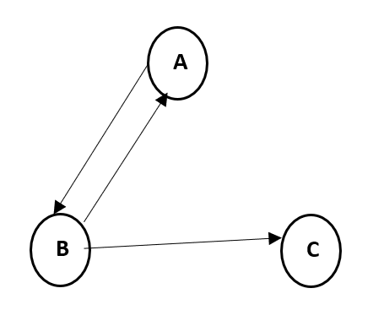*

**Case 2:** Client sends the following to the server:

*Input:*

|  |  |  |  |  |  |  |  |  |  |  |  |  |
| --- | --- | --- | --- | --- | --- | --- | --- | --- | --- | --- | --- | --- |
| |  |  |  | | --- | --- | --- | | *0* | *1* | *0* | | *1* | *0* | *1* | | *0* | *0* | *0* | | *, 2, C, A* |  |  |

where, there is an adjacency matrix, 2 is the length of the path from node C to node A.

Server should return the following:

*Output 1: No, there is no path of length 2 from node C to node A.*

*Output 2: Graph: *

**Submission Template**

**\\Screenshots** **of Input and Output Screens**

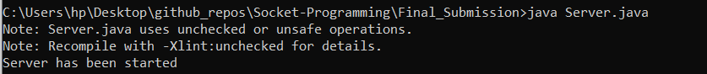

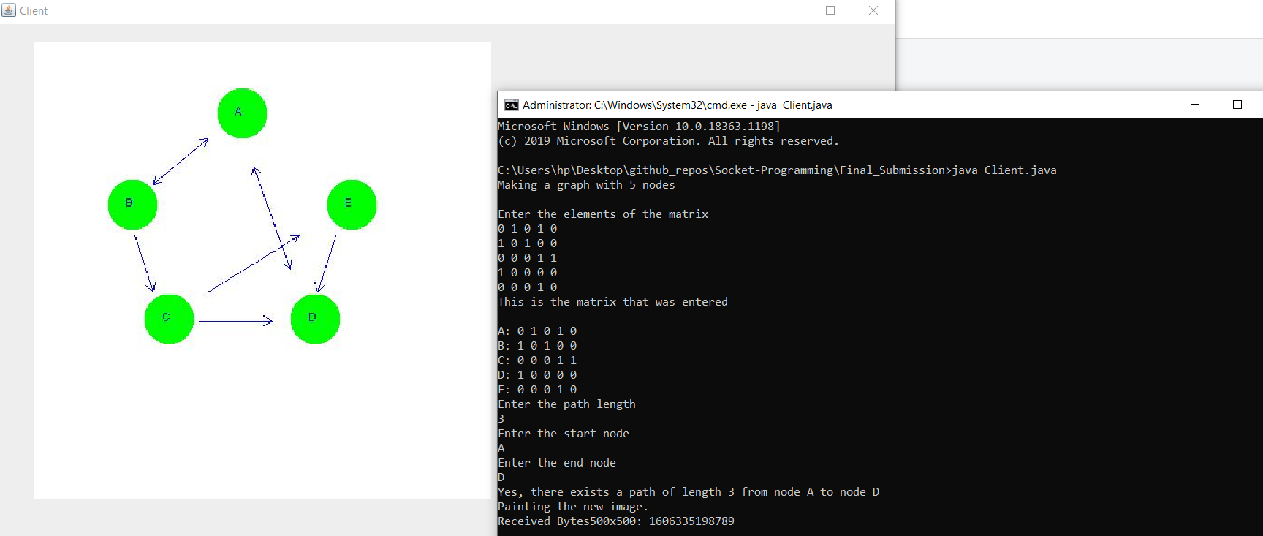

**\\ Link to the Github repository**

Here, all my work can be tracked right from day 1 and how it kept on changing and updating over the period of time. This is to maintain authenticity of my work. Link: <https://github.com/prakharrathi25/Socket-Programming>

The repository is currently private and will be made public after the deadline to avoid anyone else from accessing it. Additionally, I can provide access to the repository by adding as a collaborator, in case the access is needed earlier.

**\\ Walkthrough Video**

I have also created a walkthrough video to show my work in action and how to run the program effectively. This can be used for testing the code. Link: <https://drive.google.com/file/d/16W3K3VP6XFmY8qrgebQGMOHyWbqdAof-/view?usp=sharing>

**\\Server** **side code – put the code here**

/*  
 * To change this license header, choose License Headers in Project Properties.  
 * To change this template file, choose Tools | Templates  
 * and open the template in the editor.  
 */  
package com.mycompany.serverside;  
  
/* Import java Packages */  
import javax.imageio.ImageIO;  
import javax.swing.*;  
import java.awt.*;  
import java.io.*;  
import java.net.*;  
import java.nio.ByteBuffer;  
import java.util.*;  
import java.util.List;  
import javax.swing.*;  
import java.awt.*;  
import java.awt.image.BufferedImage;  
  
*/**  
 * Name: Prakhar Rathi   
 * Roll Number: 1810110169  
 */*public class Server extends JFrame{  
  
 // Global adjmatrix  
 static int[][] *globalAdjMatrix* = new int[5][5];  
  
 // Declare global image  
 static Image *global_img*;  
  
 // Global socket variable  
// static ServerSocket serverSocket;  
// static Socket socket;  
// static DataInputStream input;  
 static DataOutputStream *output*;  
  
 /* function to convert adjacency matrix to adjacency list */  
 public static ArrayList<Integer>[] mat_to_list(int[][] m){  
  
 // Collect number of vertices  
 int vertices = m[0].length;  
  
 // Declare an Array  
 ArrayList<Integer>[] adjList = new ArrayList[vertices];  
  
 // Create a new list for each vertex to store the vertices  
 for (int i = 0; i < vertices; i++) {  
 adjList[i] = (new ArrayList<Integer>());  
 }  
  
 // Store the vertices in the adjacency list  
 for (int i = 0; i < m[0].length; i++) {  
 for (int j = 0; j < m.length; j++) {  
 if (m[i][j] >= 1) {  
 adjList[i].add(j);  
 }  
 }  
 }  
  
 return adjList;  
  
 }  
  
 // Set the loaction of the points in the graph  
 Point A = new Point(220, 80);  
 Point B = new Point(100, 180);  
 Point C = new Point(140, 305);  
 Point E = new Point(340, 180);  
 Point D = new Point(300, 305);  
  
 int drawnEdges1[] = new int[25];  
 int drawnEdges2[] = new int[25];  
  
 // Overriding the paint function and including exception handling in the same  
 public void paint(Graphics g) {  
 *global_img* = createGraphImage();  
 }  
  
 public static BufferedImage toBufferedImage(Image img)  
 {  
 if (img instanceof BufferedImage)  
 {  
 return (BufferedImage) img;  
 }  
  
 // Create a buffered image with transparency  
 BufferedImage bimage = new BufferedImage(img.getWidth(null), img.getHeight(null), BufferedImage.*TYPE_INT_ARGB*);  
  
 // Draw the image on to the buffered image  
 Graphics2D bGr = bimage.createGraphics();  
 bGr.drawImage(img, 0, 0, null);  
 bGr.dispose();  
  
 // Return the buffered image  
 return bimage;  
 }  
  
 // Function to draw the tip of the edge in the graph  
 private void drawEdgeTip(Graphics g, int x1, int y1, int x2, int y2) {  
 int x,y;  
 double rads = 0.5236;  
 double hyp_multiplier = 10;  
 int diff_y = y2 - y1;  
 int diff_x = x2 - x1;  
 double t = Math.*atan2*(diff_y, diff_x);  
 double r = rads + t;  
 for (int j = 0; j < 2; j++) {  
 x = (int)(x2 - hyp_multiplier * Math.*cos*(r));  
 y = (int)(y2 - hyp_multiplier * Math.*sin*(r));  
 g.drawLine(x2, y2, x, y);  
 r = t - rads;  
 }  
 }  
  
 public void drawEdge(Graphics g, int x1, int y1, int x2, int y2) {  
 int midx = (x1 + x2)/2;  
 int midy = (y1 + y2)/2;  
 x1 = (midx + x1)/2;  
 x2 = (midx + x2)/2;  
 y1 = (midy + y1)/2;  
 y2 = (midy + y2)/2;  
  
 // Add the connecting line  
 g.drawLine(x1, y1, x2, y2);  
  
 // Add the tip of the edge to the connecting graph  
 drawEdgeTip(g, x1, y1,x2, y2);  
  
 }  
  
 // Function to visualise the graph nodes and the edges  
 private Image createGraphImage() {  
  
 // Create a buffered image object  
 BufferedImage image = new BufferedImage(500, 500, BufferedImage.*TYPE_INT_RGB*);  
  
 // Instantiate graphics object  
 Graphics g = image.getGraphics();  
  
 /* Design the ovals which are the nodes */  
 g.fillRect(0, 0, image.getWidth(), image.getHeight());  
 g.setColor(Color.*green*); // node colors  
 g.fillOval(200, 50, 55, 55);  
 g.fillOval(80, 150, 55, 55);  
 g.fillOval(320, 150, 55, 55);  
 g.fillOval(120, 275, 55, 55);  
 g.fillOval(280, 275, 55, 55);  
  
 g.setColor(Color.*blue*); // text and edge color  
 /* Add the node names */  
 g.drawString("A", A.x, A.y);  
 g.drawString("B", B.x, B.y);  
 g.drawString("C", C.x, C.y);  
 g.drawString("D", D.x, D.y);  
 g.drawString("E", E.x, E.y);  
  
 for (int i = 0; i < 25; i++) {  
 drawnEdges1[i] = -1;  
 drawnEdges2[i] = -1;  
 }  
 for (int i = 0; i < 5; i++) {  
 for (int j = 0; j < 5; j++) {  
 if (*globalAdjMatrix*[i][j] > 0) {  
 int n = 0;  
 int m = 0;  
 if (drawnEdges1[0] == -1)  
 drawnEdges1[0] = i;  
 else {  
 while (drawnEdges1[n] != -1)  
 n++;  
 drawnEdges1[n] = i;  
 }  
 if (drawnEdges2[0] == -1)  
 drawnEdges2[0] = j;  
 else {  
 while (drawnEdges2[m] != -1)  
 m++;  
 drawnEdges2[m] = j;  
 }  
 }  
 }  
 }  
  
 for(int i=0; i<25;i++){  
 if(drawnEdges1[i]>-1 && drawnEdges2[i]>-1){  
 int a1=0,b1=0,a2=0,b2=0;  
 switch(drawnEdges1[i]){  
 case 0:  
 a1 = A.x;  
 b1 = A.y;  
 break;  
 case 1:  
 a1 = B.x;  
 b1 = B.y;  
 break;  
 case 2:  
 a1 = C.x;  
 b1 = C.y;  
 break;  
 case 3:  
 a1 = D.x;  
 b1 = D.y;  
 break;  
 case 4:  
 a1 = E.x;  
 b1 = E.y;  
 break;  
 }  
 switch(drawnEdges2[i]){  
 case 0:  
 a2 = A.x;  
 b2 = A.y;  
 break;  
 case 1:  
 a2 = B.x;  
 b2 = B.y;  
 break;  
 case 2:  
 a2 = C.x;  
 b2 = C.y;  
 break;  
 case 3:  
 a2 = D.x;  
 b2 = D.y;  
 break;  
 case 4:  
 a2 = E.x;  
 b2 = E.y;  
 break;  
 }  
 drawEdge(g, a1, b1, a2, b2);  
// System.out.println("Drew an edge");  
 }  
// System.out.println("Outside Loop");  
 }  
  
 // Return the image  
 return image;  
 }  
  
 /* Function to check if the required path length in the given path lengths */  
 public static boolean checkPathLength(ArrayList<Integer>[] list, int source, int dest, int vertices, int reqLength) {  
 // Create an array of visited nodes  
 boolean[] hasVisited = new boolean[vertices];  
 ArrayList<Integer> pathList = new ArrayList<>();  
  
 // add the source node to the path (subtract 1 from path length)  
 pathList.add(source);  
 ArrayList<Integer> pathLength = new ArrayList<>();  
  
 // Call recursive DFS function  
 *pathLengthDFS*(list, source, dest, pathLength, hasVisited, pathList);  
  
 // Return whether the path length exists or not  
 return pathLength.contains(reqLength);  
 }  
  
 /* Function to recursively check the path and then add to the list of path lengths */  
 private static void pathLengthDFS(ArrayList<Integer>[] adjList, Integer s, Integer d, List<Integer> lengths, boolean[] hasVisited, List<Integer> funcPathList) {  
  
 if (s.equals(d)) {  
  
 // Add the path length to the path lengths list (subtract 1 to remove source node)  
 lengths.add(funcPathList.size()-1);  
  
 // If we have found a matching node then we can directly return after adding the length to tha path lenght  
 return;  
 }  
  
 // Mark the current node as visited  
 hasVisited[s] = true;  
  
 // Recur to all the adjacent nodes for all the vertices  
 for (Integer i : adjList[s]) {  
 if (!hasVisited[i]) {  
 // store current node in the path to begin traversal  
 funcPathList.add(i);  
 *pathLengthDFS*(adjList, i, d, lengths, hasVisited, funcPathList);  
  
 // remove current node from the path  
 funcPathList.remove(i);  
 }  
 }  
  
 // Mark the current node  
 hasVisited[d] = false;  
 }  
  
  
 public static void main(String args[])throws Exception{  
 try{  
  
 // create a server socket and bind it to the port number   
 ServerSocket serverSocket = new ServerSocket(9000);  
 System.*out*.println("Server has been started");  
   
 while(true){  
   
 // Create a new socket to establish a virtual pipe   
 // with the client side (LISTEN)  
 Socket socket = serverSocket.accept();  
   
 // Create a datainput stream object to communicate with the client (Connect)  
 DataInputStream input = new DataInputStream(socket.getInputStream());  
  
 // Create a dataoutput stream object to communicate with the client (Connect)  
 *output* = new DataOutputStream(socket.getOutputStream());  
   
 // Read the data from the client (Receieve)  
 int pathLength = input.readInt();  
 int start = input.readInt();  
 int end = input.readInt();  
  
 // Collect the nodes and the matrix through the data  
 int nodes = input.readInt();  
 for (int i = 0; i < nodes; i++)  
 for (int j = 0; j < nodes; j++)  
 *globalAdjMatrix*[i][j] = input.readInt();  
  
 // Convert adjacency matrix to adjacency list  
 ArrayList<Integer>[] adjList = new ArrayList[nodes];  
 adjList = *mat_to_list*(*globalAdjMatrix*);  
  
 // Check whether path length is present in the array  
 boolean pathExists = *checkPathLength*(adjList, start, end, nodes, pathLength);  
  
 // Send the Y or N to the client  
 char response;  
 if(pathExists)  
 response = 'Y';  
 else  
 response = 'N';  
  
 // Send the response  
 *output*.writeChar(response);  
  
 /* Graph Visualisation */  
 JFrame frame = new Server();  
 frame.setSize(600, 600);  
 frame.setVisible(true);  
 frame.setTitle("Graph Visualisation from Server");  
 frame.setDefaultCloseOperation(JFrame.*EXIT_ON_CLOSE*);  
  
 while(*global_img* == null){  
 System.*out*.println("Stay Idle for Transmission");  
 }  
  
 //flushing the img here  
 ByteArrayOutputStream arrayOutputStream = new ByteArrayOutputStream();  
 BufferedImage temp = *toBufferedImage*(*global_img*);  
 ImageIO.*write*(temp, "jpg", arrayOutputStream);  
  
 byte[] size = ByteBuffer.*allocate*(4).putInt(arrayOutputStream.size()).array();  
 *output*.write(size);  
 *output*.write(arrayOutputStream.toByteArray());  
 *output*.flush();  
 System.*out*.println("Flushed Bytes: " + System.*currentTimeMillis*());  
 *global_img* = null;  
  
 System.*out*.println("Closing: " + System.*currentTimeMillis*());  
  
 }  
 } catch(IOException e){}  
 }  
}

**\\Client** **Side Code – put the code here**

package com.mycompany.clientside;  
  
import java.awt.*;  
import java.awt.event.WindowAdapter;  
import java.awt.event.WindowEvent;  
import java.awt.image.BufferedImage;  
import java.io.*;  
import java.net.Socket;  
import java.nio.ByteBuffer;  
import java.util.Scanner;  
  
import javax.imageio.ImageIO;  
import javax.swing.*;  
  
*/**  
 * Name: Prakhar Rathi  
 * Roll Number: 1810110169  
 */*public class Client extends JFrame {  
  
 // Global Image  
 static Image *global_img*;  
  
 public void paint(Graphics g) {  
  
 System.*out*.println("Painting the new image.");  
  
 super.paint(g);  
 Image img = *global_img*;  
  
 // Draw the image from the bytes   
 g.drawImage(img, 50, 50, this);  
  
 }  
 /* Main Function */  
 public static void main(String[] args) {  
  
 // Collect inputs from the user  
 Scanner input = new Scanner(System.*in*);  
  
 /* Read the matrix */  
 int nodes = 5;  
 System.*out*.println("Making a graph with 5 nodes\n");  
  
 // Declare the matrix  
 int adjMatrix[][] = new int[nodes][nodes];  
 int entry;  
 // Read the matrix values  
 System.*out*.println("Enter the elements of the matrix");  
 for (int i = 0; i < nodes; i++)  
 for (int j = 0; j < nodes; j++) {  
 entry = input.nextInt();  
 if(entry >= 1)  
 entry = 1;  
 else  
 entry = 0;  
 adjMatrix[i][j] = entry;  
 }  
  
 // Display the entered matrix  
 System.*out*.println("This is the matrix that was entered\n");  
 StringBuilder s = new StringBuilder();  
 for (int i = 0; i < nodes; i++) {  
 s.append((char)(i+ (int)'A') + ": ");  
 for (int j : adjMatrix[i]) {  
 s.append((j) + " ");  
 }  
 s.append("\n");  
 }  
 System.*out*.print(s.toString());  
  
 // Input path length  
 System.*out*.println("Enter the path length");  
 int pathLength = input.nextInt();  
  
 // Input starting and ending nodes (convert alphabets to index values)  
 System.*out*.println("Enter the start node");  
 int start = (int)Character.*toUpperCase*(input.next().charAt(0)) - (int)'A';  
  
 System.*out*.println("Enter the end node");  
 int end = (int)Character.*toUpperCase*(input.next().charAt(0)) - (int)'A';  
  
 // TCP Connection and communication with the server  
 try {  
 // Make a new client side connection  
 Socket clientSocket = new Socket("localhost", 9000);  
  
 // Make a new inputstream object  
 DataInputStream dataInput = new DataInputStream(clientSocket.getInputStream());  
  
 // Create an output stream  
 DataOutputStream dataOutput = new DataOutputStream(clientSocket.getOutputStream());  
  
 // Send data to the server  
  
 // Send Path length  
 dataOutput.writeInt(pathLength);  
 dataOutput.flush();  
  
 // Send start and end  
 dataOutput.writeInt(start);  
 dataOutput.flush();  
 dataOutput.writeInt(end);  
 dataOutput.flush();  
  
 // Send the number of nodes and the matrix  
 dataOutput.writeInt(nodes);  
 dataOutput.flush();  
 for (int i = 0; i < nodes; i++)  
 for (int j = 0; j < nodes; j++)  
 dataOutput.writeInt(adjMatrix[i][j]);  
 dataOutput.flush();  
  
 // Read the response input from the server  
 char response = dataInput.readChar();  
  
 // Convert start and end node to alphabets  
 char startNode = (char)((int)start + (int)'A');  
 char endNode = (char)((int)end + (int)'A');  
 String statement = "";  
  
 // Check response from the server  
 if(response == 'Y'){  
 statement = "Yes, there exists a path of length " + pathLength + " from node " + startNode + " to node " + endNode;  
 }else if(response == 'N'){  
 statement = "No, there exists no path of length " + pathLength + " from node " + startNode+ " to node " + endNode;  
 }  
  
 // Print the statement  
 System.*out*.println(statement);  
  
 /* Load the image */  
  
 // getting img from server  
 byte[] sizeAr = new byte[4];  
 dataInput.read(sizeAr);  
  
 int size = ByteBuffer.*wrap*(sizeAr).asIntBuffer().get();  
 byte[] imageArray = new byte[size];  
 dataInput.read(imageArray);  
 BufferedImage image = ImageIO.*read*(new ByteArrayInputStream(imageArray));  
 *global_img* = image;  
  
 JFrame frame = new Client();  
 frame.setTitle("Client");  
 frame.setSize(1000, 1000);  
 frame.setVisible(true);  
  
 System.*out*.println("Received Bytes " + image.getHeight() + "x" + image.getWidth() + " : " + System.*currentTimeMillis*());  
  
 // Call the constructor to load image  
 dataOutput.close();  
 clientSocket.close(); // close the connection  
  
 } catch (IOException ex){}  
  
 }  
}