Programming Assignment
Overview
This project implements several mathematical algorithms using Python.
The notebook demonstrates fundamental computational techniques including:
- Computing the Greatest Common Divisor (GCD) using the Euclidean algorithm
- Approximating Euler’s number (e) using both limit and series methods
- Determining whether a number is a power of another number
These implementations illustrate how mathematical concepts can be translated into efficient algorithms.

Project Structure
The notebook contains three main sections:
- GCD Computation
- Euler Number Approximation
- Power Detection Algorithms
Each section includes Python functions and demonstrations of their behavior.

Learning Outcomes
- Understanding of Algorithmic Thinking
The project helped in understanding how mathematical problems can be translated into computational algorithms using programming logic such as loops, conditions, and functions.
- Implementation of the Euclidean Algorithm
Learned how to implement the Euclidean Algorithm in Python to efficiently compute the Greatest Common Divisor (GCD) of two integers.
- Application of Mathematical Concepts in Programming
Gained experience applying mathematical formulas such as the limit definition and series expansion to approximate Euler’s number (e) using Python.
- Numerical Approximation Techniques
Developed an understanding of numerical approximation methods and how increasing iterations or terms improves the accuracy of results.
- Error Analysis in Computation
Learned how to measure the difference between an approximated value and the actual value of a mathematical constant using error calculations.
- Understanding Convergence of Series
Observed how infinite series gradually converge to a specific value, particularly in the approximation of Euler’s number.
- Problem Solving Using Iterative Methods
Improved skills in solving computational problems using iterative techniques such as repeated division and incremental summation.
- Working with Mathematical Libraries in Python
Learned to utilize Python’s math module, including functions like factorial() and constants such as math.e.
- Development of Logical Validation Functions
Implemented functions to determine whether a number is a power of another number, strengthening understanding of number properties.
10.Code Organization and Function Design
Improved ability to structure programs using reusable functions, making code modular, readable, and efficient.
Key Concepts Demonstrated
- Euclidean algorithm for efficient GCD computation
- Numerical approximation of mathematical constants
- Infinite series convergence
- Algorithmic number property checks

PROBLEM 1
PART 1 :- Greatest common divisor
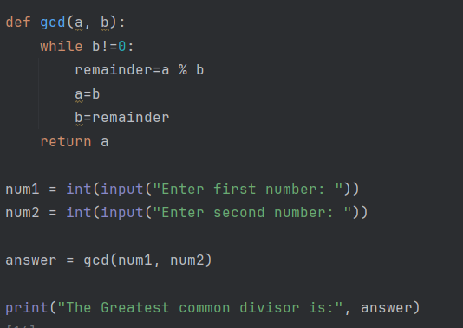
Purpose
This function calculates the Greatest Common Divisor (GCD) of two numbers.
The GCD is the largest integer that divides both numbers without leaving a remainder.
Example:
GCD(24, 36) = 12

Algorithm Used
The Euclidean Algorithm
Key idea:
$$gcd(a,b)=gcd(b,a\%b)$$
We keep replacing the numbers until the second number becomes 0.

PART 2 :-
Purpose
Testing how the function behaves with negative numbers.
Important point:
Python’s % operator behaves differently for negative numbers, so the result might have a negative sign.
Example result:
gcd(50,-100)
Mathematically GCD should be 50, but Python may return -50 depending on operations.
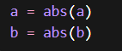
If we use this absolute function , then the answer will always be positive.

PROBLEM 2 :-
PART 1 :-
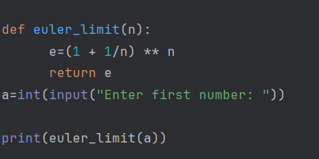
Mathematical Formula
$$e=\underset{n→∞}{lim⁡}(1+\frac{1}{n})^{n}$$
The larger n becomes, the closer we get to e.
Explanation of the Code
This Python program approximates the mathematical constant e using Euler’s limit formula. The constant e is approximately equal to 2.71828 and plays an important role in mathematics, especially in calculus, exponential growth, and logarithms.
The program first defines a function named euler_limit(n). A function in Python is a reusable block of code that performs a specific task. In this case, the function takes one parameter, n, which represents a number used to approximate the value of e.
Inside the function, the expression e = (1 + 1/n) ** n is calculated. This line implements Euler’s mathematical limit formula:
e = lim (n → ∞) (1 + 1/n)ⁿ
This formula states that as the value of n becomes very large, the expression (1 + 1/n)ⁿ approaches the value of e. Therefore, the program uses this formula to compute an approximation of e based on the value of n.
After calculating the value, the function returns the result using the return e statement. The return keyword sends the calculated value back to the part of the program where the function was called.
Next, the program asks the user to enter a number using the statement input("Enter first number: "). The input() function reads the value entered by the user as a string. Since mathematical operations require numeric values, the program converts this input into an integer using the int() function and stores it in the variable a.
Finally, the program calls the function using euler_limit(a) and prints the result using the print() function. This displays the approximated value of e calculated from the user’s input.
In summary, the program takes a number from the user, applies Euler’s limit formula (1 + 1/n)ⁿ, and prints the resulting approximation of the mathematical constant e. The larger the value of n, the closer the result will be to the true value of e.

PART 2 :-
If n becomes extremely large like:
For ecample:-10^16
Then:
(1/n)
becomes so small that the computer rounds it to 0 because of floating-point precision,
therefore Python calculates:
(1 + 0)^n = 1
Which is obviously wrong for e.

PART 3 :-
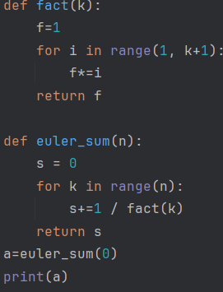
Explanation of the Program
This Python program approximates the mathematical constant e using the Euler series expansion. The value of e is approximately 2.71828 and it can be represented mathematically as an infinite series:
e = 1 + 1/1! + 1/2! + 1/3! + 1/4! + ...
The program uses this formula and calculates the sum of the first n terms of the series.
The program begins by defining a function called fact(k), which calculates the factorial of a number. The factorial of a number k (written as k!) is the product of all positive integers from 1 up to k. For example, 4! = 4 × 3 × 2 × 1 = 24.
Inside the fact(k) function, a variable f is initialized with the value 1. A for loop is then used to multiply all integers from 1 to k. In each iteration of the loop, the current value of i is multiplied with f, and the result is stored back in f. After the loop finishes, the function returns the factorial value stored in f.
The program then defines another function called euler_sum(n). This function calculates the approximation of e using the Euler series. A variable s is initialized with the value 0 to store the running total of the series.
A for loop runs from 0 to n-1. For each value of k, the term 1 / fact(k) is calculated and added to the variable s. The function fact(k) is called to compute the factorial of k, which is used as the denominator of the term. As the loop continues, more terms of the series are added to s, making the approximation closer to the actual value of e.
After all the terms are added, the function returns the final sum stored in s.
Finally, the program calls the function using a = euler_sum(0) and prints the result using print(a). Since the input value is 0, the loop inside the function does not execute, and the sum remains 0. Therefore, the program prints 0 as the output.
In general, if a larger value of n is used, the program will add more terms of the series and produce a more accurate approximation of the mathematical constant e.
PART 4:-
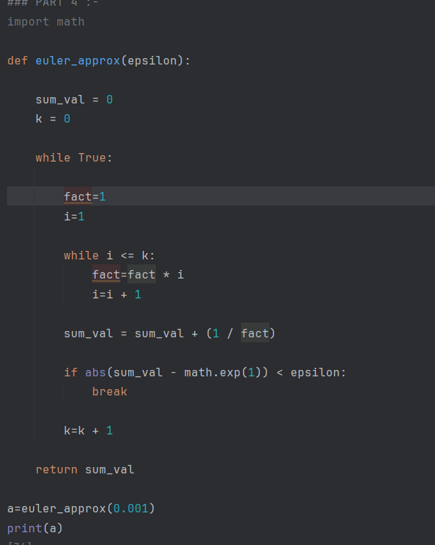
Short Explanation of the Code
This Python program approximates the mathematical constant e using the Euler series expansion and stops when the approximation becomes sufficiently accurate.
The program first imports the math module so that it can use math.exp(1), which gives the actual value of e. A function named euler_approx(epsilon) is then defined. The parameter epsilon represents the maximum acceptable error between the calculated value and the true value of e.
Inside the function, the variables sum_val and k are initialized. sum_val stores the running total of the series and k represents the current term number in the series. The program then enters an infinite loop using while True.
Within the loop, the factorial of k is calculated using another loop. The term 1 / k! is then added to sum_val, which follows the Euler series formula:
e = 1 + 1/1! + 1/2! + 1/3! + ...
After adding each term, the program checks the difference between the calculated value (sum_val) and the true value of e using math.exp(1). If the absolute error becomes smaller than the specified epsilon, the loop stops using the break statement.
Finally, the function returns the approximated value of e. The function is called with epsilon = 0.001, meaning the program stops when the error is less than 0.001, and the result is printed.
PART 5 :-
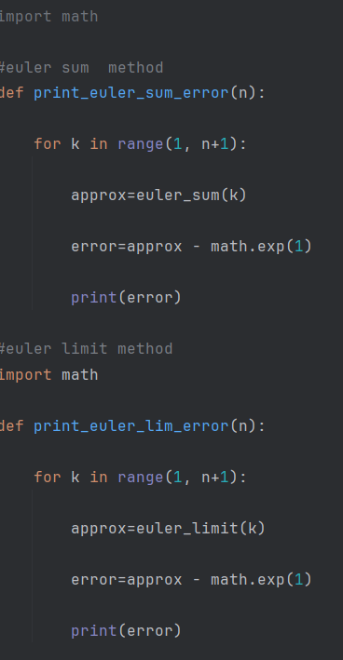
These functions calculate and print the difference between the approximation
and the true value of e. This helps compare the accuracy of the two methods:
the series approximation and the limit approximation.
The function print_euler_sum_error(n) calculates the error when approximating e using the Euler series method. A loop runs from 1 to n, and for each value of k, the program computes an approximation of e using the function euler_sum(k). The error is then calculated by subtracting the true value of e (math.exp(1)) from the approximated value. This error is printed for each iteration.
The second function, print_euler_lim_error(n), performs a similar task but uses the Euler limit method instead. It calculates the approximation using euler_limit(k) and then computes the difference between the approximation and the true value of e. The error for each step is printed.
In summary, these functions help analyze how the approximation of e improves as more terms or larger values of k are used in both methods.

PROBLEM 3 :-
PART 1 :-
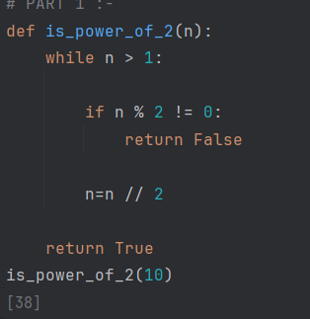
This Python program checks whether a given number is a power of 2. A number is considered a power of 2 if it can be written in the form (2^k), where (k) is a non-negative integer. Examples include 1, 2, 4, 8, 16, and so on.
The function is_power_of_2(n) takes a number n as input. Inside the function, a while loop runs as long as n is greater than 1. During each iteration, the program checks whether the number is divisible by 2 using the condition n % 2 != 0. If the number is not divisible by 2, the function immediately returns False, indicating that the number is not a power of 2.
If the number is divisible by 2, the program divides the number by 2 using integer division (n = n // 2) and continues the loop. This process keeps reducing the number until it becomes 1.
If the loop finishes and the number becomes 1, the function returns True, which means the original number was a power of 2.
Finally, the function is called with the value 10 using is_power_of_2(10), which checks whether 10 is a power of 2.
PART 2 :-
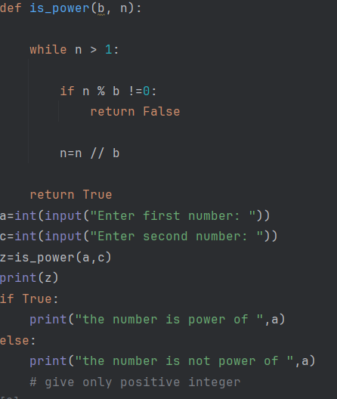
Short Explanation of the Code
This Python program checks whether a number is a power of another number. The function is_power(b, n) determines if the number n can be written as (b^k), where b is the base and k is a positive integer.
Inside the function, a while loop runs as long as n is greater than 1. During each iteration, the program checks whether n is divisible by b using the condition n % b != 0. If n is not divisible by b, the function returns False, indicating that n is not a power of b.
If n is divisible by b, the value of n is divided by b using integer division (n = n // b). This process continues until n becomes 1. If the loop ends and n equals 1, the function returns True, meaning that the number is a power of the base.
After defining the function, the program takes two inputs from the user: the base a and the number c. It then calls the function is_power(a, c) and prints the result (True or False).
Finally, the program attempts to print a message stating whether the number is a power of the base. However, the condition if True: always executes, so the program will always print that the number is a power of a, regardless of the actual result.

