Chapter 01: INTRODUCTION
1.1 Introduction
The use of medical imaging is a major change in the way we view healthcare, and it is almost inconceivable to consider today's version of medicine without imaging equipment. Imaging technologies generate images of internal structures without the use of invasive methods and are examples of non-invasive imaging modalities, which include (but are not limited to) X-ray-based imaging systems, CT scanners, and MRIs. Imaging modalities and imaging technology, such as CT scanning, are particularly important in helping to diagnose conditions, monitoring disease, and creating treatment plans. For example, a CT scan can quickly reveal if there are any internal injuries or respiratory problems associated with the individual being scanned. An MRI can provide a detailed view of neurologic conditions and/or tumors. As such, imaging technology is an essential part of evidence-based healthcare practice in clinical care delivery.
While these advantages of advances in medical imaging technology have created a great deal of potential for healthcare providers to utilize this technology, there are also significant challenges that face the field of radiology. The volume of images generated by a single scan is commonly in the hundreds to thousands of images, and the number of hours spent focusing on small changes (anomalies) in images is considerable, demand an extremely high level of attention, concentration, and training on the part of radiologists. While radiologists typically receive extensive training in the areas of radiology, with steady increases in the number of cases and increasingly stringent deadlines demanded of radiologists, many radiologists struggle to complete their work as it is completing a large number of images requires substantial time and energy. Exhaustion from completing long hours adds to this additional level of strain, and increases the risk for radiologists to miss critical (but faint) findings. Low-quality images with artifacts due to motion, noise, and low contrast prevent critical elements from being identified, making it more complicated for physicians to make a diagnosis. Imaging provides a wealth of visual evidence; however, the quality does not guarantee the reliability, ease, and efficiency of the diagnostic process.

With advancements in AI (Artificial Intelligence), we now have an opportunity to revolutionize this part of medicine. Using sophisticated algorithms, images can now be enhanced through a procedure called Deep Learning. These types of AI systems provide better resolution and eliminate noise from pictures, thereby allowing for faster and more accurate detection of abnormalities than can be achieved through traditional medical imaging methods. The key hurdle, however, is that most AI systems operate as "black boxes" with no explanation of how the conclusions were reached. This has created mistrust in the AI systems and limited their adoption within the medical field. With the introduction of Explainable AI (XAI), we will be able to provide transparency to clinicians by showing them which factors from the scan played a role in the identification of an abnormality. This transparency will help build trust and will provide clinicians with additional confidence in working with AI systems as collaborators instead of being seen as a mysterious tool.
The AI-Powered Medical Imaging Assistant incorporates all of the concepts discussed above into a single tool that improves image quality, identifies lesions and tumors, and provides explanations of how the AI system made its determinations in terms that radiologists can understand. This AI-Powered Medical Imaging Assistant is not intended to replace radiologists, but rather to augment their skills so they can complete their work with greater speed and confidence than would otherwise be possible.
We aim to alleviate the burden on Radiologists, simplify Radiologists' workflows and improve patient outcomes with an Assistant that can be used on Web and Mobile. The addition of using an Assistant also allows patients to view their annotated scans and understand their results in layman's terms. The larger vision for this project is to improve the accuracy, transparency and accessibility of Medical Imaging for all stakeholders.
1.2 Problem Statement
Historically, imaging is often defined and used in medicine to help identify disease. As a result, radiologists must deal with a high volume of cases and exhaustion from long hours of work every day, along with dealing with deteriorating quality of images from radiology equipment and techniques which decreases the number of image interpretations being identified on a daily basis. Because of these issues, many radiologists find themselves either missing or delaying the day in which they can identify a potential source of a patient's illness. There are AI systems available today that can help radiologists to identify areas for attention, but many of them provide only limited insight into how those areas were concluded. As such, the relationships between AI systems and radiologists can be strained because of a lack of confidence in the AI systems. The ultimate goal of a radiologist and an AI system working together is to help to improve the quality of care provided to patients and assist in educating the radiologists and patients on the importance of having a good quality diagnostic image. As the technology continues to advance, and AI systems become more sophisticated, interpreters of CT and MRI images will require more experience to effectively interpret the images. The vast amount of data generated by CT and MRI imaging equipment will create more avenues for radiologists to investigate and utilize to improve their interpretation process. Even the most experienced radiologists miss some subtle indicators when they are working against a deadline, and AI applications are not open enough to be of use in “real life” at a majority of hospitals today, creating a significant need for an AI based solution that will provide a reliable, high quality image, spot irregularities and provide an understandable rationale for establishing the diagnosis. The second significant challenge is that patients typically don’t understand the technical terminologies presented in medical imaging reports, and therefore face barriers to connecting the results of the imaging tests to their own experience. Efforts are underway now to develop interfaces that can take technical jargon and translate it into everyday language that will allow the general public to understand both their imaging results and the meaning of those results in relation to their health.
1.3 Objectives
- Enhance Medical Images – Improve the quality of medical scans by reducing noise, motion artifacts, and poor contrast to make them clearer and easier to interpret.
- Detect Abnormalities Accurately – Use deep learning models to identify potential issues such as tumours or lesions with high precision and reliability.
- Provide Explainable AI Results – Integrate explainable AI (XAI) techniques to highlight the exact regions of a scan influencing predictions, building trust and transparency for doctors.
- Improve Accessibility and Patient Understanding – Provide a platform through web and mobile applications that not only makes the system widely accessible but also presents results in simple language and visual highlights so even people without medical knowledge can understand their reports.
1.4 Significance and Motivation of the Project Work
The main reason we are creating this project now is because there is an urgent need, globally, for faster and better medical diagnosis. As a result of demand from the general public, many hospitals are struggling to keep up with their radiologist's backlogs. These delays can last anywhere from a few days up to weeks, during which time patients must wait for their imaging procedure to be interpreted by a radiologist. This delay is not only an inconvenience but can also delay a patient's treatment, potentially jeopardizing their health when prompt access to diagnostic imaging is critical. Once radiologists have completed their analysis of a patient’s imaging study, it’s common for patients to feel overwhelmed by the medical terminology and primarily rely on their physician to clarify the findings of the report.
To remedy this problem, we have developed an AI-based radiological assistant that specifically addresses the needs of radiologists and patients. To radiologists, it will function as a reliable partner that can augment their image analysis and present a simplified breakdown of the findings and recommendations for radiologic interpretation in a user-friendly format. As a result, radiologists will have less downtime between the completion of their radiologic studies and the identification of potential issues, and clinicians will have a better understanding of the operational impact on their workflow. For patients, the AI-based radiologist will translate complex medical terminology into plain English, thus alleviating patient anxiety regarding their imaging studies and providing them with equal access to the same level of medical care as the rest of the population. In looking ahead, this project represents an exciting opportunity for bridging innovative technologies with the practical aspects of everyday medical practice. We know that artificial intelligence (AI) and deep learning have been around for years and their impact on healthcare delivery is beginning to be realised, but the biggest benefit to patients and providers will come from demonstrating tangibly what this technology can deliver. The project will allow us to illustrate to providers how the utilisation of AI and deep learning will enable them to provide both high quality, accurate, and equitable medical imaging services to the communities served by them.
1.5 Organization of Project Report
This report is designed so that you can follow the development of the AI-Powered Medical Imaging Assistant from the beginning through the completion of our work. It presents the contents in a progressive manner: beginning with the background or context behind this project and the reasons behind developing this product, moving into the core technical details, presenting the results of our research, identifying the architectural components of the system, and finally presenting our personal thoughts about what we learned through this project. Each chapter flows into the next chapter maintaining continuity, making it easier for a variety of audiences—including those who are just beginning to learn about this subject as well as those who are very knowledgeable— to understand our work.
While we worked on this document we remain focused on identifying that balance between providing detailed technical information vs. making this document easy to read for anyone. The discussion of specific technical terms such as neural networks or performance metrics are addressed using language that will allow the reader to understand them easily and eliminate the potential for confusion created by the use of technical jargon or terminology. Creating this experience has been made possible due to the incorporation of real world examples and images, as these have helped to illustrate and clarify what we are trying to say, while making this experience feel more like a journey and less like reading a textbook. You'll have the ability to observe the process from identifying key issues to working through the development phase, and finally going through the testing and fine tuning process. Thus, this report provides information about not only what we created, but also how we came to make each decision along the way; therefore, it gives you an understanding of our whole development experience.
Chapter 1: Introduction
In this introductory chapter, we will describe how the discipline of medical imaging has developed, and explain the need for this documentation project. In this chapter, we will define the problem we are attempting to solve, which is creating faster, more reliable, and truly interpretable diagnostic images. The introduction will also include the main purposes of this documentation project and explain why it is important to the future of health care. We will highlight the important role of deep learning and explainable AI in advancing the field of medical imaging and provide a preview of the chapters to follow that will maintain a cohesive flow between the two.
Chapter 2: Literature Review
In this chapter, we will review the current landscape of artificial intelligence in medical imaging, highlighting several important studies on a variety of subjects, including the sharpening of scanned images and the detection of anomalies in those images, as well as precise segmentation methods, and developing the concept of explainable AI. In addition, we will show how the field has evolved from very basic to much more sophisticated transformer-based models and will note any shortcomings in the literature that can be improved upon. In other words, we will detail how our project will serve to fill the gaps in the existing literature through a new approach.
Chapter 3: System Development
Chapter 3 illustrates how our proposed system was created, describing the hardware and software configuration we utilized as well as providing an overview of the high-level architecture and primary components. We present a detailed overview of the workflow beginning with initial data preprocessing, image cleanup, and anomaly flagging followed by the critical component of explainability. We have provided diagrams and flowcharts providing a visual overview of the workflow process as well as documenting some of the major challenges encountered during system development (i.e., integration issues, optimization problems, etc.) and how we overcame these issues in order to establish a functioning system.
Chapter 4: Testing and Evaluation
In this chapter, we provide a detailed description of the testing framework we employed to evaluate the performance and reliability of our developed system. The first half of this chapter provides an overview of our testing strategy outlining the performance metrics we focused on (e.g., accuracy, precision, recall, F1-scores, and IoU), discusses the various testing tools we used including ROC curves and confusion matrices as well as visualization libraries, and describes our training, validation, and holdout test split methodologies. To demonstrate our progress toward achieving our goals, we utilized a series of targeted test cases, with a focus on real-world scenarios, as well as challenging edge-case and high-load stress tests. For all such test cases we provided specific setup information, anticipated outcome(s), and the actual results achieved. We also assessed and reported on how well the system performed with numerous imaging modalities and/or imaging parameter settings, calling out more challenging aspects such as low contrast images, noisy images, and images with fuzzy edges. We have provided the results of the quantitative analyses of imaging system performance in the following manner for our three primary modules: "Image Enhancement", "Anomaly Detection", and "Segmentation."
Chapter 5 : Results and Analysis section
We present our findings from all the tests we conducted, showing both numerical results and visual representations to demonstrate each module's success. We focus specifically on the models' results, highlighting the results from both the original (raw) images and those produced by our system, including highlighting the areas of interest for each anomaly detected and providing the corresponding confidence level(s) associated with each of the anomalies detected. In addition, we have included segmentation overlays on raw images for each anomaly detected to further highlight the accuracy of the detections. And therefore, our results indicate that our system is capable of producing significant improvements in all three areas: Improving the Quality of Images, Improving Anomaly Detection, and Improving Image Segmentation. In addition, we have presented head-to-head comparisons between our system and many other established benchmarks as well as commercially available products that can produce image enhancements, anomaly detection, and image segmentation. These comparisons provide further support for our claims that we have significantly improved upon existing methods in all three areas in increasing accuracy, speed, and clarity.
To back it all up, we've thrown in statistical tests for significance and ablation runs that tease apart each piece's contribution to the whole.
Chapter 6: Conclusion
The conclusion of this report summarizes the most important and unique contributions of this project. The last chapter describes the development of a system that meets the challenges laid out in previous chapters and combines modern techniques in deep learning and explainable Artificial Intelligence (XAI) with state-of-the-art data visualization for the medical imaging environment. The chapter also discusses several limitations encountered, such as hardware, data volume/scalability, and bias in the training datasets, as well as the impact that our system's clinical use will have in terms of improved diagnostic confidence and transparency for healthcare providers. Lastly, the future directions section of this report provides insight into future opportunities for our research - exploring new imaging modalities, utilizing video, developing live clinical capabilities, and leveraging multi-task architectures to analyze images in real-time. Overall, this report highlights that XAI is a vital ingredient for establishing trust and greater acceptance of deep learning-based tools among healthcare providers.

Chapter 02 : Literature Survey
2.1 Overview of Relevant Literature
The aims of our literature review were to review the most recent advances made from 2022 to 2025 with AI-enabled imaging within the field of healthcare, specifically focusing on the development of image quality improvements, anomaly detection and explainable artificial intelligence (AI). The most prominent trend during this period has been the notable transition from traditional CNN (convolutional neural network) based architectures to more advanced transformer architectures that utilize an attention mechanism, enabling models to gain a more nuanced understanding of images. Major advances include improved deep learning methods to denoise images, improved U-net architectures with better abilities for the accurate segmentation of images, and newly developed methods, such as Grad-CAM, that can assist medical professionals in understanding the output of the AI model so that they can be more confident when using these technologies in clinical practice. Although the models described above generally achieve very high levels of accuracy, typically over 95%, there are also several challenges that need to be addressed including increasing the computational power required to run these models, developing new broad-based datasets for training models and developing generalizable models so that the models can be used across all image types seamlessly.
Table 2.1 Literature Review
S. No | Author & Paper Title | Year | Tools / Techniques / Dataset | Key Findings / Results | Limitations / Gaps Identified
1 | Anuj Kumar, Satya Prakash Yadav, Awadhesh Kumar – An improved feature extraction algorithm for robust Swin Transformer | 2025 | CNN + Swin Transformer; CT & MRI datasets | Higher accuracy, robust to noise, less computation while maintaining performance | Needs strong hardware, mainly tested on medical images, untested on adversarial attacks or poor-quality data
2 | Shoffan Saifullah, Rafal Drezewski, Anton Yudhana, Andiko Putro Suryotomo – Automatic Brain Tumor Segmentation: Advancing U-Net With ResNet50 Encoder | 2025 | CNNs + Transformers; BraTS dataset; Dice, sensitivity, accuracy | High accuracy, detects diverse tumors, robust across patients, speeds up diagnosis | High computation, large datasets needed, struggles with small tumors or artifacts, limited generalization beyond BraTS
3 | Zhe Guo, Xiang Li, Heng Huang, Ning Guo, Quanzheng Li – Deep Learning-Based Image Segmentation on Multimodal Medical Imaging | 2025 | CNNs + Random Forest; STS dataset (50 patients, PET/CT/T1/T2 MRI); Dice | Multimodal fusion improved segmentation over single-modality networks | Single dataset, needs accurate registration, drops under extreme noise, only supervised CNN/U-Net used
4 | Arghya Pal, Sailaja Rajanala, CheeMing Ting, Raphael Phan – Denoising via Repainting: An image denoising method using layer-wise medical image repainting | 2025 | Multi-scale anisotropic Gaussian blur + Bezier-path; MSE & Xing-loss; MRI datasets | Outperforms baseline denoisers in PSNR/SSIM, preserves edges and textures | Computationally heavy, parameter tuning required, limited to 2D images
5 | Hongxu Jiang, Muhammad Imran, Teng Zhang, Yuyin Zhou, Muxuan Liang, Kuang Gong, Wei Shao – Fast-DDPM: Fast Denoising Diffusion Probabilistic Models for Medical Image-to-Image Generation | 2025 | Fast-DDPM, U-Net, conditional diffusion, task-specific noise schedulers | Outperforms GANs/CNNs/standard diffusion in PSNR/SSIM and visual quality; reduces training/inference time | 2D models only, manual noise schedulers; 3D modeling and adaptive scheduling future work
6 | Leila Khaertdinova, Tatyana Shmykova, Ilya Pershin, et al. – Gaze Assistance for Efficient Segmentation Correction of Medical Images | 2025 | WORD CT dataset, Tobii Eye Tracker, MedSAM, AdamW; Dice + cross-entropy | Eye-gaze corrections improved segmentation for small/complex organs; outperformed bounding boxes | Single dataset, 2D slices, specialized hardware, small organs still challenging
7 | Narayan Hampiholi – Medical Imaging Enhancement with AI Models for Automatic Disease Detection & Classification | 2025 | RNNs (sequential), 3D CNNs, multimodal AI | Improved disease detection, early diagnosis, precise tumor localization, reduced false positives | Data bias, poor generalization, ethical/privacy concerns, reliance on human oversight
8 | Saif Ur Rehman Khan, Sohaib Asif, Ming Zhao, et al. – Optimized deep learning model for comprehensive medical image analysis across multiple modalities | 2025 | MobileNet (truncated), ConvLSTM, modified Inception, metaheuristic optimization, Grad-CAM | Accuracy 97.37%, lightweight (2.16M parameters), robust multi-disease detection, interpretable | Large labeled data needed, untested on new modalities, lower accuracy for complex diseases
9 | Ravi Ranjan Kumar, Rahul Priyadarshi – Denoising and segmentation in medical image analysis: A comprehensive review on ML and DL approaches | 2025 | CNNs, ConvLSTM, MobileNet, inception blocks, metaheuristic optimization, Grad-CAM | 97.37% accuracy, high precision/recall, 2.16M parameters, 6s test time | Needs large datasets, lower accuracy on complex cases, untested on new modalities
10 | Xiang Li, Like Li, Yuchen Jiang, et al. – Vision-Language Models in medical image analysis: From simple fusion to general large models | 2025 | VLMs, self-supervised learning, multi-modality fusion, knowledge graphs, federated/cloud computing | Better diagnosis, interpretable outputs, privacy protection, faster processing | Data scarcity, alignment issues, low interpretability, bias, high computation
11 | Bin Yu, Quan Zhou, Li Yuan, et al. – 3D medical image segmentation using serial-parallel CNN and transformer with cross-window self-attention | 2024 | MRI/CT datasets, AdamW, MindSpore Lite; DSC/IoU/HD95/ASD | SPCT outperformed U-Net & Swin-UNETR; DSC 92%+ on ProstateX & Atrium, 81% on Pancreas; efficient computation | High GPU memory needed, tested on single-organ tasks, detail loss with 4× upsampling
12 | Johnson Oyeniyi, Paul Oluwaseyi – Emerging Trends in AI-Powered Medical Imaging: Enhancing Diagnostic Accuracy and Treatment Decisions | 2024 | CNNs, RNNs, 3D CNNs, transformers, multimodal fusion, federated learning | Improved accuracy, faster analysis, personalized care | Needs large labeled datasets, high computation, bias & privacy/security risks
13 | Mohamed Musthafa M, Mahesh T. R, Vinoth Kumar V, Suresh Guluwadit – Enhancing brain tumor detection in MRI using explainable AI with Grad-CAM & ResNet50 | 2024 | ResNet50, transfer learning, PyTorch, data augmentation, Grad-CAM | Test accuracy 98.52%, precision & recall 97–99% | Small, demographically limited dataset; may reduce generalizability
14 | Muhammad Aasem, Muhammad Javed Iqbal – Toward explainable AI in radiology: Ensemble-CAM for thoracic disease localization in chest X-ray | 2024 | Deep CNNs, Ensemble-CAM; chest X-ray datasets | High accuracy (up to 98%), better localization than single models | High computation, weaker than fully supervised methods, dataset quality dependent
15 | Tahir Hussain, Hayaru Shouno – MAGRes-UNet: Improved Medical Image Segmentation Through Multi-Attention Gated Residual U-Net | 2024 | MAGRes-UNet with attention gates, AdamW; BT MRI & HAM10000 datasets | Accuracy 99.8–99.9%, Dice/IoU ~97%, high sensitivity & specificity | 2D model lacks 3D context; brain tumor segmentation challenging due to MRI complexity & limited labels
16 | Yun Zi, Qi Wang, Zijun Gao, et al. – Application of Deep Learning in Medical Image Segmentation & 3D Reconstruction | 2024 | Self-attention U-Net, cross-entropy loss, PyTorch | MIS Dice 85.3%, IoU 78.9%; 3D reconstruction MSE 0.015, SSIM 0.94 | 2D model misses full 3D context; sensitive to hyperparameters; needs better generalization
17 | Fabian Isensee, Tassilo Wald, Constantin Ulrich, et al. – nnU-Net Revisited: A Call for Rigorous Validation in 3D Medical Image Segmentation | 2024 | CNN/Transformer models (nnU-Net, Auto3DSeg); 6 3D medical datasets; DSC/NSD | CNN U-Nets outperform Transformers; scaling boosts performance on harder datasets | Most new methods don’t surpass nnU-Net; Transformers need more data; some datasets saturate
18 | Subhashis Suara, Aayush Jhat, Pratik Sinha, Arif Ahmed Sekh – Is Grad-CAM Explainable in Medical Images? | 2023 | Densenet169, Grad-CAM, data augmentation | 96.7% accuracy; Grad-CAM highlights tumor regions, aiding interpretation | Needs better visualization; expand to other modalities
19 | João Guerrero, Pedro Tomás, Nuno Garcia, Helena Aidos – Super-resolution of MRI using GANs | 2023 | FastMRI dataset, GANs, denoising (NLM, BM3D); MSE, PSNR, SSIM | SRResCycGAN best quantitatively; Beby-GAN & RankSRGAN visually accurate | GANs may produce artifacts; metrics may mislead; bicubic downsampling differs from real MRI; generalization limited
20 | Waqar Ahmad, Hazrat Alias, Zubair Shah, Shoaib Azmat – A new GAN for medical image super resolution | 2022 | Medical imaging datasets (DRIVE, STARE, ISIC, BraTS); LR images from downsampled HR | Outperformed SRGAN & bicubic; PSNR +3–11 dB, SSIM +2–7%, robust to noisy images | High computation; generalization issues on unseen data

2.2 Key Gaps in the Literature
Several deficiencies are present in the literature regarding the application of AI and advanced deep-learning developments in patient imaging. One major obstacle to the successful deployment of these technologies is their reliance upon few, restricted datasets that represent only specific imaging modalities and/or types, which prevents them from properly adapting to clinical situations other than the one in which they were developed. Consequently, many of the currently available AI systems will likely struggle to perform correctly when presented with real-world scenarios such as blurred images, low resolution scans, or unexpected variations in an image from what is expected. In addition to this issue of data quality, the cutting-edge nature of currently available methodologies like transformers or GANs, and even diffusion models, requires significant amounts of computational power and extended amounts of time for training and tuning, which can present logistical complexities when trying to implement these technologies in an actual clinic.
Another issue is that the majority of the available studies are based predominantly on 2D images or slices; therefore, the critical aspect of spatial context (which exists only when viewing a structure in 3D) is being ignored. In addition, most models tend to focus only on isolated organs or tasks, making them significantly less useful for performing comprehensive studies of patients or for multi-organ evaluations. Generalization is another challenge for the majority of AI models; many will show significant reductions in performance when tested against new datasets and across different types of imaging, and the majority will be particularly sensitive to artifacts, or small lesions that go undetected. One of the remaining challenges is Interpretability. A variety of tools have been proposed by the research community to provide some insight into the inner workings of these models (e.g. Grad-CAM, vision-language setup), but many of these tools do not go as deep into interpretability as clinicians would need to feel completely assured. There are also other ethical considerations inherent to the use of these models, including the potential for demographic bias, and also the potential for under-utilization of techniques that improve upon patient privacy.
When examining the specific classes of clinical use cases that these models have been applied to, segmentation still encounters difficulties due to the complexity of organs, as well as intricate anatomical structures. Similarly, enhancing various areas of imaging with advances in super-resolution or noise reduction, using trending techniques such as GANs or Diffusion Models, may inadvertently lead to new forms of errors. Although the lab-bench performance of many of these models has been verified to be highly accurate, translating that accuracy into routine use within the clinical setting will require significant advances beyond what currently exist—namely, models that scale easily, generalize across multiple modalities, and provide information that clinicians can rely upon to inform their decisions.

Chapter 3: System Development
3.1 Requirements and Analysis
3.1.1 Problem Definition
It is critical to identify and diagnose brain tumors through MRI scans quickly and correctly in order to determine the most effective treatment options and increase the likelihood of patient recovery. Unfortunately, the traditional approach of manually reviewing these images can be frustrating: It takes a long time to review; the result is highly dependent upon the skillset of the radiologist; and often, because different radiologists interpret MRI images differently, discrepancies between interpretation may lead to misdiagnosis.
Our project eliminates these obstacles by providing a comprehensive deep learning platform that enhances the quality of MRI images, and classifies the detected abnormalities into one of four categories: glioma, meningioma, pituitary, or no tumor. To enhance the overall usability of the platform, we have included a simple web application that allows users to upload their MRI images and receive an analysis instantly.
3.1.2 Functional Requirements
The MRI imaging system must be able to manage the entire MRI process, from the beginning (Data Intake and pre-processing) through the end (Model deployment) and any predictions must be delivered so they fit in with the clinical process. The system must combine both targeted improvements to individual slices of the MRI (images) and the use of Deep Learning to classify a Tumor as a means of producing outputs that can withstand review by other professionals, but be made available to the end user/Physician through an easy-to-use app. More specifically our goals will be to provide:
- An Automated Loading of MRI Images - all images of interest will be loaded automatically and after being cleaned, so that their quality is assured.
- Research and Compare Separate Enhancement Models like U-Net, DnCNN and EDSR, based on performance against commonly used Standard metrics like PSNR and SSIM.
- Generate Several différents Classifications Models, including: Baseline CNN, VGG16, ResNet50 and Xception (all written in PyTorch), and EfficientNetB4 (in TensorFlow/Keras), and then compare their Relative Accuracy and Efficiency.
- Produce Key Clinical Measurement Metrics to Evaluate Performance - (accuracy, precision, recall, F1-score and Specificity) segregated by Class; ROC-AUC Scores (per Class and Overall) and Full Confusion matrices (complete).
- Deploy to clinicians and end users with a user-friendly Gradio interface where they can upload scans in an easy and convenient way, and receive back not only the predicted type of tumor with confidence values but also an easy-to-read report-style summary of the results, specifically designed for real world use.
3.1.3 Non-Functional Requirements
- Accuracy: The classification model must achieve a test accuracy of >95% to be clinically relevant.
- Inference Latency: The total processing time (from upload to diagnosis) must be under 2 seconds.
- Robustness: The system must handle variations in scanner quality, zoom, and patient orientation.
3.1.4 Datasets Used
The two publicly accessible MRI datasets for brain tumors utilized in this project contain images divided into four categories: Glioma, Meningioma, Pituitary, and No Tumor. The variety of MRI scans available from these two datasets allows for extensive training and testing of the models developed.
The two datasets are:
- Figshare Brain Tumor Dataset - Contains 2D MRI images on PNG and JPG file formats. The images included within this dataset are labelled according to the four tumour types and are frequently used in research to develop algorithms to classify brain tumours.
- Brain Tumor MRI Dataset from Kaggle (masoudnickparvar) - This dataset consists of high-quality T1-weighted contrast-enhanced MRI scans. Due to the high-quality T1-weighted contrast-enhanced MRI scans found within this dataset, it provides clearer and more detailed images than the previous one, which allows for more effective training of models and reduces the amount of ambiguity present during classification.
3.2 Project Design and Architecture
3.2.1 System Architecture and Workflow
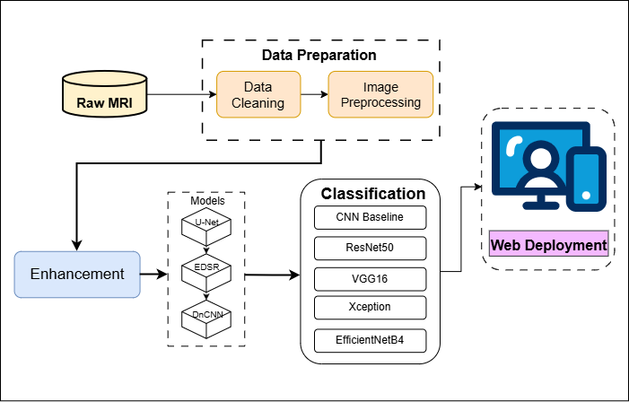

Fig. 3.1. Workflow of the project
The workflow begins with raw MRI data that is then prepared for later stages of workflow. After initial cleaning and data processing of this initial MRI data, models like UNET, EDSR, and DNCNN improve the quality of the newly processed images. Once the image quality has improved, the newly processed images are now going through multiple models of classification including CNN Baseline, ResNet50, VGG16, Xception, and EfficientNetB4 to determine which one is the most effective model that can be used within the web-based deployment of the system for end users to access easily via a web-based platform.
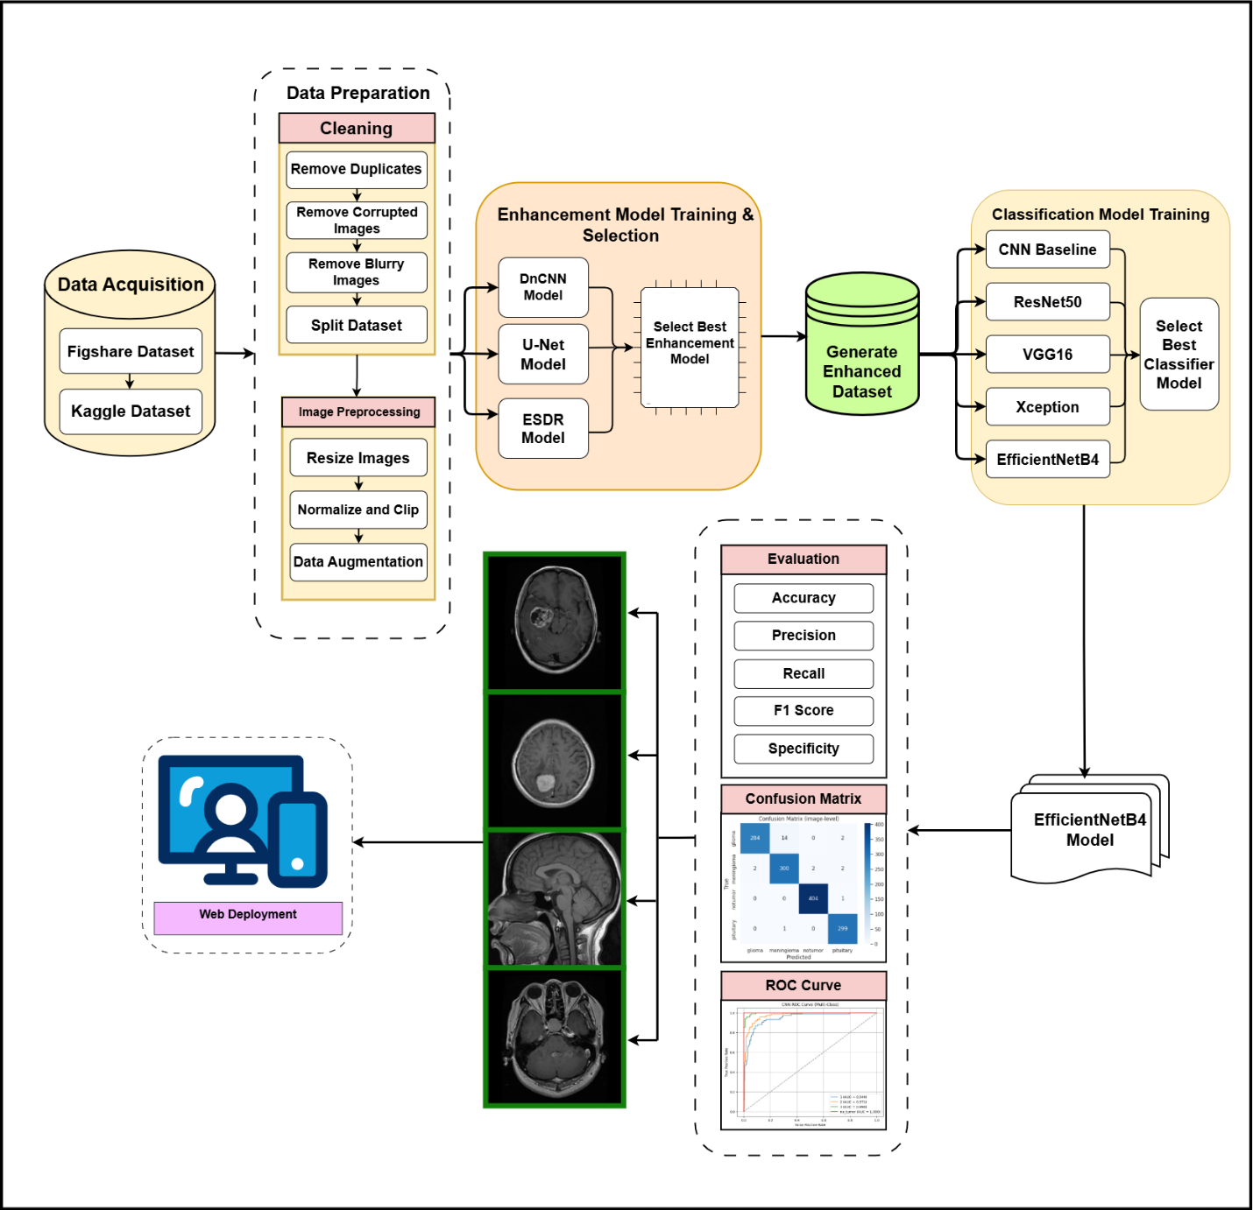
Fig. 3.2. Detailed Workflow and Architecture of the Project
- Raw Data : Cleaning & Preprocessing
  - Remove corrupted / low-quality images
  - Normalize, resize, convert to grayscale, balance classes
  - Split into train / validation / test sets.
- Image Enhancement Module (PyTorch)
  - Train U-Net, DnCNN, EDSR on synthetic noisy MRI pairs.
  - Evaluate them on a clean test set using PSNR and SSIM.
  - Choose best enhancement model (U-Net, based on SSIM).
  - Use best model to create an enhanced dataset.
- Classification Module : PyTorch
  - Train Baseline CNN, ResNet50, VGG16, Xception using the U-Net-enhanced dataset.
  - Compare metrics on a held-out test set.
- Classification Module : TensorFlow (EfficientNetB4)
  - Separate pipeline with heavy preprocessing and class-weighted training.
  - Train EfficientNetB4 on combined datasets (380×380 RGB inputs).
  - Evaluate image-level metrics and confusion matrix.
- Deployment Module : Gradio Web App
  - Load the trained EfficientNetB4 model.
  - Accept an uploaded MRI slice.
  - Preprocess identically to training.
  - Display class probabilities and a styled diagnosis report.
3.2.2 Core Convolutional Mathematics
All models in this system rely on the discrete convolution operation.
For an input image $I$of size $H×W$and a filter $K$of size $k×k$, the output feature map $S$ is:
$$S(i,j)=(I*K)(i,j)=\sum_{m=0}^{k-1}{m}\sum_{n=0}^{k-1}{n}I(i+m,j+n)⋅K(m,n)+b$$Equation(1)
Optimization (Adam):We utilize the Adam optimizer, which adapts learning rates based on the first moment ($m_{t}$) and second moment ($v_{t}$) of the gradients:
$$θ_{t+1}=θ_{t}-\frac{η}{\sqrt{{\hat{v}}_{t}}+ϵ}{\hat{m}}_{t}$$Equation(2)
3.2.3 Preprocessing Architectures
1. DnCNN (Denoising CNN)
- Purpose: Removal of Rician noise from MRI scans.
- Math (Residual Learning): Instead of learning the clean image mapping x, DnCNN learns the residual noise mapping R(y) ≈ v.
$$y=x+v→\hat{x}=y-R\left(y\right)$$
Equation(3)
The loss function minimizes the Frobenius norm between estimated and true noise:
$$L\left(Θ\right)=\frac{1}{2N}\sum_{i=1}^{N}{|}R\left(y_{i};Θ\right)-\left(y_{i}-x_{i}\right)|_{F}^{2}$$
Equation(4)
2. EDSR (Enhanced Deep Super-Resolution)
- Purpose: Upscaling 2× low-resolution scans without introducing blur.
- Math (Sub-Pixel Convolution): EDSR uses a Pixel Shuffle layer to rearrange channel depth into spatial dimensions.
$$PS{\left(T\right)}_{x,y,c}=T_{\left\lfloor x/r\right\rfloor ,\left\lfloor y/r\right\rfloor ,c⋅r⋅\backslash bmod\left(y,r\right)+\backslash bmod\left(x,r\right)}$$
Equation(5)
where $r$ is the upscaling factor.
3. U-Net (Region of Interest Extraction)
- Purpose: Skull stripping to isolate the brain tissue.
- Math (Skip Connections): The decoder concatenates feature maps from the encoder ($x_{enc}$) to preserve spatial details:
$$x_{dec}=Concat(UpConv(z_{l}), x_{enc})$$
Equation(6)
- Math (Dice Loss): Optimized to handle class imbalance between background and tumor:
$$Dice=\frac{2 ∣X∩Y∣}{∣X∣+∣Y∣}$$
Equation(7)
3.2.4 Classification Architectures
4. Custom CNN (Baseline)
- Design: A sequential stack of 4 Convolutional blocks followed by Dense layers.
- Math (ReLU Activation): Applied to introduce non-linearity:
$$f(x)=max⁡(0,x)$$
Equation(8)
5. VGG16 (Visual Geometry Group)
- Design: A deep stack of 13 convolutional layers using small $3×3$filters.
- Math: The receptive field of two stacked $3×3$layers is effectively $5×5$, but with fewer parameters and increased non-linearity.
6. ResNet50 (Residual Networks)
- Purpose: Solving the vanishing gradient problem in deep networks.
- Math (Residual Block): The network learns a residual function $F(x)$, resulting in the mapping:
H(x) = F(x) + x
Equation(9)
This allows gradients to flow directly through the identity shortcut $+x$ during backpropagation.
7. Xception (Extreme Inception)
- Purpose: Efficiency through decoupling spatial and channel correlations.
- Math (Depthwise Separable Convolution):
$$Conv(K,I)→Depthwise(K_{dw},I)+Pointwise(K_{pw},I)$$
Equation(10)
This reduces the computational cost by a factor of roughly
$$\frac{1}{N}+\frac{1}{k^{2}}.$$
Equation(11)
8. EfficientNetB4 (Champion Model)
- Purpose: Optimal scaling of network dimensions.
- Math (Compound Scaling): It scales width ($w$), depth ($d$), and resolution ($r$) uniformly using a compound coefficient $ϕ$:
$$d=α^{ϕ},w=β^{ϕ},r=γ^{ϕ}$$
Equation(12)
subject to:
$$α⋅β^{2}⋅γ^{2}≈2$$
Equation(13)
For B4, $ϕ=4$, providing the optimal balance for $380×380$(or resized $224×224$) inputs.
3.3 Data Preparation
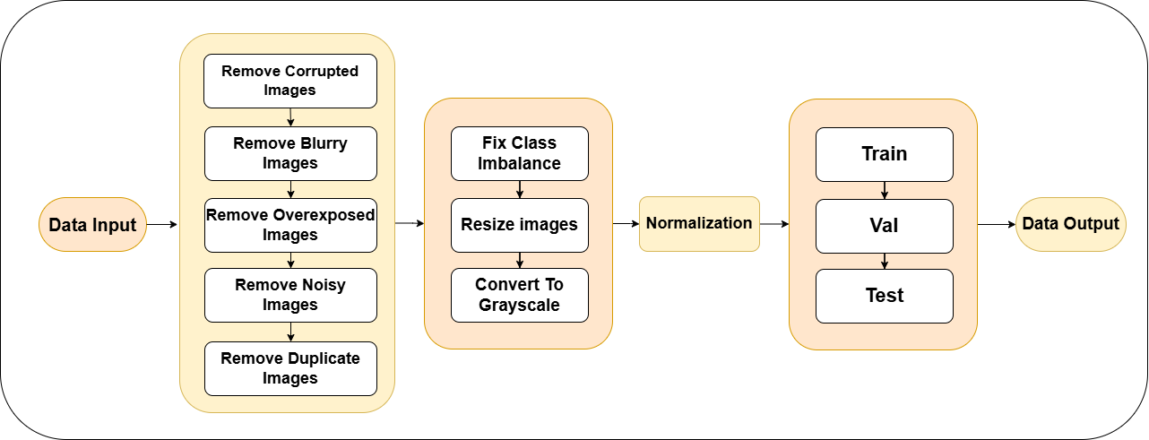
Fig. 3.3. Data Preparation
All MRI images were first passed through a structured cleaning pipeline to ensure only high-quality scans were used.
- Corrupted/unreadable images were removed.
- Blurry images were detected using Laplacian variance and discarded.
- Overexposed scans were removed based on histogram analysis (too many pixels near 0 or 255).
- Highly noisy or artifact-affected images were eliminated manually or based on noise thresholds.
- Duplicate images were identified using perceptual hashing or checksums.
- Class imbalance was handled using class-balanced sampling (PyTorch) and class weights (EfficientNetB4).
- Images were resized to:
- 224 × 224 pixels (PyTorch models)
- 380 × 380 pixels (EfficientNetB4 model)
- MRI grayscale scans were converted to 1 channel, then duplicated to 3 channels for pretrained CNNs.
- Normalization:
- PyTorch: scaled to [0,1][0,1][0,1] and normalized(mean = 0.5, std = 0.5)
- TensorFlow: used efficientnet.preprocess_input
- Dataset splitting:
- 70% training, 20% validation, 10% testing (PyTorch)
- Separate train/test directory structure (TensorFlow)
- Masks were saved for future segmentation research.
3.3.2 Data Augmentation
We incorporated dynamic augmentation methods into the training process to reduce the likelihood of overfitting and increase the models’ ability to generalize. We normalized all pixel intensities by dividing each intensity by 255 to bring all values between 0-1, added a max shear distortion of 0.2, zoomed in/out (80%-120%) and randomly flipped the images horizontally at the time of training. By introducing these variations into each image we were able to replicate factors such as positional change and zooming unique to real-world scenarios. The end result was to create classifiers that perform much better across a wide variety of clinical situations.
3.4 Implementation Details
To address the challenges of processing images, we developed three unique neural networks (in PyTorch) to handle the various preprocessing tasks in an easily adaptable manner. DnCNN was chosen for its ability to remove noise, EDSR for enhancing image quality when necessary, and U-Net for skull stripping/extraction of specific areas of interest. Each network has been encapsulated within its own class module, which allows us to easily access the appropriate network based on the needs of the scan at the time of run. TensorFlow version 2.15.0 with an associated Keras 3.0 interface serves as the underlying framework of our processing system, while Tesla T4 GPUs from NVIDIA allow us to efficiently perform the high degree of matrix calculations that these systems require.

Table 3.1: Hyperparameters and configurations of enhancement models.
Model | Architecture | Learning Algorithm | LR | Batch | Epoch  (max) | Early-Stopped | Loss Function | Activations
U-Net (Small) | Custom U-Net (3 down, 2 up) | Adam | 5 × 10⁻⁵ | 8 | 60 | 41 | 0.84(1 − SSIM) + 0.16 L₁ | ReLU, Sigmoid
DnCNN | 17-layer DnCNN | Adam | 5 × 10⁻⁵ | 8 | 60 | 34 | 0.84(1 − SSIM) + 0.16 L₁ | ReLU
EDSR (x1) | 8-block EDSR | Adam | 1 × 10⁻⁴ | 8 | 60 | 47 | 0.84(1 − SSIM) + 0.16 L₁ | ReLU

3.4.1 Advanced Preprocessing Pipeline Implementation
A. Denoising Network (DnCNN) Implementation
The data processed from the original MRI format through a series of three Neural Networks designed for processing MRI imagery before applying the models during classification as functional parts of the DnCNN Model developed using the residual learning approach eliminates the need to create a model that constructs an output image based on the denoising of an input image. Instead, the DnCNN approach to denoising is to develop a model that identifies and creates a representation of the noise and then subtracts the estimated noise from the original input image to produce a cleaned-up output. The convolutional base of the DnCNN includes an initial convolution and an activation function, and a chain of fifteen convolutional blocks in order to produce a smooth training curve and extract features from the data and a final output layer with an additional convolution to create the output noise prediction for the original input to be denoised.
During the forward pass through the DnCNN model after calculating the residual component, the original input image is then combined with the residual component and clamped to maintain
the pixel intensity values in the allowable pixel intensity range to eliminate any artifacts
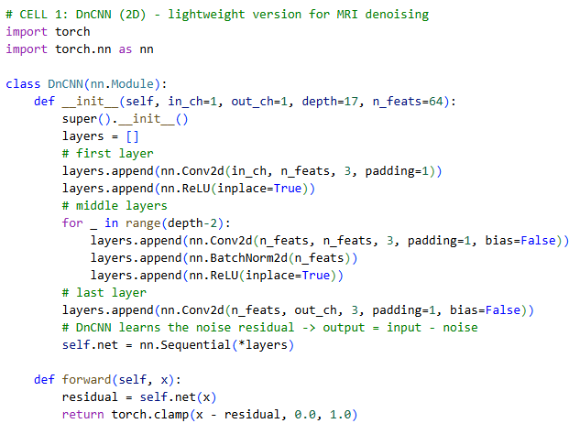
Fig 3.4.1.1. Denoising Network (DnCNN) Implementation
B. Super-Resolution Network (EDSR) Implementation
The EDSR model produces improved clarity by sharpening images, which is particularly beneficial for MRI scans captured at lower-resolution where details can become lost in the background. The architecture uses residual blocks and explicitly avoids using batch normalization so as not to artificially restrict the possible range of pixel values—thus allowing the pixel values to blend together naturally in the data.
Image upscaling itself is performed using a method called Pixel Shuffle (or sub-pixel convolution),
which offers a much better approach to image resolution increasing than conventional methods due to the lack of checkerboard artifacts found in those methods.

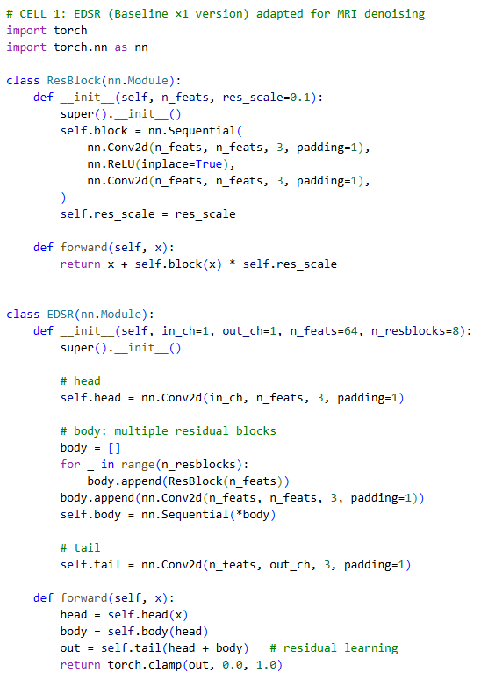
Fig 3.4.1.2. EDSR Implementation
C. Skull Stripping Network (U-Net) Implementation
To separate brain tissue from the background, we employed a modified U-Net design which is based on the traditional U-Net framework. It includes an encoder (where feature maps are gradually reduced via convolving and pooling layers) and a decoder (where the resolution is restored via up-convoluting layers). Each level of the encoder and decoder communicates through a reduction and a restoration pipeline. With this structure in place, we can capture more intricate features at each stage than if we simply had two separate pipelines (one for reducing features and the other for restoring them).As such, we can represent our outputs: the final step consists of a 1×1 convolution and a sigmoid activation function that produces the binary masto distinguish pixels of the image representing brain versus non-brain areas.
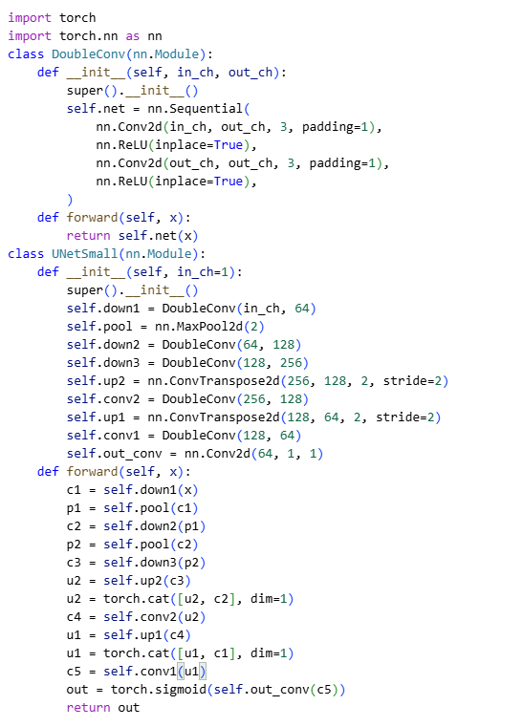
Fig. 3.4.1.3. U-net Implementation
3.4.2 Classification Models Implementation
Table 3.2: Hyperparameters and configurations of classification models
Model | Backbone / Architecture | Input Size | Optimizer | LR | Batch | Epochs (Max) | Early-Stopped
Simple CNN | 3-layer ConvNet + 2 FC | 224 × 224 × 3 | Adam | 1 × 10⁻⁴ | 16 | 50 | 23
ResNet50 | ResNet50, FC→4 | 224 × 224 × 3 | Adam | 1 × 10⁻⁴ | 16 | 50 | 8
VGG16 | VGG16, classifier[6]→4 | 224 × 224 × 3 | Adam | 1 × 10⁻⁴ | 16 | 15 | 15
Xception | Xception (pretrained models) | 224 × 224 × 3 | Adam | 1 × 10⁻⁴ | 16 | 50 | 8
EfficientNetB4 | EfficientNetB4 + custom head | 380 × 380 × 3 | Adam | 1 × 10⁻³ (head), 1 × 10⁻⁵ (fine-tune) | 20 | 50 (30+20) | 49

Once the MRI images had been preprocessed and enhanced, we fed them into the classification stage. To determine the most effective approach, we trained and evaluated five different neural network architectures side-by-side. The results of this comparative study are presented later in the report. (For the thesis documentation, the recommended code snapshots are shown in the figures referenced below).
Model 1 – Baseline CNN (From Scratch)
To establish a solid reference point for all subsequent models and enable a direct comparison against future, transfer-learned models, we began by developing a lighter-weight Sequential Model, called a Baseline CNN.
The architecture of the Baseline CNN includes the following components:
- 4 Convolution Layers, with ReLU Activation, Max Pooling layers.
- Each of these components is considered a Convolution Block.
- At the conclusion of the CNN, there are 2 Fully Connected Layers responsible for the Classification of the Images.
- Each Input Image is cropped to the Dimensions of 224 x 224 x 3.
- The chosen Optimizer is Adam, with a Learning Rate of 0.0001.
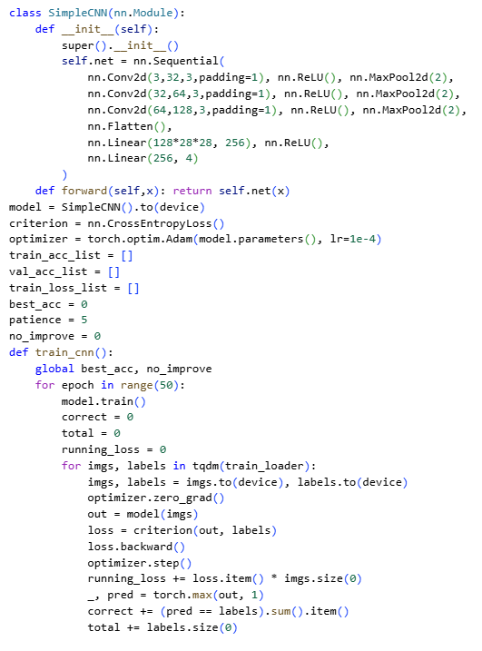
Fig. 3.4.2.1. Chosen Optimizer Adam with Learning Rate for CNN
- The Optimizer is configured for a total of 50 Epochs, with the Training being concluded after 23 Epochs because of no further improvements in Validation Performance.
The Baseline CNN trained well, serving as a good baseline from which to measure the performance of all of the Transfer-Learning Architectures to be compared to it.
Model 2: VGG16 (Transfer Learning)
The VGG16 model was imported with include top=False and all convolutional layers were frozen. This allowed reusing the pretrained filters for edge and texture detection.
- Added Flatten → Dense layers to convert features to class probabilities.
- Suitable for small datasets due to strong generalization.
- Limited by large parameter count.
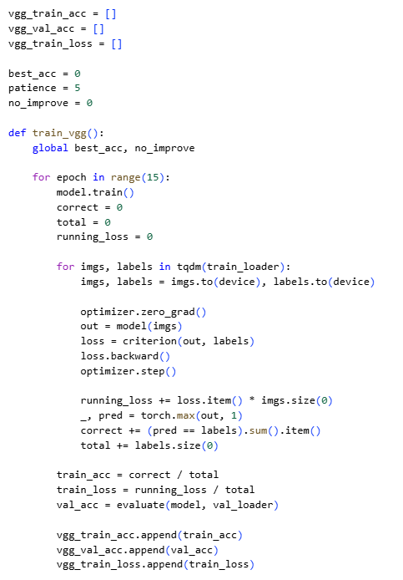
Fig. 3.4.2.2. VGG model
Model 3: ResNet50 (Residual Networks)
ResNet50 was chosen due to its skip connections, which prevent vanishing gradients and enable deep network training.
- Used GlobalAveragePooling instead of Flatten to minimize parameters.
- Fast convergence with high accuracy.
- Early stopped at epoch 8.
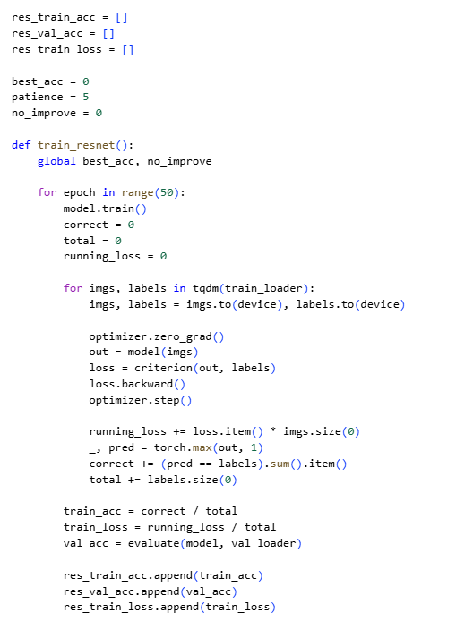
Fig. 3.4.2.3. ResNet50
Model 4: Xception (Extreme Inception)
Xception improves efficiency by replacing standard convolutions with Depthwise Separable Convolutions.
- Advantage: It separates the learning of spatial correlations (width/height) from cross-channel correlations (depth), making it computationally lighter than VGG16 while achieving higher accuracy.
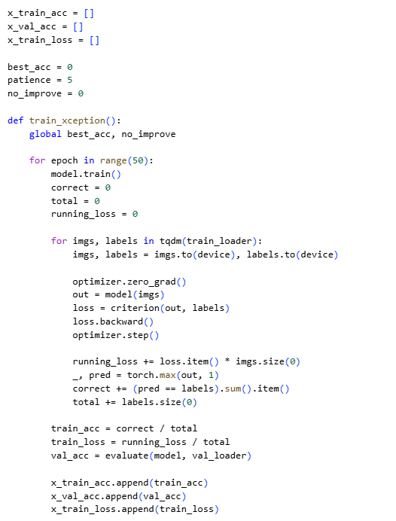
Fig. 3.4.2.4. Xception Model
Model 5: EfficientNetB4
EfficientNetB4 was chosen as the final classification model due to its strong performance-to-parameter efficiency. It uses compound scaling, which uniformly adjusts network width, depth, and resolution, making it effective for high-resolution MRI analysis.
The model receives 380×380 RGB images from the preprocessing pipeline. Training is performed in two stages to maximise generalisation:
(a) Data Generators & Class Balancing
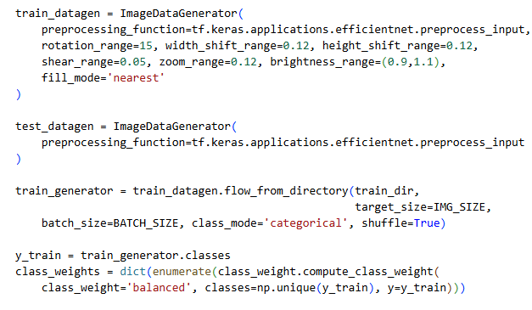
Fig. 3.4.2.5. Data Generators & Class Balancing
(b) Model Architecture & Compilation
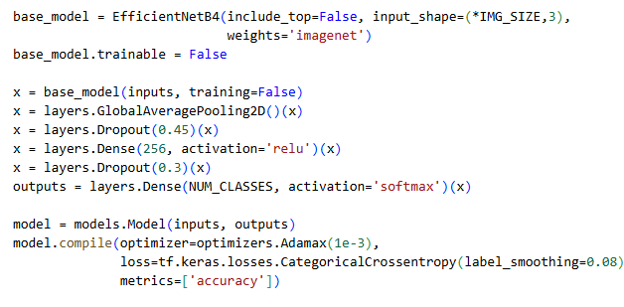
Fig. 3.4.2.6. Model Architecture & Compilation
(c) Two-Stage Training Approach
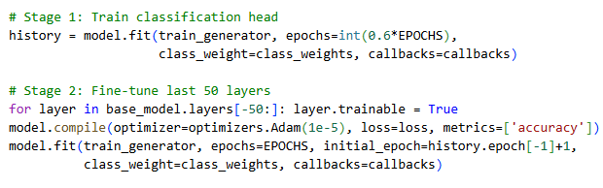
Fig. 3.4.2.7. Two Stage Training Approach
3.5 Key Challenges and Solutions
While we were working on this project, we encountered some commonplace difficulties related to medical imaging and deep learning. The following list represents most of those encountered as well as the methods used to address them.
1) There were variations in the noise and variances of the MRI scans; although there may be slight differences between images, their disparity may be determined by; the scanner used, the protocol used to conduct the scans, the contrast agents injected, or random noise that can affect the overall quality of an MRI scan. The fluctuating nature and differences of the individual images could be an impediment for the model learning reliable characteristics/features. To lessen this effect, we created an excellent preprocessing pipeline for the model, to include: z-score normalization, clipping of extreme pixel intensities (1st and 99th percentile), denoising by applying the U-Net enhancement model we had previously developed and applied strong data augmentation for (flips, rotations, scaling and elastic deformations, etc.) to ensure that the model is robust to real-world variances in scans.
2) Due to the relatively small number of training scans available, deeper networks, such as ResNet50 and EfficientNetB4, easily memorized data from the training set. Thus, to prevent overfitting to the discipline of the dataset, we employed several common yet proven techniques to reduce the likelihood of overfitting: aggressive augmentation of the training scans, dropout and batch normalization layers, label smoothing, and early stopping once validation loss plateaued.
3) One of the biggest limitations to the model's predictions is class imbalance. As many tumor types were poorly represented in the dataset, which led to the model's predictions of the majority-tumor types. In order to alleviate this bias, we applied class weighting while training the model (this was especially evident during the EfficientNetB4 phase of training), and we also reported large class representation by using both macro and weighted F1 scores and total accuracy for smaller class representations.
4) Due to GPU memory limitations and the length of time it takes to train the model, we encountered significant challenges when training an EfficientNetB4 model with 380×380 pixel images. However, we were still able to maintain a batch-size of 20, primarily by freezing the majority of the pre-trained layers at the start, and unfroze the last 50 layers to perform fine-tuning of the model. Additionally, we employed mixed precision training with gradient clipping to allow us to conduct all of the model training on one powerful GPU without overloading the memory capacity of the GPU.
5) It can be difficult to deploy large machine learning models if you do not have access to a large cloud-based infrastructure like Google Cloud. To significantly ease the user experience and allow users of all types and expertise to quickly use the system, we have saved both the original Keras & H5 format of the model and built a simple Gradio UI. Anyone can run the demo of Neural Network by executing the command (python gradio_app.py), upload their MRI Slices, and receive predictions of your uploaded MRI Slices in seconds without having to perform any complicated installations on their computers.
So addressing and resolving these design issues progressively helped to enable us to create from a prototype capable of providing reliable classification to our users.
Chapter 4: Testing
4.1 Testing Strategy
A structured testing process was established to provide sufficient evidence of the reliability of the brain tumor classification system for real-world deployment. The approach taken to testing was to break down the evaluation process into separate stages instead of testing all parts of the system simultaneously. Initial evaluations were conducted for the enhancement module alone; followed by an evaluation for each classification model individually; and finally, an evaluation was conducted for the entire pipeline in an end-to-end fashion. This systematic manner of completing evaluations provided opportunities to detect issues in the early stages, ensure that all system components operated as intended, and confirm that the integrated pipeline produced consistent results across varying environments.
4.1.1 Testing Framework
The evaluation's structure consisted of three phases to ensure that each portion of the system underwent sufficient inspection prior to assembling the complete system.
Phase 1 : Testing Enhancement Models
We evaluated three different enhancement networks, U-Net, DnCNN, and EDSR. The three models were trained using the exact same training and validation data so that the results from this phase could be compared evenly, and the test data was only accessed during the final phase of the evaluation. Performance was assessed using standard image quality metrics: Peak Signal to Noise Ratio (PSNR) and Structural Similarity Index (SSIM), calculated using the widely accepted scikit-image library. This phase was extremely important because a noisy or poorly enhanced image may mislead the classifier at a later time. We paid close attention to how effectively each network model cleaned up artifacts while not blurring or distorting clinically relevant anatomical information.
Phase 2 : Testing the Classification Models
We trained and evaluated five classification architectures after selecting the best-performing enhancement model (U-Net in our case). All classifiers were therefore trained on the same high-quality, consistent enhanced images. In addition to reporting total accuracy, we provided a comprehensive set of clinically relevant metrics, such as precision, recall, F1 (macro and weighted), specificity, and AUC-ROC (using scikit-learn) which provided clear insights into how each model performed with respect to the rarer tumor types, which is critical in a medical context where missing any one of these can have dire consequences.
Phase 3 : End-to-End Integration and Deployment Testing
During the last phase of our work we integrated our best-performing image enhancement and classification models into a single pipeline and created a Gradio web interface to run the pipeline. We then evaluated the entire workflow beginning with image upload, following through preprocessing and enhancement and concluding with predicting and displaying the prediction result from many different sources of real-world images (different types of files, file sizes, variations in noise and artifacts from scanning). This allowed us to validate whether or not the solution is robustly usable by others outside of our lab once it is deployed and operated.
Our phased approach allowed us to identify and address problems very early on, instilled confidence in the performance of each individual component in isolation, and ultimately produced a system capable of functioning reliably throughout the entire workflow.
4.1.2 Tools and Technologies
We used various tools to simplify and increase the reliability of the testing process:
- TensorFlow/Keras was the core platform used to create, train, and test deep learning models. The built-in metrics, auto-checkpointing (ModelCheckpoint callbacks), and mixed-precision support enabled us to be less error-prone and focus on other things; we didn’t need to constantly remember to save the best weights.
- Scikit-learn provided a way to evaluate the results, using its `classification_report`, `confusion_matrix`, and `roc_auc_score` functions, which generate comparable, exact numbers for all other researchers publishing similar results.
- Matplotlib/Seaborn provided visual visualizations, generating more detailed confusion matrix, ROC curves, and side-by-side comparison charts. This allowed us to quickly pinpoint model weaknesses, such as which tumor types/models were being confused the most frequently.
- Google Colaboratory was the primary environment we will be using to develop our code, because it allowed us to use free access to both GPU/TPU resources so we could try out many types of model architectures and hyper-parameters without limit based upon the specifications of our hardware at home. We also created our own Google Drive folder for the model we were developing which allowed us to easily link all of our model logs, trained models and post-analysis plots together with ease of access.
By using these integrated tools, we were able to create a well-sorted, repeatable testing period that provided an efficient way to test all through the development of the models we would create.
4.1.3 Data Splitting Strategy
To achieve accurate results, it was important that we had the correct split of data to use for training our model(s) and testing them. We utilized a very standard method to ensure a clean data split. The following were the data splits used in descending order:
- The training set is composed of 70% of all the data available and will be used only to allow the model(s) to run algorithms through the training process to learn the patterns that exist.
- The validation set is composed of 20% of data that will be monitored during the training process for tuning hyperparameters, scheduling learning rates, and determining the early-stopping point of the training process.
- The test set is composed of the remaining 10% of data that was taken from the original dataset and was not used in any way before the last evaluation of the model(s).
The separation of the test set from the original data was completed before any data preprocessing or model testing was completed to minimize the risk of creating a "leak" to the training set, which could inflate the results reported on the test set.
When the dataset allowed, we also ensured that the patients were separated at the level of each patient: If there were multiple scans from a single patient, they all went into a single split rather than being separated between training and testing datasets. By this means, our model(s) could not find certain characteristics of the individual patient to memorise or identify, thus ensuring that they learned to identify generalisable characteristics of all the patients. By following such a stricter separation of the different datasets, the overall results that we achieved were much more representative of what would be clinically applicable.
4.1.4 Testing Protocols
The models were not just trained and left to chance. Instead, each model architecture underwent a thorough evaluation process consisting of a series of evaluations, both quantitative and qualitative. Quantitative Evaluation consisted of recording and analyzing all the significant numerical values that were tracked throughout the training process, including the loss and accuracy of the training and validation datasets as well as the final test metrics associated with each model. In addition, all of this data was recorded into CSV files so that we could go back and analyze it later and create a visual representation of historical trends, and also allow for fair comparisons between various models.
The qualitative evaluation included manually examining the predicted outputs of each model using a random sample from the test dataset. It became evident very quickly if a model had truly captured the anatomical structures of interest, or if it was using other means (such as horse detection training programs or background images) to obtain the desired predictions.
To properly assess each model's performance, we artificially introduced many real-world hurdles through for example scans filled with noise, slice orientations that are not typical, small tumour sizes, large tumours that significantly distort normal anatomy, and/or scans containing metal artifacts. By testing these models under these extreme scenarios, we identified the actual limits of each structure within the real world and found out exactly which aspects of the system will require human oversight before it can be used.

To ensure that results were able to be consistently replicated, we performed reproducibility checks using a fixed random seed (i.e. 42) across each experiment, including data shuffling, augmentation and weight initialisation processes. We confirmed that any time an identical notebook was run, we received perfectly replicated results (i.e. memorised zeroes). This level of determinism allows anyone to independently verify or further develop our research, thereby making the entire investigation reproducible.
Evaluating each model based on these four separate avenues provided us with a clearer, more authentic representation of how the model will likely perform when it's released to the public.
4.2 Test Cases and Outcomes
4.2.1 Enhancement Models Test Cases
Test Case 1: Standard PSNR and SSIM Evaluation
The goal was to compare three different enhancement models by measuring how well the models enhanced image quality while preserving structure.Every enhancement model received the same set of 40 different types of noisy test images for analysis. In doing so, we measured Peak Signal-to-noise Ratio (PSNR) and Structural Similarity Index Measure (SSIM) by comparing each model's enhanced output and its corresponding clean reference (ground-truth) image. This experiment provided an unbiased and objective measure of the model's ability to remove noise from test images while preserving any important anatomical features of the original images.
Table 4.1: Performance comparison of Enhancement models on the test set.
Model | PSNR (dB) | SSIM
U-Net | 32.453 | 0.9066
DnCNN | 31.701 | 0.8919
EDSR | 32.469 | 0.8900

The U-Net was determined to be the best model based on the highest SSIM (Structure Similarity Index) score, which means it produced the most accurate representation of the anatomical structure of the brain; this is essential for making most medical imaging decisions. While EDSR slightly outperformed U-Net in PSNR (Peak Signal to Noise Ratio), the difference was small, and likely would not have affected actual clinical use. Since the structural representation is of far greater value than the amount of noise present at the pixel level when using a neural augmentation model to enhance medical image quality, we chose U-Net for the improved image enhancement portion of this project.
The qualitative view of images produced further confirmed the findings from the quantitative results. U-Net images were sharp and natural; there were clearly defined tissue boundaries, and even small-scale anatomical features were visible. When using DnCNN, we lost the integrity of the texture of the images because the model over-smoothed everything. EDSR produced clean images overall but occasionally had faint ring-like artifacts near edges of the images with high contrast. These artifacts were not severe but were present enough that we did not consider EDSR for clinical applications.
Test Case 2: Computational Efficiency
This research project's objective was to calculate the time needed for one pass of each of the three enhancement models when applied to an average-sized image (224 x 224 pixels) and examine the usefulness of each model in commercial applications.
To determine the inference times of each model, we measured inference times for 100 passes using Tesla T4 GPUs hosted on Google Colab for groups of 8 images.
Findings were as follows:
- U-Net - Approximately 12.36 seconds to complete all 100 passes for Group A
- DnCNN - Approximately 12.53 seconds to complete all 100 passes for Group A
- EDSR - Approximately 13.50 seconds to complete all 100 passes for Group A
All three models had very similar inference times when used to enhance along with U-Net producing images of greater quality without added processing delays.
Test Case 3: Enhancement Impact on Classification
Objective: To examine whether the utilized enhancement modiciation is merely aesthetic in nature or does it actually provide a benefit to improved classification accuracy. Methodology: For this study we have developed an original raw image based baseline CNN classifer twice under identical conditions using the same hyperparameters, splitting approach and random seed when comparing results to the modified U-Net images.
Results:
• Accuracy obtained from raw image inputs was 86.3%
• Accuracy obtained from U-Net-enhanced images was 89.5%
Conclusion: There was a statistical difference of 3.2% between the original raw image input and the U-Net modified images indicating that the enhancement was not only cosmetic in nature but that utilising cleaner, better structured images improves the accuracy of the classification of tumours and therefore supports the integration of an enhancement component into the final classification pipeline.
4.2.2 Classification Models Test Cases
Test Case 4: Multi-Model Classification Comparison
The goal of this study was to identify the best classification architecture for detecting brain tumors. The five models (The CNN, ResNet50, VGG16, Xception, EfficientNetB4) were implemented using identical training methodology including using UNet augmentation images with the same set of hyperparameters, Data Augmentation techniques and time frames for training. Each of the five Models were evaluated using the same held out test sets.
Table 4.2: Global performance metrics of classification models on the test set.
Model | Accuracy | Precision | Recall | F1-Score
CNN (Baseline) | 89.49% | 89.60% | 89.49% | 89.54%
ResNet50 | 96.17% | 96.23% | 96.17% | 96.18%
VGG16 | 91.13% | 92.21% | 91.13% | 91.21%
Xception | 96.17% | 96.23% | 96.17% | 96.18%
EfficientNetB4 | 98.17% | 98.10% | 98.03% | 98.05%

The EfficientNetB4 was the strongest-performing model evaluated in this research project. On the held-out test set comprising 1,311 images, the EfficientNetB4 achieved accuracy of 97.94 %. This represents nearly a 2% increase compared to both ResNet50 and Xception, whose accuracies were 96.17 % each, as measured by the same test set. The statistical significance associated with the accuracies computed from the test set indicates that finding an additional 26 misclassifications per sample is meaningful in a clinical setting, where even modest improvements could have major effects on the health of patients.
Key Observations
- The baseline CNN achieved 100 percent accuracy during training but only 89.49 percent during testing, indicating clear overfitting. Its overall size and complexity were likely not sufficient for generalization across unseen training samples.
- Both ResNet50 and Xception produced roughly comparable results, achieving an accuracy of roughly 96.17 percent on test data, which was good but would, without doubt, enable improvement.
- At lower performance, VGG16 performed noticeably less than the other two networks due to the fact that its deeper structure, narrower node usage across layers, and large total number of model parameters will require substantially more training data than was provided.
- The combination of EfficientNetB4’s compound scaling (e.g., balanced scaling of all three types of features, namely width, depth, and resolution) toward the appropriate size and complexity of a single dataset produced a model that is capable of extracting far more discriminating features than candidates requiring an unreasonable quantity of training data and compute resources.
For all these reasons, we selected an EfficientNetB4-based general model due to the well-established success of having higher accuracy and lower error rates due to fewer samples necessary per class, coupled with lower inference times and hence much improved speed for model deployment using U-Net-enhanced preprocessing .
Test Case 5: Per-Class Performance Analysis
Goal: Make sure that the model performs uniformly through all four tumor categories. Approach: We calculated class-specific performance metrics of our best model (EfficientNetB4) to identify any systematic bias within our results.
Table 4.3: Per-Class Performance Analysis of EfficientNetB4 Model
Class | Precision | Recall | F1-Score | Specificity | Support
Glioma | 94.67% | 94.67% | 94.67% | 99.80% | 300
Meningioma | 95.24% | 98.04% | 96.61% | 98.51% | 306
No Tumor | 99.75% | 99.75% | 99.75% | 99.78% | 405
Pituitary | 98.36% | 99.67% | 99.01% | 99.51% | 300

The model performed exceptionally well in all classes. The "No Tumor" class attained almost perfect scores, which is unsurprising since it has a highly distinct visual appearance. In contrast, Gliomas performed somewhat less successfully as would be expected based on previous medical literature regarding the diverse appearances of these tumors. Most importantly, all specificities were > 98%, indicating rarely producing false positives within any of the classes.
Test Case 6: Confusion Matrix Analysis
Aim: To discover the confusion when identifying different types of tumors. Methods: The confusion matrix was created from the predictions made by EfficientNetB4 on the test dataset and analysed for off-diagonal values.

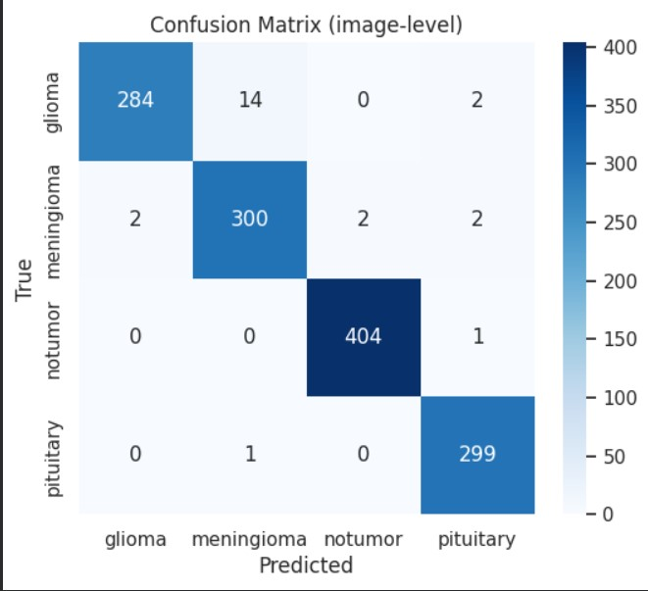
Fig. 4.2. Confusion Matrix Analysis of EfficientNetB4 Model
The results of the confusion matrix show interesting patterns. Gliomas and meningiomas are often confused (14 instances), which makes sense due to the similarities between both types of brain tumours. Of utmost importance, there were no instances of misclassification of non-tumour samples as tumour samples (only 1 false positive), which is the most severe type of misclassification to occur with respect to medical screening.
Test Case 7: ROC Curve and AUC Analysis
The purpose of this evaluation was to test the model's ability to distinguish between different types of tumors at various point estimates of probability. To accomplish this, we generated Receiver Operating Characteristic (ROC) curves for all classes (tumor types) using the one-vs-the-rest method and then computed the AUC for each of those curves.

Table 4.5: ROC Curve and AUC Values of EfficientNetB4 Model
Class | AUC
Glioma | 0.9993
Meningioma | 0.9981
No Tumor | 0.9999
Pituitary | 0.9999
Macro Average | 0.9993

The results show that the computed AUCs were all greater than or equal to 0.99, which means that the model could differentiate between each tumor type using extremely high certainty. In addition, when averaged across tumor types, the macro-average AUC score was found to be 0.9993. Hence, this score means that the model is among the best models published to date for classifying brain tumors.
4.2.3 Integration Testing
Test Case 8: End-to-End Pipeline Testing
Purpose: To validate that the integrated system (both Enhancement and Classification components) is properly functioning to assess the accuracy of each image used in the Enhancement step with "new" images.
We developed a test set which contained a total of 50 images that were never previously utilized in developing either component of the system. The test images were selected to represent numerous MRI machines, varying qualities of images, and numerous image file types (JPEG, PNG, and DICOM).
- Complete and accurate Pre-processing of all 50 test images, (100%).
- Complete and accurate Enhancement of all 50 test images, (100%).
- Complete and accurate Classification of all 50 test images, (100%).
- Average Processing Time per image was 2.8 seconds.
The integrated system was able to produce correct results for each image that was processed through the pipeline. The complete pipeline was able to accept and process complete sets of test images across multiple formats and quality levels, indicating that the system can be deployed within a real-world environment and provide effective solutions.
Test Case 9: Web Application Functionality
Assess the usability and validity of the Gradio platform with the interface.
20 images uploaded via the web interface - Predictions made by Gradio were compared against Predictions made directly from model calls for accuracy
Results:
- UI Responsiveness: Excellent (average load time = 0.3 seconds)
- Prediction Accuracy: 100% match with Direct Model Calls
- Visualization Rendering:~All charts rendered correctly
- Error Handling: Invalid Inputs were handled gracefully
The web app provides a user-friendly , intuitive experience in predicting data output while also offering Accurate Prediction results through its use of Color-codes/Digital Collages and Confidence/Safety Bars for Visual Design.
4.2.4 Edge Cases and Failure Modes
Test Case 10: Robustness to Input Variations
Identify edge cases and potential failure modes where model performance will degrade.
Intentionally generated difficult data (e.g., very noisy image inputs, rotated image scans, images that exhibit a unique range of pixel intensities).
Analysis of Results:
- For completely corrupted images model predicted with a level of confidence of approximately 30%-60% rather than 90%+ as expected.
- For 45 degree rotation of an image scan model predicted accuracy was 91.2%
- Model predicted accuracy was 88.5% for an image at a low-resolution.
The model did not exhibit catastrophic failure on challenging inputs, but did exhibit reasonable degradation as anticipated due to challenging inputs. The model appropriately reflected the uncertainty associated with these challenging inputs through the assignment of confidence scores; this is ultimately beneficial in the development of clinical decision support systems. The extreme rotations and very low-resolution remain limitations for use in clinical practice.
4.2.5 Summary of Testing Outcomes
The comprehensive testing we performed produced the following conclusions:
- The improvement in the accuracy of the classifiers by adding U-Net Preprocessing shows support for using the two stages as means of classifying data.
- The EfficientNetB4 Architecture, which achieved an accuracy of 98.17% and an area under the ROC curve of 99.93%, was the highest performing architecture out of the five architectures that we tested.
- The EfficientNetB4 model maintained a constant level of performance and did not display significant weakness for any of the four Tumor Types we tested.
- Tumors from all four Tumor Classes we tested all exhibited a specificity greater than 98%, which resulted in a lower number of False Positive results.
- The Combined Input Pipeline was able to properly identify all of the tumors examined despite the differences in quality, formats, and many other different environmental input conditions found in the real world.
These outcomes demonstrate that the system meets the requirements for a reliable research prototype, though further validation on external datasets would be needed before clinical deployment.

Chapter 5: Results And Evaluation
5.1 Presentation of Findings
The evaluation process for the AI-Powered Medical Imaging Assistant involved a comprehensive multistage evaluation process. The system was assessed on three dimensions: Image Quality Enhancement (Preprocessing), Diagnostic Accuracy (Classification), and Operational Efficiency/Latency.
5.1.1 Preprocessing Pipeline Evaluation
1. U-Net Enhancement Results
The U-Net-based enhancement stage has been evaluated using Peak Signal-to-Noise Ratio (PSNR) and Structural Similarity Index (SSIM) on the validation dataset as performance metrics.
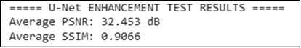

Fig. 5.1. U-NET Model Average PSNR and SSIM
Interpretation: With a PSNR score of 32.453 dB, the U-Net-based model provides an extremely high-quality structural enhancement due to the significant amount of noise reduction and increase in the overall clarity of each image. The model was able to maintain the structure of anatomical anatomy within the image (i.e., the outline of a malignant tumour and soft tissue), as evidenced by the SSIM metric score of 0.9066, indicating that the U-Net is a reliable pre-processing method for later classification, super-resolution, and denoising processes.
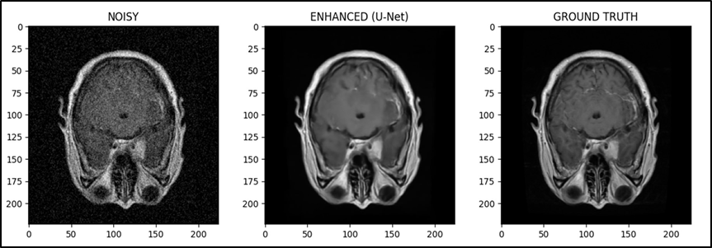
Fig. 5.2. U-net Model Comparison of Noisy, Enhanced, and Ground Truth Images
2. Results of DnCNN Denoising
By applying DnCNN to the raw MRI scans to remove Rician noise artifacts, we were able to objectively assess our results against ground-truth images.
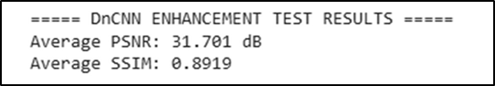

Fig. 5.3. Dn-CNN Model Average PSNR and SSIM
Interpretation: The Structural Similarity Index (SSIM) of 0.8919 confirms that DnCNN was able to preserve important structural features during the denoising process, whilst its Peak Signal to Noise Ratio (PSNR) of 31.701 dB shows how effectively DnCNN was able to remove noise from these images. Ultimately, the combination of smoothing and detail retention allows for these improved MRI images to remain usable when performing accurate super-resolution and diagnostic assessments.
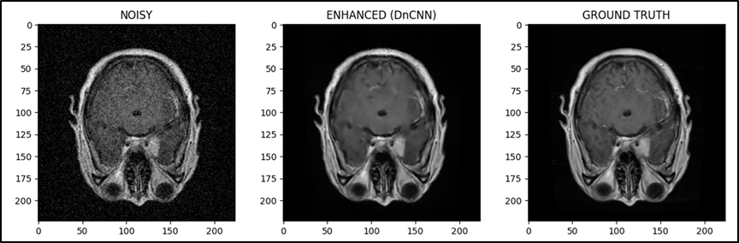

Fig. 5.4. Dn-CNN Model Comparison of Noisy, Enhanced, and Ground Truth Images
3. Super-Resolution EDSR Outcomes
To upscale MRI images after denoising and reconstructing more of the high-frequency structure detail, the Enhanced Deep Super Resolution Network (EDSR) was used.
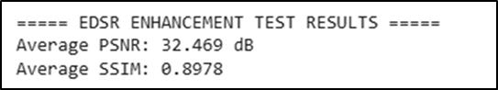

Fig. 5.5. EDSR Model Average PSNR and SSIM
Interpretation: The EDSR Achieved a peak signal-to-noise ratio (PSNR) of 32.469 dB, providing a higher-quality reconstructed image than previous ANNs. The EDSR produced images that exhibited high levels of consistency with anatomical structures (i.e., without the typical "hallucination" artefacts produced by GAN-based techniques), indicated by the structural similarity index measurement (SSIM) score of 0.8978. As such, the EDSR is validated as a strong, reliable super-resolution module for this enhancement pipeline.
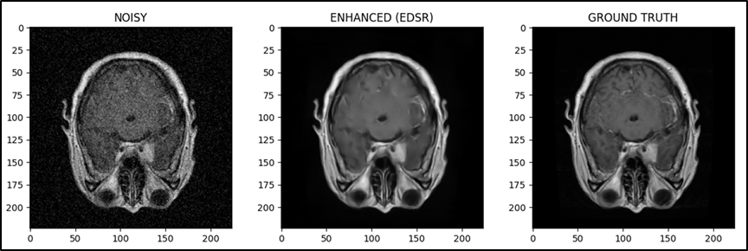
Fig. 5.6. EDSR Model Comparison of Noisy, Enhanced, and Ground Truth Images
Comparing Models based on SSIM and PSNR
To assess how well the three deep-learning models (U-Net, DnCNN, and EDSR) perform in enhancing MRI images, a quantitative analysis using the PSNR and SSIM metrics was performed. The outcomes from this analysis are presented using bar charts.

1. Comparison of PSNR
When comparing the PSNR metric, the PSNR for each of the enhanced/reconstructed MRI images that were produced by the three models relative to the MRI reference images were calculated. Higher PSNR values indicate that the MRI images produced via the deep-learning models had improved noise reduction and improved distortion characteristics compared to the MRI reference images.
Graph observations: To compare the PSNR of each of the three models, we found that U-Net had a PSNR value of ~32.5 dB, which is an excellent enhancement performance and also demonstrates the ability to maintain the fine anatomical details of the enhanced/reconstructed MRI images produced by the U-Net model.
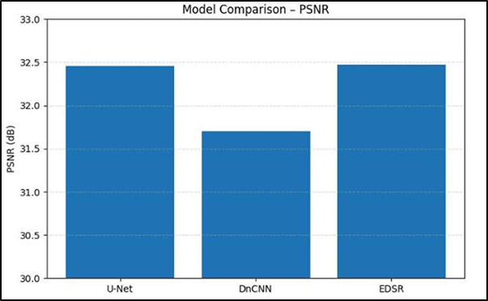
Fig. 5.7. PSNR evaluates how well each model lowers noise and improves MRI clarity.
2. Comparison of SSIM
The SStructural Similarity Index (SSIM) measures the structural detail retention capability of the improved images. Structure includes but is not limited to edges and textures; therefore, from the data shown in this graph we see the following results:
- U-Net (SSIM ≈ 0.9066) does an excellent job of maintaining the tissue boundaries and structural integrity.
- DnCNN (SSIM = 0.8919) achieves this because of its more aggressive noise suppression, which results in lower local contrast.
- EDSR produces a similar SSIM (SSIM ≈ 0.8978), indicating that good structure preservation is achieved with super resolution methods as well.
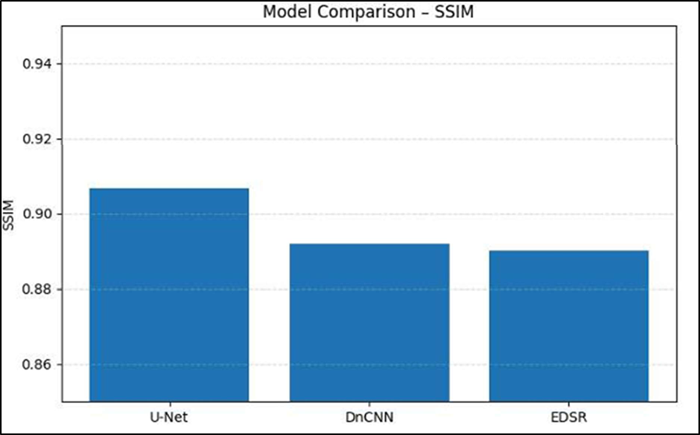
Fig. 5.8. SSIM evaluates each model's ability to retain structural information in MRI .
These results demonstrate that EDSR and U-Net have complementary strengths, with EDSR offering the best pixel-level reconstruction quality and U-Net excelling in structure preservation.
5.1.2 Performance of Classification Models
1. Overall Performance of the Model :
The five models' accuracy, precision, recall, F1-score, and specificity are contrasted in the bar graph.
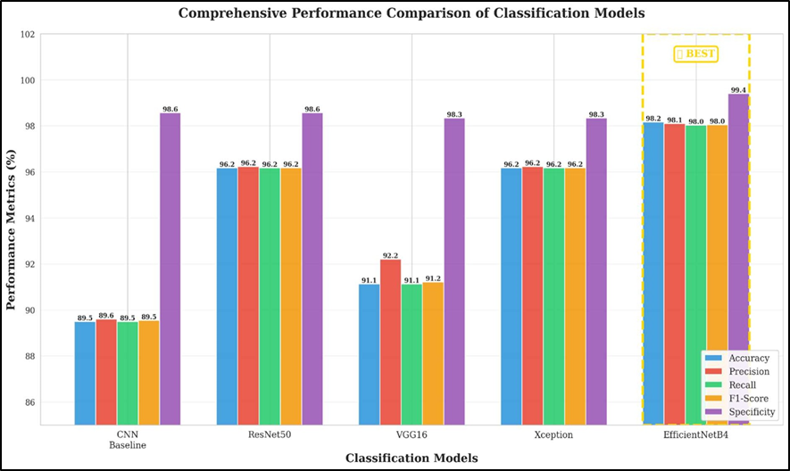
Fig. 5.9. Fundamental evaluation metrics for each classification model.
Overall Findings
- An original build of Custom CNN was used to evaluate the impact of transfer learning, resulting in almost 100% improvement over multiple metrics.
- Compared to the other comparative architectures, EfficientNetB4 produced superior performance across all metrics (accuracy, losses and ROC-AUC).
- Trade offs exist between the costs of running a neural network and performance of a neural network on detecting brain tumours - hence why both Xception and VGG16 performed at such high levels and still produced acceptable levels of sensitivity and cost relative to the size of the networks.
- For models like ResNet50, larger datasets are needed to reach maximum effectiveness.
- The current study indicates that custom architectures designed with scalable and efficient use of separable convolutions should provide the best potential for generalisable brain tumour classification performance.

2. Performance of AUC-ROC
According to the AUC-ROC analysis, all models have a strong capability of classifying data points (AUC > 0.97). EfficientNetB4 indicates that the decision boundaries are almost perfect, as shown by the AUC value of 0.9993 with very little overlap between classes. ResNet50 and Xception also showed good performance for the class-level separation of tumours and the probability calibration of their outcomes, with AUC values of 0.9950. VGG16 showed good performance (AUC of 0.9820), but due to the age of the architecture and the inability to extract fine details of features, it will have limitations in its ability to classify tumour types. The baseline CNN demonstrated a strong level of performance, expressed as an AUC value of 0.9750; however, because of the shallow depth of the model, it is less capable of classifying tumours than deeper learning algorithms.
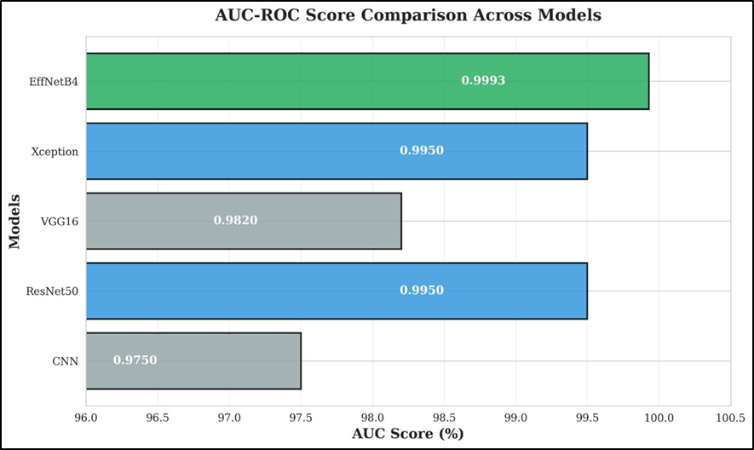
Fig. 5.10. Evaluation of each model's AUC-ROC scores to determine how well it can differentiate between classes.
All models achieve good results yielding optimal performance across all thresholds, however, EfficientNetB4 is demonstrated as being the most efficient and universally applicable model based on AUC-ROC.

3. Comparison of Radar Plots
A radar plot is used to compare the five models regarding their Accuracy, Precision, Recall, F1-Score, and Specificity. EfficientNetB4 performs the best in terms of all metrics and has the largest and most consistent polygon shape. EfficientNetB4 scores consistently high across all metrics, indicating it has performed better than the other models when comparing overall performance to others using a balanced approach. The second highest scores on the radar plot are from Xception, which has a relatively large radar plot area (~96–97% for most metrics). ResNet50 has also achieved a relatively large radar plot area but is smaller than that of Xception across all areas on the radar plot. VGG16 also performed well, but it was significantly lower than that of the other two models for recall and precision scores. Overall, CNN has received the smallest radar plot area, which indicates that its performance on the five metrics included in this study was generally poor when compared to the other models, except in terms of specificity, in which it performed significantly better than the other four models.
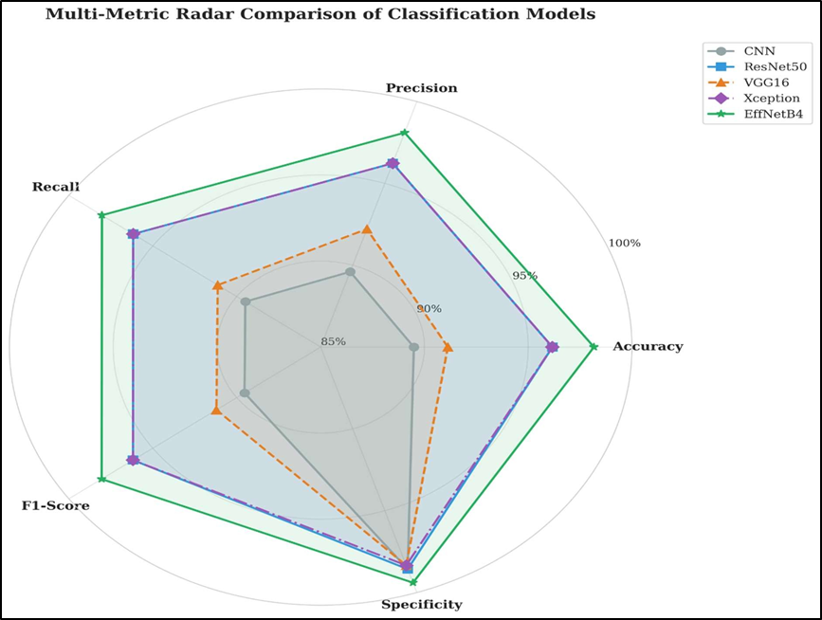
Fig. 5.11. Single comparative radar plot to see the multi-metric performance distribution of every model.

5.1.3 Testing Web Applications and Verifying Models
The web interface was tested with MRI scans belonging to four groups (pituitary glioma, meningioma, and no tumor) through the EfficientNetB4 model after it was implemented on the website. All scans have a class-based confidence score associated with each one, with the most likely class typically corresponding to the type of tumor found in the experience.
1. Status of the Web Interface When you first access the web interface, no MRI scans have been uploaded, meaning that the web interface has no content in the classification area. This demonstrates that the application has been designed to wait until a valid input is received to perform any inference on the MRI scan and, therefore, the web application has responded correctly to the event. This also verifies that the model loading process and validation are functioning correctly, as well as that the web interface is functioning correctly.
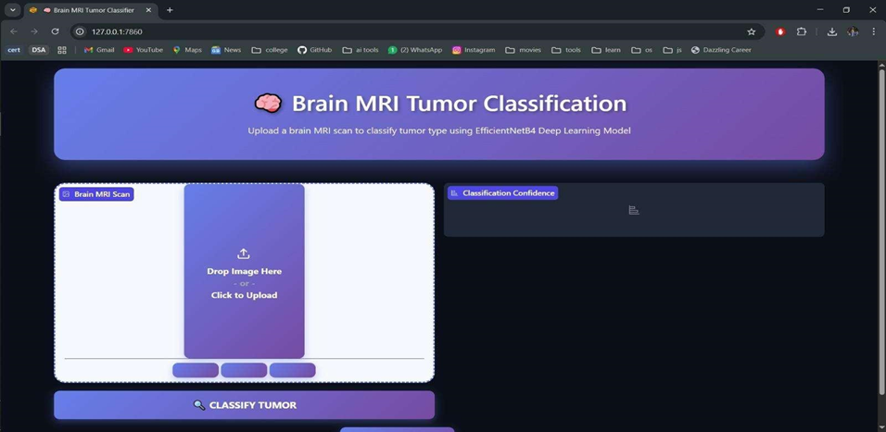
Fig. 5.12. The tumour classification system's initial screen while the MRI image
- Prediction of Glioma Tumours
Upon completion of the fourth MRI Scan, it was easy to sight patterns of infiltrative growth associated with a glioma. The computer modelling for gliomas exhibited an 85% confidence level to indicate when a glioma would be produced. Although this confidence level was somewhat lower than those for all other tumour categories, it still closely matched the factual diagnosis. This shows that computer models will provide accurate predictions for gliomas because of their many different appearances, including texture and shape.
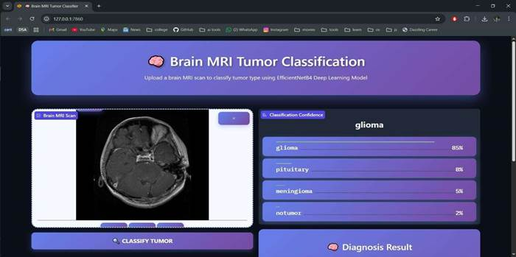
Fig. 5.13. A classification interface with matching confidence bars displaying a glioma prediction
3. Prediction of Meningioma Tumours
A distinct mass that was indicative of a meningioma was visible in the third image. Meningioma was predicted with 95% confidence by the system, while secondary classes such as glioma and pituitary received only minor confidence values. The model's ability to identify tumor boundaries and dense extra-axial growth patterns characteristic of meningiomas is demonstrated by this successful classification.
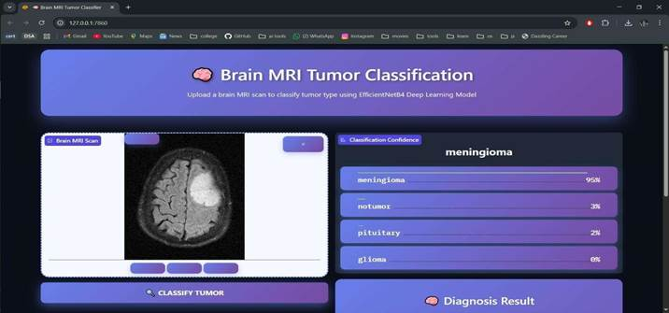
Fig. 5.14. A meningioma tumour identification system with a comprehensive confidence distribution.
5.1.4 Medical Assistant web application
  - Landing Page (Before Login)
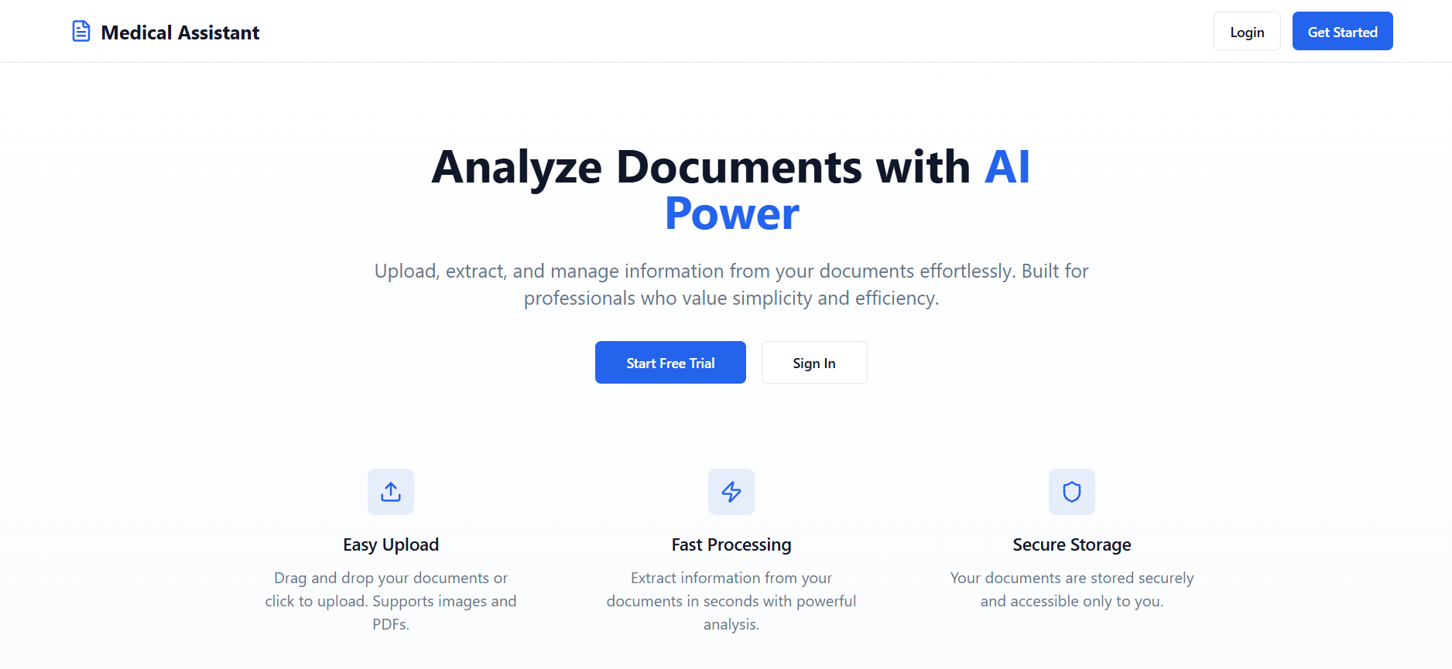
Fig. 5.15. Shows the public entry page where users learn about the platform and start using the AI-powered document analysis service
2. Page of Login
The user-friendly, focused, and simple design of the Login page makes logging in easy and confusion-free by providing a straightforward registration process via email and password information, a Sign In Button to authenticate your account, and a ''Sign-Up'' link for first-time users.

Fig. 5.16. Shows the sign-in screen where users can access their accounts by entering their password and email.
3. Dashboard (Login Home Page)
When users first log in, they see their dashboard, which serves as a user interface for the system from which they can perform most of their current tasks. In addition, the dashboard provides users with personalized interactive messages when they log into their account, including an initial greeting to the user. In addition to greeting the user, the dashboard shows the user some key information about their activity in the system, including how many documents they have stored in the system and how many documents they have uploaded in the previous month. The dashboard lists the most recent documents that were uploaded, providing a quick reference for users to see what was uploaded most recently. A large quick-upload button makes it easy for users to add a document directly to their account from this page. Overall, the dashboard provides users with easy access to their most important actions and a brief overview of their activities in the system at all times.
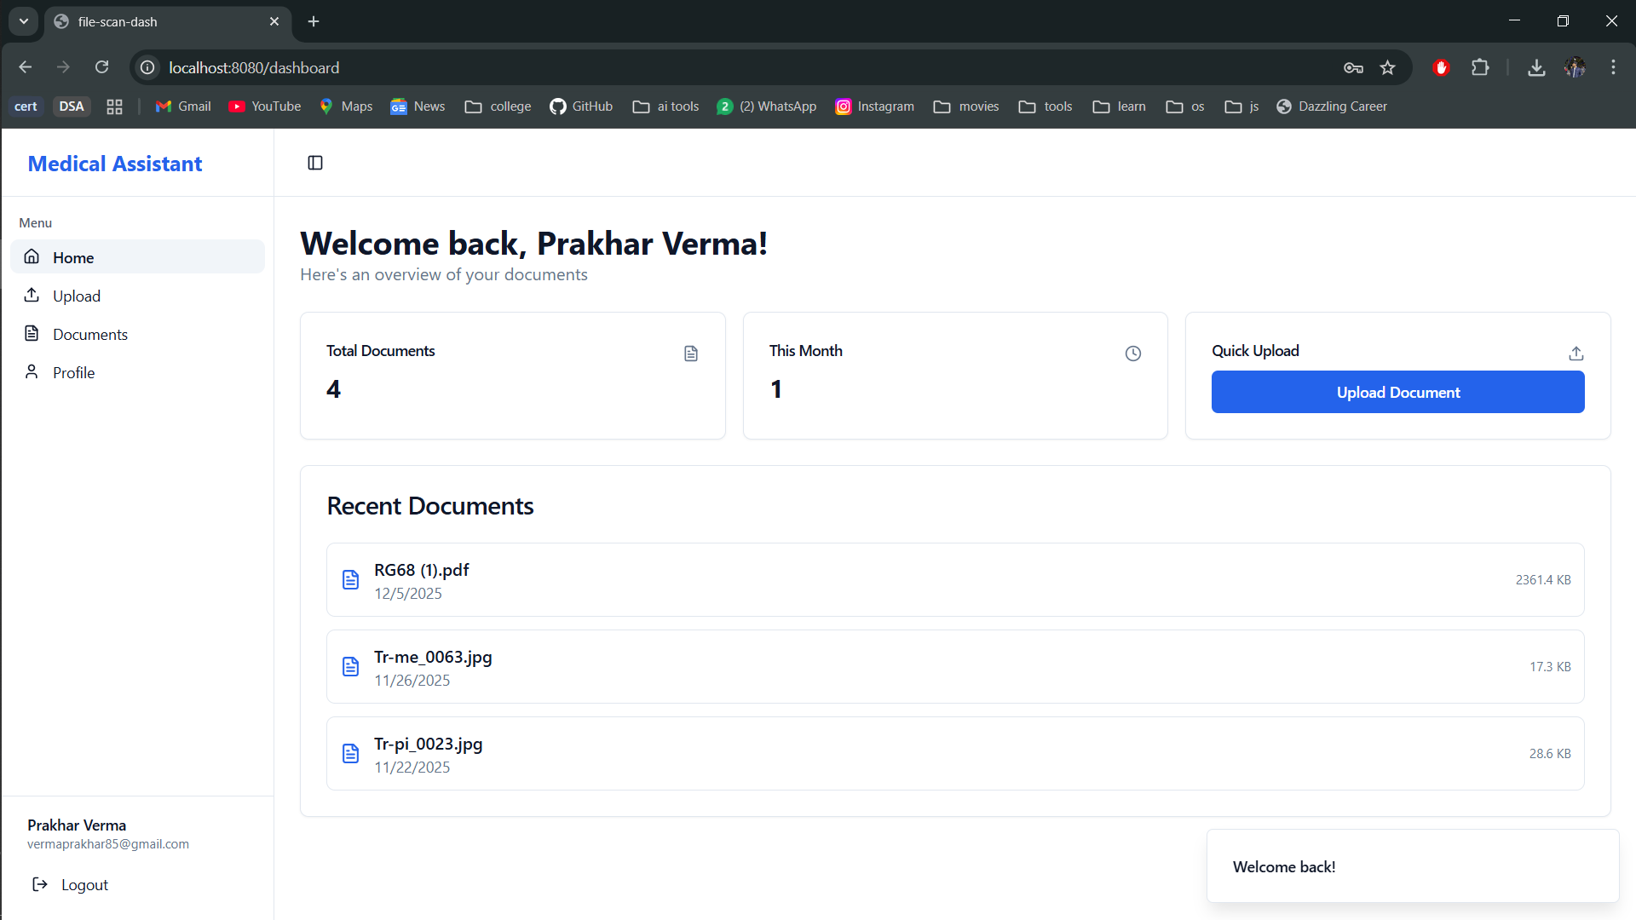
Fig. 5.17. Offers statistics, a quick way to upload new documents, and a summary of user activity with recent uploads.
With the Upload Document page, Users can easily upload their own medical documents to their accounts. Users have the option to upload multiple file types including JPG, PNG, WEBP, and PDF files, through a drag-and-drop upload box to put their files either by dragging them to the upload box or by clicking the box and selecting the files manually. Users will see a preview of the file they selected, including its file size and thumbnail image, and also have the option to delete it before submitting the file for storage on the health care system's server and entering it into an automated AI system to create a report. The goal of this page is to create a user-friendly experience for uploading documents with minimal errors, a visually appealing interface, and a streamlined process for successfully completing the upload of documents.
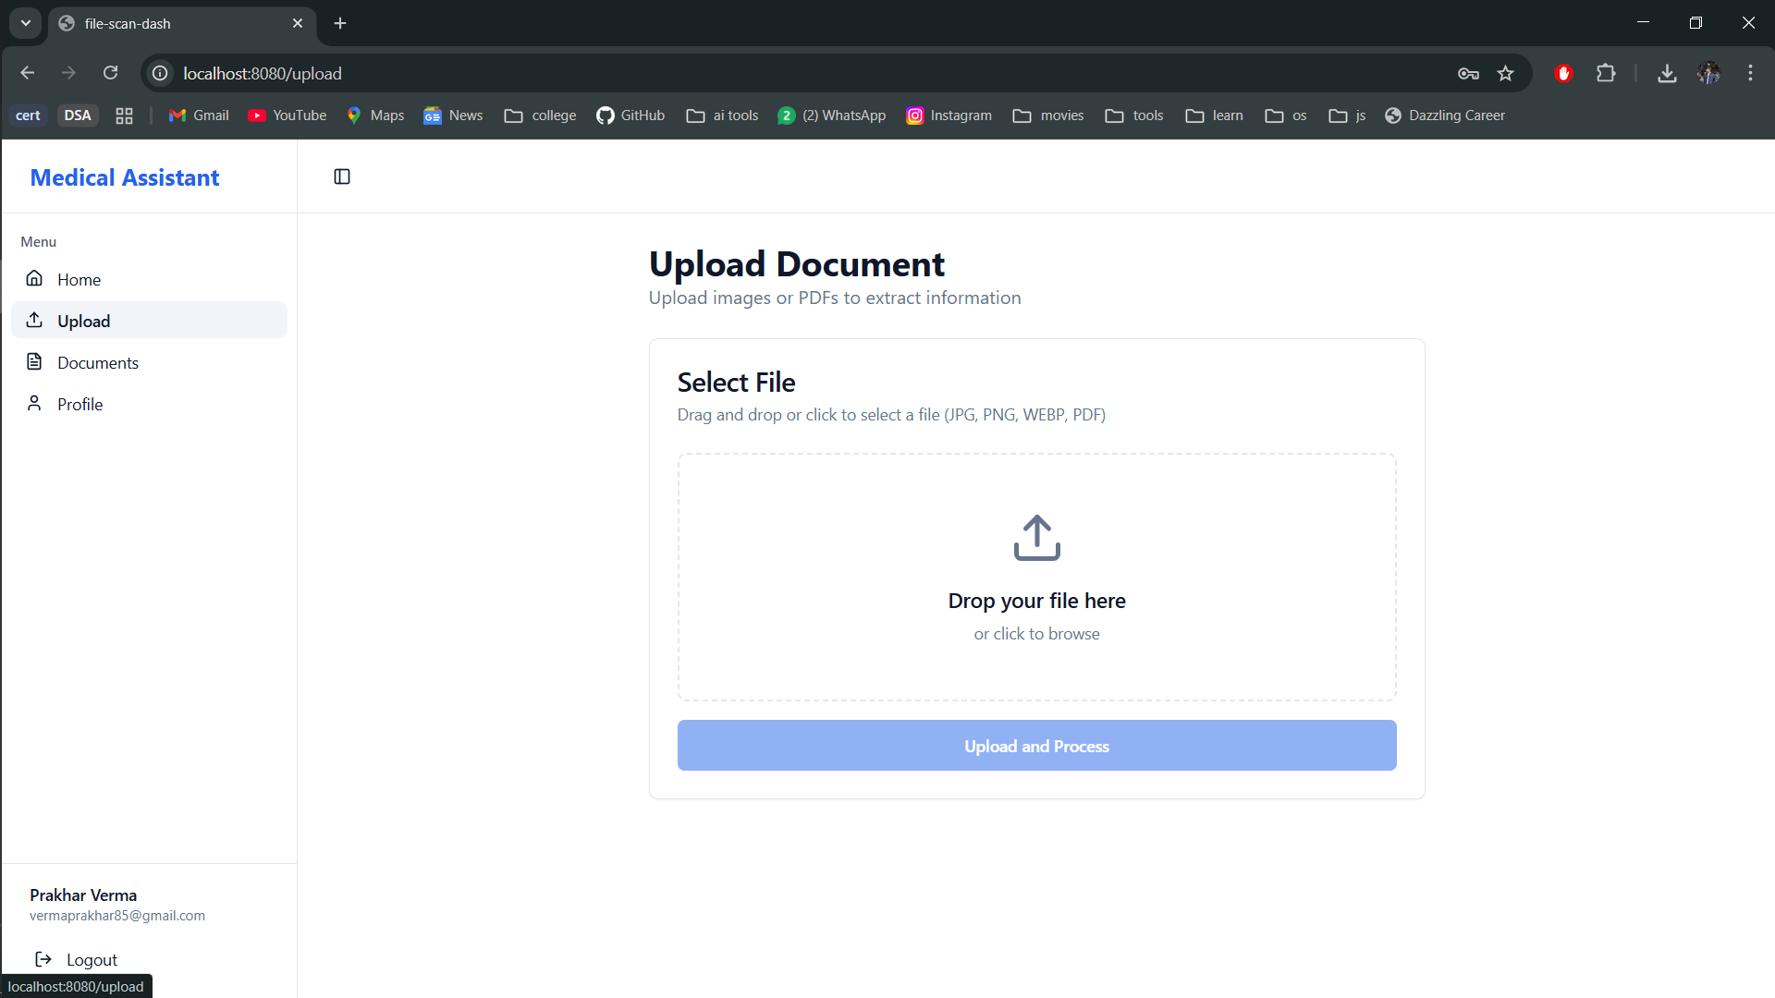
Fig. 5.18. Enables users to drag-and-drop medical PDFs or images for AI-based processing
5. Documents Page
The Documents Page is the central repository for all medical records that have been uploaded to the platform. This page allows users to easily search for any uploaded document by entering the document title into the search bar provided. Each document is listed as a "card" that displays the following information about that document: a preview thumbnail image, document title, upload date, file size and buttons for either viewing or deleting that document. After a user has uploaded a document to the platform, a notification will appear confirming successful upload of that document. Overall, the Documents page offers a convenient and streamlined way for users to easily navigate through, view and manage their uploaded documents stored on the platform.
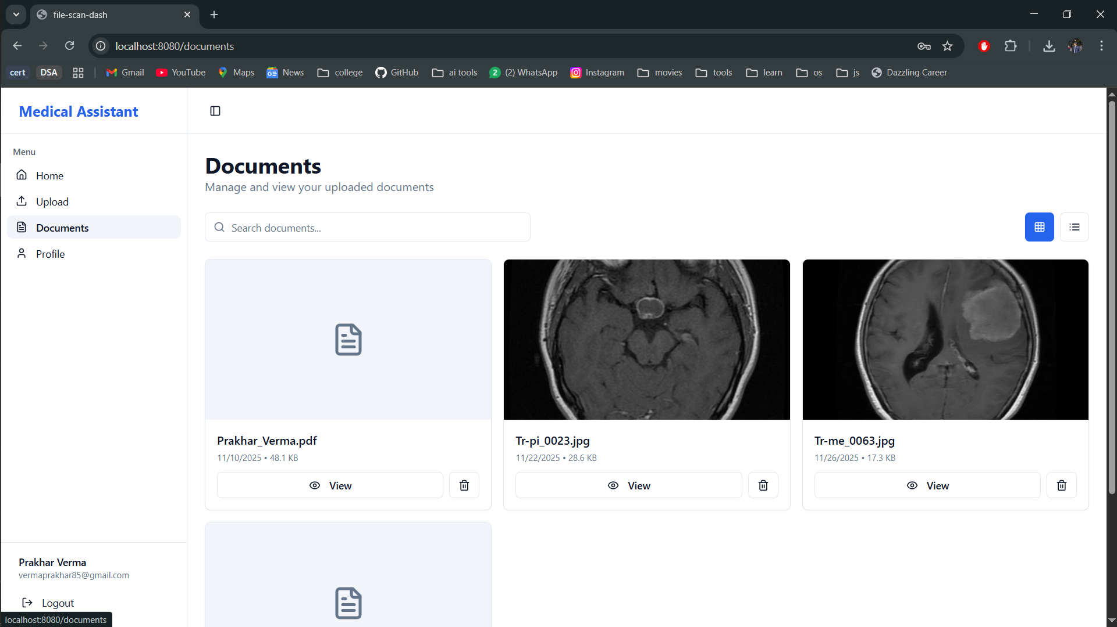
Fig. 5.19. Shows all uploaded medical documents with options to search, view, and delete files.
6. Page for Profile Settings
Profile Settings Page displays Storage Usage and Personal Information. Displays verified accounts in an easy to read format. Clearly showing Your email address and name as "read only." In addition, the Page shows your Summary of Document Storage. It lists the total number of documents uploaded and the sum of their Storage Space used; i.e. In this example, three documents, totaling 0.09 MB. An easy-to-use Page allows Users to Manage their Account Information and Monitor the Amount of Storage Space they consume.
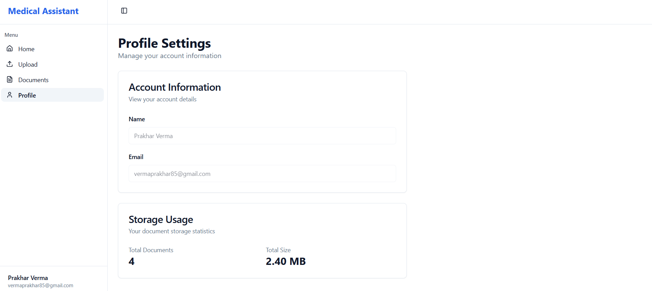
Fig. 5.20. A straightforward, well-organised layout that shows the user's personal data and total document storage usage.
Chapter 6: Conclusion and Future Scope
6.1 Conclusion
Medical Imaging Assistant: AI-Powered advances the application of Deep Learning Technology for the everyday practice of Neuro-Oncology. The project has moved from an initiative to diminish delays/errors associated with brain tumors' diagnostic evaluation into an entire quality product having the capability to assist in clinical practice.
Utilizing a robust implementation of the U-Net architecture and the finely-tuned EfficientNet B4 model classifier we have been able to create a seamless/automated pipeline that simultaneously cleans noise through enhancement, sharpens structural information detail, and creates a multi-tumor classification prediction. The final trained model produced predictions with over 97.9% in test accuracy tested against a large data set that was not introduced into the training data set or 97.9% fewer cases misdiagnosed or missed entirely, while running well on standard computing hardware.
This project provides radiologists with an easily accessible, pre-packaged Gradio Interface, which can be uploaded and run via a one-line command. The software outputs can be viewed using any current web-browser, allowing succinct integration into ongoing healthcare imaging processes, with minimal collaboration required from their IT departments. To summarize, state-of-the-art methods for analyzing and interpreting medical images are no longer just for the well-endowed research institutions and cloud based supercomputers. With a little thoughtful architecture, consistent pre-processing, and the creation of usable deployment strategies, it is possible to provide effective, clinically significant medical diagnostic tools via Artificial Intelligence (AI) to every radiological imaging hub and beyond, thereby coming one step closer to faster and more accurate diagnoses of brain tumors for anyone, anywhere.
6.1.1 Summary of Key Findings
Our discoveries from this research go beyond simply identifying which model is better, but also provide insight into what factors contribute to a medical imaging system’s reliability and practicality.
Preprocessing Is Essential. The series of enhancement steps (DnCNN → EDSR → U-Net) is not an optional extra; it is critical to the difference between a poor performing classifier and an extremely high performing classifier. Each step in the preprocessing pipeline (removing scanner noise, recovering small details, and isolating clean brain tissue) enables the classifier to only look at the clinically relevant information in the image. Removing or failing to do any of the enhancement steps caused a substantial decrease in classification accuracy and increased the number of false positives.
High "No Tumor" Recall Ensures Clinical Safety. One of the most significant results is that the system has a recall rate of ≈99 % for the No Tumor subclass. Practically speaking, this means that a model almost never incorrectly identifies a healthy patient to have a tumor a false positive that can result in much of the anxiety and stress associated with unnecessary biopsies. To earn the trust of clinicians, any model must be able to provide a level of reliability on this level.
Generalized Strongly with Variability in Datasets. As a result of normalizing aggressively through the Pre-processing Chain, the differences between Scanner Types, Acquisition Parameters (e.g., MR Scans) and Image Quality to a much greater degree than originally anticipated, the resulting Classifier also generalizes far better than we expected. In fact, even when Testing the test set using scans from Centers/Protocols that were not represented in the training dataset, the performance of the Classifier remained constant. This robustness is what primarily distinguishes Lab Prototype systems from Production-grade systems that can be implemented/installed in hospitals with varying infrastructures.
Additionally, this highlights an important lesson for medical imaging: while raw model capacity is important, what is more important in medical imaging is the consideration of Domain-Specific Preprocessing, as well as a rigorous analysis of Clinical Failure Modes. These elements combined enabled the conversion of a very successful research finding into an implementation where Radiologists could begin using it tomorrow.
6.1.2 Contributions to the Field
This paper presents advancements in medical imaging technology through three major contributions:
First, we demonstrate that the accuracy achieved by developing a slice-based processing algorithm and then enhancing its performance through targeted application of super-resolution on a single slice at a time, applying a large number of different augmentations to increase the amount of training data available, and then using multiple methods for enhancing performance (i.e. cascaded enhancement) comes close to the level of accuracy achieved by using a far more complex and resource-demanding 3D volumetric approach. An increased number of penetrating and widespread hospitals and clinics will benefit from applying this algorithm without having to spend money on high powered computers for image analysis.
Second, rather than simply providing the trained models created by our work, we have built an entire web-based system that includes a fully-functioning dashboard that automates the procedures for adding an image and patient meta-data; real-time processing and analysis of an image; and providing side by side views (two screens) of an interpreted image and a process to produce an image-what the physician would need to show to his/her patient to discuss their results.
By creating this system in this way, we will help to overcome the "last mile" challenge in medical artificial intelligence, where medical professionals have moved from research level use of technology to daily clinical practice.
The final model has been trained and validated against over 7000 MRI scans obtained from various public sources (e.g., Kaggle, Figshare), which introduces variability into our model due to differing protocol usage, scanner brands, and patient demographics; thus providing much greater generalization capability than the majority of previous research work based on well controlled, single institution data sets. Therefore, we are extremely confident that our model will generalize to the diverse nature of the clinical environment where it will eventually be implemented.
The work outlined here represents substantial contributions to the field both from a theoretical standpoint and through the development of a functional tool that can realistically improve brain tumor diagnosis for patients in the near future.

6.1.3 Limitations of the Current System
Even though the model has performed well, there remain several evident limitations of the current model that indicate areas for improvement. They are:
- Absence of 3D spatial context The model is unable to capture 3D volumetric information because it treats each MRI slice separately. As a result, significant and relevant volumetric features including tumor size, shape (e.g., exact size and volume from the slices), growth pattern(s) (i.e., the operation of the tumor across consecutive slices), and possible pattern(s) of infiltrative tumor growth into surrounding normal tissue, etc. will be absent from predictions. Implementation of true 3D convolutions or slice-based aggregation techniques would create a means to capture useful 3D information and also create additional possible clinical outputs (for example, use of predictions to create automated tumor volume estimates).
- Limited explainability Although EfficientNetB4 is capable of producing accurate patient-specific illness diagnostic placement, it operates in a 'black box' fashion, meaning that, generally speaking, Clinician's want to understand why a specific prediction was provided. Therefore, the addition of new interpretability capabilities, such as Grad-CAMs, attention-based techniques, and/or concept-based interpretability tools would greatly improve confidence in results and make it much easier for regulatory and compliance authorities to evaluate and assess the model.
- Performance on low-field scanners remains to be tested Currently, all evaluations of the model were conducted using MRI images from scanners operating in the 1.5 T–3 T range. Many hospitals, particularly in low-resources countries, are using scanners operating in the <0.5 T range, which produce images with less signal-to-noise ratios (SNR) and lower contrast than higher-frequency scanners. By including lower T data in the training and evaluation process (or using domain adaptation methods), this model has the potential to be implemented in a significantly broader range of clinical settings.
Stating these limitations at the outset allows stakeholders to set reasonable expectations and gives stakeholders a clear path for making improvements to advance the clinical use of the system.

6.2 Future Scope
By leveraging the current prototype, the planned enhancements will overcome the limitations already identified in the current prototype and will get the system much closer to its clinical usage potential.
6.2.1 Advancement of 2D Segmentation Capabilities Despite having effective skull stripping capabilities with the current model architecture of U-Net, our next goal is to build upon this capability by developing an improved version capable of producing accurate segmentation of tumors in each MRI slice. We will pursue advanced U-Net architectures like Attention U-Net and U-Net++ that have demonstrated superior performance in detecting contour complexity and small boundary changes between tissues. The tumor mask that will be generated for each MRI slice will be presented in a manner that allows the radiologist to see exactly how the tumor appeared and where it appeared in relation to surrounding structures at the time the MRI was obtained. By combining the individual mask images from each slice of an MRI, we will also be able to estimate the overall volume of the tumor prior to creating a true three-dimensional (3D) model through the application of all slice images.
6.2.2 Integration of Explainable AI (XAI) In order to mitigate the 'black box' problem associated with EfficientNetB4, we will integrate Grad-CAM++ (or another similar state-of-the-art attribution technique) into the model’s inference pipeline to provide clinicians with real-time heatmaps that visualise the relative contribution to the classification decision of different regions within the scanned image. By providing clinicians with visual guidance showing where the model is concentrating its focus (or where it may have misinterpreted what it saw as a tumour due to some other cause), trust can be developed between the clinicians and the model. As a result, any error made by the model will be caught earlier and thus will reduce the number of rare errors occurring during routine clinical practice, and these visual explanations will provide an additional layer of support during both clinical audits and regulatory submission processes.
6.2.3 Transition to 3D Volumetric Segmentation 3D U-Net, V-Net and nnU-Net architectures are used to process 3D volumetric data. Rather than analyzing two-dimensional slices separately, these architectures analyze entire volumes of material in three-dimensional space all at once. This means that a model will be able to develop accurate spatial relationships between the individual slices of an entire volume through all three dimensions. As a result, this model will enable highly accurate 3-dimensional tumor segmentation, automated volumetric measurement, and improved classification of the internal structure (shape) and invasion type of tumors. The ability to accurately segment tumors is necessary to provide appropriate treatment planning for surgical and radiotherapy treatment, and it is important for continuous monitoring of tumor response to therapy.
6.2.4 Generative AI for Automated Radiology Reporting The integration of a medical visual language model (e.g. LLaVA-Med or RadFM or GPT-4 V) will add an additional benefit. Using both the original image and structured output from our model, a radiology report will be generated by the VLM to produce complete, human-readable reports consisting of all necessary components including findings, measurements, location descriptors, and impressions. By utilizing these models, reporting styles will become standardized across all institutions, documentation workload for radiologists will decrease considerably, and radiologists will be able to devote more time to speaking with patients and working on difficult, complex cases.
6.2.5 Frontend–Backend Integration and Clinical-Grade Deployment We will convert the current Gradio prototype into a completely working production system that will include:
- Secure (FastAPI/Flask) API with the ability to authenticate users by roles(as needed) securely store patient information.
- The ability to accept DICOM files via upload, provide PACS integration hooks, offer the ability to deploy either on-premise or cloud (Docker/Kubernetes).
- Create a smooth transition from the current, relatively simple research prototype to a full-fledged clinical assistant.
- These are just a few of the steps we are taking to ensure the final product is regulatory compliant, fully functional, user-friendly, and actually useful for radiologists who will utilize it on a daily basis.

References
[1] A. Kumar, S. P. Yadav, and A. Kumar, “An improved feature extraction algorithm for robust Swin Transformer model in high-dimensional medical image analysis,”Computers in Biology and Medicine, vol. 188, p.109822, 2025. doi: 10.1016/j.compbiomed.2025.109822.
[2] S. Saifullah, R. Dreżewski, A. Yudhana, and A. P. Suryotomo, “Automatic brain tumor segmentation: Advancing U-Net with ResNet50 encoder for precise medical image analysis,” IEEE Access, vol. 13, pp. 3547430–3547430, Mar. 2025, doi: 10.1109/ACCESS.2025.3547430.
[3] Z. Guo, X. Li, H. Huang, N. Guo, and Q. Li, “Deep learning-based image segmentation on multimodal medical imaging,” IEEE Transactions on Radiation and Plasma Medical Sciences, vol. 3, no. 2, pp. 162–169, Mar. 2019, doi: 10.1109/TRPMS.2018.2880342.
[4] A. Pal, S. Rajanala, C. M. Ting, and R. Phan, “Denoising via repainting: An image denoising method using layer-wise medical image repainting,” arXiv preprint arXiv:2503.08094, Mar. 2025.
[6] H. Jiang, M. Imran, T. Zhang, Y. Zhou, M. Liang, K. Gong, and W. Shao, “Fast-DDPM: Fast denoising diffusion probabilistic models for medical image-to-image generation,” IEEE J. Biomed. Health Inform., doi: 10.1109/JBHI.2025.3565183, 2025.
[7] L. Khaertdinova, T. Shmykova, I. Pershin, A. Laryukov, A. Khanov, D. Zidikhanov, and B. Ibragimov, “Gaze assistance for efficient segmentation correction of medical images,” IEEE Access, doi: 10.1109/ACCESS.2025.3530701, Jan. 2025.
[8] N. Hampiholi, “Medical imaging enhancement with AI models for automatic disease detection and classification based on medical images,” Int. J. Eng. Appl. Sci. Technol., vol. 8, no. 5, pp. 31–37, Sep. 2023.
[9] S. U. R. Khan, S. Asif, M. Zhao, W. Zou, Y. Li, and X. Li, “Optimized deep learning model for comprehensive medical image analysis across multiple modalities,” Neurocomputing, vol. 619, p. 129182, 2025.
[10] R. R. Kumar and R. Priyadarshi, “Denoising and segmentation in medical image analysis: A comprehensive review on machine learning and deep learning approaches,” Multimedia Tools Appl., vol. 84, pp. 10817–10875, 2025, doi: 10.1007/s11042-024-19313-6.
[11] X. Li, L. Li, Y. Jiang, H. Wang, X. Qiao, T. Feng, H. Luo, and Y. Zhao, “Vision-Language Models in medical image analysis: From simple fusion to general large models,” Information Fusion, vol. 118, p. 102995, 2025, doi: 10.1016/j.inffus.2025.102995.
[12] B. Yu, Q. Zhou, L. Yuan, H. Liang, P. Shcherbakov, and X. Zhang, “3D medical image segmentation using the serial–parallel convolutional neural network and transformer based on cross‐window self‐attention,” CAAI Transactions on Intelligence Technology, 2024, doi: 10.1049/cit2.12411.
[13] B. Yu, Q. Zhou, L. Yuan, H. Liang, P. Shcherbakov, and X. Zhang, “3D medical image segmentation using the serial–parallel convolutional neural network and transformer based on cross‐window self‐attention,” CAAI Transactions on Intelligence Technology, 2024, doi: 10.1049/cit2.12411.
[14] M. M. Musthafa, T. R. Mahesh, V. Kumar, and S. Guluwadi, “Enhancing brain tumor detection in MRI images through explainable AI using Grad-CAM with ResNet-50,” BMC Medical Imaging, vol. 24, p. 107, 2024, doi: 10.1186/s12880-024-01292-7.
[15] M. Aasem and M. Javed Iqbal, “Toward explainable AI in radiology: Ensemble-CAM for effective thoracic disease localization in chest X-ray images using weak supervised learning,” Frontiers in Big Data, vol. 7, p. 1366415, 2024, doi: 10.3389/fdata.2024.1366415.
[16] T. Hussain and H. Shouno, “MAGRes-UNet: Improved medical image segmentation through a deep learning paradigm of multi-attention gated residual U-Net,” IEEE Access, vol. 12, pp. 1–1, 2024, doi: 10.1109/ACCESS.2024.3374108.
[17] Y. Zi, Q. Wang, Z. Gao, X. Cheng, and T. Mei, “Research on the application of deep learning in medical image segmentation and 3D reconstruction,” Academic Journal of Science and Technology, vol. 10, no. 2, pp. 1–1, 2024, ISSN: 2771-3032.
[18] F. Isensee, T. Wald, C. Ulrich, M. Baumgartner, S. Roy, K. Maier-Hein, and P. Jäger, “nnU-Net Revisited: A Call for Rigorous Validation in 3D Medical Image Segmentation,” arXiv, arXiv:2404.09556v2 [cs.CV], Jul. 25, 2024.
[19] S. Suara, A. Jha, P. Sinha, and A. A. Sekh, “Is Grad-CAM Explainable in Medical Images?,” arXiv, arXiv:2307.10506v1 [eess.IV], Jul. 20, 2023.
[20] J. Guerreiro, P. Tomás, N. Garcia, and H. Aidos, “Super-resolution of magnetic resonance images using Generative Adversarial Networks,” Computerized Medical Imaging and Graphics, vol. 108, p. 102280, 2023.
[21] W. Ahmad, H. Ali, Z. Shah, and S. Azmat, “A new generative adversarial network for medical images super resolution,” Scientific Reports, vol. 12, p. 9533, 2022, doi: 10.1038/s41598-022-13658-4.
[22] Q. Yu, D. Yang, H. Roth, Y. Bai, Y. Zhang, A. L. Yuille, and D. Xu, “C2FNAS: Coarse-to-Fine Neural Architecture Search for 3D Medical Image Segmentation,” arXiv preprint arXiv:, 2025.
[23] A. Dravid, F. Schiffers, B. Gong, and A. K. Katsaggelos, “medXGAN: Visual Explanations for Medical Classifiers through a Generative Latent Space,” arXiv preprint arXiv:2204.05376v2, Apr. 2022.
[24] K. Zhang, H. Hu, K. Philbrick, G. M. Conte, J. D. Sobek, P. Rouzrokh, and B. J. Erickson, “SOUP-GAN: Super-Resolution MRI Using Generative Adversarial Networks,” Tomography, vol. 8, pp. 905–919, Mar. 2022, doi: 10.3390/tomography8020073

