Technical Design Document
AI-Assisted Procurement SOP Governance Platform
Start-small architecture, implementation design, and infra budget estimate

Dokumen ini menerjemahkan blueprint dan board deck yang sudah disetujui menjadi rancangan teknis untuk fase MVP dan pilot. Fokus desain adalah start small: menggunakan Next.js full-stack di Vercel sebagai application layer, dengan database, object storage, AI, OCR/conversion, email, dan integrasi sebagai managed/external services. Dengan begini kita bisa launch lebih cepat tanpa langsung membangun arsitektur enterprise yang kebanyakan upacara, karena rupanya aplikasi belum jadi tapi diagram sudah bisa bikin pusing duluan.
Item | Isi
Version | v1.0 - Technical planning draft
Scope | MVP 3 bulan + pilot growth 12 bulan
Audience | Corporate Compliance, IT, PMO, Engineering, Procurement Governance stakeholders
Exclusion | Manpower cost, procurement discount, legal/security assessment quotation
Currency assumption | USD to IDR rounded at Rp18,100/USD for planning

1. Executive Technical Summary
Untuk fase awal, platform tidak perlu dipisah menjadi frontend dan backend terpisah. Rekomendasi teknis adalah modular full-stack Next.js di Vercel. Next.js menangani UI, route handlers/API ringan, server actions, RBAC, webhook receiver, orchestration ke AI/provider eksternal, dan penyimpanan hasil ke database. Proses berat seperti document conversion, OCR, dan long-running AI analysis tidak dijalankan sebagai proses berat di Next.js; Next.js hanya mengirim request ke service eksternal dan menyimpan hasil final.
- Application layer: Next.js full-stack, one repository, deployed to Vercel.
- Database: managed PostgreSQL untuk metadata, workflow, validation, action item, dan audit log.
- Object storage: S3-compatible storage untuk SOP, regulasi, evidence, dan versi dokumen.
- Document conversion: Gotenberg API/container untuk konversi Office/HTML/Markdown ke PDF bila diperlukan.
- OCR/document intelligence: optional, hanya untuk scanned PDF atau dokumen yang tidak bisa diekstrak teksnya secara normal.
- AI analysis: provider eksternal/third-party, hasil disimpan sebagai structured output ke database melalui callback/webhook atau polling.
- ClickUp/Jira: bukan agenda baru; hanya execution integration untuk action yang sudah tervalidasi jika dibutuhkan.
2. Guiding Decision: Modular Monolith First
Keputusan arsitektur yang direkomendasikan adalah Modular Monolith First. Artinya satu aplikasi utama, satu repo, satu deployment utama, tetapi struktur kode tetap dipisahkan per domain module agar mudah dipelihara dan siap dipecah di masa depan bila volume dan kompleksitas memang menuntut.

Area | Decision | Reason
Frontend & backend ringan | Digabung di Next.js | Mempercepat delivery MVP, lebih sedikit repo/deployment, cocok untuk start small
Heavy processing | Delegasikan ke external/managed service | Menghindari timeout dan beban berlebih di Vercel Functions
Database & file | External managed service | Data persistence tidak bergantung ke runtime Vercel
AI analysis | External provider + structured result storage | Lebih cepat, tidak perlu membangun AI worker kompleks di MVP
Background job kompleks | Tidak masuk MVP | Tidak ada di BRD saat ini, cukup disiapkan sebagai future consideration

3. MVP Scope Mapping
Capability | MVP Implementation | Notes
Procurement Governance Hub | Homepage dashboard in Next.js | Hero carousel, announcement, quick action, document center, task awareness
SOP Repository | CRUD SOP metadata + file upload to object storage | Includes BU, PIC, language, status, current version
SOP Request | Request form + AI-assisted template drafting | New SOP/template request can start from BU
SOP Refinement | Call AI provider with draft/current SOP + preferred reference layer | Output: gap, recommendation, evidence, fraud indicator, spending analysis note
Validation & Approval | Reviewer queue + approve/reject/request revision | Human-in-the-loop is mandatory
Repository Publishing | Approved SOP becomes new SOP or new version | Version history is mandatory
Monitoring & Follow-up | Basic action item, owner, due date, status, reminder | ClickUp/Jira integration optional in MVP
Executive Intelligence | Basic dashboard and copilot Q&A based on portal data | Context-bound AI only

4. Recommended MVP Architecture
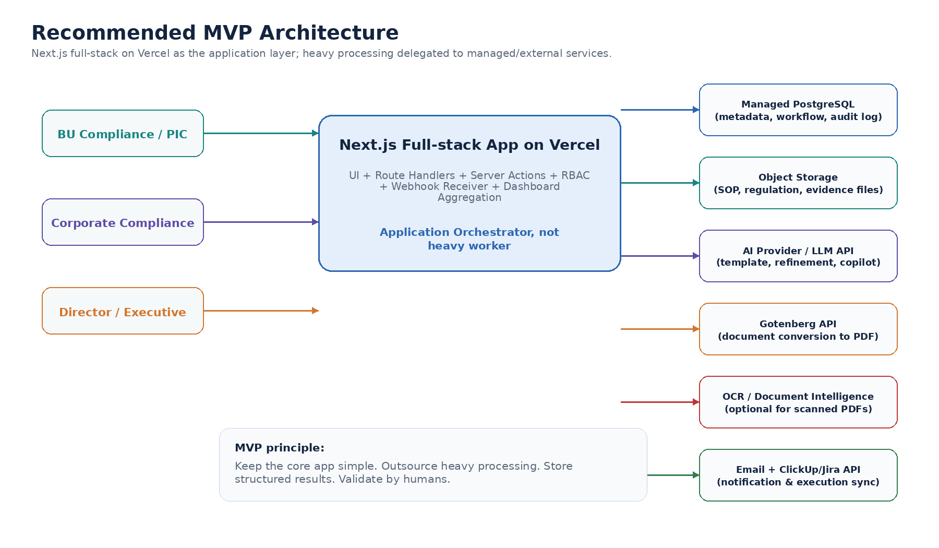
Diagram di atas menunjukkan Next.js sebagai application orchestrator. Ini penting: Next.js bukan tempat memaksa OCR besar, scraping, atau long-running AI analysis. Next.js mengatur request, akses, validasi, webhook, dan persistence; proses berat dipindahkan ke provider/service yang memang dibuat untuk itu.
5. Application Structure
Walaupun frontend dan backend dijadikan satu aplikasi, struktur kode harus modular. Kalau tidak, dalam 2 bulan repo akan berubah menjadi gudang kabel kusut yang hanya bisa disentuh oleh developer yang paling berani.
Folder / Module | Purpose
/app | Next.js app routes, pages, layouts, route handlers
/components | Reusable UI components
/modules/sop | SOP repository domain logic
/modules/request | SOP request and template generation logic
/modules/refinement | AI refinement orchestration and result mapping
/modules/validation | Validation workflow and decision logic
/modules/action | Action item, owner, due date, notification
/modules/dashboard | Dashboard aggregation and metrics
/server/db | Database client and query layer
/server/auth | Authentication, RBAC, session logic
/server/storage | Object storage adapter
/server/ai | AI provider adapter
/server/integrations | Gotenberg, OCR, email, ClickUp/Jira adapters
/lib | Shared utilities, constants, validation schemas

6. SOP Refinement Technical Flow
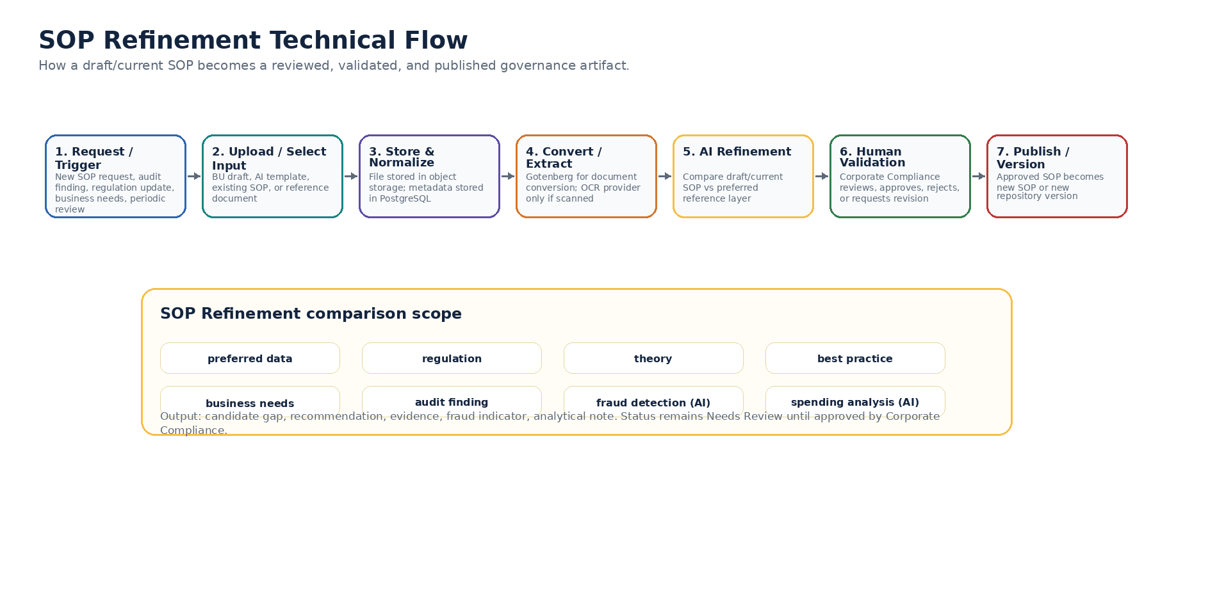
SOP Refinement adalah langkah analisis utama. Input-nya bisa berupa draft SOP baru, AI-generated template, atau current SOP dari repository. Proses membandingkan draft/current SOP terhadap preferred data, regulation, theory, best practice, business needs, audit finding, fraud detection (AI), dan spending analysis (AI). Output AI tidak otomatis resmi; status awalnya Needs Review sampai Corporate Compliance melakukan validasi.
Untuk MVP, proses AI dan pemrosesan dokumen berat tidak dijalankan langsung di server aplikasi. Aplikasi Next.js berperan sebagai orchestration layer yang mengirim konten SOP dan reference source ke managed AI/document service, menerima hasil analisis dalam format terstruktur, menyimpannya ke database, dan menampilkannya untuk validasi manusia.
7. External Processing Strategy
Processing Type | Recommended Approach | MVP Notes
Document conversion | Gotenberg API/container | Cocok untuk Office/HTML/Markdown to PDF. Bukan OCR utama.
Text extraction | Basic PDF/DOCX extraction first | Jika dokumen born-digital, cukup extraction standar.
OCR scanned PDF | Textract/Azure/Google/OCR provider optional | Hanya aktif bila scanned document muncul dalam pilot.
AI template drafting | LLM API call from Next.js | Store generated draft as request artifact.
AI SOP Refinement | Provider-side long-running analysis if needed | Next.js create job, provider callback/polling, store structured result.
Regulatory monitoring | Not in MVP core | Can be external service later; MVP starts with manual reference upload.
ClickUp/Jira sync | Optional integration | Create task only from validated action item.

8. API & Route Handler Design
Route | Method | Purpose
/api/sops | GET/POST | List/create SOP metadata
/api/sops/[id] | GET/PATCH | Read/update SOP detail
/api/sops/[id]/versions | GET/POST | Manage SOP version history
/api/requests | GET/POST | Create and track SOP requests
/api/references | GET/POST | Upload/list preferred reference sources
/api/refinement/jobs | POST | Start SOP Refinement job
/api/refinement/jobs/[id] | GET | Check refinement status/result
/api/webhooks/ai-result | POST | Receive AI provider result callback
/api/validation/queue | GET | Reviewer queue for findings
/api/validation/[findingId] | POST | Validate/reject/request revision
/api/actions | GET/POST | Create and track action item
/api/dashboard/summary | GET | Dashboard KPIs and executive summary
/api/copilot | POST | Context-bound Q&A
/api/integrations/clickup | POST | Optional task creation/sync
/api/notifications/email | POST | Send email/reminder

9. Logical Data Model
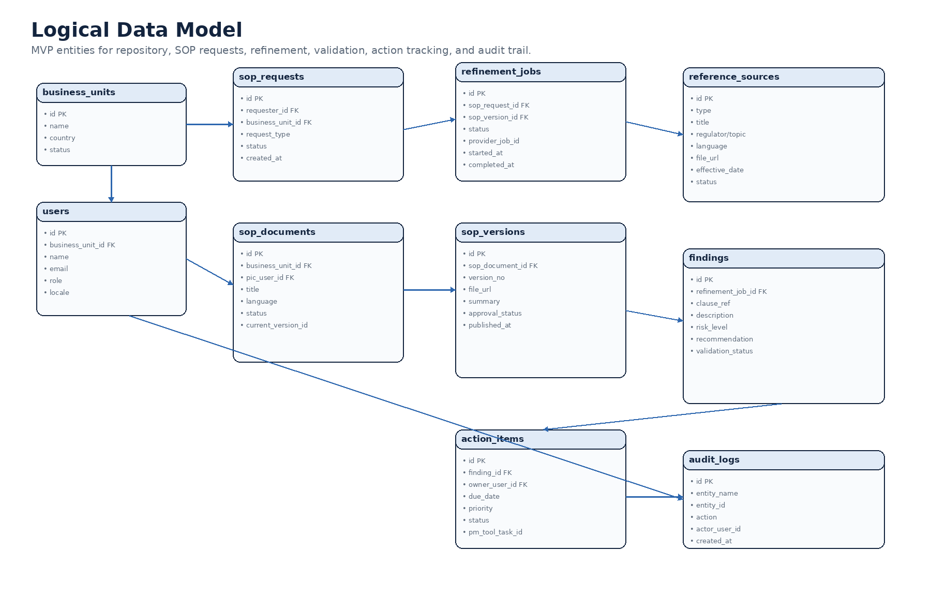
Database utama disarankan PostgreSQL. File fisik tidak disimpan di database, tetapi di object storage. Database menyimpan metadata, pointer file URL/path, status workflow, validation result, action item, dan audit log.
10. Core Database Tables
Table | Purpose | Key Fields
business_units | Master business unit/entity | id, name, country, status
users | User and role mapping | id, business_unit_id, name, email, role, locale
sop_requests | New SOP/template/revision request | id, requester_id, request_type, status
sop_documents | SOP master record | id, business_unit_id, pic_user_id, title, language, status
sop_versions | Versioned SOP files | id, sop_document_id, version_no, file_url, approval_status
reference_sources | Preferred reference layer | id, type, title, regulator/topic, file_url, effective_date
refinement_jobs | AI analysis orchestration | id, sop_request_id, sop_version_id, status, provider_job_id
findings | Candidate/validated findings | id, refinement_job_id, description, risk_level, validation_status
action_items | Follow-up tracking | id, finding_id, owner_user_id, due_date, priority, status
audit_logs | Immutable/append-only trail | id, entity_name, entity_id, action, actor_user_id, created_at
chat_sessions | Copilot logs and QA visibility | id, user_id, question, answer_summary, created_at

11. Security, Access Control, and Audit Trail
- Role-based access control: BU PIC, Corporate Compliance Reviewer, Corporate Compliance Admin, Director/Executive, IT Admin.
- Business unit scoping: BU users can only view/update SOPs and actions relevant to their BU unless granted broader access.
- All validation decisions must write audit log: who, when, what decision, source finding, comment/reason.
- AI outputs must not overwrite official data directly. AI outputs are drafts/candidates until validated.
- Uploaded files should use signed URL or protected access pattern, not public bucket exposure.
- Secrets for AI, email, storage, and PM tools must be stored in environment secret manager, not code.
12. AI Guardrails Implementation
Guardrail | Implementation
Context-bound response | Copilot receives only approved portal context and retrieved source snippets
Evidence-based output | Refinement result schema requires source/reference, finding text, recommendation, risk, evidence
Human approval mandatory | System blocks publish/action conversion until finding is validated
No silent automation | AI cannot approve, close, or change official status by itself
Logged prompts/results | Store prompt version, model/provider, timestamp, job ID, and output summary
Fallback behavior | If data not available, AI must say data is not available rather than inventing

13. Deployment & Environment Model
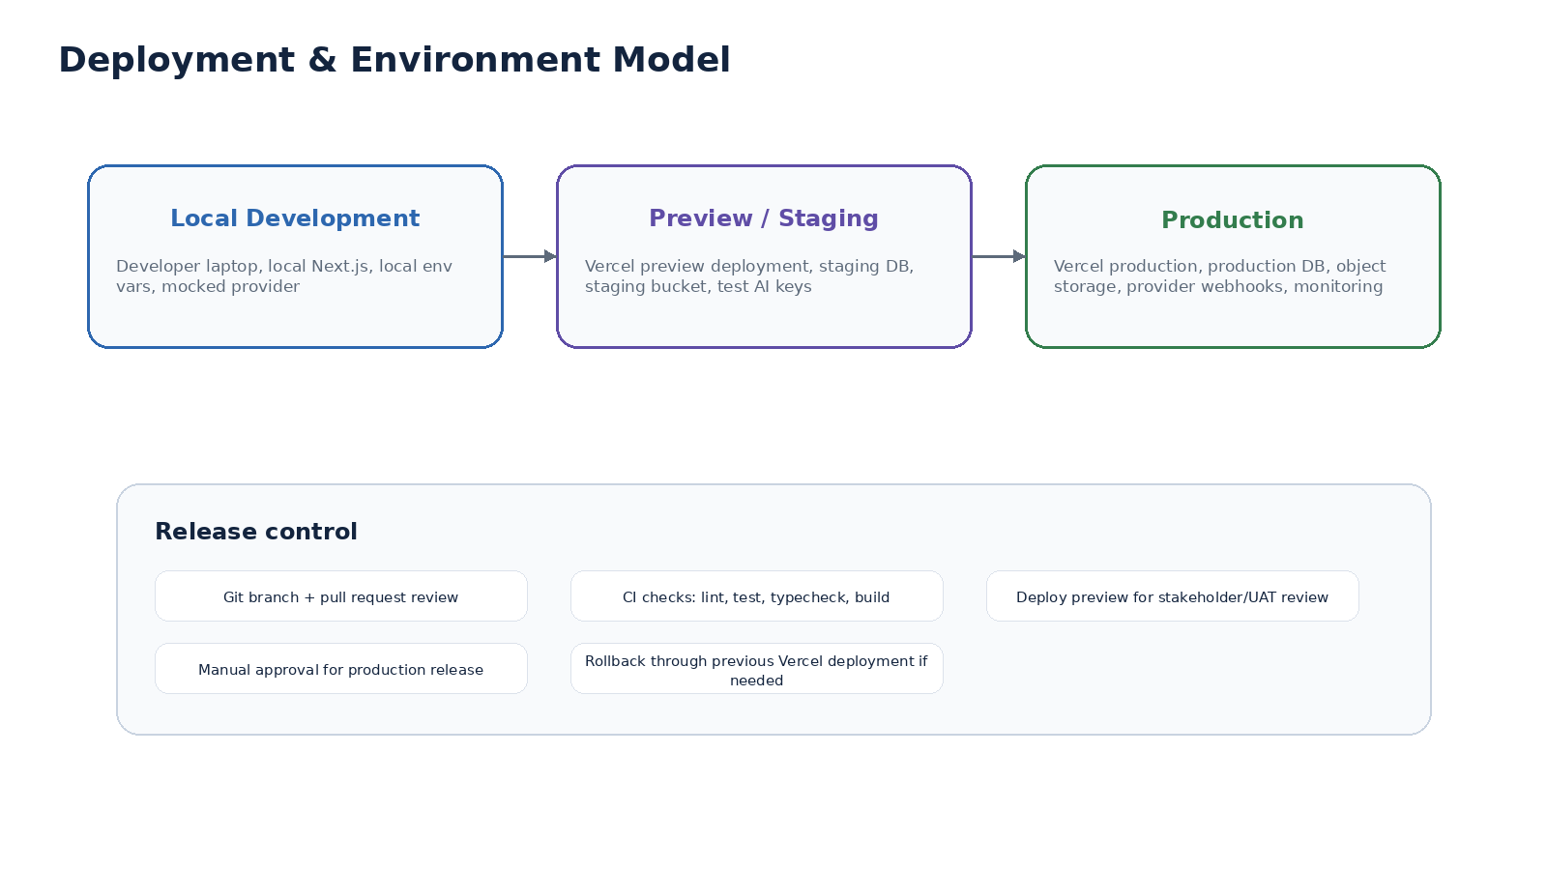
14. CI/CD & Operational Controls
- Use Git-based workflow with pull request review before merge to main.
- Every pull request deploys to Vercel Preview for user/stakeholder review.
- Run automated checks: lint, typecheck, unit test, build test.
- Use separate environment variables for development, staging, and production.
- Production release should be manual-approved during MVP/pilot.
- Rollback strategy: revert to previous stable Vercel deployment.
15. Recommended Tech Stack
Area | Recommended for MVP | Reason
Web application | Next.js full-stack | Fast delivery, UI + backend route handlers in one app
Hosting | Vercel Pro | Fast deploy, preview environments, CDN, serverless functions
Database | Supabase PostgreSQL / Neon / managed Postgres | Managed DB, fast setup, standard SQL
ORM/query | Prisma or Drizzle | Typed schema and migrations
Object storage | Cloudflare R2 / S3-compatible storage | Low-cost document storage, external persistence
Document conversion | Gotenberg container/API | Office/HTML/Markdown to PDF conversion
OCR | AWS Textract / Azure DI / Google Document AI optional | Only for scanned PDF or complex extraction
AI provider | OpenAI / Azure OpenAI / Anthropic | Template drafting, refinement, copilot
Email | Resend / SendGrid / corporate SMTP | Transactional notification and reminders
PM integration | ClickUp/Jira API | Create/sync action items if validated
Monitoring | Vercel analytics/logs + Sentry optional | Error tracking and usage monitoring

16. Infrastructure Budget Assumptions
Angka berikut adalah planning estimate, bukan quotation final. Kurs memakai pembulatan Rp18,100/USD. Estimasi tidak memasukkan manpower, procurement discount, security assessment, legal review, vendor enterprise contract, atau biaya internal corporate IT. Karena ini masih fase start small, budget didesain dengan asumsi Next.js + Vercel + managed database + external AI/provider, bukan microservices enterprise besar-besaran.
Assumption | Lean MVP | Controlled Pilot | Department Production
Users | 20-50 | 50-100 | 100-200
Business Units | 5-10 pilot BU | 10-30 BU | All BU / multi-entity
SOP documents | 50-150 | 150-500 | 500-2,000+
Storage | 10-20 GB | 20-50 GB | 50 GB - 100 GB
AI refinement jobs/month | 50-150 | 150-600 | 600-2,000+
Copilot questions/month | 500-2,000 | 2,000-10,000 | 10,000+
OCR pages/month | 0-2,000 optional | 2,000-10,000 optional | 10,000+ if scanned docs dominate

17. Infra Budget Summary
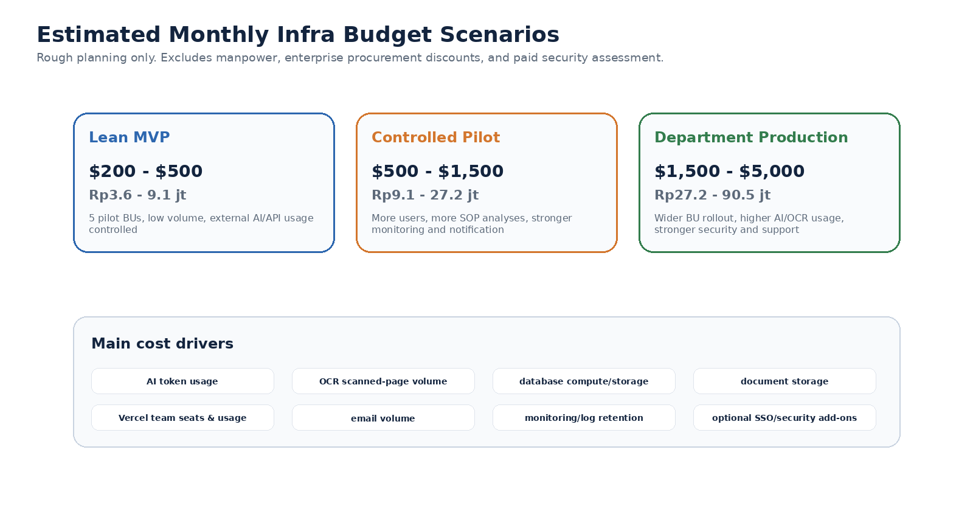
Scenario | Estimated Monthly USD | Estimated Monthly IDR | Best for
Lean MVP | $200 - $500 | Rp3.6 - 9.1 juta | 3-month pilot launch, low document/AI volume, manual reference upload
Controlled Pilot | $500 - $1,500 | Rp9.1 - 27.2 juta | More BU onboarding, more refinement jobs, stronger monitoring/notification
Department Production | $1,500 - $5,000 | Rp27.2 - 90.5 juta | Wider adoption, higher AI/OCR usage, stronger DB/security/observability
Enterprise Hardened | $5,000+ | Rp90.5 juta+ | SSO enterprise, stricter SLA, support, compliance/security add-ons

18. Infra Budget Detail by Component
Component | MVP Approach | Indicative Monthly Cost | Notes
Vercel hosting | Pro plan, 2-5 seats | $20 | Base plan is per user/seat. Higher usage may add consumption cost.
Managed PostgreSQL | Supabase Pro/Neon/managed Postgres | $25 | Start small; scale compute/storage only when needed.
Object storage | Cloudflare R2 or S3-compatible | $30 | SOP PDFs and reference docs are usually not huge in MVP.
AI API usage | Model mix for template, refinement, copilot | $100 - $1,000 | Most variable line item; apply monthly quota and usage dashboard.
Gotenberg container/API | Small hosted container/API | $10 - $60 | Conversion service only; not OCR.
OCR / document intelligence | Optional, only scanned docs | $0 - $300 | Use only when text extraction fails or scanned docs dominate.
Email delivery | Resend/SendGrid/corporate SMTP | $0 - $50 | MVP notification volume should be small.
Monitoring/logging | Vercel logs + Sentry optional | $0 - $50 | Add Sentry/observability if production pilot needs it.
PM tool integration | ClickUp/Jira API | $0 - $50 | Assumes existing license. Integration cost mostly dev effort, not infra.
Security add-ons | WAF included/basic + optional tools | $20 | Enterprise SSO/security review may change budget significantly.

19. AI Cost Control Model
AI adalah cost driver yang paling mudah bocor kalau tidak dibatasi. Karena setiap user bisa bertanya macam-macam, wajib ada quota, logging, dan model routing. Jangan biarkan chatbot menjadi mesin pembakar token berkedok produktivitas.
- Set monthly AI budget cap per environment: dev, staging, production.
- Separate AI usage category: template drafting, SOP Refinement, copilot Q&A, summary/translation.
- Use cheaper model for classification/summary; reserve stronger model for SOP Refinement or strategic reasoning.
- Cache reference analysis where possible; do not re-analyze the same SOP/reference repeatedly without reason.
- Store structured results so reviewers can reuse findings without re-calling AI.
- Show usage dashboard: jobs count, tokens/cost estimate, failed calls, average cost per SOP Refinement.
Formula | Explanation
AI cost = input tokens x input rate + output tokens x output rate | Rate depends on selected model/provider. Use provider pricing page as source of truth.
Cost per SOP Refinement = document tokens + reference tokens + output recommendation tokens | Large SOP/reference documents can increase cost quickly. Use chunking and retrieval.
Monthly AI budget = refinement jobs + copilot Q&A + template drafting + summaries | Set cap before broad rollout.

20. OCR and Document Conversion Cost Control
Gotenberg dapat dipakai sebagai document conversion API untuk mengubah Office/HTML/Markdown ke PDF. Untuk OCR scanned PDF, gunakan OCR/document intelligence provider hanya jika perlu. Born-digital PDF/DOCX sebaiknya diekstrak teks secara normal dulu, baru fallback ke OCR jika extraction gagal.
Case | Recommended Handling | Budget Impact
DOCX/PPTX/XLSX to PDF | Gotenberg conversion | Container hosting cost, usually predictable
Born-digital PDF | Text extraction without OCR | Very low cost
Scanned PDF / image PDF | OCR provider such as Textract/Azure/Google | Cost per page; must be monitored
Complex tables/forms | Document intelligence / layout extraction | Higher cost than raw OCR
MVP policy | OCR only as fallback | Avoid paying for OCR when plain extraction is enough

21. Delivery Roadmap - Technical
Phase | Timeline | Technical Deliverables
Phase 1 - MVP Launch | 0-3 months | Next.js app, Vercel deploy, auth/RBAC, SOP repository, request form, AI template draft, reference upload, SOP Refinement v1, validation queue, dashboard basic, ID/EN
Phase 2 - Workflow Stabilization | 4-6 months | Email notification, action tracking, ClickUp/Jira create task, audit trail v1, reviewer assignment, improved dashboard, usage/cost monitoring
Phase 3 - AI & Executive Visibility | 7-9 months | Executive copilot improvement, AI impact analysis, controlled regulatory monitoring input, SLA/overdue tracking, refinement quality tuning
Phase 4 - Scale & Control | 10-12 months | More BU rollout, stronger access review, security hardening, audit log retention, multi-country readiness, operational runbook

22. Initial Backlog for ClickUp/Jira
Epic | Sample Stories
Platform Foundation | Set up Next.js repo, Vercel deployment, environment separation, CI checks
Authentication & RBAC | User login, role mapping, BU scoping, protected routes
SOP Repository | Create/list/update SOP metadata, upload document, version history
SOP Request | Create new SOP request, generate AI template, submit for review
Reference Source | Upload regulation/reference, classify type, attach metadata
SOP Refinement | Start refinement job, call AI provider, receive callback, store findings
Validation Workflow | Reviewer queue, validate/reject/request revision, decision comment
Publishing | Publish approved SOP as new document/version, update history
Action Tracking | Create action item, owner, due date, status, notification
Dashboard & Copilot | KPI cards, executive summary, context-bound Q&A
Integration | Email provider, optional ClickUp/Jira task creation
Audit & Monitoring | Audit log, error tracking, AI usage monitoring, cost dashboard

23. Risks and Mitigations
Risk | Impact | Mitigation
Scope creep into enterprise platform before MVP | Delivery delay | Lock MVP scope; advanced worker/scraper/analytics as later phase
AI hallucination | Incorrect compliance interpretation | Evidence-based output, context-bound retrieval, human validation
OCR cost explosion | Budget overrun | Use OCR only for scanned docs; log pages processed and cost
Vercel request timeout for long jobs | Failed analysis | Use provider-side async analysis and webhook/polling
Document access leakage | Confidential data exposure | Private bucket, signed URLs, RBAC, audit log
Provider lock-in | Hard migration later | Use adapter pattern for AI/storage/email/PM tools
Unclear ownership of validation | Workflow stuck | Define Corporate Compliance validation owner before launch
Data quality issues | Poor AI output | Mandatory metadata, source classification, reviewer feedback loop

24. Source Pricing References
Pricing below must be rechecked during procurement because provider pricing changes. The current estimate uses public pages available at the time of drafting.
Provider / Source | Pricing facts used | URL
Vercel | Pro plan starts at $20/month and includes usage credit | https://vercel.com/pricing
Supabase | Pro starts at $25/month; includes 8GB disk, 250GB egress, 100GB file storage; Team starts at $599/month | https://supabase.com/pricing
Cloudflare R2 | Standard storage $0.015/GB-month; no egress bandwidth charges for standard storage | https://developers.cloudflare.com/r2/pricing/
OpenAI API | Model/token pricing varies by selected model; charged per 1M tokens and tool usage where relevant | https://developers.openai.com/api/docs/pricing
AWS Textract | Detect Document Text example uses $0.0015/page for first 1M pages; structured extraction costs more | https://aws.amazon.com/textract/pricing/
Gotenberg | Docker-based API for PDF conversion; cost is hosting/container infra, not per API license | https://gotenberg.dev/
Bank Indonesia JISDOR | USD/IDR reference around Rp18,099 on 14 July 2026 | https://www.bi.go.id/id/statistik/informasi-kurs/jisdor/default.aspx

25. Final Recommendation
Untuk kondisi BRD dan target launch cepat, rekomendasi final adalah membangun MVP sebagai Next.js full-stack application di Vercel, dengan managed PostgreSQL, object storage, AI provider, Gotenberg/API conversion, optional OCR provider, email service, dan optional ClickUp/Jira integration. Jangan split frontend/backend di awal kecuali kebutuhan skala atau compliance internal memaksa. Pisahkan proses berat ke provider eksternal, simpan hasil terstruktur, dan pastikan semua keputusan compliance tetap melalui validasi manusia.
Dengan pendekatan ini, proyek tetap kecil, cepat, dan realistis, tetapi tidak menutup jalan menuju arsitektur yang lebih kuat saat platform sudah terbukti dipakai. Akhirnya satu keputusan teknologi yang tidak langsung mengundang 17 microservices hanya demi terlihat serius.

