Date: 25th August, 2025

Program Title: vacuum cleaner

Observation:

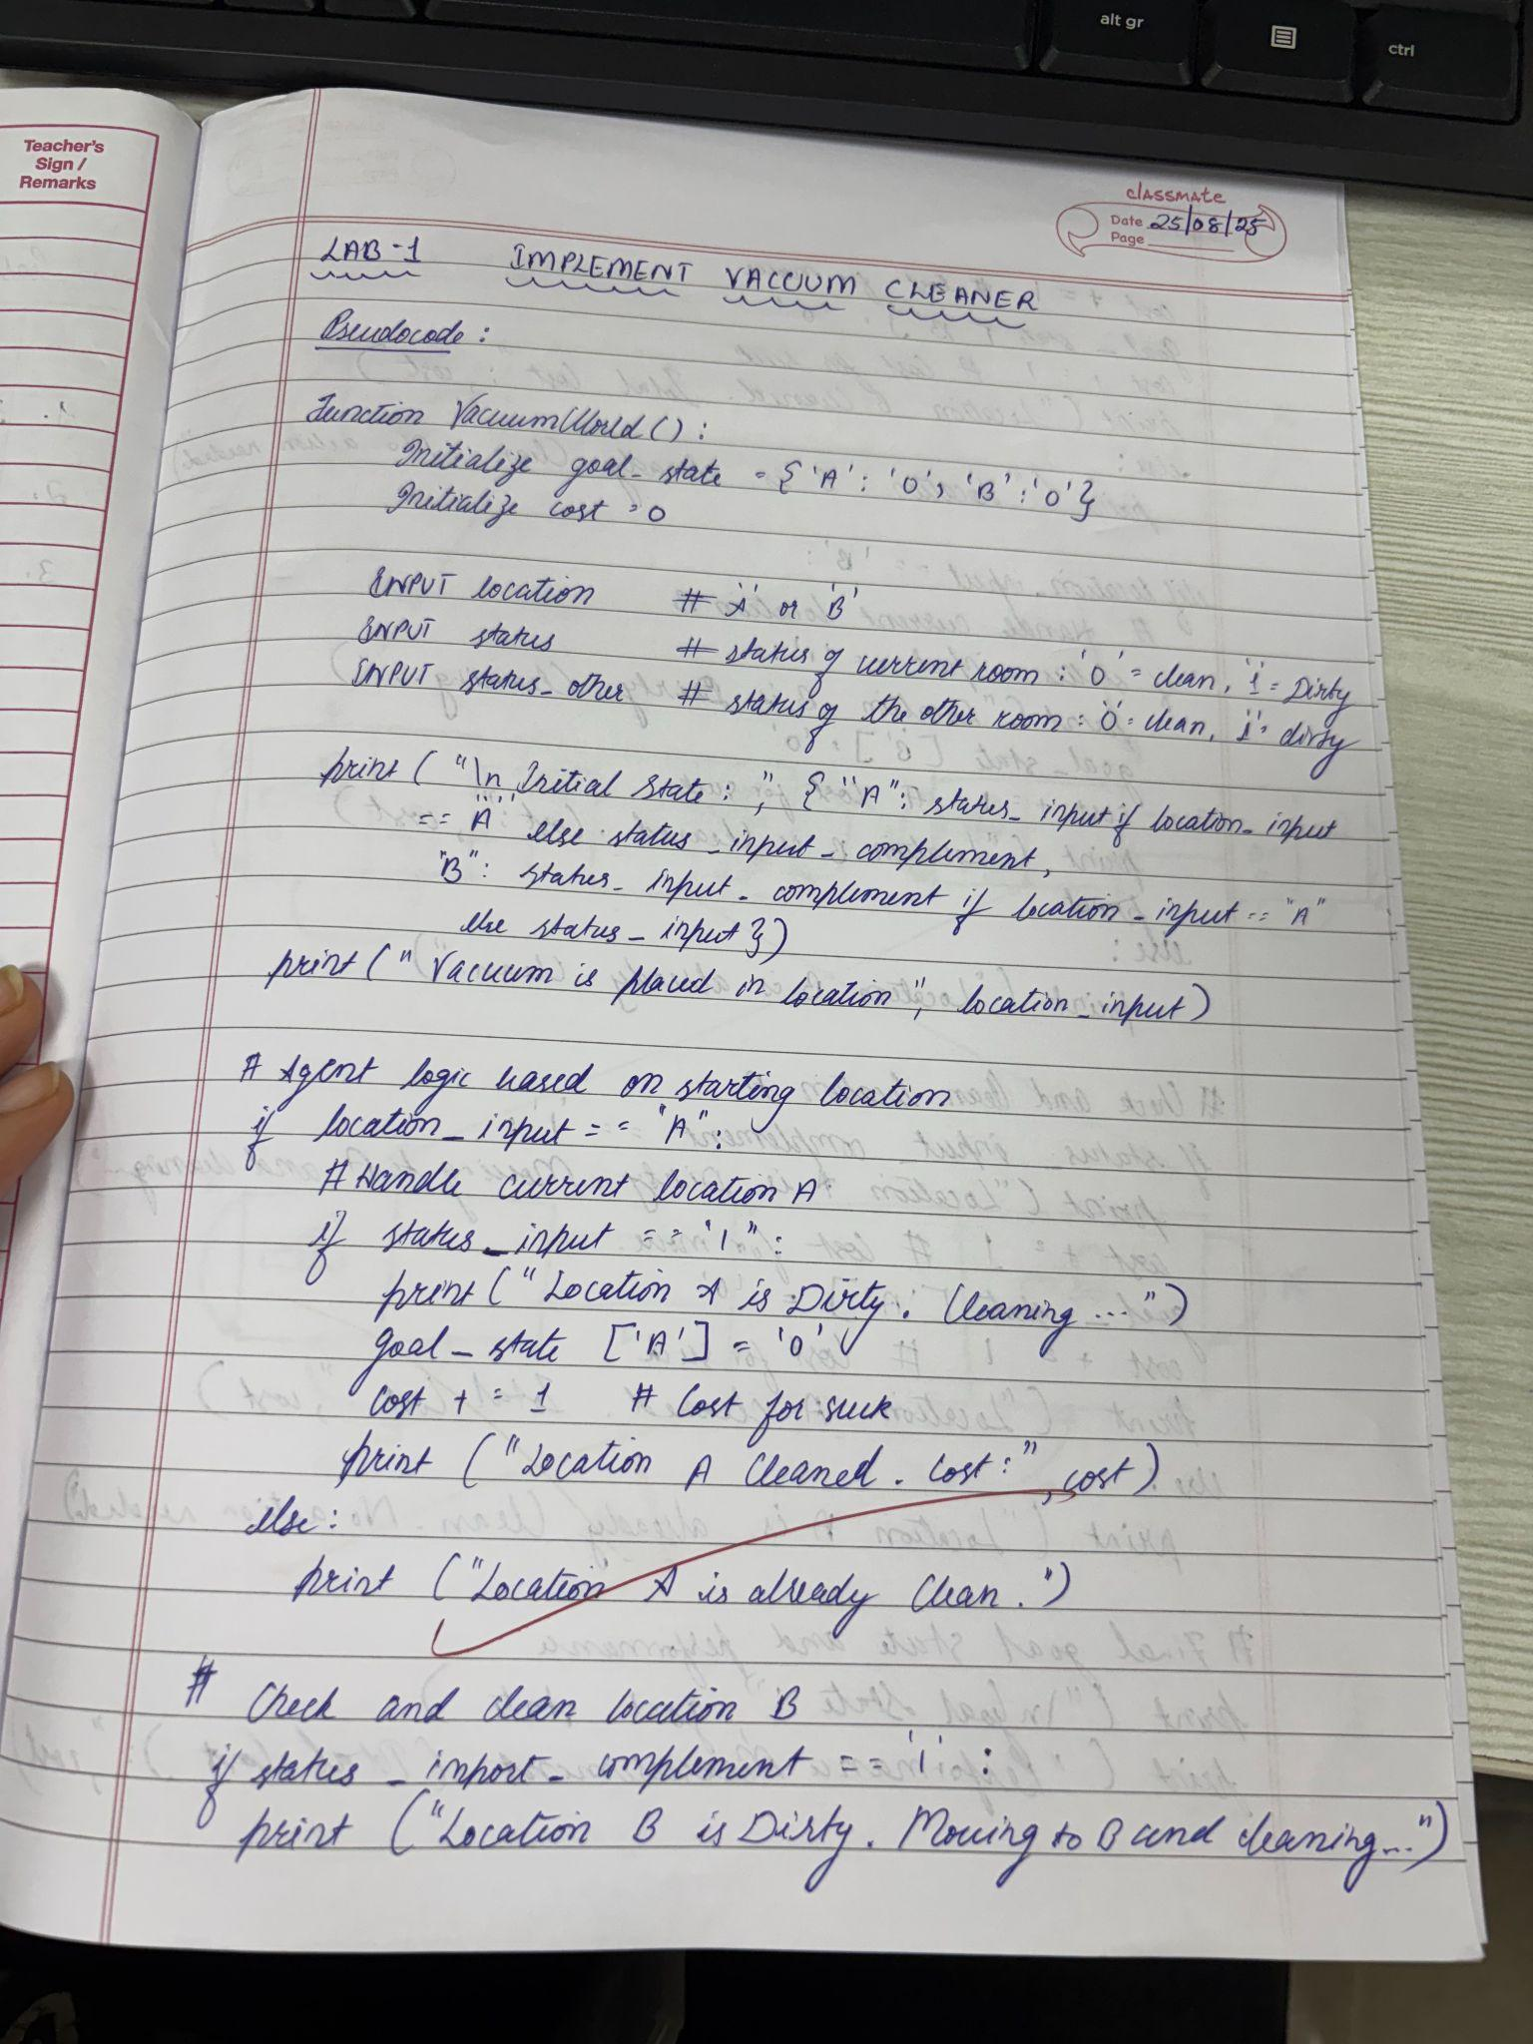

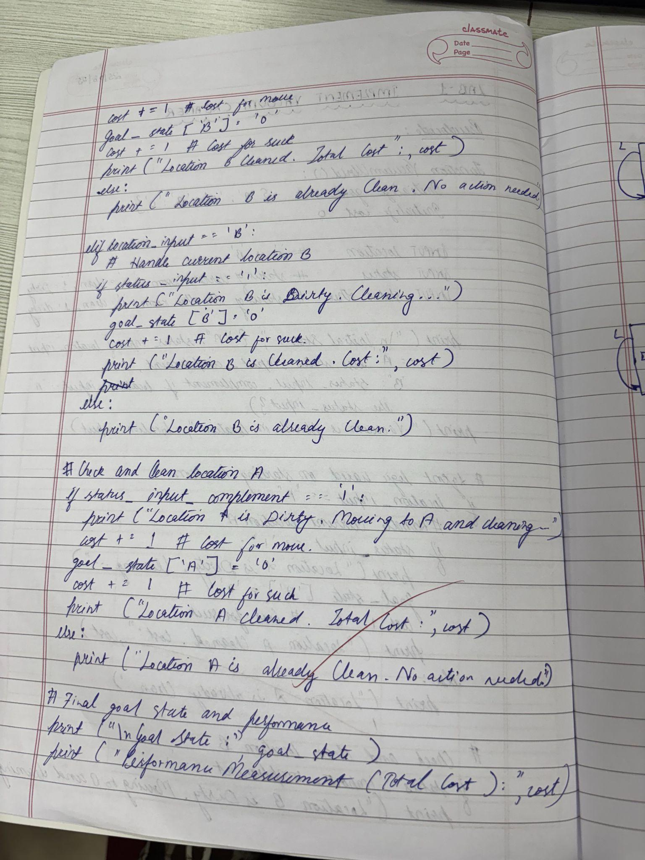
Syntax:

def
vacuum_world():
# initializing goal_state
# 0 indicates Clean and 1 indicates Dirty
goal_state = {'A': '0', 'B': '0'}
cost = 0
location_input = input("Enter Location of Vacuum") #user_input of
location vacuum is placed
status_input = input("Enter status of " + location_input) #user_input if
location is dirty or clean
status_input_complement = input("Enter status of other room")
print("Initial Location Condition" + str(goal_state))
if location_input == 'A':
# Location A is Dirty.
print("Vacuum is placed in Location A")
if status_input == '1':
print("Location A is Dirty.")
# suck the dirt and mark it as clean
goal_state['A'] = '0'
cost += 1 #cost for suck
print("Cost for CLEANING A " + str(cost))
print("Location A has been Cleaned.")
if status_input_complement == '1':
# if B is Dirty
print("Location B is Dirty.")
print("Moving right to the Location B. ")
cost += 1 #cost for moving right
print("COST for moving RIGHT" + str(cost))
# suck the dirt and mark it as clean
goal_state['B'] = '0'
cost += 1 #cost for suck
print("COST for SUCK " + str(cost))
print("Location B has been Cleaned. ")
else:
print("No action" + str(cost))
# suck and mark clean
print("Location B is already clean.")

if status_input == '0':
print("Location A is already clean ")
if status_input_complement == '1':# if B is Dirty
print("Location B is Dirty.")
print("Moving RIGHT to the Location B. ")
cost += 1 #cost for moving right
print("COST for moving RIGHT " + str(cost))
# suck the dirt and mark it as clean
goal_state['B'] = '0'
cost += 1 #cost for suck
print("Cost for SUCK" + str(cost))
print("Location B has been Cleaned. ")
else:
print("No action " + str(cost))
print(cost)
# suck and mark clean
print("Location B is already clean.")
else:
print("Vacuum is placed in location B")
# Location B is Dirty.
if status_input == '1':
print("Location B is Dirty.")
# suck the dirt and mark it as clean
goal_state['B'] = '0'
cost += 1 # cost for suck
print("COST for CLEANING " + str(cost))
print("Location B has been Cleaned.")
if status_input_complement == '1':
# if A is Dirty
print("Location A is Dirty.")
print("Moving LEFT to the Location A. ")
cost += 1 # cost for moving right
print("COST for moving LEFT" + str(cost))
# suck the dirt and mark it as clean
goal_state['A'] = '0'
cost += 1 # cost for suck
print("COST for SUCK " + str(cost))
print("Location A has been Cleaned.")
else:
print(cost)
# suck and mark clean
print("Location B is already clean.")
if status_input_complement == '1': # if A is Dirty
print("Location A is Dirty.")
print("Moving LEFT to the Location A. ")
cost += 1 # cost for moving right
print("COST for moving LEFT " + str(cost))
# suck the dirt and mark it as clean
goal_state['A'] = '0'
cost += 1 # cost for suck
print("Cost for SUCK " + str(cost))
print("Location A has been Cleaned. ")
else:
print("No action " + str(cost))
# suck and mark clean
print("Location A is already clean.")
# done cleaning
print("GOAL STATE: ")
print(goal_state)
print("Performance Measurement: " + str(cost))
Output:
vacuum_world()

Output:

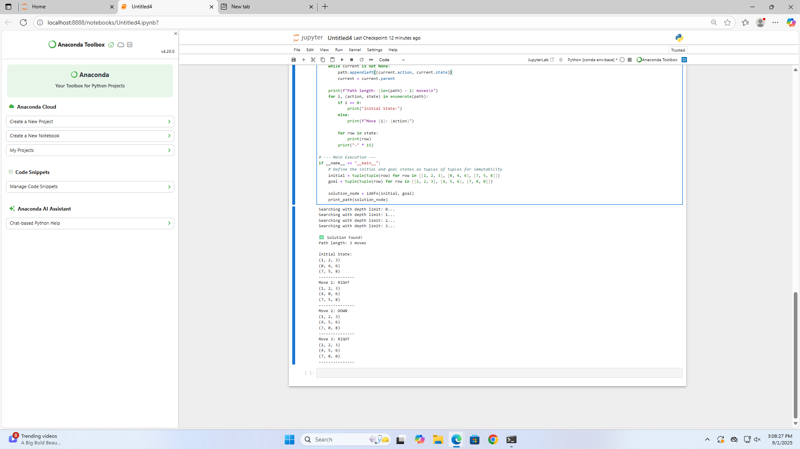

Tracing:

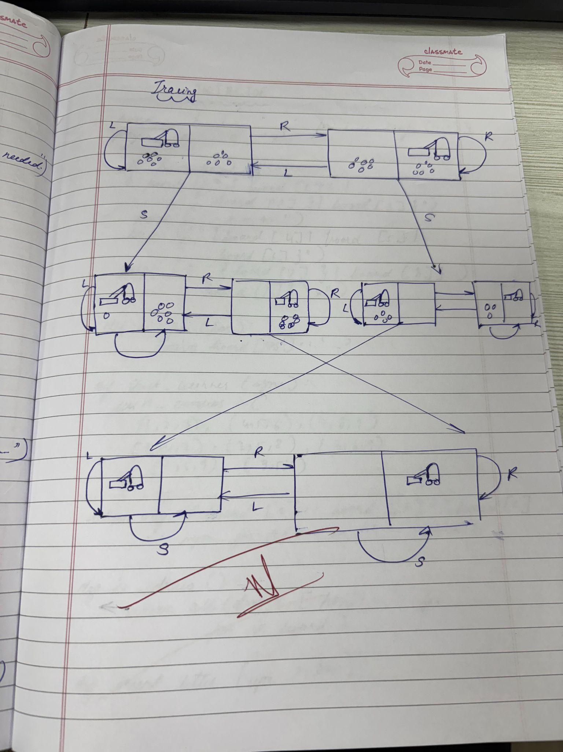

Tictactoe:
board={1:' ',2:' ',3:' ',
4:' ',5:' ',6:' ',
7:' ',8:' ',9:' '
}

def printBoard(board):
print(board[1]+'|'+board[2]+'|'+board[3])
print('-+-+-')
print(board[4] + '|' + board[5] + '|' + board[6])
print('-+-+-')
print(board[7] + '|' + board[8] + '|' + board[9])
print('\n')

def spaceFree(pos):
if(board[pos]==' '):
return True
else:
return False

def checkWin():
if(board[1]==board[2] and board[1]==board[3] and board[1]!=' '):
return True
elif(board[4]==board[5] and board[4]==board[6] and board[4]!=' '):
return True
elif(board[7]==board[8] and board[7]==board[9] and board[7]!=' '):
return True
elif (board[1] == board[5] and board[1] == board[9] and board[1] != ' '):
return True
elif (board[3] == board[5] and board[3] == board[7] and board[3] != ' '):
return True
elif (board[1] == board[4] and board[1] == board[7] and board[1] != ' '):
return True
elif (board[2] == board[5] and board[2] == board[8] and board[2] != ' '):
return True
elif (board[3] == board[6] and board[3] == board[9] and board[3] != ' '):
return True
else:
return False

def checkMoveForWin(move):
if (board[1]==board[2] and board[1]==board[3] and board[1] ==move):
return True
elif (board[4]==board[5] and board[4]==board[6] and board[4] ==move):
return True
elif (board[7]==board[8] and board[7]==board[9] and board[7] ==move):
return True
elif (board[1]==board[5] and board[1]==board[9] and board[1] ==move):
return True
elif (board[3]==board[5] and board[3]==board[7] and board[3] ==move):
return True
elif (board[1]==board[4] and board[1]==board[7] and board[1] ==move):
return True
elif (board[2]==board[5] and board[2]==board[8] and board[2] ==move):
return True
elif (board[3]==board[6] and board[3]==board[9] and board[3] ==move):
return True
else:
return False

def checkDraw():
for key in board.keys():
if (board[key]==' '):
return False
return True

def insertLetter(letter, position):
if (spaceFree(position)):
board[position] = letter
printBoard(board)

if (checkDraw()):
print('Draw!')
elif (checkWin()):
if (letter == 'X'):
print('Bot wins!')
else:
print('You win!')
return

else:
print('Position taken, please pick a different position.')
position = int(input('Enter new position: '))
insertLetter(letter, position)
return

player = 'O'
bot ='X'

def playerMove():
position=int(input('Enter position for O:'))
insertLetter(player, position)
return

def compMove():
bestScore=-1000
bestMove=0
for key in board.keys():
if (board[key]==' '):
board[key]=bot
score = minimax(board, False)
board[key] = ' '
if (score > bestScore):
bestScore = score
bestMove = key

insertLetter(bot, bestMove)
return

def minimax(board, isMaximizing):
if (checkMoveForWin(bot)):
return 1
elif (checkMoveForWin(player)):
return -1
elif (checkDraw()):
return 0

if isMaximizing:
bestScore = -1000

for key in board.keys():
if board[key] == ' ':
board[key] = bot
score = minimax(board, False)
board[key] = ' '
if (score > bestScore):
bestScore = score
return bestScore
else:
bestScore = 1000

for key in board.keys():
if board[key] == ' ':
board[key] = player
score = minimax(board, True)
board[key] = ' '
if (score < bestScore):
bestScore = score
return bestScore

while not checkWin():
compMove()
playerMove()

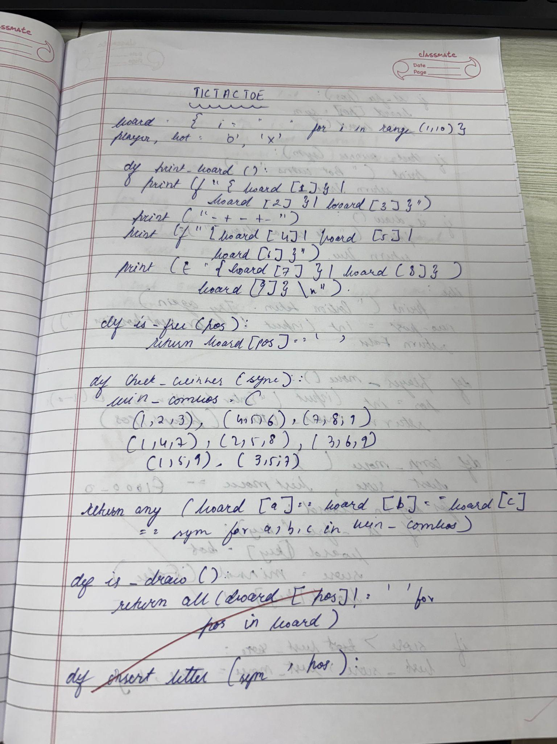

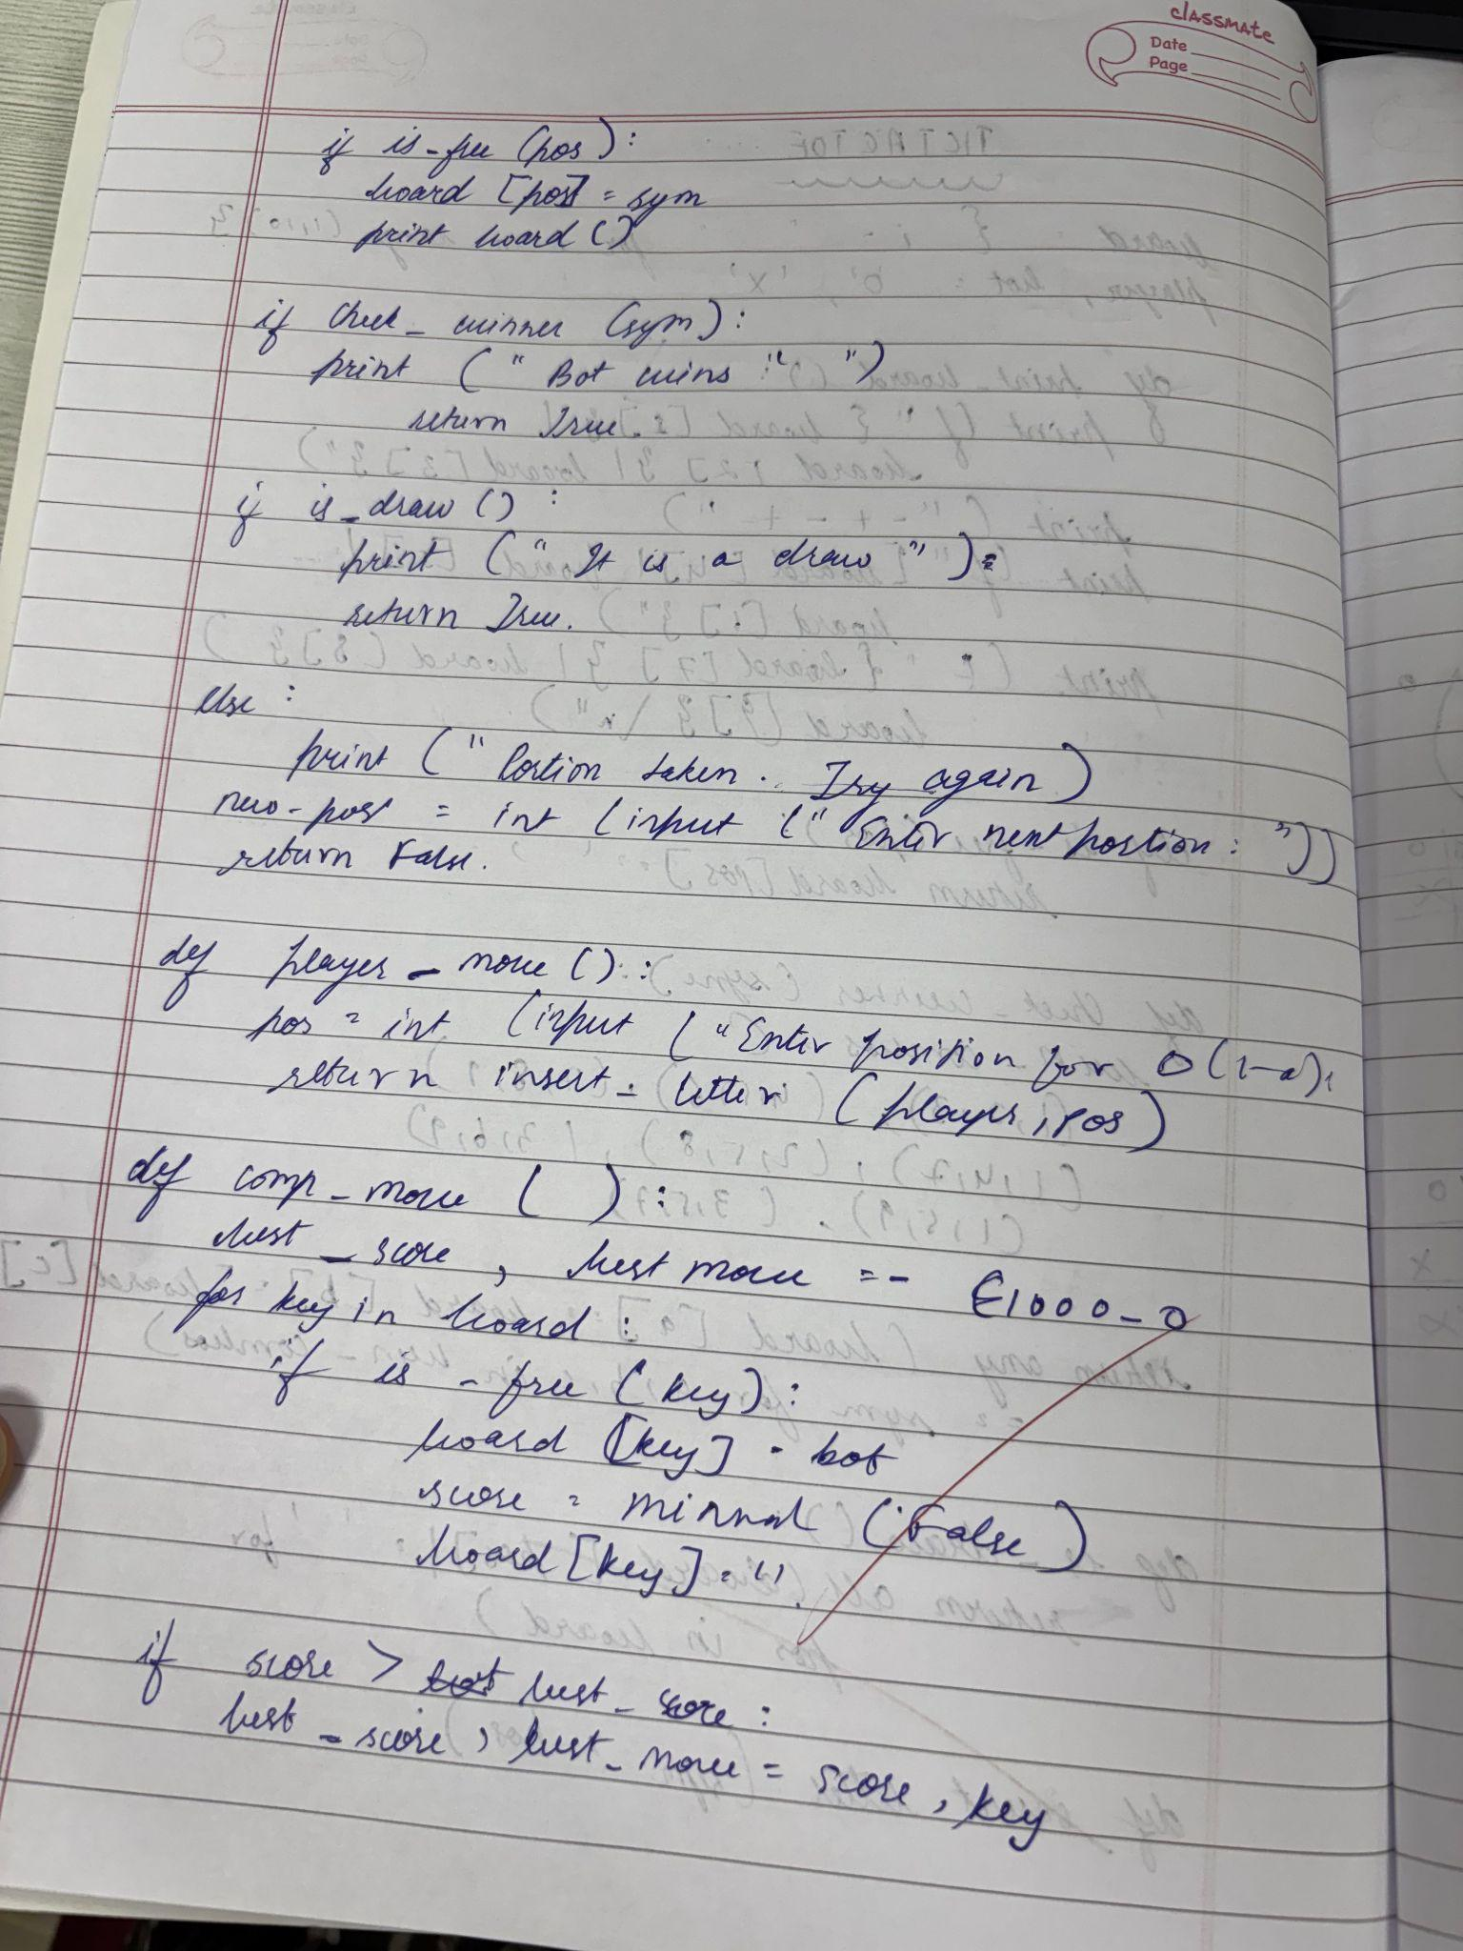

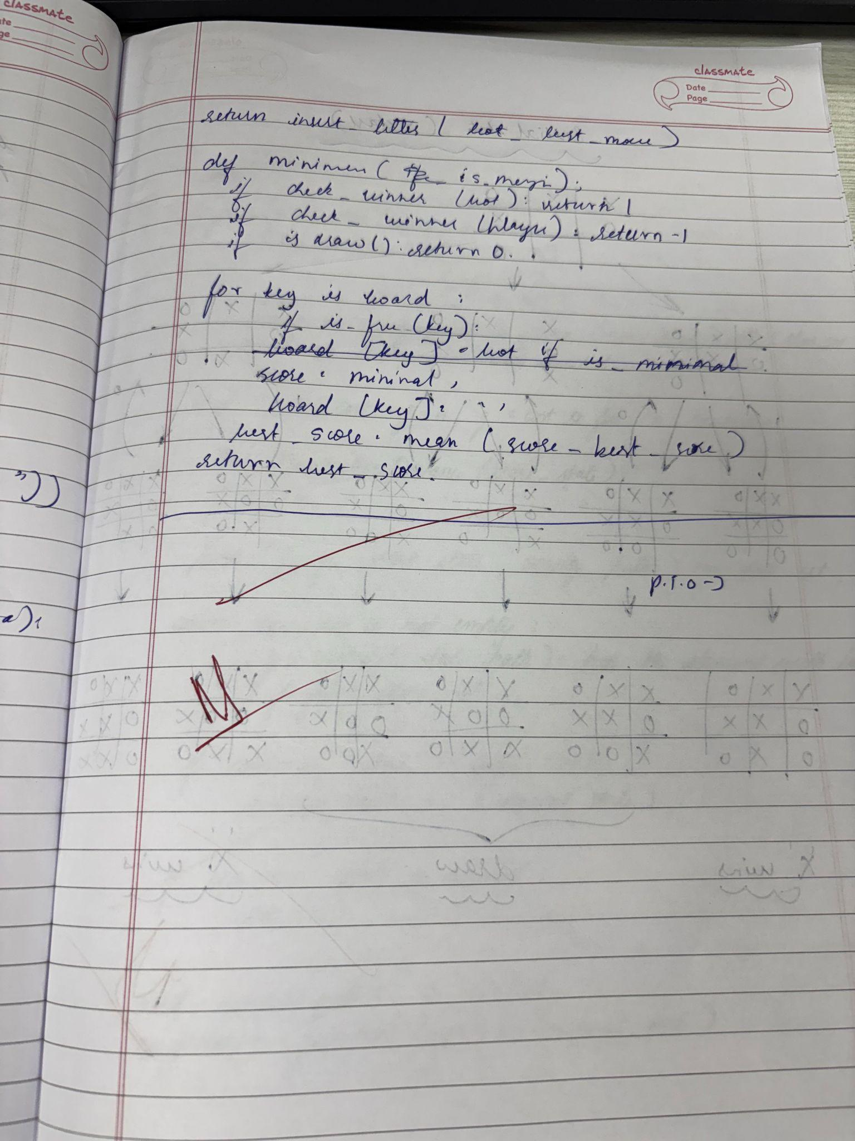

Tracing:
