Retail Sales Data Visualization Analysis
Final Project Written Paper
Prakriti Dahal
Regis University
MSDS670
John Koenig
March 6, 2026

Introduction
Retail businesses collect large amounts of transactional data every day. However, raw numbers alone do not provide meaningful insights into how the business is performing. Data visualization helps transform complex data into visual patterns that are easier to understand. This paper analyzes retail sales data from the Sample Superstore dataset and explains key visualizations that reveal patterns in sales, profitability, and regional performance.

Problem/Situation
Retail stores collect a large amount of transaction data every day. However, raw numbers alone do not clearly explain what is happening in business. Through data analysis and visualization, patterns in sales, product performance, and profitability can be identified.
Visualizing the data helps decision makers quickly understand business trends and make better strategic decisions.
Research Questions
This analysis focuses on several key questions.
- What patterns exist in retail sales data that help explain which products customers buy the most?
- Are the products that generate the highest sales also the ones that generate the most profit?
- How do discounts influence profitability, and do higher discounts reduce overall profit?
- Do sales change over time or vary across regions, and what factors may explain those differences?
Data
The data set used in this project is the Sample Superstore retail dataset. It contains approximately 10,000 sales transactions. Important variables include order date, sales, profit, discount, product category, sub-category, and region. These variables make it possible to analyze profitability, time trends, and geographic differences in business performance.
Methodology
Python was used to perform the analysis and create the visualizations. The dataset was first loaded using the pandas library. After loading the data, cleaning and preparation steps were performed to ensure the dataset was consistent and usable. The data was then grouped and summarized to identify patterns in sales and profit. Finally, Matplotlib was used to create charts that visually communicate the insights discovered during the analysis.

Profit By Sub-Category
The profit by sub-category visualization compares the profitability of different product sub-categories. Copiers generate the highest profit of all products, making them one of the most valuable items for the business. In contrast, tables produce the largest financial loss with negative profit exceeding fifteen thousand dollars. Other products such as phones, accessories, and paper contribute strong positive margins, while smaller items like fasteners and labels contribute the least to overall profitability.
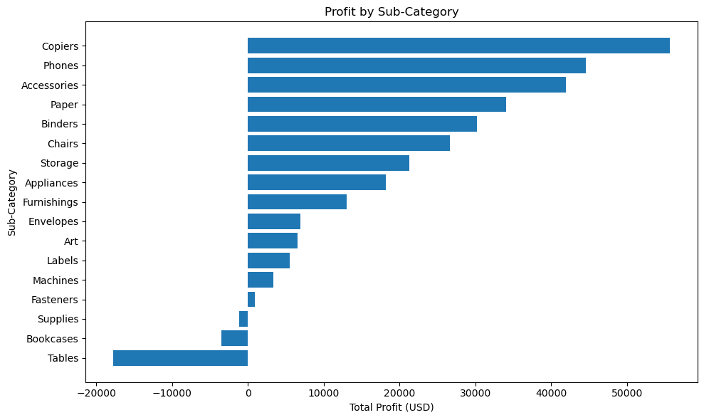
Monthly Sales Trend
The monthly sales trend visualization illustrates how sales changed over time from 2013 to 2016. The chart shows a strong long-term increase in sales, indicating business growth during this period. A seasonal pattern is also visible where sales rise significantly in November and December. After these peaks, sales decline again at the beginning of the following year, showing a repeating yearly cycle.

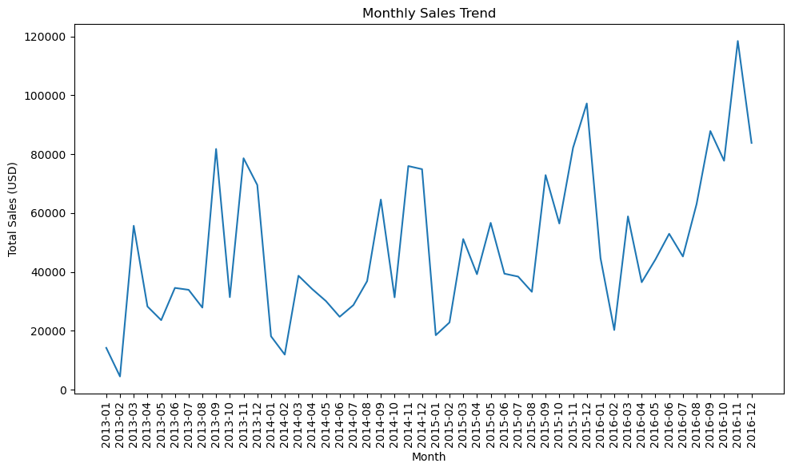
Discount Vs Profit
This visualization examines the relationship between discounts and profit.
The analysis reveals a clear downward trend where higher discounts are associated with lower profits. Profits are generally highest when no discount is applied. Once discounts exceed roughly twenty percent, profits frequently become negative, meaning the company loses money on those transactions.
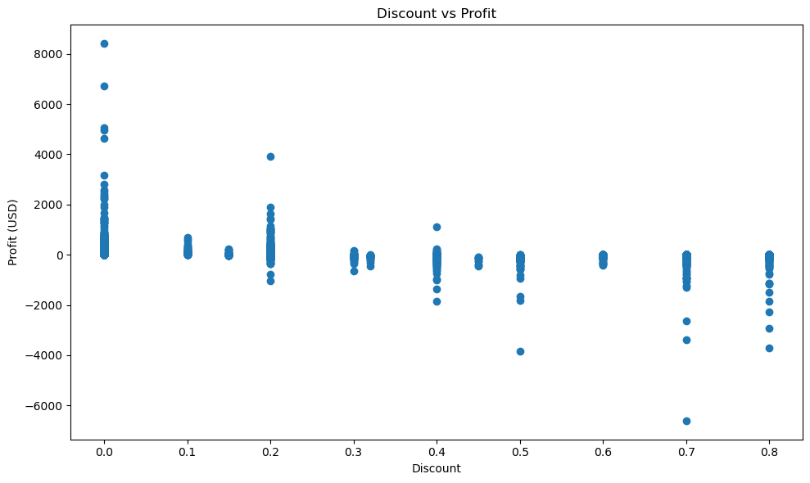
Sales Vs Profit
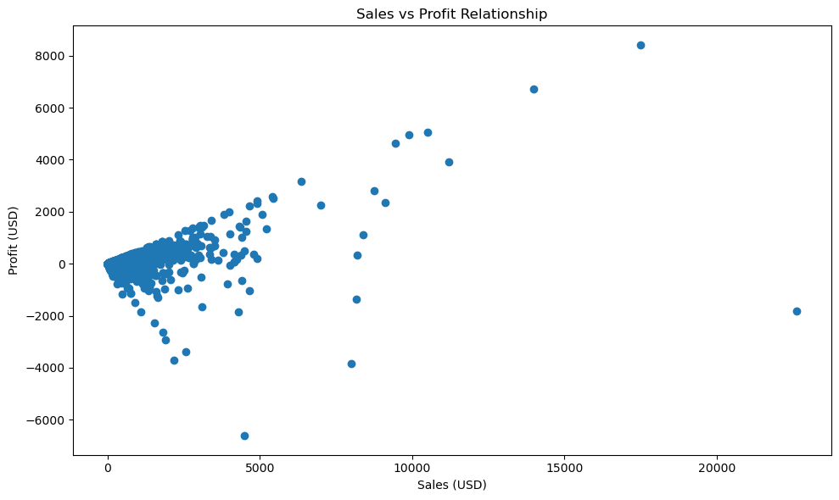
The sales versus profit visualization explores the relationship between revenue and profitability. In many cases, higher sales are associated with higher profits.
However, the visualization also shows that some large sales transactions still produce negative profit. This indicates that high sales volume does not always guarantee profitability and that factors such as discounts and costs influence financial outcomes.
Sales By Region
This visualization compares total sales across geographic regions. The West region generates the highest sales, followed by the East region. The Central and South regions generate comparatively lower revenue. These results suggest that the West and East regions represent the strongest markets for the business.

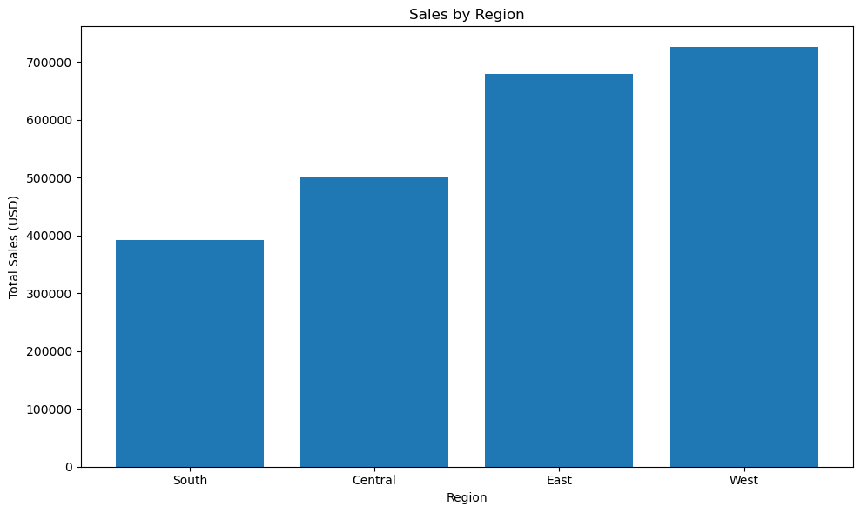

Conclusion
The results demonstrate the importance of data visualization for understanding retail sales performance. The analysis shows that high sales do not always lead to high profits and that excessive discounts can significantly reduce profitability. Seasonal patterns and regional differences in sales are also clearly visible in the data. These insights can help organizations make better decisions related to pricing strategies, product management, and regional marketing efforts.

