**19BCE1655**

**LSDP_DA1**

**PRAKRITI SHARMA**

**How to run the code?**

**NAVIGATE TO THE FOLDER**

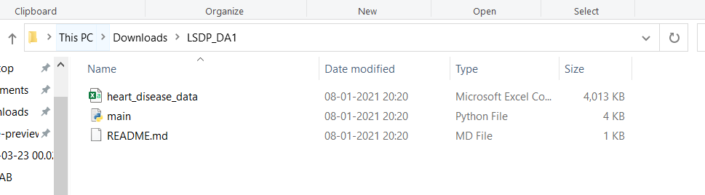

**TYPE CMD IN THE ADDRESS BAR**

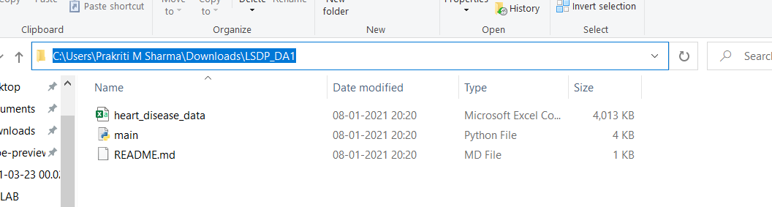

**COMMAND PROMPT WILL APPEAR**

You should have python and pip installed in your system.

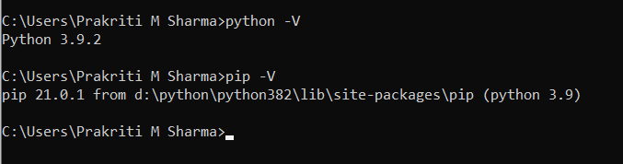

**GO ABOUT EXECUTING py main.py to run the main file.**

It takes some time to execute and iterate through the huge dataset.

