Navigating to ansible roles directory

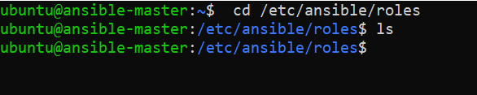

Creating an ansible role called tomcat

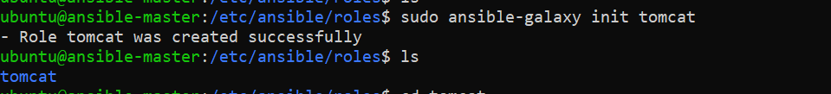

Below is the content of yml at tomcat task directory under roles file to start the tomat

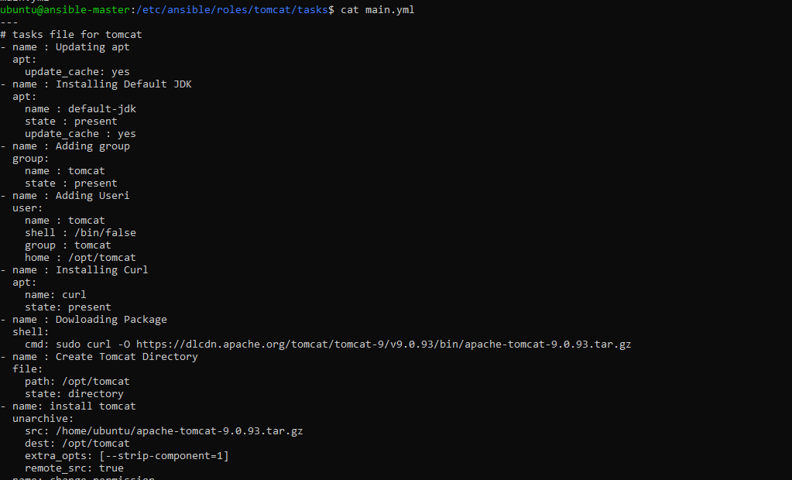

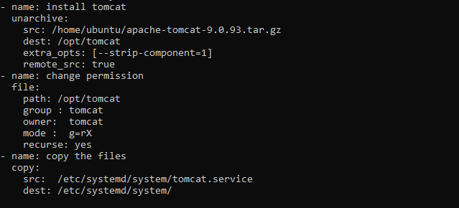

Below is the content of /etc/systemd/system/tomcat.service

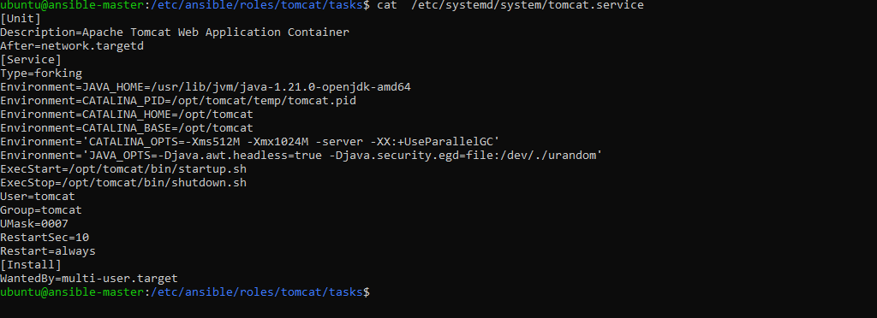

Calling tomcat role from stack.yml

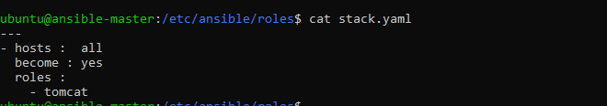

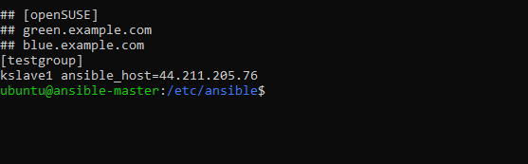

**NOTE: Configured to install tomcat at slave node.**

Running playbook and the output.

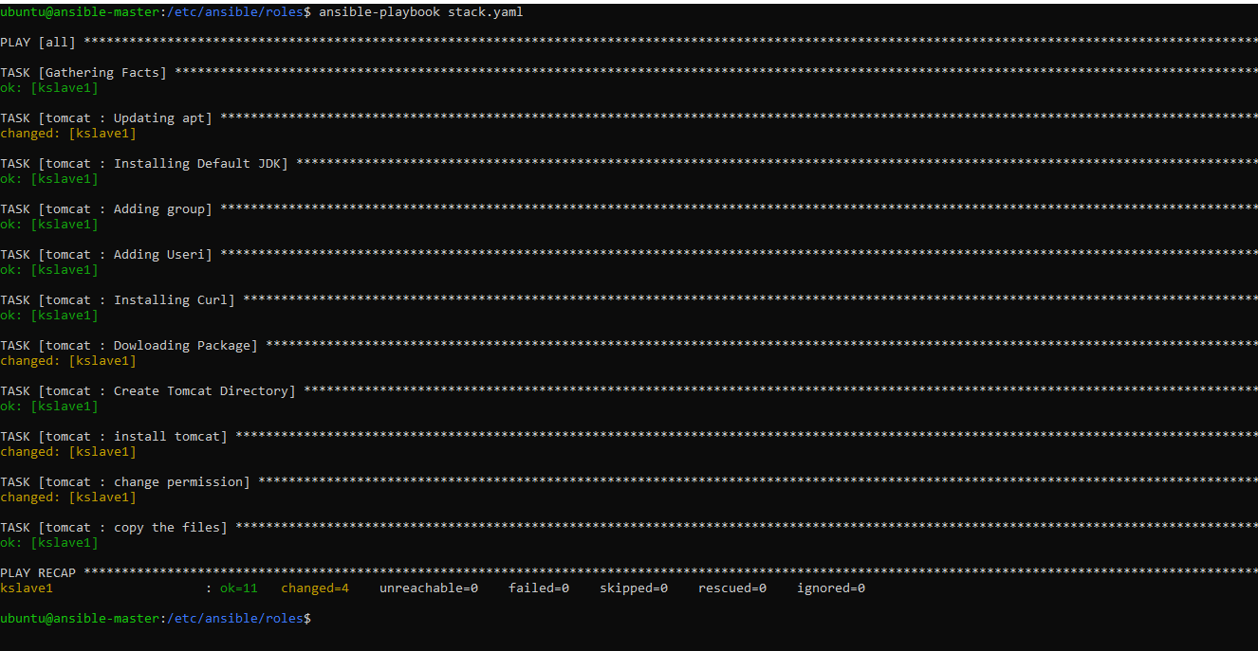

Checking Whether tomcat is running in slave node:

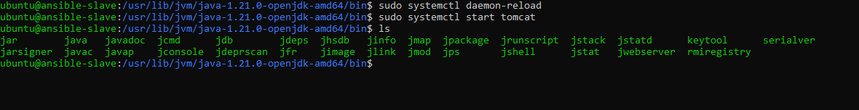

**Screenshot of tomcat launching at 8080**

