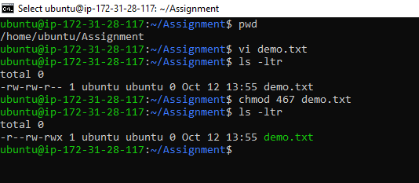
Created the file using Vi command
Changed the permission using chmod
4—read
6—read and write
7—read write execute

