1)Open a terminal and go to the folder containing your `docker-compose.yml`.
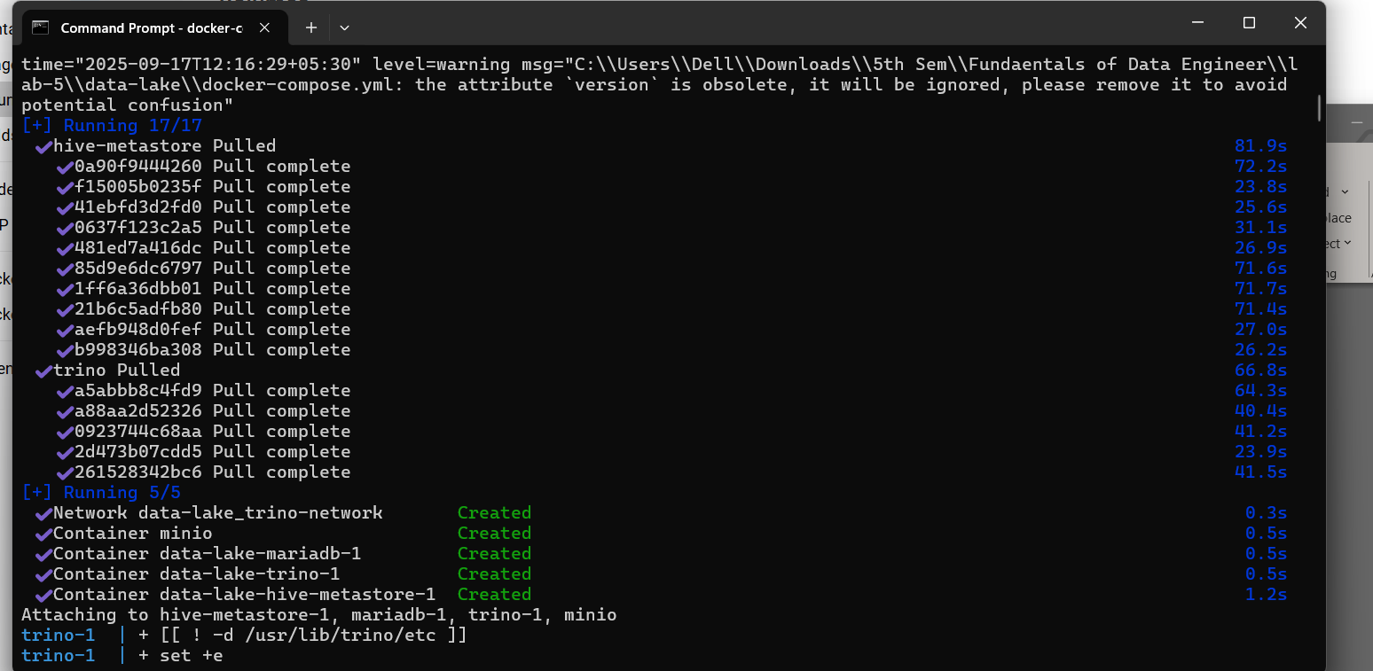
Execute the command: docker-compose up

2) Created volume in Docker:
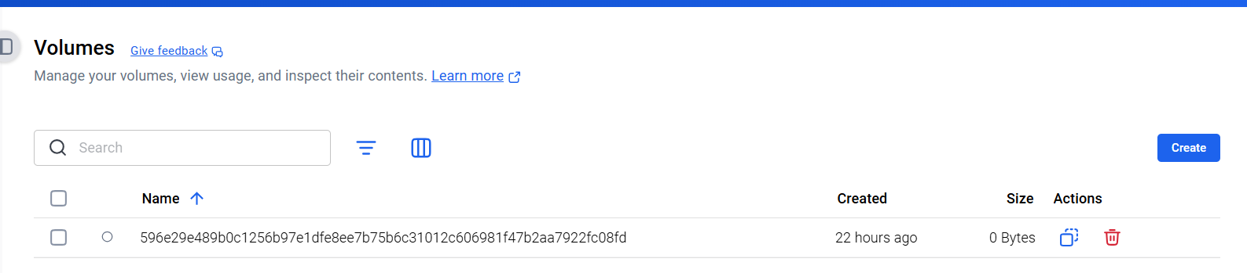

3)MinIO Dashboard:
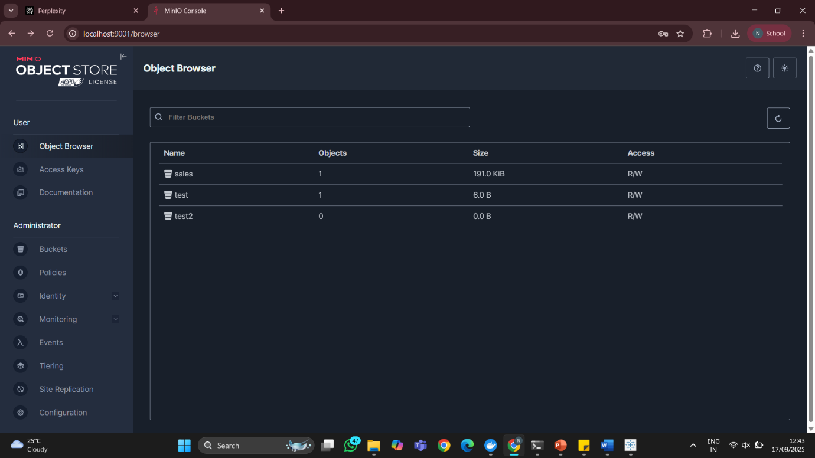

4) Trino:
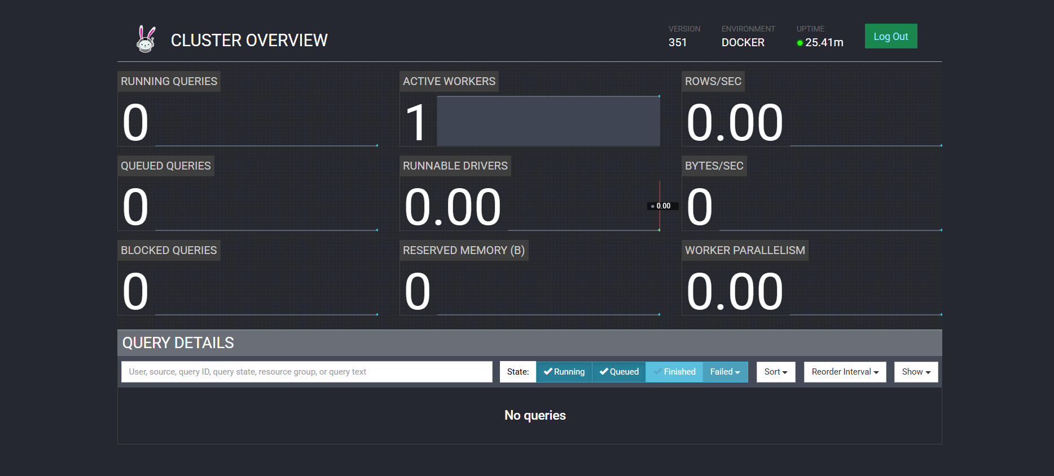

5)DBeaver:
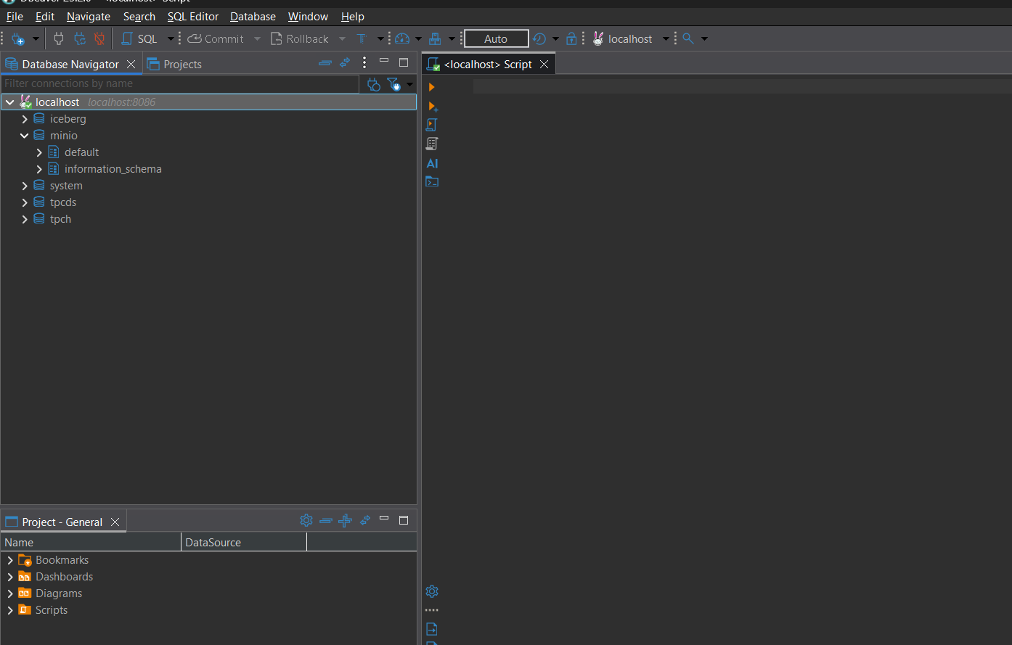

6)Create Schema
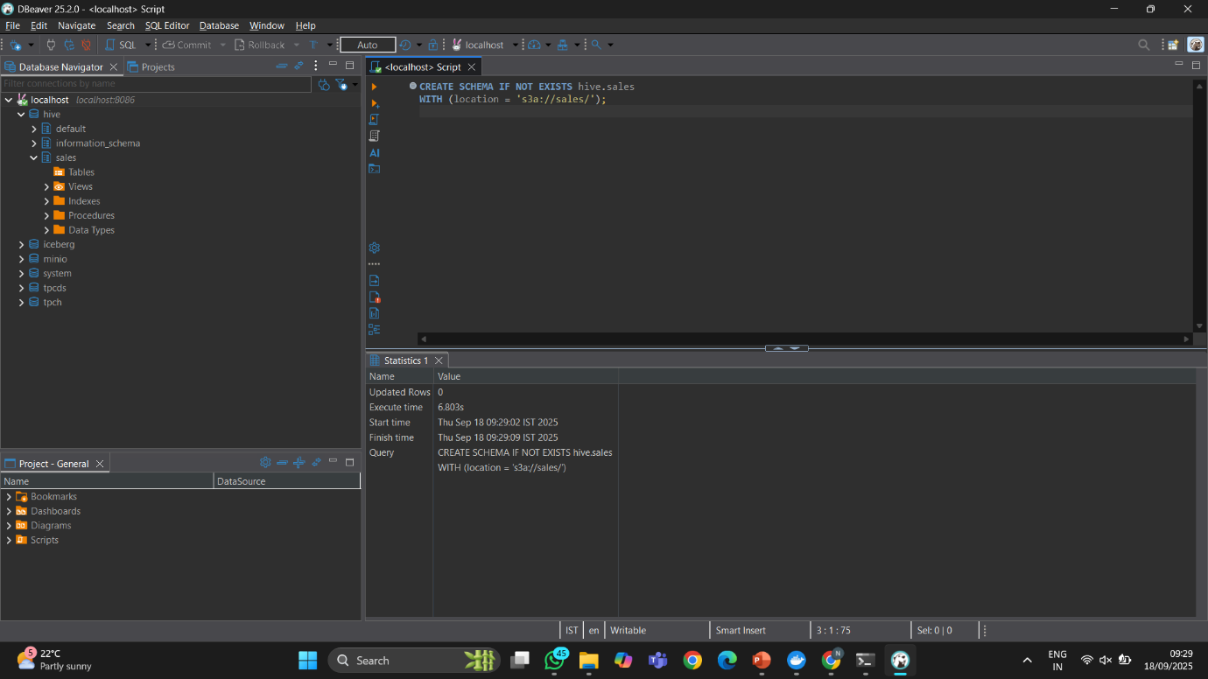

8) Table of sales_tz:
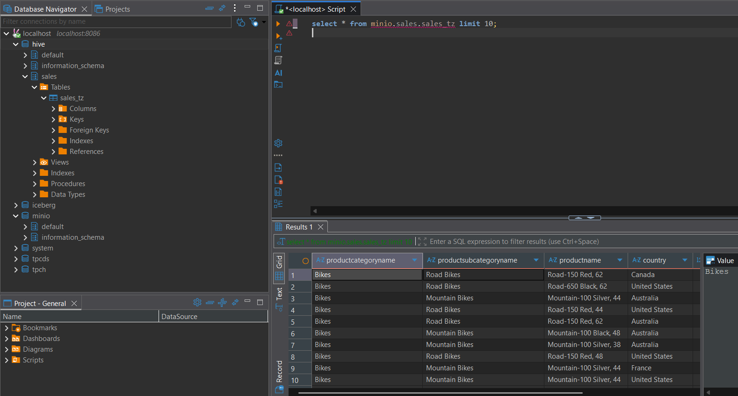

Github Link:

