Project 3: Comparison of Deep Learning Architectures
Study of Feedforward Neural Networks (FNN), Convolutional Neural Networks (CNN), and Recurrent Neural Networks (RNN)
Student Name: | Prakruthi BR
Subject / Course: | Deep Learning
Project Assignment: | Project 3 - Architecture Analysis & Comparison
Date of Submission: | August 31, 2026

Part 1: Foundational Deep Learning Concepts (Notebook Reference)
1. What is meant by Deep Learning?
- Definition: Deep Learning is a specialized subset of Machine Learning which uses Artificial Neural Networks (ANNs) inspired by the human brain.
- Automatic Feature Extraction: Unlike traditional ML algorithms that require manual feature extraction, Deep Learning automatically learns hierarchical feature representations directly from raw input data.
- Performance on Large Datasets: Deep learning architectures scale exceptionally well with massive datasets, performing significantly better as data volume increases.
- High Automation: Delivers end-to-end automated processing across image recognition, natural language processing, audio synthesis, and predictive analytics.
2. Define Input Layer, Hidden Layer, and Output Layer in DNN
- Input Layer: The initial layer that receives input data or feature vectors directly from the dataset. It does not perform mathematical transformations; it simply passes input values to the next layer.
- Hidden Layer: Intermediate processing layers situated between the input layer and output layer. Basically, hidden layers handle feature transformation by calculating weighted sums, adding biases, and applying non-linear activation functions to learn complex data patterns.
- Output Layer: The final layer of the neural network that produces output predictions, classifications, or continuous numerical values.
3. Explain Neurons (Artificial Neurons)
- Definition: An artificial neuron (or node) is the fundamental computational building block of a neural network.
- Inputs (x): It receives input signals xᵢ from previous layers or external data.
- Weights (W): Each input connection carries a learnable scalar weight Wᵢ reflecting the relative importance of that input.
- Bias (b): A learnable scalar value b added to the weighted sum, shifting the activation threshold.
- Weighted Summation: Calculates z = ∑ (Wᵢ · xᵢ) + b.
- Activation Step: Passes the linear result z through an activation function f(z) to produce the final output activation a = f(z).
4. Difference between Forward Propagation and Backward Propagation
- Forward Propagation Direction: Moves sequentially from the Input Layer through Hidden Layers to the Output Layer.
- Forward Propagation Purpose: Used primarily to calculate network predictions ŷ and compute loss error L(y, ŷ). It does not update weights.
[ Input Layer --> Weights (W) --> Bias (b) --> Hidden Layer --> Output Layer (Predictions) ]
- Backward Propagation Direction: Moves in reverse from the Output Layer back towards the Input Layer.
- Backward Propagation Purpose: Used primarily to evaluate prediction error, compute gradients using the mathematical chain rule, and update weights and biases (W, b) to minimize total network loss.
[ Output Layer (Error Loss) --> Gradients (∂L/∂W) --> Hidden Layer --> Update Weights (W, b) --> Input Layer ]
5. What is meant by Activation Function?
- Definition: An activation function is a mathematical function applied to the weighted sum of a neuron to decide whether that neuron should be activated ('fired') or not.
- Adding Non-Linearity: Without activation functions, a neural network would just be a series of linear transformations, restricting it to simple linear boundaries.
- Learning Complex Patterns: Enables the neural network to learn complex non-linear patterns, high-dimensional decision boundaries, and intricate feature relationships.
- Common Examples: Sigmoid (maps outputs to 0–1 for binary probability), ReLU (zeroes negative values, max(0,z)), Tanh (zero-centered -1 to 1), Softmax (multi-class probability distribution).
Task 1: Basic Architecture of Feedforward Networks, CNNs, and RNNs
1.1 Feedforward Neural Networks (FNN / Multilayer Perceptrons)
Feedforward Neural Networks (FNNs) are the foundational architecture of deep learning. Information moves strictly in one forward direction—from input nodes, through hidden layers, to output nodes—without any feedback loops or cyclic paths.
Key Structural Components
- Input Feature Vector: Receives a fixed-size 1D vector x = [x₁, x₂, ..., xₙ]ᵀ.
- Dense Connections: Fully connected (dense) layers where every single neuron in layer l connects to every neuron in layer l-1.
- Layer Computation: Linear transformation z = Wx + b followed by non-linear activation a = σ(z).
- Training Mechanism: Updates all weights W and biases b using backpropagation and gradient descent.
Limitations of FNNs
- Destroys Spatial Layout: Flattening a 2D image grid (e.g., 224×224) into a 1D vector destroys spatial pixel neighborhoods.
- Parameter Explosion: Parameter count scales quadratically with input size, causing severe overfitting on high-dimensional data.
- No Sequential Memory: FNNs possess zero memory of past inputs, making them unsuitable for temporal sequential streams.
1.2 Convolutional Neural Networks (CNN)
Convolutional Neural Networks (CNNs) were created to process spatial grid data (such as 2D images or 3D video volumes) by replacing dense matrix multiplication with sliding convolutional kernels.
Key Structural Components
- Convolutional Filters: Small learnable 2D matrices (e.g., 3×3 or 5×5) that slide across the input grid to detect local features like edges, textures, corners, and shapes.
- Parameter Sharing: The same filter weights are used across the entire image grid. This drastically reduces parameters and guarantees translation invariance.
- ReLU Activation: Applies element-wise non-linearity (typically ReLU) to preserve positive feature responses.
- Max Pooling: Downsampling layers (e.g., 2×2 Max Pooling) that reduce spatial map dimensions while retaining peak feature activations.
- Flattening & Classifier Head: Converts 3D feature maps into a 1D vector to feed dense classifier layers.
1.3 Recurrent Neural Networks (RNN & LSTM / GRU)
Recurrent Neural Networks (RNNs) are designed for sequential and temporal data (such as text sentences, time-series measurements, or audio speech) where the current step depends heavily on previous context.
Key Structural Components
- Recurrent Memory State: Maintains an internal hidden state h_t at step t combining current input x_t with previous state h_{t-1}: h_t = tanh(W_{hh} h_{t-1} + W_{xh} x_t + b_h).
- Temporal Weight Sharing: The exact same weight matrices (W_{hh}, W_{xh}) are shared across all sequence time steps.
- Gated LSTMs & GRUs: Standard vanilla RNNs suffer from vanishing gradients over long sequences. LSTMs introduce a Cell State c_t governed by Forget, Input, and Output gates to preserve long-term context.
Task 2: Identify Suitable Applications for Each Architecture
2.1 FNN Application: Credit Card Fraud Detection
- Suitable Domain: Tabular dataset problems where features are independent, categorical, or continuous variables without intrinsic spatial or temporal order.
- Concrete Case Study: Real-time banking pipeline evaluating whether a transaction is legitimate (0) or fraudulent (1).
- Input Data: Static 5D tabular vector: [Transaction Amount, Distance from Home, Merchant Risk Score, Hour of Day, Transaction Velocity].
- Pipeline Workflow: Input vector passes into dense hidden layers (128 and 64 neurons with ReLU) to evaluate feature interactions, ending in a Sigmoid output neuron.
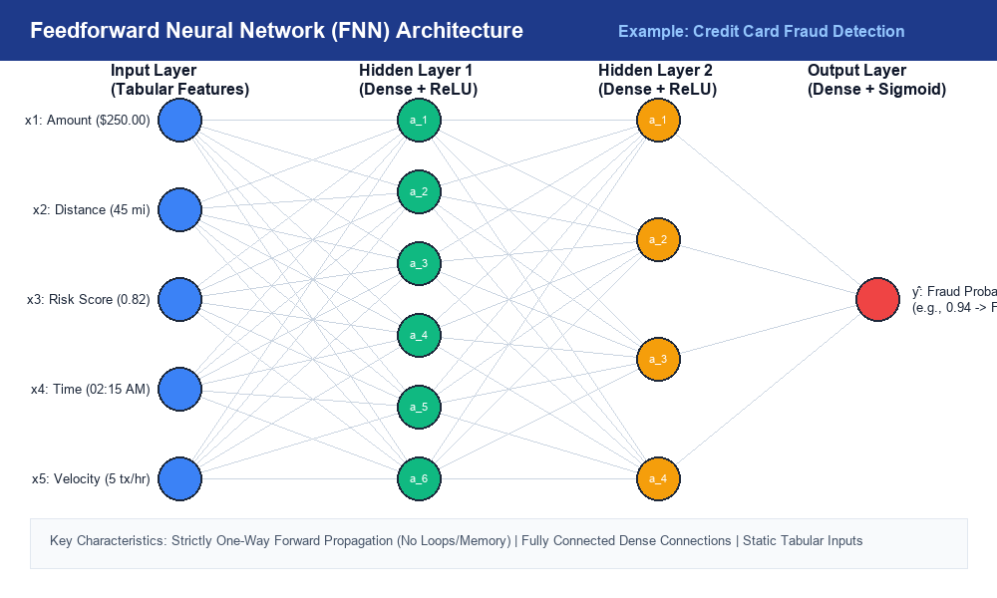
Figure 1: Feedforward Neural Network (FNN) architecture for Credit Card Fraud Detection.
Google / Wikimedia Source Page: https://commons.wikimedia.org/wiki/File:Feed_forward_neural_net.gif
2.2 CNN Application: Medical Chest X-Ray Pneumonia Diagnosis
- Suitable Domain: Computer vision and visual inspection tasks where spatial correlations between adjacent pixels form semantic structures.
- Concrete Case Study: Automated triage system classifying chest X-ray scans as Normal vs Pneumonia.
- Input Data: 2D Grayscale image matrix of size 224 × 224 × 1 (49,952 pixel values).
- Pipeline Workflow: Convolutional filters extract rib bone edges and lung opacity patterns, Max Pooling downsamples spatial size, and dense layers produce the diagnosis score.
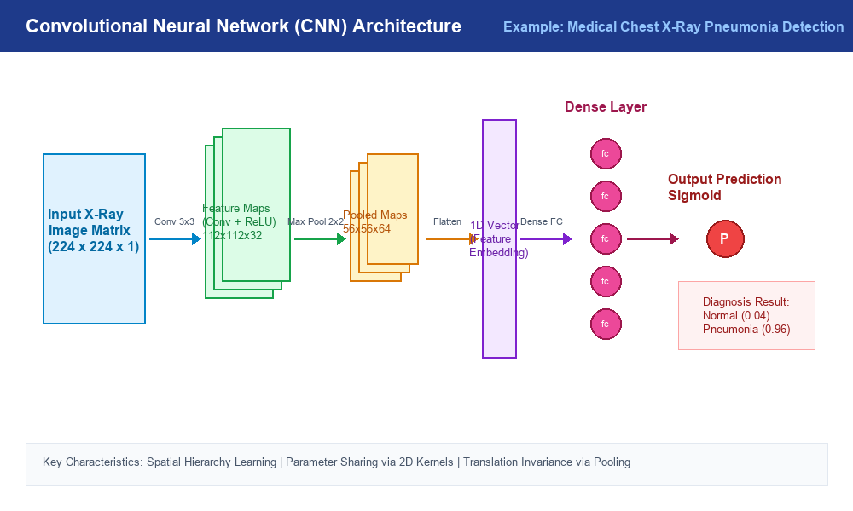
Figure 2: Convolutional Neural Network (CNN) pipeline for Medical Chest X-Ray Pneumonia Diagnosis.
Google / Wikimedia Source Page: https://commons.wikimedia.org/wiki/File:Typical_cnn.png
2.3 RNN Application: Natural Language Sentiment Analysis
- Suitable Domain: Sequential, temporal, and natural language processing tasks where order and past context dictate meaning.
- Concrete Case Study: E-commerce platform analyzing customer review text to assign automated product sentiment scores.
- Input Data: Variable-length token sequence: ['The', 'movie', 'was', 'absolutely', 'fantastic!'].
- Pipeline Workflow: Word vectors enter sequential time steps. The hidden state updates at each word, accumulating sentiment context to output a positive rating.
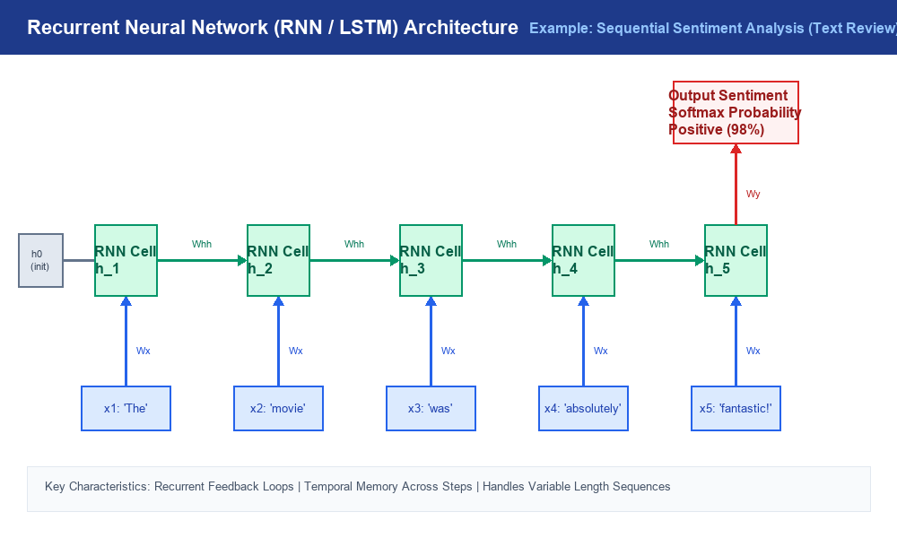
Figure 3: Unfolded Recurrent Neural Network (RNN / LSTM) processing text sequence for Sentiment Analysis.
Google / Wikimedia Source Page: https://commons.wikimedia.org/wiki/File:Recurrent_neural_network_unfold.svg
Task 3: Compare Architectures Based on Structure, Input Data, and Applications
3.1 Detailed Point-by-Point Comparison
- 1. Network Structure: FNN uses dense fully connected layers; CNN uses localized 2D convolution filters; RNN uses recurrent feedback loops across time steps.
- 2. Input Data Type: FNN accepts 1D tabular vectors; CNN accepts 2D/3D visual pixel grids; RNN accepts variable-length 1D temporal sequences.
- 3. Parameter Efficiency: FNN has no weight sharing; CNN shares filter weights across spatial grids; RNN shares weights across temporal sequence steps.
- 4. Spatial Sensitivity: FNN destroys 2D spatial layout; CNN excels at spatial feature extraction; RNN focuses on 1D temporal sequence order.
- 5. Sequential Memory: FNN and CNN are stateless with zero memory across samples; RNN maintains dynamic memory via hidden state vectors h_t.
3.2 Comprehensive Architectural Comparison Matrix
The table below summarizes FNN, CNN, and RNN across 10 critical evaluation parameters:
Evaluation Parameter | Feedforward Network (FNN) | Convolutional Network (CNN) | Recurrent Network (RNN)
Primary Data Type | Fixed-size 1D Tabular vectors | 2D/3D Spatial Image Grids | Variable-length 1D Sequences
Layer Connectivity | Fully connected (Dense) layers | Local receptive fields & Conv filters | Recurrent feedback loops over time
Core Mathematical Operation | Matrix multiplication (z = Wx + b) | 2D Spatial Convolution & Pooling | Sequential hidden state update (h_t)
Parameter Sharing | None (Every node pair has weight) | High (Filters shared over grid) | High (Weights shared over time)
Spatial Layout Awareness | No (Destroys 2D pixel layout) | High (Extracts visual hierarchies) | No (Focuses on temporal order)
Sequential Memory State | None (Stateless, independent) | None (Stateless, independent) | High (Retains past state context)
Parameter Complexity | Explodes quadratically on high-dim | Efficient (Independent of resolution) | Moderate (Independent of sequence len)
Major Advantage | Simple, fast for tabular records | Translation invariant visual features | Handles dynamic text & sequence context
Major Vulnerability | Overfits spatial/sequential data | Heavy computation for 1D text | Vanishing gradients on long steps
Standard Industry Applications | Credit scoring, fraud detection | Medical imaging, self-driving vision | Translation, sentiment analysis, speech

Conclusion & Decision Rules
- Tabular Selection Rule: Use FNN for static tabular records.
- Spatial Selection Rule: Use CNN for image grids requiring spatial feature extraction.
- Temporal Selection Rule: Use RNN (or LSTM/GRU) for temporal sequences, text, and speech.
Google & Wikimedia Image Reference Pages
- Google/Wikimedia FNN Diagram Page: https://commons.wikimedia.org/wiki/File:Feed_forward_neural_net.gif
- Google/Wikimedia CNN Diagram Page: https://commons.wikimedia.org/wiki/File:Typical_cnn.png
- Google/Wikimedia RNN Diagram Page: https://commons.wikimedia.org/wiki/File:Recurrent_neural_network_unfold.svg

