

See discussions, stats, and author profiles for this publication at: [https://www.researchgate.net/publication/359494296](https://www.researchgate.net/publication/359494296_Faults_Occur_in_Solar_PV_Power_Generation_System?enrichId=rgreq-caf0fe162e8639cd36e475f79d8d4dbf-XXX&enrichSource=Y292ZXJQYWdlOzM1OTQ5NDI5NjtBUzoxMTM5NTM1NjQ3OTExOTM3QDE2NDg2OTc4Nzg5NTM%3D&el=1_x_2&_esc=publicationCoverPdf)

[Faults Occur in Solar PV Power Generation System](https://www.researchgate.net/publication/359494296_Faults_Occur_in_Solar_PV_Power_Generation_System?enrichId=rgreq-caf0fe162e8639cd36e475f79d8d4dbf-XXX&enrichSource=Y292ZXJQYWdlOzM1OTQ5NDI5NjtBUzoxMTM5NTM1NjQ3OTExOTM3QDE2NDg2OTc4Nzg5NTM%3D&el=1_x_3&_esc=publicationCoverPdf)

**Research** · March 2022

DOI: 10.15662/IJAREEIE.2022.1103009

CITATIONS

0

READS

652

**5 authors**, including:

[Adarsh Singh](https://www.researchgate.net/profile/Adarsh-Singh-37?enrichId=rgreq-caf0fe162e8639cd36e475f79d8d4dbf-XXX&enrichSource=Y292ZXJQYWdlOzM1OTQ5NDI5NjtBUzoxMTM5NTM1NjQ3OTExOTM3QDE2NDg2OTc4Nzg5NTM%3D&el=1_x_5&_esc=publicationCoverPdf)

[Galgotias University](https://www.researchgate.net/institution/Galgotias-University?enrichId=rgreq-caf0fe162e8639cd36e475f79d8d4dbf-XXX&enrichSource=Y292ZXJQYWdlOzM1OTQ5NDI5NjtBUzoxMTM5NTM1NjQ3OTExOTM3QDE2NDg2OTc4Nzg5NTM%3D&el=1_x_6&_esc=publicationCoverPdf)

**5** PUBLICATIONS **70** CITATIONS

[Ayush Kumar](https://www.researchgate.net/profile/Ayush-Kumar-187?enrichId=rgreq-caf0fe162e8639cd36e475f79d8d4dbf-XXX&enrichSource=Y292ZXJQYWdlOzM1OTQ5NDI5NjtBUzoxMTM5NTM1NjQ3OTExOTM3QDE2NDg2OTc4Nzg5NTM%3D&el=1_x_5&_esc=publicationCoverPdf) [University of Delhi](https://www.researchgate.net/institution/University_of_Delhi?enrichId=rgreq-caf0fe162e8639cd36e475f79d8d4dbf-XXX&enrichSource=Y292ZXJQYWdlOzM1OTQ5NDI5NjtBUzoxMTM5NTM1NjQ3OTExOTM3QDE2NDg2OTc4Nzg5NTM%3D&el=1_x_6&_esc=publicationCoverPdf)

**11** PUBLICATIONS **12** CITATIONS

[SEE PROFILE](https://www.researchgate.net/profile/Adarsh-Singh-37?enrichId=rgreq-caf0fe162e8639cd36e475f79d8d4dbf-XXX&enrichSource=Y292ZXJQYWdlOzM1OTQ5NDI5NjtBUzoxMTM5NTM1NjQ3OTExOTM3QDE2NDg2OTc4Nzg5NTM%3D&el=1_x_7&_esc=publicationCoverPdf)

[SEE PROFILE](https://www.researchgate.net/profile/Ayush-Kumar-187?enrichId=rgreq-caf0fe162e8639cd36e475f79d8d4dbf-XXX&enrichSource=Y292ZXJQYWdlOzM1OTQ5NDI5NjtBUzoxMTM5NTM1NjQ3OTExOTM3QDE2NDg2OTc4Nzg5NTM%3D&el=1_x_7&_esc=publicationCoverPdf)

[Satyendra Vishwakarma](https://www.researchgate.net/profile/Satyendra-Vishwakarma-2?enrichId=rgreq-caf0fe162e8639cd36e475f79d8d4dbf-XXX&enrichSource=Y292ZXJQYWdlOzM1OTQ5NDI5NjtBUzoxMTM5NTM1NjQ3OTExOTM3QDE2NDg2OTc4Nzg5NTM%3D&el=1_x_5&_esc=publicationCoverPdf)

[Babasaheb Bhimrao Ambedkar University](https://www.researchgate.net/institution/Babasaheb-Bhimrao-Ambedkar-University?enrichId=rgreq-caf0fe162e8639cd36e475f79d8d4dbf-XXX&enrichSource=Y292ZXJQYWdlOzM1OTQ5NDI5NjtBUzoxMTM5NTM1NjQ3OTExOTM3QDE2NDg2OTc4Nzg5NTM%3D&el=1_x_6&_esc=publicationCoverPdf)

**23** PUBLICATIONS **189** CITATIONS

[SEE PROFILE](https://www.researchgate.net/profile/Satyendra-Vishwakarma-2?enrichId=rgreq-caf0fe162e8639cd36e475f79d8d4dbf-XXX&enrichSource=Y292ZXJQYWdlOzM1OTQ5NDI5NjtBUzoxMTM5NTM1NjQ3OTExOTM3QDE2NDg2OTc4Nzg5NTM%3D&el=1_x_7&_esc=publicationCoverPdf)

**Some of the authors of this publication are also working on these related projects:**

 DEVLOPMENT OF A MATLAB/SIMULINK MODEL OF A THREE PHASE GRID CONNECTED SOLAR PV SYSTEM [View project](https://www.researchgate.net/project/DEVLOPMENT-OF-A-MATLAB-SIMULINK-MODEL-OF-A-THREE-PHASE-GRID-CONNECTED-SOLAR-PV-SYSTEM?enrichId=rgreq-caf0fe162e8639cd36e475f79d8d4dbf-XXX&enrichSource=Y292ZXJQYWdlOzM1OTQ5NDI5NjtBUzoxMTM5NTM1NjQ3OTExOTM3QDE2NDg2OTc4Nzg5NTM%3D&el=1_x_9&_esc=publicationCoverPdf)

All content following this page was uploaded by [Satyendra Vishwakarma](https://www.researchgate.net/profile/Satyendra-Vishwakarma-2?enrichId=rgreq-caf0fe162e8639cd36e475f79d8d4dbf-XXX&enrichSource=Y292ZXJQYWdlOzM1OTQ5NDI5NjtBUzoxMTM5NTM1NjQ3OTExOTM3QDE2NDg2OTc4Nzg5NTM%3D&el=1_x_10&_esc=publicationCoverPdf) on 31 March 2022.

The user has requested enhancement of the downloaded file.



**Volume 11, Issue 3, March 2022**

**Impact Factor: 7.282**

**Faults Occur in Solar PV Power Generation System**

**Yash Gupta1, Nitesh Pratap Yadav2, Adarsh Singh3, Ayush Kumar4, Satyendra Vishwakarma5** Student, Department of Electrical Engineering, UIET, Babasaheb Bhimrao Ambedkar University, India1234 Faculty, Department of Electrical Engineering, UIET, Babasaheb Bhimrao Ambedkar University, India 5

**ABSTRACT:** PV array faults affect the output power performance and result in severe and potentially dangerous situations. Conventional techniques commonly include fuses or circuit breakers in series with PV components for fault protection and detection in a PV array. These protective devices can only handle faults as well as isolate faulty circuits whena large faulty current is present.Fault detection in the PV system is considered essential to guarantee security and increase PV array output power. Not only can PV faults decrease output power as well as efficiency,however also decrease a system's working duration.Most frequent and chronic PV faults are shadowing fault, a line to ground, line to line, and arc fault whereas less frequent and acute faults are bypass diode, degradation, hotspot as well as connection faults. The present fault detection methods as highlighted in this article have several drawbacks, which might lead to a fault’smisdetection.This articlefocuses on the mathematical formulation of several PV faults and led to the latter’s critical analysis in terms of reliability, complexity, efficiency,and precision. The given study also assists to determine the type and reasons for a PV fault. This study serves as a particular set of references as well as suggestions for investigators and the PV production industry to improve the prospects of fault-finding in solar PV systems.

**KEYWORDS:** PV array, Fault,method for Analysis and IV characterstics.

# INTRODUCTION

A PV array normally contains many parallel PV strings and there are many modules in series in each string. Each module, string as well as whole array have its I-V characteristics as well as unique MPP:“maximum power point” whether in normal or a fault state. Their total I-V curve is controlled by the interactions between the PV modules. Therefore, PV modules function together as a chain, which is just a powerful as the weakest link. The weakest connection is the lowest module or string performance for a PV array under standard conditions [6]. This also true to the PV array in failure situations.PV array faults destroy PV modules and wires and cause electrical shock threats along with fire danger. For instance, two fire threats due to ground faults and line-to-line failures in PV arrays were shown using case studies of a big PV power plant in “California”, USA [4]. Furthermore, faults in PV arrays can lead to a significant loss of power. For example, In the United Kingdom, yearly energy loss is estimated at up to 18.9% owing to PV system faults [7]. Thus, fault analysis for the PV array is a significant task for reliability analysis and system efficacy. On the basis of the simulation model developed in Chapter 2, this chapter investigates the modelling and tests on a number of forms of faults in PV array with the high irradiance level, such as MPPT algorithm impacts. Fundamental fault analysis methodologies are described on the basis of the I-V analysis, numerical computation, electrical circuit analyses, and knowledge of MPPT algorithms.

Our study contains certain specific assumptions as well as considerations. The only source for fault current is considered the PV array. In other terms, it is expected that any inverter, battery, lightning strike, or external source does not cause an overcurrent or overvoltage. This is acceptable as many 10kW or fewer grid-connected inverters cannot transmit the current back to PV array faults from the utility grid [7]. Further, this study analyses the faults in PV arrays with zero impedance for simplicity. As per fault current behaviors in power systems frequently include three states: transient, pre-fault as well as post-fault steady state (Figure 3.1). The transient state in the analysis of fault is not taken into consideration as the current fault set-up time is insignificant (for example, for a 175 W crystalline silicon PV module short-circuit fault is less than 0.1 m), and the transients have no consequences on conventional safety equipment. Thus, this studyfocuses only on normal conditions (“pre-fault steady state”) andfault conditions (“post- fault steady-state”)

In the literature [3, 5, 7, 8-12] many methodologies forthe analysis of PV systems faults were suggested. The Study [8] first provides a summary of the main reasons for failure in terrestrial PV modules however, there is no detailed current fault analysis.The I-V 49 characteristic PV array analysis is investigated initially in the literature under typical faults [9]. However, it just shows the total performance of the faulty array without revealing any PV or string interconnection

investigations. Similarly, for a few kinds of failure in the PV array with no estimates of faults current, only power versus Voltage (P-V) characteristic is simulated in [10-11]. The article [3] focuses on overcurrent protectiveequipment in PV arrays selection, like fuses, depending onthe highest probable fault current. However,there is no detailed current fault analysis under various environmental or electric situations. An examination of PV system ground fault protection devices [5] focused on the “ground fault” problems on the AC side. However, there is no current of fault on the DC side. A long-term PV system performance data was gathered and divided into several forms of faults [7].However, only the faults shown in the figure focused on the yearly energy losses instead ofthe detailed analyses of faults.

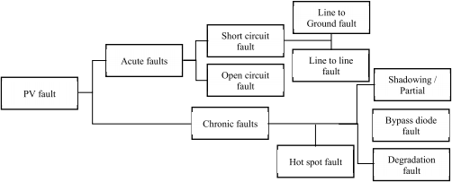

Fig. 1 types of faults [1]

# FAULT IMPACT ON PV ARRAYS PERFORMANCE

PV array faults affect the power output and result in critical and maybe dangerous circumstances. The PV array is considered the only cause of fault current in this work. Traditional techniques commonly incorporate fuse or circuit breakers in series to PV components for fault detection as well as protection in the PV array [3-5]. These protective devices can handle faults and insulate fault circuits only when they have a high faulty current. For instance, as per the US *NEC* [2], notbelow 1.56 times the *Isc* (“short circuit current”) of PV modules is classified in the nominal currents of serial PV fuses. Nevertheless, due to PV arrays current limitationsas well as non-linear I-V characteristics, losses could not lead to considerable overcurrent. Furthermore, the following considerations could make fault analysis in PV more challenging:

* Faults forms may vary according to then fault locations, PV array configurations and number of solar PV modules;
* PV inverter MPPT effects may affect fault currents;
* Environmental factors, including different irradiance levels as well as PV array temperature;
* PV technology is distinct to the aging, the hot spot along with other PV mismatch faults.

These causes might lead to a decrease in fault current than predicted. Therefore, conventional protective devices may not be able to appropriately eliminate the fault. The next sections explore these fault protection difficulties.

# TYPICAL FAULTS IN PV ARRAYS

It normally contains many simultaneous PV strings, and several modules are available for each string. Each module, string, and complete array has its I-V characteristics and a distinct MPP under normal or fault conditions. When PV modules are joined together, the interactions between them define their overall I-V curve. Therefore, PV modules function together as a chain, which is just a powerful as the lowest connection. For the performance of a PV array, the lowest connection under typical situations is the lowest module or string [6]. This also true to the PV array in failure situations.

PV array faults cause damage to PV modules and wires and electrical shock and fire danger. Two fire threats due to ground faults as well as line-to-line failures in PV arrays were shown using case studies of a big PV power plant in “California”, USA[4]. Furthermore, faults in PV arrays could lead to a significant loss of power. For example, In the United Kingdom, yearly energy loss is estimated at up to 18.9% owing to PV system faults [7]. Thus, fault analysis for the PV array is a significant task for reliability analysis and system efficacy.

As per fault current behaviors in power systems frequently include 3 states: transient, post-fault, and pre-fault steady state (Figure 2). The transient state in the analysis of fault is not taken into consideration as the current fault set-up time is insignificant (for example, for a 175 W crystalline silicon PV module short-circuit fault is less than 0.1 m), and the transients have no consequences on conventional safety equipment. Thus, this study focuses only on “pre-fault steady state” and “post-fault steady-state”.

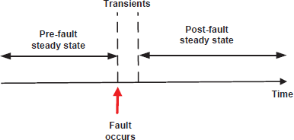

Fig. 2. Three states of power systems fault evolutions

“Maximum power point tracking” (MPPT) was also explored in the literature for problems with reliability in PV systems [2]. It examines only PV array MPPT reliability with partial shade rather than array faults. In general, the PV inverter MPPT algorithm has a major effect on PV arrays in fault scenarios. However, none ofthe earlier investigations have highlighted that properly.

# APPROACHES OF FAULT ANALYSIS

This paper first provides three basic fault analysis methodologies for a PV array. To demonstrate these methods, this study presents a standard series-parallel PV system arrangement illustrated in Figure 3. The PV scheme has *n* parallel PV strings linked in a distinct positive or negative bus via the PV string cables. The negative bus is purposefully based on *NEC* standards [2]. Each string contains a sequence of *m* PV modules.Figure 3 does not indicate the grounding of the equipment. This PV array works in standard conditions and generates a current of I*1,I2… In* in each string. If the strings of PV are all electrically equivalent and operate in the same working environment then*I1=I2=… =In=I*. The overall current through the inverter is*Ipos=n×I*. Two GFPD switches are closed under standard work conditions, and the *Ig*(“ground-fault current”) in GFPD is nil. As a consequence, the current following out of theinverter *Ineg*must be equivalent to *Ipos*(*Ipos*=*Ineg*).

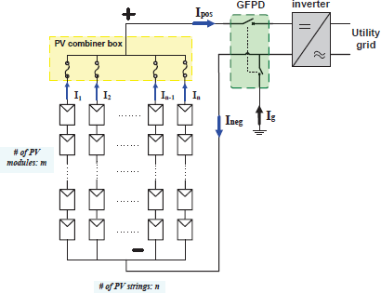

Fig. 3A grid-connected PV system schematic diagram with *m×n* modules

When a fault occurred in the PV array in Figure 3, the configuration of the PV array is adjusted correspondingly. The layout for the faulted PV array may be changed by combining two PV string groups (see Figure 4). There arecurrents *If2*flowing into and *If1*flowing out the faultycomponent of the array. In the meantime, currents *In2*flowing intoand *In1*flowing out the normal part of the array with *In1=In2*.The ground-fault current will be zero (*Ig=If1-If2=0*) if there is not a fault on the ground.On the other hand, when a ground fault is present its point creates a ground fault path because the negative conductors are already a system ground point. As aresult, the ground-fault current *Ig=If1-If2*might not be zero. When*Ig*indicates high enough(i.e.,>0.5A), *Ig* may trip the GFPD andthe fault circuitry would be isolated. The 2 connected switches are opened further on in the GFPD. Thus, the entire PVarray, as well as the inverter,generally would be turned off.

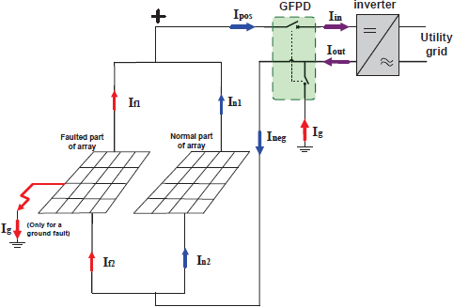

Fig. 4Modified PV system schematic diagram under fault

Thefundamental approaches of fault analysis include KCL: “Kirchhoff's Current Law”, I-V characteristics as well aspower conservation analysis.

# I-V characteristics analysis

The I-V characteristic explains the PV array's behaviorand it is a key tool for fault &normal analysis. The normal part and faulted part have a faulted PV array with the same operating voltage as the series-parallel configuration. In accordance with the I-V characteristic provided for PV arrays as well as array operating voltage, normal & faulted work points of the array may be derived.

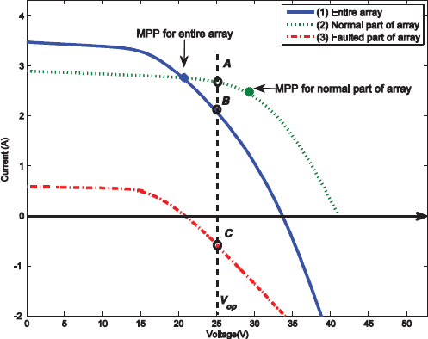

Fig. 5 I-V array characteristics under STC fault

In general, PV array faults may induce fluctuations in the voltage along with unequal currents between PV strings. Usually,unequal currents might back feed into the faulty string to harm interconnecting conductors or PV modules [2]. For instance, the previous faulted array I-V characteristics (see Figure. 3) are presented in Fig. 5 only for the purposes of illustration. Figure 5 illustrates that the I-V curves vary significantly across the entire array, the normal part, and the fault parts of the array. The normal part &faulted part of the array should work at a similar voltageand parallel to one another. However, they no longer have the same MPP. For instance, the normal part, an entire array as well as the faulted part operating points may be identified at points A, B & C, correspondingly at *Vop* (“operation voltage”) on the I-V curve in Figure.It is also noted that even under fault, the normal part still has a positive current, but the array faulted part has a back-fed current, which might harm cable and PV modules.

The major cause for the fault current is because the I-V curve shifts the faulty string to alow *Voc*(“open-circuit voltage”). But, as MPPT in inverter reacts rather gradually to the fault, the *Vop*of the array does notvary quickly after a failure. Thus, the MPPT maintains a relatively steady system voltage just after the fault. In the 4th quadrant of its I-V curve, the fault string should function as a load rather than as a source in the 1st quadrant (see Figure 5). If the fault occurred on a clear day, the back-fed current is likely to be sufficiently high and the OCPD (“over-current protection devices”) with faulted PV string would be tripped. However, it is probable that the back-fed current will not be strong enough to trigger the OCPD if faults occur on a cloudy day or night.

# KCL analysis

KCL demands the total of currents that flow into that node at each node (or junction) on electrical circuits, equivalent to the sum of current that flows out of the node where a node is any location with 2 or more wires are attached to that node. From this perspective,a negative/positive bus bar, a ground-fault point,or the inverter might be considered a node for PV systems. The current relations should be complied by applying the “KCL analysis” to a PV system for ground faults previously displayed in Figure 3.

* At GPFD: *Iout+Ig-Ineg*=0
* At inverter: *Iin=Ipos* &*Iin=Iout*
* At negative bus bar: 2 *Ineg-(If2+In2)*=0
* At ground-fault point: *If2-(If1+Ig)=*0
* At positive bus bar: 1 *(If1+In1)-Ipos=0*

# Conservation of power analysis

The PV arrays may use the power conservation law. The power production in PVarrays must be the sum of the power losses as well asload power mentioned in (1).

*“PG*=*Pload*+*Ploss*+*Pfault*(1)”

Here,*PG*indicates the power produced byusing PV array; *Pload*represents the power supplying to the inverter;*Ploss*signifies the losses power in PV array, that is mostly due to wiring cables resistance [13]; *Pfault*denotes a specific load that is the power dissipated during fault working conditions in thefaulted part of the array.

The PV system's power conservation may be determinedbyfault array I-Vcharacteristicsin Figure 5. *As Ipos= In1+If1*on the *Vop*, *Ipos.Vop=(In1+If1)* isconcluded.*Vop*, that is equal to*PG=Pload+Pfault*, where*Ploss*is so small that can be neglected.

# Ground faults in a PV array under STC

It is an electric short circuit that is accidental and involves ground and some usually referred current-carrying conductors. The magnitude of the ground-fault current is based on geographical factors, fault impedance, and fault location. When a ground fault is not correctly protected, the fault connection may start generating a DC arc that may turn into a fire danger and maintain it. The following are generally the typical causes for ground faults [14-15]:

* Ground faults with PV modules, that is the short-circuiting of solar cells to the grounded module frames by degrading PV module encapsulation, damage to impact or water corrosion, etc;
* Incidental short circuit in the ground and normal conductor, such as a cable in the junction box of a module that contacted a grounded conductor;
* A cable insulation fault, such as an animal eating by cable insulation, causes a ground fault.

# Line-line faults in a PV array under STC

This fault is a low-resistance link made in an electrical system or network between two different points of potential. The line-to-line fault is generally described in PV systems as a “short-circuit” fault for array cables or PV modules of various potential. It is considered that line to line faults does not include “ground points” in this investigation. Any ground points may be classified as a ground fault for a line-line fault. Like“ground faults”, the line-to-line fault current magnitude alsorelies on forms oflossesas well as environmental issues. A line-to-line fault can be caused mainly by the following [15]:

* DC junction box line to line faults such as water ingress, corrosion as well as mechanical damage;
* Cables Insulation failure for example an animal eatingbycable insulation causes a line fault;
* Incidental short circuit among current conductors, that is a nail driven by exposed wires.

# Mismatch faults in a PV array

In the PV modules, mismatches arise if one module's electrical characteristics are substantially modified compared with the other modules. Furthermore, the modules or solar cells interconnectionthat has varied conditions in their environment (such astemperature or irradiance), is the cause of mismatch faults. Mismatch fault is the most prominent form of defect in PV arrays compared to ground faults as well as line-to-line faults. Mismatch faults can result in permanent PV module damage and substantial power losses. However, employing traditional safety measures is difficult to detect, as they don't often contribute to large fault currents. Mismatch faults can causemajor difficulties in arrays, as well as PV modules due to the entire PV module's worst-case operating condition,which is defined asthe lowest performance with the PV module. The effect, as well as power loss owing to the mismatch, are strongly linked to:

* Parameter variation of different PV modules;
* The PV array configuration;
* The PV module operating point (i.e., array voltage *Vsys*).

Mismatch faults may be divided into two categories i.e.,permanent & temporary.The following are their causes.

1. Permanent mismatches: degradation/aging issues, PV strings or modules open-circuit faults, hot spots because of defective PV modules or /and bypass diode failure [19].
2. Temporary mismatches: non-uniform temperature and/or partial shading on a PV array [16-21];

The first category is temporary mismatches, like non-uniform PV array installation shading. In larger centralized PV arrays, non-uniform cloud shading is particularly common [17], which disproportionately affects the performance of the system and might lead to issues of the local heating (termed “hot spots”). Each PV module in a PV array is commonly supplied with numerous diode bypasses to avoid hot spot damage to bypass the additional current which the module maynot allow. The 2nd category consists of “permanent mismatches”, whichwould damage PV arrays more severely and affect the efficiency and reliability of systems.

# CONCLUSION

For fault protection and detection in PV arrays, traditional methods commonly incorporate OCPD(circuit fuses or breakers) in PV components series w. These protective devices can only clear faults as well as isolate faulty circuits when it contains the large faulty current[17-19]. For instance, the nominal current of series fuses in PV modules is rated at1.56 times the *Isc* of PV modules according to *NEC* [12]. However,owing to the PV array's current-limiting nature as well as the non-linear current-voltage (I-V) characteristics, sometimes fault currents cannot be high enough to trigger theOCPD.Furthermore, PV faults can be more complexdue to mismatches between PV modules, different fault locations varying environmental conditions as well as the MPPT of the inverters. This needs specific attention in PV arrays for fault analysis.

# REFERENCES

1. I. U. Khalil *et al*., "Comparative Analysis of Photovoltaic Faults and Performance Evaluation of its Detection Techniques," in *IEEE Access*, vol. 8, pp. 26676-26700, 2020.
2. NFPA70, "Article 690 - Solar Photovoltaic Systems of National Electrical Code," ed, 2011.
3. M. Calais, N. Wilmot, A. Ruscoe, O. Arteaga, and H. Sharma, "Over-current protection in PVarray installations," presented at the ISES-AP-08 Sydney, 2008.
4. D. E. Collier and T. S. Key, "Electrical fault protection for a large photovoltaic power plantinverter," in Photovoltaic Specialists Conference, 1988., Twentieth IEEE,pp. 1035-1042, vol.2, 1988.
5. W. Bower and J. Wiles, "Investigation of ground-fault protection devices for photovoltaic powersystem applications," in Photovoltaic Specialists Conference, 2000. Twenty-Eighth IEEE, pp. 1378-1383, 2000.
6. A. Strand and B. Harris. Improving PV system Energy Yield with "Parallel" Wiring. Available:<http://www.sustainableenergy.com/fileadmin/user> upload/product information/Parallel Wiring forIncreased Energy Yield - Whitepaper.pdf
7. S. K. Firth, K. J. Lomas, and S. J. Rees, "A simple model of PV system performance and its use infault detection," Elsevier - solar energy, 2009.
8. J. Wiles. (2008) To Fuse or Not to Fuse? Home Power #125, code corner. 106-108.
9. S. E. Forman, "Performance of Experimental Terrestrial Photovoltaic Modules," Reliability, IEEETransactions on, vol. R-31, pp. 235-245, 1982.
10. D. Stellbogen, "Use of PV circuit simulation for fault detection in PV array fields," inPhotovoltaicSpecialists Conference, Conference Record of the Twenty Third IEEE, pp. 1302-1307,1993.
11. K.-H. Chao, S.-H. Ho, and M.-H. Wang, "Modeling and fault diagnosis of a photovoltaic system,"Electric Power Systems Research, 2008.
12. K.-H. Chao, C.-J. Li, and S.-H. Ho, "Modeling and fault simulation of photovoltaic generation systems using circuit-based model," in Sustainable Energy Technologies, 2008. ICSET 2008. IEEEInternationalConference on, pp. 290-294, 2008.
13. G. Petrone, G. Spagnuolo, R. Teodorescu, M. Veerachary, and M. Vitelli, "Reliability Issues in Photovoltaic Power Processing Systems," Industrial Electronics, IEEE Trans. on, vol. 55, pp. 2569-2580, 2008.
14. "A guide to photovoltaic (PV) system design and installation," California energy commission,consultant report, June 2001.
15. T. Markvart and L. Castaner, Practical Handbook of Photovoltaics: Fundamentals andApplications: Elsevier Advanced Technology, The Boulevard. Langford Lane, KidlingtonOxfordOX5 lGB, UK, 2003.
16. N. Dzung and B. Lehman, "An Adaptive Solar Photovoltaic Array Using Model-BasedReconfiguration Algorithm," Industrial Electronics, IEEE Transactions on, vol. 55, pp. 2644-2654,2008.
17. D. D. Nguyen and B. Lehman, "Modeling and Simulation of Solar PV Arrays under ChangingIllumination Conditions," in Computers in Power Electronics, 2006. COMPEL '06. IEEEWorkshops on, pp. 295-299, 2006.
18. N.D. Kaushika, Anil K. Rai, An investigation of mismatch losses in solar photovoltaic cell networks,Energy, Volume 32, Issue 5, 2007, Pages 755-759, ISSN 0360-5442.
19. Satyendra Vishwakarma, Study of Partial shading effect on Solar module using MATLAB, International, Journal, of Advanced Research in Electrical, Electronics and Instrumentation Engineering, 6(7), 5303-5308, July 2017.
20. E. L. Meyer and E. E. van Dyk, "Assessing the reliability and degradation of photovoltaic moduleperformance

parameters," Reliability, IEEE Transactions on, vol. 53, pp. 83-92, 2004.

1. Satyendra Vishwakarma, Behaviour of battery energy storage system with PV, - International Journal of Innovative Science, Engineering & Technology, Vol. 2 Issue 9, September 2015, ISSN 2348 – 7968.

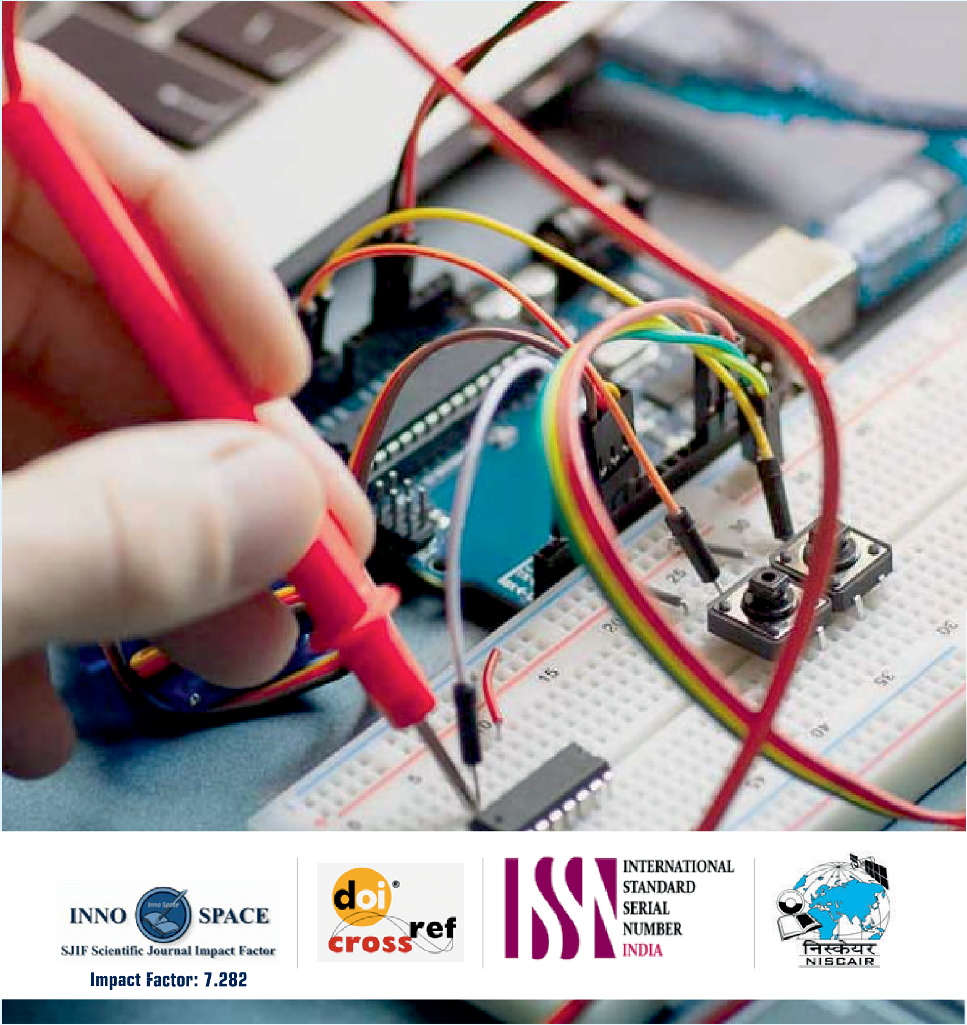



[View publication stats](https://www.researchgate.net/publication/359494296)

              

