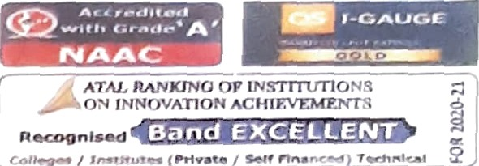lhISô"CTU4-R œ! ûläGlNEERIï•›

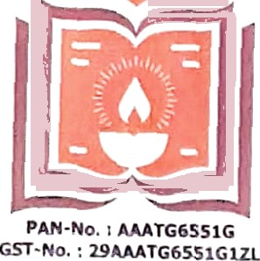

&ND Ï EClJ NOL9C•°t^ FOR Vf*3Mz› 1



Date: 02/ 02/ 2023

ENDORSEMENT

This is to certify that below mentioned are bonafide student(s) of Department of Electrical & Electronics Engineering in the UG degree program of our institution. If the project proposal submitted by thèse students under the 46” series of Student Project Programme is selected by KSCST, we will provide the requisite laboratory / Computer / infrastructure support in our college / Institution. Further we also take necessary steps to see that the project team will exhibit / demonstrate their project in the nodal centre and in the State Level Seminar and Exhibition (if selected). If the student team fails to send the completed project report or fails to attend the evaluation in nodal centre or fails to attend the State Level Seminar and Exhibition, the supported project amount will be returned to KSCST

SI. No Sfudeaf I Studeof 2 Student 3 Student 4

|  |  |  |  |  |
| --- | --- | --- | --- | --- |
| 1 | Ganavi G | Hi ashree HS | Renuka S Manner | Tejashree S |
| 2. | Nisarga B | Nisarga M | Harshitha L | Sahana R K |

# 3. “Chandana H R Mouna M D

Supritha A

# 4 ishwarya M Dakshayini N Dhanushree N Divya E R

1. ›°.ishwarya R Kavya Vishwanath Nimrah Zain R

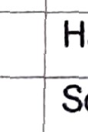

Sonika U P

Sameera Maheen Taj

1. Bindushree

Archana R Pooja Sharma

Priyadarshini R

Rakshitha G PraŸuthi K N Vidyashree K

Bhoomi›‹a C P



1slgoature of the Pri»cipai with Seau

Princiç••l

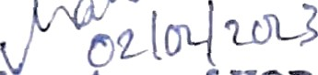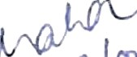

(S1g¥zatore of HOD

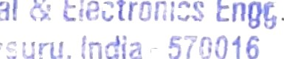 

# Email id: hodeeeÿ gsss.ed u.in

Contact No.: 9980147498

Email Id: principale gsss.edu. us

Contact I2o.:98111OG 2 ï1