## ACTIVITY-3

Spreading public awareness under rural outreach program

**Activity Details:**

|  |  |  |
| --- | --- | --- |
| **Activity Head** | **:** | Spreading public awareness under rural outreach program |
| **Total Duration Spent** | **:** | 80 hours |
| **Activity Place** | **:** | Mysore |

# Abstract of the Activity:

The main objective is to spread awareness about community response, measures taken by government duringpandemic and spread awareness for the measures to be taken during natural disaster among the rural people.

# Activity Summary:

The activity was done every day for one hour thirty minutes in online mode, during the month June 2022 - July2022

### DAY 01-10 [June 1 2022 - June 10 2022] COMMUNITY RESPONSE NETWORK

**Objectives:**

Community Response Network (CRN 101) is a simple course designed to give a student a basicunderstanding of disaster management and how government systems work in general.

The objective of CRN 101 course is to educate and create awareness about various government systems involvedin the mitigation of disaster management. It covers a brief introduction to various government systems and how these systems coordinate together at times of disasters.

# Topic discussed:

* The local self-government (Panchayat/Municipality/Corporation).
* Health care infrastructure.
* Revenue system.
* Panchayat level in Block level and district level.
* Response with a community.
* Vaccines.

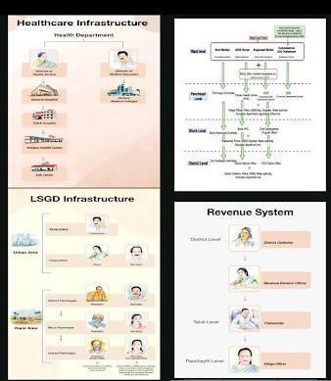

### Fig. Community Response Network

**THE LOCAL SELF GOVERNMENT**

The 3-tier panchayat system

### Rural areas:

The ward members from various Wards report to a Panchayat Committee. The Panchayat committee alsohas appointed members along with the elected members. The Panchayat Committee has a President (Elected Member) and Secretary (government appointed member) and various standing committees (e.g.:Standing Committee on health, welfare, finance).

### Urban areas:

The Municipalities (Municipals Councils/Nagar Palinka /Nagar Palinka Parishad) and Corporations (Municipal Corporations) are the local government in India that administer urban areas with a populationof more than 25 thousand and more than 10 lakhs respectively. Some states in India have City Councils(Nagar-Panchayat) as an additional division. The area administered by a municipality or corporation is divided into territorial constituencies known as wards. Members are elected to the wards committee on the basis of adult franchise for a term of five years. These members are known as councilors. The number of wards is determined by the population of the city.

### HEALTH SYSTEM

The public-health care system in India is based on a three-tiered health-care system to provide preventiveand curative health care in rural and urban areas. It consists of sub-centers, primary health centers and community health centers.

### REVENUE SYSTEM

In pre-independent India, there was one person who was in charge of collecting tax revenues from the public. This person was the “Collector” in the “Revenue” Department. The District Collector heads therevenue system within a district in addition to many other administrative responsibilities including that of the District Magistrate.

### COORDINATION OF THESE SYSTEMS IN DIFFERENT LEVELS

The municipalities and corporations are also divided into Divisions. A division is bigger than a ward with almost 10 times the population. Each division again has a Rapid Response Team (RRT) with a Counsellor (instead of a ward member), ASHA (Accredited Social Health Activist) worker (usually morethan 1, depending on the population) Anganwadi Worker and Area Development Society (ADS) by Columbate.

### DAY 11-20 [11 June 2022 – 20 June 2022]

**COVID -19 Infection**

COVID-19 infection is most commonly associated with symptoms like fever, dry cough and lethargy/ tiredness. Other symptoms include ache/pain, sore throat, nasal congestion, conjunctivitis, loss of taste or smell, headache,breathing difficulties and diarrhea in some patients. Anyone can be infected with COVID-19 irrespective of ageor sex or religion or nationality

### Response to COVID-19

How does the government system deal with Coronavirus spread within a Ward? (Management of suspects)The Corona Virus has not just affected our health as a population but has also managed to alter the behavior of our whole community. It is important to learn how the community has evolved to deal with the Corona Virus. While public gatherings are restricted, travelling is also discouraged.

### Management of Covid-19 patients by Rapid Response Systems (RPR) with help of some systems

* + Tele Health Helpline.
  + First-Line Treatment Centers.
  + Field Response Home Care teams.

### Treatment of Covid-19 patients

* + First Principle: "Separating COVID and Non COVID by creating a parallel COVID health care system".
  + Second Principle: "De centralization of existing system to the panchayat and ward level**".**

### Categorization of COVID patients and the 3-Tier Healthcare System

Symptomatic patients are sub classified into Mild, Moderate and Severe.

### Health care system

* + **First Line Treatment Centre**: **FLTC** patients who are below the age of 60 years and have mildsymptoms with no significant comorbidities.

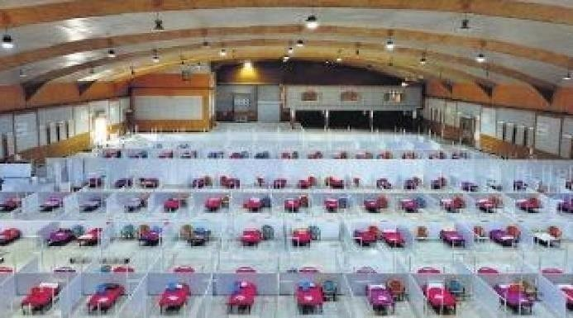

### Fig. First line treatment

* + **Second Line Treatment Centre**: **SLTC** will be catering to patients with moderate symptoms and thoseabove 60 years or having any commodities with moderate symptoms.

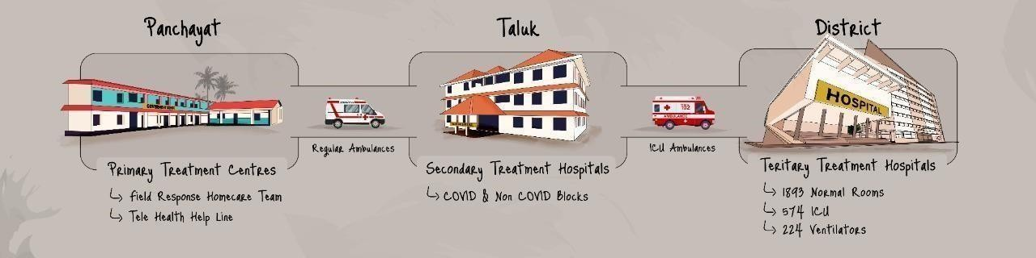

### Fig. Health care infrastructure

**Testing of COVID -19**

It is recommended that people with symptoms undergo testing. We have an antigen and RT PCR test currently available in our medical field of expertise. The RT PCR test is a global standard system, it is costly (varies fromRs.500-1500 in various states) and the result is accurate, but time- consuming (approx. 24hours).It tests for viral Real Presence and Virus genetic material may be detected. The Antigen tests (cost varies from Rs.150 to Rs.300) check the presence of protein, the accuracy is lesser as compared to RT PCR. It is an easily accessible test. The virus particle is detected. For checking antibodies present, a blood samples taken and if the virus enters a person’s body, it will take around 7 days.

### Vaccines

A vaccine is a biological preparation that provides active acquired immunity to a particular infectious disease. A vaccine typically contains an agent that resembles a disease-causing microorganism and is often made from weakened or killed forms of the microbe, its toxins, or one of its surface proteins. The agent stimulates the body's immune system to recognize the agent as a threat, destroy it, and to further recognize and destroy any of the microorganisms associated with that agent that it may encounter in the future.

### Production of vaccines:

On average, it takes between 12-36 months to manufacture a vaccine before it is ready for distribution. Successful manufacturing of high- quality vaccines require international standardization of starting materials, production and quality control testing, and the setting of high expectations for regulatory oversight of the entire manufacturing process from start to finish, all while recognizing that this field is in constant change.

### Major challenges during pandemic:

1. **Uncontrolled spread of the infection**: The uncontrolled spread of infection in the community due to lack of adequate precautions and awareness in the general population.
2. **Large volume of patients:** Even the most advanced nations across the world fail due to the sheer volume of patients that a pandemic creates in a short period of time. Therefore, it is essential to tackle this by preventing an uncontrolled spread.
3. **Augmenting our Healthcare Infrastructure to meet the load:** Our existing healthcare infrastructure maybe inadequate to cater to those who are affected by the pandemic and for regular patients. The healthcare system of any state should be able to absorb the load created by the increased number of sick people so that the system doesn't collapse due to overload.

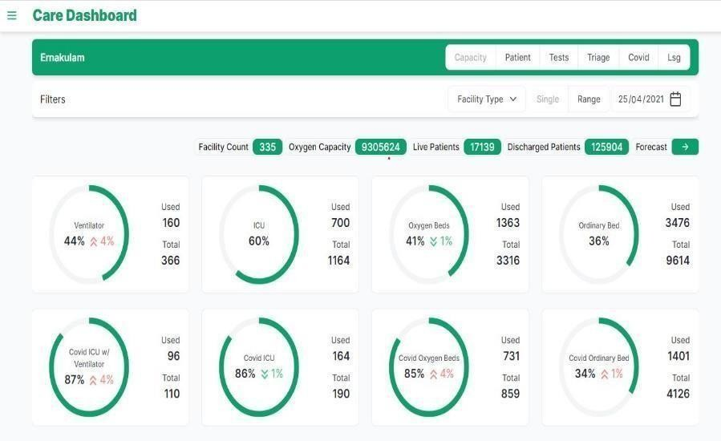

### Our Immediate future with COVID-19.

The first step forward is to create a good public awareness regarding COVID-19, safety precautions to be followed, existing facilities that can be utilized and the proposed plan of action for the future. A community-based approach is essential to fight the impacts of this pandemic as its tentacles have gripped various segments of our daily life including healthcare, economy, education, secure employment, supply of essential requirements etc. Every individual will have a role in rebuilding or reinventing methods to revive various sectors/segments of the community. It is time that the citizen, especially the youth step up and take more in this fight against the virus.

### DAY 21-30 [21 June 2022 – 30June 2022]

**Disaster Management:**

Disaster Management can be defined as the preparedness, response and recovery methods in order to lessen the impact of disasters. A disaster disrupts the normal function of the society to the extent that it cannot function without outside help. Disasters can be classified as natural, technological or complex emergencies systems of disaster management.

### Prevention of disaster management:

* Vegetative measures: Preserving vegetation, grasses and trees can minimize the amount of water infiltrating into the soil, slow the erosion caused by surface-water.
* Management measures: Integrated River basic approach public awareness, participation and insurance and use zoning &risk assessment flood fore casting and warning system.

### Landslides:

Landslides are caused by rain, earthquakes or other factors that make the slope unstable. They are of four types fall and toppling, slides(rotational and translational), flows and creep.

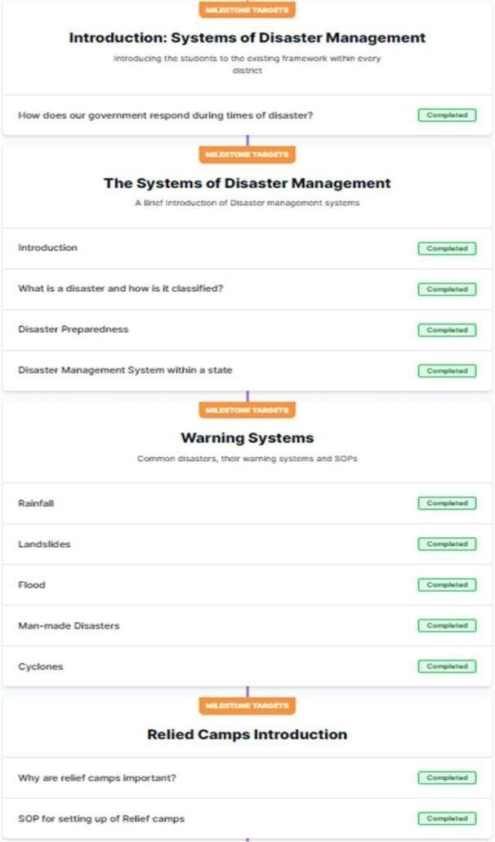

### Cyclones:

Cyclone account for 30% of the total occurrences of disasters in India. It is defined as a region of low atmospheric pressure surrounded by high atmospheric pressure resulting in swirling atmospheric disturbance and accompanied by powerful winds. The Odissa super-cyclone in 1999 had a wind speed of 260300 km/hand killed thousands.

### Relief camps:

Setting up and managing camps is one of the most challenging tasks when a disaster occurs. They are indispensable and require proper planning and execution. The process is dynamic in nature. The camps need tube constructed such that the physical, emotional, cultural and social well-being of the campaign habitant ensured.

### Standard Operating Procedure for Relief Camps Location:

The site should not be vulnerable to natural disasters like landslides, earthquakes etc. Preferably accessible by motor vehicles.

### Shelter:

Inhabitants should be protected from adverse effects of the climate Sufficient warmth, air, security and privacy must be maintained.

### General administration of the camp:

A camp officer should co-ordinate and supervise the day-to-day activities in the camp. Any government officer can be asked to assist depending upon the requirements in the camp.

### Management of the camp:

* Treat every inhabitant of the camp with dignity and respect.
* Make effective arrangement for distribution of to the people in the camp.
* Special care should be taken to ensure that vulnerable people like disabled, elderly, pregnant women and children get adequate aid and supply off food and other facilities.
* Voluntary Organizations and leading citizens may been courage and involve in management of relief camp Basic Facilities.
* Lighting Arrangement and Generator Set.
* Water facilities.
* Creating partition and laying of beds.
* Prepping of washrooms, drinking water facility,recreational area.
* Setting up of the nursing station.
* Demarking and sealing isolation area.
* Setting up of administrative area.
* Identifying the staff and training them

**DAY 31-40 [31 June 2022 – 09 July 2022]**

# CARE SYSTEM

This course tells you all about 'CARE', an open-source tool used for pandemic management. There is a task on the last level of the course which will be used to assess your performance

CARE is a comprehensive capacity and patient management tool, built specifically for disaster management purposes. It is a web-based application hosted at https://gdc.coronasafe.network It has dedicated features for COVID testing, inventory management, teleconsultation, etc. It keeps the digital record of a patient's health and enables treatment across different healthcare facilities

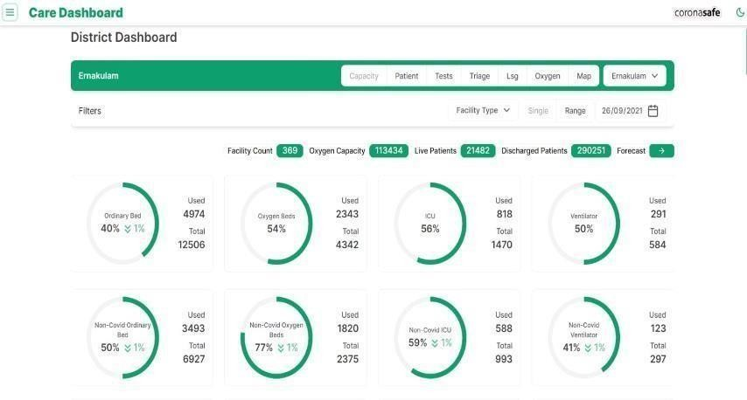

CARE IS OPEN-SOURCE SOFTWARE WITH AN MIT LICENSE.

**Open-Source Software**: The entire codebase of this application is available to the public. The software that forms CARE is developed on an online portal called GitHub that hosts open- source software so that engineers from all across the world may view the codebase of the software and contribute towards the development of the same.

**MIT License**: This is a license that explicitly allows anyone to use the code-base of the software in whatever way they deem fit.

**User Management**: CARE was initially deployed in Ernakulam district of Kerala where the officials of the National Health Mission and the Department of Health Services, Kerala depend on it for managing the large number of COVID patients that they have. The tool was later deployed across 5 states and is in the process of deployment in 8 more states. As of 03rd February, 2022, the system has managed over 3.5 Lac patients and shifted over 1.2 Lac patients between different health facilities within the district. There are various levels of Users within CARE:

**Volunteer:** A volunteer that is linked to a facility has access to view all information saved within the facility but cannot edit it.

**Pharmacist:** A Pharmacist that is linked to a facility has access to view all patient and facility information saved within the facility but cannot edit it.

**Staff:** This is the staff (data entry/ administrator) within a facility. The staff has access to all the patient details within the facility and may amend or add more information.

**Staff** (Read-Only): This is the staff (data entry/ administrator) within a facility. The staff has access to all the patient details within the facility but cannot amend or add more information.

**Doctor:** The doctor, if linked to a facility has full access to all patient information within the facility. Only individual patients may also be linked to the doctor for teleconsultation or specialist consultation. In that case, the doctor has access to the records of only that particular patient.

**Local body Admin:** The Local body admin can see the list of positive cases in a day within their local body (Panchayat, municipality, or corporation). If they are linked to a facility, they have full access to all information of the patient within the facility.

**Ward Admin:** The ward admin can see the list of positive cases in a day within their ward in the external result module. If they are linked to a facility, they have full access to all information of the patient within the facility. They may also add/edit patient information within the facility.

**District Admin:** The district admin has full access to all facilities registered within the district and all patients within those facilities.

**District (Read-Only) Admin:** The district admin has full access to view information of all facilities registered within the district and all patients within those facilities. But no edit permissionis given.

**District Lab Admin:** Can view and edit all lab information and all sample details within the district.

**State Admin:** The state admin has full access to all facilities registered within the state and all patients within each facility.

**State (Read-Only) Admin:** This user can see all facilities and patients registered in the state but cannot edit the information.

**State Lab Admin:** Can view and edit all lab information and all sample details within the state The user creation is done in a decentralized manner where every user can generate users with an equal level of access or a lower level of access. For Eg: A district admin that has the maximum user access, can create any user type while a volunteer with the minimum access can only create another volunteer in the system.

**Who is a volunteer?** A volunteer could be any person, may not necessarily be a qualified caregiver like a doctor or a nurse, but an active member of the community, or even a friend or relative who wants to support the patient by monitoring his data, giving counselling or simply monitoring the health condition.

### CAPACITY MANAGEMENT FACILITY

**Capacity Management**: CARE system is a platform that makes available real-time data of all subsets within the healthcare system of any identified location. This makes the management of assets within a hospital easier at the same time empowering the administrators and decision-makers to make better informed decisions.

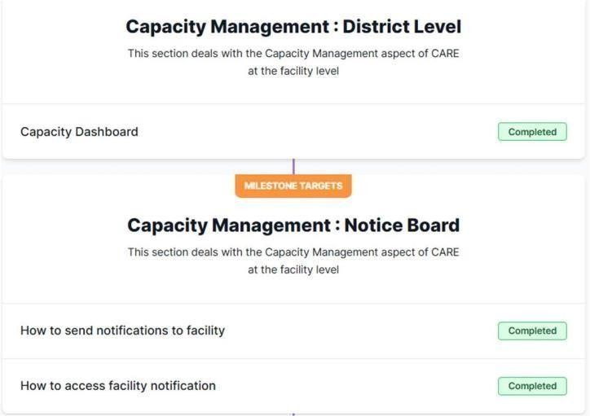

How to register?

### Steps to log-in:

Go to https://gdc.coronasafe.network on your browser. (The preferred browser is Google Chrome) Type in the username and password generated and given to you by the administrator. Click on Log-in

Steps to create a new facility

* + After log-in, click on "Create new facility”. Fill out the form. You will see the following fields
  + Facility Type- Choose from the various types of facilities from the drop-down menu.
  + Facility Name- Name of your facility in full
  + State
  + Locale Body- Locale body within which the facility is located in
  + Address- Full and correct address of the facility
  + Emergency Contact Number- phone number of the Nodal person for the facility
  + Oxygen Capacity in liters- If your facility has oxygen storage, mention the capacity in liters. If your facility has no capacity for oxygen storage, leave this field blank.
  + Location- you may pin the exact location of your facility using the "Pin tool" in the center. The Latitude and Longitude of the facility then automatically appear in the field
  + Click on "Save Facility"
  + you will see a notification on the top right corner of the screen confirming that the new facility has been created.
  + To edit your facility details, you can log-in, enter the Facility Dashboard by clicking "View Facility".
  + Here, on the top right corner, you can see the option to "Update Facility Details"

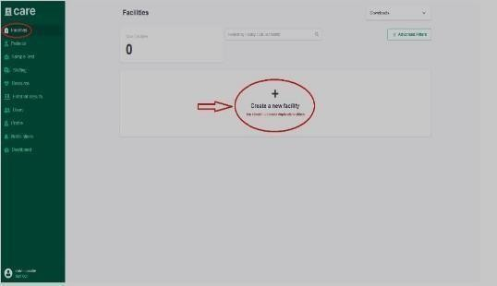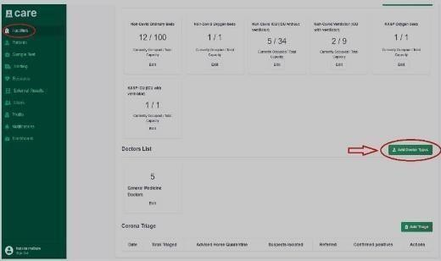

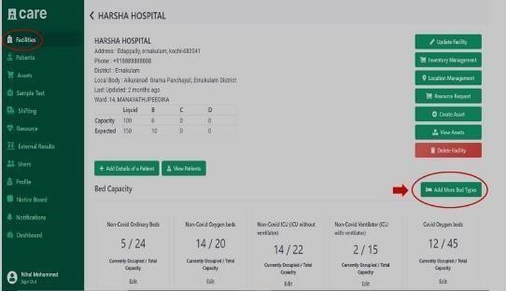

STEPS TO ADD THE NUMBER OF DOCTORS WORKING IN THE FACILITY

* + - Log into https://gdc.coronasafe.network
    - Log-in using your username and password.
    - Click on "View Facility" on the Facility card already created
    - On the bottom right side of the page, the option to "Add more Doctor Types" is visible. Click on it. You will be redirected to a form. This is the same page you will be redirected to after creating a facility.

### DAY 41-50 [10 July 2022 – 19

**July 2022] RECORDING THE CONSULTATION**

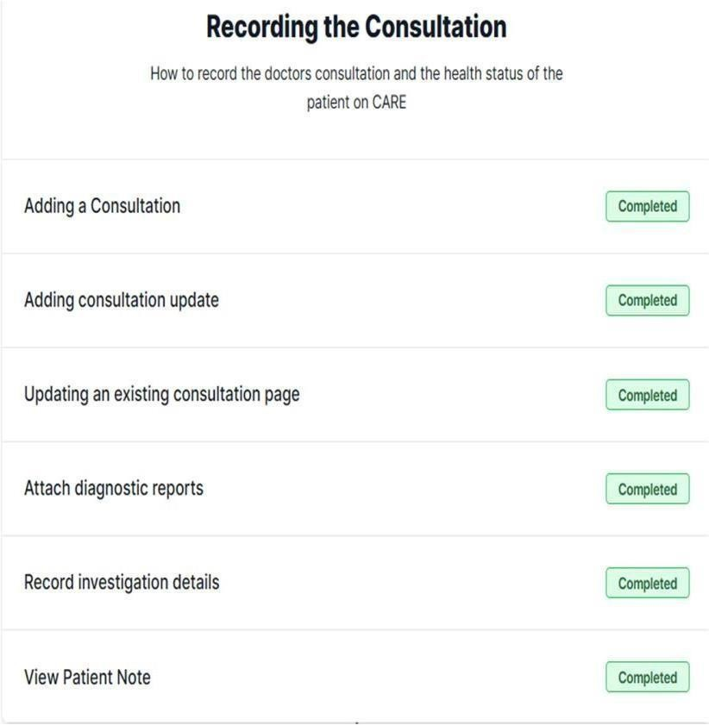

For the consultation details symptoms, Details of examination, prescribed medication, category, Decision after OP triage and admission details.

To view the records, go to the "Patients" tab on the left side of the screen. Find and click on the patient card. Scroll down to the "Consultation History" section. Click on "View Details" under Updates to expand and see all the information.

Steps to Upload File on Consultation

* + Log into https://gdc.coronasafe.network • Log in using your username and password.
  + Click on the 'Patients' tab, on the left.
  + Click on the Patient's name.
  + Scroll down, in the consultation history section, on the consultation card, click on the 'view/upload consultation files' button.
  + Under New File, click on the 'Choose file' button and select your file to be uploaded.
  + In the File name column, specify the file name.
  + Click on the 'Upload' button, to upload the file.
  + On the Top right, you will get a notification on successful upload.
  + To view the uploaded file:
  + On the left, click on the 'Patient' tab, scroll down the page, Under Consultation history, click on the 'view/upload consultation files' button. Under the view consultation files, you will find the uploaded file. -OR-
  + On the left, click on the 'Patient' tab, scroll down the page, Under Consultation history, click on the 'View Consultation/Consultation Updates' button. Scroll down the page, you will find the uploaded file.

## Steps to Upload Audio File on Consultation

* + Log into https://gdc.coronasafe.network • Log in using your username and password.
  + Click on the 'Patients' tab, on the left.
  + Click on the Patient's name.
  + Scroll down, in the consultation history section, on the consultation card, click on the 'view/upload consultation files' button.
  + Click on "Record" button to start the recording and click on "Stop" button once recoding is completed.
  + Click on "Save Recording" to upload the audio file to consultation.

## Steps to Upload File on Consultation

* + Log into https://gdc.coronasafe.network • Log in using your username and password.
  + Click on the 'Patients' tab, on the left.
  + Click on the Patient's name.
  + Scroll down, in the consultation history section, on the consultation card, click on the 'view/upload consultation files' button.
  + Under New File, click on the 'Choose file' button and select your file to be uploaded.
  + In the File name column, specify the file name.
  + Click on the 'Upload' button, to upload the file.
  + On the Top right, you will get a notification on successful upload.
  + To view the uploaded file:
  + On the left, click on the 'Patient' tab, scroll down the page, Under Consultation history, click on the 'view/upload consultation files' button. Under the view consultation files, you will find the uploaded file.
  + On the left, click on the 'Patient' tab, scroll down the page, Under Consultation history, click on the 'View Consultation/Consultation Updates' button. Scroll down the page, you will find the uploaded file.

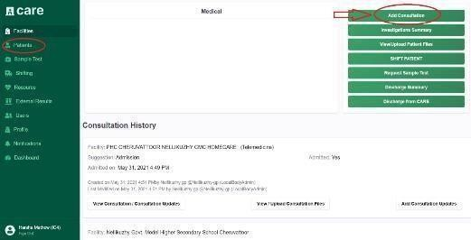 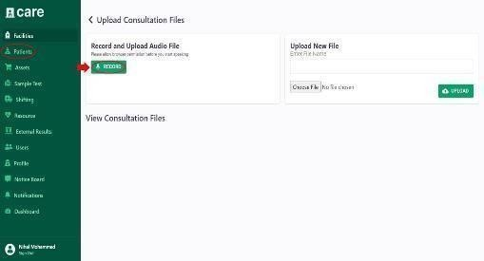

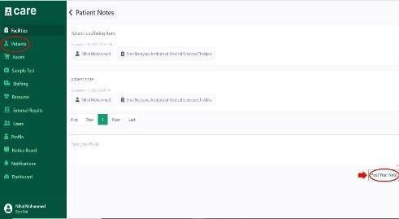

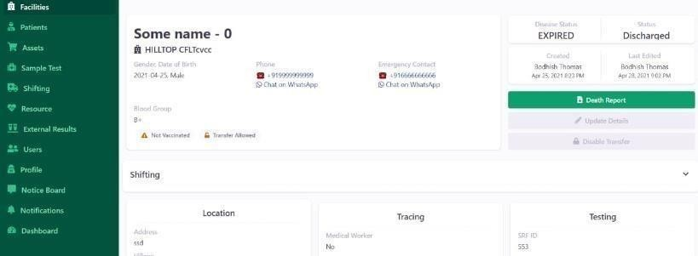 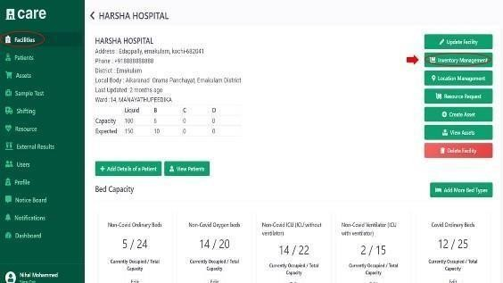

There are several disease statuses for a patient. Once a patient has passed away after being admitted to afacility, you can generate a digital report for the deceased.

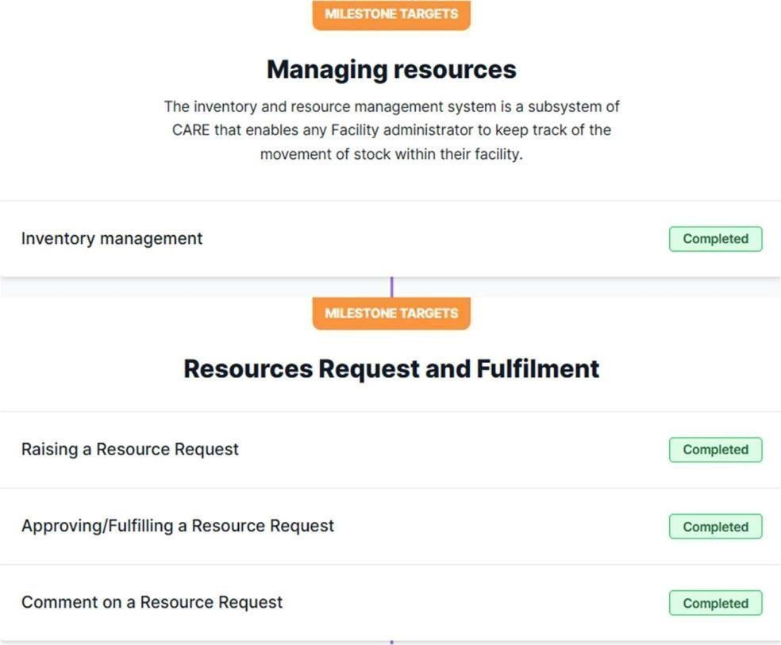

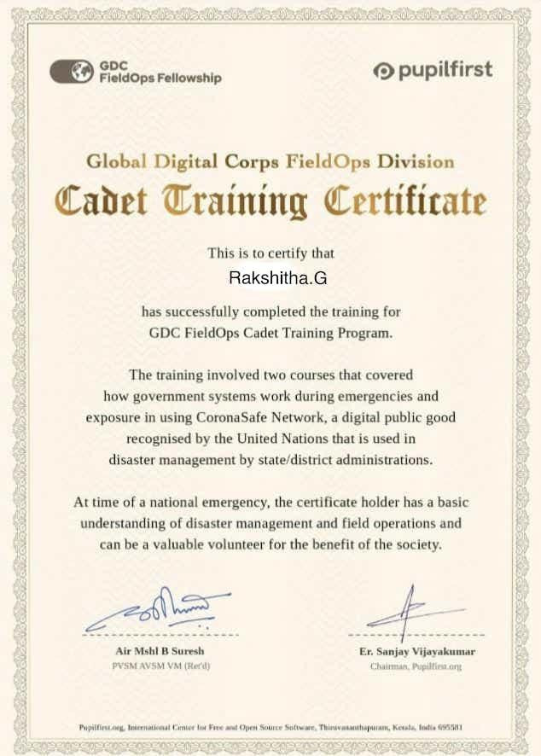

# OUTCOME OF THE ACTIVITY

The course helped in understanding different parts of the local government and their roles during disaster management. It explained how the government's initiatives towards digital technology have helped in reduction of the contact from person to person during the pandemic.

The course gave a case study of Kerala and how the Corona Safe Network helped the hospital sectors in resource management, patient consultation, shifting of patients and transfer of patient history. It gave the different approaches taken up by the Government of Kerala to reduce human contact and isolation of infected people depending on the severity of their illness.

The course teaches how to access and use the CARE system efficiently and about the different facilities given by the website for proper communication between different hospitals and war rooms. It showed how to accessthe website and work on the website for patient shifting, patient discharge, raising resource requests, and dividing the resources given by the government properly among thehospitals.

Disaster management requires many trained volunteers and this course helps the volunteers to be prepared for such emergencies. At a given time the students can be utilized as human resources toreduce the overhead of the other workers.

The course explains the different approaches taken by the government to prevent and manage different disasters caused by natural or manmade. It gives different case studies to explain the different types of steps that need to be taken during disasters.

## Blog link

<https://kavithaseervi24.blogspot.com/2023/01/care-system.html>

<https://kavithaseervi24.blogspot.com/2023/01/awarness-about-community-response.html>

<https://kavithaseervi24.blogspot.com/2023/01/disaster-management.html>