### VISVESVARAYA TECHNOLOGICAL UNIVERSITY



#### “Jnana Sangama”, Machhe, Belagavi, Karnataka-590 018

A Project Report On

### “ESTIMATION AND MITIGATION OF HARMONICS WITH SINGLE TUNED HARMONIC FILTER FOR INDUSTRIAL LOADS”

*Submitted in partial fulfillment of the requirements for the award of the degree of*

**Bachelor of Engineering**

### in

**Electrical & Electronics Engineering**

*Submitted by*

#### BHOOMIKA A R 4GW19EE004

**DIVYA S RAJ 4GW19EE012**

#### MONISHA U 4GW19EE019

**BHARATI S HIPPARAGI 4GW19EE044**

**Under the Guidance of** Shilpashri V N Assistant Professor

Dept. of EEE, GSSSIETW

### DEPARTMENT OF ELECTRICAL & ELECTRONICS ENGINEERING

**(Accredited by NBA, New Delhi, Validity from 01.06.2021 to 30.06.2024)**

### GSSS INSTITUTE OF ENGINEERING & TECHNOLOGY FOR WOMEN

**(Affiliated to VTU, Belagavi, Approved by AICTE, New Delhi & Govt. of Karnataka)**

**K.R.S ROAD, METAGALLI, MYSURU-570016, KARNATAKA**

**Accredited with Grade “A” by NAAC**

### 2023

***Geetha Shishu Shikshana Sangha (R )***



#### GSSS INSTITUTE OF ENGINEERING & TECHNOLOGY FOR WOMEN

**K.R.S Road, Mysuru-570016, Karnataka**

(Affiliated to VTU, Belagavi, Approved by AICTE -New Delhi & Govt. of Karnataka)

**Accredited with Grade “A” by NAAC**

**DEPARTMENT OF ELECTRICAL & ELECTRONICS ENGINEERING**

**(Accredited by NBA, New Delhi, Validity from 01.06.2021 to 30.06.2024)**

### CERTIFICATE

This is to certify that the 8th Semester Project titled **“Pesticide Sprinkler With IOT Based Security”** is a bonafide work carried out by **BHOOMIKA C P (4GW19EE005), PRAKRUTHI K N (4GW19EE026), RAKSHITHA G (4GW19EE030), VIDYASHREE K (4GW19EE041)** in partial fulfilment for the award of degree of Bachelor of Engineering in **Electrical & Electronics Engineering** of the Visvesvaraya Technological University, Belagavi, during the year 2022-23. The Project report has been approved as it satisfies the academic requirements with respect to the project work prescribed for Bachelor of Engineering Degree.

|  |  |  |
| --- | --- | --- |
| **Signature of Guide** | **Signature of HOD** | **Signature of Principal** |
| **Shilpashri V N**  Asst. Professor | **Dr. G. Sreeramulu Mahesh**  Professor & Head | **Dr. Shivakumar M**  Principal |

### External Viva

#### Name of the Examiners Signature with Date

1.

2

## ACKNOWLEDGEMENT

The joy and satisfaction that accompany the successful completion of any task would be incomplete without the mentioning the people who made it possible.

First and foremost, we offer our sincere phrases of thanks to **Smt. Vanaja B Pandit,Honorary Secretary, GSSS(R) and the Management of GSSSIETW**, **Mysuru** for providing helpand support to carry out the project.

We would like to express our gratitude to our **Principal, Dr. Shivakumar M** for providing us a congenial environment for engineering studies and also for having showed us the way to carry out the project.

We consider it is a privilege and honour to express our sincere thanks to **Dr. G. Sreeramulu Mahesh,** Professor and Head, Department of Electrical and Electronics Engineering for his support and invaluable guidance throughout the tenure of this project.

We would like to thank our Guide **Shilpashri V N,** Assistant Professor, Department ofElectrical and Electronics Engineering for her support, guidance, motivation, encouragement for thesuccessful completion of this project.

We would like to thank our Project Co-Ordinator **Dr. Raghvendraprasad Deshpande,** Associate Professor, Department of Electrical and Electronics Engineering for their constant monitoring, guidance & motivation throughout the tenure of this project.

We intend to thank all the teaching and non-teaching staffs of Electrical & Electronics Engineering for their immense help and co-operation.

Finally, we would like to express our gratitude to our parents and friends who always stood us to complete this work successfully.

#### BHOOMIKA C P (4GW19EE005)

**PRAKRUTHI K N (4GW19EE026)**

#### RAKSHITHA G (4GW19EE030) VIDYASHREE K (4GW19EE041)

i

## ABSTRACT

The Electrical Power Quality has been improved by controlling the harmonics from the non- linear loads. A variable frequency drive is considered as one of the non-linear loads and thus draws non-linear current from the sources, which is a major concern in improving the power Quality. The harmonic current components generated due to VVVFDs i.e, Variable Voltage Variable Frequency Drive at different operating frequencies and at standard loading conditions of the motor. Due to the presence of non-linear loads. The harmonics are present in the system, a harmonic filter is designed for the non-linear loads using MATLAB software and the analysis of the harmonics is also done. And the overall THD of VVVFD will be reduced. The proposed harmonic filter will be simulated using MATLAB software and installed in parallel to the load to reduce the total harmonic distortion.

***Key Words: Power quality, harmonics, non-linear load, VVVFD (Variable Voltage Variable Frequency Drive).***

## CONTENTS

|  |  |
| --- | --- |
| CERTIFICATE |  |
| ACKNOWLDGEMENT | i |
| ABSTRACT | ii |
| CONTENTS | iii |
| LIST OF FIGURES | iv |
| LIST OF TABLES | v |

|  |  |  |
| --- | --- | --- |
| **Chapter 1** | **Introduction** | **1-6** |
|  | 1.1 Air Handling Unit | 1 |
|  | 1.2 Power Quality | 3 |
|  | 1.3 Harmonics & Filters | 3 |
|  | 1.4 Objectives | 5 |
| 1.5 Proposed Methodology | 5 |
| 1.6 Block Diagram | 5 |
| 1.7 Problem Statement | 6 |
| **Chapter 2** | **Literature Review** | **7-12** |
| **Chapter 3** | **Software Description** | **13-17** |
|  | 3.1 MATLAB Introduction | 13 |
|  | 3.2 MATLAB Implementation | 14 |
|  | 3.3 Simulink Implementation | 16 |
| **Chapter 4** | **Program to Determine THD** | **18-25** |
|  | 4.1 MATLAB code for THD without using filter | 18 |
|  | 4.2 Design of Single Tuned Passive Filter | 20 |
|  | 4.3 Simulink model for THD with using filter | 23 |
| **Chapter 5** | **Results and Discussion** | 26 |
| **Chapter 6** | **Conclusion And Future Scope** | **27** |
|  | 6.1 Conclusion | 27 |
|  | 6.2 Future scope | 27 |
| **REFERENCE** |  |  |

**LIST OF FIGURES**

|  |  |  |
| --- | --- | --- |
| **Figure No** | **Title** | **Pag no.** |
| 1.1 | Air handling unit | 1 |
| 1.6 | Block diagram | 5 |
| 3.2.1 | MATLAB | 15 |
| 3.3.1 | Simulink library | 16 |
| 3.3.2 | Simulation Analysis tools window | 17 |
| 3.3.3 | Output window | 17 |
| 4.3.1 | Simulink model for THD with Filter | 23 |
| 4.3.3 | Single-Tuned Passive Filter Simulation Test Results  Waveform Graph | 25 |

## LIST OF TABLES

|  |  |  |
| --- | --- | --- |
| **TableNo** | **Title** | **Page no** |
| 4.1.1 | Results of THD without filter | 19 |
| 4.1.2 | Output waveform for THD without filter | 20 |
| 4.2.2 | Filter components | 22 |
| 4.3.2 | Results of THD with Single tuned filter | 24 |
| 5 | Overall results of THD without and with filter turned on | 26 |

**CHAPTER 1**

## INTRODUCTION

### Air Handling Unit

An air handling unit, commonly called an AHU, is the composition of elements mounted in large, accessible box-shaped units called modules, which house the appropriate ventilation requirements for purifying, air-conditioning or renewing the indoor air in a building or premises. They are usually installed on the roof of buildings and, through ducts, the air is circulated to reach each of the rooms in the building in question.

Air handling units condition and distribute air within a building. They take fresh ambient air from outside, clean it, heat it or cool it, maybe humidify it and then force it through some ductwork around to the designed areas within a building. Most units will have an additional duct run to then pull the used dirty air out of the rooms, back to the AHU, where a fan will discharge it back to atmosphere. Some of this return air might be recirculated back into the fresh air supply to save energy. Otherwise, where that isn’t possible, thermal energy can extracted and fed into the fresh air intake.

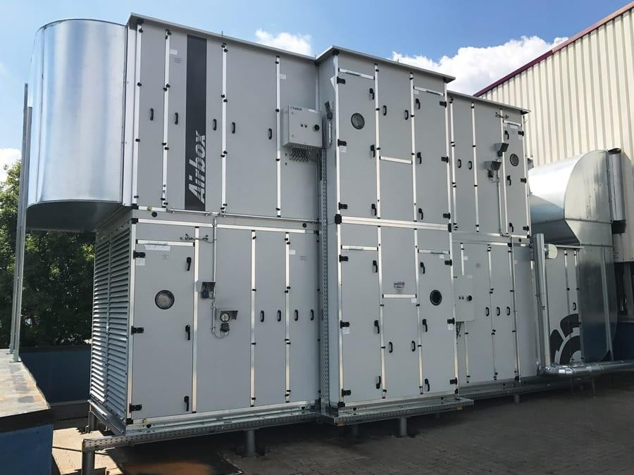

**Fig 1: Air handling unit**

### Main functions of an AHU

In addition to managing the proper ventilation of the interior with outside air, the AHU performs other functions:

* + - Filtration and control of the quality of the air that will reach the interior, thanks to the air purification filters, and depending on the retention of these filters, the air will be clean.
    - Control of the air temperature that regulates the air conditioning system in cold or hot, so that the thermal sensation in the interior is the desired one.
    - Relative humidity monitoring for greater indoor comfort.

### Energy efficiency of AHUs

The ultimate aim of an air handling unit is energy efficiency and this is mandatory since 2016 by the European Ecodesign Regulation 1235/2014.By having heat recovery units, the AHU reduces the use of energy required in air conditioning, as in the exchanger, the indoor and outdoor air is mixed, so that when the air reaches the coil the temperature contrast is lower, therefore, the climatic contribution is also lower and energy consumption is also reduced.

### Power Quality

The power quality has started to play an important role in the electronic industry. As the power providers are turning to smart grid and smart meters, the standards for power quality need to be improved. The power quality can be categorized into two groups, one addressing the standard for the power quality supplied at the grid level and the other group which deals with the factors that affect the power quality at user level. These factors include harmonics, voltage changes, sags, transients, voltage unbalance, etc.

In order to reduce the kVA demand and to improve the power quality of the system, maintaining high power factor was considered as the only necessary parameter in earlier days. Hence, more emphasis was placed on finding solutions to improve the power factor. For harmonic reduction, there is a need to identify, measure the type & level of harmonics in a system. Thus detailed power quality analysis must be done. And then a solution has to be provided for reducing harmonic levels in the system. [3]

But in the presence of harmonic-rich environment, mere PF improvement does not meet the challenge of improving the power quality. Hence, mitigation techniques of harmonics are

of great importance in industrial electrical systems in order to increase system reliability, to reduce the losses in rotating machines, to avoid capacitor failures, and nuisance tripping of protection relays. Besides Load flow and stability studies, Reactive power flow studies, and power system studies should also contain harmonic analysis and the harmonic analysis studies for industrial systems. Here, harmonic analysis is done through power analyzer.[12]

Power quality has caused a great concern to electrical system engineers with the increasing usage of nonlinear loads like Static power converters, Rectifiers, Arc furnaces, Computers, Telecommunication equipment, Television receivers, Saturated transformers etc. These nonlinear loads result in generation of harmonics. High level of harmonic distortion is harmful to various equipment within the installation and it also affects the utility as well as plant distribution systems.

### Harmonics & Filters

Nowadays industries prefer to use power electronics based devices due to their effectiveness. Though these power electronics based devices are advantageous to the electronics and electrical industry, these devices generate and inject the harmonics in the power industry. These harmonics are known as electrical disturbances which are the main cause of the power quality associated harmonics. The main problems due to the harmonics are power losses in the electrical equipment, irregular function of protective devices, errors in measurement of metering devices and interference with the telecommunication lines. Therefore mitigation of harmonics and improvement of the power quality is essential under the situation.[13]

The nonlinear characteristics of many industrial and commercial loads such as power converters, fluorescent lamps, computers, light dimmers, and variable speed motor drives (VSDs) used in conjunction with industrial pumps, fans, and compressors and also in air- conditioning equipment have made the harmonic distortion a common occurrence in electrical power networks. Harmonic currents injected by some of these loads are usually too small to 4cause a significant distortion in distribution networks. However, when operating in large numbers, the cumulative effect has the capability of causing serious harmonic distortion levels. These do not usually upset the end-user electronic equipment as much as they overload neutral conductors and transformers and, in general, cause additional losses and reduced power factor. Large industrial converters and variable speed drives on the other hand are capable generating significant levels of distortion at the point of common coupling (PCC), where other users are

connected to the network.[10]

As nonlinear loads causes the harmonics in the system and therefore the power quality gets reduce because of these non linear load. Because of the strict requirement of power quality at the input AC mains, various harmonic standards and engineering recommendations to limit the level of distortion at the PCC. To comply with these harmonic standards, installations utilizing power electronic and nonlinear loads often use one of the growing numbers of harmonic mitigation techniques. Because of the number and variety of available methods, the selection of the best-suited technique for a particular application is not always an easy or straightforward process.[5]

The harmonic filtering is one of the solutions to prevent the troublesome harmonics from entering the rest of the system. There are basically two types of filters: i) passive, where the filter components are passive elements such as resistor, inductor, and capacitor, and ii) active, where the filter has a controlled current or voltage source. Among the passive filters, there are two approaches to suppress undesired harmonic currents; a) using a series impedance to block them, b) diverting them by means of a low impedance shunt path. The former is called a series filter and the latter is called a shunt filter. Series filters are not commonly used because they must carry full load current and be insulated for full line voltage. These factors make a series filter more expensive than shunt filters. In comparison with series filters, shunt filters carry only a fraction of the current and are also less expensive.[19]

The most commonly used passive filter is the single-tuned filter. This filter is simple as compared with other means for mitigating the harmonic problems. For designing the single- tuned filter it is essential to select the appropriate capacitor value that enables good power factor at system frequency. A single tuned filter which is a series RLC circuit tuned to a single harmonic frequency provides a low harmonic impedance characteristic generally, an ideal single-tuned filter is said to be tuned on the frequency that makes its inductive and capacitive reactance to be equal.[6]

### Objective

* + - Measurement of Harmonics and THD of VVVF Drives at different loads of AHU, using Fluke power analyzer 1750.
    - Developing a MATLAB algorithm to calculate the THD and to generate the waveforms for the input data Comparing the Power analyzer data with the MATLAB software.
    - Designing a passive filter through MATLAB software to mitigate the dominating harmonic, simulating the output waveforms & estimating the THD post filter implementation.

### Proposed Methodology

* + - The harmonics are evaluated from the AHU data obtained from fluke analyzer.
    - The THD is measured (for any one of the phase).
    - The dominant frequencies are noted (5th , 7 th and 9th etc)
    - The harmonics filter is designed for the dominant harmonics to reduce the THD of VVVFD.
    - Above analysis is performed using MATLAB software

### Block Diagram

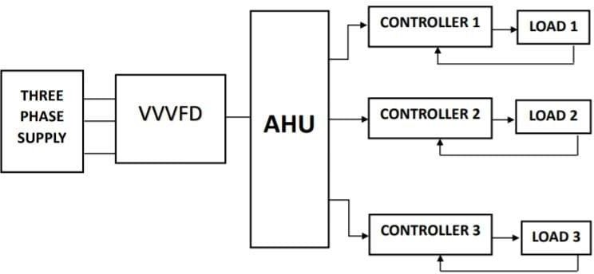

#### Fig 1.6: Block diagram

* + - Three phase supply is given to VVVFD, where VVVFD is variavle voltage variable frequency drive which regulates the input voltage and frequency throught by drawing less current. VVVFD is further connected to Air Handling Unit (AHU).
    - AHU is used to circulate the air within the room, to remove the unwanted contaminated dust particles from air and also to maintain humidity and temperature.
    - AHU is connected to different loads with the help of controller which acts as a damper to control the amount of air entering into room.
    - If the room is set to 8 degree and if there is a presence of air entering into room, then there will be difference of temperature.
    - So to set back to its normal temperature it draws more current rom supply which will harmonics.
    - By the data obtained rom company we will get distorted sinusoidal waveforms which indicates the presence of harmonics.
    - So to reduce these harmonics we will be designing a single tuned passive harmonic filter to reduce single dominant frequency.
    - Hence maximum effiency can be obtained, improved power factor.

### Problem Statement

* + - As industries prefer to use power electronics based devices due to their effectiveness

,these devices generate and inject the harmonics in the power industry.

* + - The main problems due to the harmonics are power quality, power losses in the electrical equipment.
    - Therefore to mitigate these harmonics we are designing a single tuned passive filter which will improve the power quality as well as power factor.

## CHAPTER 2

**LITERATURE SURVEY**

#### H. Hoevenaars "The Answer to Harmonics”

From this paper Point of Common Coupling (PCC): (As found on p75 of IEEE Std 519- 1992) a point of metering, or any point as long as both the utility and the consumer can either access the point for direct measurement of the harmonic indices meaningful to both or can estimate the harmonic indices at point of interference (POI). Within an industrial plant. the PCC is the pint between the nonlinear load and the other loads. Computers and allied equipment, such as programmable controllers, frequently require ac sources that have no more than a 5% harmonic voltage distortion factor, with the largest single harmonic being no more than 3% of the fundamental voltage. Higher levels of harmonic result in erratic, sometimes subtle, malfunctions of the equipment that can, in some cases, have serious consequence.[5]

#### J. F. Hibbard, "Understanding and Correcting Harmonic Distortion"

From this paper harmonic distortion is observed when the sinusoidal voltages or currents have frequencies that are integer multiples of the fundamental frequency being supplied. This distortion is continuous and the most common result is unwanted heating in the electrical system. It is interesting to note that some of the very equipment that is sensitive to power quality disturbances is often equipment that generates harmonics. Equipment such as adjustable speed drives, computer power supplies, UPS equipment and other power electronics create harmonic currents. Harmonic currents generate harmonic voltages as they pass through the system impedance.[1]

1. **From IEEE Recommended Practice for Monitoring Electric Power Quality**, From this the Institute of Electrical and Electronics Engineers (IEEE) has attempted to address THD problem by developing a standard that includes definitions of power disturbances. This IEEE Recommendes Practice for Monitoring Electrical Power Quality, defines disturbances as: sags and swells, long duration variations, impulsive transients, oscillatory transients, harmonic distortion, voltage fluctuations, and noise.[3]

#### Young, S.C., and Hanju C, "A Single-Tuned Passive Harmonic Filter Design Using Transfer Function Approach for Industrial Process Application”

From this paper presents a new analytical design method of passive harmonic filter for industrial process application using a transfer function approach and provides a graphical formulation so that a visualised insight into an interaction between individual filter and system response can be attained. Harmonic impedance, voltage division and current division transfer function are used as a design tool, which makes calculated filter parameters to satisfy IEEE-519 requirements. A simple six-step design procedure is introduced in the filter design and the procedure includes measurement analysis on system, selection of filter location (PCC), calculation of filter specification, decision of tuning order, filter design for system and fit filter to system. Principle of the design procedure is based on a numerical/graphical iterative solution as well as trial and error with visualisation feed-back using 'algebra on the graph'. Finally, performance of the designed passive harmonic filter is evaluated in experiment and the result shows that 5th, 7th, 11th and 13th harmonics are decreased within IEEE-519 requirements, respectively.[6]

#### M. I. Fahmi, "Harmonic reduction by using single-tuned passive filter in plastic processing industry"

This paper tells how non-linear loads generated by industrial machinery may result the current harmonics that do not reach to IEEE 519 - 1992 standards. The use of a control device composed of electronic components may cause the electrical load to be non- linear. This is due to the switching process of the components. The problem can be solved by doing a harmonic reduction by using a filter. Harmonics is a phenomenon caused by the operation of a non-linear electric load, where a basic frequency wave of 50 Hz or 60 Hz will occur and also cause the ideal current sinusoidal waveform and voltage wave to be not sinusoidal. In this research, we will do the harmonics reduction at a plastic processing factory.[7]

#### E. B. Makram, E. V. Subramaniam, A. A. Girgis, and R. Catoe, “Harmonic filter design using actual recorded data,”

This paper presents a filter design scheme where the filter was not directly connected through a transformer. It suggested that in order to obtain the same filtering action as before (filter directly connected), the RLC filter components would have to change.

The condition was that the impedance versus frequency functions measured from the bus should remain constant and also showes the effectiveness of harmonic filters and protection reactance in compensating the reactive power. Also the effectiveness of the protection reactance (or converter transformer reactance) in reducing voltage notch and distortion factors was discussed. A smaller commutation angle, leads to higher harmonic contents. The filters used were fifth, seventh, eleventh harmonics. A higher harmonic order was also inserted on two sides of the protection reactance (one on the supply side of the protection reactance, and the other on the a.c. side of the converter). The voltage notch dimensions were affected by location of filter and the ratio of the protection and equivalent supply reactance.[19]

#### T. Muni Jahnavi, G, Rajesh, Dr. B. Sarvesh, “ Harmonic Analysis and its mitigation technique in industrial environment ”

This paper tells how the nonlinear characteristics of many industrial and commercial loads such as power converters, fluorescent lamps, computers, light dimmers, and variable speed motor drives (VSDs) used in conjunction with industrial pumps, fans, and compressors and also in air-conditioning equipment have made the harmonic distortion a common occurrence in electrical power networks. Harmonic currents injected by some of these loads are usually too small to cause a significant distortion in distribution networks. However, when operating in large numbers, the cumulative effect has the capability of causing serious harmonic distortion levels. These do not usually upset the end-user electronic equipment as much as they overload neutral conductors and transformers and, in general, cause additional losses and reduced power factor. Large industrial converters and variable speed drives on the other hand are capable of generating significant levels of distortion at the point of common coupling (PCC), where other users are connected to the network.[12]

#### C. Venkatesh, D. Srikanth Kumar, D. V. S. S. Siva Sarma, M. Sydullu, “Estimation and Mitigation of Voltage and Current Harmonics in Distribution System”

Passive filters have been extensively used to simultaneously meet one or more objectives and also meet the requirements of IEEE Std. 519 with respect to total demand distortion (TDD) at the point of common coupling (PCC). The single-tuned filter, also called low-pass filter is most commonly applied. However, one filter may not be

adequate to filter effectively all the troublesome harmonics. Two single-tuned filters will have characteristics identical to a double bandpass filter. A highpass filter will allow a percentage of all harmonics above its notch frequency to pass through. This results in large rating at fundamental frequency and high losses in the resistor. The filter is commonly applied for higher frequencies and notch reduction. The composite filter consists of two branches of bandpass filters and a parallel branch of high-pass filter for higher frequencies. Single-tuned or double-tuned filters are not possible to employ for certain loads like cycloconverters or when the power system has interharmonics.[14]

1. **Satish Karekar, “Analysis, Comparison and study on Mitigation of Harmonics by using Active and Passive Harmonics filters by using MATLAB Simulation”** Harmonic current is isolated by using harmonic filters in order to protect the electrical equipment from getting damaged due to harmonic voltage distortion. They are also be used to improving the electrical power factor. Harmonic distortion is a growing concern for many customers and for the overall power system due to increasing application of power electronics equipment. Harmonic distortion levels can be found throughout the complete harmonic spectrum, with the magnitudes of each individual harmonic component varying inversely with their position in the spectrum. Furthermore, the phase angle of each component is unique into itself. It is also common to use a single quantity, the total harmonic distortion (THD), as a measure of the magnitude of harmonic distortion. Passive filters exhibit the best relationship cost-benefit among all other mitigation techniques when dealing with low and medium voltage rectifier system.

#### I. A. Adejumobi, O. I. Adebisi and J. E. Amatu, “ Harmonics Mitigation on industrial loads using series and parallel resonant filters ”

From this paper Power quality problem is a germane issue in power system and is of great concern to electrical power and control engineers. Basically, power systems are designed to operate at specified fundamental frequency of 50 or 60 Hz. However, certain types of loads most especially inductive loads which are characteristically non- linear, produce current and voltage waveforms with frequencies that are integral multiples of the 50 or 60 Hz fundamental frequency. These higher frequencies are electrical pollution known as power system harmonics. Presence of harmonics in power system results in distortion of supply system base waveform and this has deleterious

effects on the performance of many industrial applications high technology devices related to communication, advanced control, automation, precise manufacturing technique and on-line services [1]. Due to the increase in the usage of non-linear loads in industrial applications, most especially Variable Frequency Drives (VFDs), problem of harmonics in power system has attracted significantly the attention of researchers globally. While VFDs play significant role in enhancing system efficiency and provide great energy saving, their vulnerability to harmonics generation poses great threat to their widespread application.

#### Hussein A. Kazem. "Harmonic Mitigation Techniques Applied to Power Distribution Networks"

Fom this paper The nonlinear characteristics of many industrial and com-mercial loads such as power converters, fluorescent lamps, computers, light dimmers, and variable speed motor drives (VSDs) used in conjunction with industrial pumps, fans, and compressors and also in air-conditioning equipments have made the harmonic distortion a common occurrence in electrical power networks. Harmonic currents injected by some of these loads are usually too small to cause a significant distortion in distribution networks. However, when operating in large numbers, the cumulative effect has the capability of causing serious harmonic distortion levels. These do not usually upset the end-user electronic equipment as much as they overload neutral conductors and transformers and, in general, cause additional losses and reduced power factor. Large industrial converters and variable speed drives on the other hand are capable of generating significant levels of distortion at the point of common coupling (PCC), where other users are connected to the networkBecause of the strict requirement of power quality at the input AC mains, various harmonic standards and engineering recommendations are employed to limit the level of distortion at the PCC. To comply with these harmonic standards, installations utilizing power electronic and nonlinear loads often use one of the growing numbers of harmonic mitigation technique

#### Zubair Ahmed Memon, Mohammad Aslam Uquaili, and Mukhtiar Ali Unar, “ Harmonic Mitigation of Industrial Power System Using Passive Filters ”

In this paper effectiveness and design of single-tuned filter and second order high pass filter has been investigated for suppressing the harmonic currents in industrial power

system. The most commonly used passive filter is the single-tuned filter. This filter is simple and least expensive as compared with other means for mitigating the harmonic problems. The LC STF (Single Series Filter) is most common and inexpensive type of passive filter. This filter is connected in shunt with the main distribution system and is tuned to present low impedance to a particular harmonic frequency.Therefore, harmonic currents are diverted from the least impedance path through the filter. For designing the single-tuned filter it is essential to select the appropriate capacitor value that enables good power factor at system frequency.

#### W. L. Stebbins, "Power Distortion: A User's Perspective On The Selection and Application Of Mitigation Equipment and Techniques"

The intent of this paper is to present information on power quality issues as they affect end-use equipment. The goal of industrial customers is, of course, to stay competitive in the production of their particular product or service. One effective way of accomplishing this is to reduce downtime and thus production loss by limiting the effects of power disturbances. The goal of electric utilities is to maintain a healthy and effective relationship with customers while also promoting the use of electrical energy. It is essential that industrial customers and the utility work together to provide solutions to power quality problems.

## CHAPTER 3

**SOFTWARE DESCRIPTION**

### MATLAB Introduction

The tutorials are independent of the rest of the document. The primarily objective is to help you learn quickly the first steps. The emphasis here is ”learning by doing”. Therefore, the best way to learn is by trying it yourself. Working through the examples will give you a feel for the way that MATLAB operates. In this introduction we will describe how MATLAB handles simple numerical expressions and mathematical formulas. The name MATLAB stands for MATrix LABoratory. MATLAB was written originally to provide easy access to matrix software developed by the LINPACK (linear system package) and EISPACK (Eigen system package) projects. MATLAB is a high-performance language for technical computing. It integrates computation, visualization, and programming environment. Furthermore, MATLAB is a modern programming language environment: it has sophisticated data structures, contains built-in editing and debugging tools, and supports object-oriented programming. These factors make MATLAB an excellent tool for teaching and research. MATLAB has many advantages compared to conventional computer languages (e.g., C, FORTRAN) for solving technical problems. MATLAB is an interactive system whose basic data element is an array that does not require dimensioning. The software package has been commercially available since 1984 and is now considered as a standard tool at most universities and industries worldwide. It has powerful built-in routines that enable a very wide variety of computations. It also has easy to use graphics commands that make the visualization of results immediately available. Specific applications are collected in packages referred to as toolbox. There are toolboxes for signal processing, symbolic computation, control theory, simulation, optimization, and several other fields of applied science and engineering

### MATLAB Implementation

MATLAB, which stands for Matrix Laboratory, is a state-of-the-art mathematical software package for high performance numerical computation and visualization provides an interactive environment with hundreds of built in functions for technical computation, graphics and animation and is used extensively in both academia and industry. It is an interactive program for numerical computation and data visualization, which along with its programming capabilities provides a very useful tool for almost all areas of science and engineering. At its core, MATLAB is essentially a set (a “toolbox”) of routines (called “m files” or “mex files”) that sit on your computer and a window that allows you to create new variables with names (e.g. voltage and time) and process those variables with any of those routines (e.g. plot voltage against time, find the largest voltage, etc). It also allows you to put a list of your processing requests together in a file and save that combined list with a name so that you can run all of those commands in the same order at some later time. Furthermore, it allows you to run such lists of commands such that you pass in data.

#### MATLAB Windows:

MATLAB works with through these basic windows

#### Command Window

This is the main window .it is characterized by MATLAB command prompt ¿¿ when you launch the application program MATLAB puts you in this window all commands including those for user-written programs, are typed in this window at the MATLAB prompt

#### The Current Directory Window

The Current Directory window displays a current directory with a listing of its contents. There is navigation capability for resetting the current directory to any directory among those set in the path. This window is useful for finding the location of particular files and scripts so that they can be edited, moved, renamed, deleted, etc. The default current directory is the Work subdirectory of the original MATLAB installation directory

#### The Command History Window

The Command History window, at the lower left in the default desktop, contains a log of

commands that have been executed within the Command window. This is a convenient feature for tracking when developing or debugging programs or to confirm that commands were executed in a particular sequence during a multistep calculation from the command line.

#### Graphics Window

The output of all graphics commands typed in the command window are flushed to the graphics or figure window, a separate gray window with white background color the user can create as many windows as the system memory will allow.

#### Edit Window

This is where you write edit, create and save your own programs in files called M files.

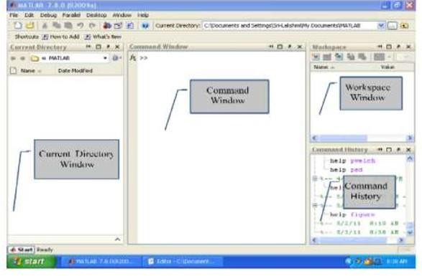

**Figure 3.2.1: MATLAB**

### Simulink Implementation

* + - Open the matlab software
    - Click on the simulink library

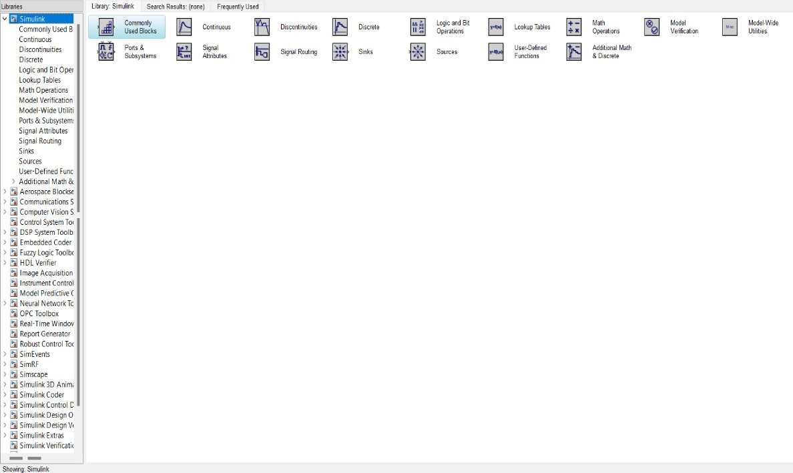

#### Fig 3.3.1 : Simulink library

* + - Select the necessary simulink.

Voltage measurements connect to the current measurements and scope for the respective.and select the series RL branch and connect to positive of the voltage measurements and othe side will be connected to the positive of the current measurements. One side of the AC voltage source will be given to the positive of the voltage measurements and other side will be connected to the negative of the voltage measurements .. Current measurements will be connected to the filter.

* + - Click on the powergui
    - Select the FFT analysis in that click on the FFT window.

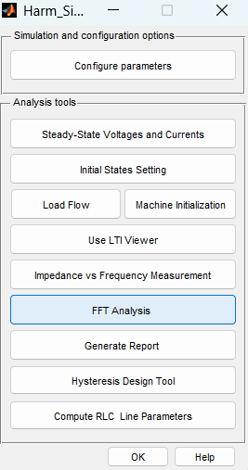

#### Fig3.3.2: Simulation Analysis tools window

* + - Click on the display.

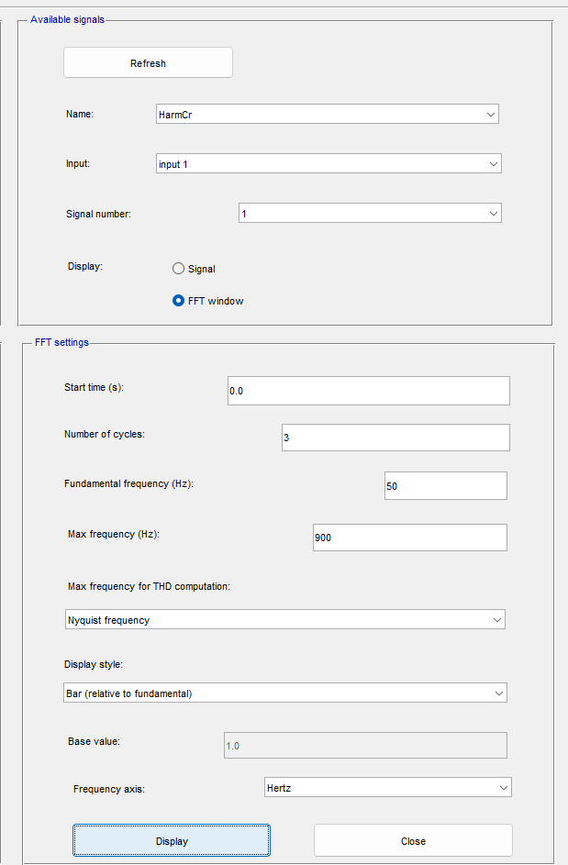

**Fig 3.3.3 : Output Window**

## CHAPTER 4

**PROGRAM TO DETERMINE THD**

### MATLAB code for THD without using filter

clc; fs=256;

T=1/fs; freq=50;

t=0:1/(freq*fs):0.01995; y=data(:,1); N=length(y);

x=y(1:N);

[thd1]=Xthd1(x,fs)

% a=[1 -1];b=[1];

% w_size=60;

% b=(1/w_size)*ones(1,w_size);

% a=1;

%p=filter(b,a,x);

%subplot(2,1,1) plot(t,x)

%subplot(2,1,2) plot(t,p)

%thdp=Xthd1(p,fs) grid xlabel('time(sec)');

ylabel('I(amp)');

function [thd]=Xthd(x,N) y=fft(x); half=1:rand(N/2); xabs=abs(y); [C,I]=max(xabs);

xabs(I)=[]; xrms=norm(xabs);

thd=(xrms/C)*100;

thd_3=xabs(3)/C *100 thd_5=xabs(5)/C *100 thd_7=xabs(7)/C *100 thd_9=xabs(9)/C *100 thd_11=xabs(11)/C *100 thd_13=xabs(13)/C *100 thd_15=xabs(15)/C *100 thd_17=xabs(17)/C *100

### Output For THD without filter

|  |  |
| --- | --- |
| **Order** | **THD (%)** |
| 3 | 6 |
| 5 | 49.53 |
| 7 | 22.01 |
| 9 | 0.93 |
| 11 | 5.74 |
| 13 | 6.08 |
| 15 | 0.94 |
| 17 | 1.95 |
| Total THD (%) | 127.2245 |

#### Table 4.1.1: Results of THD without filter

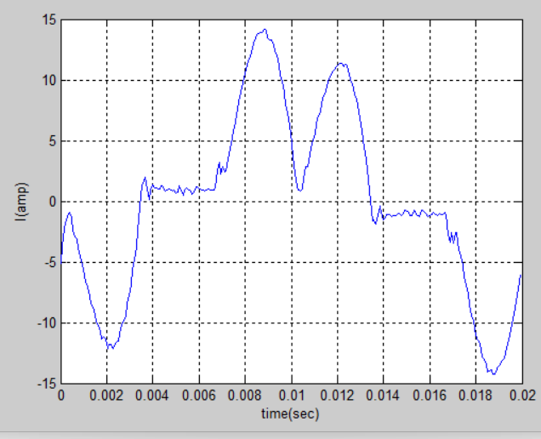

**Table 4.1.2: Output waveform for THD without filter**

### Design of Single Tuned Passive Filter

A filter is an electronic circuit that has the ability to pass or amplify a certain range of frequencies and block or attenuate other frequencies. They are used for filtering specific frequencies from a signal. Filters are used in signal processing such as removal of noise from a signal and extraction of a message from a signal etc.There are different types of filters such as digital and analog filters, active and passive filters, linear and non-linear, low-pass, high pass, bandpass filters, etc. We are going to discuss the differences between the active and passive filters.

**Active Filter:** Active filter is a type of filter that is designed using active components such as op-amp and transistor. They are used in combination with resistor and capacitor but not inductor. Such filters are capable of providing a power gain. However, their design is complex as compared to passive filters.

**Passive Filter:** The passive components can handle very high frequency. As a result, passive filters are used for high-frequency applications. but they are not suitable for very low-frequency applications. This filter does not require an external power source to operate and that is why they do not provide any power gain. However, they do use an inductor that makes them able to withstand high current. The passive components can handle very high frequency. As a result,

passive filters are used for high-frequency applications. but they are not suitable for very low- frequency applications.

### Features of Passive Filter

* + - Passive filter use only passive components such as resistor, capacitor and inductor.
    - It does not require an external power source.
    - It does not provide any power gain.
    - The change in load resistance affects the characteristics of the passive filter.
    - It has no frequency limitation and is mostly used for high-frequency applications due to the use of inductor.
    - For low-frequency applications, it requires a large inductor which increases the size and cost of the passive filter.
    - It has a simple and easy design.
    - It is cheaper than an active filter.
    - It has a larger size and heavy

Single tuned filter is a series of RLC circuit which reduces single dominant harmonic frequency.

#### Table 4.2.1: Measurement Results by Using Power Quality Analyzer Tool

|  |  |  |  |
| --- | --- | --- | --- |
| Symbol | Name | Value | Unit |
| V | Voltage | 234.45 | V |
| P | Active Power | 80 | KW |
| PF | Power Factor | 0.94 |  |

The calculation of the R, L, C filters used to reduce the current harmonics by using the current harmonics exceeding the IEEE 519-1992 harmonic standard limits. The order of harmonics to be reduced is only the 5th order. The 3 phases loads are considered in a balanced state so that simulation and data analysis is done on one phase only, which is selected in phase R.

**Step 1:** To determine the capacitor capacity (Qc) it is assumed that the power factor is improved from pf1 = 0.94 to pf2 = 0.99. To calculate the capacitor capacity required as a harmonic filter is:

Qc=P{tan(cos−1 𝑝𝑓1)-tan(cos−1 𝑝𝑓2)}

**Step 2:** To determine the reactance of the capacitor (Xc) is as follows:

Xc= V²

𝑄𝑐

**Step 3:** To determine the capacitance of the capacitor (C) is as follows:

C= 1

2𝜋 𝑓0𝑋𝑐

**Step 4:** Assuming the quality factor of single-tuned passive filter (Q) = 100, then determine the value of resistance (R) in the filter as follows

R= X𝑐

𝑄

Based on the calculation of Single-tuned Passive Filters of R, L, C components which will be used to reduce the current harmonics are shown in table

|  |  |  |  |  |
| --- | --- | --- | --- | --- |
| No | Filter Components | Symbol | Unit | Value |
| 1 | Reactance | R | Ω | 0.0061939 Ω |
| 2 | Inductance | L | H | 0.3943 𝑚H |
| 3 | Capacitance | C | F | 1027.8 µF |

**Table 4.2.2: Filter components**

### Simulink model for THD with Filter

The circuit drawing of Matlab Simulation by using Single-tuned Passive Filter consisting of components R, L and C can be seen as figure 6.4. Single-tuned Passive filter simulation by using Matlab program is done, then added with an RLC filter in parallel with load. RLC value has been calculated and obtained value R = 0,0061939 Ω, L = 0, 3943 mH, C = 1027,8 μF. This value became the block parameter value of the RLC filter.

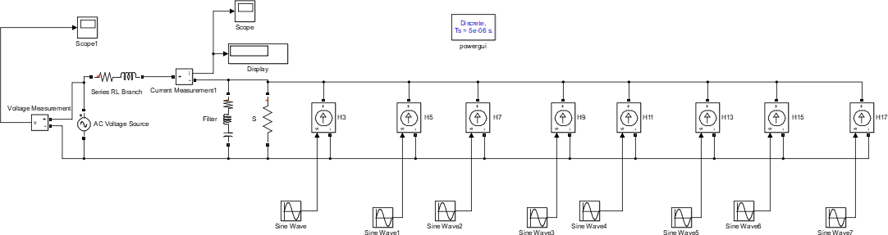

#### Fig 4.3.1: Simulink model for THD with Filter

The result of current harmonic reduction by simulation using single-tuned passive filter shows the magnitude of individual harmonic flow as shown in table 5. Table 5 is the result of simulating current harmonic reduction by using single-tuned passive filter, this filter can reduce the total current harmonics from 127.2245% to 5.22%. When it is viewed from individual harmonic currents, the simulation results show that the entire THD Order of harmonics has been reach the IEEE 519-1992 standard.

Single-Tuned Passive Filter Simulation Results (IHDi %)

|  |  |
| --- | --- |
| **Order** | **THD (%)** |
| 3 | 3.01 |
| 5 | 0.56 |
| 7 | 0.96 |
| 9 | 0.96 |
| 11 | 0.72 |
| 13 | 1.13 |
| 15 | 1.17 |
| 17 | 0.80 |
| Total THD (%) | 5.22 |

#### Table 4.3.2: Results of THD with Single tuned filter

The current waveform generated by using Matlab / Simulink with single-tuned passive filter can be seen in below fig that shows the resulting waveform has been sinusoidal shape that also indicating the system has been seperated from current harmonic interference.

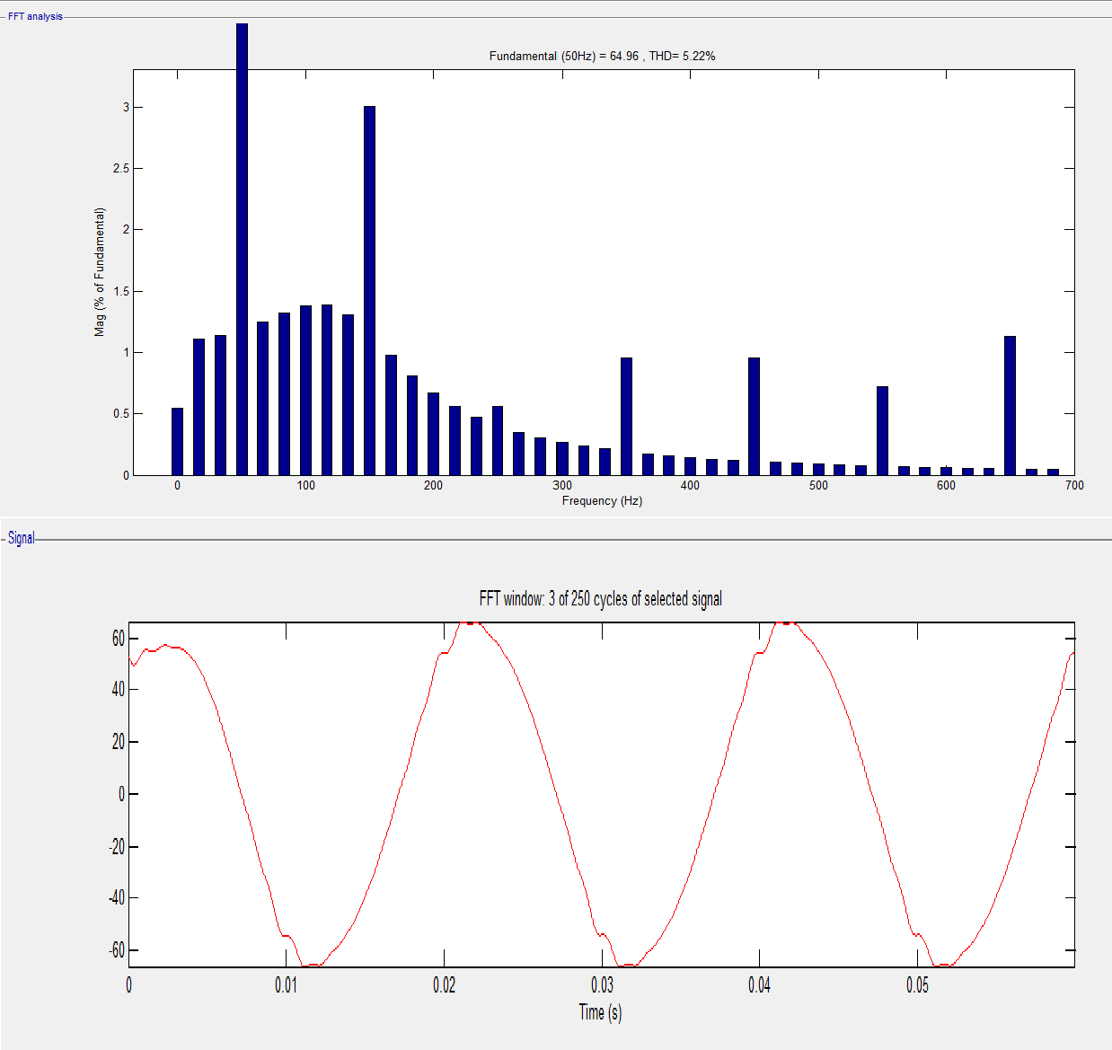

**Fig 4.3.3: Single-Tuned Passive Filter Simulation Test Results Waveform Graph**

## CHAPTER 5

**RESULTS & DISCUSSION**

Dominant harmonic frequency is reduced by designing single tuned passive filter and this reduces total harmonic distortion of VVVFD by connecting the filter parallel to the load. Single-tuned passive filters reduces current harmonics by 127.22% to 5.22%, indicating that the total THD current is reduced by 122% without using filter. The filter reduction level in decreasing the harmonicity in each order can be seen in below table. In the 5th order IHD, which is the target of harmonic to be reduced, it can be seen that the single-tuned passive filter can decrease the current harmonics by 48.97% from the current harmonics of 49.53% can be reduced to 0.56%. From this it is observed that current THD are reduced and power factor is improved after implementation of single tuned passive filter.

|  |  |  |  |  |  |  |  |  |  |
| --- | --- | --- | --- | --- | --- | --- | --- | --- | --- |
| **Order** | **3rd** | **5th** | **7th** | **9th** | **11th** | **13th** | **15th** | **17th** | **TOTAL**  **%** |
| **Without filter Turned on** | 6.00 | **49.53** | 22.01 | 0.93 | 5.74 | 6.08 | 0.94 | 1.952 | 127.22 |
| **With filter Turned on** | 3.01 | **0.56** | 0.96 | 0.96 | 0.72 | 0.13 | 0.17 | 0.80 | 5.22 |

**Table 5: Overall results of THD without and with filter turned on**

## CHAPTER 6

**CONCLUSION & FUTURE SCOPE**

### CONCLUSION

* + - Simulation modeling by using Single-tuned Passive Filter shows that THD Current from 127.22% has been reduced to 5.22%.
    - Powe factor is improved after implementation of single tuned harmonic filter.
    - Single-tuned passive filter has capability in decreasing one desired harmonic order.
    - Single tuned filter is simple to design, easy to replace and economic.

### FUTURE SCOPE

* + - We can suggest IT company that by implementing this method can reduce THD so that maximum efficiency can be obtained which will improve power factor and increases the life span of the machines.
    - Harmonic Filteration can be done for all the three phases.
    - Measurement of the filter harmonics can also be done for other types of passive filters.

## REFERENCES

1. J. F. Hibbard, "Understanding and Correcting Harmonic Distortion", PCIM/Power Quality '92 Conference and Exhibition.
2. W. L. Stebbins, "Power Distortion: A User's Perspective On The Selection and Application Of Mitigation Equipment and Techniques", IEEE Textile Industry Technical Conference.
3. IEEE Recommended Practice for Monitoring Electric Power Quality.
4. IEEE Recommended Practices and Requirements for Harmonic Control in Electrical Power Systems.
5. A. H. Hoevenaars "The Answer to Harmonics”: Is it Mitigation or a Robust Transform CEE News-The Power Quality Advisor.
6. Young, S.C., and Hanju C., "A Single-Tuned Passive Harmonic Filter Design Using Transfer Function Approach for Industrial Process Application", International Journal of Mechatronics and Automation, Volume 1, No. 2, pp. 90-96,2011.
7. M. I. Fahmi, "Harmonic reduction by using single-tuned passive filter in plastic processing industry",10th international conference Numerical Analysis in Engineering, IOP conference series.
8. D. E. Steeper and R. P. Stratford, "Reactive compensation and harmonic suppression for industrial power systems using thyristor converters", IEEE Trans.
9. Satish Karekar,“Analysis, Comparison and study on Mitigation of Harmonics by using Active and Passive Harmonics filters by using MATLAB Simulation”, Vol 4, 2018.
10. Hussein A. Kazem. "Harmonic Mitigation Techniques Applied to Power Distribution Networks",Volume 2013, Article ID 591680.
11. K. K. Sen and A. E. Emanuel, “Unity power factor single phase power conditioning,” IEEE-PESC Conk Rec., pp. 516-524, 1987.
12. T. Muni Jahnavi, G, Rajesh, Dr. B. Sarvesh, “ Harmonic Analysis and its mitigation technique in industrial environment ”, International Research Journal of Engineering and Technology, Volume 2, 2015.
13. Zubair Ahmed Memon, Mohammad Aslam Uquaili, and Mukhtiar Ali Unar, “Harmonic Mitigation of Industrial Power System Using Passive Filters”, Mehran University Research Journal of Engineering and Technology,Vol 31, No. 2, 2012.
14. C. Venkatesh, D. Srikanth Kumar, D. V. S. S. Siva Sarma, M. Sydullu, “Estimation and

Mitigation of Voltage and Current Harmonics in Distribution System” IEEE Trans.

1. George, J.W., "Power Systems Harmonics Fundamentals, Analysis and Filter Design", Springer, 2001.
2. Dan, S.G., Benjamin, D.D., Magureanu, R., Asminoaei, L., Teodorescu, R., and Blaabjerg, F., "Control Strategies of Active Filters in the Context of Power Conditioning", European Conference on Power Electronics and Applications, Dresden, pp. 10, 2005.
3. H. Akagi, “New trends in active filters for power conditioning,” IEEE Transactions on Industry Applications, vol. 32, no. 6, pp. 1312–1322, 1996
4. B. Singh, K. Al-Haddad, and A. Chandra, “A review of active filters for power quality improvement,” IEEE Transactions on Industrial Electronics, vol. 46, no. 5, pp. 960–971, 1999.
5. E. B. Makram, E. V. Subramaniam, A. A. Girgis, and R. Catoe, “Harmonic filter design using actual recorded data,” IEEE Transactions on Industry Applications, vol. 29, no. 6, pp. 1176– 1183, 1993.
6. R. L. Smith and R. P. Stratford, “Power system harmonics effects from adjustable-speed drives,” IEEE Transactions on Industry Applications, vol. 20, no. 4, pp. 973–977, 1984.
7. E. F. El-Saadany and M. M. A. Salama, “Reduction of the net harmonic current produced by single-phase non-linear loads due to attenuation and diversity effects,” International Journal of Electrical Power and Energy Systems, vol. 20, no. 4, pp. 259– 268, 1998.
8. I. A. Adejumobi, O. I. Adebisi and J. E. Amatu, “ Harmonics Mitigation on industrial loads using series and parallel resonant filters ”, Nigerian Journal of Technology , vol 34, pp. 611-620.
9. C. P. Henze and N. Mohan, “A digitally controlled AC to DC power conditioner that draws sinusoidal input current,” IEEE-PESC Conf. Record, pp. 531-540, 1986.

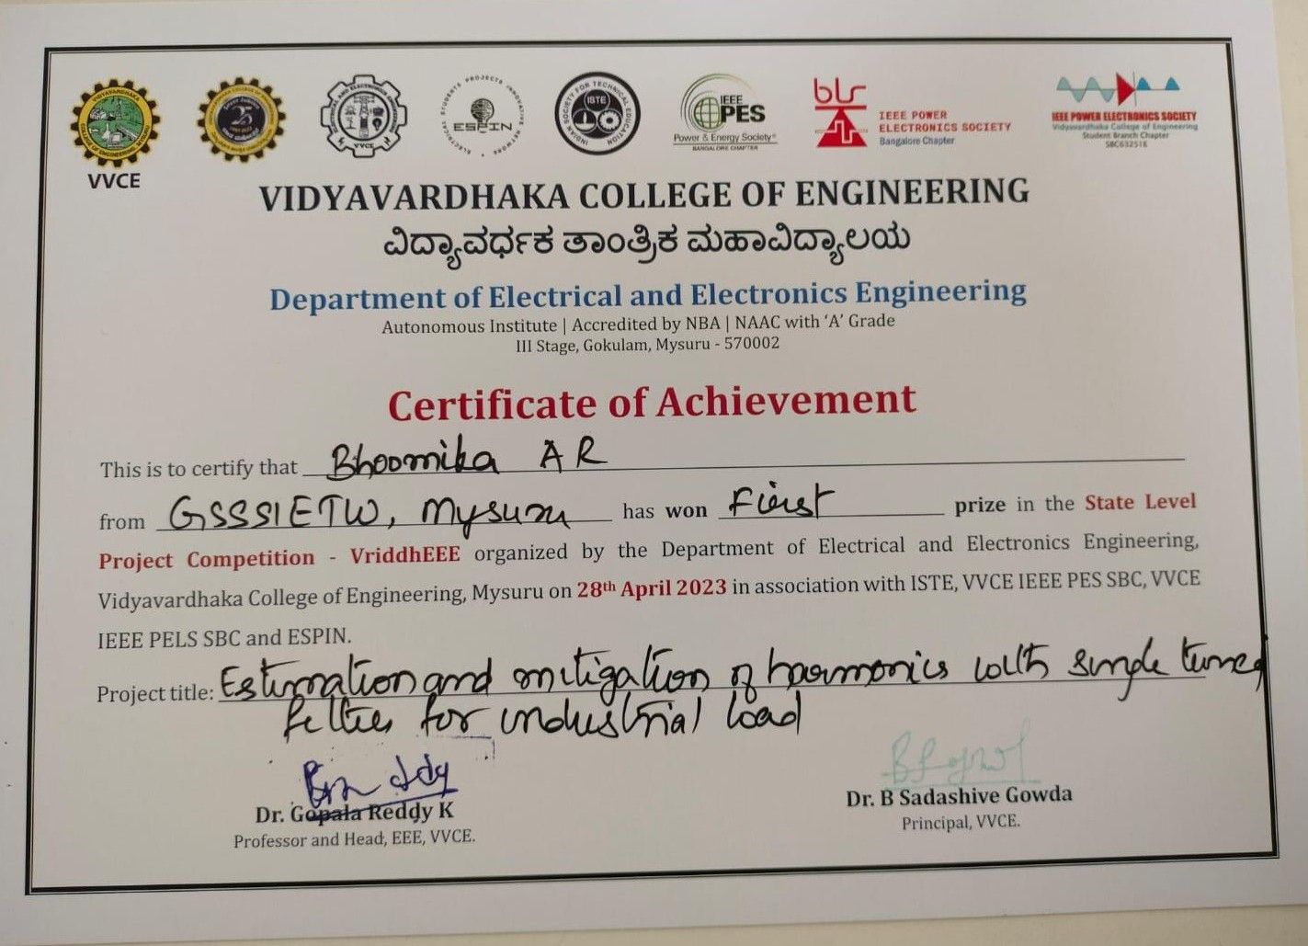

School Name • Ms. Writer • September 4, 20XX

Project ID: 4

## DEPARTMENT OF ELECTRICAL AND ELECTRONICS ENGINEERING

**Participation Certiﬁcate**

This is to certify that

# Bhoomika A R of GSSSIETW

**has successfully presented project work entitled**

# ESTIMATION AND MITIGATION OF HARMONICS WITH SINGLE TUNED FILTER FOR INDUSTRIAL LOADS

in the “Pioject Exhibition Shakthistaavaia-2023**”** Organized by Department of Electrical

and Electronics Engineering, GSSS Institute of Engineering and Technology For Women, Mysuru, in association with IEEE PES Student Chapter, Bangalore Section, on **26th April 2023.**

# HOD-EEE



**Dr. G Sreeramulu Mahesh**

# Principal

**Dr. Shivakumar M**