*The 11th International Renewable Energy Congress (IREC 2020)*

Performance analysis of solar heat generation system for multi-purpose applications

# Mohammed Abdunnabi

Center for Solar Energy Research and Studies Tripoli, Libya

[moh_jum@yahoo.com](mailto:moh_jum@yahoo.com)

# Mokhtar BenAbead

Center for Solar Energy Research and Studies Tripoli, Libya

[mukhtarabeid@csers.ly](mailto:mukhtarabeid@csers.ly)

# Basim Belgasim

Center for Solar Energy Research and Studies Tripoli, Libya

Mechanical Engineering Department, University of Benghazi, Libya

[basim.belgasim@yahoo.com](mailto:basim.belgasim@yahoo.com)

# Faisal Mohamed

Libyan Authority for Research, Science and Technology Tripoli, Libya

***Abstract*— This study presents a thermal performance simulation of solar central heat generation system for multi- purpose applications. A theoretical model is developed using TRNSYS software and an experimental test rig is planning to be installed at the Center for Solar Energy Research and Studies in Tajoura, Libya. The system consists 80 evacuated tubes collectors solar field arranged in parallel and series and attached to two hot water storage tanks of 1200 liters. In the first phase, the system will be used for space heating of the administration building and the production of fresh water using MSF desalination unit of 5 m3/day. The results of the simulation show that over 90% of the required energy of space heating can be provided by the solar system and about 60% for the desalination unit.**

***Keywords—Solar heat generation; Thermal performance; TRNSYS; Libya.***

1. INTRODUCTION

Residential sector is responsible for over 40% of the total global primary energy consumption and 30% of the greenhouse gas emission [1]. Most of the final energy consumes in buildings are due to heating, cooling and domestic hot water. This thermal energy can be easily obtained from solar energy.

The global solar thermal market grew up to 472 GWth in 2017 which corresponding to 388 TWh. In the recent years, solar assisted district heating systems and solar space heating/cooling applications in the commercial and industrial sectors have gained increasing interest all over the world. By the end of 2016 over 113 million solar thermal systems was in operation, around 63% of which are small systems installed in a single-family house [3].

Many strategies have been considered in order to increase energy efficiency in buildings. They are including Building Added (BA) or Building Integrated Solar (BIS) to exploit solar energy in buildings and to reduce capital cost [2].

Many studies have been conducted considering the applications of solar thermal energy in the building heating and cooling sector. Lamrani et al [4] have studied the improvement in energy consumption of a new administration building in Morocco by insulating the envelope through the simulation by TRNSYS. The building is divided into five thermal zones, and an occupation scenario is adopted. The results have shown that the reduction in the energy demand of the building in the case of insulating the roof as well, is up to 55% which is equivalent to 6887 kWh annually. Abdualla [5] has validated TRNSYS model for solar assisted solar thermal system for space heating of building in Aman-Jordan. The performance of the solar system and the building performance are measured experimentally and calculated by TRNSYS. The comparison of modelled and measured results for solar space heating, auxiliary heating and solar fraction are 13%, 7% and 10%, respectively. In addition, number of studies investigated solar- driven AB/AD sorption system for space heating and cooling for in buildings [6-11].

Moreover, the solar space heating and cooling can be combined with small scale power generation system represented in the Organic Rankine Cycle (ORC). It is required low-to-medium temperature heat source which can be provided by solar energy. This technology is well established worldwide with a number of commercial systems in operation ranging from few kW to 10 MW [12]. A project to generate 3 kWe of electricity using 75 m2 of parabolic-trough collector in Lesotho, Africa is implemented [13], another small sized experimental project in Athens, Greece to generate 2.5 kW of electricity to run a solar reverse osmosis desalination unit using 88 m2 of evacuated-tube solar collectors [14].

This paper presents a performance analysis of a solar heat generation system for multi-purposes applications including space heating and water desalination unit. The system is designed to be located at The Centre for Solar Energy Research and Studies (CSERS), Tajoura, Libya. The CSERS has an area

978-1-7281-5572-2/20/$31.00 ©2020 IEEE

of 8 hectares and has 10 buildings. The main buildings are the administration, Laboratories and conference building. The average annual electric energy consumption of the Centre is 263 MWh based on the average recorded data of year 2012 and 2013 as shown in Fig.1. The actual energy consumption is a bit higher than the recorded amount because of some of facilities are not functioning regularly such as the mechanical workshops, laboratories due to the current situation in the country. The estimated electric energy consumption of the administration building is 155 MWh, the recorded measurement of the date 6/03/2018 is shown in Fig. 2. A 6 kWp of PV grid connected system is installed at the center since 2013. The envelope of the building is insulated and the windows are double glazed. The current space heating and cooling of the building is the air conditioning.

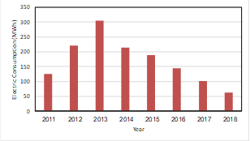

Fig. 1: The annual electric energy consumption of CSERS

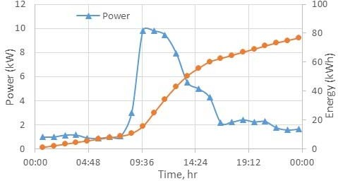

Fig. 2: Power and accumulated energy of the administrative building (date: 06/03/2018)

*B. Building description*

The administrative building of the CSERS was built in 2002 and is located in Tajoura (latitude 32° 48’, N, longitude 13° 26’ E, elevation 65 m), within Tripoli municipality. The targeted building is a ground floor building and the total area considered for space heating is 265.5 m2, and the height is 2.6

m. The building's main façade is oriented to the west. The building is consisting of 30 offices and the building envelope adopts 200 mm concrete slabs with 60 mm thickness EPS (expanded polystyrene) insulation. The general view of the building is shown in Fig. 3.

The overall heat loss coefficient of the exterior wall (U-value

= 0.508 W/m2k), ceiling (U-value = 0.316 W/m2k) and windows (U-value = 2.89 W/m2k). In addition, the internal walls are made of the same layers as the exterior walls. The glass surface represents 10% of the external facades.

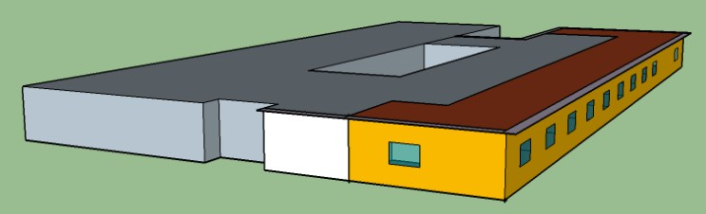

Fig. 3. The administration building

The southern part of the building is attached to the solar field using cast iron radiators. The considered part of the building is divided into three thermal zones as shown in Fig. 3. The base of heating degree-day is 21 °C. The heating degree days of the building based on Meteonorm climate data are 607 degree- hour.

*C. MSF desalination unit*

The desalination unit targeted in this study is small scale low temperature MSF desalination unit. The capacity of the unit is 5 m3/day and it works at 70-80 °C. The technical specification of the unit is given in Table1. The general view of the unit is shown in Fig. 4.

Table 1: Technical specification of MSF unit [15]

1. METHODOLOGY

|  |  |
| --- | --- |
| **Parameter** | **Value** |
| Average daily production of fresh water | 5 m3/day (0.208 m3/hr) |
| Max working temperature | 80 ° C |
| Thermal energy consumption | 15.6 kW |
| Designed specific consumption of electric power | 4.8 kWh/m3. |
| Rate of flow of sea water | 2.3 m3/hr |
| Flow rate of saline solution | 2.1 m3/hr |
| Spec. of desalinated water | << 100 ppm |

*A. Solar field*

In this research, a solar field is designed using TRNSYS software. It is consisting of 80 evacuated tubes solar collectors arranged in two columns and 18 rows. Two 4000 liters of thermal energy storage tanks is integrated to the field to achieve the regular supply of thermal energy to the applications. The optimum layout of central solar field is found to operate space heating system of the administration building at CSERS and MSF water desalination unit.

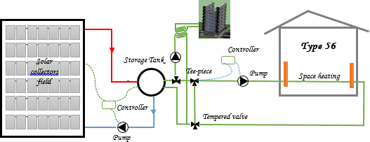

1. *Weather Data*

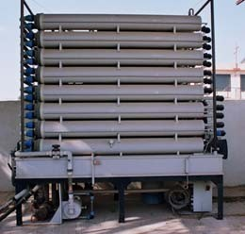Fig. 4 MSF desalination unit

1. SYSTEMS MODELLING

Fig. 6 Schematic diagram of the whole system

8:00 am morning to 4:00 pm from Sunday to Thursday. The system is off during weekend (Friday and Saturday) as shown in Fig. 5. The operation scenario of the MSF desalination is running 12 hours per day during the year. The daily productivity is 2.5 m3 per day with annual nominal fresh water production of 912.5 m3 per year.

The prevailing weather condition in the city is the Mediterranean climate. According to the weather data reported in Meteonorom provided in TRNSYS 18, the average ambient temperature is 20.1 °C, the average wind speed is 3.19 m/s, the annual global radiation on horizontal is 1964 kWh/m2, the annual diffuse radiation is 545 kWh/m2, the DNI is 1989.15 kWh/m2, and the annual sun shine is 3057 hours.

1. *Operating Data*

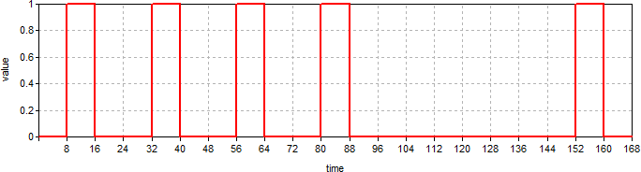

Fig. 5. Operating hours during the week for space heating system

The space heating is required during the working hours of week at the administration building. The working time is from

Table 2 Specifications of solar collectors

|  |  |
| --- | --- |
| **parameter** | **value** |
| Length (mm) | 2040 |
| Width (mm) | 1000 |
| Depth (mm) | 102 |
| Gross area (m2) | 2.04 |
| Active area (m2) | 2.73 |
| Aperture area (m2) | 1.74 |
| weight (kg) | 50 |
| ηo | 0.596 |
| a1 (W/m2/K) | 0.91 |
| a2 (W/m2/k2) | 0.0034 |

TRNSYS Model

The proposed system including solar field, space heating and desalination unit is developed using transient systems simulation TRNSYS software version 18 [16]. The schematic diagram of the whole system is demonstrated in Fig. 6. TRNSYS is a quasi-steady state simulation program. The main

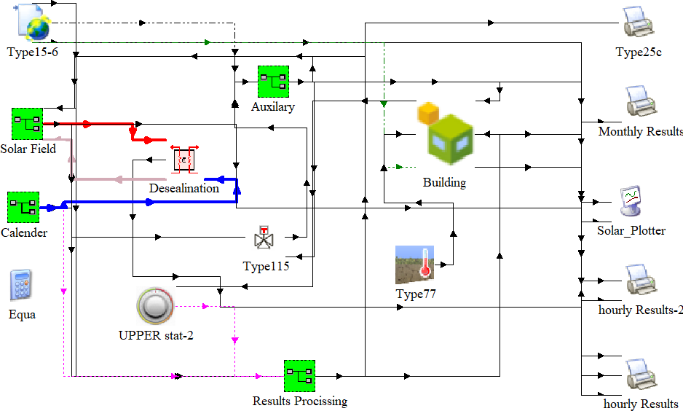

Fig.7 the TRNSYS model for the heating system

components of the model are: solar field of evacuated tubes solar collectors (Type 1288), the building model (Type 56), hot water cylinder (Type 534), pipe duct (Type 31), and differential control (Type 2b). The main components implemented in TRNSYS environment are shown in Fig. 7.

The main components of the system (solar collectors, storage tanks, MSF desalination unit and heating radiators) are available and exist at the CSERS. The technical specifications and thermal properties of the whole components are used in the simulation model. The solar collectors used are evacuated tube solar collectors (AMK-DRC-10) with technical specification given in Table 2 [16]. The total number of collectors are 80 with gross area of 163 m2. A 1200 liters thermal storage tanks are implemented and their specification are presented in Table 3.

Table 3 Technical specifications of storage tank.

|  |  |  |  |  |  |
| --- | --- | --- | --- | --- | --- |
| **parameter** | **unit** | **Value** | | | |
| Capacity, weight | liter, kg | 1000, 265 | | | |
| Surface area of the tube heat exchanger | m2 | 2.5 | | | |
| Capacity of tube heat exchanger | liter | 13.3 | | | |
| Primary circuit flowrate | m3/h | 3 | | | |
| Pressure drop for a flowrate of 3 m3/h | mbar | 250 | | | |
| Primary entrance temp. | C | 55 | 70 | 80 | 90 |
| Power of tube heat exchanger | kW | 20 | 40 | 53 | 65.5 |
| Continues supply of hot water | liter/h | 500 | 980 | 1300 | 1600 |

1. RESULTS AND DISCUSSINS

The simulation of the proposed system is conducted for one year based on the operating, design and weather conditions given in previous sections. The results of the solar space heating and the desalination unit are presented in this section.

1. *Space heating*

The annual heating demand for the administration building is shown in Fig 8. It can be observed that solar field can provide the space heating system by over 93% of the entire energy required which is equivalent to about 5.1 MWh annually. The

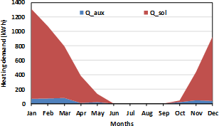

Fig. 8 Annual heating demand for the building

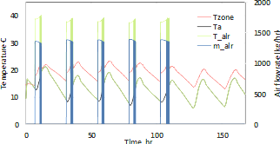

Figure 9 The first week of January results of building solar

daily performance of the heating system is demonstrated in Fig. 9 which is represents the first week of January. The zone air temperature varied within one degree which is around 21 oC during the working days. The ambient temperature is about

5.8 Co and 21.3 Co.

1. *MSF Desalination*

The performance of the thermal energy required by the MSF desalination unit is demonstrated in Fig. 10. The results show that the energy required for running the unit for 12 hours per day for the whole year is 155 MWh annually. It is proved that over 69.5% of this energy can be obtained from the solar field.

CONCLUSION

A central heat generation system for multi-purpose applications was investigated for two application working simultaneously, space heating and water desalination. The suggested system is based on 80 evacuated tube solar collectors and 1200 liters thermal storage tank capacity. The system was simulated using TRNSYS environment and the optimum layout of the solar field is investigated. The results of the simulation for one year have shown that the system can provide up to 93% of heating load for space heating demand and 69.5% of the energy requirement for the desalination from solar energy. The heating demand for space heating was 5.1 MWh and heating requirement for running small scale MSF desalination unit to produce 319 m3 yearly is 155 MWh.

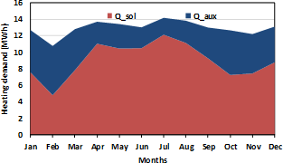

Figure 10 Energy consumption for the MSF unit

REFERENCES

1. International Energy Agency - IEA, Energy Climate and Change - World Energy Outlook Special Report, Special

Report on Energy and Climate Change on iea.org/publications website, 2015

1. Buonomano, A., Forzano C., Kalogirou S.A., Palombo A., (2018). Building-façade integrated solar thermal collectors: Energy-economic performance and indoor comfort simulation model of a water based. Renewable Energy, pp 1-17.
2. Weiss, W., Spork-Dur M., (2018). Solar Heat Worldwide; Global Marked Development and Trends in 2017.
3. Lamrani A, Safar S., Rougui M., (2018). Parameteric study of the thermal performance of a typical administrative building in the six thermal zones according to the RTCM, using TRNSYS. MATEC Web of Conferences 149, 02097; https://doi.org/10.1051/matecconf/201814902097.

Rankine cycle system for RO desalination. Solar Energy. 83(5) pp 646–56.

1. Abdunnabi M., Ramadan, A., (2012). Simulation Study of the Thermal Performance of MSF Desalination Unit Operating by Solar Vacuum Tube Collectors, IASTED Proceedings, Las Vegas, 12-14, Nov, 2012.
2. Solar Energy Laboratory: “TRNSYS: a transient simulation program version 18”, Madison, University of Wisconsin, USA, 2016.
3. Performance test according to EN 12975-2:2006 for DRC10 evacuated tube collector, AMK-Collectra AG, Test Report No. C928 LPEN

.

1. Abdalla, N., (2014). Validated TRNSYS Model for Solar Assisted Space Heating Systems. Solar Energy and Sustainable Development 4,(1), 28-37.
2. Henning, H and Döll, J., (2012). Solar systems for heating and cooling buildings. Energy Procedia, 30, pp. 633-653.
3. Siddiqui, M.U. and Said, S.A., (2015). A review of solar powered absorption systems. Renewable and Sustainable Energy Reviews, 42, pp. 93-115.
4. Wu, W., Zhang, X., Li, X., Shi, W., Wang, B. (2012). Energy saving potential of low temperature hot water system based on air source absorption heat pump. Applied Thermal Engineering, 48, pp. 317-334.
5. M. Vallès, M. Bourouis, D. Boer, (2019). Solar-driven absorption cycle for space heating and cooling, Applied Thermal Engineering, doi: https://doi.org/10.1016/j.applthermaleng.2019.114836.
6. Al-Alili, A., Hwang, Y., Radermacher R, (2014). Review of solar thermal air conditioning technologies. International Journal of Refrigeration, 39, pp. 4-22.
7. Abdulateef, J., Sopian, K., Alghoul, M., (2008). Optimum design for solar absorption refrigeration systems and comparison of the performances using ammonia-water, ammonia-lithium nitrate and ammonia-sodium thiocyanate solutions. International Journal of Mechanical and Materials Engineering, 3, pp. 17-24.
8. James F., Klaus H., Christos N. M., (2015). An assessment of solar-powered organic Rankine cycle systems for combined heating and power in UK domestic applications, Applied Energy 138 , pp 605–620.
9. Quoilin S, Orosz M, Hemond H, Lemort V., (2011). Performance and design optimization of a low-cost solar organic Rankine cycle for remote power generation. Sol Energy, 85(5) pp

955–66.

1. Manolakos D, Kosmadakis G, Kyritsis S, Papadakis G., (2009). On site experimental evaluation of a low-temperature solar organic