



KARNATAKA STATE COUNCIL FOR SCIENCE AND TECHNOLOGY
Indian Institute of Science campus, Bengaluru
Telephone: 080 -23600978, 23341652 || Email: spp@kscst.org.in
Website: www.kscst.iisc.ernet.in/spp.html or www.kscst.org.in/spp.html
FORMAT FOR STUDENT PROJECT PROPOSAL FOR THE
46th SERIES OF STUDENT PROJECT PROGRAMME
(Handwritten proposals will not be accepted, please fill all the details in this MS word file, insert images / diagrams wherever necessary. Convert to pdf file, get it approved from the project guide / head of the department and principal of your institution. Keep ready the scanned pdf file of 1) Declaration and Endorsement 2) details of processing fees made and fill-up the Google Form. Send the softcopy of the project proposal including the three scanned pages and send the proposal (All information in one pdf file) by email to spp@kscst.org.in
https://forms.gle/pMfzw4iKL7LNAojd8
Name of the College:
GSSS Institute of Engineering and Technology for Women,mysore.
Project Title:
PESTICIDE SPRINKLER WITH IOT BASED SECURITY
Branch:
Electrical & Electronics Engineering
Theme (as per KSCST poster):
Stream 7
Name(s) of project guide(s):
- Name: Mrs. Shilpashri V N
Email id:shilpashri@gsss.edu.in
Contact No:8722031159

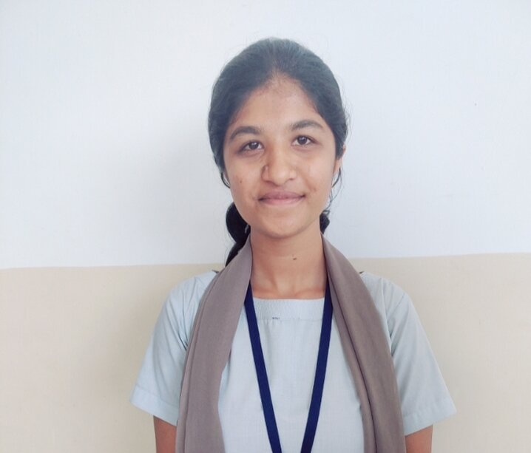
Name of Team Members (Strictly not more than four students in a batch):

Name: Bhoomika C P
USN No: 4GW19EE005
Email id: bhoomikapoonacha@gmail.com
Mobile No: 8861493073
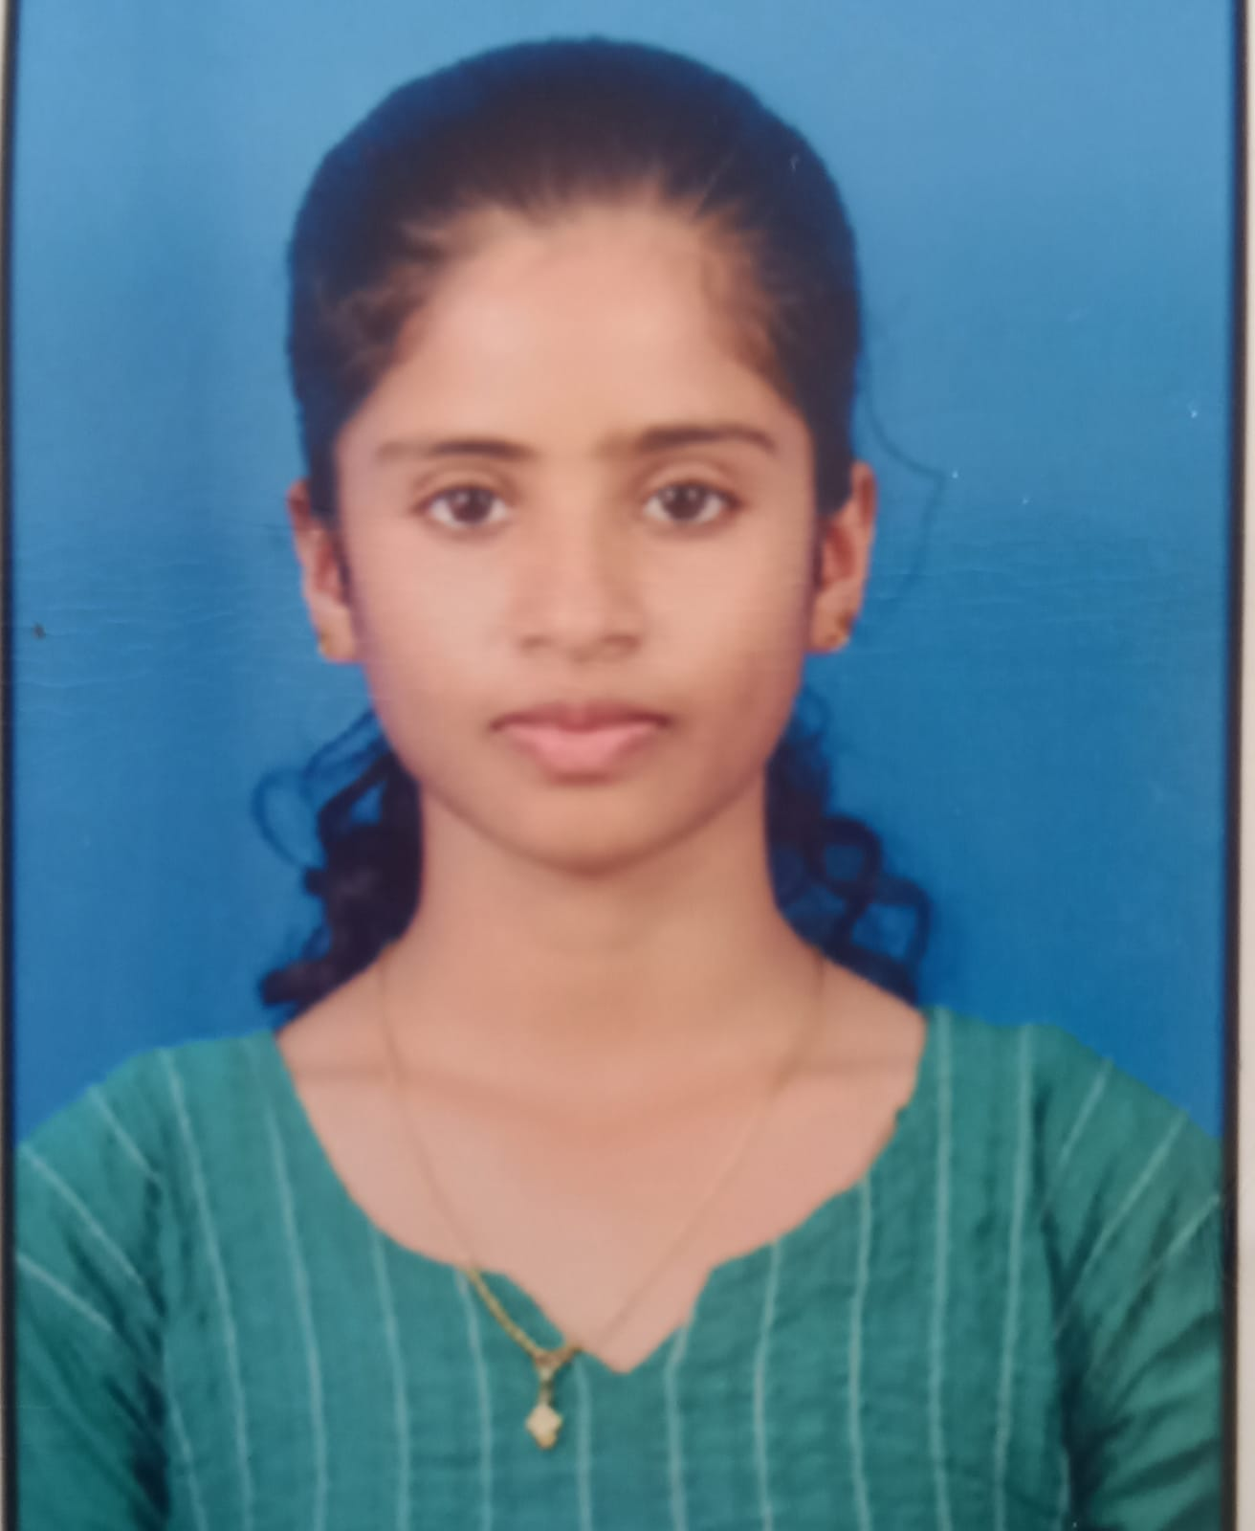
Name: Prakruthi K N
USN No: 4GW19EE026
Email id: prakruthigowdakn02@gmail.com
Mobile No: 8088321587

Name: Rakshitha G
USN No: 4GW19EE030
Email id: rakshitharakshi218@gmail.com
Mobile No: 6363498778
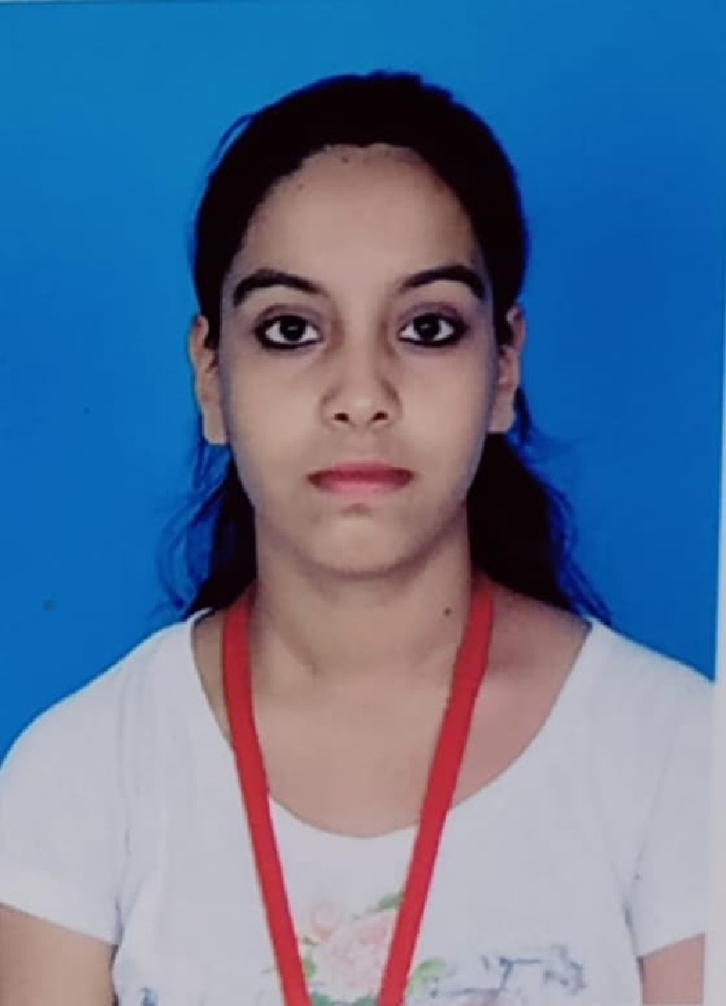
Name: Vidyashree K
USN No: 4GW19EE041
Email id: vidyakantharaju6@gmail.com
Mobile No: 8660020352
Team Leader of the Project:
Name: Rakshitha G
USN No: 4GW19EE030
Email id: rakshitharakshi218@gmail.com
Mobile No: 6363498778
Processing Fee Details (Through Online Payment only):
(processing fee of Rs. 1000/-)
Please furnish the payment made details provided in the last page of this proposal.
UPI No: 000394063218
Date: 31/01/2023
Bank Name: CANARA BANK
Date of commencement of the Project:
05/10/2022
Probable date of completion of the project:
05/05/2022
Scope / Objectives of the project:
• To reduce human effort in the agricultural field with the use of small machine.
• To perform all operations at single time, hence increases production and saves time.

Methodology:
The robot is made to travel in the farm and it is powered through batteries using a programming board and its direction controlled by Android application(blynk). The spraying of pesticides which can be done with the help of pesticide sprinkling pump and is periodically sprayed whenever the process is on the spraying angle is kept exactly at 180֯. And the length of the spraying mouth can be extended as much as we required.The system focused on the design, development and the fabrication of the agricultural robot with pesticide spraying system in addition to security system using IOT. The problems associated with the manual operated spraying machine are rectified and designed a new machine to overcome those problems.Selection of the motor is a major problem because it depends on the torque required and weight to be pulled, by using formals the motor has been selected. The battery selection also places an important role the required power is delivered to the system by the battery. The choice of materials for a vehicle is the first and most important factor for automotive design. In this we used Mild Steel bar alloy as a base material for chassis it will provide maximum strength and minimum deflection compared to other chassis material.

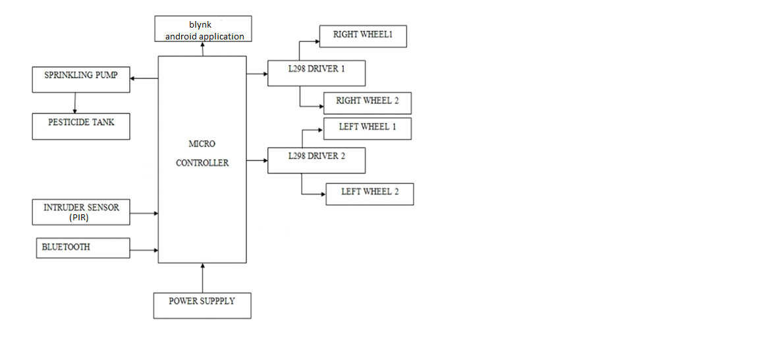

Expected Outcome of the project:

- The spraying time of insecticides is depending on the quantity of pesticide to be sprayed.
- Internet of Things is far and wide castoff in relating devices and gathering statistics. This agriculture monitoring system serves as a reliable and efficient system and corrective action can be taken. Wireless monitoring of field reduces the human power.

Is the project proposed relevant to the Industry / Society or Institution?
Yes / No:
No
If Yes, please provide details of the Industry / institution and contact details:
No

Can the product or process developed in the project be taken up for filing a Patent?
Yes / No:
No
Prior Art search done?
Yes/No:
No
Budget details (break-up details should be given):
Note: KSCST will provide nominal grant support for carrying out the project by students if selected by the project selection committee.
Budget | Amount
a) Materials / Consumables (Please specify) | 7000.00
b) Labor (Describe) | 3000.00
c) Travel (Describe) | 500.00
e) Miscellaneous (Please specify) | 500.00
Total | 11000.00

Any other technical details (Please specify):
Hardware Requirements:
- Arduino
- Buzzer
- Car kit
- LN298 Motor Driver
- PIR Sensors
Software Requirements:
- Arduino IDE
- Blynk

SPP Coordinator (Identified by the college):
Note: To be identified by the principal of the institution. The project proposals must be submitted to KSCST through SPP coordinator designated by the Principal.

Name: Mr. RAJASHEKAR M B
Email id: rajashekar@gsss.edu.in
Contact No.:9620268281

- Name of the Project Guide:  Shilpashri V N | Name of the HOD:  Dr.G.Sreeramulu Mahesh
Email id:shilpashri@gsss.edu.in | Email id: hodeee@gsss.edu.in
Contact No.: 8722031159 | Contact No.: 9980147498

DECLARATION
(From Project Students)

We, the project team hereby declare that the details enclosed in the project proposal (Title of the Project: Pesticide Sprinker with IOT based Security. Branch: Electrical & Electronics Engineering. College:GSSSIETW Mysore are true and correct to the best of our knowledge and belief and we undertake to inform KSCST of any changes there in the project title, students name will be intimated immediately through project guide. In case any of the above information is found to be false or untrue or misleading, we are aware that we may be held liable for it. We hereby authorize sharing of the project information with this project proposal with the Karnataka State Council for Science and Technology, Bangaluru.
We are aware that the project team must exhibit / demonstrate the project in the nodal centre and interact regarding project with the experts and to exhibit the project in the State Level Seminar and Exhibition (if selected). If the student team fails to attend the evaluation in nodal centre or fails to attend the State Level Seminar and Exhibition, the supported project amount will be returned to KSCST.
We also hereby, enclose the endorsement form to KSCST, Bengaluru.

Name of the students with USN No. Signature with date
1. BHOOMIKA C P (4GW19EE005)
2. PRAKRUTHI K N (4GW19EE026)
3. RAKSHITHA G (4GW19EE030)
4. VIDYASHREE K (4GW19EE041)
Mrs. Shilpashri V N  (Name & Signature of Project Guide with Seal) | Dr.G Sreeramulu Mahesh  (Name & Signature of HOD with Seal)
Email id: shilpashri@gsss.edu.in | Email id: hodee@gsss.edu.in
Contact No.:8722031159 | Contact No.: 9980147498

ENDORSEMENT
(From College, endorsement to be taken in the institution / Department Letter head)
(To scan this page and enclose in the project proposal)

This is to certify that 1) Ms. Bhoomika C P, 2) Ms. Prakruthi K N, 3) Ms. Rakshitha G, 4) Ms. Vidyashree K are bonafide student(s) of Department of Electrical & Electonics Engineering, in the degree program of our institution. If the project proposal submitted by these students under the 46th series of Student Project Programme is selected by KSCST, we will provide the requisite laboratory / Computer / infrastructure support in our college / Institution. Further we also take necessary steps to see that the project team will exhibit / demonstrate their project in the nodal centre and in the State Level Seminar and Exhibition (if selected). If the student team fails to send the completed project report or fails to attend the evaluation in nodal centre or fails to attend the State Level Seminar and Exhibition, the supported project amount will be returned to KSCST.

Mrs. Shilpashri V N  (Name & Signature of  Project Guide with Seal) | Dr.G.Sreeramulu Mahesh  (Signature of HOD with Seal) | Dr.M Shivakumar  (Signature of the Principal with Seal)
Email in:  shilpashri@gsss.edu.in | Email id:  hodee@gsss.edu.in | Email id:  principal@gsss.edi.in
Contact No.: 8722031159 | Contact No.:9980147498 | Contact No.:98333406214

DETAILS OF PROCESSING FEES MADE THROUGH
NEFT / UPI PAYMENT
(Note: Include this page in the softcopy of the student project proposal. The student team shall furnish the details in the Google Form. It is informed to the students to 1) keep ready the softcopy of the project proposal and other documents and 2) Furnish the payment made details as processing fees and 3) update the details in the Google Form on the same day of payment made to KSCST by NEFT / UPI payment).

- TITLE OF THE PROJECT | : | Pesticide Sprinkler with IOT based Security
- NAME OF THE TEAM LEADER | : | Rakshitha G
- EMAIL ID | : | rakshitharakshi218@gmail.com
- CONTACT MOBILE NO. | : | 6363498778
PAYMENT MADE DETAILS
- BANK REF. NO. / UTR NO. / UPI No. (12 digits) | : | 000394063218
- TRANSACTION ID | : | 000394063218
- NAME OF THE SENDER / ACCOUNT HOLDER and CONTACT NUMBER | : | Principal,GSSSIETW
- NAME OF THE BANK | : | CANARA BANK
- PROCESSING FEES | : | Rs. 1000/-
- DATE OF PAYMENT MADE | : | 31-01-2023
- TIME | : | 12:02:44
- MODE OF PAYMENT MADE  (NEFT / UPI, PLEASE SPECIFY) | : | Funds Transfer Debit – KARNATAKA STATE  COUNCIL FOR SCIENCE: Cheque

Rakshitha G  (Name & Signature of  the team leader) | Dr.G.Sreeramulu Mahesh  (Name & Signature of  Project Guide or HOD with Seal)
KARNATAKA STATE COUNCIL FOR SCIENCE AND TECHNOLOGY
Indian Institute of Science campus, Bengaluru
46th SERIES OF STUDENT PROJECT PROGRAMME (SPP)
(Note: This page is for information about bank details of KSCST to the student team and college / institution and not to include this page in the project proposal softcopy)

BANK ACCOUNT DETAILS OF KSCST
Name and address of the Institution | Karnataka State Council for Science and Technology, IISc Campus, Bangalore -560012
Account holder’s name / Designation | Secretary, Karnataka State Council for Science and Technology
Bank Account No. & Name of the bank | Current A/C No. 0683201000024  Canara Bank, IISc Campus Branch, Bangalore-560012
IFSC Code | CNRB0000683
MICR Code | 560015023
Bank Branch Address | Canara Bank, Indian Institute of Science, Bangalore-560012

