Q1. Do we have actors in the actor table that share the full name and if yes display those shared names.

select first_name,last_name from actor

group by first_name,last_name

having count(actor_id)>1

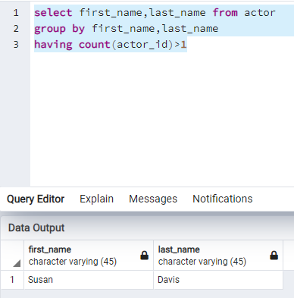

Q2. Return the customer IDs of customers who have spent at least $110 with the staff member who has an ID of 2.

SELECT customer_id, staff_id FROM payment

WHERE staff_id = 2

GROUP BY customer_id, staff_id

HAVING SUM(amount) >= 110

ORDER BY customer_id;

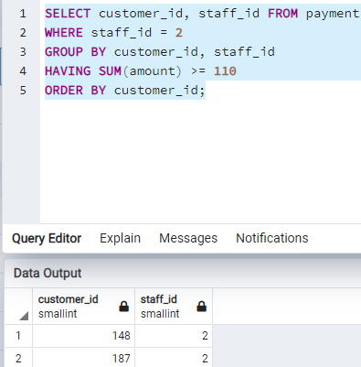

Q3. How many films begin with the letter J?

select count(*) from film where title ilike 'j%';

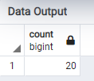

Q4. What customer has the highest customer ID number whose name starts with an 'E' and has an address ID lower than 500?

select customer_id, first_name, last_name from customer

where first_name ilike 'E%' and address_id < 500

order by address_id desc limit 1;

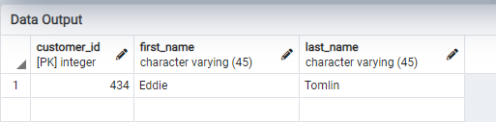

Q5. How many films have the word Truman somewhere in the title?

select count(*) from film where title ILIKE '%Truman%';

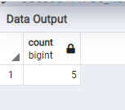

Q6. Display the total amount payed by all customers in the payment table.

select sum(amount) from payment;

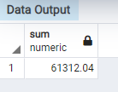

Q7. Display the total amount payed by each customer in the payment table.

select customer_id,count(customer_id) as Total_Trans,sum(amount) as

total_amount from payment

group by customer_id

order by sum(amount);

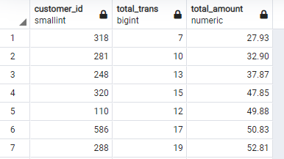

Q8. What is the highest total_payment done.

select customer_id, sum(amount) from payment

group by customer_id

order by sum(amount) desc limit 1;

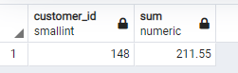

Q9. Which customers have not rented any movies so far.

select customer_id, first_name, last_name from customer where active = 0;

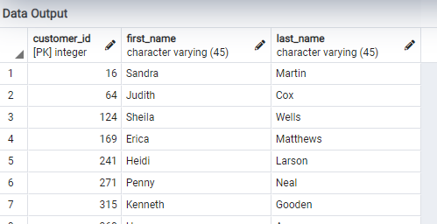

Q10. How many payment transactions were greater than $5.00?

select count(*) from payment where amount >=5;

