Problem 1: (HW)
Let 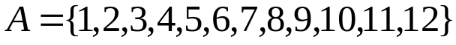. On this set define the relation R by  iff  is a multiple of 5. Verify that R is an equivalence relation.
Problem 2: (HW)
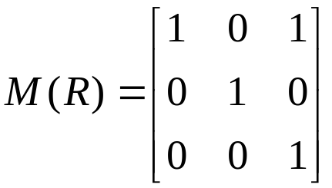
A relation R by on a set 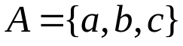 is represented by as
Determine whether R is a equivalence relation.
Problem 3: (HW)
Let 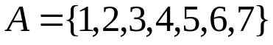 and R be the equivalence relation on A that induces the partition find R.
Problem 4: (HW)
Let 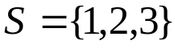 and P(S) be the power set S. On P(S) define the relation R by XRY iff . Show that this relation is partial order on P(S). Draw its Hasse diagram
Problem 5: HW
In a certain area of the country side, there are 5 villages A, B, C, D, E. An Engineer is to devise a system of roads so that, after the system is completed, no village will be isolated. In how many ways can he do this?
Problem 6:HW
In how many ways can one arrange the letters in the word CORRESPONDENTS so that
- There is no pair of consecutive identical letters?
- There are exactly two pairs of consecutive identical letters?
- There are at least three pairs of consecutive identical letters?
Problem 7: HW
There are eight letters to eight different people to be placed in eight different addressed envelopes. Find the number of ways of doing this so that at least one letter gets to the right person.

