Day 3: Peripheral Troubleshooting

Learning Objectives
After this session, students will be able to:
- Identify common peripheral problems.
- Understand troubleshooting steps.
- Fix printer, scanner, keyboard, mouse, and webcam issues.
- Apply logical troubleshooting methods in real-life situations.

Theory Session

What is Peripheral Troubleshooting?
Peripheral troubleshooting means finding and fixing problems in external devices connected to a computer.
Examples:
- Printer not printing
- Webcam not detected
- Keyboard not typing
- Mouse not working
- Scanner not scanning

Basic Troubleshooting Flow
Identify Problem
↓
Check Connections
↓
Check Power Supply
↓
Check Drivers
↓
Restart Device
↓
Test Device
↓
Replace Hardware if Needed

Common Peripheral Issues and Solutions

1. Printer Not Printing

Possible Causes
- Printer is OFF
- USB cable disconnected
- No paper
- Paper jam
- Driver missing
- Printer Offline

Solutions
✔ Check power cable
✔ Check USB/Wi-Fi connection
✔ Load paper
✔ Remove paper jam
✔ Restart printer
✔ Reinstall printer driver

Printer Components
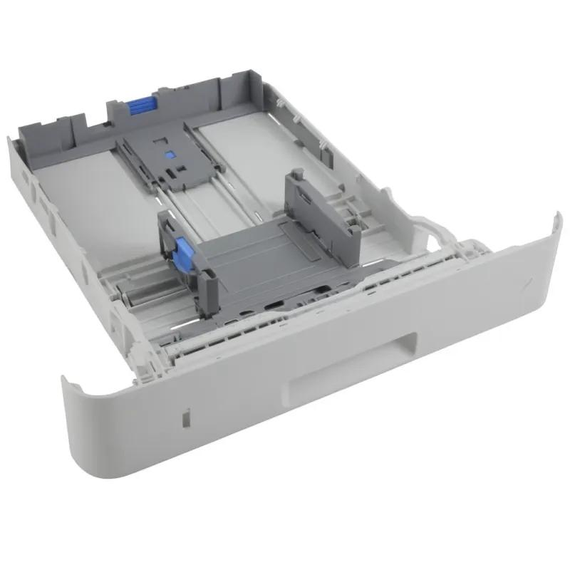
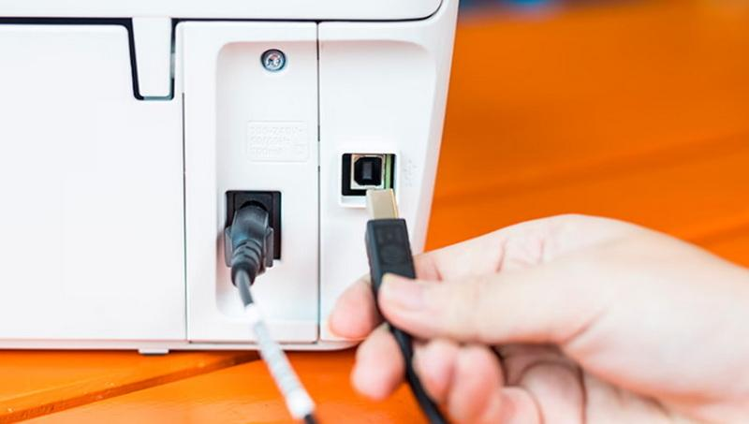
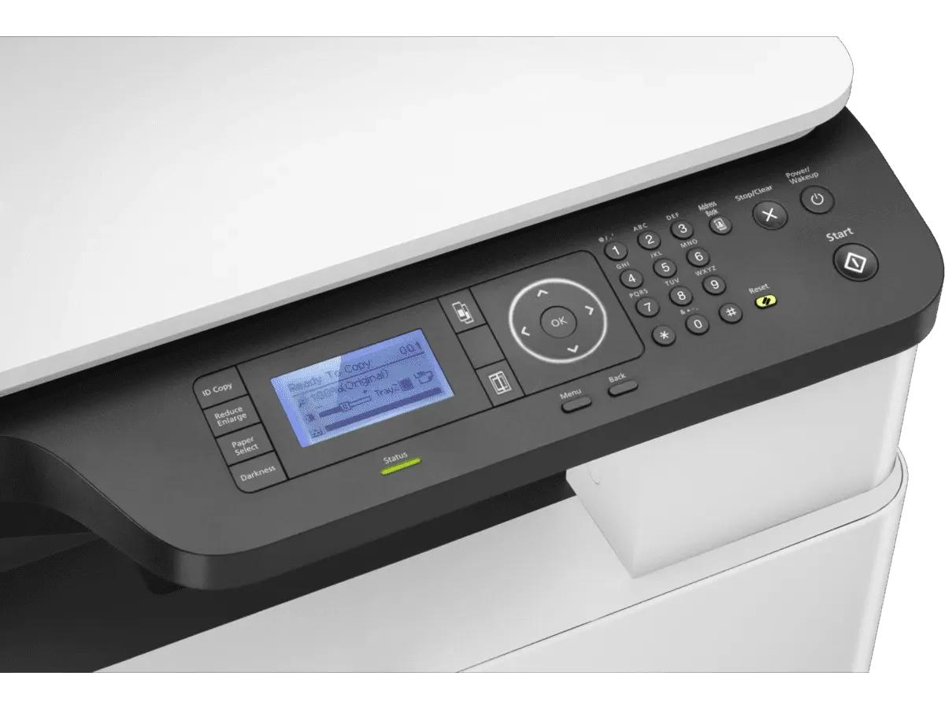
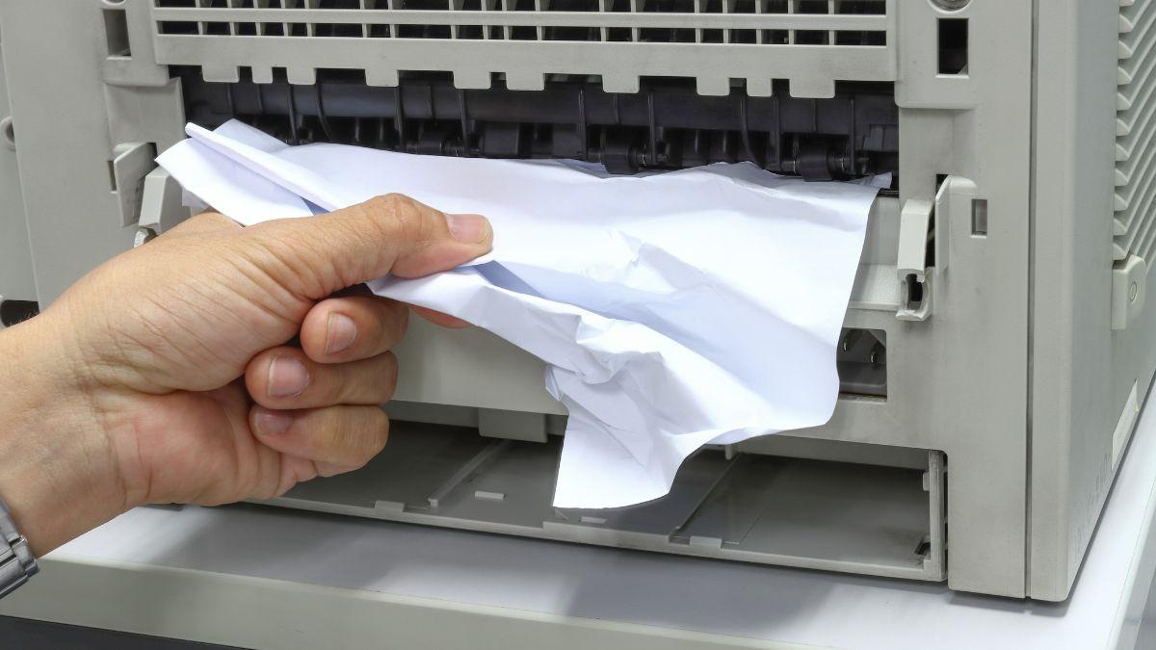

2. Keyboard Not Working

Causes
- Loose USB cable
- Driver issue
- Dust inside keyboard

Solutions
✔ Reconnect keyboard
✔ Try another USB port
✔ Restart computer
✔ Update drivers

3. Mouse Not Working

Causes
- USB problem
- Battery dead (wireless mouse)
- Surface issue

Solutions
✔ Change batteries
✔ Use mouse pad
✔ Try another USB port

4. Webcam Not Working

Causes
- Driver missing
- Camera blocked by privacy settings
- USB issue

Solutions
✔ Check camera permissions
✔ Reconnect webcam
✔ Update driver
✔ Test in Camera Application

Webcam Examples
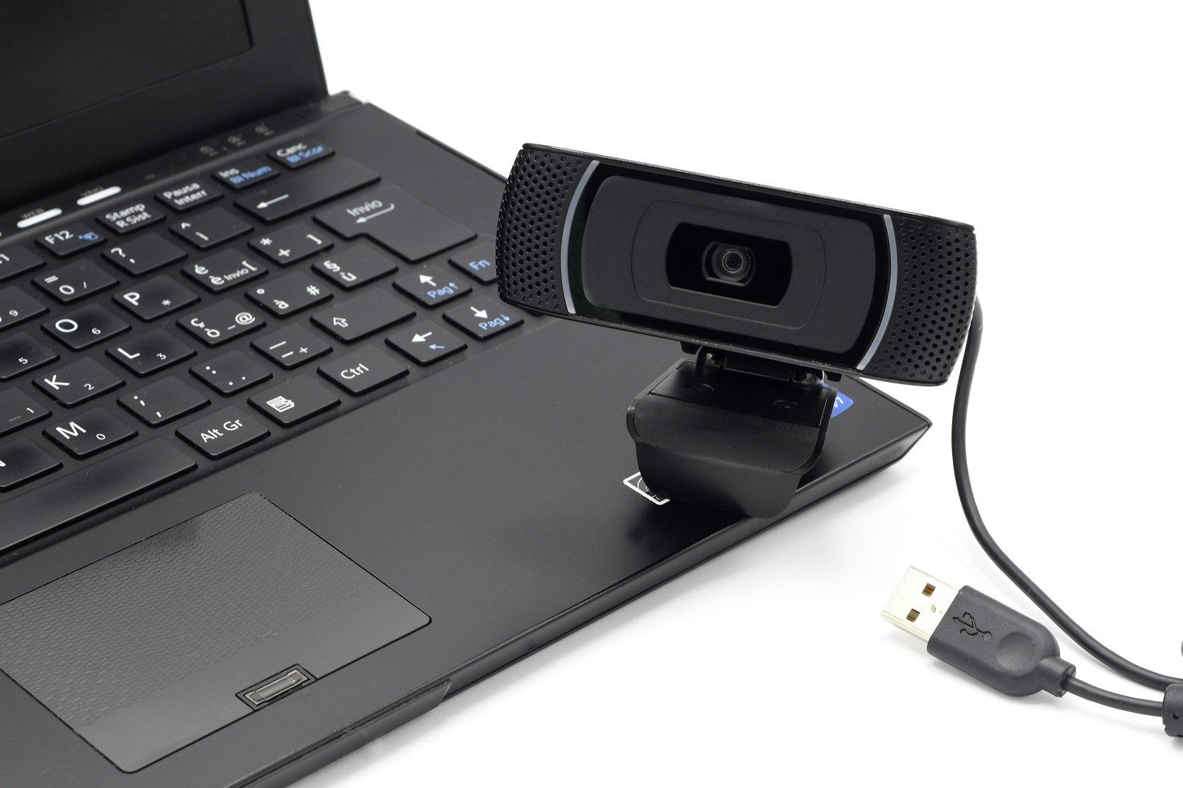
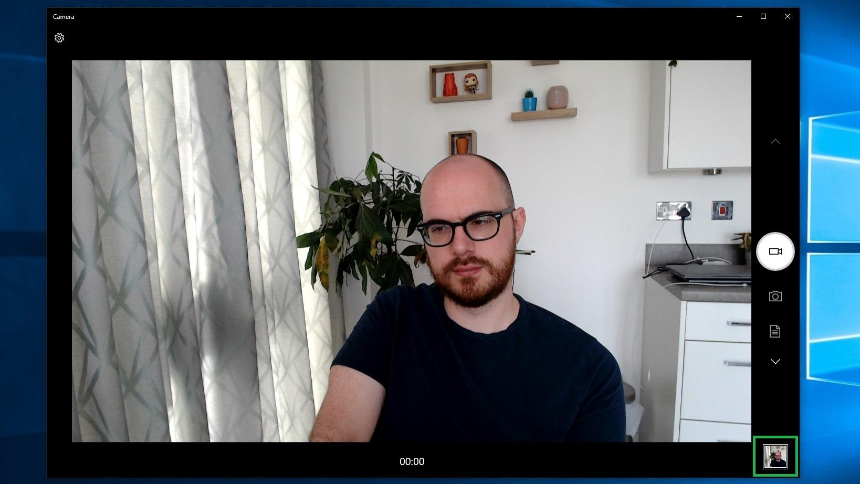
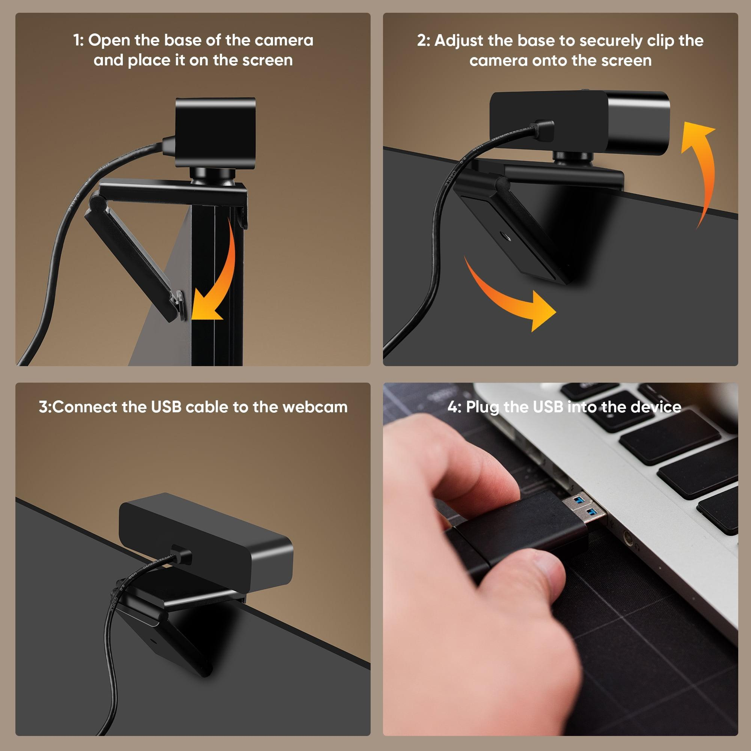
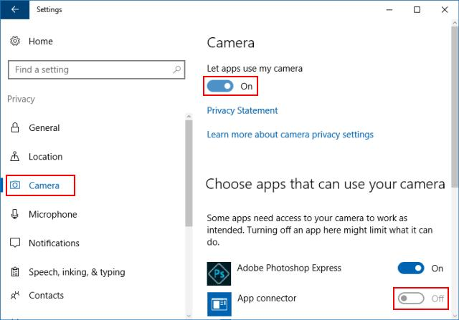
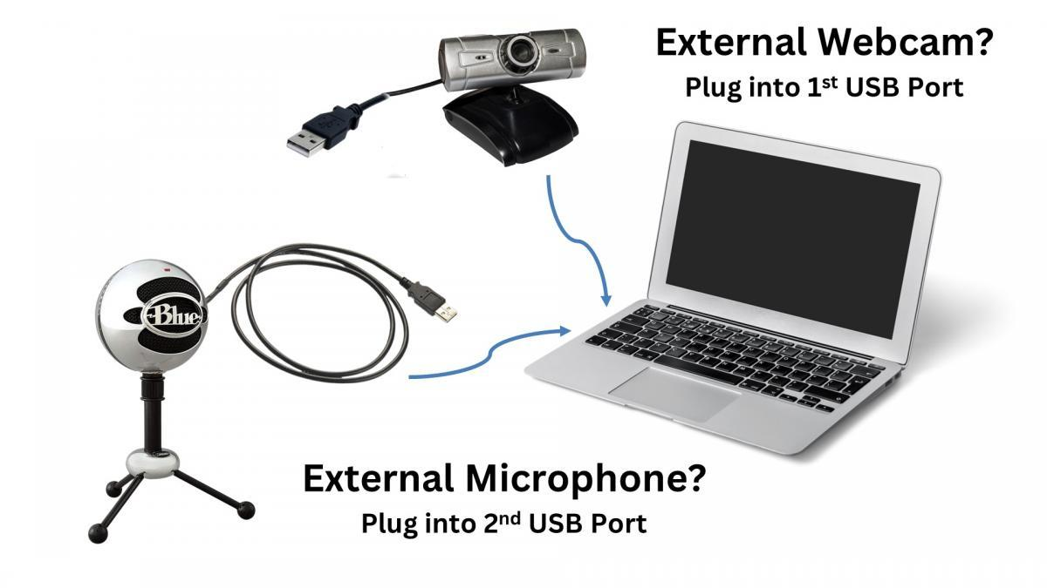
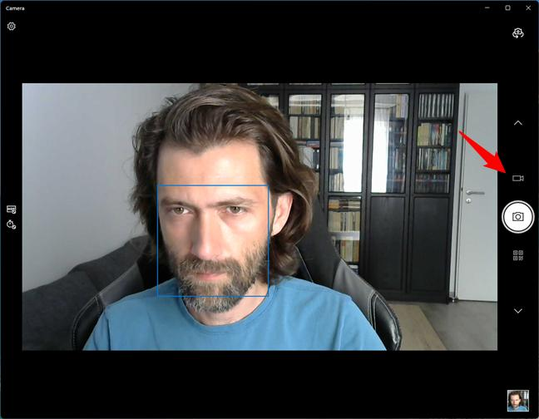

5. Scanner Not Working

Causes
- Driver missing
- USB disconnected
- Scanner software problem

Solutions
✔ Check cable
✔ Restart scanner
✔ Reinstall software
✔ Test with Windows Scan App

Real-Life Troubleshooting Tips

Rule 1
Always check physical connections first.

Rule 2
Restart device before making major changes.

Rule 3
Check Device Manager for errors.

Rule 4
Test device on another computer.

Rule 5
Never assume hardware is faulty immediately.

Practical Session

Practical 1: Troubleshoot Non-Working Printer

Scenario
Student reports:
"Printer is connected but not printing."

