Next Level: Day 8 – Advanced Networking Lab
Since students already know ipconfig, ping, tracert, nslookup, Wireshark, and basic networking, the next step is to move toward Advanced Networking and Real-World IT Support Practicals.
These practicals can be performed directly on a Windows laptop.

Practical 1: Calculate Subnetting Manually
Task: Calculate the Network ID, Broadcast IP, and Usable Host Range for the following IP address.
192.168.10.25/27
Students must find:
- Subnet Mask
- Network Address
- Broadcast Address
- First Usable IP
- Last Usable IP
- Total Usable Hosts

Practical 2: PowerShell Network Audit
Open PowerShell and execute the following commands.
1. View network adapters
powershell
Get-NetAdapter
2. View IP configuration
powershell
Get-NetIPConfiguration
3. View the IPv4 routing table
powershell
Get-NetRoute -AddressFamily IPv4
4. View ARP and neighbor cache entries
powershell
Get-NetNeighbor -AddressFamily IPv4
Student Task:
- Execute all four commands.
- Understand the output of each command.
- Record the results in an observation table.

Practical 3: Check TCP Ports and Services
Step 1: View listening TCP connections.
powershell
Get-NetTCPConnection -State Listen
Step 2: Open Command Prompt as Administrator and run:
cmd
netstat -abno
Student Task:
- Identify local port numbers.
- Find the corresponding Process ID (PID).
- Open Task Manager and identify the process using its PID.
- Record the results.
Do not terminate unknown processes without understanding their purpose.

Practical 4: Create a Local Web Server on Your Laptop
Objective: Learn how a web server works by hosting a simple webpage locally.
Step 1: Check whether Python is installed.
cmd
python --version
Step 2: Create a folder and create a file named index.html inside it.
Add the following HTML:
HTML
Wrap linesCopy codePreview
<h1>My Networking Lab</h1>
<p>Local Web Server is Working!</p>
Step 3: Open Command Prompt in that folder and run:
cmd
python -m http.server 8000 --bind 127.0.0.1
Step 4: Open your browser and visit:
http://127.0.0.1:8000
Expected Result: The browser displays your HTML webpage.
This server is bound to localhost, so it is not accessible from other computers. Press Ctrl + C in Command Prompt to stop it.

Practical 5: Analyze Packet Loss and Network Delay
Step 1: Test the local TCP/IP stack.
cmd
ping -n 50 127.0.0.1
Step 2: Test the default gateway.
cmd
ping -n 50 <gateway-IP>
Replace <gateway-IP> with your actual default gateway address.
Student Task: Compare the results.
Test | What to Understand
Loopback ping | Local TCP/IP stack
Gateway ping | Local network connectivity
Packet loss | Number of unanswered packets
Average time | Average round-trip delay

Practical 6: Check Network Profile and Firewall
Open PowerShell and execute:
1. Check the network profile
powershell
Get-NetConnectionProfile
2. Check Windows Firewall profiles
powershell
Get-NetFirewallProfile
Student Task:
- Identify whether the current Wi-Fi network is configured as Public or Private.
- Check the status of Domain, Private, and Public firewall profiles.
- Record the results.
There is no need to disable the firewall for this practical.

Check Disk Space and System Health
Objective: Identify whether low disk space or Windows system-file problems could affect performance.
Step 1: Open PowerShell.
Step 2: Check disk space:
powershell
Get-PSDrive -PSProvider FileSystem
Step 3: Check Windows system files. Open Command Prompt as Administrator and run:
cmd
sfc /verifyonly
This checks protected system files for integrity problems without repairing them.
Expected result: Disk information shows used and free space. The SFC command reports whether it finds integrity violations.
Student task:
- Record the free space on the Windows drive.
- Record the SFC result.
- Explain why a nearly full system drive can affect a computer's performance.
Note: System-file verification may take several minutes.
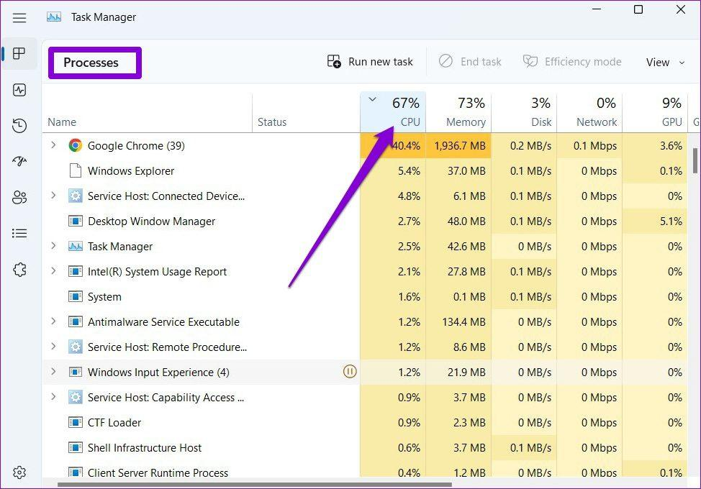
Objective: Find applications using excessive CPU, memory, or disk resources.
Step 1: Press Ctrl + Shift + Esc.
Step 2: Open Task Manager and select Processes.
Step 3: Check the CPU, Memory, and Disk columns.
Step 4: Identify the applications consuming the most resources.
Alternatively, use PowerShell:
powershell
Get-Process |
Sort-Object CPU -Descending |
Select-Object -First 10 ProcessName, Id, CPU
This lists processes with the highest accumulated CPU time, not necessarily the highest current CPU usage.
Expected result: Students identify resource-intensive processes and learn to distinguish a busy application from a malfunctioning one.
Student task: Record the top three processes and their resource usage. Do not terminate unknown processes or unsaved applications.

Check Windows Services

