Checkbox->Multiple Item

RadioButton->Single Item

Task:

Screen 1->

Give a Title Login with Font(Color) and text Style

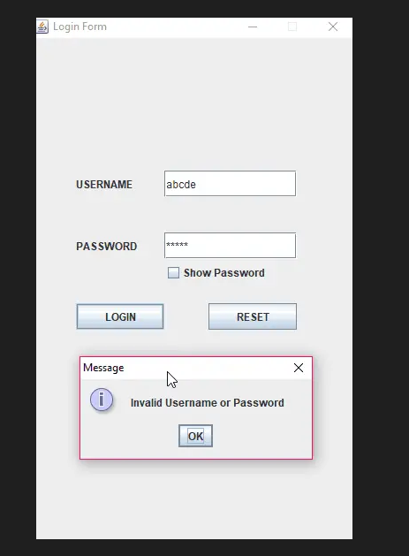

Screen 2:

Café ordering system with 6 items

[optional: Add Images of Product]

Screen 3:

Bill Generate

Screen 4:

Exit