**BDA - Lab 4**

SEM 7- CE142

**Objective**

To practice MapReduce programming in Hadoop using Java Coding.

**Exercise**

Step. 1.1: Create a file named 'pages.txt' in local file system. Store line by line content as shown below. Each line data represents number of pages of a sample book.

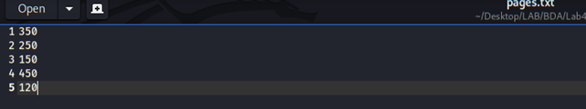

Step. 1.2: Put the file from local file system to hdfs with folder named 'input'. Confirm the presence of above data.

**Command :**

**hadoop dfs -mkdir -p /bookdata**

**hadoop dfs -put pages.txt /bookdata**



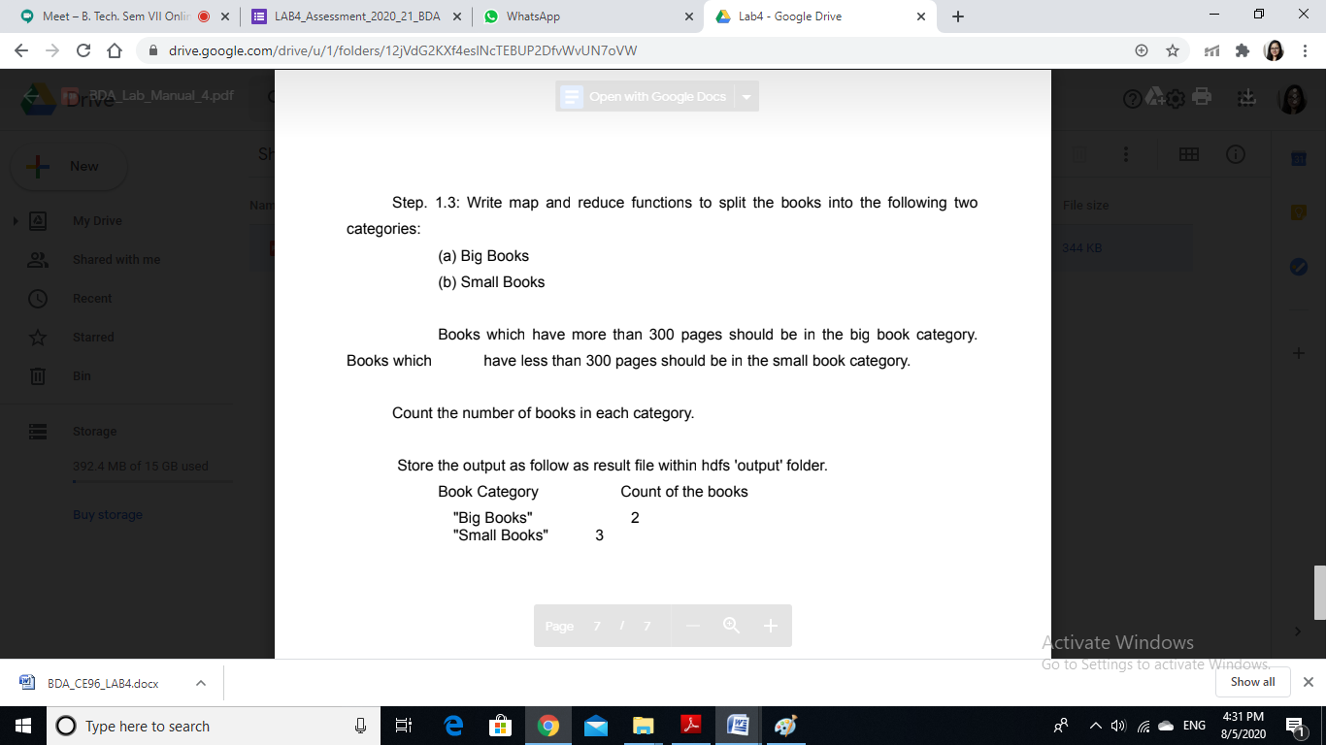

**Java code**

Imported packages.

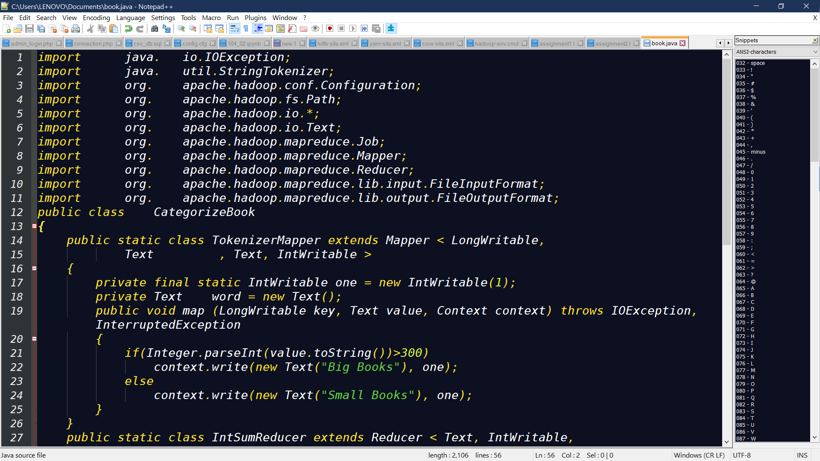

Classes we have written..



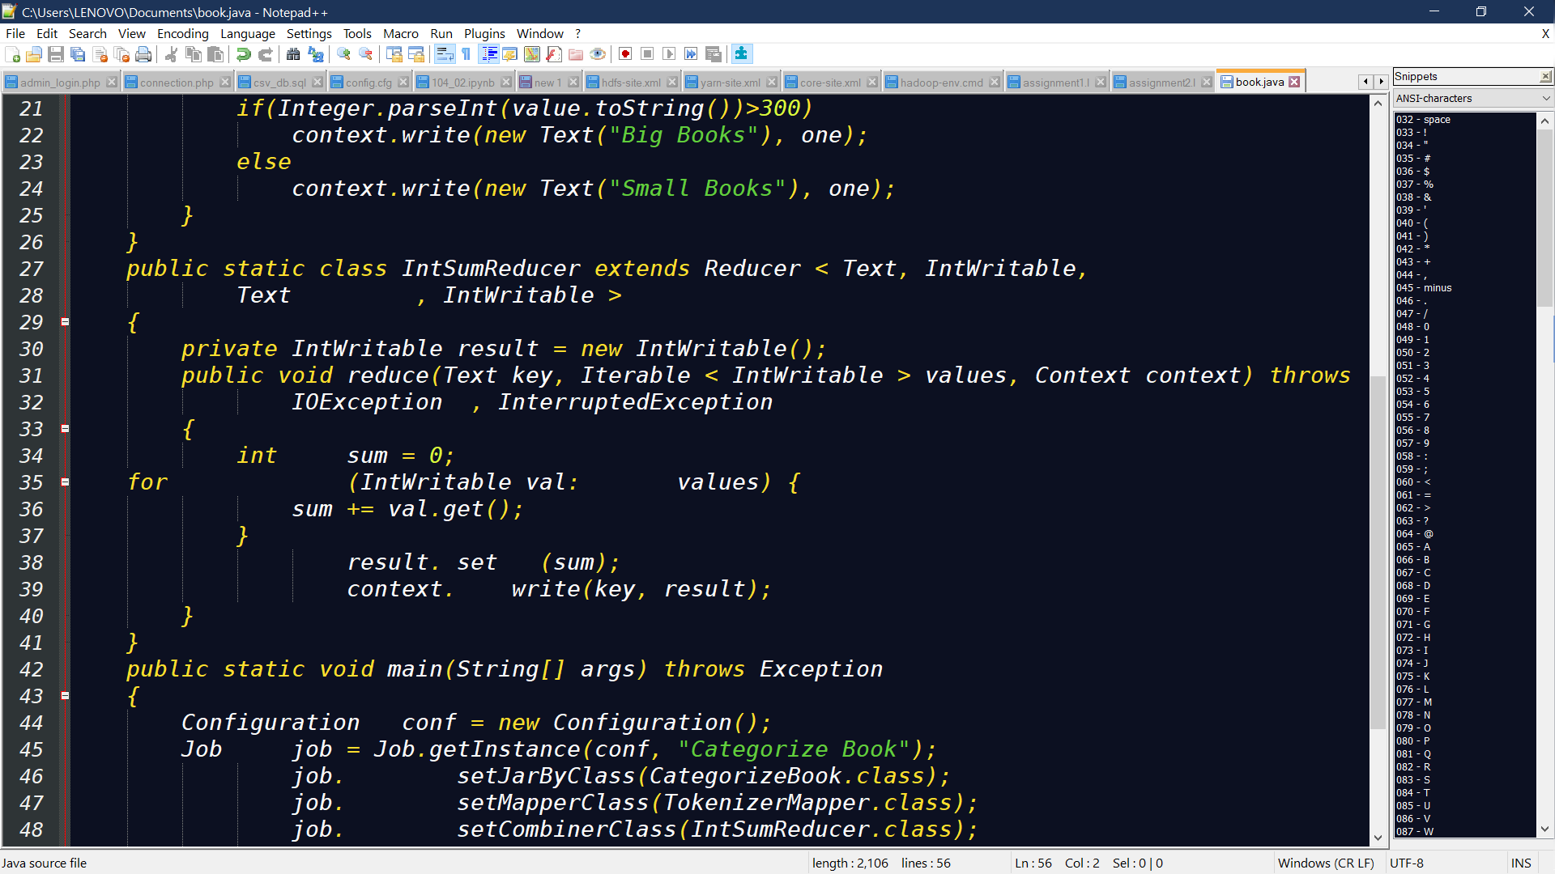

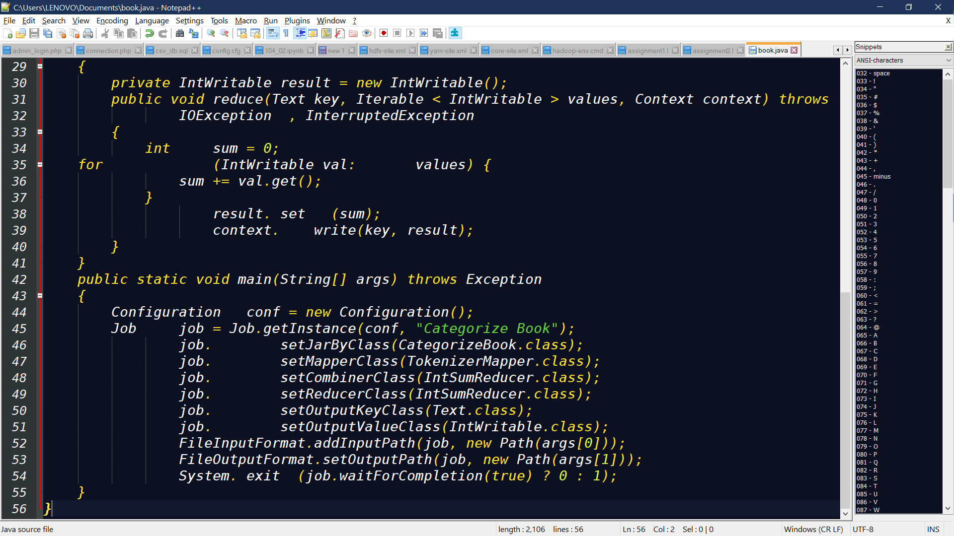

Run The Jar File :

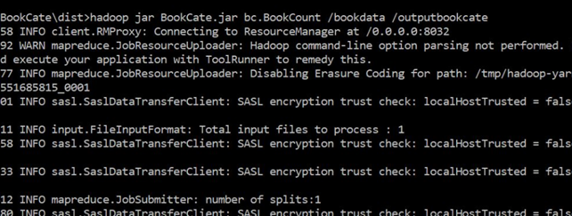

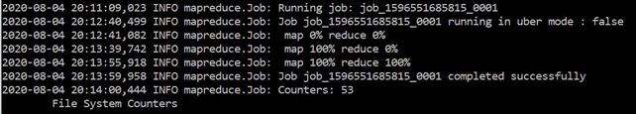

Output Directory:-

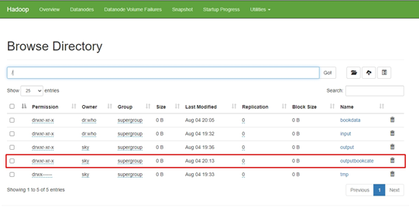

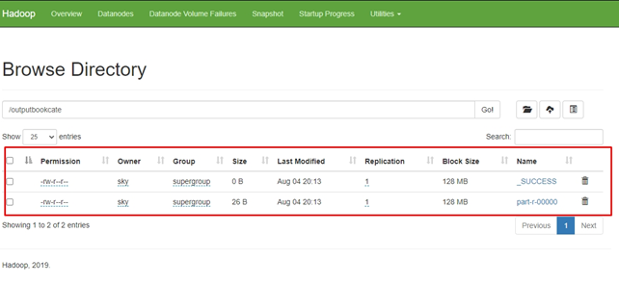

Final Output:-

