**BDA LAB 5**

**CE 142**

**Aim: - Map-reduce solution to a custom problem at hand.**

**Modelling the problem into mapreduce architecture.**

* **Problem Statement: -**

Data given is about yearly and monthly resource consumption of an organization.

It contains monthly and yearly average for various years.

If we are given above data as an input then we have to write map reduce solution

to process it and produce analysis based results such as the year of maximum

usage, year of minimum usage etc.

* **Steps:-**

Create a file named 'input.txt' in local file system. Store data as shown below in it.

(13 columns other than year: 12 for month average and 1 for yearly average)

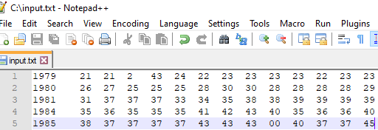

Put the file from local file system to hdfs with folder named 'input'. Confirm the presence of

above data.

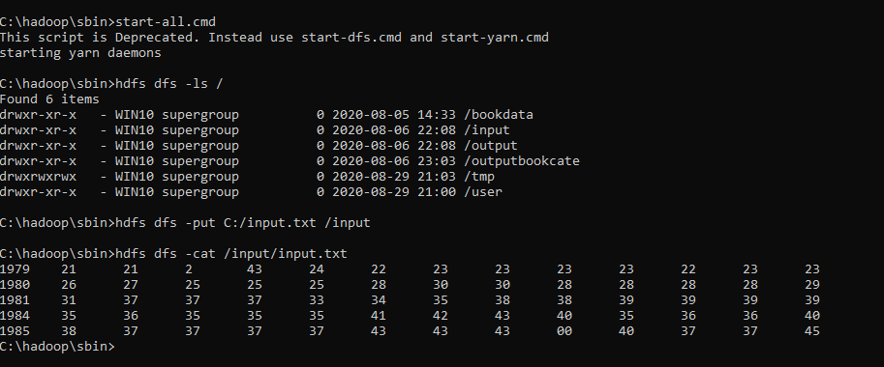

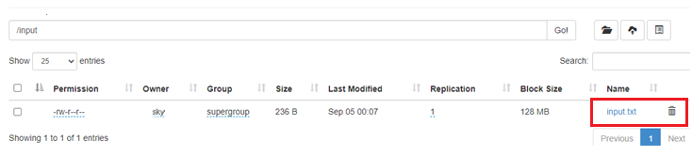

Write map and reduce function.

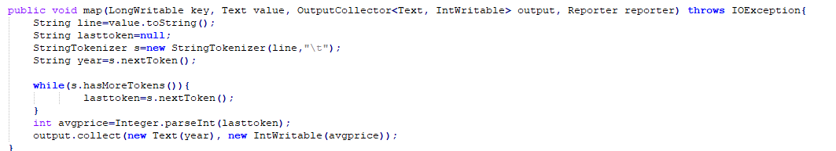

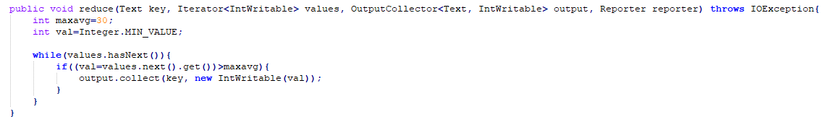

Compile ProcessUnit.java file and create .jar file as shown below.



Then execute the .jar file you have created.

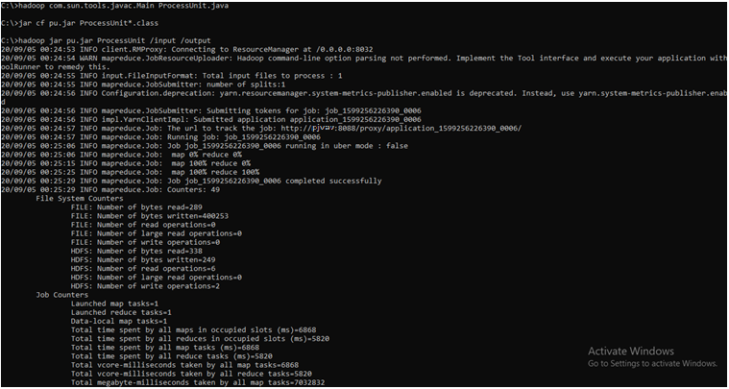

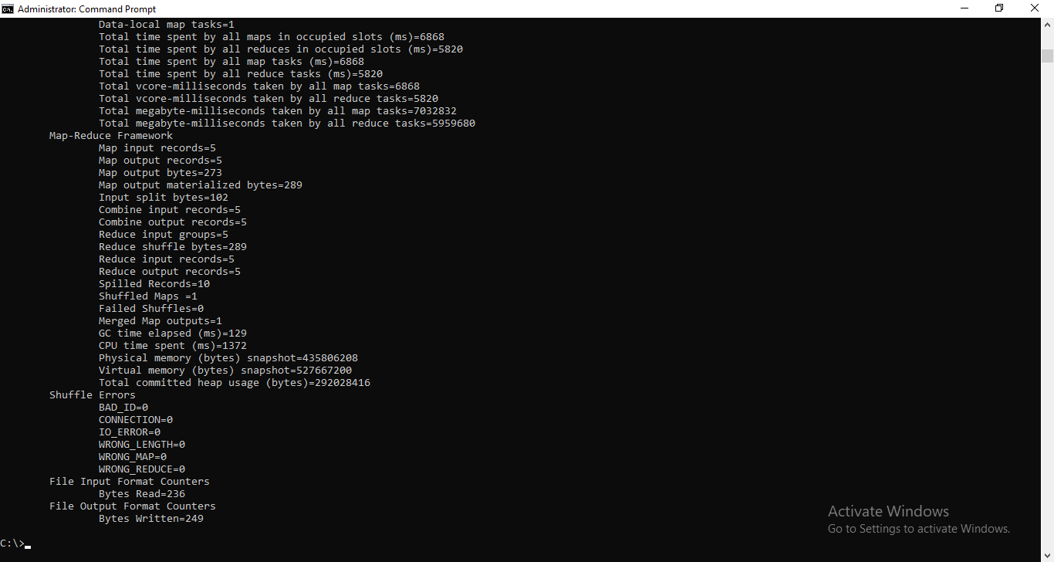

Now you can see output file on hdfs and also content of part-r-00000 file.

