**BDA LAB 6**

**CE142 SEM 7**

**Aim : "Connecting to NoSQL database/s and querying to provide analysis using api like aggregation, etc. To be able to successfully import/export from/to CSV."**

**Exercise:**

**1. Set up mongodb with python using pymongo module**

**For that run the following command on your command**

**Prompt**

**-pip install PyMongo**

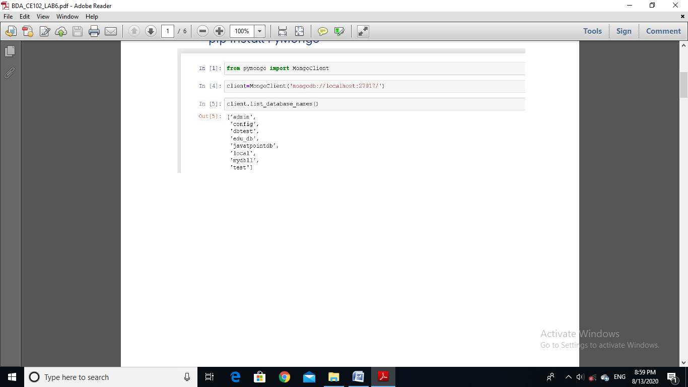

**2. Write the insert method to store the following document in**

**MongoDB**

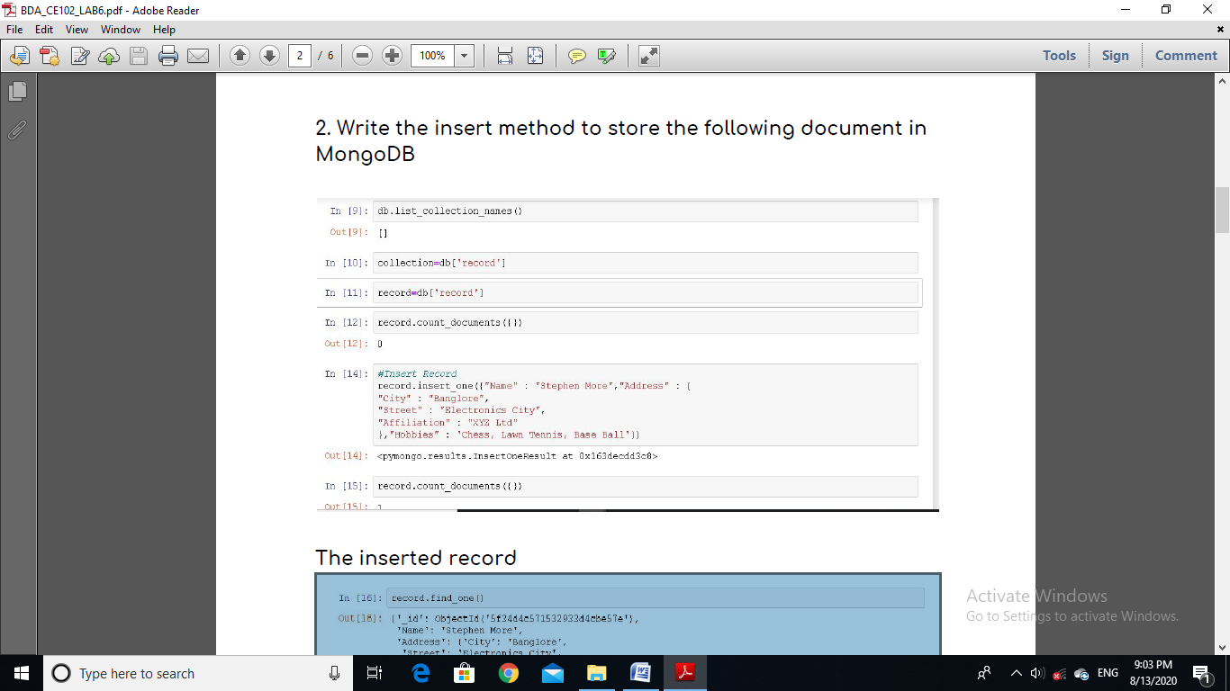

**The inserted record**

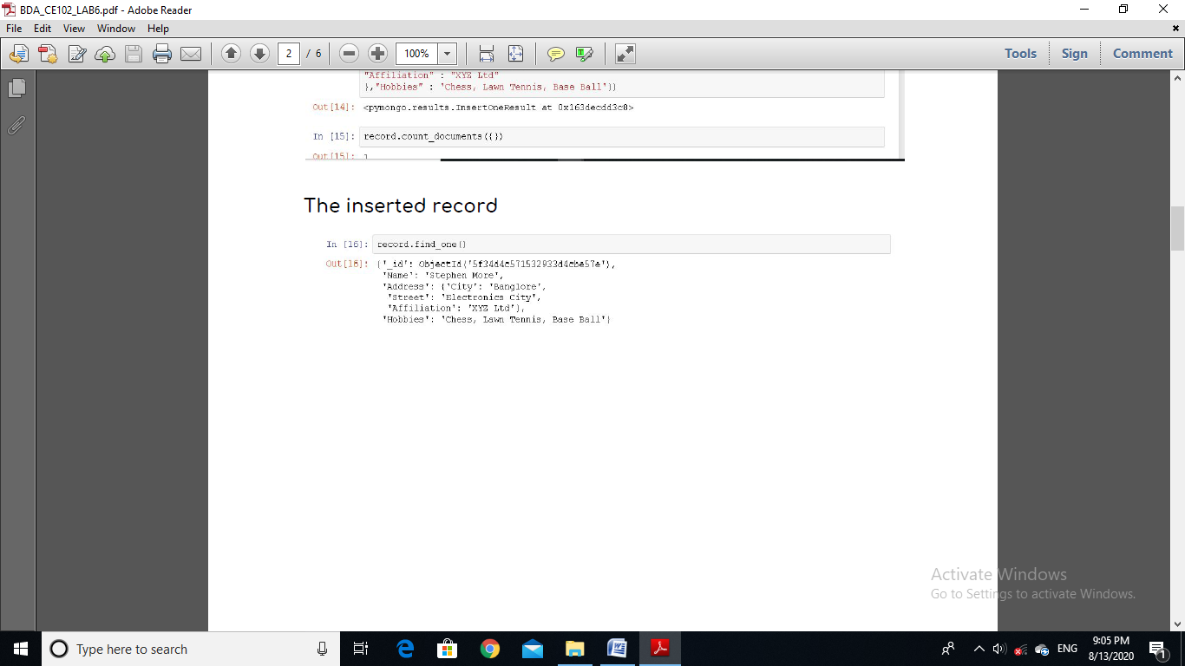

**3. To practice MapReduce programming in MongoDB.**

**Step. 3.1 : Insert 5 documents as shown below in collection**

**named 'books'.**

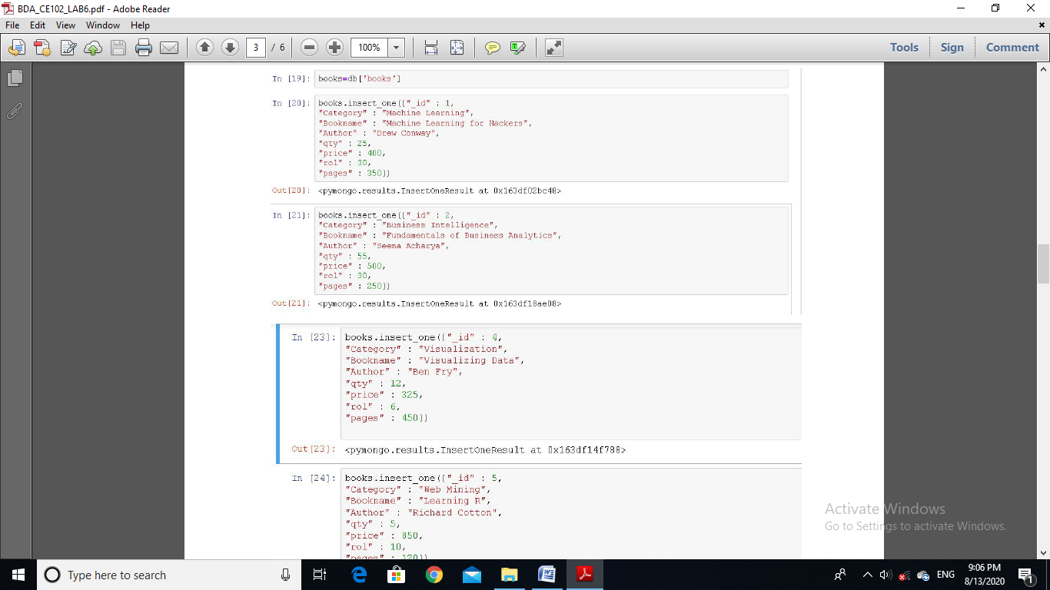

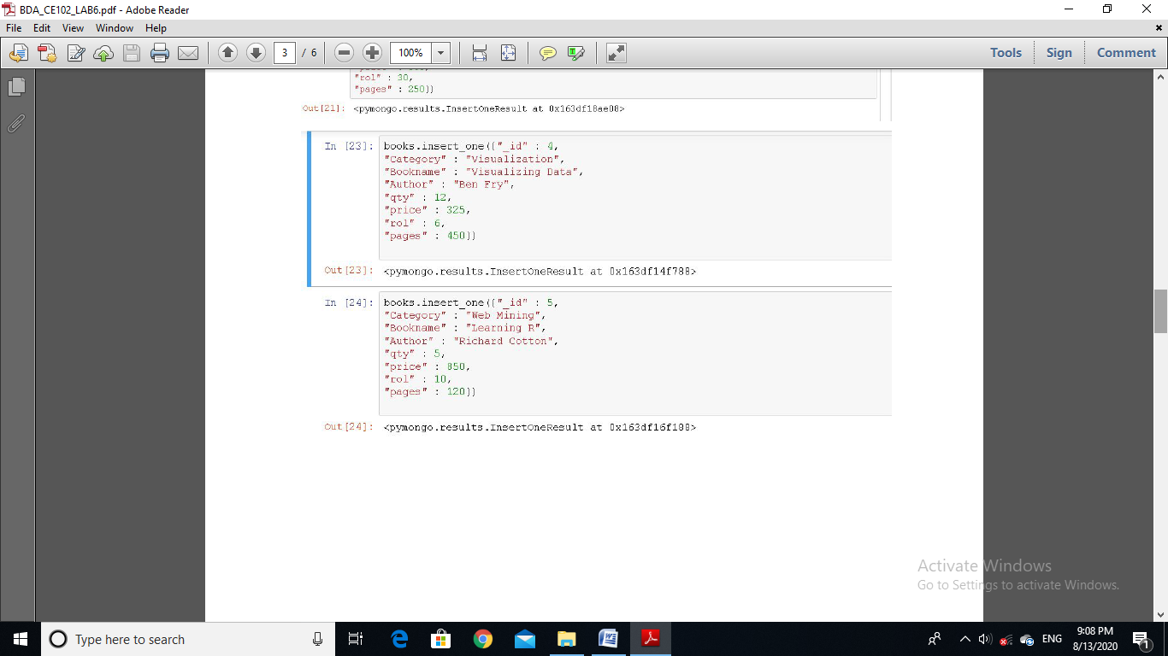

**Step. 3.2: Confirm the presence of above documents in the**

**“books” collection.**

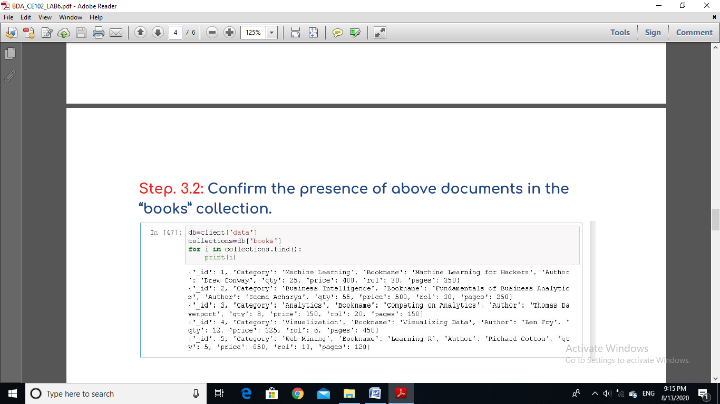

**Step. 3.3: Write map and reduce functions to split the books**

**into the following two categories:**

**(a) Big Books**

**(b) Small Books**

**Step. 3.4: Count the number of books in each category.**

**Step. 3.5: Store the output as follow as documents in a new**

**collection, called “Book_Result”.**

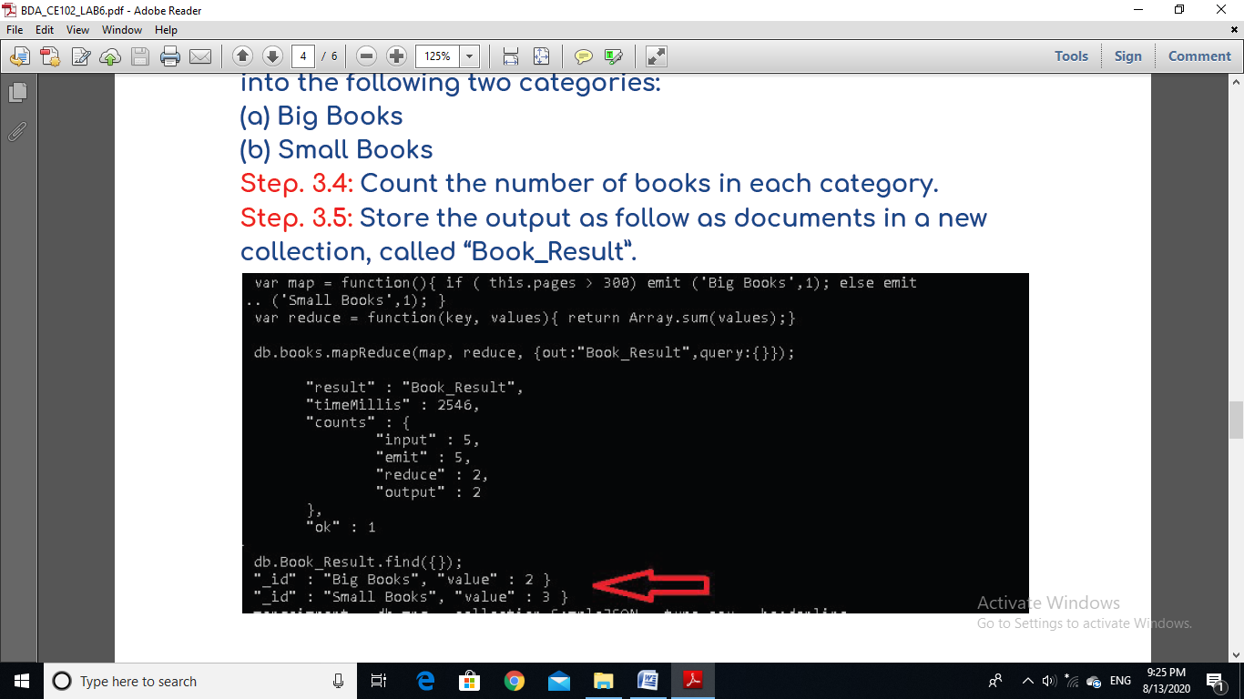

**4. To practice import, export and aggregation in MongoDB.**

**Run the following command to import the data from csv file.**

**mongoimport --db data --collection new_record --type csv**

**--file C:\Users\abc\Desktop\social\Dataset3.csv**

**--headerline**

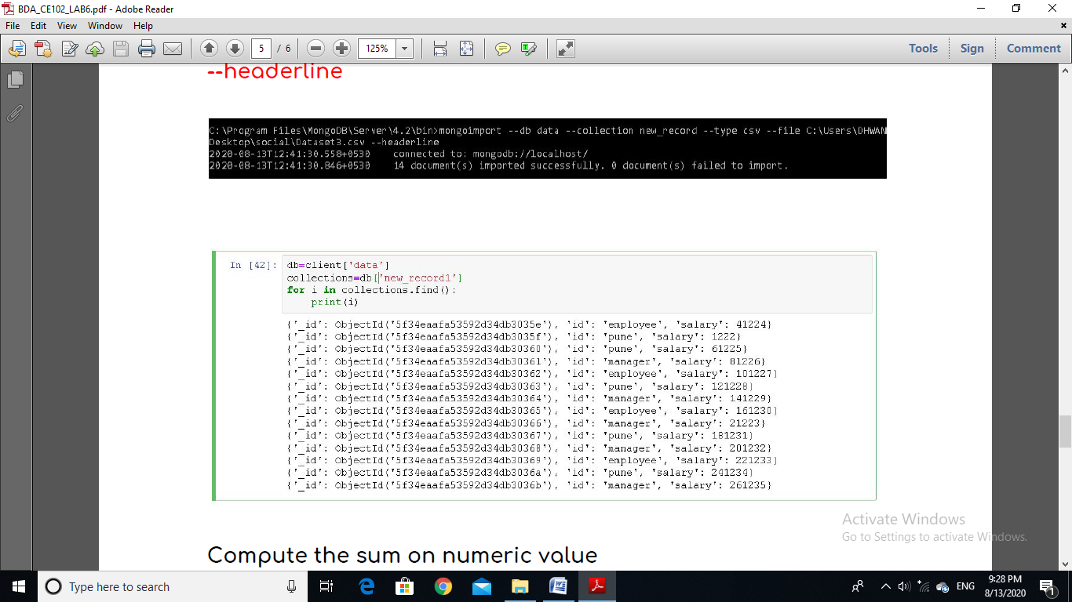



**Compute the sum on numeric value**

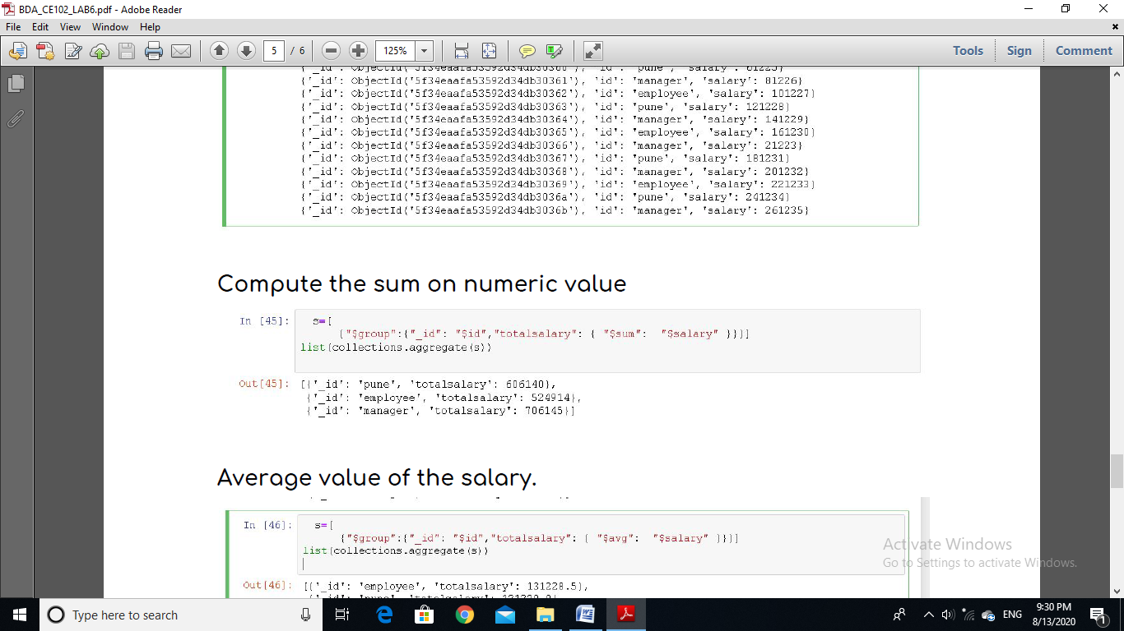

**Average value of the salary.**

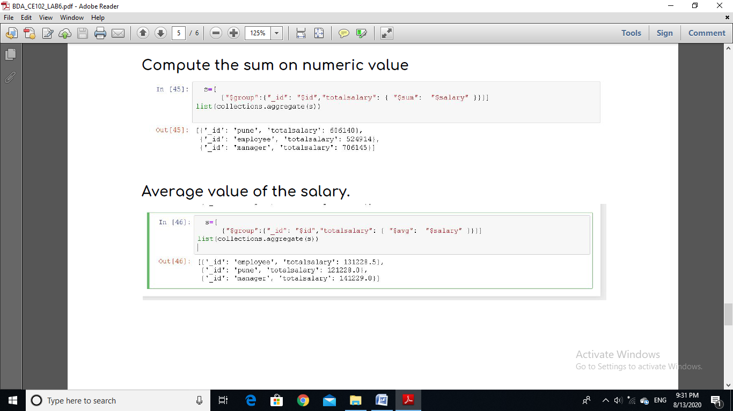

**5. Exercise Python to MongoDB Connectivity using JuPyter**

**Notebook.**

**We can use imongo, for that you can run following command**

**Pip install imongo-kernel**

**We can use PyMongo , for that you can run**

**Pip install PyMongo**

**And import pymongo in jupyter**