**BDA LAB 8**

**CE142**

**Aim** : **Setting up clusters for hadoop on Google Cloud Platform using dataproc.**

**Exercise:**

* **Setting up Google dataproc for hadoop:**
* **Go to the GCP console**

<https://console.cloud.google.com/home/dashboard>

* **From menu go to the Big Data Section**
* **Create Cluster**

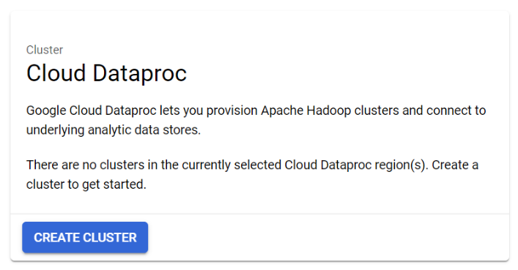

* **Create cluster name as bda-cluster**

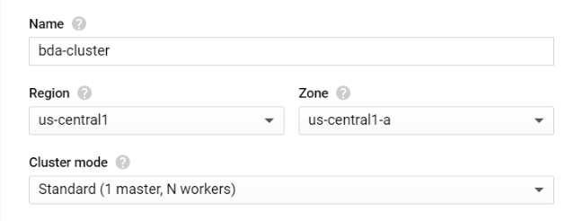

* **Configuration for Master Node**

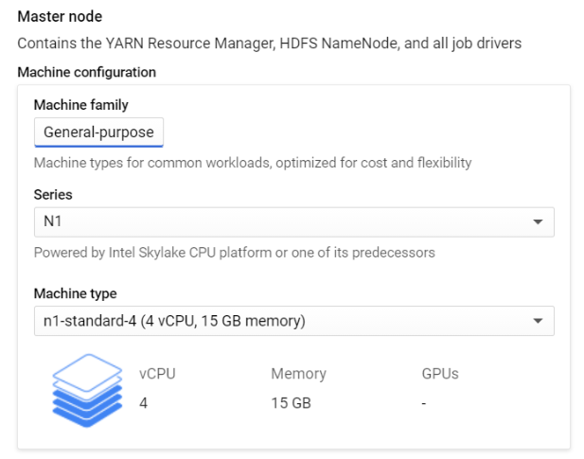

* **Configuration for Worker Nodes**

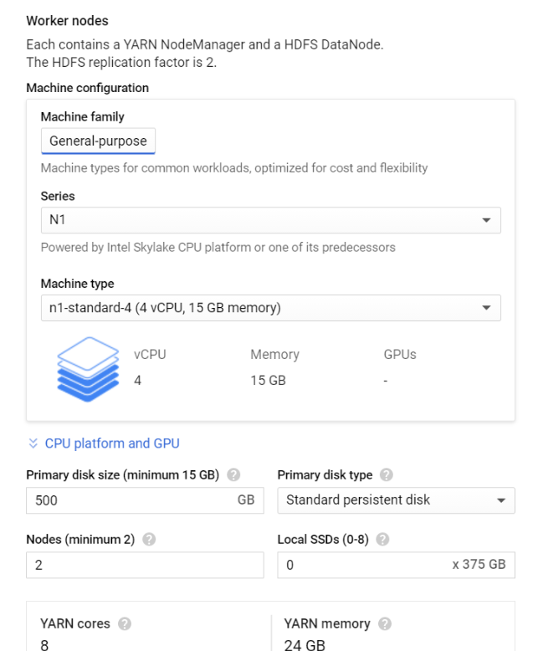

* **Select Standard Cloud Dataproc Image**

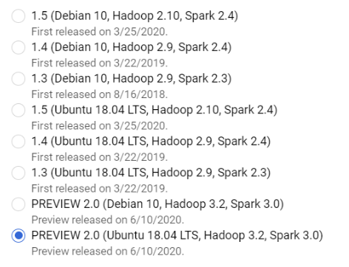

* **Finally click on create cluster and created cluster shown as below**

