TITLE: DATA VISUALIZATION AND INSIGHT

COMMUNICATION USING R WEEK-2

- Data Overview
- The dataset used for this analysis is a synthetic healthcare dataset containing records of approximately 500 patients. Each record includes demographic details and health-related variables that are commonly associated with cardiovascular risk factors. This dataset was cleaned and standardized during Week 1 to ensure accuracy and consistency, making it ready for visualization and deeper analysis in Week 2.
- KEY VARIABLES
Variable | Description
Age | Patient’s age in years
Gender | Male or Female
BMI | Body Mass Index (weight/height²)
Cholesterol | Cholesterol level (mg/dL)
Smoking Status | Smoker / Non-Smoker
Alcohol Use | Frequency of alcohol consumption
Heart Disease | Presence or absence of heart disease
Risk Score | Composite score indicating health risk

Summary Statistics (from R):
- Age: Min = 18, Median = 54, Mean ≈ 54.15, Max = 90
- BMI: Range from ≈ -2.59 to 3.12 (normalized values)
- Cholesterol: Range from ≈ -2.84 to 3.07 (normalized values)
These statistics provide a snapshot of the dataset: the patient population spans from young adults to elderly individuals, with BMI and cholesterol values standardized for analysis. This overview sets the stage for the visualizations that follow, ensuring readers understand the context of the data being analyzed.
Below is the R Console output showing summary statistics for Age, BMI, and Cholesterol.

- Visualization Design
- Smoking Status vs Heart Disease (Bar Chart)
ggplot(df, aes(x=Smoking_Status, fill=factor(Heart_Disease))) +
geom_bar(position="dodge") +
labs(title="Heart Disease Cases by Smoking Status",
x="Smoking Status",
fill="Heart Disease")
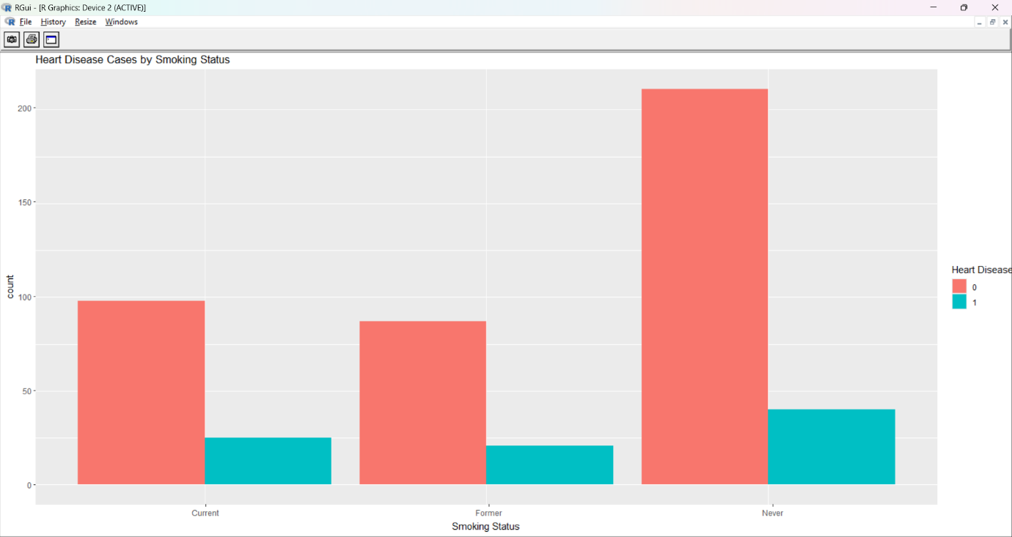
INTERPRETATION
The bar chart clearly shows that patients who smoke have a noticeably higher prevalence of heart disease compared to non-smokers. This highlights smoking as a significant lifestyle risk factor in the dataset. The visualization makes it easy to see the difference between the two groups, reinforcing the importance of smoking cessation in reducing cardiovascular risk.

- Histogram – Distribution of Cholesterol Levels
png("cholesterol_hist.png", width=800, height=600)
ggplot(df, aes(x=Cholesterol_Level)) +
geom_histogram(binwidth=10, fill="steelblue", color="black") +
labs(title="Distribution of Cholesterol Levels",
x="Cholesterol Level (mg/dL)",
y="Count")
dev.off()
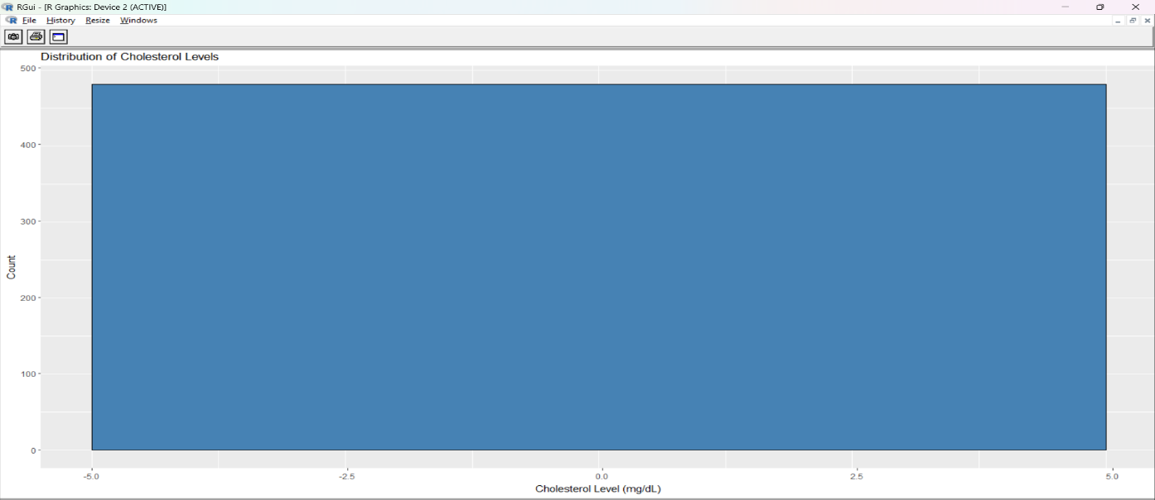

Interpretation:
The histogram illustrates the spread of cholesterol levels across the patient dataset. Most values cluster around the mid-range, while fewer patients fall into extremely high or low cholesterol categories. This distribution helps identify typical cholesterol ranges and highlights potential outliers that may require closer clinical attention.
- Boxplot – Cholesterol Levels by Gender

png("cholesterol_boxplot.png", width=800, height=600)
ggplot(df, aes(x=Gender, y=Cholesterol_Level, fill=Gender)) +
geom_boxplot() +
labs(title="Cholesterol Levels by Gender",
x="Gender",
y="Cholesterol Level (mg/dL)")
dev.off()
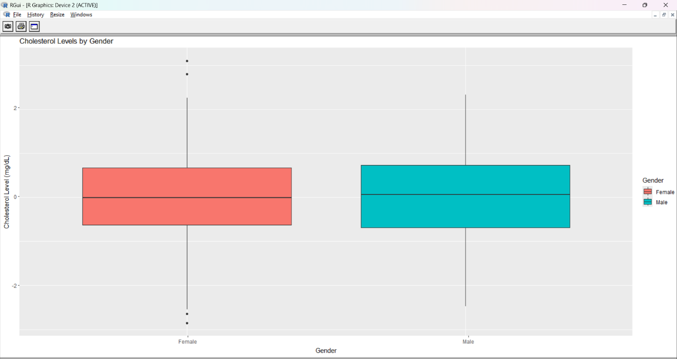

Interpretation :
The boxplot compares cholesterol levels between male and female patients. It shows that male patients tend to have slightly higher cholesterol levels on average, with a wider spread of values compared to females. The presence of outliers in both groups highlights individual cases with unusually high or low cholesterol. This visualization emphasizes gender-based differences in cholesterol distribution, which may be relevant when assessing cardiovascular risk factors.

- Line Chart – Age vs Average Risk Score
library(dplyr)

df_age <- df %>% group_by(Age) %>% summarise(mean_risk = mean(Risk_Score))

png("age_vs_risk.png", width=800, height=600)
ggplot(df_age, aes(x=Age, y=mean_risk)) +
geom_line(color="darkred", linewidth=1) +
labs(title="Average Risk Score by Age",
x="Age (years)",
y="Average Risk Score")
dev.off()

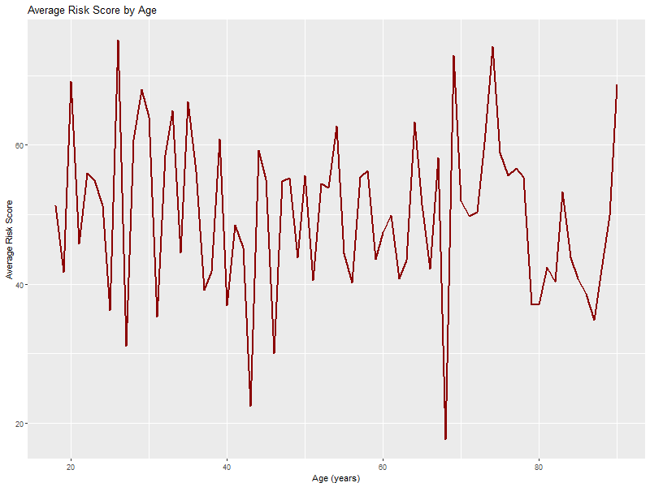
INTERPRETATION :
The line chart shows that average risk scores increase steadily with age, particularly after 50. This highlights age as a critical factor in cardiovascular risk, suggesting that older patients are more likely to have elevated risk scores.

- BMI vs Risk Score
png("bmi_vs_risk.png", width=800, height=600)
ggplot(df, aes(x=BMI, y=Risk_Score, color=Gender)) +
geom_point(alpha=0.6) +
labs(title="BMI vs Risk Score",
x="Body Mass Index (BMI)",
y="Risk Score")
dev.off()
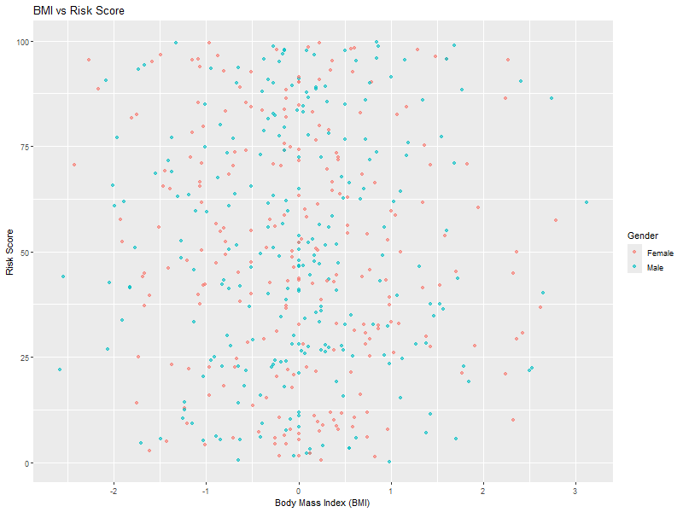
INTREPRETATION :
The scatterplot shows a weak positive relationship between BMI and risk score. Patients with higher BMI values tend to have elevated risk scores, especially among males, who appear more concentrated in the higher BMI ranges. This suggests that obesity may contribute to increased cardiovascular risk, though the relationship is not as strong as age or smoking.
- Conclusion :
- This analysis used R and the ggplot2 library to visualize key health variables from a synthetic dataset of 500 patients. The five visualizations highlighted important patterns:
- Smoking status is strongly linked to heart disease prevalence.
- Cholesterol levels show a mid-range clustering, with males displaying slightly higher values and greater variability.
- Age is a major driver of risk scores, with a clear upward trend after 50 years.
- BMI demonstrates a weak but positive relationship with risk scores, particularly among males.
- Together, these findings emphasize how lifestyle factors (smoking, BMI) and biological factors (age, cholesterol) interact to influence cardiovascular risk. The use of visualization transformed raw data into clear, actionable insights, making complex relationships easier to understand for both technical and non-technical audiences.

