BUSINESS ANALYTICS PROJECT REPORT
AdPulse AI
Marketing spend intelligence for UAE online brands

Prepared by: Prakshaal
Programme: Master of Global Business (MGB), June 2026 cohort, Global Marketing specialisation
Institution: SP Jain School of Global Management, Dubai
Date: November 2026
Prototype: Streamlit web application (03_Code/app.py), deployable from GitHub to Streamlit Community Cloud

Note on data
All brand, campaign and customer data used in the prototype and in Sections 8 to 13 is synthetic. It was generated by 03_Code/generate_data.py from assumptions stated in Section 7 so that every feature can be demonstrated end-to-end. It is not evidence about the UAE market. Market figures in Sections 2 and 5 come from the published sources listed in the References. No survey responses are reported: the survey in Section 4 and Appendix A is ready to field.

Contents
1. Executive Summary
2. Business Problem
3. Proposed Solution: AdPulse AI
4. Customer Discovery and Survey Design
5. Target Customer and Market
6. Business Model
7. Data and Methodology
8. Descriptive Analytics
9. Diagnostic Analytics: the Attribution Truth Check
10. Predictive Analytics: Will a Campaign Make Money?
11. Prescriptive Analytics: Budget Optimisation
12. Customer Segmentation and LTV : CAC
13. Scenario Analysis
14. Pricing and Break-even
15. Dashboard and Product Design
16. Implementation Roadmap
17. Risks, Ethics and Limitations
18. Conclusion
19. AI Use Statement
References
Appendix A: 24-Question Customer Survey
Appendix B: Data Dictionary
Appendix C: Repository Structure and Deployment

1. Executive Summary
Online brands in the UAE spend a growing share of their marketing budgets on Meta, Google, TikTok, Snapchat, YouTube and influencers. Each of these platforms reports its own results, and each counts a sale as its own whenever the shopper touched one of its ads. The result is that a typical small brand cannot answer three basic questions: which channels really make money, how the budget should be split, and which channels bring customers worth keeping. These questions change every week, involve thousands of rows of data across six or more dashboards, and depend on product margins that ad platforms never see. They cannot be answered by looking at two numbers side by side, which is why a dedicated software product is justified.
AdPulse AI is a web application that connects ad-platform spend with real store orders and turns them into profit-based decisions. The Streamlit prototype has eight modules: Command Centre, Truth Check (claimed vs verified revenue), Profit Predictor (Random Forest), Budget Optimiser (diminishing-returns response curves), Customer Value (K-means segmentation and LTV : CAC), Scenario Lab, Business Case, and Data & Method with CSV upload.
To demonstrate the analytics, a synthetic dataset of 2,148 campaign-weeks (48 campaigns, 6 fictional UAE brands, 52 weeks of 2025) and 4,000 customers was generated. On this data the prototype shows:
- Platforms claimed AED 28.18M in revenue; store orders confirm AED 20.23M, an over-claim of 39% (claimed ROAS 4.04x vs verified 2.90x).
- 49% of ad spend (AED 3.45M) went into campaign-weeks that lost money once product margin is counted.
- A Random Forest predicts, before a week runs, whether a campaign-week will be profitable with 85.0% accuracy and ROC AUC 0.933 on a later, unseen time period, against 63.9% for a naive rule. A simpler logistic regression performs about as well (AUC 0.934), which is reported honestly in Section 10.
- Re-splitting the same budget along fitted response curves raises revenue by 8.4% and gross profit by about AED 797k a year across the six brands (about AED 133k per brand).
- Google Search customers return 2.7x their acquisition cost in 12-month gross profit; TikTok customers return 0.49x. Two-thirds of TikTok-acquired customers fall in the discount-driven segment.
AdPulse would be sold as a SaaS subscription in three tiers (AED 590, 1,490 and 3,900 per month). Under the illustrative cost assumptions, the business needs about 84 subscribers to cover running costs, has an LTV : CAC of 4.8x, and reaches monthly operating break-even in month 26 in the base case (month 21 to 34 across scenarios). The next step is to field the 24-question survey and run three pilot brands on real data, which the prototype already supports through CSV upload.

2. Business Problem

2.1 Context: a fast-growing, digital-first market
The UAE e-commerce market reached AED 42.2 billion in 2025, more than double its 2020 size, and is forecast to grow at about 9.9% a year to roughly AED 67.2 billion by 2030 (WAM, 2026; TradeArabia, 2026). Advertising has followed shoppers online: UAE digital advertising spend is estimated at about USD 2.15 billion in 2025, rising to USD 2.7 billion by 2027, with TikTok the fastest-growing social platform (AGBI, 2025). The supply side is large and fragmented: the Ministry of Economy reported 557,000 SMEs at the end of 2022, with a target of one million by 2030 (WAM, 2023).
Most of the brands selling online in this market are small: a founder, a marketing manager or a freelance media buyer running campaigns on four to six platforms at once, usually across Arabic, English and bilingual creative, and through a retail calendar that includes Ramadan and Eid, White Friday, Dubai Shopping Festival and the summer slowdown.

2.2 The problem: three blind spots
Blind spot 1: every platform grades its own homework. Each ad platform uses its own attribution window and counts a conversion whenever its ad was in the shopper's path. When a shopper sees a TikTok ad, clicks a Meta ad and finally searches on Google, all three may claim the same order. Industry analyses of marketing-mix models report that platforms over-state their own contribution by roughly 1.2x to 2.3x on average (Pixis, n.d.), and field experiments at Facebook found that observational attribution methods often over-estimate advertising effects compared with randomised tests (Gordon et al., 2019). A marketer who trusts the dashboards will move money toward the channels that over-claim the most.
Blind spot 2: ROAS is not profit. A ROAS of 2.5x is excellent for a fragrance brand with a 65% gross margin and a loss for an electronics-accessories brand with a 32% margin, which needs at least 3.1x just to break even. Ad platforms do not know product margins, so they cannot tell a brand which campaigns lose money.
Blind spot 3: diminishing returns and customer quality are invisible. Every channel saturates: the tenth thousand dirhams on Google Search earns far less than the first. Some channels bring cheap first orders from discount-driven shoppers who never return. Neither effect shows up in a weekly platform report.

2.3 Why this needs software, not a spreadsheet
A product earns its place when the decision is too large, too fast-changing or too complex to make by eye. AdPulse meets all three tests:
- Volume: even the small demo portfolio produces 2,148 campaign-weeks and 91,541 orders in one year across six platforms and a store backend.
- Speed: budgets are changed weekly, costs per click rise in peak seasons, and creative fatigues within weeks.
- Complexity: the right answer depends on margins, diminishing returns, seasonality and repeat behaviour together, which requires statistical models rather than a side-by-side comparison.
Problem statement
UAE online brands cannot see which of their ad dirhams create profit, because the only numbers they have are self-reported by the platforms they pay, expressed as revenue rather than profit, and blind to diminishing returns and repeat purchasing.

3. Proposed Solution: AdPulse AI
AdPulse is a web application that pulls spend from ad platforms and orders from the brand's store (Shopify, WooCommerce, Salla or a CSV export), matches them using UTM tags, discount codes and order IDs, adds each brand's gross margin, and then answers one question on every screen: where is the next dirham of ad spend most profitable?
Module | Question it answers | Analytics used | Analytics type
Command Centre | How much did I really make, where am I losing money, and what should I change this week? | KPIs, loss ranking, optimiser output | Descriptive / prescriptive
Truth Check | How much revenue did each channel claim vs actually drive? | Platform vs store reconciliation | Diagnostic
Profit Predictor | Will this campaign make money next week, and what is a better option? | Random Forest classifier; logistic baseline | Predictive
Budget Optimiser | How should a fixed weekly budget be split across channels? | Log-log response curves; greedy marginal allocation | Prescriptive
Customer Value | Which channels bring customers worth keeping? | K-means clustering; LTV : CAC | Descriptive / diagnostic
Scenario Lab | What if budgets, ad costs or demand change? | Response-curve simulation | Predictive / what-if
Business Case | Can AdPulse itself be a profitable business? | Pricing, break-even, unit economics | Financial
Data & Method | Can I run this on my own data? | CSV upload, validation, methodology | Enabler
Table 3.1: AdPulse modules and the decisions they support.
The value proposition in one line: AdPulse tells a UAE online brand, in dirhams of profit rather than platform ROAS, which campaigns to cut, which to scale, and how to split next week's budget.

4. Customer Discovery and Survey Design
The business idea rests on assumptions about how UAE online brands manage ad spend today and what they would pay to do it better. These assumptions must be tested with real customers before any further build. A 24-question survey was designed for this purpose (full text in Appendix A). It has not yet been fielded, and no responses are reported or estimated in this report.

4.1 Research objectives and hypotheses
# | Hypothesis | Survey questions | Test
H1 | Most UAE online brands rely mainly on platform dashboards to judge ad performance. | Q7 | One-sample proportion test vs 50%
H2 | Marketers perceive that platform-reported sales exceed real sales (mean agreement > 3 on a 5-point scale). | Q12 | One-sample t-test vs neutral (3)
H3 | Brands spending over AED 40k a month find budget splitting harder than smaller brands. | Q4, Q15 | Mann-Whitney U test
H4 | The acceptable price range includes AED 590 to 1,490 per month. | Q21-Q24 | Van Westendorp price sensitivity
H5 | Data-sharing concerns are the main barrier to adoption. | Q19, Q20 | Frequency ranking; chi-square by spend band
Table 4.1: Hypotheses, the questions that test them, and the planned statistical tests.

4.2 Survey structure
Section | Questions | Purpose
A. Business profile | Q1-Q5 | Role, category, sales channels, monthly ad spend, platforms used (segmentation variables)
B. Current practice | Q6-Q11 | How often budgets move, which numbers are trusted, reporting time, margin and repeat tracking
C. Pain points | Q12-Q17 | Likert agreement on over-claiming, confidence, seasonal uncertainty, budget splitting; open frustration; perceived waste
D. Solution fit | Q18-Q20 | Feature ranking, willingness to connect data, adoption barriers
E. Willingness to pay | Q21-Q24 | Van Westendorp price sensitivity meter (too cheap, bargain, getting expensive, too expensive)
Table 4.2: Survey sections.

4.3 Sampling plan and fieldwork
- Population: decision-makers for paid digital advertising at UAE-based online brands (founders, heads of marketing, performance marketers) and at agencies that run ads for such brands.
- Target sample: 40-60 complete responses, with at least 15 from brands spending over AED 40k a month so that H3 can be tested.
- Recruitment: LinkedIn outreach to UAE e-commerce founders and marketers, Dubai SME and founder communities, Shopify and Salla merchant groups, and the SP Jain alumni network. Non-probability (purposive and snowball) sampling, so results will describe the respondents rather than estimate population values precisely.
- Tool and timing: Google Forms, about 8 minutes, open for two weeks. A screening question removes respondents with no paid advertising.
- Qualitative follow-up: 8-10 short interviews with respondents who agree, focused on how they currently decide budgets during Ramadan and White Friday.
- Ethics: anonymous by default, no personal data beyond optional contact details for interviews, consent statement on the first page, in line with the UAE Personal Data Protection Law.

4.4 How the results will change the product
If the survey finds... | Then AdPulse will...
Most brands trust platform dashboards (H1 supported) | Lead marketing with the Truth Check: 'see what your ads really earned'.
Brands do not track margins (Q9 = never) | Ask for category margins at sign-up and pre-fill typical values.
Data sharing is the top barrier (H5) | Offer a CSV-only Starter tier with no account connections.
Van Westendorp range is below AED 590 | Add a lower 'Lite' tier or annual discount; re-run break-even.
Weekly WhatsApp or email summaries are preferred to dashboards (Q16 comments) | Make the weekly digest the core product and the dashboard secondary.
Table 4.3: Decision rules linking survey results to product decisions.

5. Target Customer and Market

5.1 Customer personas
Persona | Who | Main job to be done | Tier
The founder-marketer | Owner of a UAE D2C brand (fragrance, fashion, home, food), AED 15-60k monthly ad spend, runs ads personally | "Tell me which ads are losing money so I can stop them." | Starter
The performance manager | In-house marketing lead at a growing brand, AED 60-250k monthly spend, reports to a CEO or investor | "Defend my budget split with numbers my CEO trusts." | Growth
The agency | Dubai performance-marketing agency managing 5-10 client brands | "Produce honest, profit-based reports for every client without a data scientist." | Agency
Table 5.1: Target personas.

5.2 Market size
Market size is estimated top-down for context and bottom-up for planning. The bottom-up figures rest on an assumption about the number of target businesses, which the survey (Q4) and pilot work must validate.
Level | Definition | Estimate | Basis
Context | UAE e-commerce market (2025) | AED 42.2bn | EZDubai report via WAM (2026)
Context | UAE digital ad spend (2025) | ~USD 2.15bn (~AED 7.9bn) | AGBI (2025)
TAM | Digital ad spend that could be measured and optimised by a tool like AdPulse | ~AED 7.9bn of spend under management | All UAE digital ad spend
SAM | UAE online brands and agencies spending AED 10k+ per month on 3+ paid channels | ~6,000 businesses x AED 1,281 x 12 = ~AED 92M a year in subscription revenue | Assumption (to validate); blended ARPU from Section 14
SOM | Subscribers reachable in 36 months (base case) | ~525 subscribers, ~AED 8.07M annual recurring revenue (~9% of SAM) | Section 14 projection
Table 5.2: Market size. SAM and SOM are planning assumptions, not measured values.

5.3 Competition and positioning
Alternative | Strength | Gap that AdPulse fills
Native dashboards (Meta Ads Manager, Google Ads, TikTok, Snapchat) | Free, detailed, real-time | Each one credits itself; no margins; no cross-channel view
Google Analytics 4 / store analytics | Free, cross-channel, linked to orders | Generic; no profit view; no budget recommendation or LTV by channel
Third-party attribution tools for e-commerce brands | Strong multi-touch attribution | Designed mainly for North American Shopify brands and priced in USD; not built around the Gulf retail calendar or Arabic creative
Open-source marketing-mix models (e.g., Meta Robyn, Google Meridian) | Statistically rigorous, free | Need a data scientist; no product interface for an SME
Agencies and spreadsheets | Human judgement, local knowledge | Slow, monthly, manual, and often based on the same platform-reported numbers
Table 5.3: Competitive alternatives.
Positioning: AdPulse is the profit-first, UAE-built alternative: it speaks AED and gross margin rather than ROAS, models Ramadan, White Friday and DSF explicitly, handles Arabic, English and bilingual creative as a variable, includes Snapchat (important in the Gulf), and is priced for SMEs.

6. Business Model
The business model is summarised as a Business Model Canvas.
Block | AdPulse
Customer segments | UAE online (D2C) brands with AED 10k+ monthly ad spend; performance-marketing agencies; later KSA and wider GCC brands
Value proposition | Profit-based truth about ad spend; weekly cut/scale recommendations; budget split that earns more from the same spend; customer quality by channel; built for the UAE calendar, AED and Arabic/English
Channels | Founder-led sales and LinkedIn content; Shopify and Salla app listings; agency partnerships (white-label); free 'Truth Check' audit as lead magnet; Dubai founder and SME events
Customer relationships | Self-serve onboarding with CSV or account connection; weekly digest by email or WhatsApp; quarterly strategy call for Growth and Agency tiers
Revenue streams | Monthly SaaS subscription in three tiers (AED 590 / 1,490 / 3,900); annual plans at two months free; paid set-up and holdout-test design for larger brands
Key resources | Data connectors; analytics engine (attribution, prediction, optimisation, segmentation); UAE seasonal and benchmark data built up across clients
Key activities | Connector maintenance; model monitoring; product development; customer success; content marketing
Key partners | Ad platforms (APIs); e-commerce platforms (Shopify, WooCommerce, Salla); agencies; cloud provider; Dubai SME and free-zone programmes
Cost structure | Team salaries (largest cost); cloud and data-connector fees; customer acquisition (sales and marketing); licences and visas. Illustrative fixed costs AED 95k per month (Section 14)
Table 6.1: Business Model Canvas for AdPulse.
The model has a useful network effect: every client adds seasonal and channel benchmarks (for example, how much costs per click rise during Ramadan) that make the predictions better for the next client in the same category.

7. Data and Methodology

7.1 Data in a live deployment
- Ad platforms: weekly spend, impressions, clicks and platform-reported conversions and revenue from the Meta, Google Ads, TikTok and Snapchat APIs; influencer spend entered manually or by CSV.
- Store backend: orders, revenue, customer IDs, discount codes and UTM parameters from Shopify, WooCommerce or Salla.
- Brand inputs: gross margin by category or product, and campaign metadata (objective, creative format, language, targeting).

7.2 The demonstration dataset (synthetic)
Because no real brand data was available for this project, two synthetic datasets were generated with a fixed random seed (03_Code/generate_data.py). The generator encodes assumptions that are realistic in direction but invented in size. Their purpose is to show that the AdPulse pipeline works end-to-end and that its models can recover known structure from noisy data. They are not evidence about real UAE brands.
Item | Description
campaign_performance.csv | 2,148 rows: one per campaign per week, 2025-01-06 to 2025-12-29. 48 campaigns across 6 fictional brands and 6 channels. 22 columns (Appendix B).
customers.csv | 4,000 rows: customers acquired in 2025 with 12-month orders, AOV, recency, discount use and gross profit, sampled in proportion to each channel's new customers.
Brands | Oudh Lane (fragrance, 65% margin), Sahra Active (fashion, 55%), Voltbay (electronics accessories, 32%), Dar Living (home, 45%), Greenbite (health food, 40%), Little Nakhla (baby & kids, 48%). All fictional.
Revenue model | revenue = k x spend^b x (objective, creative, language, emirate, category-fit, season and fatigue multipliers) x random noise, with b between 0.55 and 0.85 (diminishing returns).
Over-claiming | Platform-reported revenue = verified revenue x a channel factor (Influencers 1.05 via promo codes, Google Search 1.15, Meta 1.45, Snapchat 1.60, TikTok 1.70, YouTube 1.90) x noise. The range is consistent with the 1.2x-2.3x reported in industry analyses.
Seasons | Ramadan & Eid, White Friday & 11.11, DSF & National Day, Back to School, Summer, Regular. Each changes demand by category, ad costs (0.90x-1.35x) and typical spend.
Customers | Repeat purchasing, AOV and discount use differ by acquisition channel (for example, more discount-driven buyers from TikTok and Snapchat, more repeat buyers from Google Search).
Table 7.1: Demonstration data and the main generation assumptions.

7.3 Key definitions
- Verified ROAS = store-verified revenue / ad spend. Platform ROAS = platform-reported revenue / ad spend.
- Contribution = verified revenue x gross margin - ad spend. A campaign-week is profitable if contribution > 0, i.e. verified ROAS > 1 / gross margin (the break-even ROAS).
- CAC = channel spend / new customers acquired. LTV (12 months) = average gross profit per customer in the first 12 months.

7.4 Analytics pipeline
Stage | Method | Section
Descriptive | KPIs by channel, category, season and objective | 8
Diagnostic | Platform-claimed vs verified revenue by channel | 9
Predictive | Random Forest classifier (400 trees, max depth 12) vs logistic regression; time-based hold-out; 5-fold cross-validation | 10
Prescriptive | Per brand x channel log-log response curves with season dummies; greedy marginal-return budget allocation with guard-rails | 11
Segmentation | K-means on orders, AOV, recency and discount share (standardised); k chosen by silhouette; LTV : CAC by channel | 12
Simulation | Scenario modelling on fitted curves (budget, cost, demand changes) | 13
Financial | Tiered pricing, break-even, LTV : CAC and 36-month projection for AdPulse itself | 14
Table 7.2: Analytics pipeline. All code is in 03_Code/adpulse_engine.py and is shared by the app and the report.

8. Descriptive Analytics
Across the year the six brands spent AED 6.97M on advertising and recorded AED 20.23M in verified revenue, a blended verified ROAS of 2.90x. After product costs, advertising generated AED 2.91M of contribution, but 49% of spend sat in campaign-weeks with negative contribution.
Channel | Spend | Share | Verified revenue | ROAS | Contribution | % weeks profitable | CAC
Meta Ads | AED 2.12M | 30% | AED 6.56M | 3.09x | AED 1.00M | 72% | AED 153
Google Search | AED 1.31M | 19% | AED 6.42M | 4.89x | AED 1.75M | 90% | AED 90
TikTok Ads | AED 1.14M | 16% | AED 2.34M | 2.05x | AED 32k | 51% | AED 224
Snapchat Ads | AED 986k | 14% | AED 2.56M | 2.60x | AED 330k | 65% | AED 201
Influencers | AED 935k | 13% | AED 1.77M | 1.89x | -AED 6,357 | 39% | AED 175
YouTube | AED 470k | 7% | AED 579k | 1.23x | -AED 191k | 11% | AED 303
Table 8.1: Performance by channel, 2025 (synthetic data). Contribution = verified revenue x margin - spend.
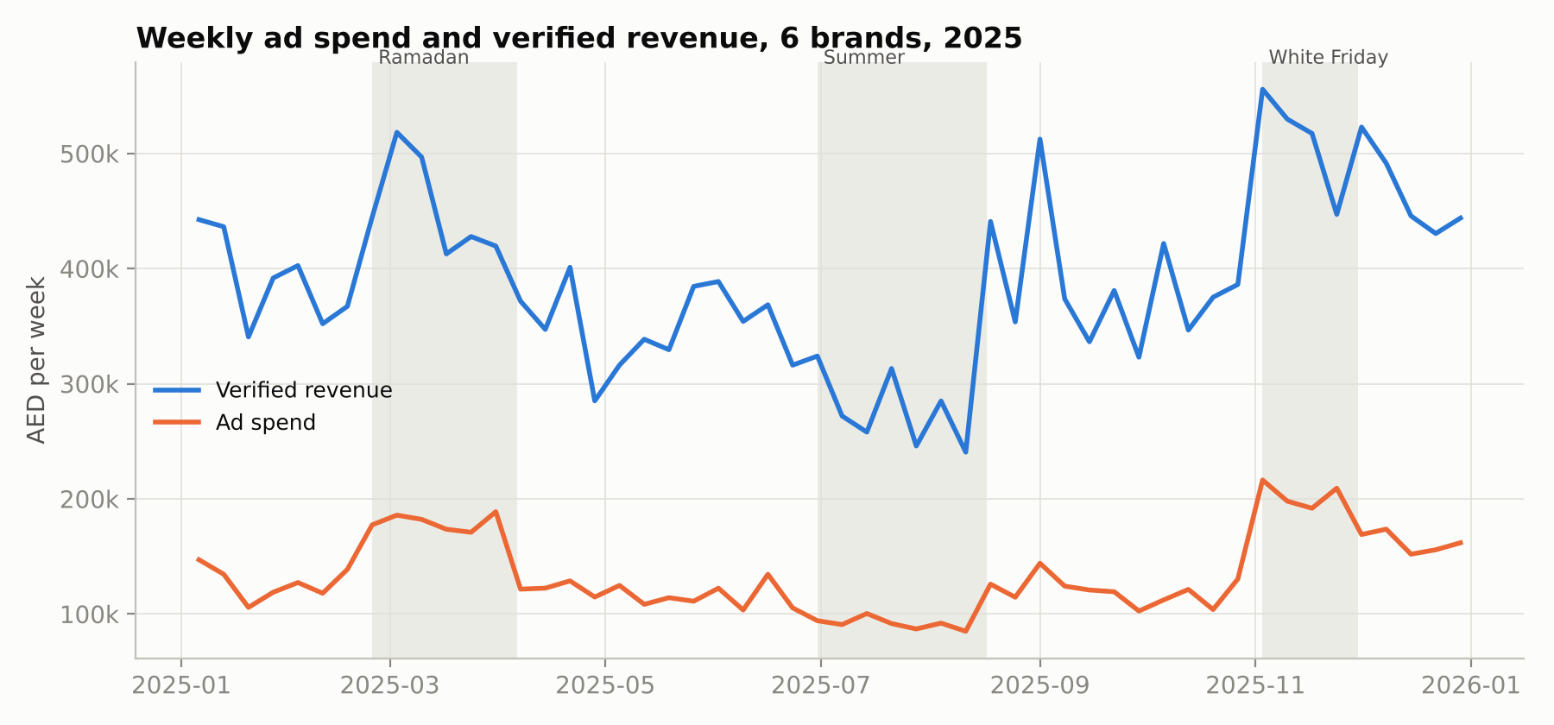
Figure 8.1: Weekly spend and verified revenue. Shaded bands mark Ramadan, Summer and White Friday.
Spend rises sharply in peak seasons, but revenue does not rise in proportion. Table 8.2 shows why: in Ramadan and White Friday weeks the return on each dirham falls, because brands spend more (moving further along their diminishing-returns curves) at the same time as costs per click rise.
Season | Campaign-weeks | Spend | Verified ROAS | % weeks profitable
Back to School | 119 | AED 384k | 3.40x | 68%
Regular | 1069 | AED 3.09M | 3.05x | 65%
Summer | 288 | AED 641k | 3.02x | 67%
DSF & National Day | 254 | AED 959k | 2.89x | 67%
Ramadan & Eid | 251 | AED 1.08M | 2.52x | 56%
White Friday & 11.11 | 167 | AED 815k | 2.51x | 60%
Table 8.2: Performance by season.
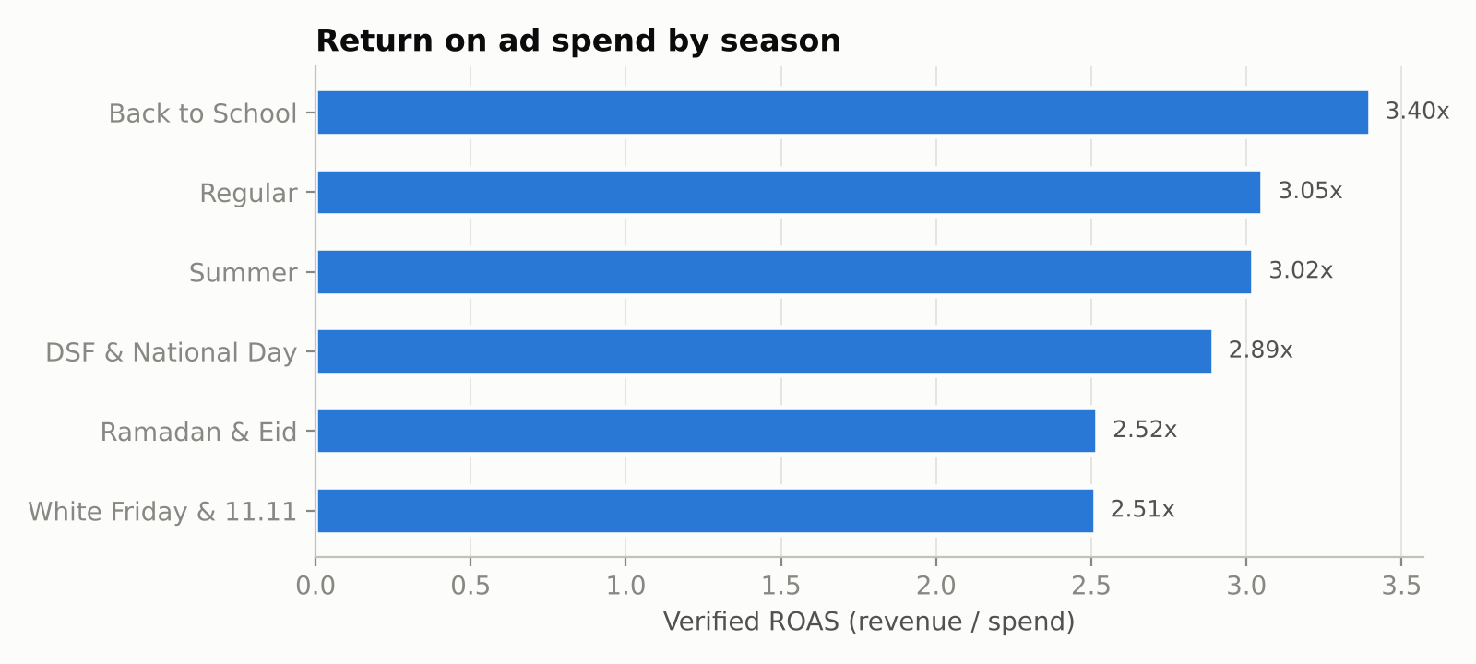
Figure 8.2: Verified ROAS by season.
Category | Gross margin | Break-even ROAS | Spend | Verified ROAS | Contribution | % weeks profitable
Fragrance & Beauty | 65% | 1.54x | AED 1.77M | 2.73x | AED 1.37M | 75%
Electronics Accessories | 32% | 3.12x | AED 1.72M | 2.42x | -AED 385k | 36%
Fashion & Activewear | 55% | 1.82x | AED 1.32M | 2.86x | AED 753k | 71%
Home & Living | 45% | 2.22x | AED 817k | 3.37x | AED 423k | 64%
Baby & Kids | 48% | 2.08x | AED 729k | 3.67x | AED 557k | 77%
Health Food & Snacks | 40% | 2.50x | AED 620k | 3.29x | AED 197k | 65%
Table 8.3: Performance by product category. The same ROAS means very different things at different margins.
Table 8.3 is the clearest illustration of Blind spot 2. Voltbay (electronics accessories) has a verified ROAS of 2.42x, which looks healthy on a platform dashboard, but its 32% margin means it needs about 3.1x to break even, and its advertising destroyed value over the year. Oudh Lane has a similar ROAS (2.73x) but, at a 65% margin, generated the most contribution of any brand.
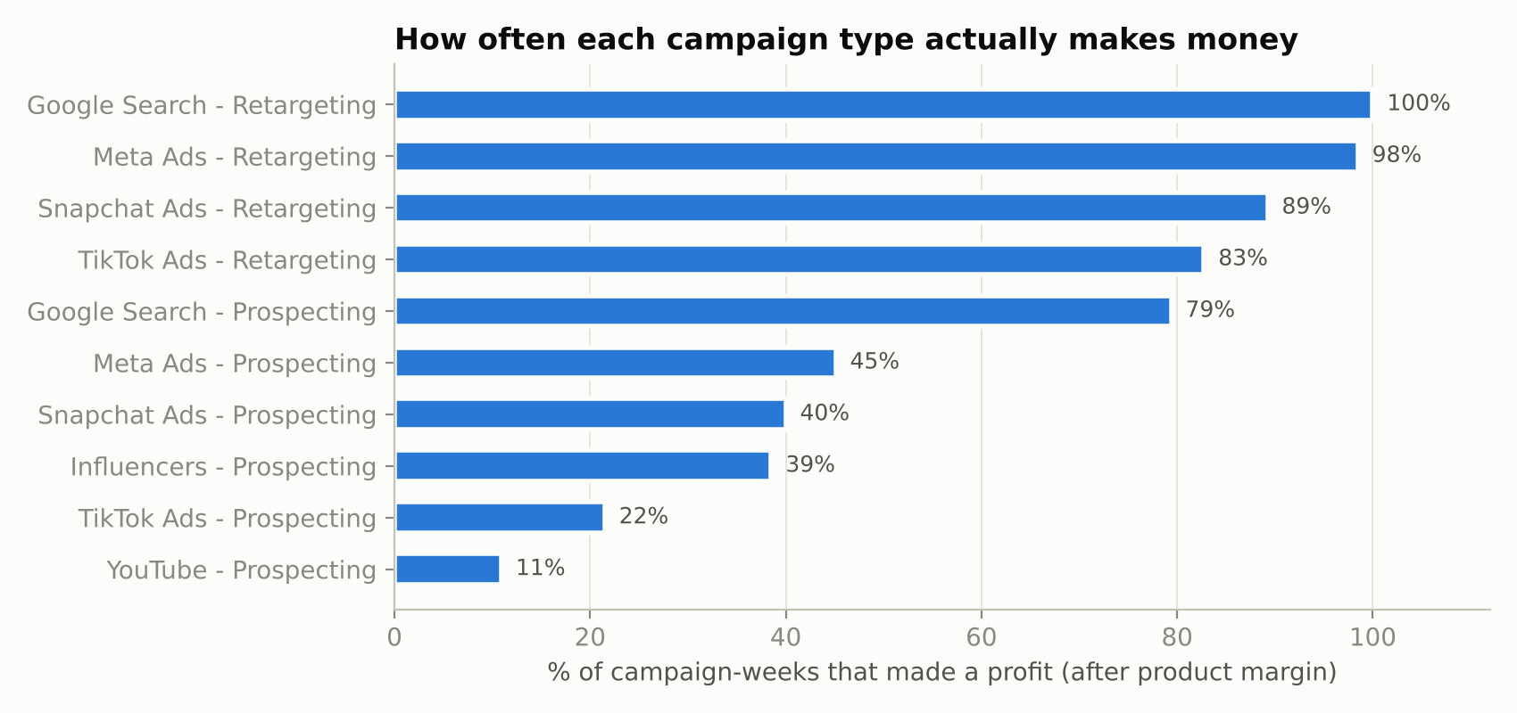
Figure 8.3: Share of campaign-weeks that made a profit, by channel and objective.
Retargeting is almost always profitable on a last-order basis (Google 100%, Meta 98%), while prospecting is much less reliable: Meta 45%, Snapchat 40%, TikTok 22%, YouTube 11%. Section 17 explains why retargeting results should be treated with caution: retargeted shoppers were often going to buy anyway.

9. Diagnostic Analytics: the Attribution Truth Check
Summed across channels, the platforms reported AED 28.18M of revenue against AED 20.23M recorded by the stores: AED 7.95M of "phantom" revenue, or 39% more than really happened.
Channel | Platform-claimed revenue | Verified revenue | Claimed ROAS | Verified ROAS | Over-claim
YouTube | AED 1.10M | AED 579k | 2.34x | 1.23x | +90%
TikTok Ads | AED 3.98M | AED 2.34M | 3.49x | 2.05x | +70%
Snapchat Ads | AED 4.12M | AED 2.56M | 4.18x | 2.60x | +61%
Meta Ads | AED 9.61M | AED 6.56M | 4.53x | 3.09x | +47%
Google Search | AED 7.50M | AED 6.42M | 5.71x | 4.89x | +17%
Influencers | AED 1.86M | AED 1.77M | 1.99x | 1.89x | +6%
Table 9.1: Claimed vs verified revenue, ranked by over-claim.
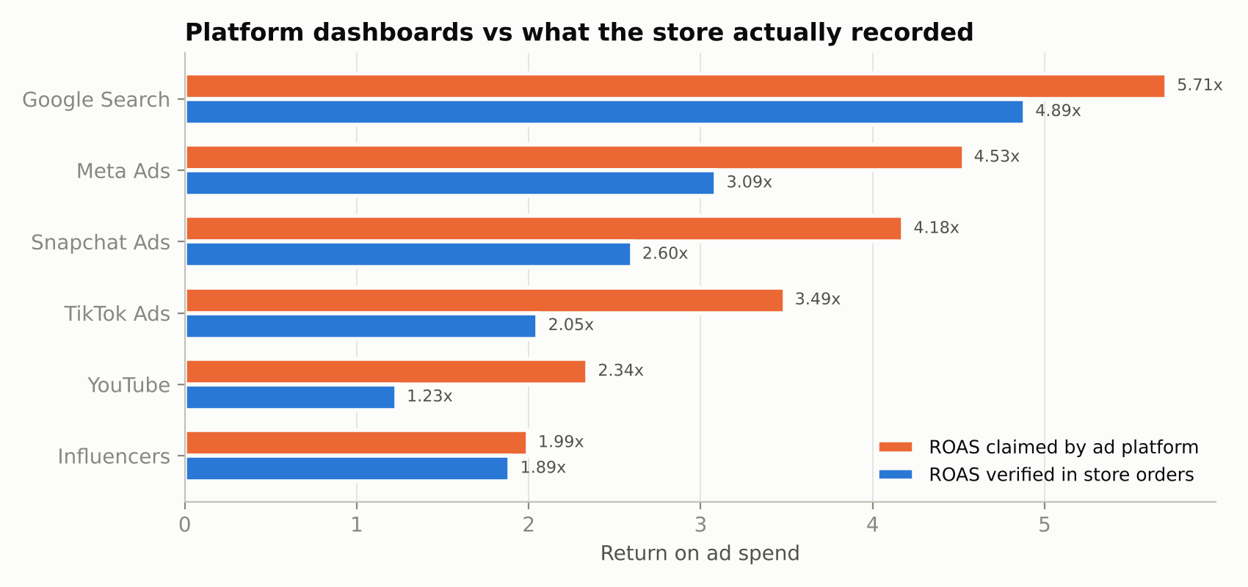
Figure 9.1: ROAS claimed by each platform vs ROAS verified in store orders.
Why this matters for decisions
On platform numbers, Snapchat claims a 4.18x ROAS, which would make it look more efficient than Meta really is (3.09x verified). On verified numbers, Snapchat returns 2.60x.
The channels that over-claim most (YouTube, TikTok, Snapchat) are also the ones with the weakest verified returns. A marketer who follows the dashboards will systematically move money in the wrong direction.

10. Predictive Analytics: Will a Campaign Make Money?

10.1 Business question and design
Before renewing or launching a campaign for the coming week, a marketer wants to know: will it make money after product costs? This is framed as binary classification: profitable (contribution > 0) or not.
To make the model usable in practice, it only uses information known before the week runs: product category and gross margin, channel, objective, creative format, ad language, target emirate, season, creative age (weeks since last refresh) and planned spend. Outcome variables such as clicks or orders are excluded, because including them would leak the answer into the model.
The data was split by time, not at random: the model was trained on the 1,603 campaign-weeks before 2025-10-06 and tested on the 545 later weeks, which include White Friday and DSF. This is a stricter test than a random split because the model must predict a future it has not seen. Five-fold cross-validation on the training period was used as a stability check.

10.2 Results
Model | Accuracy | Precision | Recall | F1 | ROC AUC
Random Forest | 0.850 | 0.949 | 0.807 | 0.873 | 0.933
Logistic Regression (baseline) | 0.829 | 0.944 | 0.779 | 0.854 | 0.934
Naive rule (always predict majority class) | 0.638 | n/a | n/a | n/a | 0.500
Table 10.1: Hold-out performance (Oct-Dec 2025). Random Forest 5-fold CV AUC on the training period: 0.923 ± 0.016.
 | Predicted: loss | Predicted: profit
Actual: loss | 182 (correctly flagged) | 15 (false alarm of profit)
Actual: profit | 67 (missed opportunity) | 281 (correctly approved)
Table 10.2: Confusion matrix, Random Forest, threshold 0.5.
The Random Forest classifies 85.0% of unseen campaign-weeks correctly, against 63.9% for a naive rule that always predicts the majority class. Its precision of 94.9% matters most commercially: when it says a campaign will be profitable, it is right 19 times out of 20. It is deliberately cautious (recall 80.7%), which suits budget decisions: missing some profitable weeks is cheaper than funding losing ones.
An honest comparison: logistic regression achieves almost the same AUC (0.934 vs 0.933) with slightly lower accuracy. The extra complexity of the Random Forest is therefore not strongly justified on this data, mainly because the synthetic generator uses largely multiplicative effects that a linear model on log-spend can capture. On real data with stronger interactions (for example, Arabic creative working on Snapchat but not on Google), the Random Forest would be expected to pull ahead. AdPulse keeps both models and would choose between them per client on hold-out performance.
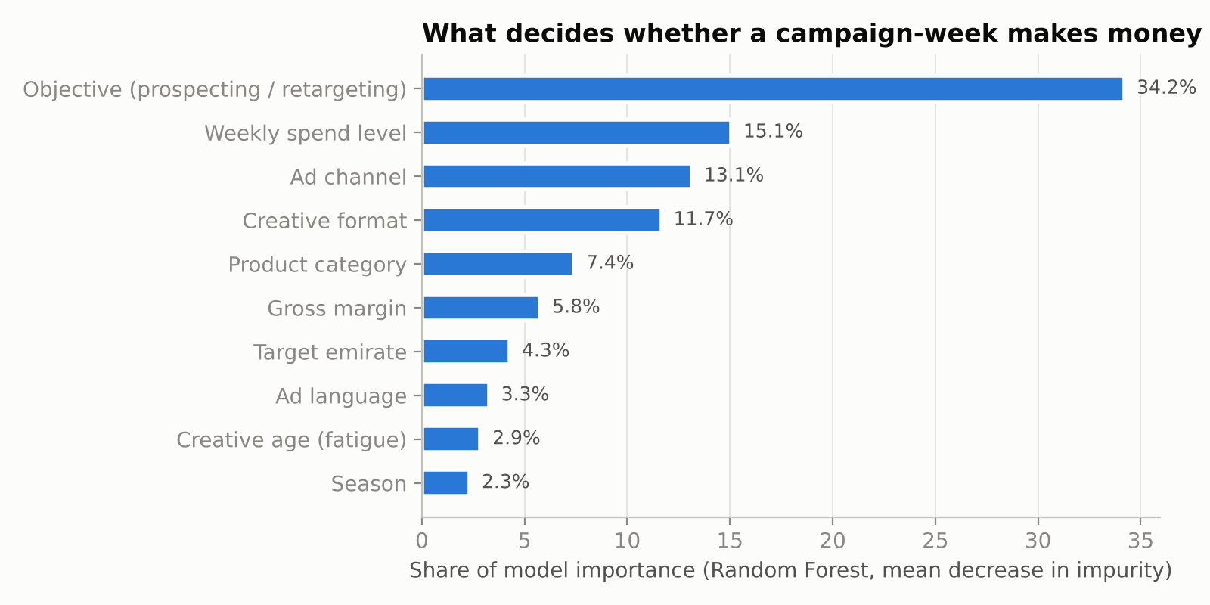
Figure 10.1: Feature importance (Random Forest, grouped back to business variables).
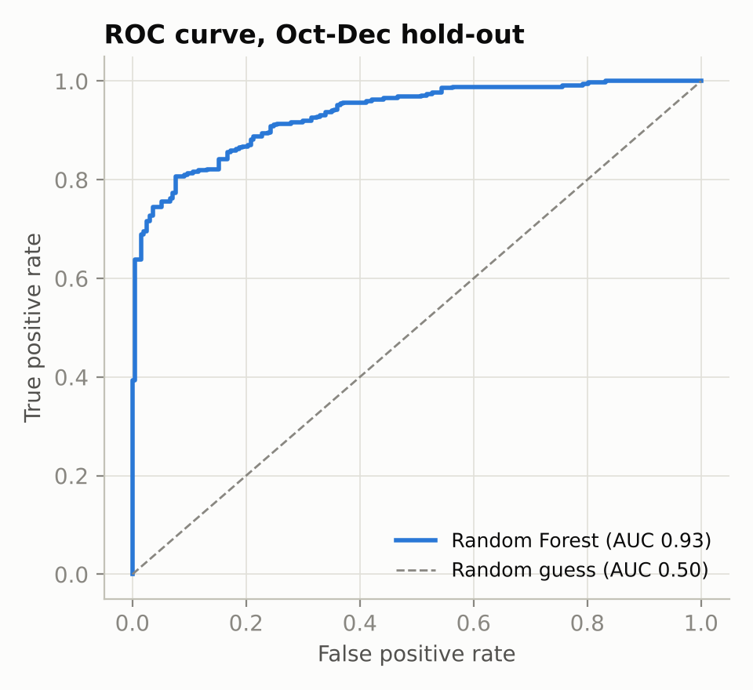
Figure 10.2: ROC curve on the Oct-Dec hold-out.
Campaign objective (prospecting vs retargeting) is the most important driver, followed by spend level, which is direct evidence of diminishing returns: the more a campaign spends in a week, the lower its chance of profit. Channel and creative format come next. In the app, the Profit Predictor turns this into an action: for any planned campaign it shows the probability of profit and lists the alternative channel, objective and creative combinations with the highest predicted probability at the same budget.

11. Prescriptive Analytics: Budget Optimisation

11.1 Method
For each brand and channel, weekly spend and verified revenue were aggregated and a constant-elasticity response curve was fitted by least squares on logs (Hanssens et al., 2001):
ln(revenue) = a + b x ln(spend) + season dummies + error
Here b is the spend elasticity: b = 0.6 means a 10% increase in spend raises revenue by about 6%. The curve is converted back to AED with a smearing correction (Duan, 1983). The optimiser then starts each channel at 30% of its historical average and repeatedly gives the next block of budget (1/600th of the total) to the channel with the highest marginal revenue, until the budget is spent. Two guard-rails keep recommendations realistic: each channel stays between 0.3x and 2x its historical average (no extrapolation far outside observed data), and b is constrained to 0.30-0.90.
Of the 28 brand-channel curves, 5 had unconstrained estimates above 0.90 (mostly influencer and YouTube spend, the noisiest channels) and were constrained. Curve R-squared ranges from 0.27 to 0.75 (median 0.50): spend explains roughly half of week-to-week revenue variation, which is typical for weekly marketing data and a reason to roll out changes gradually.

11.2 Results
Channel | Elasticity b | R² | Current spend/week | Recommended | Marginal ROAS now
Google Search | 0.50 | 0.50 | AED 5,489 | AED 11k | 2.48
Influencers | 0.90 * | 0.66 | AED 6,092 | AED 2,551 | 1.45
Meta Ads | 0.64 | 0.69 | AED 8,499 | AED 12k | 1.80
Snapchat Ads | 0.53 | 0.45 | AED 5,291 | AED 6,167 | 1.69
TikTok Ads | 0.63 | 0.60 | AED 6,857 | AED 3,082 | 1.17
YouTube | 0.90 * | 0.51 | AED 3,930 | AED 1,179 | 1.20
Table 11.1: Oudh Lane response curves and recommendation. * = elasticity constrained to 0.90.
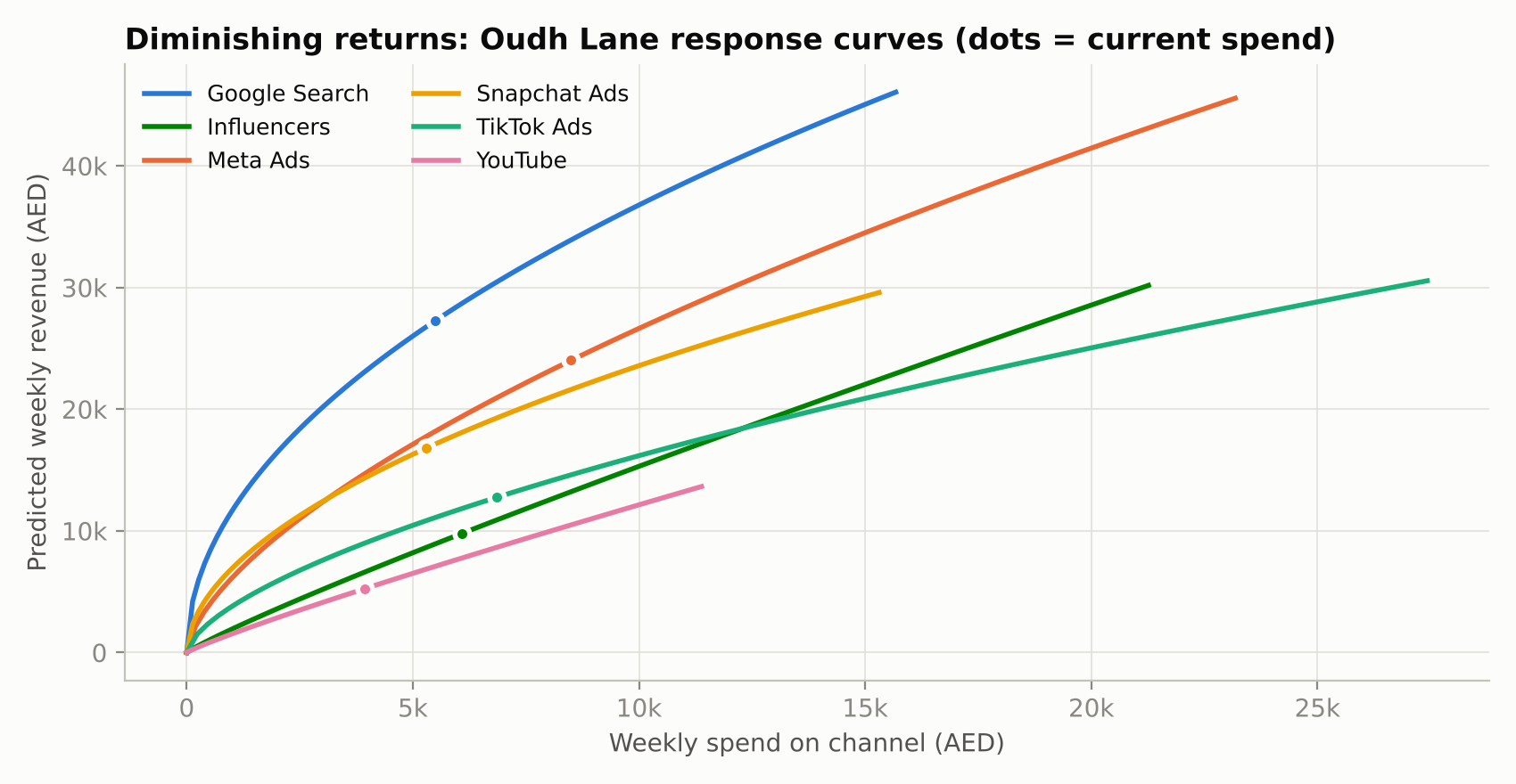
Figure 11.1: Oudh Lane response curves. Dots show current average weekly spend.
The marginal ROAS column is the key decision variable. At current spend, an extra dirham on Google Search returns about AED 2.48 in revenue, while an extra dirham on TikTok returns about AED 1.17, which at a 65% margin barely covers itself. Moving money from the flat curves to the steep ones raises revenue without raising the budget.
Brand | Margin | Weekly budget | Revenue (current split) | Revenue (AdPulse split) | Uplift | Extra gross profit / year
Dar Living | 45% | AED 17k | AED 59k | AED 65k | +10.0% | AED 138k
Greenbite | 40% | AED 13k | AED 43k | AED 46k | +5.1% | AED 46k
Little Nakhla | 48% | AED 15k | AED 55k | AED 62k | +12.8% | AED 175k
Oudh Lane | 65% | AED 36k | AED 96k | AED 101k | +5.3% | AED 173k
Sahra Active | 55% | AED 26k | AED 73k | AED 76k | +3.9% | AED 81k
Voltbay | 32% | AED 34k | AED 82k | AED 93k | +13.4% | AED 184k
Table 11.2: Optimiser results by brand at the current budget.
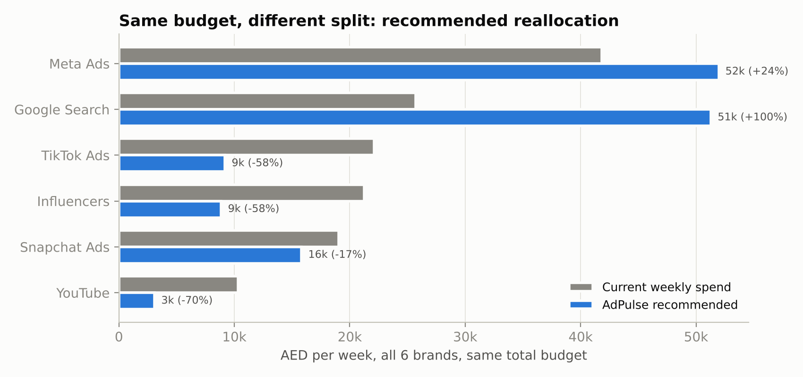
Figure 11.2: Current vs recommended weekly spend by channel, all brands, same total budget.
Across the portfolio, the optimiser recommends roughly doubling Google Search, increasing Meta, and cutting TikTok, Influencers and YouTube, for a 8.4% revenue uplift and about AED 797k of extra annual gross profit with no additional spend. Voltbay still makes a loss after optimisation: re-allocation reduces the loss but cannot fix a 32% margin business that relies on paid prospecting. That is a pricing and product-mix problem, and AdPulse should say so rather than hide it.

12. Customer Segmentation and LTV : CAC

12.1 K-means segmentation
Customers were clustered on four standardised behavioural variables: number of orders in 12 months (log), average order value (log), days since last order and share of orders using a discount code. K-means was run for k = 2 to 7.
k | Silhouette score | Inertia
2 | 0.210 | 12,625
3 | 0.234 | 10,229
4 | 0.250 | 8,301
5 | 0.248 | 7,001
6 | 0.236 | 6,476
7 | 0.226 | 6,005
Table 12.1: Choosing k. Silhouette peaks at k = 4.
The silhouette score peaks at k = 4 (0.250). A score of about 0.25 means the segments overlap: they are useful groupings for targeting rather than sharply separated customer types, which is normal for behavioural data.
Segment | Customers | Share | Orders | AOV | Recency (days) | Discount share | 12m gross profit | Profit share
Loyal repeat buyers | 747 | 19% | 4.0 | AED 238 | 43 | 28% | AED 440 | 42%
Recent big-basket buyers | 1,673 | 42% | 1.4 | AED 245 | 48 | 24% | AED 161 | 34%
Discount-driven shoppers | 930 | 23% | 1.4 | AED 178 | 64 | 65% | AED 111 | 13%
Lapsed one-timers | 650 | 16% | 1.3 | AED 227 | 233 | 31% | AED 136 | 11%
Table 12.2: Segment profiles (averages).
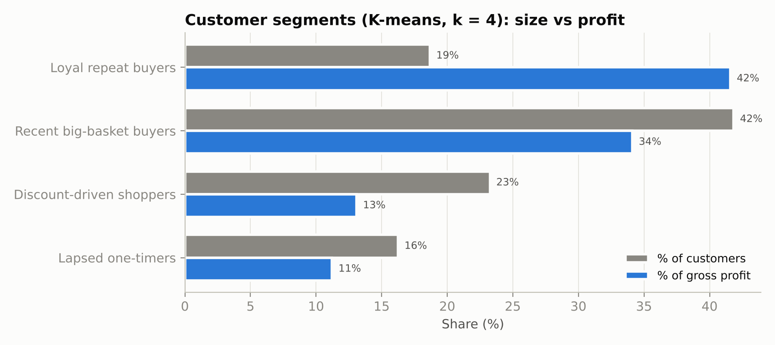
Figure 12.1: Each segment's share of customers vs share of gross profit.
Loyal repeat buyers are 19% of customers but generate 42% of gross profit. Discount-driven shoppers are 23% of customers but only 13% of profit; they rarely return and two-thirds of their orders use a discount code.

12.2 Which channels bring valuable customers?
Channel | New customers | CAC | 12m gross profit / customer | Repeat rate | LTV : CAC
Google Search | 14,674 | AED 90 | AED 242 | 57% | 2.71x
Influencers | 5,341 | AED 175 | AED 219 | 51% | 1.25x
Meta Ads | 13,911 | AED 153 | AED 182 | 45% | 1.19x
Snapchat Ads | 4,907 | AED 201 | AED 167 | 38% | 0.83x
YouTube | 1,550 | AED 303 | AED 222 | 43% | 0.73x
TikTok Ads | 5,080 | AED 224 | AED 111 | 28% | 0.49x
Table 12.3: LTV : CAC by acquisition channel.
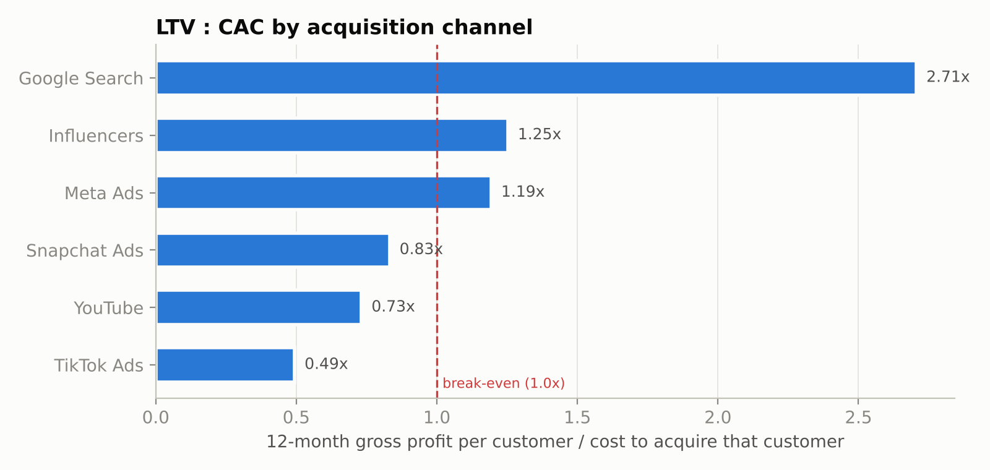
Figure 12.2: LTV : CAC by channel. Below 1.0x, customers do not repay their acquisition cost within 12 months.
The segment mix explains the result. 67% of TikTok-acquired customers are discount-driven shoppers and only 3% become loyal repeat buyers; for Google Search the figures are 1% and 29%. This confirms the optimiser's recommendation from a completely different angle: TikTok prospecting is weak on first-order profit and on long-term customer value. The marketing implication is not necessarily to abandon TikTok, but to use it for awareness with full-price offers rather than discount-led acquisition.

13. Scenario Analysis
The fitted response curves allow 'what-if' questions to be answered for the whole portfolio. Figures below are per week.
Scenario | Spend | Revenue | ROAS | Gross profit after ads | vs base
Base case (current allocation) | AED 140k | AED 408k | 2.91x | AED 59k | -
AdPulse optimised allocation | AED 140k | AED 442k | 3.15x | AED 74k | +AED 15k
Budget +20%, current allocation | AED 168k | AED 455k | 2.70x | AED 54k | -AED 4,885
Budget +20%, optimised | AED 168k | AED 488k | 2.90x | AED 68k | +AED 9,708
Budget -20%, optimised | AED 112k | AED 390k | 3.47x | AED 77k | +AED 18k
Ad costs +15% (peak-season CPMs) | AED 140k | AED 375k | 2.68x | AED 43k | -AED 16k
Ad costs +15%, optimised | AED 140k | AED 407k | 2.90x | AED 57k | -AED 1,477
Demand -10% (soft market) | AED 140k | AED 367k | 2.62x | AED 39k | -AED 20k
Table 13.1: Weekly portfolio outcomes under eight scenarios.
- Allocation beats volume. Re-allocating the current budget adds AED 15k a week in gross profit. Increasing the budget by 20% on the current split reduces profit by AED 4,885 a week, because the extra money goes mostly into channels that are already saturated.
- The portfolio is over-spending. Cutting the budget by 20% and re-allocating it produces the highest profit of all scenarios (+AED 18k a week vs base), even though revenue falls. For a profit-focused owner, this is the single most important finding.
- Cost shocks can be absorbed. A 15% rise in ad costs (typical of peak seasons) would cut weekly profit by AED 16k on the current split, but only by AED 1,477 if the budget is re-allocated at the same time.
- Demand risk is the largest. A 10% fall in consumer demand reduces profit by AED 20k a week, which argues for keeping budgets flexible rather than locked in quarterly plans.

14. Pricing and Break-even

14.1 Pricing strategy
AdPulse uses value-based, tiered subscription pricing. The anchor is the value created: in the demo data the optimiser alone is worth about AED 133k a year in extra gross profit per brand. The Growth tier, at AED 17,880 a year, captures about 13% of that value, leaving a clear return for the customer. Tiers scale with ad spend under management, so price grows with the customer's ability to pay.
Tier | Price / month | Designed for | Assumed mix
Starter | AED 590 | 1 brand, up to AED 40k monthly ad spend, 3 channels, Truth Check and Profit Predictor | 50%
Growth | AED 1,490 | 1-2 brands, up to AED 200k monthly ad spend, all channels, Budget Optimiser, Customer Value | 40%
Agency | AED 3,900 | Up to 10 brands, white-label reports, API access, quarterly strategy call | 10%
Table 14.1: Pricing tiers. Blended average revenue per user (ARPU) = AED 1,281 per month.
The price points are hypotheses to be tested with the Van Westendorp questions in the survey (Q21-Q24).

14.2 Unit economics and break-even
Assumption / result | Value | Note
Fixed costs | AED 95,000 / month | 4-person team, licences and visas, office, tools (illustrative)
Variable cost per subscriber | AED 140 / month | Cloud, data connectors, support
Gross margin per subscriber | AED 1,141 (89%) | ARPU - variable cost
Monthly churn | 4% | Average customer lifetime 25 months
Cost to acquire a subscriber (CAC) | AED 6,000 | Founder-led and partner sales
Customer lifetime value (LTV) | AED 28,525 | Gross margin x lifetime
LTV : CAC | 4.75x | Above the commonly used 3x benchmark
CAC payback | 5.3 months
Break-even subscribers (steady state) | 84 | Fixed costs / gross margin per subscriber
Table 14.2: Unit economics (illustrative assumptions, adjustable in the app's Business Case page).
Fixed costs / month | ARPU AED 1,000 | ARPU AED 1,281 | ARPU AED 1,500
AED 75k | 88 | 66 | 56
AED 95k | 111 | 84 | 70
AED 120k | 140 | 106 | 89
Table 14.3: Sensitivity of break-even subscribers to fixed costs and ARPU.

14.3 Growth projection
Three 36-month scenarios vary the number of new subscribers in month 1 and the monthly growth in new subscribers (Conservative: 3 and 5%; Base: 4 and 8%; Optimistic: 6 and 10%), with 4% churn. Acquisition spend is counted as an operating cost, so operating break-even arrives later than the 84-subscriber steady-state figure.
Case | Subs, month 12 | Subs, month 24 | Subs, month 36 | Annualised revenue, month 36 | Operating break-even | Cumulative profit, month 36
Conservative | 39 | 95 | 185 | AED 2.85M | Month 34 | -AED 2.02M
Base | 64 | 199 | 525 | AED 8.06M | Month 26 | -AED 928k
Optimistic | 108 | 406 | 1315 | AED 20.21M | Month 21 | AED 998k
Table 14.4: 36-month projection.
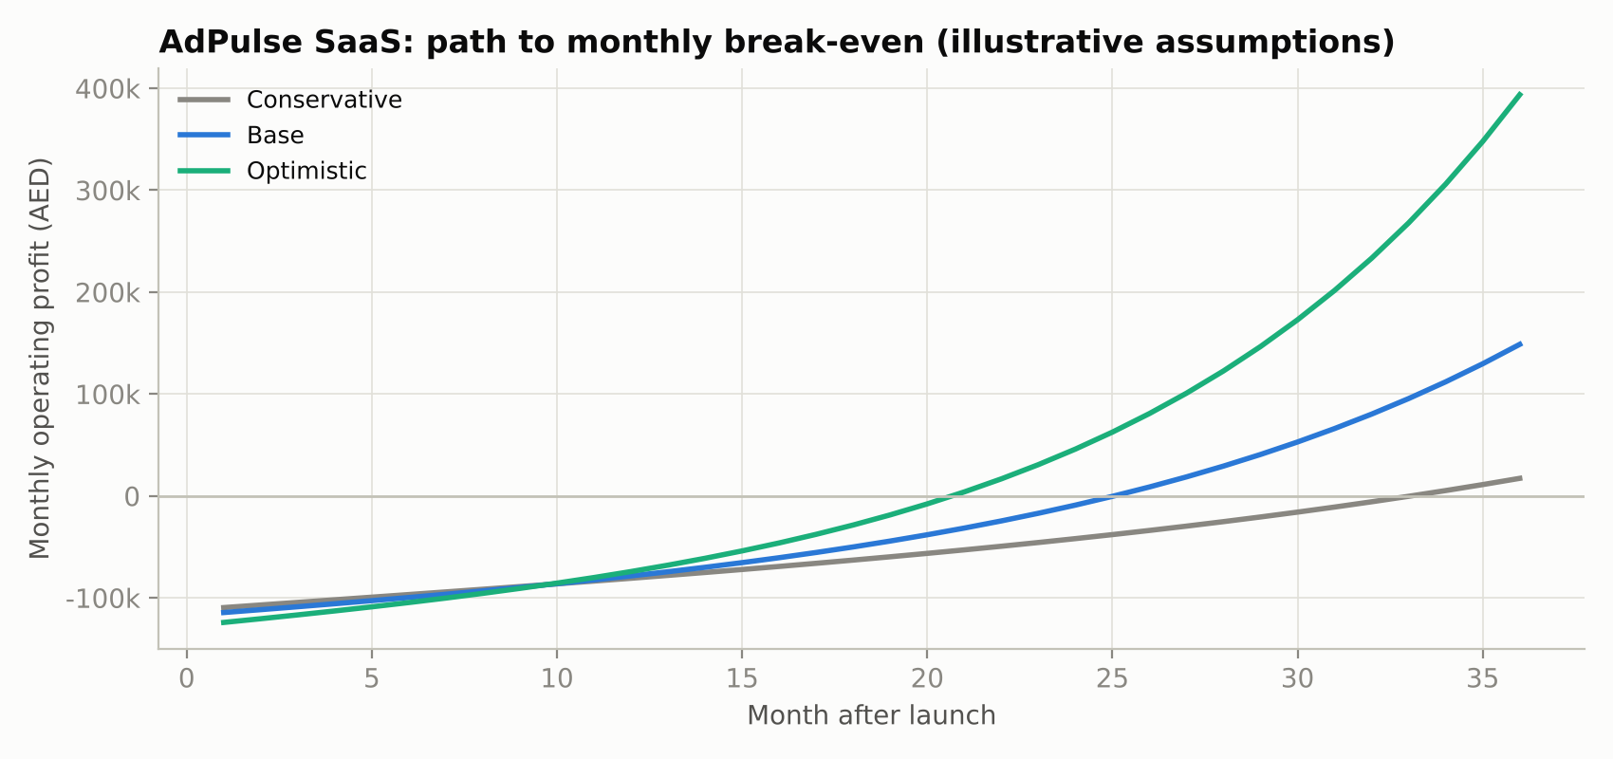
Figure 14.1: Monthly operating profit under the three scenarios.
Only the optimistic case recovers its cumulative investment within 36 months. The base case turns cash-positive on a monthly basis in month 26 and would need roughly AED 1.71M of funding to cover cumulative losses before that, which implies a pre-seed raise or a slower, founder-funded build. Reaching 525 subscribers by month 36 also probably requires expansion into Saudi Arabia, which is part of the roadmap.

15. Dashboard and Product Design
The prototype is a Streamlit web application with a navigation sidebar, a brand filter and eight pages. It follows three design rules: lead with the money (every page opens with an AED figure, not a chart), say what to do (cards that say CUT or INCREASE with an amount), and show the evidence underneath (charts, model metrics and method on the same page). Every chart has hover tooltips, and all tables can be sorted and downloaded.
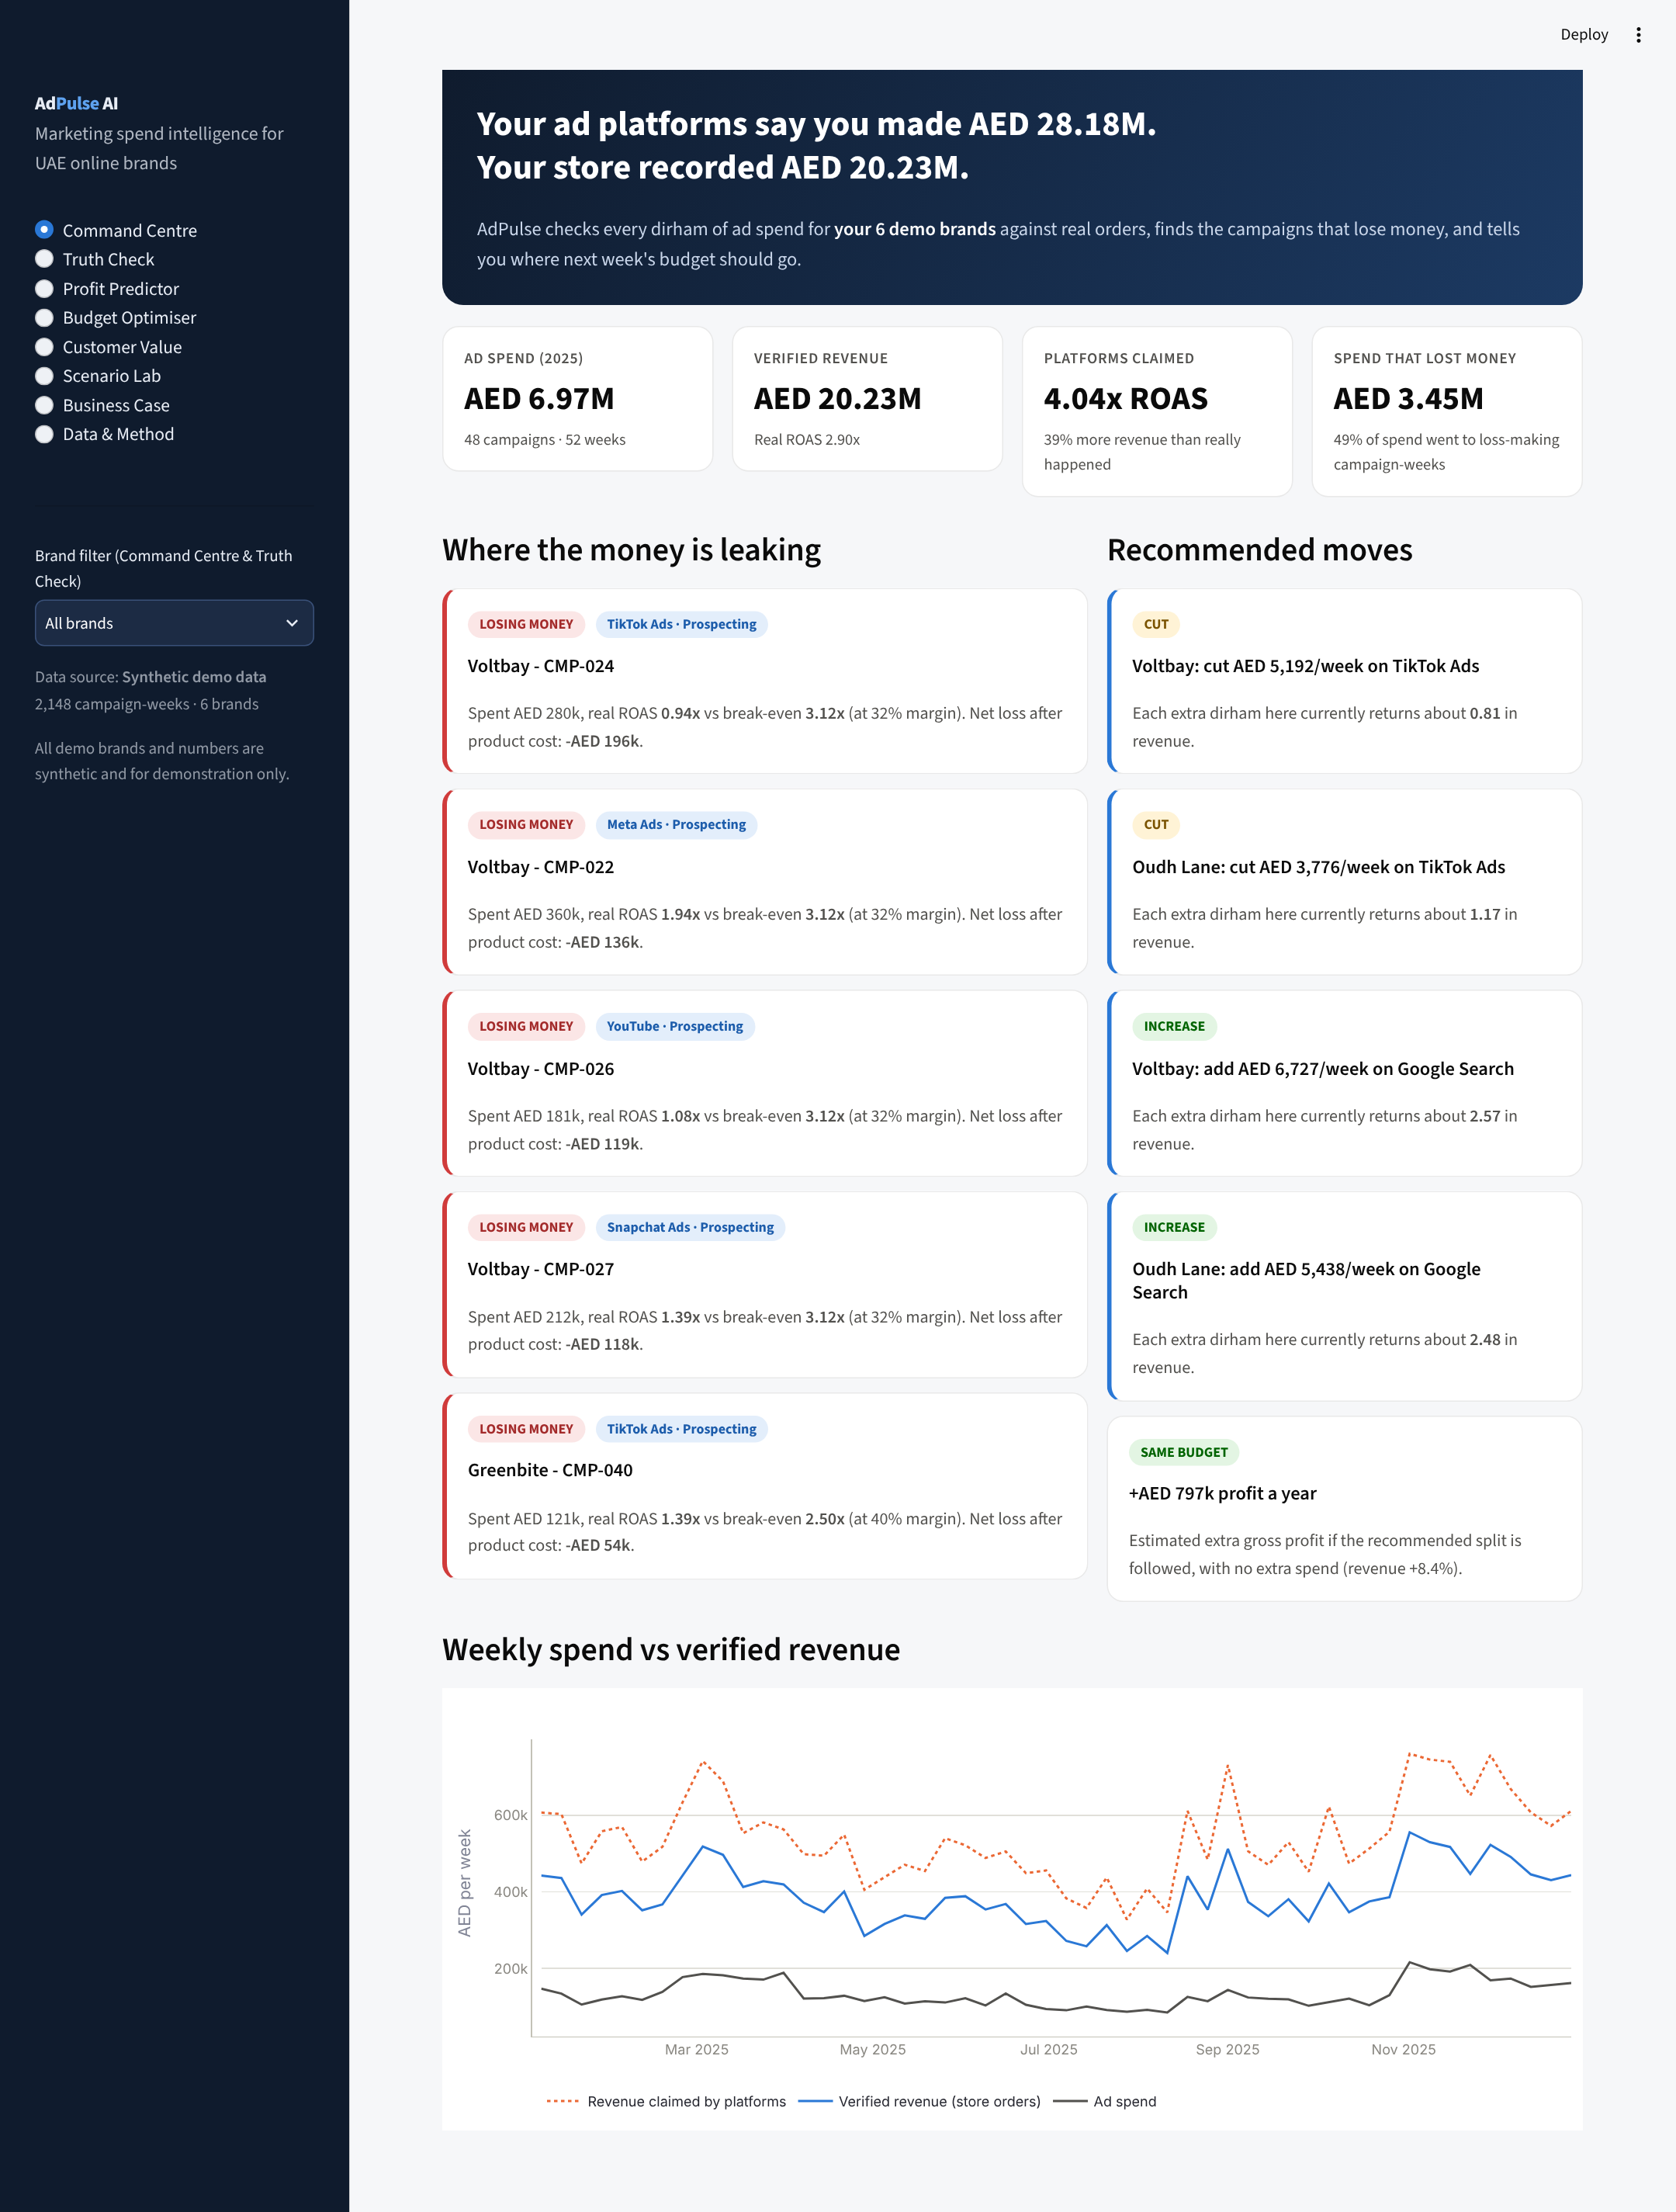
Figure 15.1: Command Centre: claimed vs verified revenue, money leaks and recommended moves.
Page | What the user sees and does
Command Centre | Headline gap between claimed and verified revenue; four KPI tiles; the five biggest money-losing campaigns; recommended cuts and increases with amounts; weekly trend
Truth Check | Claimed vs verified ROAS by channel; phantom revenue; reconciliation table
Profit Predictor | Form for a planned campaign; probability of profit with verdict; better alternatives at the same budget; model accuracy, ROC curve, feature importance
Budget Optimiser | Brand selector and budget slider; current vs recommended split; response curves; uplift in revenue and annual profit
Customer Value | Segment cards; segment mix by channel; LTV : CAC chart; adjustable k with silhouette chart
Scenario Lab | Sliders for budget, ad costs and demand; optimised-split toggle; profit curve across budget levels
Business Case | Pricing tiers; adjustable cost, churn, CAC, growth and tier mix; break-even, LTV : CAC and 36-month chart
Data & Method | Upload own campaign and customer CSVs (validated); download templates; data preview; methodology
Table 15.1: Dashboard pages. Screenshots of every page are in 05_Dashboard/screenshots.
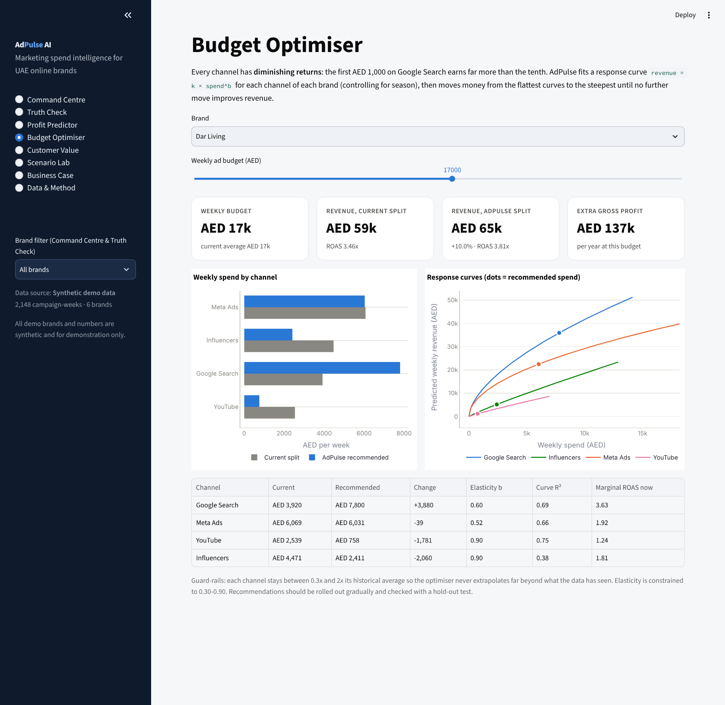
Figure 15.2: Budget Optimiser.

16. Implementation Roadmap
Phase | Timing | Deliverables | Success measure
0. Validate | Months 0-3 | Field survey (40-60 responses) and 8-10 interviews; 3 pilot brands using CSV upload in this prototype; refine pricing | H1-H5 tested; 2 of 3 pilots agree to pay
1. MVP | Months 3-9 | API connectors for Meta, Google, TikTok, Snapchat; Shopify, WooCommerce and Salla order sync; weekly email / WhatsApp digest; Arabic interface | 30 paying subscribers; weekly active use > 60%
2. Intelligence | Months 9-18 | Holdout and geo-test planner to measure true incrementality; Bayesian marketing-mix model; cash-on-delivery and returns-adjusted revenue; creative-fatigue alerts | Optimiser recommendations validated by at least 5 holdout tests
3. Scale | Months 18-36 | Agency tier and white-label; KSA expansion; approved budget changes pushed directly to platforms via API | 525 subscribers (base case); operating break-even
Table 16.1: Roadmap.

17. Risks, Ethics and Limitations

17.1 Limitations of this analysis
- Synthetic data. All results in Sections 8-13 come from generated data. The models recover patterns that the generator built in, so the results demonstrate that the pipeline works; they do not prove that the same patterns exist in real UAE brands. Real pilot data is required.
- Verified revenue is still attribution. Matching orders by UTM tags and promo codes is more honest than platform self-reporting, but it is still not causal. Some verified sales would have happened without any ad.
- Retargeting looks better than it is. Retargeting reaches people who already visited the store and were likely to buy. Its near-100% profitability in Section 8 is first-order attribution, not proof of incremental value (Blake et al., 2015; Lewis & Rao, 2015). The roadmap therefore includes holdout tests.
- Response curves are correlational. Weekly spend is chosen by marketers (for example, raised before peak seasons), which can bias elasticity estimates. Season dummies reduce but do not remove this. Recommendations should be phased in and checked with experiments.
- The profitability classifier ignores repeat purchases. It predicts first-order contribution only; Section 12 covers long-term value separately. A future version should predict 12-month contribution.
- Survey not yet fielded. Market size, pricing and adoption assumptions remain hypotheses until survey and pilot results are available.

17.2 Business risks
Risk | Impact | Mitigation
Ad platforms change APIs or restrict data access | High | Support CSV upload as fallback; maintain several connectors; monitor API changelogs
Brands unwilling to share store and ad data | High | Read-only access, UAE-hosted data, clear data-processing agreement, CSV-only Starter tier
Recommendations wrong for a specific brand | Medium | Guard-rails, gradual roll-out, holdout validation, show uncertainty; recommendations, not autopilot
Competition from platforms or global tools | Medium | Focus on UAE specifics, profit framing and SME pricing; build local benchmark data
Slow SME adoption and high churn | Medium | Free Truth Check audit as lead magnet; weekly digest builds habit; annual plans
Table 17.1: Key business risks.

17.3 Ethics and data protection
AdPulse processes customer order data, which includes personal data. It must comply with the UAE Personal Data Protection Law (Federal Decree-Law No. 45 of 2021): processing only for the stated purpose, minimal data (customer IDs can be hashed; names and addresses are not needed), secure storage, and a data-processing agreement with each client. Segmentation is behavioural only; AdPulse does not use or infer nationality, religion or other sensitive characteristics. The demonstration data contains no real people.

18. Conclusion
AdPulse addresses a problem that UAE online brands face every week and cannot solve by eye: their advertising numbers are self-reported, expressed in revenue rather than profit, and blind to diminishing returns and customer quality. The prototype shows how one product can turn raw spend and order data into four concrete decisions: which campaigns to cut, how to split the budget, which channels bring customers worth keeping, and what to expect if conditions change.
On the demonstration data, the analytics expose a 39% gap between claimed and real revenue, show that half of spend sat in loss-making campaign-weeks, predict profitability on unseen weeks with 85% accuracy, and identify about AED 797k a year of extra profit from re-allocating the same budget. As a business, AdPulse has attractive unit economics under stated assumptions (LTV : CAC 4.8x, payback 5.3 months) but needs funding to reach operating break-even in around two years.
The most important next step is evidence: fielding the survey and running three pilot brands on real data. The prototype has been built so that this can start immediately, since any brand can upload its own exports and see its own numbers.

19. AI Use Statement
Generative AI (Claude, by Anthropic) was used in this project to help write the Python code for the synthetic data generator, the analytics engine and the Streamlit application; to generate the synthetic demonstration dataset; and to draft sections of this report. The author defined the business problem and scope, reviewed and edited the outputs, and checked that the figures in the report match the result files in 04_Results, which can be regenerated by running 03_Code/generate_data.py and 03_Code/analysis.py. Market statistics were taken from the published sources listed below, not generated. The author takes full responsibility for the content.

References
AGBI. (2025, October). Ad spend in Gulf growing quicker than rest of world. Arabian Gulf Business Insight. https://www.agbi.com/analysis/media/2025/10/ad-spend-in-gulf-growing-quicker-than-rest-of-world/
Blake, T., Nosko, C., & Tadelis, S. (2015). Consumer heterogeneity and paid search effectiveness: A large-scale field experiment. Econometrica, 83(1), 155-174.
Breiman, L. (2001). Random forests. Machine Learning, 45(1), 5-32.
Duan, N. (1983). Smearing estimate: A nonparametric retransformation method. Journal of the American Statistical Association, 78(383), 605-610.
Gordon, B. R., Zettelmeyer, F., Bhargava, N., & Chapsky, D. (2019). A comparison of approaches to advertising measurement: Evidence from big field experiments at Facebook. Marketing Science, 38(2), 193-225.
Gupta, S., Hanssens, D., Hardie, B., Kahn, W., Kumar, V., Lin, N., Ravishanker, N., & Sriram, S. (2006). Modeling customer lifetime value. Journal of Service Research, 9(2), 139-155.
Hanssens, D. M., Parsons, L. J., & Schultz, R. L. (2001). Market response models: Econometric and time series analysis (2nd ed.). Kluwer Academic.
Jin, Y., Wang, Y., Sun, Y., Chan, D., & Koehler, J. (2017). Bayesian methods for media mix modeling with carryover and shape effects. Google Inc.
Lewis, R. A., & Rao, J. M. (2015). The unfavorable economics of measuring the returns to advertising. The Quarterly Journal of Economics, 130(4), 1941-1973.
Pedregosa, F., et al. (2011). Scikit-learn: Machine learning in Python. Journal of Machine Learning Research, 12, 2825-2830.
Pixis. (n.d.). Cross-platform attribution without platform bias: How to build a neutral view of your media mix. https://pixis.ai/blog/cross-platform-attribution-without-platform-bias-how-to-build-a-neutral-view-of-your-media-mix/
Rousseeuw, P. J. (1987). Silhouettes: A graphical aid to the interpretation and validation of cluster analysis. Journal of Computational and Applied Mathematics, 20, 53-65.
TradeArabia. (2026). UAE e-commerce expected to grow to $18.3bn by 2030. https://tradearabia.com/News/486918/UAE-e-commerce-expected-to-grow-to-$18.3bn-by-2030/RET
United Arab Emirates. (2021). Federal Decree-Law No. 45 of 2021 regarding the Protection of Personal Data.
Van Westendorp, P. (1976). NSS Price Sensitivity Meter: A new approach to study consumer perception of prices. Proceedings of the ESOMAR Congress.
WAM. (2023). 557,000 SMEs operated in UAE at end of 2022: Minister of Economy. Emirates News Agency. https://www.wam.ae/en/article/hszrgtp9-557000-smes-operated-uae-end-2022-minister
WAM. (2026). UAE e-commerce market size reaches AED42.2 billion in 2025. Emirates News Agency. https://www.wam.ae/en/article/c2h35yn-uae-e-commerce-market-size-reaches-aed422-billion

Appendix A: 24-Question Customer Survey
Title: How UAE online brands measure their advertising. Introduction shown to respondents: "This 8-minute survey is part of a business analytics project at SP Jain School of Global Management, Dubai. It is anonymous. Please answer only if you make or influence decisions about paid online advertising for a business selling in the UAE." Screening: respondents who answer 'We do not run paid ads' at Q5 are thanked and exit.

Section A: Business profile
Q1. What is your role?
Founder / owner · Head of marketing · Performance / digital marketer · Agency (managing clients' ads) · Other
Q2. What does your business (or main client) mainly sell?
Fragrance & beauty · Fashion & accessories · Electronics · Home & furniture · Food & health · Baby & kids · Services · Other
Q3. Where do you sell online? (select all)
Own website (Shopify / WooCommerce / Salla / other) · Amazon.ae · Noon · Instagram / WhatsApp orders · Other
Q4. What is your average monthly spend on paid online advertising?
Under AED 10k · AED 10-40k · AED 40-100k · AED 100-250k · Over AED 250k · Prefer not to say
Q5. Which paid channels do you use? (select all)
Meta (Facebook / Instagram) · Google Search / Shopping · TikTok · Snapchat · YouTube · Influencers · Other · We do not run paid ads

Section B: Current practice
Q6. How often do you review ad results and move budget between channels?
Daily · Weekly · Monthly · Only around big campaigns · Rarely
Q7. Which source do you mainly trust to judge ad performance?
Each platform's own dashboard · Google Analytics · Store backend (e.g., Shopify orders) · A spreadsheet combining sources · Agency report · Not sure
Q8. How many hours a week does your team spend compiling ad reports?
Under 1 · 1-3 · 3-6 · 6-10 · Over 10
Q9. Do you calculate profit after product cost for each campaign (not only ROAS)?
Always · Sometimes · Never · Not sure what this means
Q10. Do you track how many customers from each channel buy again?
Yes, regularly · Partly · No
Q11. Have you ever run a holdout or geo test (turning ads off for a group to measure the real effect)?
Yes · No · I don't know what this is

Section C: Pain points
Q12. "When I add up the sales reported by each ad platform, the total is higher than my real sales."
1 Strongly disagree · 2 Disagree · 3 Neutral · 4 Agree · 5 Strongly agree · Don't know
Q13. "I am confident I know which channel gives my business the best return."
1 Strongly disagree · 2 Disagree · 3 Neutral · 4 Agree · 5 Strongly agree
Q14. "During Ramadan, White Friday and other peak seasons, I am unsure whether extra ad spend pays off."
1 Strongly disagree · 2 Disagree · 3 Neutral · 4 Agree · 5 Strongly agree
Q15. "I find it hard to decide how to split my budget between channels."
1 Strongly disagree · 2 Disagree · 3 Neutral · 4 Agree · 5 Strongly agree
Q16. What is your biggest frustration with measuring your advertising today?
Open text
Q17. Roughly what share of your ad budget do you think is wasted?
0-10% · 10-25% · 25-50% · Over 50% · Don't know

Section D: Solution fit
Q18. Rank these features from most (1) to least (6) useful.
See real vs claimed revenue by channel · Predict whether a campaign will make a profit · Recommend how to split my budget · Show which channels bring repeat customers · Test 'what-if' scenarios · Weekly summary in Arabic and English
Q19. Would you connect your ad accounts and store data to a tool like this?
Yes · Yes, if data stays in the UAE and access is read-only · Only by uploading CSV files · No
Q20. What would stop you from using such a tool? (select up to 2)
Data privacy · Price · Set-up time · Not sure the recommendations are accurate · My team lacks time / skills · Nothing

Section E: Willingness to pay (Van Westendorp)
Shown with a one-paragraph description of AdPulse. Answers in AED per month.
Q21. At what monthly price would this tool be so cheap that you would doubt its quality?
AED ____
Q22. At what monthly price would it be a bargain, a great buy for the money?
AED ____
Q23. At what monthly price would it start to feel expensive, but you would still consider it?
AED ____
Q24. At what monthly price would it be too expensive to consider?
AED ____
Optional, after Q24: "Would you like a free Truth Check of your own ad data? Leave an email." (Stored separately from survey answers.)

Appendix B: Data Dictionary

campaign_performance.csv
Column | Description
week_start, week_of_year | Monday the week starts; ISO week number
season | Ramadan & Eid, White Friday & 11.11, DSF & National Day, Back to School, Summer, Regular
brand, category, gross_margin | Fictional brand, its product category and gross margin (0-1)
channel, campaign_id, objective | Ad channel; campaign identifier; Prospecting or Retargeting
creative_format, ad_language, target_emirate | Creative type; English / Arabic / Bilingual; geographic target
creative_age_weeks | Weeks since the creative was last refreshed (fatigue)
spend_aed, impressions, clicks | Media delivery for the week
orders, new_customers | Store-verified orders attributed to the campaign; of which first-time customers
verified_revenue_aed | Revenue from store-verified orders (UTM / promo code / order ID match)
platform_reported_revenue_aed | Revenue the ad platform claimed for the same week
roas, contribution_aed, profitable | Verified ROAS; revenue x margin - spend; 1 if contribution > 0

customers.csv
Column | Description
customer_id, brand, category | Customer identifier and the brand bought from
acquisition_channel, first_order_date, tenure_days | Channel of first order; date; days observed
orders_12m, avg_order_value_aed, revenue_12m_aed | Orders, average order value and revenue in the first 12 months
gross_profit_12m_aed | Revenue x margin, reduced for discounted orders
days_since_last_order, discount_order_share | Recency; share of orders using a discount code
home_emirate | Delivery emirate

Appendix C: Repository Structure and Deployment
Path | Contents
01_Report/ | This report (Word and PDF), Markdown version, survey
02_Data/ | campaign_performance.csv, customers.csv (synthetic)
03_Code/app.py | Streamlit application (main file for deployment)
03_Code/adpulse_engine.py | All analytics, shared by the app and the analysis script
03_Code/generate_data.py | Recreates the synthetic data (fixed seed)
03_Code/analysis.py | Recreates every table and chart in 04_Results
04_Results/ | CSV result tables and PNG charts used in this report
05_Dashboard/ | Dashboard specification and screenshots of all eight pages
.streamlit/config.toml, requirements.txt, README.md | Theme, Python dependencies, instructions

Deploying to Streamlit Community Cloud
- Create a new GitHub repository and upload the contents of the AdPulse_AI_Submission folder, keeping the folder structure (requirements.txt must be at the top level).
- Sign in at share.streamlit.io with GitHub and choose Create app, then Deploy a public app from GitHub.
- Select the repository and branch, and set the Main file path to 03_Code/app.py.
- Click Deploy. The first build installs the packages in requirements.txt and takes a few minutes.
To run locally: pip install -r requirements.txt, then streamlit run 03_Code/app.py. To reproduce all results: python 03_Code/generate_data.py, then python 03_Code/analysis.py.

