Department of Computer Science and Engineering
2026-2027
Odd Semester


DATA STRUCTURES AND ALGORITHMS-3
(25CS2103E)

Plagiarism Detection System using Rolling Hash Techniques

Prakshitha Malla 2520030342
Datla Sri Sai Purna Mahija 2520030261
Kheerthi Ganta 2520030383
Team Number: 10 Section: 5

COURSE INSTRUCTOR

Dr. J Sirisha Devi
Professor
Department of Computer Science and Engineering
Plagiarism Detection System using Rolling Hash Techniques
Abstract
This project builds a plagiarism detection system that finds copied passages across multiple documents in expected linear time per document pair. It is based on the Rabin-Karp string-matching algorithm: a polynomial rolling hash is computed for every sliding window of text, so matching passages are found without comparing every character against every other. Double hashing, backed by a character-by-character check of each hit, prevents false positives from hash collisions. All hash tables, string routines and arrays are written from scratch without java.util. The system reports a similarity percentage for each pair of documents and highlights the duplicated passages.
Introduction
Copied text is hard to spot by eye when many documents must be checked. A naive comparison slides a window over one document and tests it against every window of the other, which costs O(n × m × k) character comparisons for documents of length n and m and window size k. That becomes impractical as documents grow.
A rolling hash removes most of this work. When the window moves one character, the new hash is computed from the old one in O(1) time instead of being recomputed from scratch. The hashes of one document are stored in a hash table, and each window of the second document is looked up in it. Only windows whose hashes match are compared character by character. The result is a similarity score and a marked-up view of the shared wording, shown in a Swing desktop interface, an HTML report and a web frontend served by a local Java backend.
Case Study Example
Four sample text documents are supplied with the project. doc1_original.txt is the source text. doc2_copied.txt contains two sentences taken from doc1 inside other text of its own. doc3_partial.txt shares a single sentence with doc1. doc4_unrelated.txt shares nothing with the others.
Expected Result
The program loads two or more text documents, compares every pair, and prints a similarity percentage for each pair, sorted from most to least similar. For the most similar pair it prints both documents with the copied passages highlighted, and it can write the same view to an HTML report. A copied document scores high, a document that shares one sentence scores lower, and an unrelated document scores 0%.
Sample Run 1: Four Test Documents (window size k = 20)
java -cp out plagiarism.Main -k 20 -html report.html samples

Document A | Document B | Similarity
doc1_original.txt | doc2_copied.txt | 52.5%
doc1_original.txt | doc3_partial.txt | 32.8%
doc1_original.txt | doc4_unrelated.txt | 0.0%
doc2_copied.txt | doc3_partial.txt | 0.0%
doc2_copied.txt | doc4_unrelated.txt | 0.0%
doc3_partial.txt | doc4_unrelated.txt | 0.0%

In doc2_copied.txt, the sentences beginning "Data structures are fundamental to computer science" and "A hash table maps keys to values" are highlighted as copied from doc1_original.txt, while the sentences that doc1 does not contain stay unmarked. For this pair, 361 windows were hashed, 186 hash hits were found, and 0 collisions had to be rejected.
Sample Run 2: Speed Against Naive Comparison (window size k = 25)
Characters per document | Rolling hash | Naive comparison | Speed-up
3,427 | 2.3 ms | 41 ms | 18x
6,724 | 2.3 ms | 149 ms | 65x
13,479 | 5.6 ms | 650 ms | 116x
27,004 | 6.3 ms | 2,419 ms | 384x
54,244 | 8.2 ms | 9,772 ms | 1,192x

These timings were measured on a development machine after JIT warm-up. Timings on another machine will differ, but the gap widens as documents grow.
Observations
- Copied passages are found even when they sit in a different position in the second document, because matching goes through a hash index and not through file order.
- The unrelated document scored 0.0% against every other document, and no window collision reached the output.
- Comparison time grew from 2.3 ms to 8.2 ms while the text grew about 16 times, against 41 ms to 9,772 ms for the naive method.
- Text is normalised first, so differences in capital letters, punctuation and spacing do not hide copying.
- Only exact matching passages are found. A sentence that has been reworded is not matched.
Conclusion
The system finds copied passages across multiple documents in expected O(n + m) time per pair, where the naive approach needs O(n × m × k). Double hashing with a character-by-character check produced no false positives in the tests. The hash table, dynamic array, text normaliser and highlighter are all written from scratch without java.util. The similarity percentage and highlighted passages, available in the Swing interface, the HTML report and the web frontend, make the output easy to act on.
Future Scope
- Use winnowing to keep only selected hashes, which shrinks the index for very large collections.
- Add word-level shingles and stemming so lightly reworded text can be matched.
- Accept PDF and DOCX files as input.
- Keep a persistent index so a new document can be checked against an existing collection.
- Compare document pairs on several threads, and ignore quoted and cited text.

ALGORITHM / PSEUDO CODE
Rabin-Karp Rolling Hash with Double Hashing
Let the normalised text be c[0..n-1] and the window size be k. The hash of the window starting at i is a polynomial in a base B, taken modulo a prime M. Moving the window one step removes the leftmost character and appends the next one:
H(i+1) = ((H(i) - c[i] x B^(k-1)) x B + c[i+k]) mod M

One hash with a modulus near 10^9 can collide by chance, so two independent hashes are computed and joined into one 64-bit key (h1 << 32) | h2. Every hit found through a key is still verified character by character, so a collision can never be reported as a match.
Hash | Base B | Modulus M
h1 | 257 | 1,000,000,007
h2 | 131 | 998,244,353

The default window size is k = 25 normalised characters. The text is normalised first: lower-cased, with punctuation removed and spaces collapsed, while an index map back to the original text is kept so matches can be highlighted there.
Algorithm Steps
- Load each document and normalise it: lower-case, keep letters and digits, collapse everything else to single spaces, and remember each character's index in the original text.
- For documents A and B, compute the double rolling hash key of every k-character window.
- Insert every window key of A into a custom chained hash table, together with the window's position.
- For each window of B, look its key up in the table.
- For every candidate position found, compare the k characters of A and B one by one. If they are equal, mark those characters as matched in both documents. If not, count a rejected collision.
- Merge neighbouring marked characters into passages.
- Compute the similarity percentage and map the marks back to the original text to highlight the shared passages.
- When more than two documents are given, repeat steps 2 to 7 for every pair and sort the pairs from most to least similar.
Pseudocode
function windowKeys(T, k):
p = B^(k-1) mod M (for both hash pairs)
h = polynomial hash of T[0..k-1] (for both hash pairs)
keys[0] = (h1 << 32) | h2
for i = 1 .. len(T) - k:
h = ((h - T[i-1] * p) * B + T[i+k-1]) mod M (both pairs)
keys[i] = (h1 << 32) | h2
return keys

function compare(A, B, k):
keysA = windowKeys(A, k)
keysB = windowKeys(B, k)
index = new HashIndex()
for i in 0 .. len(keysA) - 1: index.put(keysA[i], i)
for j in 0 .. len(keysB) - 1:
for each position i stored under keysB[j]:
if A[i .. i+k-1] == B[j .. j+k-1]:
mark A[i .. i+k-1] and B[j .. j+k-1]
return 100 * (marked(A) + marked(B)) / (len(A) + len(B))

Time Complexity
Step | Cost
Hash all windows of a document of length n | O(n)
Insert one document's windows into the hash table | O(n) expected
Look up each window of the other document | O(1) expected each, O(m) in total
Compare one pair of documents | O(n + m) expected
Naive window-by-window comparison, for contrast | O(n x m x k)

Similarity is measured on the normalised characters covered by matches:
Similarity (%) = (matched_A + matched_B) / (length_A + length_B) x 100

CODE
The core engine uses only java.lang. The classes IntList, HashIndex, RollingHash, TextDoc, Detector, Reporter, Main, PlagiarismGUI and Benchmark make up the detector, and Server exposes it to the web frontend. The three classes below hold the algorithm.
RollingHash.java
package plagiarism;

public class RollingHash {
static final long B1 = 257, M1 = 1_000_000_007L;
static final long B2 = 131, M2 = 998_244_353L;

public static long[] windowKeys(char[] t, int k) {
int n = t.length;
if (n < k || k <= 0) return new long[0];
long p1 = 1, p2 = 1; // B^(k-1) mod M
for (int i = 0; i < k - 1; i++) {
p1 = p1 * B1 % M1; p2 = p2 * B2 % M2;
}
long h1 = 0, h2 = 0;
for (int i = 0; i < k; i++) {
h1 = (h1 * B1 + t[i]) % M1;
h2 = (h2 * B2 + t[i]) % M2;
}
long[] keys = new long[n - k + 1];
keys[0] = (h1 << 32) | h2;
for (int i = 1; i <= n - k; i++) {
h1 = ((h1 - t[i-1] * p1 % M1 + M1) * B1 + t[i+k-1]) % M1;
h2 = ((h2 - t[i-1] * p2 % M2 + M2) * B2 + t[i+k-1]) % M2;
keys[i] = (h1 << 32) | h2;
}
return keys;
}
}

HashIndex.java
package plagiarism;

public class HashIndex {
private final int[] buckets; // head entry per bucket, -1 = empty
private long[] keys;
private int[] pos;
private int[] next;
private int count = 0;

public HashIndex(int expected) {
int cap = 16;
while (cap < expected * 2) cap <<= 1;
buckets = new int[cap];
for (int i = 0; i < cap; i++) buckets[i] = -1;
keys = new long[expected + 1];
pos = new int[expected + 1];
next = new int[expected + 1];
}

private int slot(long key) {
long h = key * 0x9E3779B97F4A7C15L;
return (int) ((h >>> 33) & (buckets.length - 1));
}

public void put(long key, int position) {
if (count == keys.length) grow();
int s = slot(key);
keys[count] = key;
pos[count] = position;
next[count] = buckets[s];
buckets[s] = count++;
}

public int find(long key) {
int e = buckets[slot(key)];
while (e != -1 && keys[e] != key) e = next[e];
return e;
}

public int nextEntry(int e, long key) {
e = next[e];
while (e != -1 && keys[e] != key) e = next[e];
return e;
}

public int positionAt(int e) { return pos[e]; }

private void grow() {
int n = keys.length * 2;
long[] k = new long[n]; int[] p = new int[n]; int[] x = new int[n];
for (int i = 0; i < count; i++) {
k[i] = keys[i]; p[i] = pos[i]; x[i] = next[i];
}
keys = k; pos = p; next = x;
}
}

Detector.java
package plagiarism;

public class Detector {
private final int k;
public Detector(int windowSize) { this.k = windowSize; }

public Result compare(TextDoc a, TextDoc b) {
long t0 = System.nanoTime();
Result r = new Result();
r.a = a; r.b = b;
r.markA = new boolean[a.norm.length];
r.markB = new boolean[b.norm.length];

long[] keysA = RollingHash.windowKeys(a.norm, k);
long[] keysB = RollingHash.windowKeys(b.norm, k);

HashIndex index = new HashIndex(keysA.length);
for (int i = 0; i < keysA.length; i++) index.put(keysA[i], i);

for (int j = 0; j < keysB.length; j++) {
for (int e = index.find(keysB[j]); e != -1;
e = index.nextEntry(e, keysB[j])) {
int i = index.positionAt(e);
r.hashHits++;
// verify, never trust the hash alone
if (sameWindow(a.norm, i, b.norm, j)) {
for (int x = 0; x < k; x++) {
r.markA[i + x] = true; r.markB[j + x] = true;
}
} else r.collisionsRejected++;
}
}
r.passagesA = passages(r.markA);
r.passagesB = passages(r.markB);
r.coveredA = count(r.markA);
r.coveredB = count(r.markB);
int la = a.norm.length, lb = b.norm.length;
r.overall = (la + lb) == 0 ? 0
: 100.0 * (r.coveredA + r.coveredB) / (la + lb);
r.micros = (System.nanoTime() - t0) / 1000;
return r;
}

private boolean sameWindow(char[] x, int i, char[] y, int j) {
for (int t = 0; t < k; t++)
if (x[i + t] != y[j + t]) return false;
return true;
}

private static int count(boolean[] m) {
int c = 0;
for (int i = 0; i < m.length; i++) if (m[i]) c++;
return c;
}

static Passage[] passages(boolean[] m) {
int runs = 0;
for (int i = 0; i < m.length; i++)
if (m[i] && (i == 0 || !m[i - 1])) runs++;
Passage[] out = new Passage[runs];
int n = 0, i = 0;
while (i < m.length) {
if (m[i]) {
int s = i;
while (i < m.length && m[i]) i++;
out[n++] = new Passage(s, i);
} else i++;
}
return out;
}
}

RESULTS
Screenshots
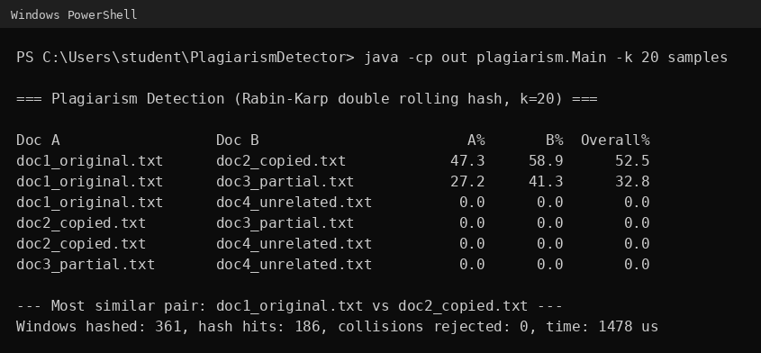
Figure 1: Console output, similarity of every pair of sample documents (k = 20)
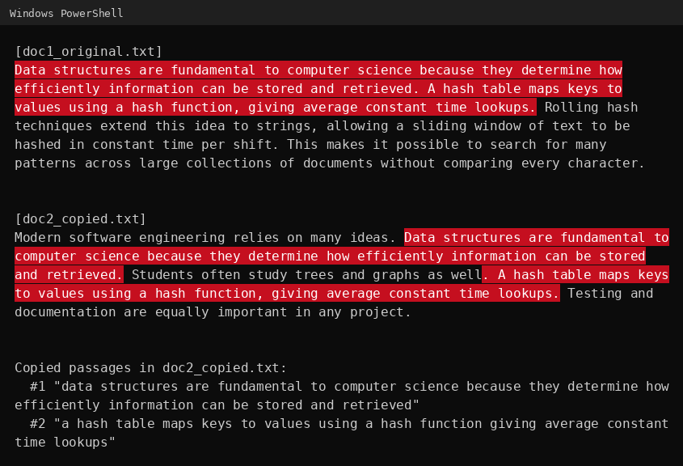
Figure 2: Console output, the most similar pair with the copied passages highlighted
[Insert screenshot: the web page with the four sample documents uploaded]
[Insert screenshot: the web page showing the similarity table and the side-by-side highlighted view]

