

MANIPAL INSTITUTE OF TECHNOLOGY, MANIPAL
Department of Computer Science and Engineering
Software Application Design Laboratory
Mini-Project Report
AIRPORT MANAGEMENT SYSTEM
Function-Oriented Design, Object-Oriented Design, Implementation and Testing
Submitted by
Prakhar Singh - 240958196
Prasang Saxena - 240958278
Krishna Gupta - 240958222
Under the guidance of
Srikanth Prabhu
Session 2026-27

Contents

1. Introduction

1.1 Problem Statement
An airport handles a large number of flights, passengers and bags every day. Flight schedules change, gates must be allocated without clashes, passengers need to find flights and reserve seats, and check-in counters must verify bookings, issue boarding passes and track every checked bag. When these activities are handled with spreadsheets or paper registers, the same seat can be sold twice, two flights can be given the same gate, and a bag's whereabouts can be lost.
The Airport Management System (AMS) developed in this mini-project is a desktop application that keeps flights, bookings and baggage in one consistent database and gives each type of user (administrator, check-in staff and passenger) exactly the functions they need.

1.2 Objectives
- Analyse the problem using both the Function-Oriented Design approach (Structured Analysis + Structured Design) and the Object-Oriented Design approach (UML).
- Write a complete Software Requirements Specification (SRS) and formal (algebraic and axiomatic) specifications for key operations.
- Implement a working GUI application in Python (Tkinter) with SQLite, organised into modules with high cohesion and low coupling.
- Verify the implementation with black-box, white-box and unit tests that can be run locally, and report their real results.

1.3 Scope of the System
The system covers four modules:
Table 1.1: Modules of the Airport Management System
Module | What it does | Main user
M1 Login & Accounts | Login/logout, passenger self-registration, admin creates staff/admin accounts, role-based access control. | All users
M2 Flight Scheduling | Add, update, view and cancel flights; change flight status; assign gates with a clash check. | Administrator
M3 Passenger Booking | Search flights, choose a seat on a seat map, book and cancel tickets, view bookings. | Passenger
M4 Check-in & Baggage | Find booking by PNR, check in, issue boarding pass, add bags with tags, compute excess-baggage fee, track bag status. | Check-in staff

Payments, airline-to-airline messaging, e-mail/SMS notifications and physical printing are outside the scope of this lab project (see Section 4.9 and Chapter 12).

1.4 Technology Used
Item | Choice | Reason
Language | Python 3.9+ | Readable, quick to develop, standard library has everything needed.
GUI | Tkinter / ttk | Ships with Python on Windows/macOS; no installation needed for the lab demo.
Database | SQLite 3 (file data/airport.db) | Serverless, single file, supports SQL constraints and transactions.
Testing | unittest (+ optional coverage) | Standard library; tests run with one command.
Diagrams | Graphviz (DFDs, structure charts, CFGs, use case, collaboration), PlantUML (class, activity, state, sequence) | Diagrams are generated from text, so names stay consistent with the code.

1.5 Organisation of this Report
Chapters 2-4 cover analysis (abstraction, life-cycle model, SRS). Chapter 5 gives formal specifications. Chapter 6 discusses cohesion and coupling. Chapters 7 and 8 form the Function-Oriented Design (FOD = SA + SD): DFDs and data dictionary, then structure charts. Chapter 9 is the Object-Oriented Design. Chapter 10 describes the implementation and GUI, Chapter 11 the testing, and Appendix A gives a traceability matrix linking every requirement to its DFD process, use case, code and tests.

2. Abstraction and Decomposition
Software engineering handles complexity with two principles. Abstraction means concentrating on the aspects of a problem that matter at a given level and ignoring irrelevant details. Decomposition means dividing a large problem into smaller, mostly independent sub-problems that can be solved one at a time and then combined.

2.1 Abstraction in the AMS
Table 2.1: Abstraction mechanisms used
Kind of abstraction | Where it is used in the AMS
Functional (procedural) abstraction | Each service method hides its steps behind one name, e.g. check_in(actor, pnr) hides the PNR lookup, the eligibility rules, the boarding-sequence update and the boarding-pass creation.
Data abstraction | Entity classes User, Flight, Booking, Bag, BoardingPass expose only their fields; how they are stored (SQL rows) is hidden in from_row().
Control abstraction | Flight and bag life cycles are expressed as transition tables (FLIGHT_TRANSITIONS, BAG_TRANSITIONS); callers just request a new status.
Levels of DFD | The context diagram shows the whole system as one process; Level 1 shows 6 processes; Level 2 and 3 add detail only where it is needed.
Layering | GUI views know nothing about SQL; services know nothing about Tkinter; validators know nothing about either.

2.2 Decomposition of the AMS
The system was decomposed top-down: first into four modules (one per user goal), then each module into functions small enough to implement and test as one unit. Figure 2.1 shows the decomposition tree; Table 2.2 maps each part to its source file.
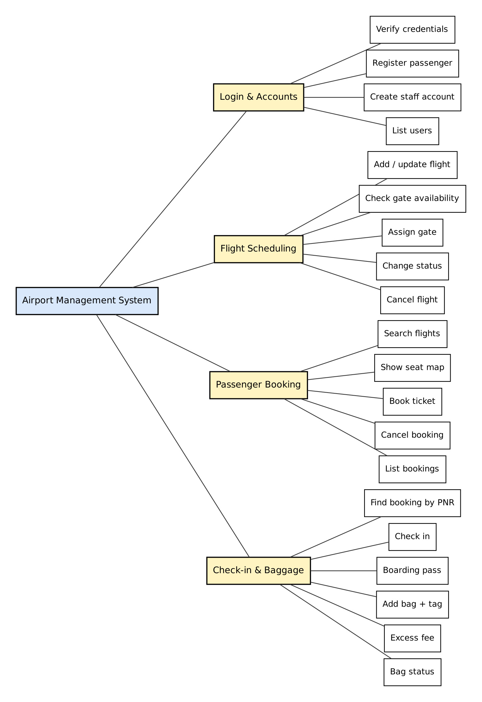
Figure 2.1: Functional decomposition of the Airport Management System
Table 2.2: Decomposition mapped to the source code
Module | Functions (service methods) | Source file
Login & Accounts | login, register_passenger, create_staff_account, list_users | ams/services/auth_service.py
Flight Scheduling | add_flight, update_flight, is_gate_available, assign_gate, change_status, cancel_flight | ams/services/flight_service.py
Passenger Booking | search_flights, get_taken_seats, book_ticket, cancel_booking, list_bookings | ams/services/booking_service.py
Check-in & Baggage | find_booking, check_in, get_boarding_pass, add_bag, baggage_summary, update_bag_status, compute_excess_fee | ams/services/checkin_service.py
Shared utilities | validation, role check, password hashing, entity classes, schema | validators.py, access.py, security.py, models.py, database.py

3. Software Development Life-Cycle Models
A software life-cycle model is a descriptive and diagrammatic representation of the life cycle of a software product: the phases it passes through and the order in which they are carried out. Following a model makes the work disciplined, defines entry and exit criteria for each phase, and lets progress be measured.

3.1 Common Life-Cycle Models
Table 3.1: Comparison of life-cycle models
Model | Key idea | Strengths | Weaknesses
Classical Waterfall | Phases in strict sequence: feasibility, requirements, design, coding & unit testing, integration & system testing, maintenance. | Simple; clear documents at every phase. | No way to go back to fix errors found later; unrealistic.
Iterative Waterfall | Waterfall with feedback paths from every phase to earlier ones. | Errors can be corrected where they were made; still document-driven; easy to manage. | Requirements still fixed early; no working product until late.
Prototyping | Build a quick throw-away prototype to clarify unclear requirements, then develop as waterfall. | Good when the user interface or requirements are unclear. | Extra cost of the prototype.
Incremental / Evolutionary | Deliver the system in increments, each adding features. | Early partial product; customer feedback. | Needs a modular design; integration overhead.
Spiral | Loops of objective setting, risk analysis, development and planning. | Explicit risk handling; good for large risky projects. | Complex; needs risk-analysis expertise.
Agile (Scrum/XP) | Short iterations, working software over documents, continuous customer involvement. | Handles changing requirements well. | Less documentation; needs an always-available customer.

3.2 Selected Model: Iterative Waterfall
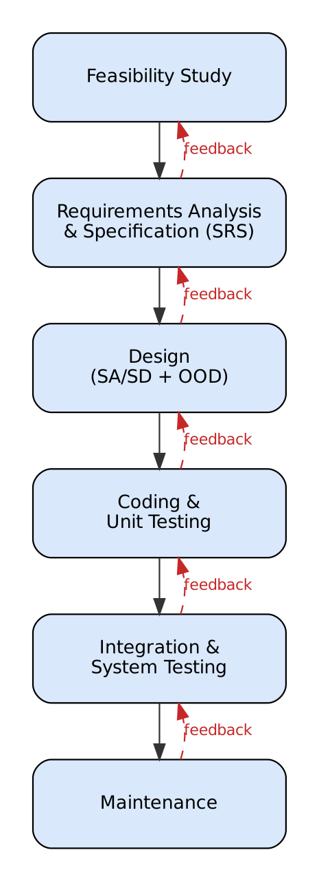
Figure 3.1: Iterative waterfall model followed in this project (dashed arrows are feedback paths)
Justification. The iterative waterfall model was chosen for the following reasons:
- Requirements are well understood and stable. Airport operations (scheduling, booking, check-in, baggage) are familiar, and the lab brief fixes the scope, so a heavy prototyping or risk-driven model is not needed.
- The lab deliverable is document-centred. The evaluation needs an SRS, SA/SD and OOD documents, which map naturally onto the separate phases of the waterfall model.
- Feedback was actually needed. Two examples: (1) while drawing the Level-2 DFDs, three store reads were found missing from Level 1, so the analysis was revised (an automatic balancing check now catches this); (2) black-box test BB20 found that the flight-number rule accepted an all-digit airline code, so the validator in the coding phase was corrected. The iterative model allows exactly this kind of going back.
- Small team, short time, low risk. The spiral model's risk analysis and agile's continuous customer involvement add overhead that does not pay off for a 3-4 week lab project.

3.3 Phases as Carried Out
Phase | Activities in this project | Output
Feasibility study | Checked that Python + Tkinter + SQLite can run on lab PCs without installation; estimated effort. | Decision to build a desktop app.
Requirements analysis & specification | Identified actors and functions; wrote numbered functional and non-functional requirements. | SRS (Chapter 4)
Design | SA: context diagram, DFDs, data dictionary. SD: structure charts. OOD: UML diagrams. Formal specs. | Chapters 5-9
Coding & unit testing | Implemented validators, services and GUI; wrote black-box, white-box and unit tests. | Source code, tests
Integration & system testing | Ran the GUI for every role end-to-end; captured screenshots. | Chapter 10-11
Maintenance | README with setup instructions; limitations and future scope recorded. | README, Chapter 12

4. Software Requirements Specification (SRS)
This SRS follows the structure recommended by IEEE Std 830-1998. Requirements are numbered so that they can be traced to DFD processes, use cases, code and test cases (Appendix A).

4.1 Introduction

4.1.1 Purpose
This document specifies the requirements of the Airport Management System (AMS). It is intended for the development team, the lab instructor who evaluates the project, and anyone who will test or maintain the software.

4.1.2 Scope
AMS is a single-site desktop application used at an airport to schedule flights and gates, let passengers book and cancel seats, and let check-in staff check passengers in and manage baggage. It stores all data in a local SQLite database. It does not process payments or communicate with external airline systems.

4.1.3 Definitions, Acronyms and Abbreviations
Term | Meaning
AMS | Airport Management System (this software)
PNR | Passenger Name Record: a 6-character booking reference, e.g. K7Q2MA
IATA code | 3-letter airport code, e.g. DEL (Delhi), BOM (Mumbai)
Gate | Boarding gate, written as terminal letter A-D and number 1-20, e.g. B7
Boarding sequence | Order in which passengers of a flight were checked in (001, 002, ...)
Bag tag | Unique bag identifier printed at check-in, format AMSnnnnnn
Excess baggage fee | Charge for checked baggage above the free allowance
Admin / Staff / Passenger | The three user roles
SA / SD / FOD / OOD | Structured Analysis / Structured Design / Function-Oriented Design / Object-Oriented Design

4.1.4 References
- IEEE Std 830-1998, Recommended Practice for Software Requirements Specifications.
- Rajib Mall, Fundamentals of Software Engineering, PHI Learning.
- Python 3 documentation: tkinter, sqlite3, unittest.

4.1.5 Overview
Section 4.2 describes the product in general terms. Section 4.3 lists the functional requirements module by module. Sections 4.4-4.6 cover interfaces, non-functional requirements and business rules. Section 4.7 gives the data requirements and Section 4.8 separates implemented features from limitations.

4.2 Overall Description

4.2.1 Product Perspective
AMS is a new, self-contained product. It is organised in three layers: a Tkinter presentation layer, a service layer that holds all business rules, and an SQLite data layer. The context diagram in Section 7.1 shows its interaction with the three external entities (Passenger, Check-in Staff, Administrator).

4.2.2 Product Functions
- Authenticate users and show a role-specific dashboard; let passengers register; let the administrator create staff accounts.
- Maintain the flight schedule: add, update, change status, cancel, and assign gates without clashes.
- Let passengers search flights, pick a seat on a seat map, book (receive a PNR) and cancel bookings.
- Let staff check passengers in within the check-in window, issue boarding passes, tag bags, show the excess-baggage fee and track bag status.

4.2.3 User Classes and Characteristics
Table 4.1: User classes
User class | Characteristics | Functions allowed
Administrator | Airport operations staff; trained; few users. | All flight-scheduling functions; create staff/admin accounts; view users and all bookings; cancel any booking; check-in functions.
Check-in Staff | Counter staff; trained; frequent daily use; speed matters. | Check-in, boarding pass, baggage; view schedule and all bookings (read-only).
Passenger | General public; no training; occasional use. | Register, search, book and cancel own bookings, view own boarding pass, view schedule.

4.2.4 Operating Environment
- Windows 10/11, macOS or Linux with Python 3.9 or newer (Tkinter and sqlite3 included).
- Minimum 1366 x 768 screen; the main window is 1100 x 700 and resizable.
- No network connection is required.

4.2.5 Design and Implementation Constraints
- Only the Python standard library may be used at run time (lab PCs may not allow installing packages).
- Single-user desktop application: one SQLite file is accessed by one running instance at a time.
- Times are local time in the format YYYY-MM-DD HH:MM; time zones are not modelled.

4.2.6 Assumptions and Dependencies
- The computer clock is correct (check-in window rules depend on it).
- Every aircraft has 6 seats per row (A-F) and a single cabin class.
- A passenger books one seat per booking and at most one active booking per flight.
- Fares are recorded but payment happens outside the system.

4.3 Functional Requirements
Each requirement lists its input, output and processing rules. Requirement IDs (R1.x - R4.x) are used in the traceability matrix in Appendix A.

4.3.1 Module M1 - Login & Accounts
Requirement | R1.1 Login
Description | Any user logs in with username and password and sees the dashboard for their role.
Input | username, password
Output | Role dashboard, or error 'Invalid username or password.'
Processing / rules | Username is case-insensitive. Password verified against the salted PBKDF2 hash. Blank fields give 'Enter both username and password.'

Requirement | R1.2 Register passenger
Description | A new passenger creates an account from the login screen.
Input | username, password, confirm password, full name, e-mail, mobile number
Output | Confirmation 'Account ... created'.
Processing / rules | Username 3-20 chars [a-z0-9_] and unique; password 6-64 chars with a letter and a digit; mobile 10 digits starting 6-9; valid e-mail. Role is always PASSENGER.

Requirement | R1.3 Create staff account
Description | The administrator creates STAFF or ADMIN accounts.
Input | username, password, full name, e-mail, mobile, role
Output | New account listed in the Users tab.
Processing / rules | Only ADMIN may call it; same field rules as R1.2.

Requirement | R1.4 View users
Description | The administrator sees all accounts.
Input | -
Output | Table of username, role, name, e-mail, phone.
Processing / rules | ADMIN only.

Requirement | R1.5 Logout
Description | Any user returns to the login screen.
Input | Click Logout
Output | Login screen.
Processing / rules | Current user is cleared from the application context.

Requirement | R1.6 Role-based access
Description | Each user sees only the tabs of their role, and every data-changing operation re-checks the role in the service layer.
Input | Logged-in user
Output | Allowed action, or 'Access denied: this action requires role ...'
Processing / rules | ADMIN: Flights (edit), Bookings, Check-in & Baggage, Users. STAFF: Check-in & Baggage, Flights (view), Bookings (view). PASSENGER: Book Flights, Boarding Pass, Flight Schedule (view).

4.3.2 Module M2 - Flight Scheduling
Requirement | R2.1 View flight schedule
Description | All users view the list of flights ordered by departure.
Input | Optional filter: include departed/cancelled
Output | Flight no., airline, route, departure, arrival, gate, booked/capacity, fare, status.
Processing / rules | Cancelled/departed shown greyed, delayed in amber, boarding in green.

Requirement | R2.2 Add flight
Description | The administrator adds a new flight.
Input | flight no., airline, origin, destination, departure, arrival, seat rows, fare, gate (optional)
Output | Flight added with status SCHEDULED.
Processing / rules | Flight no. = 2-char airline code + 1-4 digits; IATA codes differ; departure in future; arrival after departure; duration <= 20 h; rows 1-40; fare Rs 500-2,00,000; gate A1-D20; no duplicate flight no. on the same date; gate free (R2.4).

Requirement | R2.3 Update flight
Description | The administrator edits a flight that is not departed or cancelled.
Input | Selected flight + same fields as R2.2
Output | Updated flight.
Processing / rules | Same validation as R2.2. Route cannot change once tickets are booked. Rows cannot be reduced below the highest booked row.

Requirement | R2.4 Assign gate
Description | The administrator assigns a gate to a flight.
Input | Selected flight, gate
Output | Flight with new gate, or gate-conflict error.
Processing / rules | Rejected if another SCHEDULED/DELAYED/BOARDING flight at the same gate departs less than 60 minutes before or after.

Requirement | R2.5 Change flight status
Description | The administrator moves a flight through its life cycle.
Input | Selected flight, new status
Output | Flight with new status, or 'Flight status cannot change from X to Y.'
Processing / rules | Allowed transitions are those of the Flight state chart (Section 9.5).

Requirement | R2.6 Cancel flight
Description | The administrator cancels a flight.
Input | Selected flight + confirmation
Output | Flight CANCELLED, gate released; message with number of bookings cancelled.
Processing / rules | Only from SCHEDULED or DELAYED. All non-cancelled bookings of the flight become CANCELLED.

4.3.3 Module M3 - Passenger Booking
Requirement | R3.1 Search flights
Description | A passenger searches for flights.
Input | From, To (IATA, optional), date YYYY-MM-DD (optional)
Output | Matching flights with seats left.
Processing / rules | Only SCHEDULED or DELAYED flights departing in the future are shown.

Requirement | R3.2 Select seat
Description | The passenger picks a seat on a seat map of the chosen flight.
Input | Selected flight; click on a seat
Output | Seat map (rows x A-F) with taken seats disabled; selected seat highlighted.
Processing / rules | Seat must be row 1..rows and column A-F and not held by a non-cancelled booking.

Requirement | R3.3 Book ticket
Description | The passenger confirms the booking and receives a PNR.
Input | flight, seat
Output | Booking with unique 6-character PNR, status BOOKED.
Processing / rules | Flight must be bookable and not departed; seat free; one active booking per passenger per flight; fare copied from the flight.

Requirement | R3.4 Cancel booking
Description | A passenger cancels their own booking; an administrator may cancel any booking.
Input | Selected booking + confirmation
Output | Booking CANCELLED, seat released.
Processing / rules | Not allowed after check-in, after departure, or for someone else's booking (passenger).

Requirement | R3.5 View bookings
Description | Passengers see their own bookings; staff and administrators see all bookings.
Input | -
Output | PNR, passenger, flight, route, departure, seat, fare, booking status, flight status.
Processing / rules | Filtered by role.

4.3.4 Module M4 - Check-in & Baggage
Requirement | R4.1 Find booking by PNR
Description | Staff retrieve a booking by its PNR.
Input | PNR
Output | Booking details (or the boarding pass if already checked in).
Processing / rules | PNR is exactly 6 letters/digits; 'No booking found with PNR ...' if absent.

Requirement | R4.2 Check in passenger
Description | Staff check the passenger in.
Input | PNR
Output | Booking CHECKED_IN with boarding sequence; boarding pass shown.
Processing / rules | Booking BOOKED (not cancelled / already checked in); flight not cancelled/departed; now between 48 h and 45 min before departure.

Requirement | R4.3 Boarding pass
Description | Generate the boarding pass; passengers can view their own.
Input | PNR
Output | Passenger, PNR, flight, route, departure, boarding time (dep - 30 min), gate, seat, sequence.
Processing / rules | Only for checked-in bookings; passengers only for their own PNR.

Requirement | R4.4 Add bag and tag
Description | Staff record a checked bag and print its tag.
Input | PNR, weight (kg)
Output | Bag with tag AMSnnnnnn, status CHECKED_IN.
Processing / rules | Booking checked in; flight not cancelled/departed; 0 < weight <= 32 kg; at most 3 bags.

Requirement | R4.5 Baggage summary and excess fee
Description | Show bag count, total weight and excess-baggage fee.
Input | PNR
Output | e.g. '2 bag(s), 21.5 kg Excess fee: Rs 3500'
Processing / rules | Fee = Rs 500 x ceil(total - 15) when total > 15 kg, else 0.

Requirement | R4.6 Update bag status
Description | Staff track each bag.
Input | Selected bag, new status
Output | Bag with new status and time stamp.
Processing / rules | Allowed transitions are those of the Bag state chart (Section 9.5).

4.4 External Interface Requirements
Interface | Requirement
User interface | Single window with a login screen and a tabbed dashboard. Tables list records; forms have labelled fields with the expected format shown in the label; every error is shown in a dialog with a message that says what to correct. Destructive actions (cancel flight/booking) ask for confirmation.
Hardware interface | Keyboard and mouse. No printer/scanner integration; the boarding pass and bag tag are displayed on screen.
Software interface | SQLite 3 database file data/airport.db created automatically on first run.
Communication interface | None.

4.5 Non-Functional Requirements
Table 4.2: Non-functional requirements
ID | Category | Requirement
NF1 | Performance | Any screen action (search, book, check-in) completes in under 1 second for the sample data size (hundreds of records).
NF2 | Security | Passwords are never stored in plain text; PBKDF2-HMAC-SHA256 with a random 16-byte salt and 100,000 iterations is used.
NF3 | Security | Every data-changing service operation checks the caller's role (not only the GUI), so a hidden button cannot be bypassed.
NF4 | Security | Login gives the same message for an unknown username and a wrong password.
NF5 | Reliability / integrity | Database constraints back up the service rules: CHECK constraints on statuses, rows, fare and bag weight; a partial UNIQUE index prevents two active bookings for the same seat; foreign keys are enforced.
NF6 | Usability | Error messages state the rule that was broken and the expected format, e.g. 'Seat must be a row number followed by a letter, e.g. 12C.'
NF7 | Maintainability | Business limits live in one file (config.py); services are independent of the GUI; code is split into modules of one responsibility each.
NF8 | Testability | All business rules are reachable without the GUI and accept an injectable clock (now), so tests are repeatable.
NF9 | Portability | Runs unchanged on Windows, macOS and Linux with standard Python.

4.6 Business Rules
Table 4.3: Business rules and where they are implemented
Rule | Value | Defined in
Seats per row / rows per flight | 6 (A-F) / 1-40 | config.SEAT_COLUMNS, MAX_ROWS
Minimum gap between two active flights at one gate | 60 minutes | config.GATE_BUFFER_MINUTES
Maximum flight duration | 20 hours | config.MAX_FLIGHT_HOURS
Fare range | Rs 500 - Rs 2,00,000 | config.MIN_FARE, MAX_FARE
Check-in window | opens 48 h, closes 45 min before departure | config.CHECKIN_OPENS_HOURS, CHECKIN_CLOSES_MINUTES
Boarding time on pass | 30 min before departure | config.BOARDING_BEFORE_MINUTES
Bags per booking / max bag weight | 3 / 32 kg | config.MAX_BAGS_PER_BOOKING, MAX_BAG_WEIGHT_KG
Free baggage allowance / excess rate | 15 kg / Rs 500 per started kg | config.FREE_BAGGAGE_KG, EXCESS_RATE_PER_KG
Bookable flight statuses | SCHEDULED, DELAYED | booking_service.BOOKABLE_STATUSES

4.7 Data Requirements
The database has four tables, which are exactly the four data stores D1-D4 of the DFDs.
Table 4.4: Database tables
Table (store) | Key columns | Constraints
users (D1) | user_id PK, username UNIQUE, password_hash, salt, role, full_name, email, phone, created_at | role IN (ADMIN, STAFF, PASSENGER)
flights (D2) | flight_id PK, flight_no, airline, origin, destination, departure, arrival, gate, rows, fare, status | UNIQUE(flight_no, departure); rows 1-40; fare > 0; status enum
bookings (D3) | booking_id PK, pnr UNIQUE, user_id FK, flight_id FK, seat, fare, status, booked_at, checked_in_at, boarding_seq | UNIQUE(flight_id, seat) WHERE status <> 'CANCELLED'; status enum
baggage (D4) | bag_id PK, booking_id FK, tag_no UNIQUE, weight_kg, status, updated_at | 0 < weight_kg <= 32; status enum

4.8 Implemented Features and Limitations
Implemented and demonstrated: all functional requirements R1.1-R4.6 above, all non-functional requirements NF1-NF9, realistic sample data (6 users, 8 flights, 8 bookings, 2 bags), and 76 automated tests.
Not implemented (out of scope): online payment and refunds, e-mail/SMS notifications, physical printing of boarding passes and bag tags, multi-terminal network access, seat classes and dynamic pricing, connecting flights, password reset, audit log, and time-zone handling. These are listed again as future scope in Chapter 12.

5. Formal Specification
A formal specification describes what a system must do using mathematical notation, so that it is precise and can be checked for consistency and completeness. Two styles are used here: algebraic specification (an abstract data type defined by its operations and the axioms relating them) and axiomatic specification (each function defined by a pre-condition and a post-condition).

5.1 Algebraic Specification
An algebraic specification has four sections: types (the sort being defined and the sorts it uses), exceptions, syntax (operation signatures) and equations (axioms). Operations are classified as basic constructors (build every value), extra constructors, and inspectors (return a value of another sort). Equations are written for each inspector and extra constructor applied to each basic constructor, which makes the specification complete.

5.1.1 ADT SeatAllocation (seats held on one flight)
Assumptions: a Seat value is already valid for the aircraft (checked by parse_seat); n is the capacity (rows x 6). Equality on seats is string equality (e.g. 12C).
Types:
defines SeatAllocation
uses Seat, Integer, Boolean
Exceptions:
SEAT_TAKEN, FLIGHT_FULL
Syntax:
create : Integer -> SeatAllocation (basic constructor)
book : SeatAllocation x Seat -> SeatAllocation + {SEAT_TAKEN, FLIGHT_FULL} (basic constructor)
cancel : SeatAllocation x Seat -> SeatAllocation (extra constructor)
isTaken : SeatAllocation x Seat -> Boolean (inspector)
count : SeatAllocation -> Integer (inspector)
capacity : SeatAllocation -> Integer (inspector)
free : SeatAllocation -> Integer (inspector)
Equations: (a : SeatAllocation; s, t : Seat; n : Integer)
1. isTaken(create(n), t) = false
2. isTaken(book(a, s), t) = if s = t then true else isTaken(a, t)
3. count(create(n)) = 0
4. count(book(a, s)) = count(a) + 1
5. capacity(create(n)) = n
6. capacity(book(a, s)) = capacity(a)
7. free(a) = capacity(a) - count(a)
8. book(a, s) = SEAT_TAKEN if isTaken(a, s)
9. book(a, s) = FLIGHT_FULL if count(a) = capacity(a)
10. cancel(create(n), t) = create(n)
11. cancel(book(a, s), t) = if s = t then a else book(cancel(a, t), s)
Mapping to the code: get_taken_seats(flight_id) returns the set represented by the allocation; book_ticket implements book (raising BusinessRuleError for SEAT_TAKEN); cancel_booking implements cancel; search_flights reports free as 'Seats left'. Equation 8 is additionally enforced by the database index ux_active_seat. FLIGHT_FULL cannot arise separately in the code because a full flight has no free seat to select, so equation 9 is always reached through equation 8.

5.1.2 ADT BagList (checked bags of one booking)
Assumptions: weights are real numbers in kg; the free allowance is 15 kg and the excess rate Rs 500 per started kg; ceil rounds up to an integer.
Types:
defines BagList
uses Real, Integer
Exceptions:
TOO_MANY_BAGS, INVALID_WEIGHT
Syntax:
create : -> BagList (basic constructor)
addBag : BagList x Real -> BagList + {TOO_MANY_BAGS, INVALID_WEIGHT} (basic constructor)
bagCount : BagList -> Integer (inspector)
totalWeight : BagList -> Real (inspector)
excessFee : BagList -> Integer (inspector)
Equations: (b : BagList; w : Real)
1. bagCount(create()) = 0
2. bagCount(addBag(b, w)) = bagCount(b) + 1
3. totalWeight(create()) = 0
4. totalWeight(addBag(b, w))= totalWeight(b) + w
5. addBag(b, w) = INVALID_WEIGHT if w <= 0 or w > 32
6. addBag(b, w) = TOO_MANY_BAGS if bagCount(b) = 3
7. excessFee(b) = 0 if totalWeight(b) <= 15
8. excessFee(b) = 500 * ceil(totalWeight(b) - 15) if totalWeight(b) > 15
Mapping to the code: add_bag (with validate_bag_weight) implements addBag; baggage_summary returns (totalWeight, excessFee); compute_excess_fee implements equations 7-8. Example: bags of 17.5 kg and 4.0 kg give totalWeight = 21.5 and excessFee = 500 x ceil(6.5) = Rs 3,500 (verified by tests UT31 and WB17).

5.2 Axiomatic Specification
In axiomatic specification each operation is described by a pre-condition (what must hold before it is called) and a post-condition (what holds after it returns). A primed name (b') denotes the value after the operation. If the pre-condition is false, the implementation raises an exception instead of changing the state.
Assumptions used below: Bookings, Flights, Bags are the sets of records in D3, D2, D4; flight(b) is the flight of booking b; dep(f) is its departure time; now is the current time; max of an empty set is 0.
Table 5.1: Axiomatic specification of book_ticket
Function | book_ticket(actor, f, s, now) : Booking
Pre-condition | actor.role = PASSENGER AND f IN Flights AND f.status IN {SCHEDULED, DELAYED} AND dep(f) > now  AND s = r.c with 1 <= r <= f.rows, c IN {A..F}  AND NOT EXISTS b IN Bookings : b.flight = f AND b.seat = s AND b.status <> CANCELLED  AND NOT EXISTS b IN Bookings : b.flight = f AND b.user = actor AND b.status <> CANCELLED
Post-condition | Bookings' = Bookings UNION {b} where b.user = actor, b.flight = f, b.seat = s, b.fare = f.fare, b.status = BOOKED, b.booked_at = now  AND b.pnr is 6 characters AND NOT EXISTS x IN Bookings : x.pnr = b.pnr AND result = b

Table 5.2: Axiomatic specification of check_in
Function | check_in(actor, p, now) : BoardingPass
Pre-condition | actor.role IN {STAFF, ADMIN} AND EXISTS b IN Bookings : b.pnr = p AND b.status = BOOKED  AND flight(b).status NOT IN {CANCELLED, DEPARTED}  AND dep(flight(b)) - 48 h <= now <= dep(flight(b)) - 45 min
Post-condition | b'.status = CHECKED_IN AND b'.checked_in_at = now  AND b'.boarding_seq = max{ x.boarding_seq | x IN Bookings, x.flight = flight(b) } + 1  AND result.seat = b.seat AND result.gate = flight(b).gate AND result.boarding_time = dep(flight(b)) - 30 min  AND all other bookings are unchanged

Table 5.3: Axiomatic specification of compute_excess_fee
Function | compute_excess_fee(w) : Integer
Pre-condition | w >= 0
Post-condition | (w <= 15 AND result = 0) OR (w > 15 AND result = 500 * ceil(w - 15))

Table 5.4: Axiomatic specification of assign_gate
Function | assign_gate(actor, f, g) : Flight
Pre-condition | actor.role = ADMIN AND f IN Flights AND f.status NOT IN {DEPARTED, CANCELLED} AND g matches [A-D](1..20)  AND NOT EXISTS x IN Flights : x <> f AND x.gate = g AND x.status IN {SCHEDULED, DELAYED, BOARDING} AND |dep(x) - dep(f)| < 60 min
Post-condition | f'.gate = g AND all other attributes of f and all other flights are unchanged

Table 5.5: Axiomatic specification of add_bag
Function | add_bag(actor, p, w, now) : Bag
Pre-condition | actor.role IN {STAFF, ADMIN} AND EXISTS b IN Bookings : b.pnr = p AND b.status = CHECKED_IN  AND flight(b).status NOT IN {CANCELLED, DEPARTED} AND 0 < w <= 32  AND | { g IN Bags : g.booking = b } | < 3
Post-condition | Bags' = Bags UNION {g} where g.booking = b, g.weight = round(w, 1), g.status = CHECKED_IN, g.updated_at = now  AND g.tag_no = "AMS" + 6-digit g.bag_id AND result = g

Table 5.6: Axiomatic specification of cancel_booking
Function | cancel_booking(actor, b, now) : Booking
Pre-condition | actor.role IN {PASSENGER, ADMIN} AND (actor.role = ADMIN OR b.user = actor)  AND b.status = BOOKED AND dep(flight(b)) > now
Post-condition | b'.status = CANCELLED AND seat b.seat becomes free on flight(b) (isTaken = false)

6. Cohesion and Coupling
Cohesion measures how strongly the elements inside one module belong together; coupling measures how strongly one module depends on others. A good design has high cohesion and low coupling: each module does one well-defined job and talks to other modules through narrow, explicit interfaces. This makes modules easier to understand, test and change independently.

6.1 Classification
Cohesion (worst to best) | Meaning
Coincidental | Elements are unrelated.
Logical | Elements do similar kinds of things (e.g. all output).
Temporal | Elements run at the same time (e.g. initialisation).
Procedural | Elements are steps of one procedure, operating on different data.
Communicational | Elements operate on the same data.
Sequential | Output of one element is input to the next.
Functional | All elements contribute to one single function.

Coupling (best to worst) | Meaning
Data | Modules exchange only elementary data items as parameters.
Stamp | Modules exchange a composite data structure.
Control | One module passes a flag that controls the other's logic.
Common | Modules share global data.
Content | One module modifies or jumps into another's internals.

6.2 Cohesion of AMS Modules
Table 6.1: Cohesion analysis
Module | Cohesion | Justification
validators.py | Functional (each function) | Each function validates exactly one kind of field and returns the normalised value; no function depends on another's state.
security.py | Functional | Only password hashing and verification.
access.py | Functional | One function, require_role.
models.py | Communicational (data abstraction) | Entity classes and enums that describe the same domain data; no behaviour beyond conversions.
auth_service.py | Communicational | All operations act on user accounts (D1).
flight_service.py | Communicational | All operations act on flights (D2) and gate allocation.
booking_service.py | Communicational | All operations act on bookings (D3) for passengers.
checkin_service.py | Communicational / sequential | Check-in, boarding pass and baggage all act on a checked-in booking; check_in's steps form a sequence (find -> verify -> assign -> pass).
gui/*_view.py | Functional per screen | Each view handles one tab's widgets and forwards every action to a service.
database.py | Communicational | Schema creation and sample data for the same database.
config.py | Logical (by design) | Groups all business-rule constants so that each rule is changed in one place.

6.3 Coupling between AMS Modules
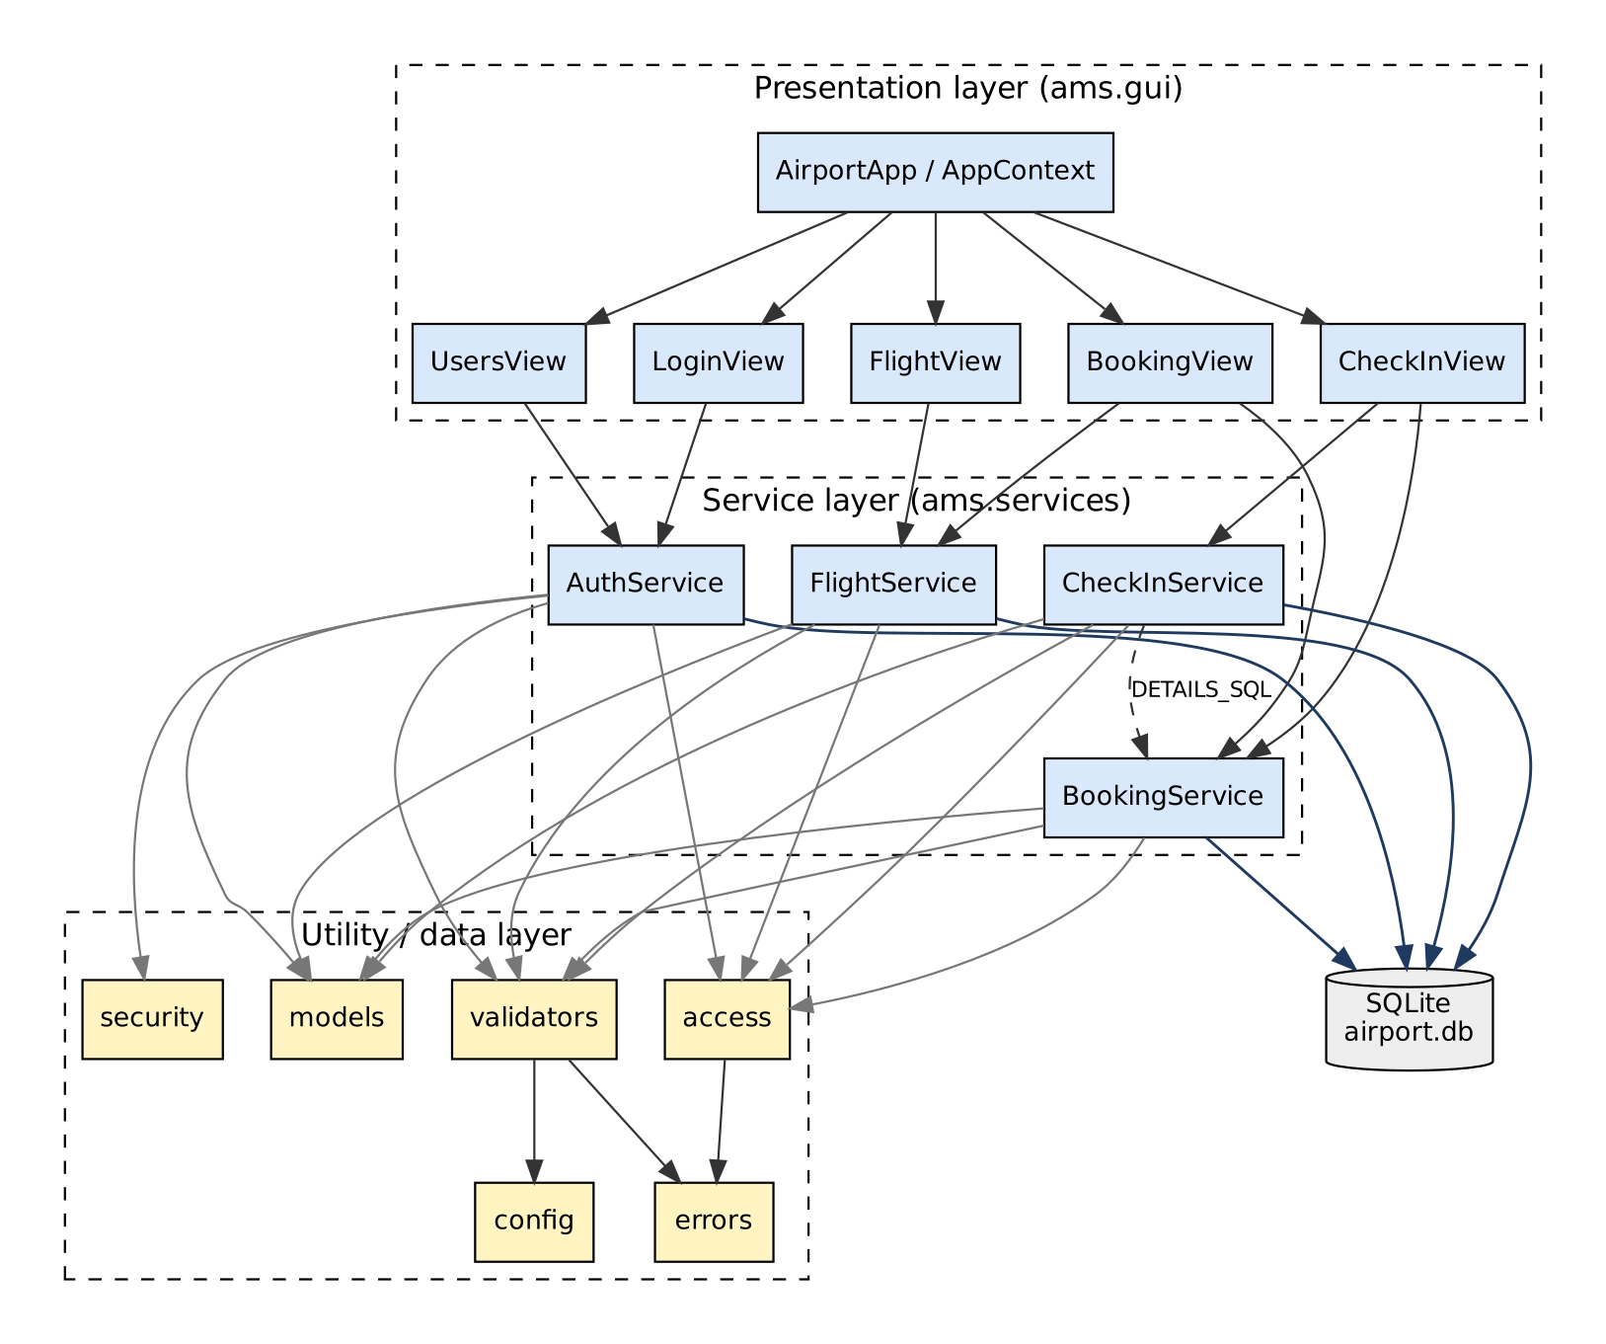
Figure 6.1: Module dependency (coupling) diagram: arrows point from the user of a module to the module used
Table 6.2: Coupling analysis
Modules | Coupling type | How it is kept low
GUI views -> services | Data / stamp | Views call service methods with plain values (strings from the form, ids) and receive entity objects. Views never run SQL.
services -> validators | Data | Pass one raw value, get back one normalised value or a ValidationError.
services -> access | Stamp | Pass the User object; nothing else is shared.
services -> database | Data (via SQL parameters) | Every query uses ? parameters; each service receives the connection in its constructor (dependency injection), so tests pass an in-memory database.
services <-> services | None, except one | Services do not call each other. CheckInService re-uses the DETAILS_SQL query constant from booking_service: a small stamp coupling accepted to avoid duplicating the join.
services -> GUI | None | Verified: no file in ams/services or the utility modules imports ams.gui. This is why every business rule can be unit-tested without a display.
Shared database tables | Common (controlled) | Bookings (D3) is written by BookingService (book/cancel), CheckInService (check-in) and FlightService (cascade on flight cancel). This is unavoidable shared data; it is controlled by database constraints and by keeping each kind of update in exactly one method.

6.4 Design Decisions that Raise Cohesion and Lower Coupling
- Layered architecture (GUI -> services -> data); dependencies only point downwards.
- One service class per module, each owning one main table.
- Pure functions for validation and fee calculation (no hidden state).
- Dependency injection of the database connection and of the clock (now parameter) and PNR generator.
- Single source for constants (config.py) instead of magic numbers spread across modules.
- Exceptions instead of control flags: services raise typed errors (ValidationError, BusinessRuleError, ...) rather than returning status codes that the caller must interpret, which avoids control coupling.

7. Structured Analysis (SA)
Structured analysis models what the system does as a hierarchy of Data Flow Diagrams (DFDs), starting from the context diagram and refining each process until the processes are atomic (each can be implemented as a single, simple function). It is the first half of Function-Oriented Design: FOD = SA + SD.
Notation used (the same as in the reference case studies): yellow rectangle = external entity (repeated beside each process it interacts with, to avoid crossing lines); blue circle = process, numbered hierarchically; open-ended rectangle with D# = data store; labelled arrow = data flow.
Table 7.1: DFD vocabulary
Element | Names used consistently in every diagram, in the code and in the data dictionary
External entities | Passenger, Check-in Staff, Administrator
Data stores | D1 Users (table users), D2 Flights (table flights), D3 Bookings (table bookings), D4 Baggage (table baggage)
Level-1 processes | 1.0 Manage Users & Authenticate, 2.0 Schedule Flights, 3.0 Search Flights, 4.0 Book / Cancel Ticket, 5.0 Check In Passenger, 6.0 Manage Baggage

7.1 Context Diagram (Level 0 DFD)
The context diagram shows the whole system as a single process (bubble 0) and all data that crosses the system boundary.
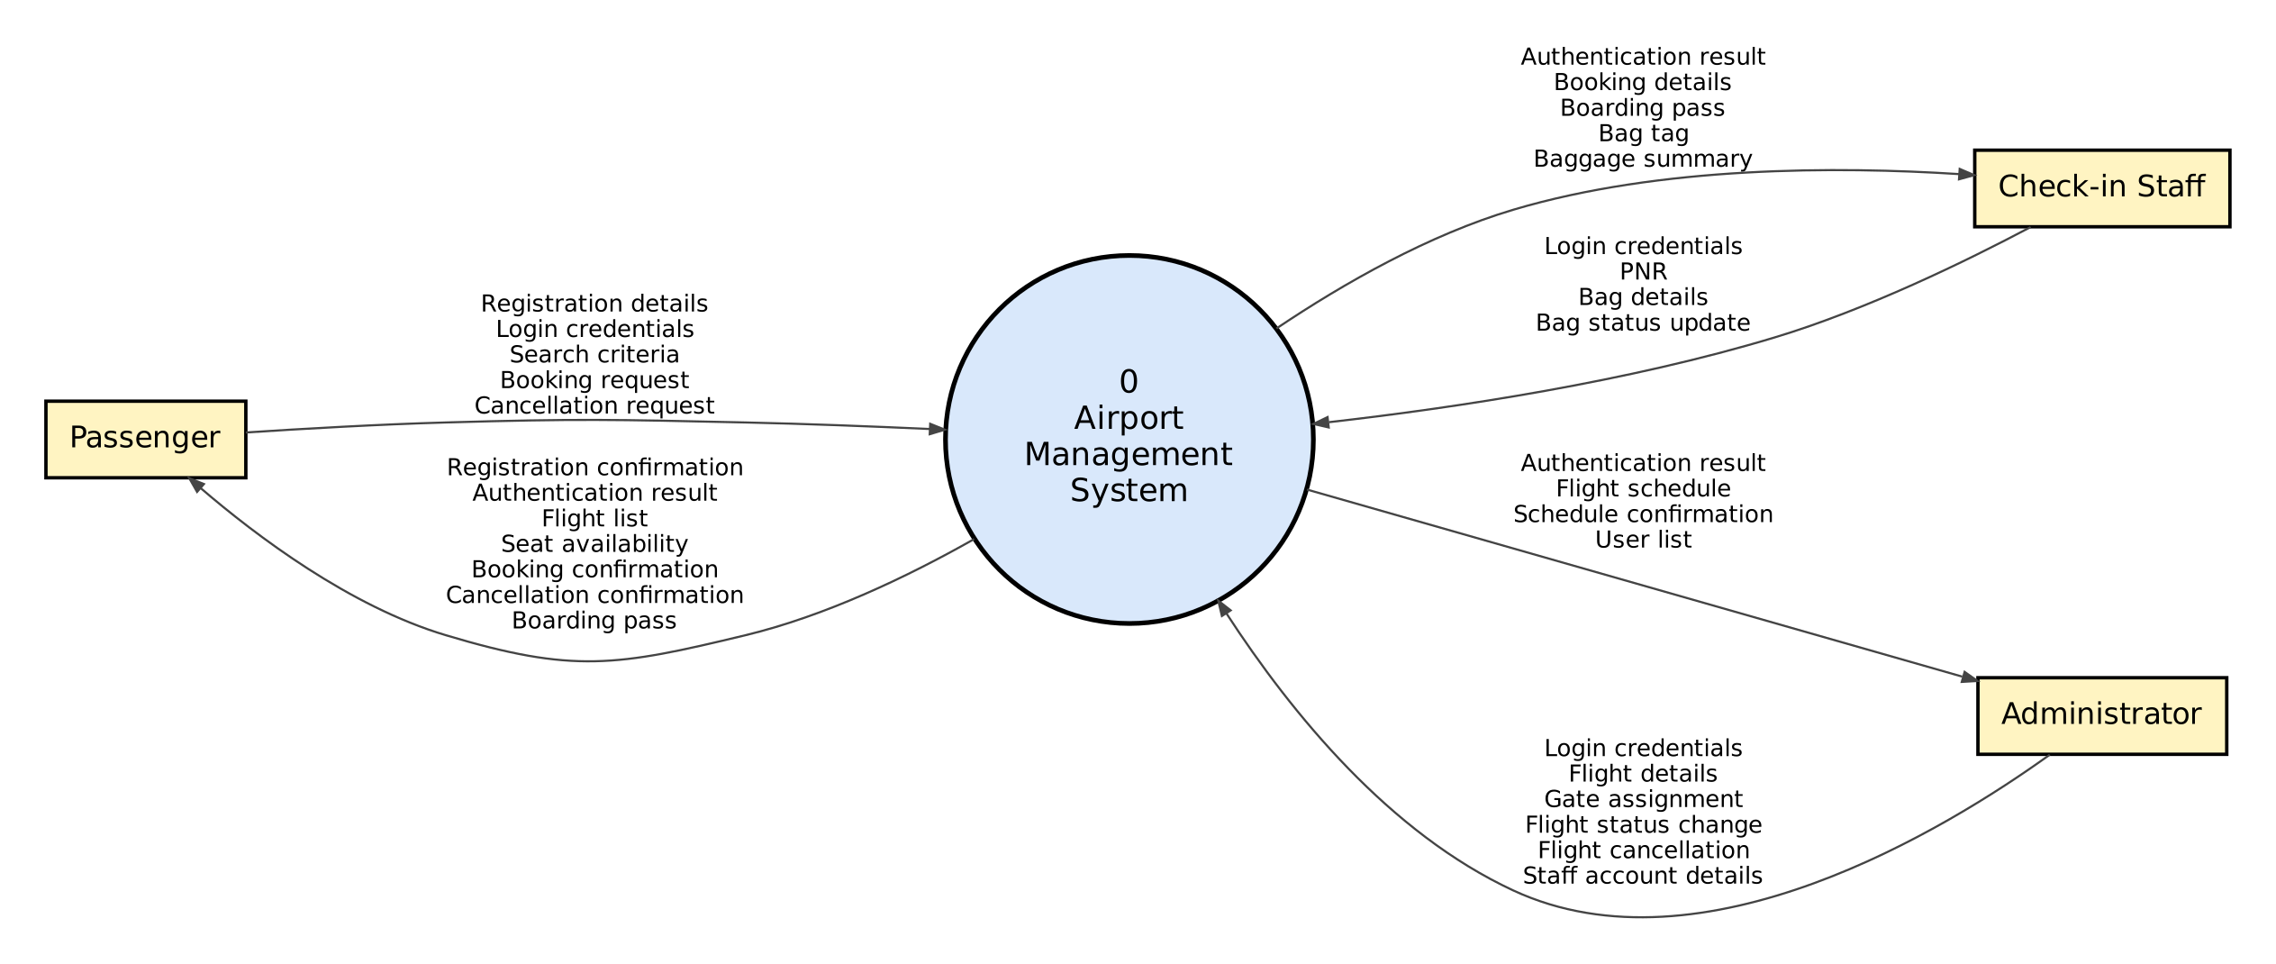
Figure 7.7: Context diagram (Level 0 DFD) of the Airport Management System

7.2 Level 1 DFD
Bubble 0 is decomposed into six processes (between 3 and 7, as recommended). Every flow to or from an external entity in Figure 7.1 appears in Figure 7.2 with the same name, so the two levels are balanced.
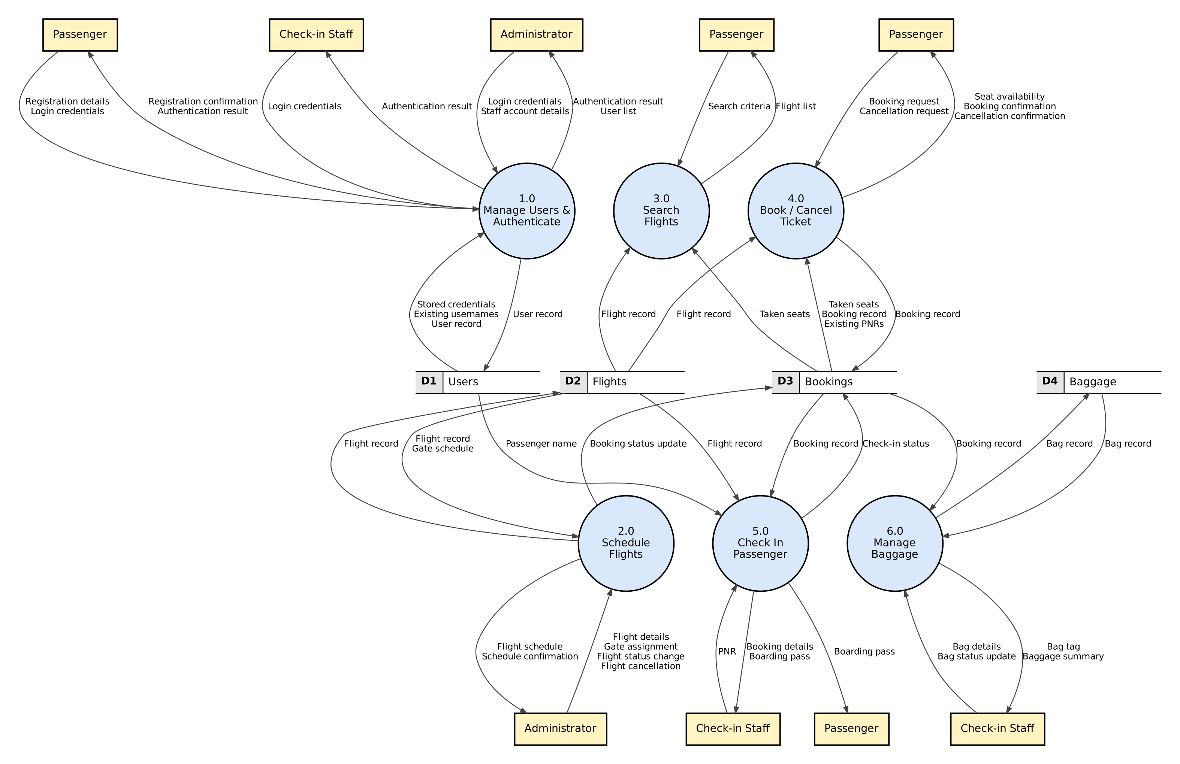
Figure 7.8: Level 1 DFD

7.3 Level 2 DFDs
Each Level-1 process is decomposed in its own diagram. Dashed circles are not used here; all processes shown belong to the parent bubble. The flows entering and leaving each diagram are exactly those of the parent bubble in Level 1.

7.3.1 Level 2: 1.0 Manage Users & Authenticate
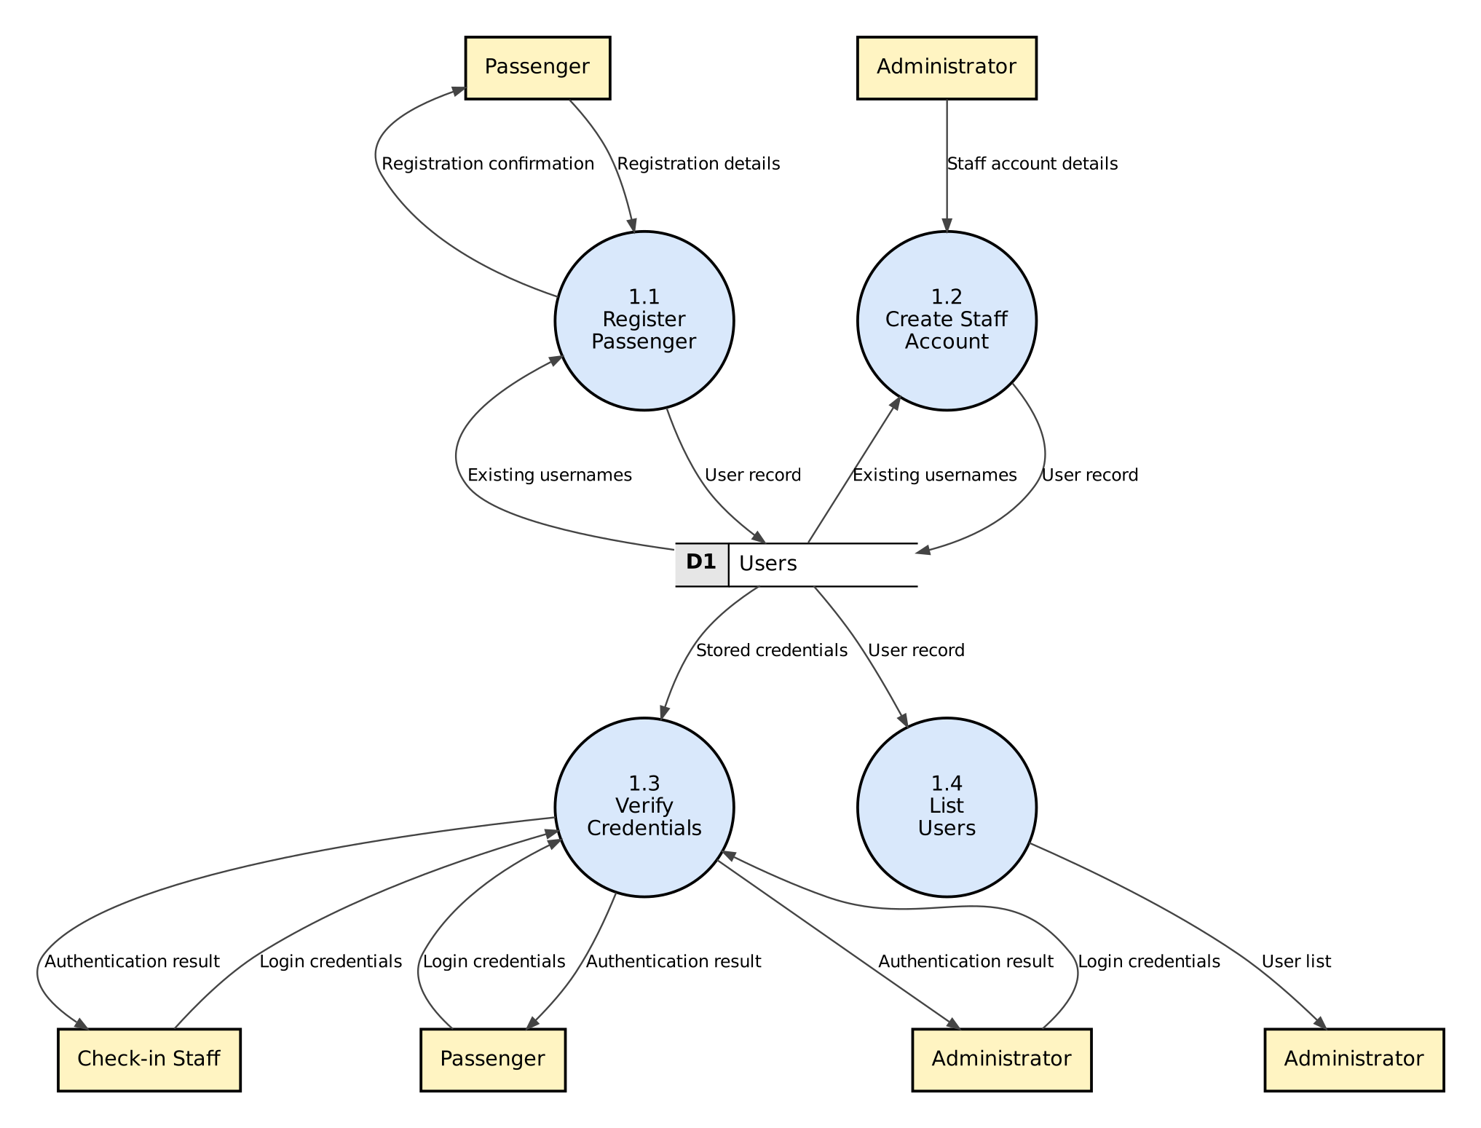
Figure 7.1: Level 2 DFD - decomposition of process 1.0 Manage Users & Authenticate
1.1 and 1.2 both read existing usernames from D1 to reject duplicates before writing a new user record; 1.3 serves all three kinds of user; 1.4 is used only by the administrator.

7.3.2 Level 2: 2.0 Schedule Flights
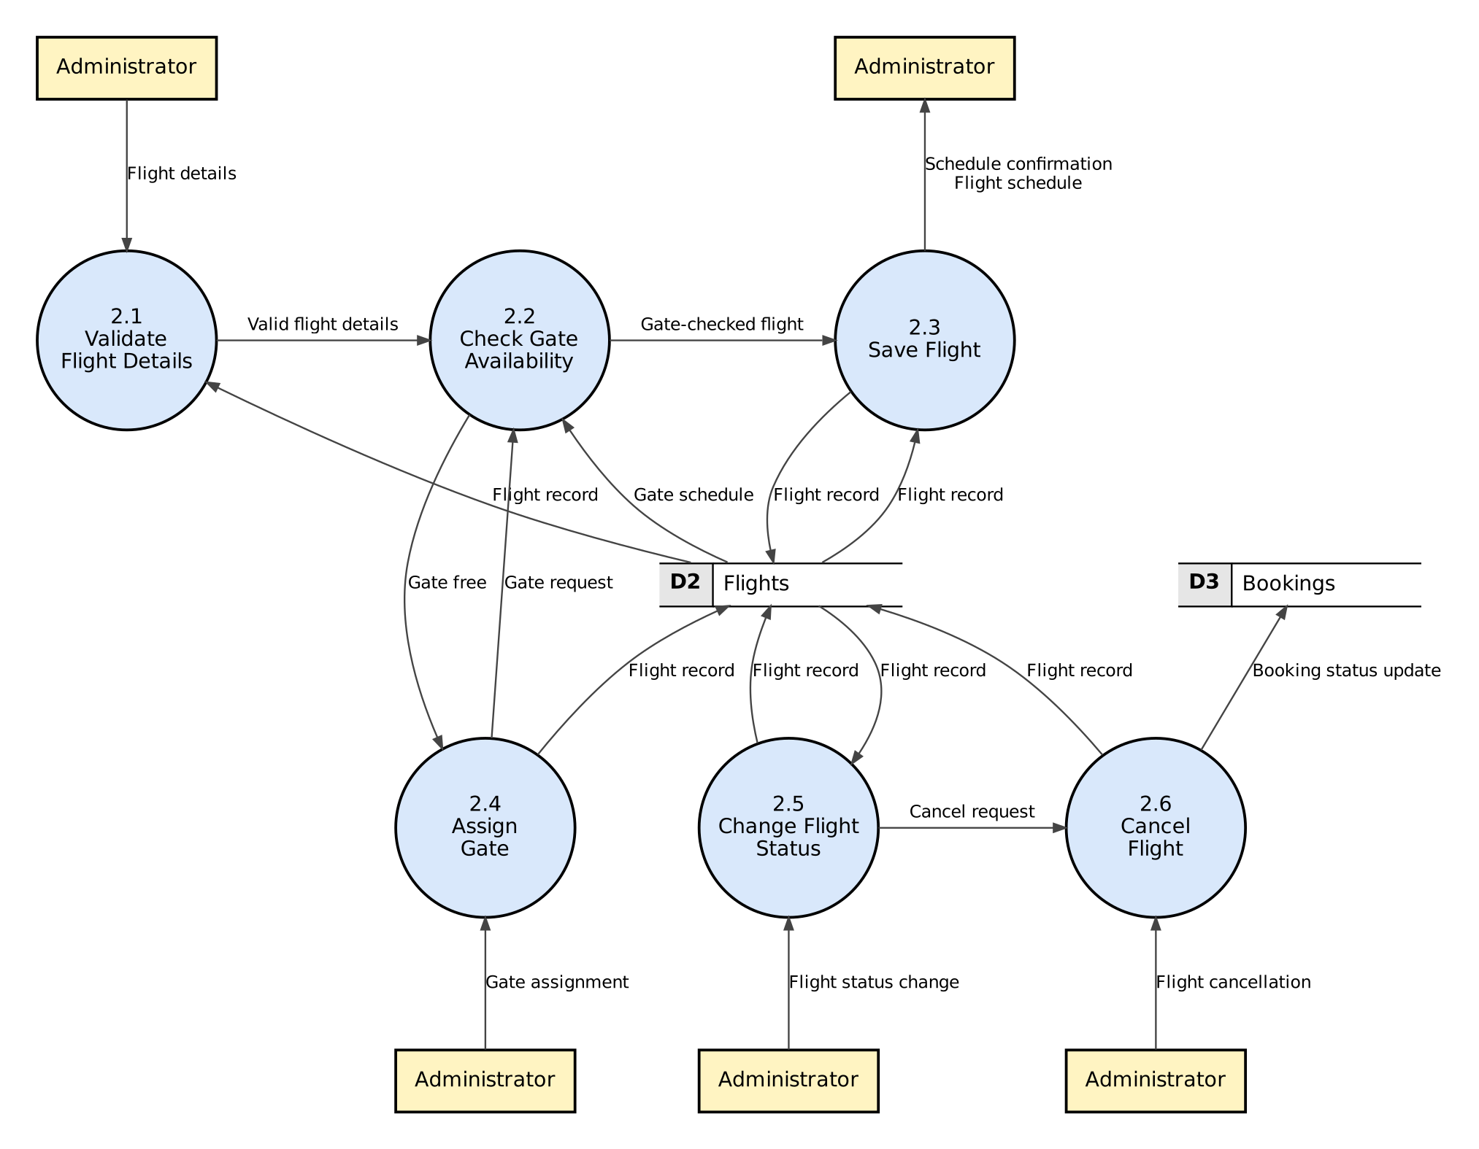
Figure 7.2: Level 2 DFD - decomposition of process 2.0 Schedule Flights
2.1 validates the form, 2.2 checks the 60-minute gate rule against the gate schedule in D2 (it is used by both 2.3 and 2.4), 2.5 applies the state chart and hands cancellations to 2.6, which also updates bookings in D3.

7.3.3 Level 2: 3.0 Search Flights
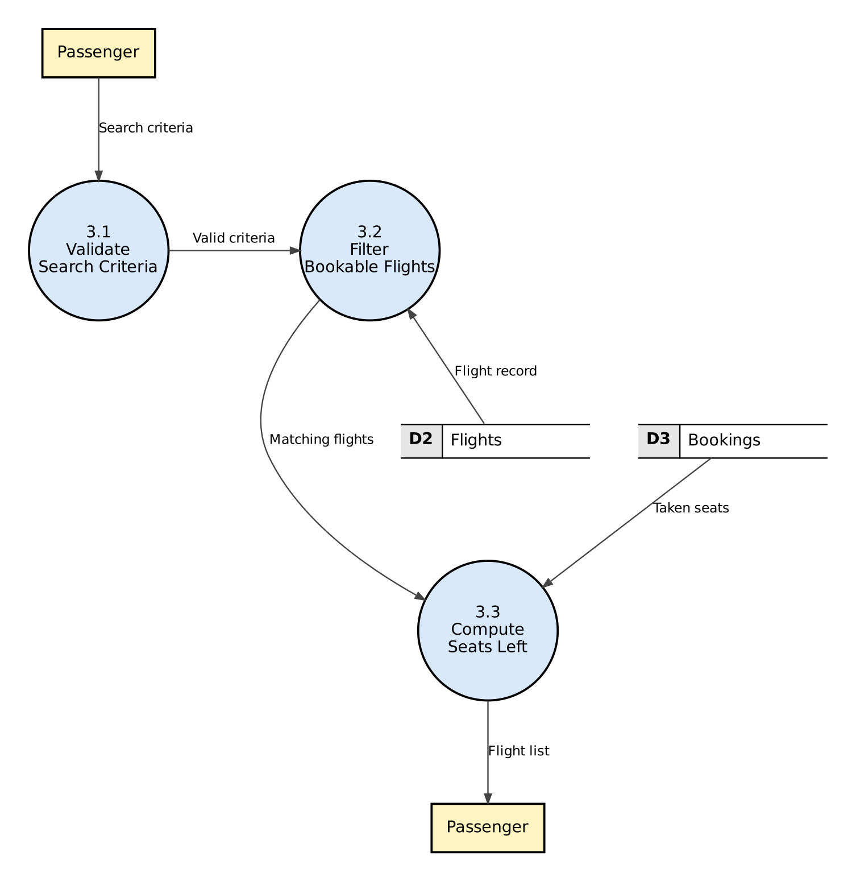
Figure 7.3: Level 2 DFD - decomposition of process 3.0 Search Flights
Search is a pure read: 3.1 validates the criteria, 3.2 selects bookable future flights from D2 and 3.3 subtracts taken seats (D3) from capacity.

7.3.4 Level 2: 4.0 Book / Cancel Ticket
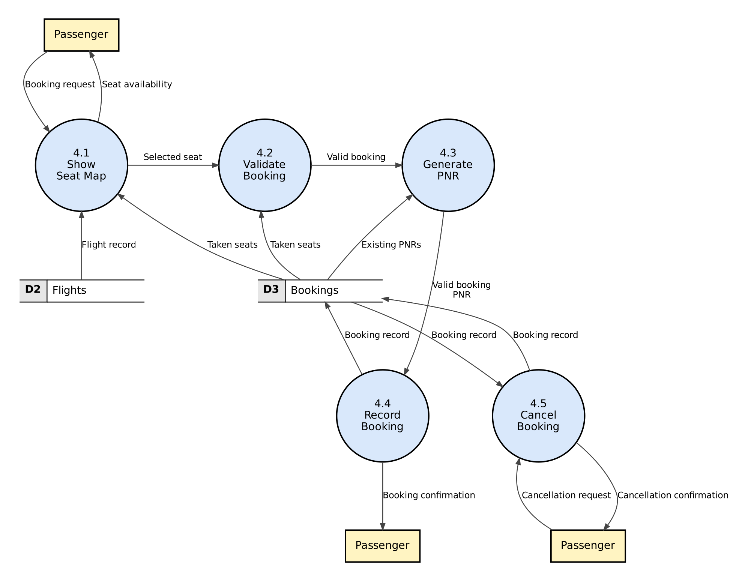
Figure 7.4: Level 2 DFD - decomposition of process 4.0 Book / Cancel Ticket
4.1 builds the seat map from D2 and D3; 4.2 re-checks the selected seat and the one-booking-per-flight rule; 4.3 produces a PNR not present in D3; 4.4 writes the booking. 4.5 cancels a booking.

7.3.5 Level 2: 5.0 Check In Passenger
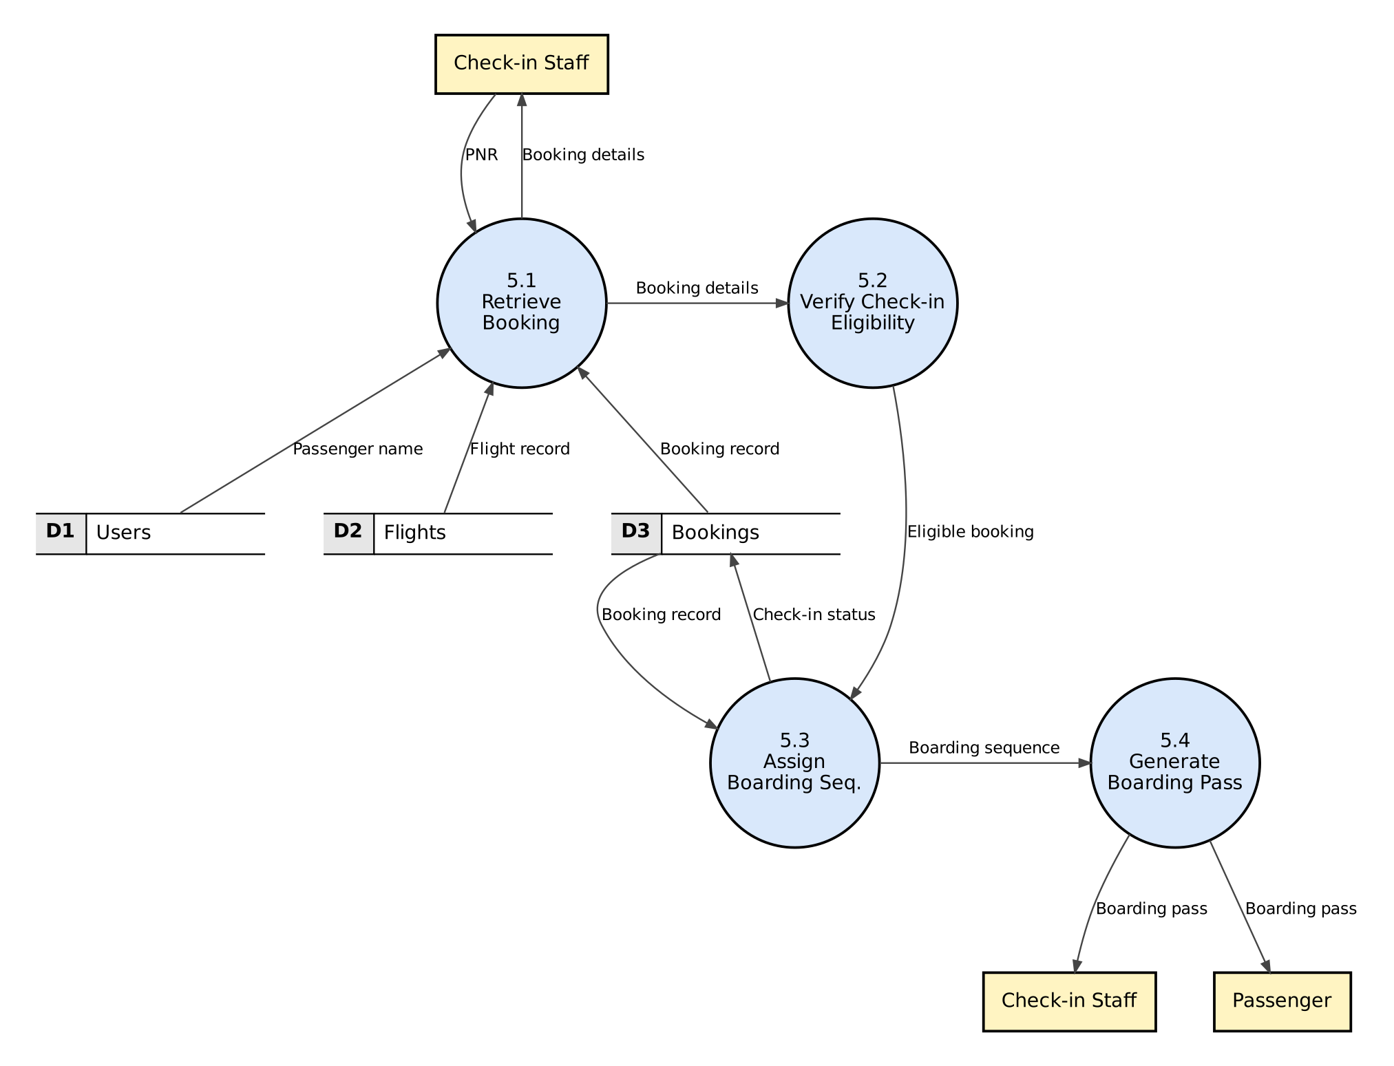
Figure 7.5: Level 2 DFD - decomposition of process 5.0 Check In Passenger
5.2 is decomposed further in Level 3 (Figure 7.9). 5.3 reads the highest boarding sequence of the flight and writes the CHECKED_IN status.

7.3.6 Level 2: 6.0 Manage Baggage
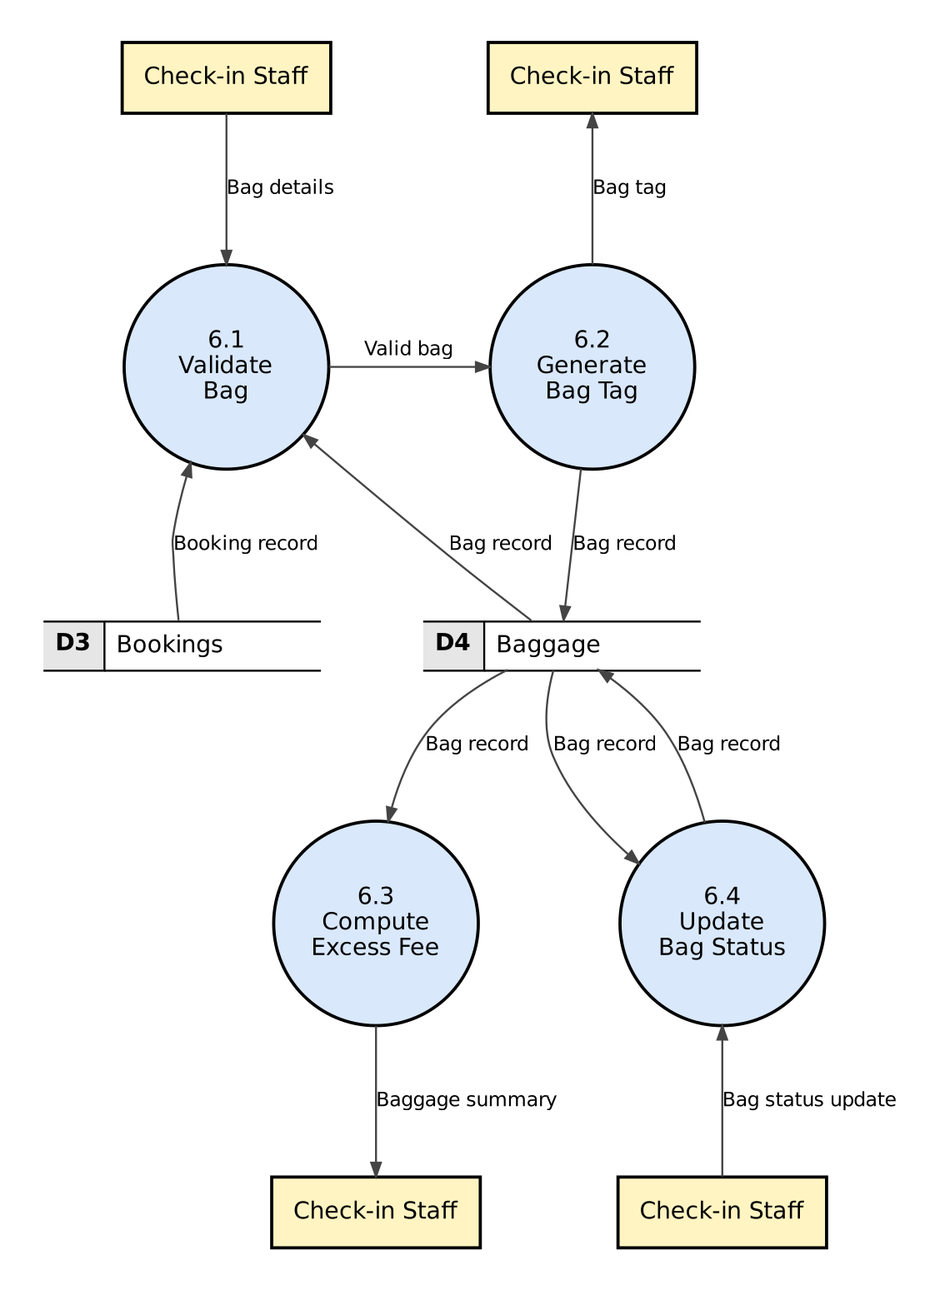
Figure 7.6: Level 2 DFD - decomposition of process 6.0 Manage Baggage
6.1 checks the weight and bag count, 6.2 stores the bag and creates its tag, 6.3 sums the weights and applies the fee rule, 6.4 applies the bag state chart.

7.4 Level 3 DFD: 5.2 Verify Check-in Eligibility
Process 5.2 contains four independent rules, so it is decomposed once more. Each of 5.2.1-5.2.4 is a single comparison and corresponds to one decision node in the control-flow graph of check_in (Section 11.3); these are the atomic processes. Dashed circles 5.1 and 5.3 are the neighbouring processes from Level 2, shown only to make the inputs and outputs clear. The four rejection reasons together form the 'Booking details' error path of 5.2 at Level 2.
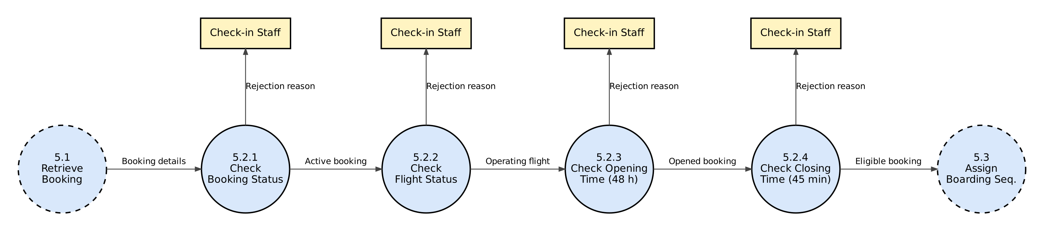
Figure 7.9: Level 3 DFD - decomposition of 5.2 Verify Check-in Eligibility
Processes at Level 2 that are not decomposed further (for example 4.3 Generate PNR, 6.3 Compute Excess Fee) are already atomic: each maps to one short function in the code (_unique_pnr, compute_excess_fee).

7.5 Balancing
A DFD is balanced when the data flowing into and out of a bubble equals the data flowing into and out of its child diagram. All DFDs are generated from one specification file (tools/dfd_spec.py), and the script tools/make_dfds.py checks balancing automatically: (a) the external flows of the context diagram equal those of Level 1, and (b) for each Level-1 bubble, the flows to entities and stores equal those of its Level-2 diagram. The final run reports BALANCING: OK. (During development this check found three store reads that had been drawn in Level 2 but not in Level 1; Level 1 was corrected.)

7.6 Data Dictionary
The data dictionary defines every data flow and data store that appears in the DFDs. Notation: = is composed of, + and, [a | b] either a or b, {x} zero or more x, (x) optional x, "..." literal value. The script tools/data_dictionary.py verifies that every one of the 54 flow names and 4 stores in the DFDs is defined below and that no entry is unused.
Table 7.2: Data dictionary - data stores and data flows
Name | Composition | Description
D1 Users | {user_id + username + password_hash + salt + role + full_name + email + phone + created_at} | Data store (table users). One record per account.
D2 Flights | {flight_id + flight_no + airline + origin + destination + departure + arrival + (gate) + rows + fare + flight_status} | Data store (table flights). UNIQUE(flight_no, departure).
D3 Bookings | {booking_id + pnr + user_id + flight_id + seat + fare + booking_status + booked_at + (checked_in_at) + (boarding_seq)} | Data store (table bookings). A seat is unique per flight among non-cancelled bookings.
D4 Baggage | {bag_id + booking_id + tag_no + weight_kg + bag_status + updated_at} | Data store (table baggage).
Active booking | Booking details | Booking whose status is BOOKED.
Authentication result | [user + role | error_message] | User object (opens the role dashboard) or 'Invalid username or password.'
Bag details | pnr + weight_kg | Entered at the check-in counter.
Bag record | bag_id + booking_id + tag_no + weight_kg + bag_status + updated_at | One row of D4.
Bag status update | bag_id + new_bag_status | new_bag_status = [LOADED | UNLOADED | CLAIMED | MISHANDLED].
Bag tag | "AMS" + 6{digit}6 | e.g. AMS000003; derived from bag_id.
Baggage summary | bag_count + total_weight_kg + excess_fee | excess_fee = 500 x ceil(total - 15) if total > 15 else 0.
Boarding pass | pnr + passenger_name + flight_no + origin + destination + departure + boarding_time + (gate) + seat + boarding_seq | boarding_time = departure - 30 min (class BoardingPass).
Boarding sequence | integer | MAX(boarding_seq of the flight) + 1.
Booking confirmation | pnr + seat | Shown after a successful booking.
Booking details | Booking record + passenger_name + flight_no + origin + destination + departure + (gate) + flight_status | Booking joined with its passenger and flight (class BookingDetails).
Booking record | booking_id + pnr + user_id + flight_id + seat + fare + booking_status + booked_at + (checked_in_at) + (boarding_seq) | One row of D3.
Booking request | flight_id + user_id | Passenger selects a flight and opens the seat map.
Booking status update | flight_id + "CANCELLED" | All active bookings of a cancelled flight become CANCELLED.
Cancel request | flight_id | Raised by 2.5 when the new status is CANCELLED.
Cancellation confirmation | message | e.g. 'Booking P9W1ZD cancelled.'
Cancellation request | booking_id | Passenger (own booking) or administrator.
Check-in status | booking_id + "CHECKED_IN" + checked_in_at + boarding_seq | Update written to D3.
Eligible booking | Booking details | Check-in still open (now <= departure - 45 min).
Existing PNRs | {pnr} | Used to guarantee a unique PNR.
Existing usernames | {username} | Used to reject a duplicate username.
Flight cancellation | flight_id | Request to cancel a flight (cascades to bookings).
Flight details | flight_no + airline + origin + destination + departure + arrival + rows + fare + (gate) | Entered by the administrator to add or update a flight.
Flight list | {flight_no + airline + origin + destination + departure + arrival + fare + seats_left + flight_status} | Search result shown to the passenger.
Flight record | flight_id + flight_no + airline + origin + destination + departure + arrival + (gate) + rows + fare + flight_status | One row of D2.
Flight schedule | {flight_no + airline + origin + destination + departure + arrival + gate + booked_count + capacity + fare + flight_status} | Schedule table shown on the Flights tab.
Flight status change | flight_id + new_status | new_status = [SCHEDULED | DELAYED | BOARDING | DEPARTED].
Gate assignment | flight_id + gate | Administrator assigns or changes the gate.
Gate free | ["true" | "false"] | Result of the gate availability check.
Gate request | gate + departure + flight_id | Sent to 2.2 to check a gate.
Gate schedule | {gate + departure + flight_status} | Active flights at a gate, used for the 60-minute conflict check.
Gate-checked flight | Valid flight details | Flight whose gate (if any) has no conflict.
Login credentials | username + password | Entered on the login screen by any user.
Matching flights | {Flight record} | Bookable (SCHEDULED/DELAYED) future flights matching the criteria.
Opened booking | Booking details | Check-in has opened (now >= departure - 48 h).
Operating flight | Booking details | Active booking whose flight is not CANCELLED or DEPARTED.
Passenger name | full_name | Read from D1 for the boarding pass.
PNR | 6{alphanumeric}6 | Booking reference, e.g. K7Q2MA (letters I, O and digits 0, 1 are not generated).
Registration confirmation | "Account created" + username | Shown after successful registration.
Registration details | username + password + confirm_password + full_name + email + phone | Entered by a new passenger on the registration dialog.
Rejection reason | message | Why check-in was refused.
Schedule confirmation | message | e.g. 'Flight AI777 added.'
Search criteria | (origin) + (destination) + (travel_date) | Blank fields match all flights.
Seat availability | {seat + ["free" | "taken"]} | Seat map; taken seats are disabled.
Selected seat | seat | Seat clicked on the seat map.
Staff account details | username + password + full_name + email + phone + role | role = ["STAFF" | "ADMIN"].
Stored credentials | username + password_hash + salt + role | Read from D1 to verify a login.
Taken seats | {seat} | Seats held by non-cancelled bookings of a flight.
User list | {username + role + full_name + email + phone} | Shown to the administrator.
User record | user_id + username + password_hash + salt + role + full_name + email + phone + created_at | One row of D1.
Valid bag | booking_id + weight_kg | 0 < weight_kg <= 32 and fewer than 3 bags on the booking.
Valid booking | user_id + flight_id + seat + fare | Booking request that passed seat, status and duplicate checks.
Valid criteria | Search criteria | Criteria in valid IATA / date format.
Valid flight details | Flight details | Flight details that passed all format and schedule checks.

Table 7.3: Data dictionary - elementary data items
Elementary item | Type / domain | Notes
username | 3-20 chars: a-z, 0-9, _ | lower-cased
password | 6-64 chars, >= 1 letter and >= 1 digit | stored only as PBKDF2 hash + salt
role | [ADMIN | STAFF | PASSENGER] | enum Role
phone | 10 digits, first digit 6-9 | Indian mobile number
flight_no | 2-char airline code (not both digits) + 1-4 digits | e.g. AI202, 6E5021
origin / destination | 3 uppercase letters (IATA) | origin <> destination
departure / arrival | YYYY-MM-DD HH:MM | departure in future; 0 < duration <= 20 h
gate | terminal A-D + number 1-20 | optional; e.g. B7
rows | integer 1-40 | 6 seats (A-F) per row
fare | integer 500-200000 (INR)
seat | row (1..rows) + column [A|B|C|D|E|F] | e.g. 12C
flight_status | [SCHEDULED | DELAYED | BOARDING | DEPARTED | CANCELLED] | enum FlightStatus
booking_status | [BOOKED | CHECKED_IN | CANCELLED] | enum BookingStatus
weight_kg | real, 0 < w <= 32, 1 decimal
bag_status | [CHECKED_IN | LOADED | UNLOADED | CLAIMED | MISHANDLED] | enum BagStatus

8. Structured Design (SD)
Structured design transforms the DFD model into a structure chart: a hierarchy of modules showing which module calls which, and the parameters passed between them. The two strategies are transform analysis (for DFDs where data flows through input -> processing -> output) and transaction analysis (for DFDs where one input selects one of several processing paths).

8.1 Structure Chart Notation
Table 8.1: Structure-chart notation
Symbol | Meaning
Rectangle | Module (a function or class method); the name of the implementing code is given in the box
Arrow between modules | Module invocation (the caller is above)
○ name ↓ / ○ name ↑ | Data couple passed to the called module / returned to the caller
● name ↑ | Control flag returned to the caller (e.g. eligible, seat_free)
Diamond under a module | Selection: the module calls exactly one of the modules below it (transaction centre)

8.2 Transaction Analysis
After login, the dashboard receives the user and, depending on the role and the tab the user opens, starts one of several independent transactions. This is a transaction-centred flow: the transaction centre show_dashboard(user) (selected using ROLE_TABS[user.role]) dispatches to one of five transaction modules, each of which calls exactly one service. The steps followed were: (1) identify the transaction centre in the Level-1 DFD (the role/tab selection in front of processes 2.0-6.0); (2) draw one branch per transaction type; (3) factor each branch further using transform analysis (Sections 8.3-8.4).
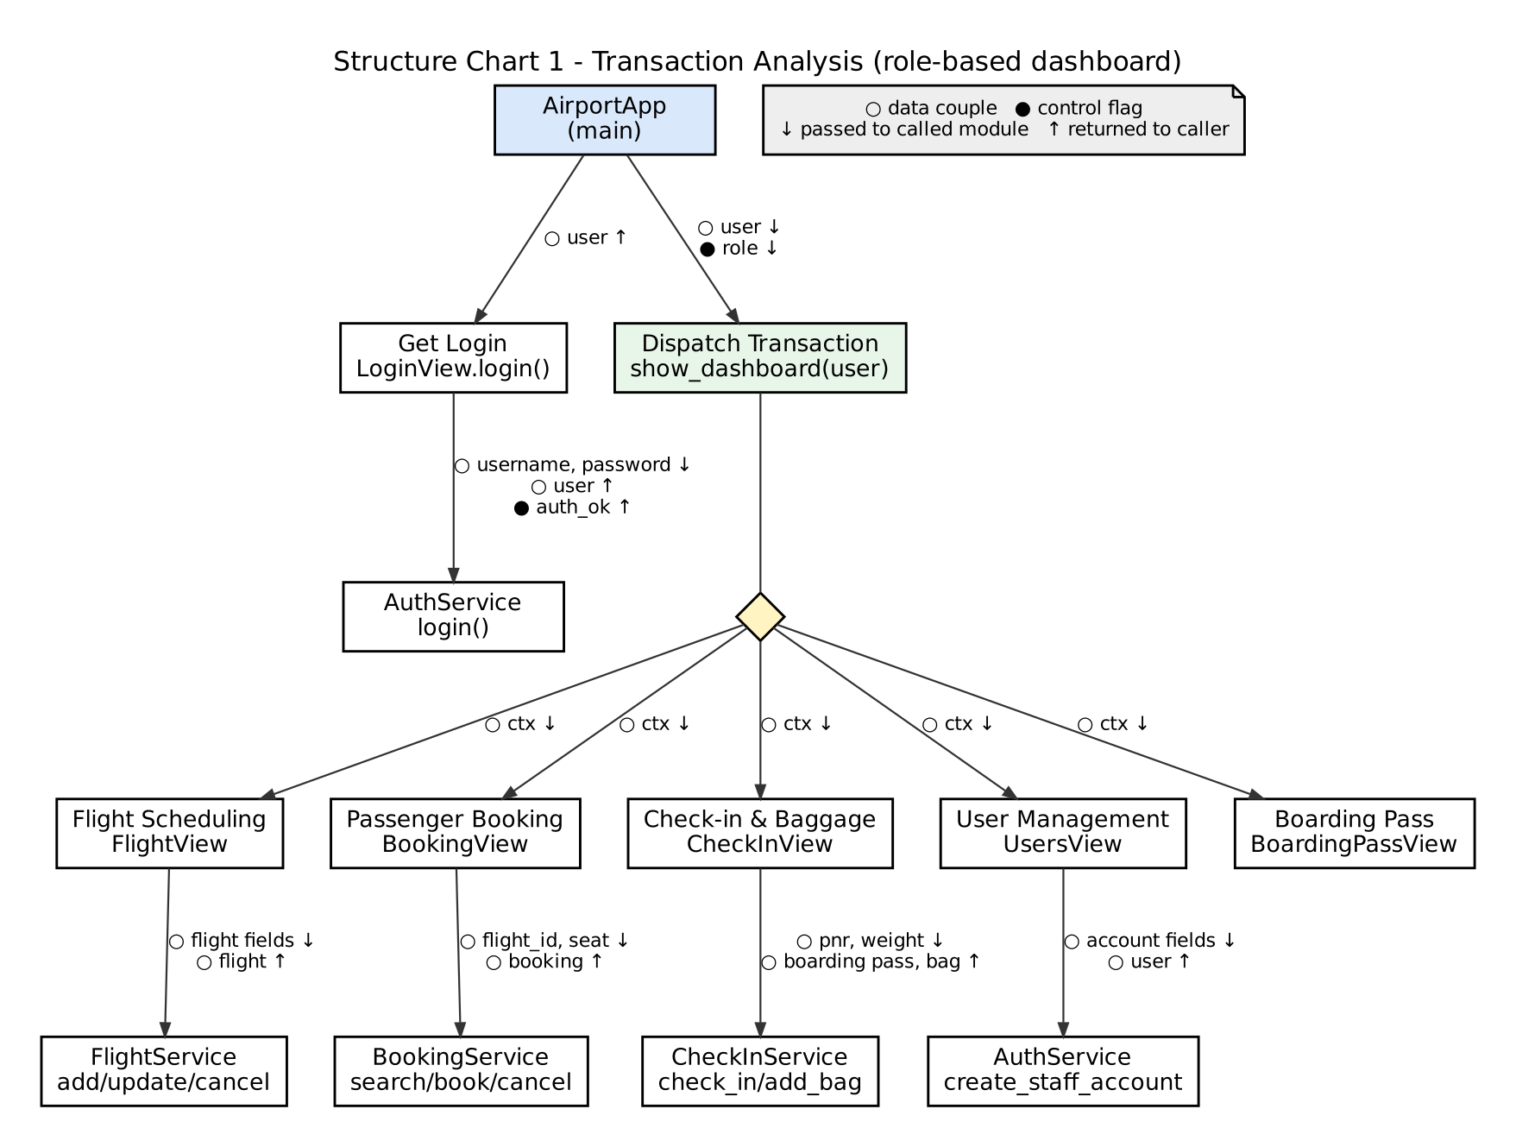
Figure 8.1: Structure chart from transaction analysis (top level)

8.3 Transform Analysis of 5.0 Check In Passenger
For DFD 5.0, the input, central-transform and output portions were identified as follows, and each became one first-level branch of the structure chart:
Table 8.2: Transform analysis of DFD 5.0
Portion | DFD processes | Structure-chart modules
Afferent (input) branch | 5.1 Retrieve Booking (read PNR, validate, fetch from D1/D2/D3) | Get Booking Details -> Read PNR, Validate PNR, Fetch Booking Row
Central transform | 5.2 Verify Check-in Eligibility, 5.3 Assign Boarding Seq. | Verify Eligibility, Assign Boarding Seq
Efferent (output) branch | 5.4 Generate Boarding Pass | Produce Boarding Pass -> Format Pass, Display Pass

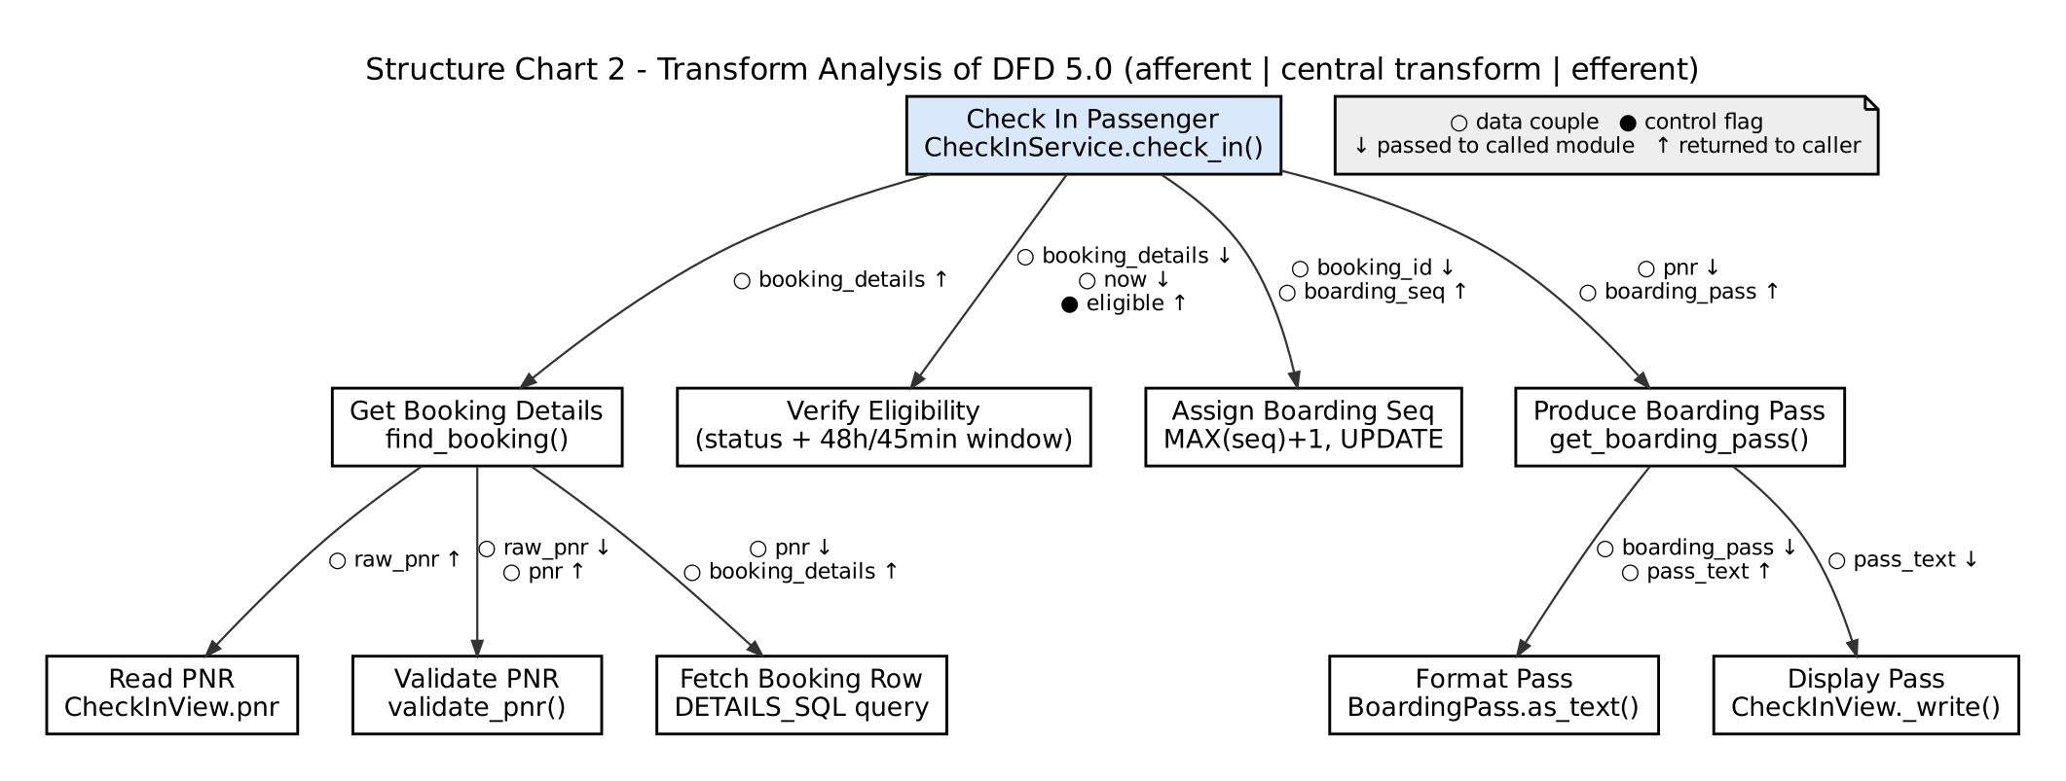
Figure 8.2: Structure chart from transform analysis of DFD 5.0

8.4 Transform Analysis of 4.0 Book / Cancel Ticket (booking path)
Table 8.3: Transform analysis of DFD 4.0
Portion | DFD processes | Structure-chart modules
Afferent branch | 4.1 Show Seat Map (selected seat), flight record from D2 | Get Valid Request -> Get Flight, Validate Seat
Central transform | 4.2 Validate Booking, 4.3 Generate PNR | Check Seat & Duplicate, Generate PNR
Efferent branch | 4.4 Record Booking (write D3, confirmation) | Record & Confirm -> Insert Booking, Show Confirmation

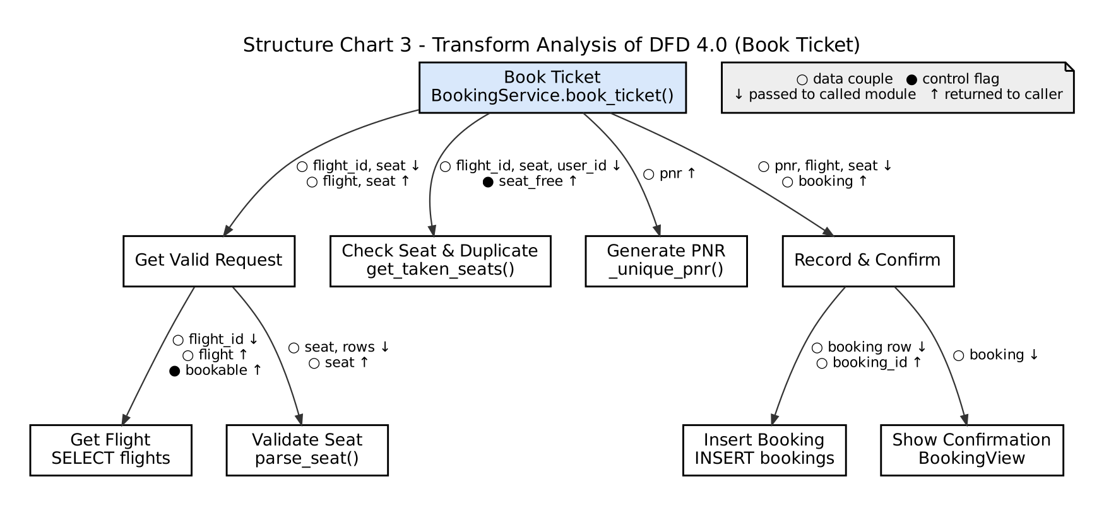
Figure 8.3: Structure chart from transform analysis of DFD 4.0

8.5 Parameter (Variable) Passing
The table lists the couples of the structure charts with the actual function signatures in the code. All couples are data couples except the two control flags, which in the code are realised as exceptions (a False flag becomes a raised BusinessRuleError) so that callers do not need to test flags.
Table 8.4: Parameter passing between modules
Module (code) | Parameters in (↓) | Returned (↑) | Couple type
AuthService.login(username, password) | username, password | User (role inside) | Data / stamp
AirportApp.show_dashboard(user) | user | - | Stamp
CheckInService.find_booking(pnr) | pnr | BookingDetails | Data in, stamp out
validators.validate_pnr(value) | raw pnr string | normalised pnr | Data
CheckInService.check_in(actor, pnr, now) | actor, pnr, now | BoardingPass | Stamp
(eligibility checks inside check_in) | booking details, now | eligible (flag; error if false) | Control flag
CheckInService.get_boarding_pass(actor, pnr) | actor, pnr | BoardingPass | Stamp
BoardingPass.as_text() | - | pass text | Data
BookingService.book_ticket(actor, flight_id, seat, now) | actor, flight_id, seat, now | Booking | Stamp
validators.parse_seat(value, rows) | seat, rows | seat | Data
BookingService.get_taken_seats(flight_id) | flight_id | set of seats | Data
BookingService._unique_pnr() | - | pnr | Data
FlightService.is_gate_available(gate, departure, exclude_flight_id) | gate, departure, flight id | bool (gate_free) | Control flag
CheckInService.add_bag(actor, pnr, weight, now) | actor, pnr, weight, now | Bag | Stamp
compute_excess_fee(total_weight_kg) | total weight | fee | Data

9. Object-Oriented Design (OOD)
The object-oriented model describes the same system in terms of interacting objects, using UML. Class, method and state names in every diagram below are the actual names in the source code.

9.1 Use Case Diagram
Passenger, Check-in Staff and Administrator are specialisations of the abstract actor User, which inherits Login, Logout and View Flight Schedule. Use cases are grouped by module. «include» marks behaviour that is always performed as part of the base use case.
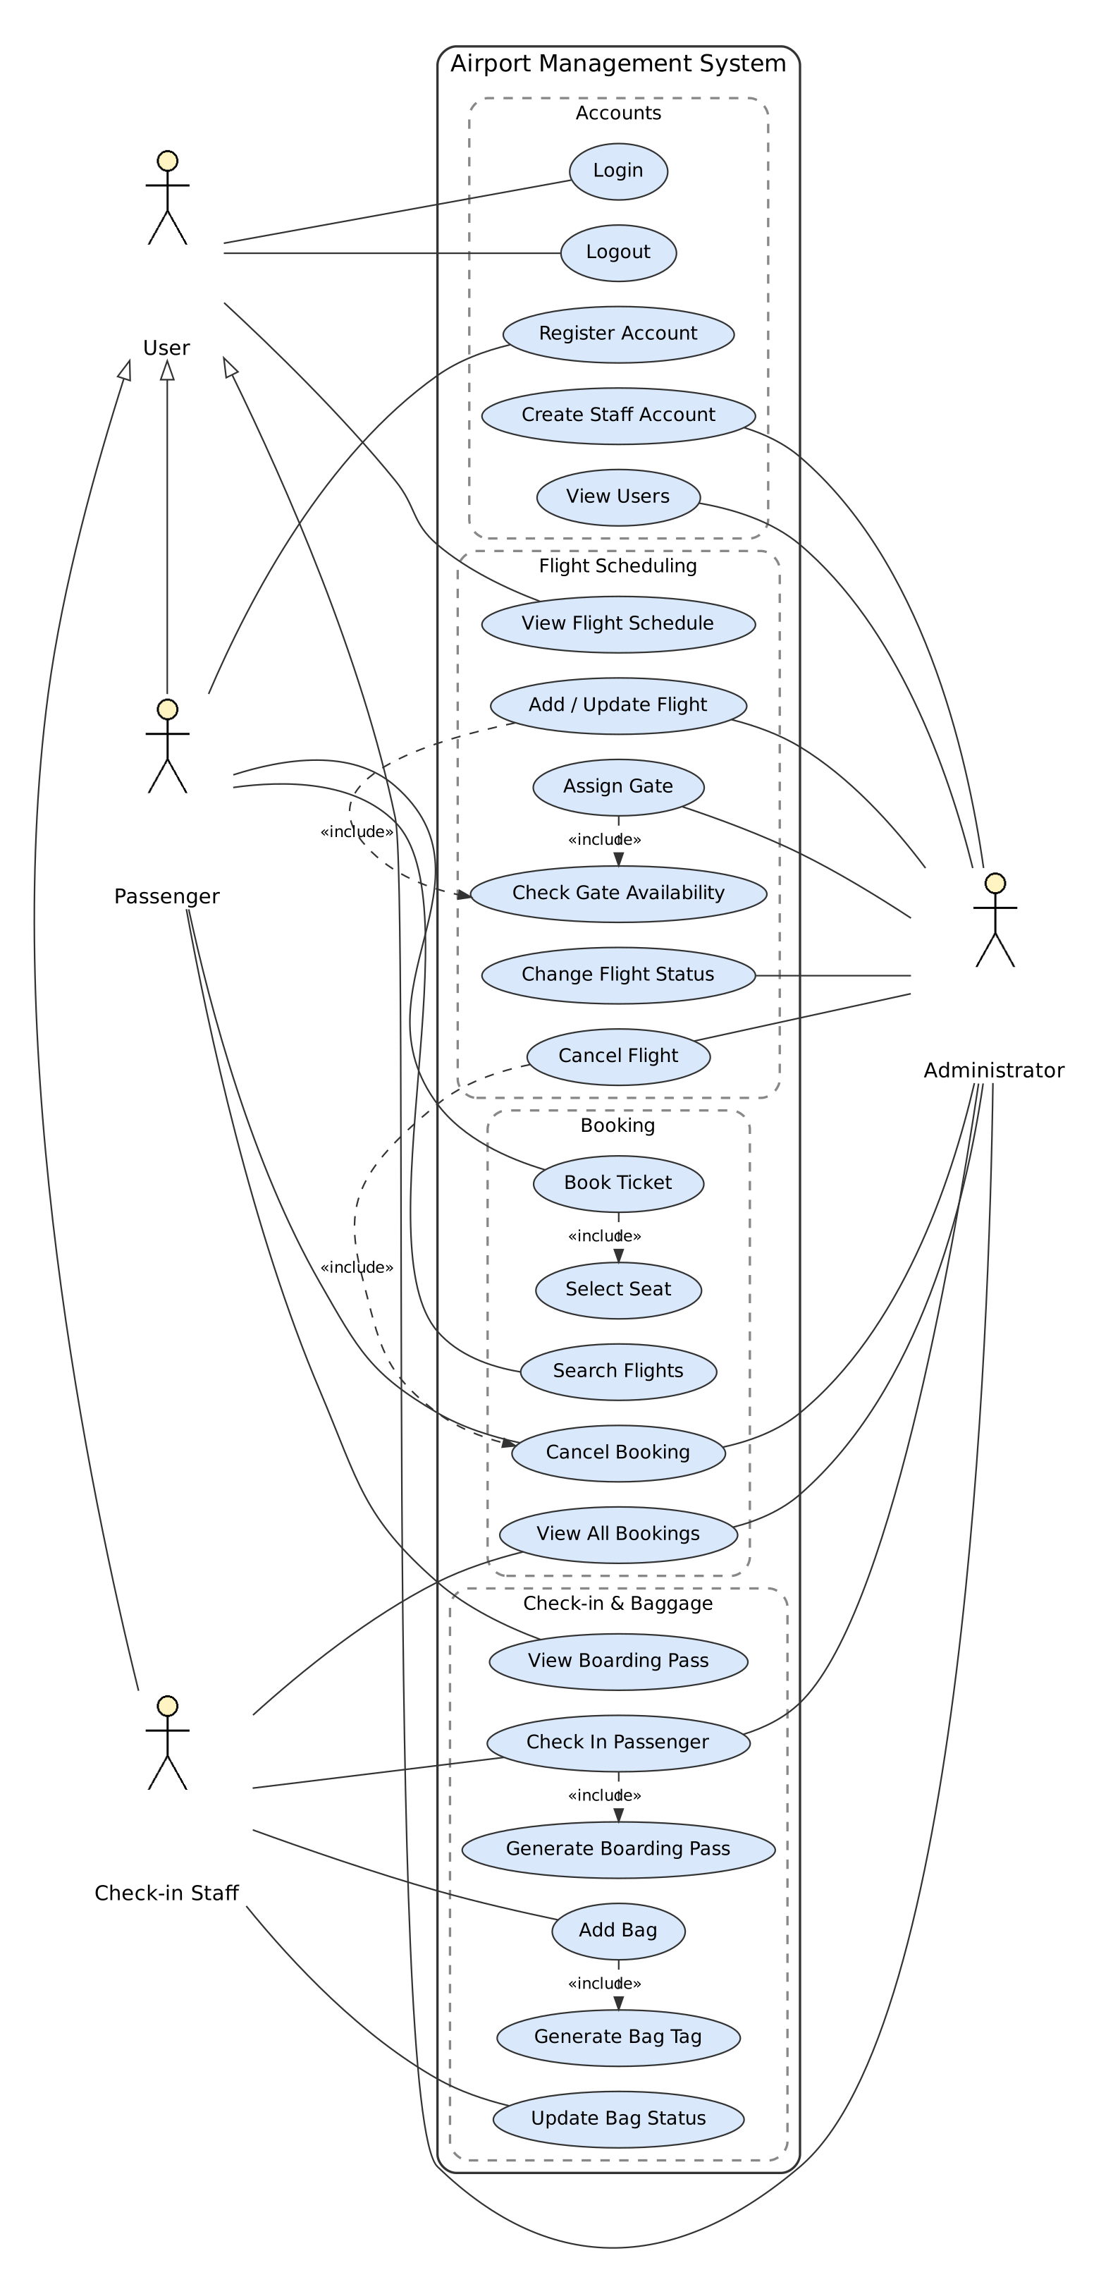
Figure 9.1: Use case diagram
Table 9.1: List of use cases
ID | Use case | Actor(s) | Module
UC01 | Login | User | M1
UC02 | Logout | User | M1
UC03 | Register Account | Passenger | M1
UC04 | Create Staff Account | Administrator | M1
UC05 | View Users | Administrator | M1
UC06 | Search Flights | Passenger | M3
UC07 | Book Ticket | Passenger | M3
UC08 | Select Seat | (included) | M3
UC09 | Cancel Booking | Passenger, Administrator | M3
UC10 | View All Bookings | Staff, Administrator | M3
UC11 | Check In Passenger | Staff, Administrator | M4
UC12 | Generate Boarding Pass | (included) | M4
UC13 | View Boarding Pass | Passenger | M4
UC14 | Add Bag | Staff | M4
UC15 | Generate Bag Tag | (included) | M4
UC16 | Update Bag Status | Staff | M4
UC17 | View Flight Schedule | User | M2
UC18 | Add / Update Flight | Administrator | M2
UC19 | Assign Gate | Administrator | M2
UC20 | Change Flight Status | Administrator | M2
UC21 | Cancel Flight | Administrator | M2
UC22 | Check Gate Availability | (included) | M2

9.2 Use Case Descriptions
Detailed descriptions are given for the main use cases. UC02, UC05, UC10, UC13 and UC17 are simple viewing operations (actor opens the tab; system lists the records allowed for the role). UC08, UC12, UC15 and UC22 are included use cases, described inside the base use cases.
Use case | UC01 Login
Actors | User (Passenger, Check-in Staff, Administrator)
Pre-condition | The user has an account. The login screen is shown.
Main flow | 1. User enters username and password and clicks Login (or presses Enter).  2. System looks up the username (case-insensitive) in D1 Users.  3. System verifies the password against the stored salted hash.  4. System builds the tabs for the user's role and shows the dashboard.
Alternate flows / exceptions | 1a. A field is blank: 'Enter both username and password.'  2a/3a. Unknown username or wrong password: 'Invalid username or password.' (same message in both cases).
Post-condition | Success: the role dashboard is shown and the user is stored in the application context. Failure: the user stays on the login screen.

Use case | UC03 Register Account
Actors | Passenger
Pre-condition | Login screen is shown.
Main flow | 1. Passenger clicks 'New passenger? Register'.  2. Passenger enters username, full name, password twice, e-mail and mobile number and clicks Register.  3. System validates every field and checks that the username is unused.  4. System stores the user with a hashed password and confirms.
Alternate flows / exceptions | 2a. Passwords differ: 'Passwords do not match.'  3a. A field is invalid: field-specific message (e.g. 'Phone must be a 10-digit mobile number starting with 6-9.')  3b. Username exists: 'Username ... is already taken.'
Post-condition | A PASSENGER account exists; the username is filled in on the login screen.

Use case | UC06 Search Flights
Actors | Passenger
Pre-condition | Passenger is logged in.
Main flow | 1. Passenger optionally enters From, To and Date and clicks Search.  2. System validates the criteria.  3. System selects SCHEDULED/DELAYED flights departing in the future that match.  4. System shows each flight with fare and seats left.
Alternate flows / exceptions | 2a. Invalid code or date: e.g. 'Date must be in YYYY-MM-DD format, e.g. 2026-11-05.'  3a. No match: the table is empty.
Post-condition | Matching flights are listed with seats left.

Use case | UC07 Book Ticket
Actors | Passenger
Pre-condition | Passenger is logged in and has searched for flights.
Main flow | 1. Passenger selects a flight and clicks 'Book selected flight'.  2. System shows the seat map with taken seats disabled (include UC08).  3. Passenger clicks a free seat and confirms the seat and fare.  4. System re-checks that the flight is bookable, the seat is valid and free, and the passenger has no other booking on this flight.  5. System generates a unique PNR, stores the booking and shows the PNR and seat.
Alternate flows / exceptions | 1a. No flight selected: 'Search and select a flight first.'  4a. Flight cancelled/boarding/departed meanwhile: 'Flight ... is CANCELLED; booking is closed.'  4b. Seat taken meanwhile: 'Seat ... is already taken. Please choose another seat.'  4c. Duplicate: 'You already hold a booking on flight ...'
Includes | UC08 Select Seat
Post-condition | A booking with status BOOKED and a unique PNR exists; the seat is no longer free.

Use case | UC09 Cancel Booking
Actors | Passenger (own bookings), Administrator (any booking)
Pre-condition | A booking with status BOOKED exists.
Main flow | 1. Actor selects a booking and clicks 'Cancel selected booking'.  2. System asks for confirmation.  3. System checks ownership, status and departure time.  4. System sets the status to CANCELLED and refreshes the lists.
Alternate flows / exceptions | 3a. Not the passenger's booking: 'You can only cancel your own bookings.'  3b. Already checked in: '... is checked in and can no longer be cancelled.'  3c. Flight departed: 'The flight has already departed.'
Post-condition | The booking is CANCELLED and its seat is free again.

Use case | UC11 Check In Passenger
Actors | Check-in Staff, Administrator
Pre-condition | Staff is logged in; the passenger gives a PNR.
Main flow | 1. Staff enters the PNR and clicks 'Find booking'; system shows the booking.  2. Staff clicks 'Check in passenger'.  3. System checks the booking status, the flight status and the check-in window.  4. System assigns the next boarding sequence, saves the check-in time and status.  5. System generates and shows the boarding pass (include UC12).
Alternate flows / exceptions | 1a. Bad PNR format or unknown PNR: error message.  3a. Booking cancelled or already checked in.  3b. Flight cancelled or departed.  3c. More than 48 h before departure: 'Check-in opens 48 hours before departure.'  3d. Less than 45 min before departure: 'Check-in closed 45 minutes before departure.'
Includes | UC12 Generate Boarding Pass
Post-condition | Booking is CHECKED_IN with the next boarding sequence; the boarding pass is shown.

Use case | UC14 Add Bag
Actors | Check-in Staff, Administrator
Pre-condition | The booking is checked in.
Main flow | 1. Staff enters the bag weight and clicks 'Add bag & print tag'.  2. System validates the weight and the number of bags.  3. System stores the bag and creates its tag (include UC15).  4. System shows the tag and recomputes '#bags, total kg, excess fee'.
Alternate flows / exceptions | 2a. Weight not a number, <= 0 or > 32 kg: e.g. 'A single bag cannot exceed 32 kg; send it as cargo.'  2b. Already 3 bags: 'A passenger may check in at most 3 bags.'  2c. Booking not checked in: 'Bags can be added only after the passenger has checked in.'
Includes | UC15 Generate Bag Tag
Post-condition | A bag with tag AMSnnnnnn and status CHECKED_IN is stored; the summary and excess fee are updated.

Use case | UC16 Update Bag Status
Actors | Check-in Staff, Administrator
Pre-condition | A bag exists.
Main flow | 1. Staff selects a bag and a new status and clicks 'Update bag status'.  2. System checks the transition against the bag state chart.  3. System saves the new status and refreshes the list.
Alternate flows / exceptions | 1a. No bag selected: warning.  2a. Transition not allowed (e.g. CLAIMED -> LOADED): 'Bag ... cannot change from CLAIMED to LOADED.'
Post-condition | The bag has the new status and a new time stamp.

Use case | UC18 Add / Update Flight
Actors | Administrator
Pre-condition | Administrator is logged in.
Main flow | 1. Administrator fills in the flight form (or selects a flight to load it) and clicks 'Add flight' or 'Update selected'.  2. System validates all fields and the schedule.  3. System checks for a duplicate flight number on the same date.  4. If a gate is given, system checks gate availability (include UC22).  5. System saves the flight and refreshes the schedule.
Alternate flows / exceptions | 2a. Invalid field: field-specific message.  3a. Duplicate: 'Flight ... is already scheduled on ...'  4a. Gate busy: 'Gate ... is already assigned to another flight departing within 60 minutes of ...'  Update only: route change after bookings, or fewer rows than the highest booked row, is refused.
Includes | UC22 Check Gate Availability
Post-condition | The flight is stored (new flights with status SCHEDULED).

Use case | UC19 Assign Gate
Actors | Administrator
Pre-condition | A flight that is not departed or cancelled is selected.
Main flow | 1. Administrator types a gate and clicks 'Assign gate'.  2. System validates the gate format and checks availability (include UC22).  3. System saves the gate.
Alternate flows / exceptions | 2a. Invalid gate: 'Gate must be a terminal letter A-D followed by 1-20, e.g. B7.'  2b. Gate busy: conflict message.
Includes | UC22 Check Gate Availability
Post-condition | The flight has the new gate.

Use case | UC20 Change Flight Status
Actors | Administrator
Pre-condition | A flight is selected.
Main flow | 1. Administrator chooses a status and clicks 'Set status'.  2. System checks the transition against the flight state chart.  3. System saves the status.
Alternate flows / exceptions | 2a. Transition not allowed: 'Flight status cannot change from X to Y.'
Post-condition | The flight has the new status.

Use case | UC21 Cancel Flight
Actors | Administrator
Pre-condition | A SCHEDULED or DELAYED flight is selected.
Main flow | 1. Administrator clicks 'Cancel flight' and confirms.  2. System cancels all non-cancelled bookings of the flight.  3. System sets the flight to CANCELLED, clears the gate and reports how many bookings were cancelled.
Alternate flows / exceptions | 1a. Flight is BOARDING, DEPARTED or already CANCELLED: '... cannot be cancelled.'
Includes | UC09 Cancel Booking (for every active booking)
Post-condition | Flight is CANCELLED, its gate is released and all its active bookings are CANCELLED.

Use case | UC04 Create Staff Account
Actors | Administrator
Pre-condition | Administrator is logged in (Users tab).
Main flow | 1. Administrator fills in username, name, password, role, e-mail, mobile and clicks 'Create account'.  2. System validates the fields and checks the username is free.  3. System stores the account and refreshes the user list.
Alternate flows / exceptions | Any non-admin calling the service: 'Access denied: this action requires role ADMIN.'  2a. Invalid field or duplicate username: error message.
Post-condition | A STAFF or ADMIN account exists.

9.3 Class Diagrams
Classes follow the entity-boundary-control pattern: entity classes (ams.models) hold data, control classes (ams.services) hold business logic, and boundary classes (ams.gui) interact with users.
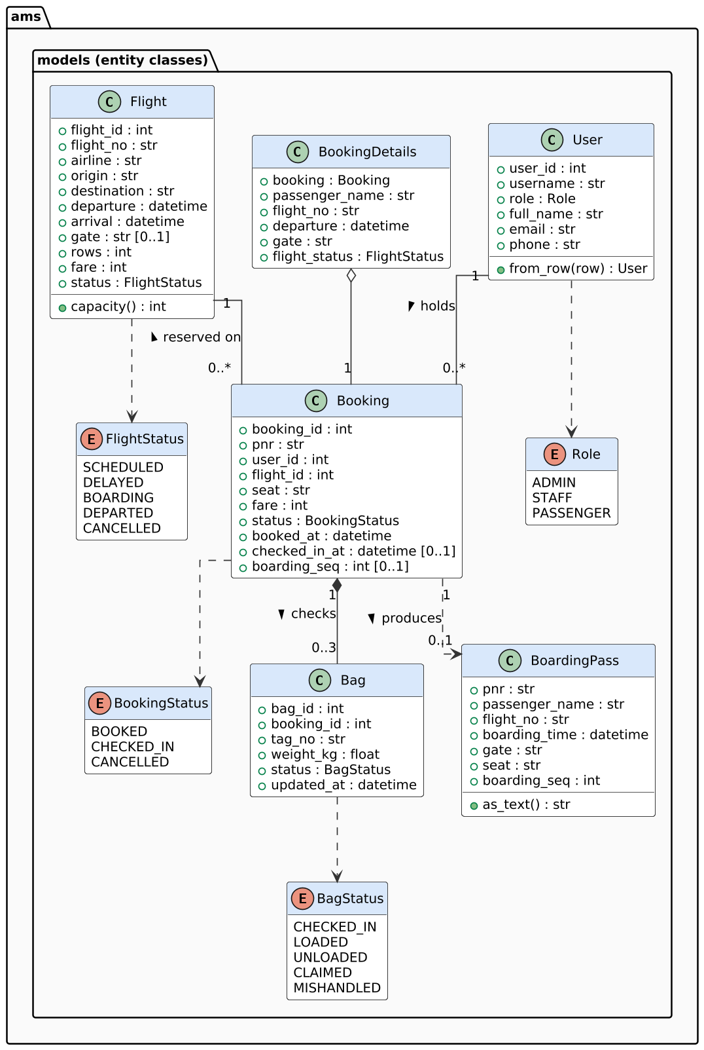
Figure 9.2: Class diagram - entity classes and enumerations
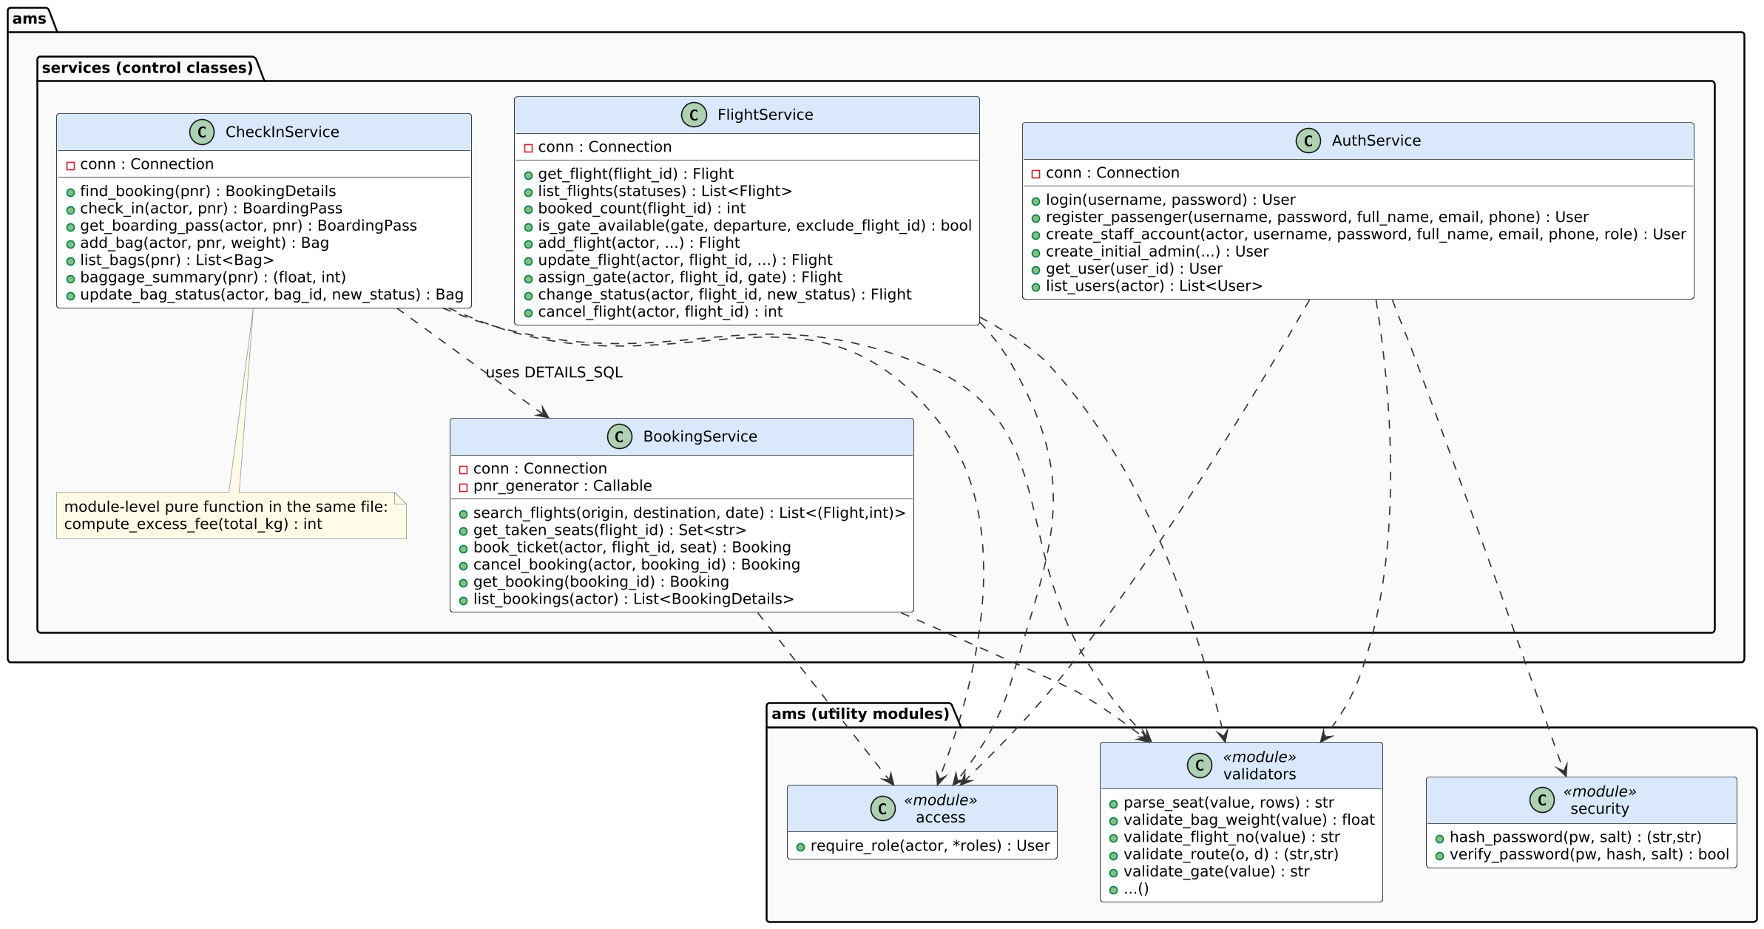
Figure 9.3: Class diagram - control (service) classes and utility modules
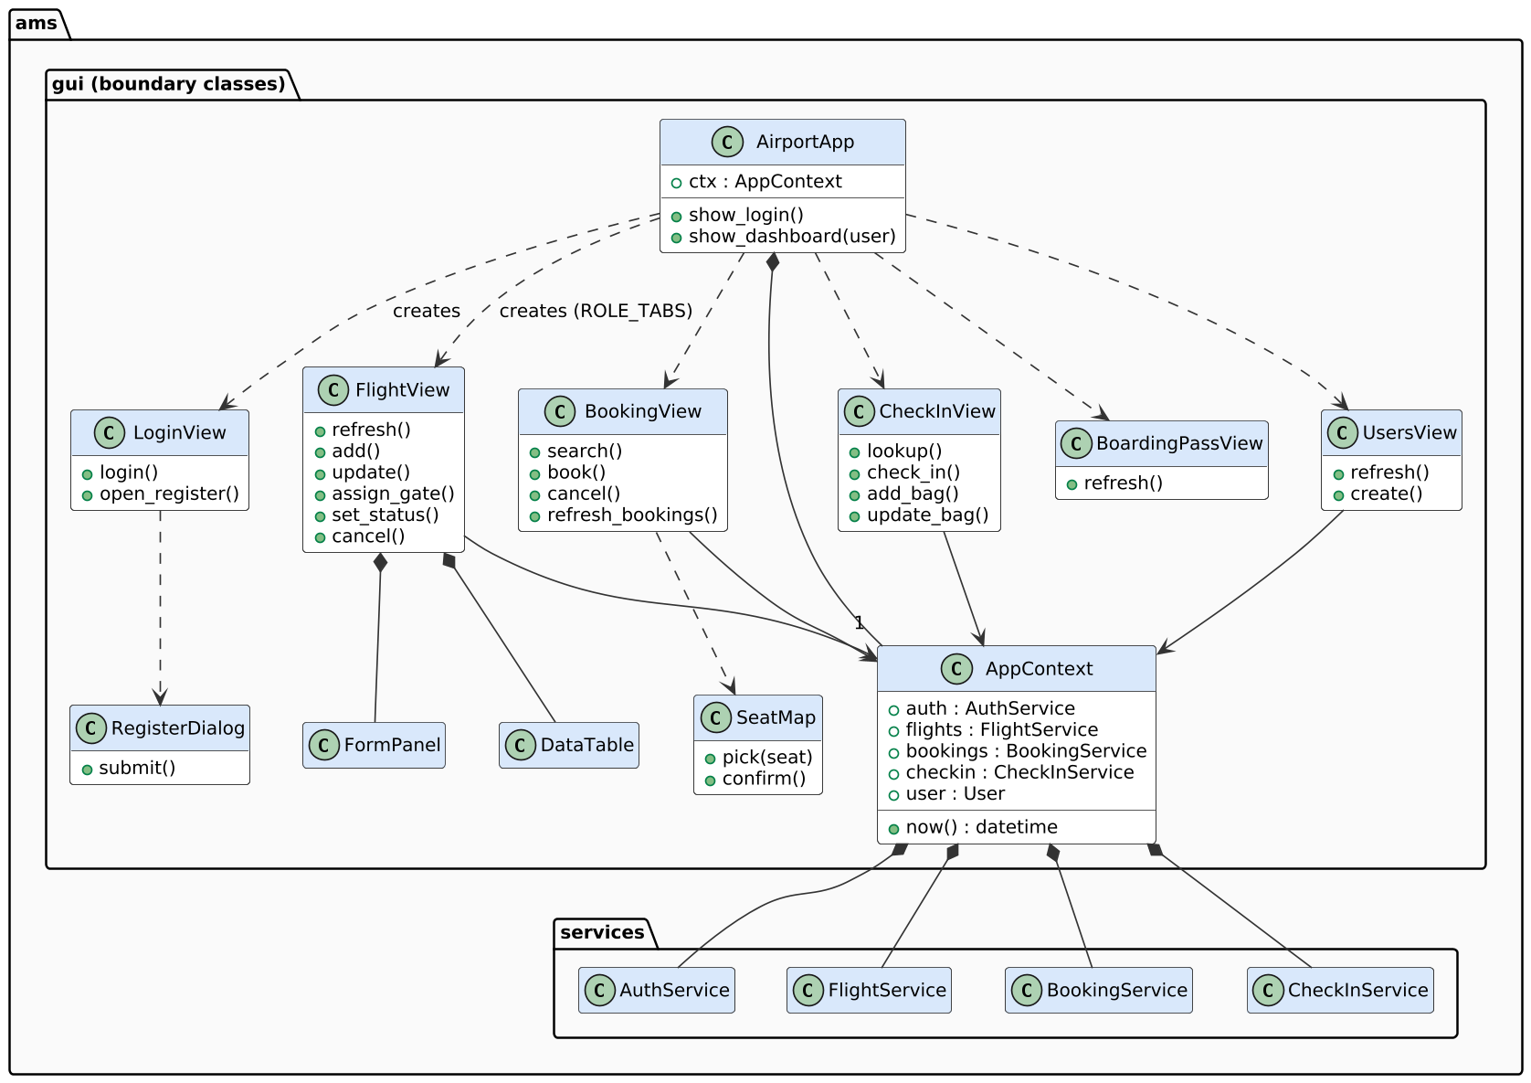
Figure 9.4: Class diagram - boundary (GUI) classes
Table 9.2: Class responsibilities
Class | Stereotype | Responsibility
User, Flight, Booking, Bag | entity | Immutable records of D1-D4; from_row() converts an SQL row.
BookingDetails, BoardingPass | entity (derived) | Booking joined with passenger and flight; boarding pass with as_text().
Role, FlightStatus, BookingStatus, BagStatus | enumeration | Allowed values of roles and states.
AuthService | control | Login, registration, staff accounts, user list.
FlightService | control | Flight CRUD, gate availability and assignment, status transitions, cancellation.
BookingService | control | Search, seat availability, booking, cancellation, booking lists.
CheckInService | control | PNR lookup, check-in, boarding pass, baggage.
AirportApp, AppContext | boundary / coordinator | Main window; holds the four services and the logged-in user.
LoginView, RegisterDialog, FlightView, BookingView, SeatMap, CheckInView, BoardingPassView, UsersView | boundary | One screen or dialog each; every action calls one service method.

9.4 Activity Diagrams
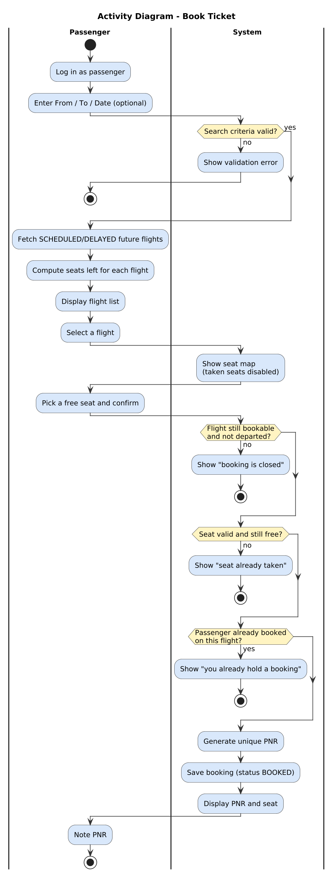
Figure 9.5: Activity diagram - Book Ticket
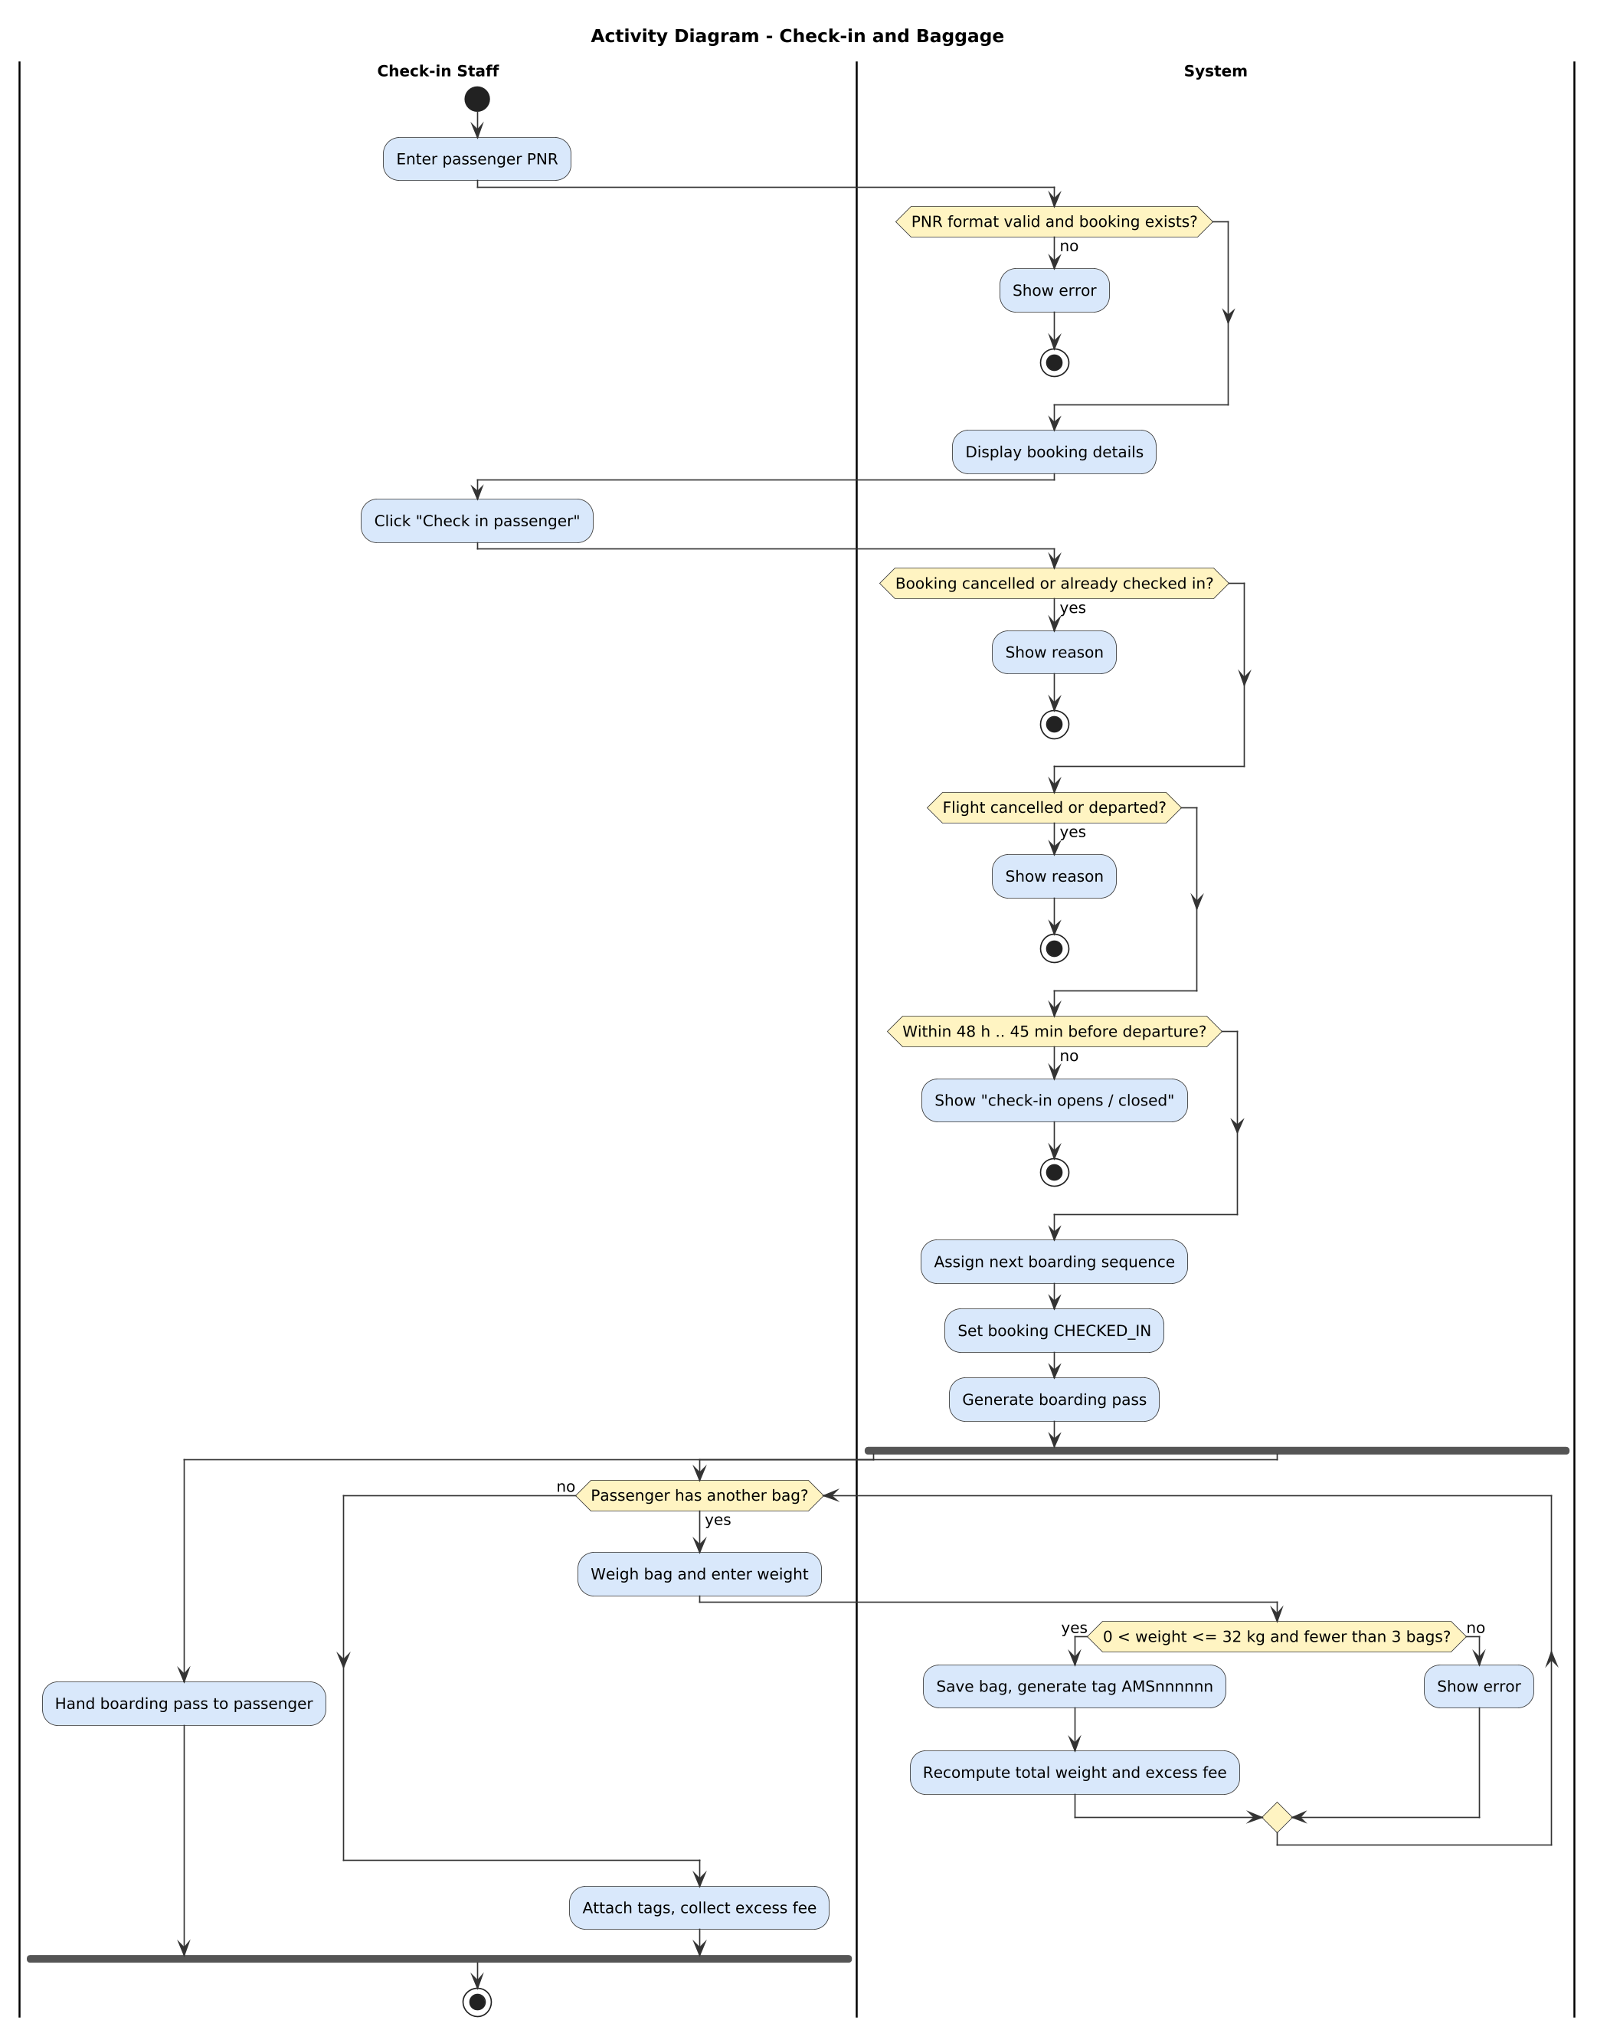
Figure 9.6: Activity diagram - Check-in and Baggage (fork: pass hand-over and bag loop proceed in parallel)
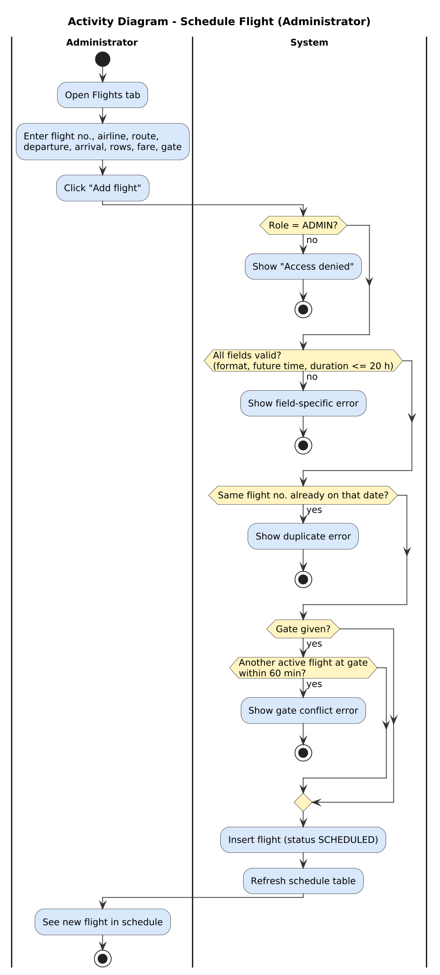
Figure 9.7: Activity diagram - Schedule Flight

9.5 State Chart Diagrams
The flight and bag diagrams are exactly the transition tables FLIGHT_TRANSITIONS (flight_service.py) and BAG_TRANSITIONS (checkin_service.py); any other transition is rejected with a BusinessRuleError. The booking life cycle is enforced by the conditions in book_ticket, check_in, cancel_booking and cancel_flight.
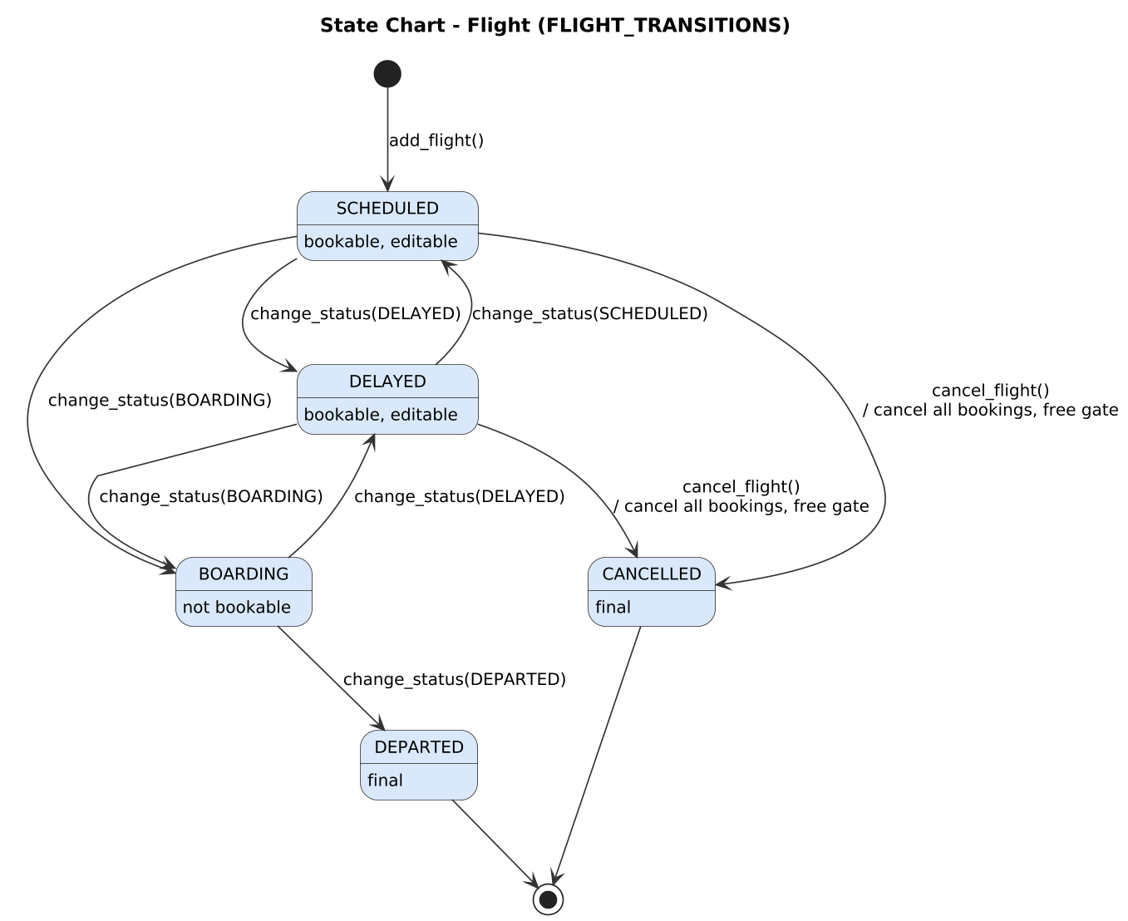
Figure 9.8: State chart - Flight
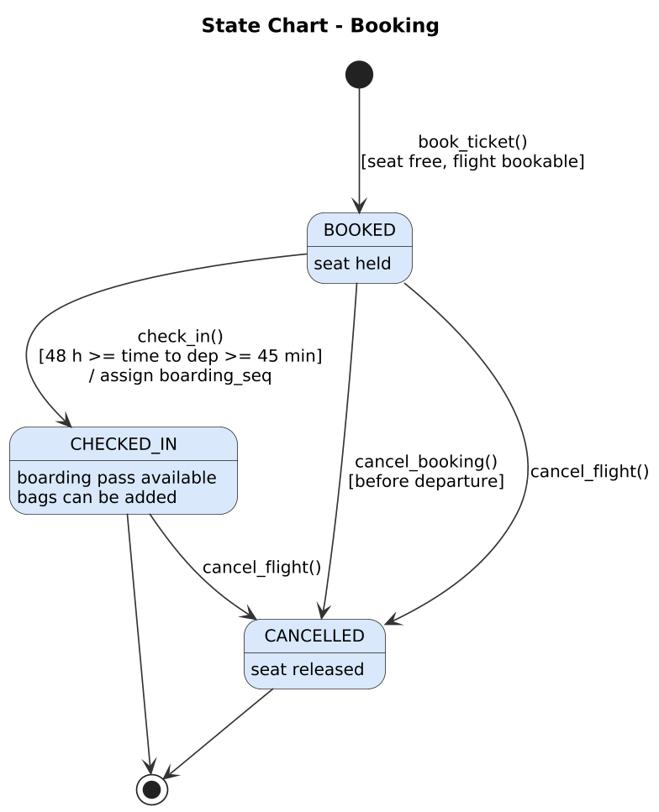
Figure 9.9: State chart - Booking
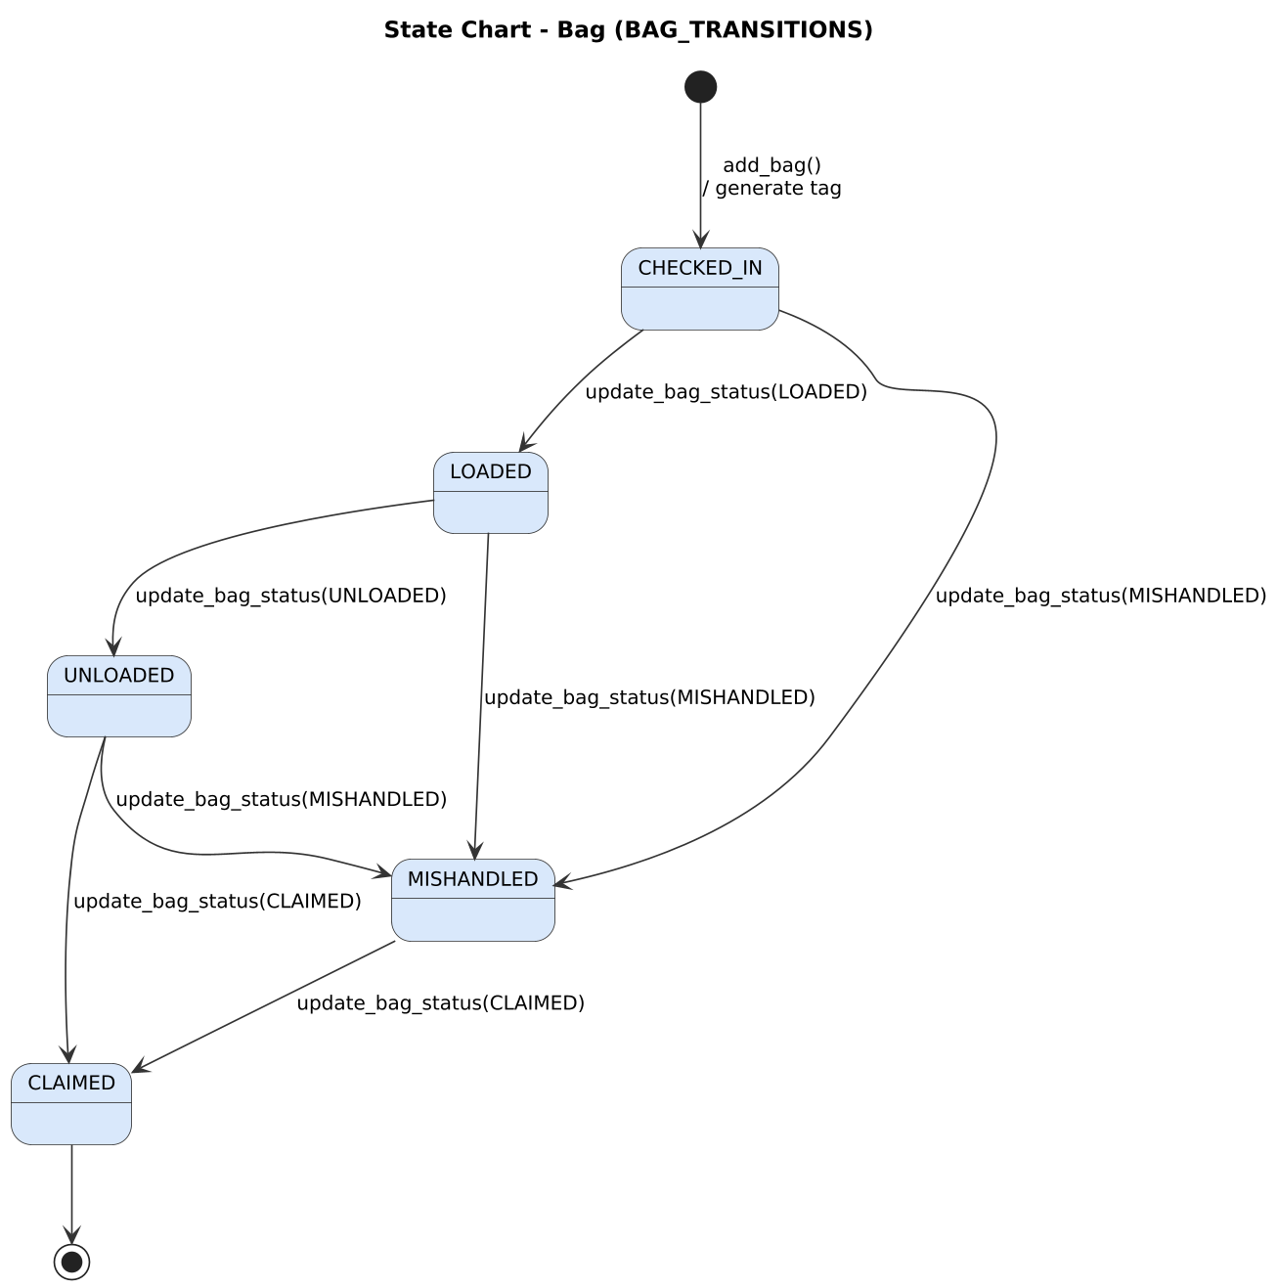
Figure 9.10: State chart - Bag

9.6 Sequence Diagrams
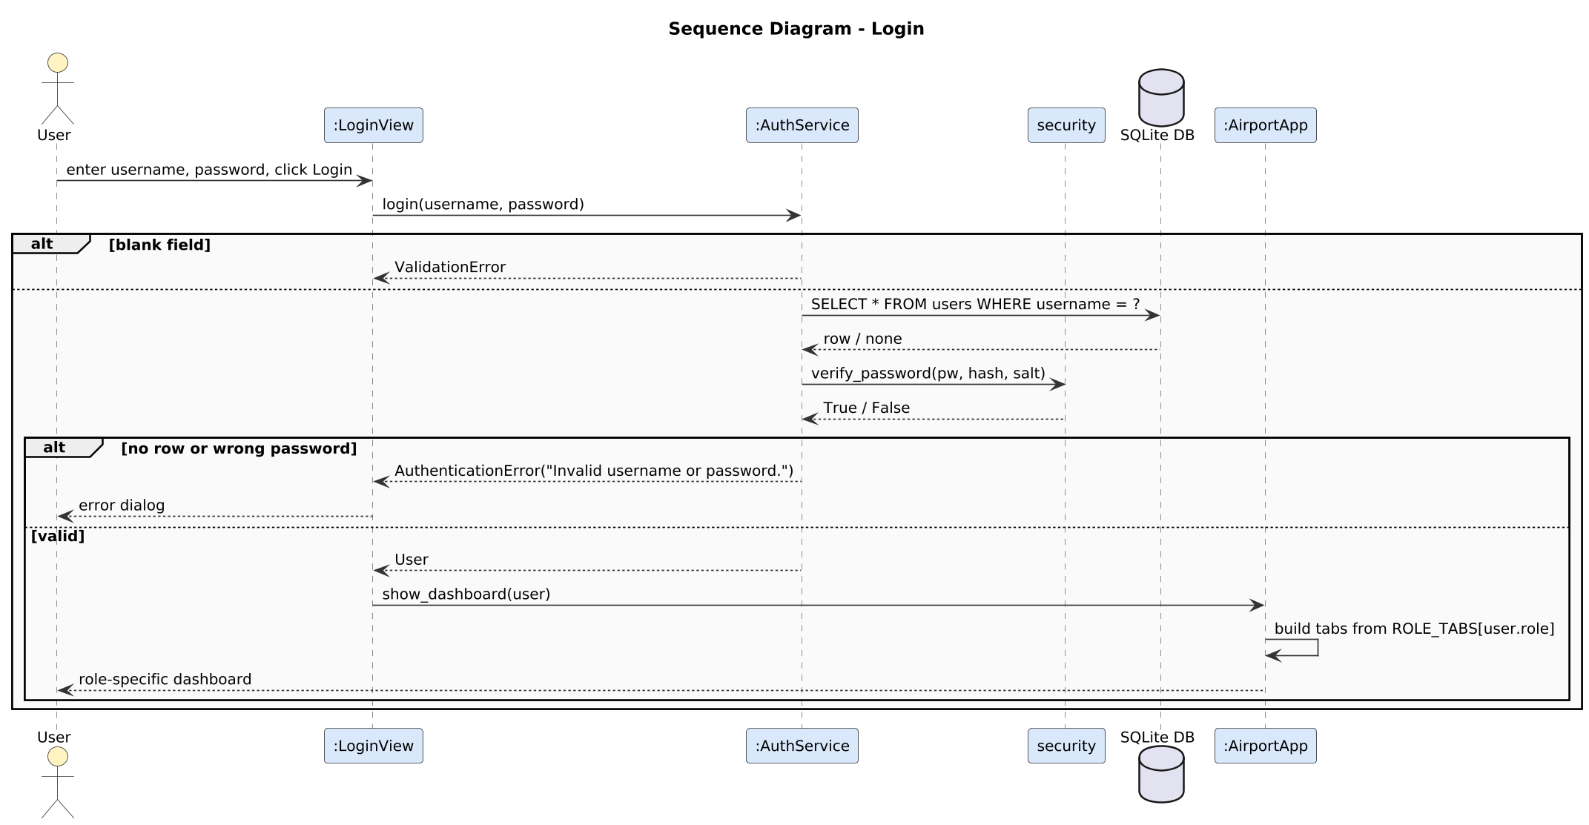
Figure 9.11: Sequence diagram - Login
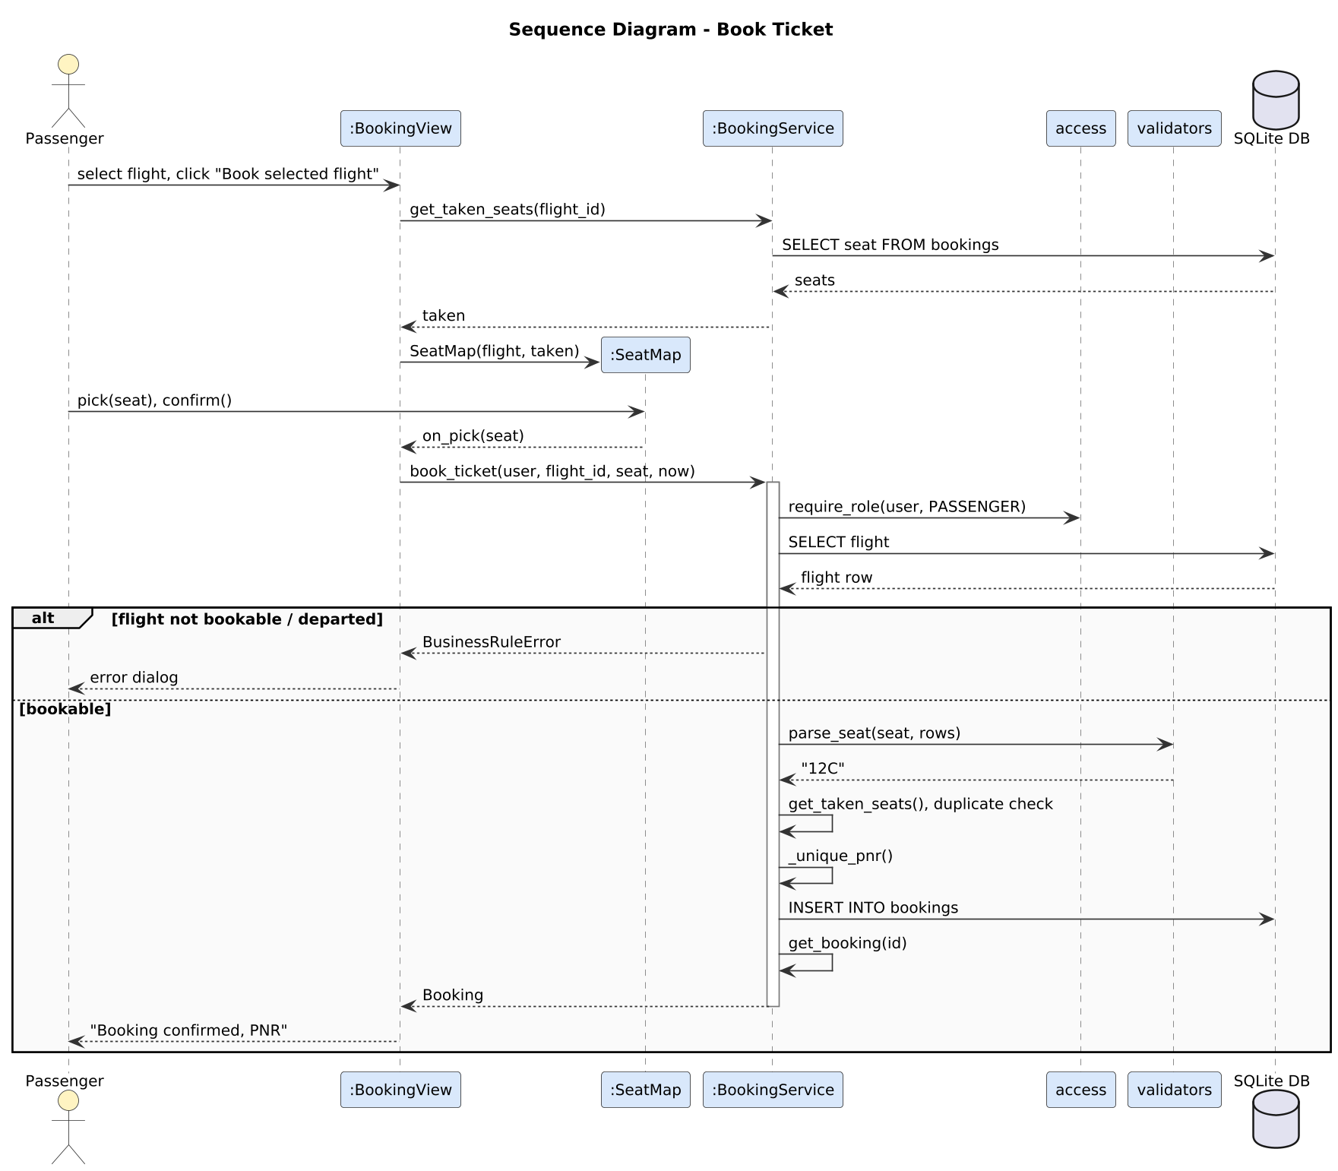
Figure 9.12: Sequence diagram - Book Ticket
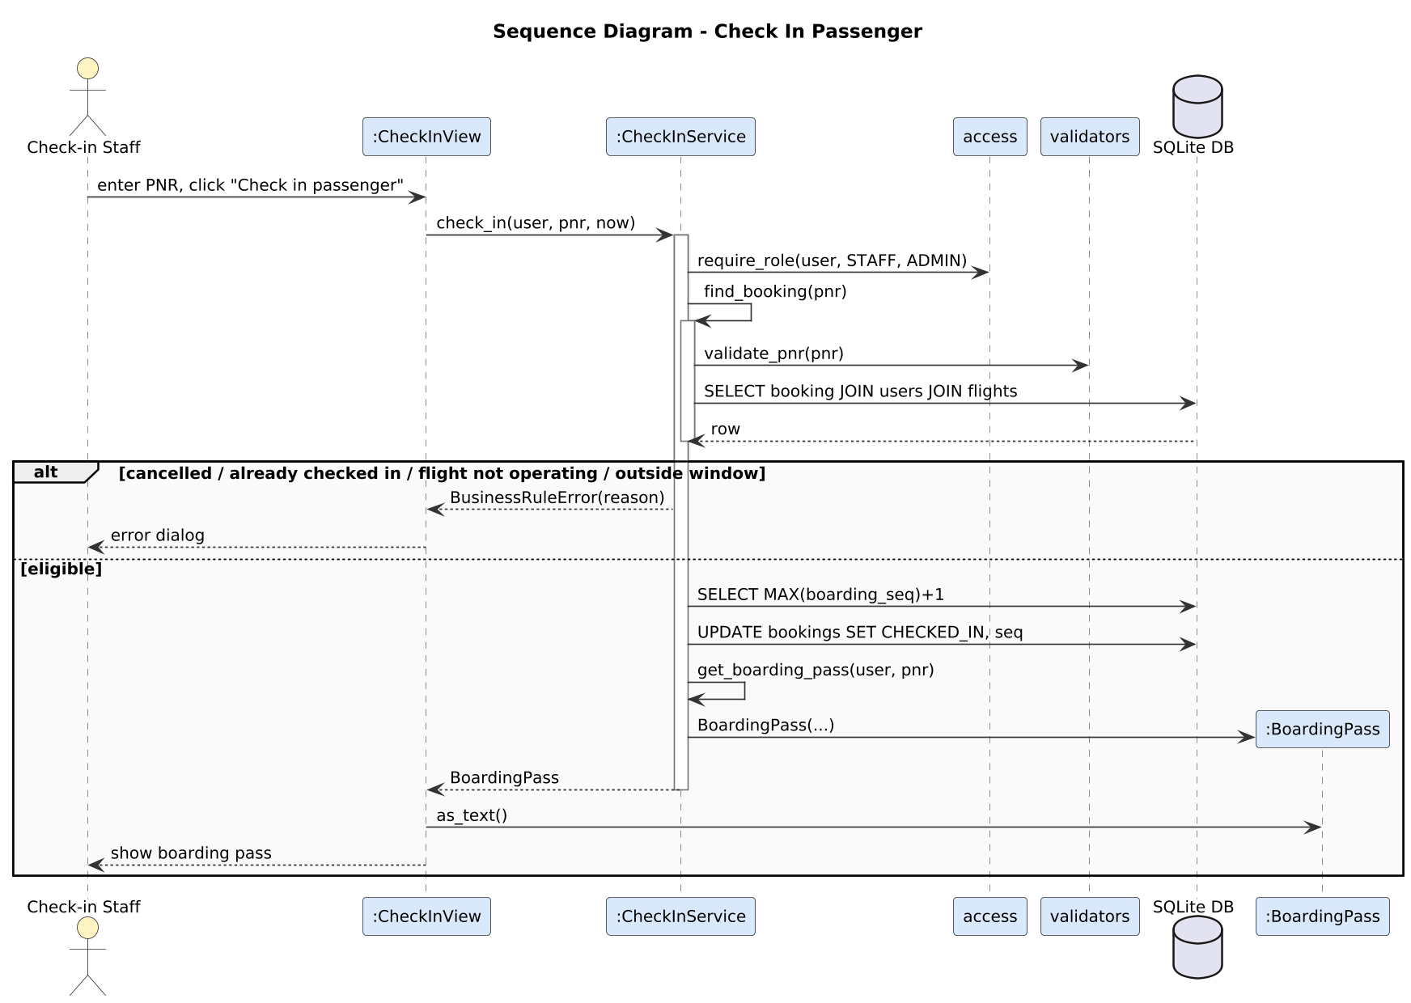
Figure 9.13: Sequence diagram - Check In Passenger

9.7 Collaboration (Communication) Diagrams
A collaboration diagram shows the same interaction as a sequence diagram but emphasises the links between objects; the order of messages is given by their numbers (nested numbers such as 5.2 are calls made while handling message 5).
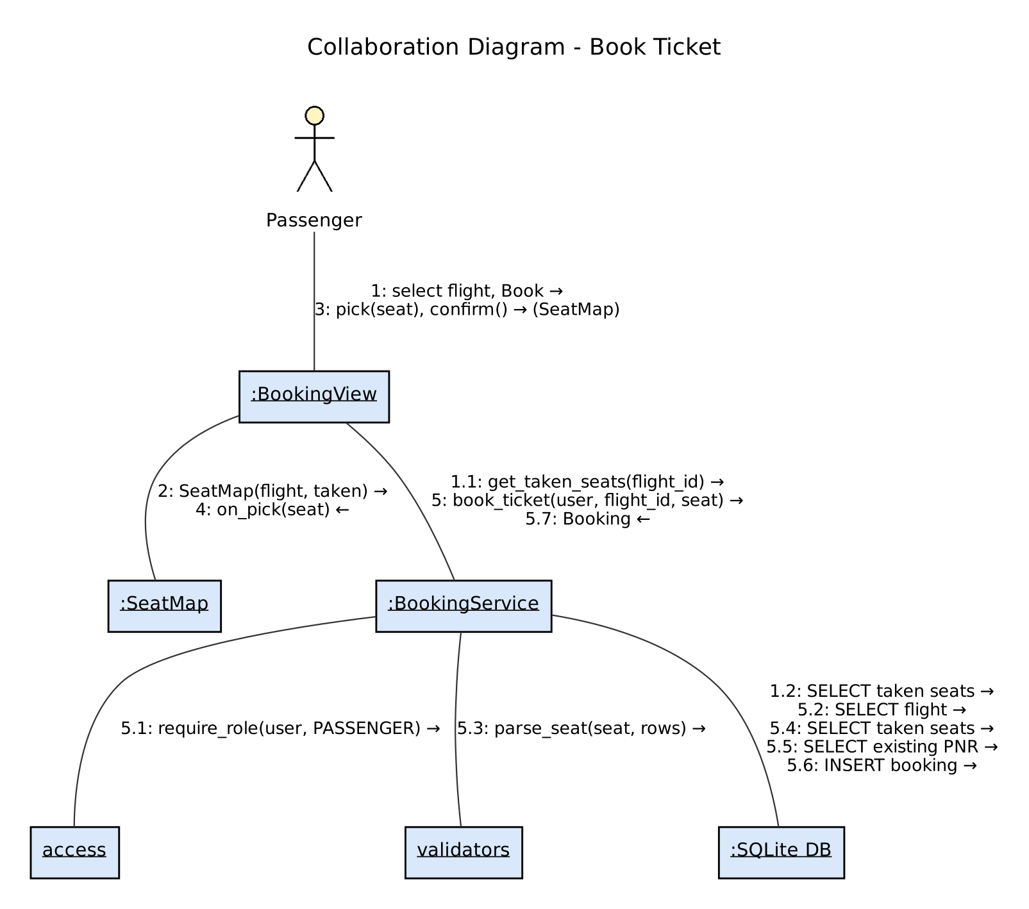
Figure 9.14: Collaboration diagram - Book Ticket
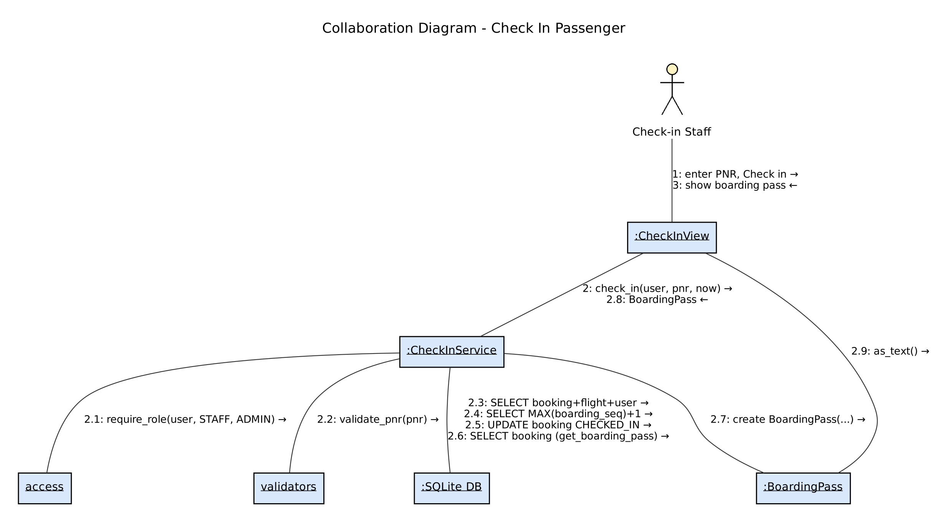
Figure 9.15: Collaboration diagram - Check In Passenger

10. Implementation and Working GUI

10.1 Architecture
The program has three layers. Dependencies point only downwards, which is what keeps coupling low (Chapter 6).
Table 10.1: Source code organisation
Layer | Package / files | Responsibility
Presentation (boundary) | ams/gui/: app.py, login_view.py, flight_view.py, booking_view.py, checkin_view.py, users_view.py, widgets.py | Windows, tabs, forms, tables, seat map; shows errors in dialogs.
Service (control) | ams/services/: auth_service.py, flight_service.py, booking_service.py, checkin_service.py | All business rules and role checks.
Utility & data | ams/: models.py, validators.py, access.py, security.py, errors.py, config.py, database.py | Entities, validation, hashing, constants, schema and sample data.
Entry points | run.py, init_db.py, run.bat | Start the GUI; create/reset the database.
Tests | tests/: test_blackbox.py, test_whitebox.py, test_services.py, helpers.py | 76 automated tests on an in-memory database with a fixed clock.

10.2 Important Algorithms and Mechanisms
- Seat uniqueness: checked in book_ticket and also guaranteed by the partial unique index ux_active_seat ON bookings(flight_id, seat) WHERE status <> 'CANCELLED'; if two bookings race for one seat the database rejects the second and the user sees 'Seat ... was just taken.'
- Gate clash check: is_gate_available compares the departure time with every other active flight at the same gate and rejects a gap below 60 minutes (white-box tested, Section 11.3).
- PNR generation: 6 random characters from an alphabet without I, O, 0, 1 (secrets module), retried until unused.
- Check-in window and boarding sequence: see the axiomatic specification in Section 5.2.
- Excess-baggage fee: Rs 500 per started kilogram above 15 kg (compute_excess_fee).
- State machines: flight and bag statuses change only through the transition tables shown in Section 9.5.
- Passwords: PBKDF2-HMAC-SHA256, 100,000 iterations, random 16-byte salt; compared with hmac.compare_digest.
- Sample data relative to the current time: seed_sample_data places flights 30 minutes to 3 days ahead of the moment the database is created, so the check-in window rules can always be demonstrated (python run.py --reset before a demo).

10.3 Input Validation and Error Messages
Table 10.2: Validation rules and messages
Field | Rule | Message shown on error
Flight no. | 2-char airline code (not both digits) + 1-4 digits | Flight number must be a 2-character airline code + 1-4 digits, e.g. AI202.
Airport code | 3 letters | Origin must be a 3-letter IATA code, e.g. DEL.
Date/time | YYYY-MM-DD HH:MM, future, arrival after departure, <= 20 h | Departure must be in YYYY-MM-DD HH:MM format, e.g. 2026-11-05 14:30. / Departure time must be in the future.
Gate | A-D + 1-20, optional | Gate must be a terminal letter A-D followed by 1-20, e.g. B7.
Seat rows / fare | 1-40 / 500-200000 | Number of seat rows must be between 1 and 40. / Fare must be between Rs 500 and Rs 200000.
Seat | row 1..rows + A-F | Seat must be a row number followed by a letter, e.g. 12C.
PNR | 6 letters/digits | PNR must be exactly 6 letters/digits, e.g. K7Q2MA.
Bag weight | 0 < w <= 32 | A single bag cannot exceed 32 kg; send it as cargo.
Password | 6-64, letter + digit | Password must contain at least one letter and one digit.
Mobile | 10 digits, starts 6-9 | Phone must be a 10-digit mobile number starting with 6-9.

10.4 Sample Data
Data | Records
Users | admin/admin123 (ADMIN), staff1, staff2/staff123 (STAFF), priya, rahul, sneha/pass1234 (PASSENGER)
Flights | AI202 DEL-BOM, 6E5021 BLR-DEL, UK811 BOM-BLR, SG134 DEL-GOI (DELAYED), AI505 MAA-CCU, QP1302 BOM-DEL (BOARDING), IX345 CCU-DEL (CANCELLED), 6E2140 DEL-BLR
Bookings | 8 bookings incl. one CHECKED_IN (R4T9XB) and one CANCELLED (C8L4KG); PNR K7Q2MA is ready for a check-in demo
Bags | 2 bags on booking R4T9XB (one LOADED)

10.5 GUI Screenshots
The screenshots below were captured from the running application by the script tools/capture_screenshots.py, which logs in as each role and performs the actions shown. Message boxes are redrawn as plain windows by the script so that they appear in the capture; the message text is the program's own.
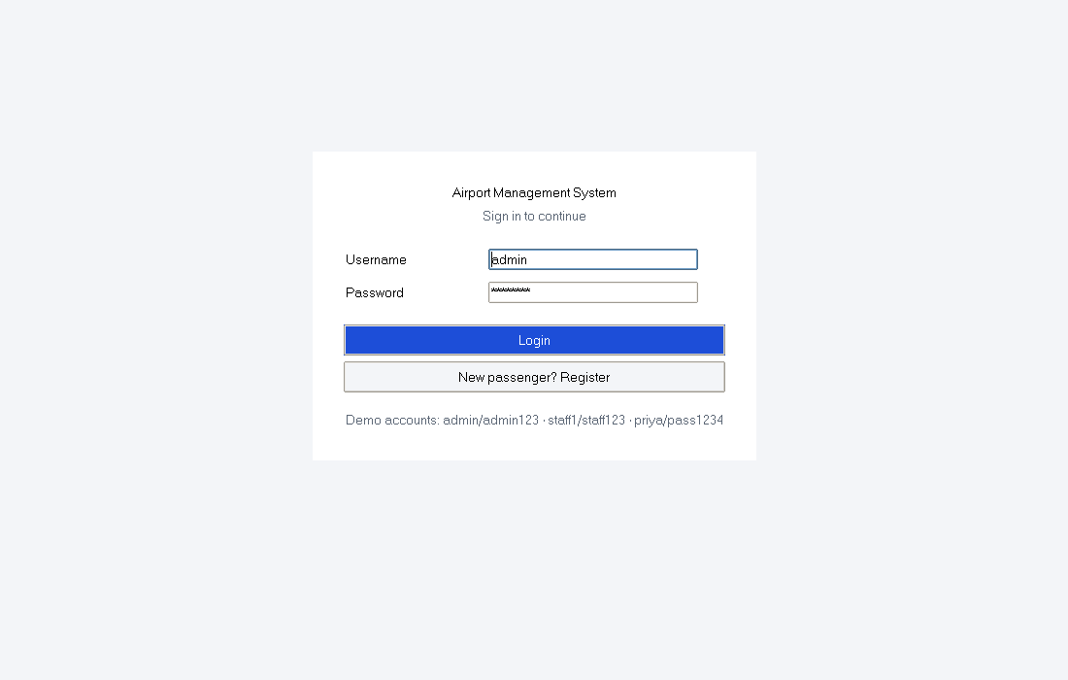
Figure 10.1: Login screen (demo accounts shown for the lab demonstration)
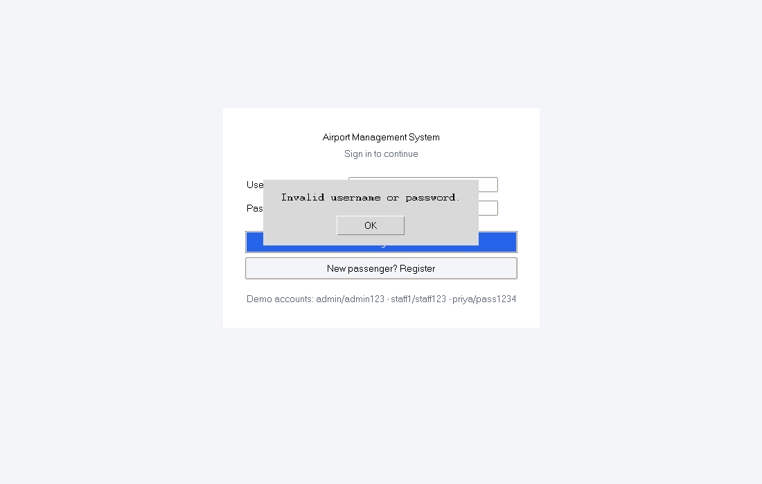
Figure 10.2: Wrong password: the same message is shown for unknown user and wrong password (NF4)
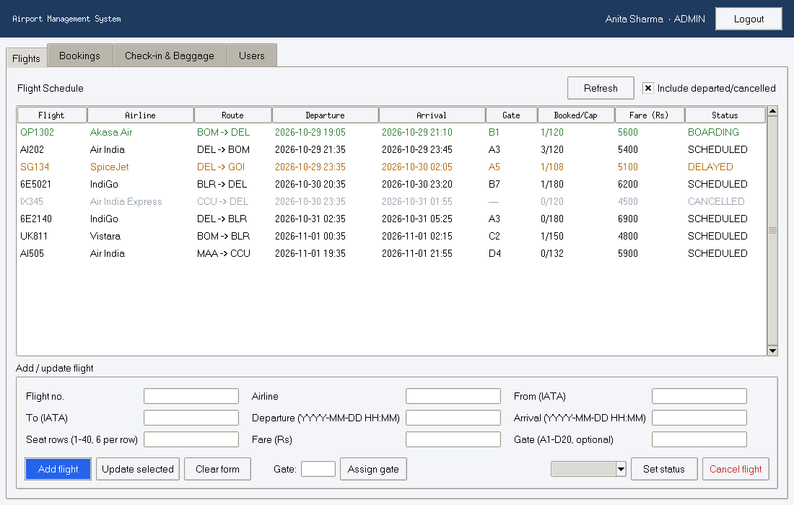
Figure 10.3: Administrator - Flight Schedule tab with add/update form, gate assignment, status and cancel controls
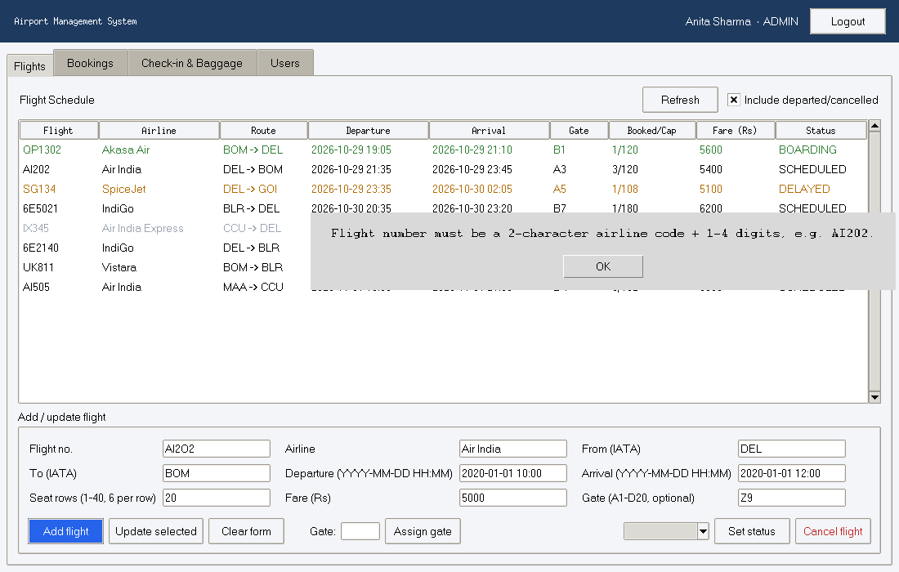
Figure 10.4: Validation error when adding a flight with an invalid flight number
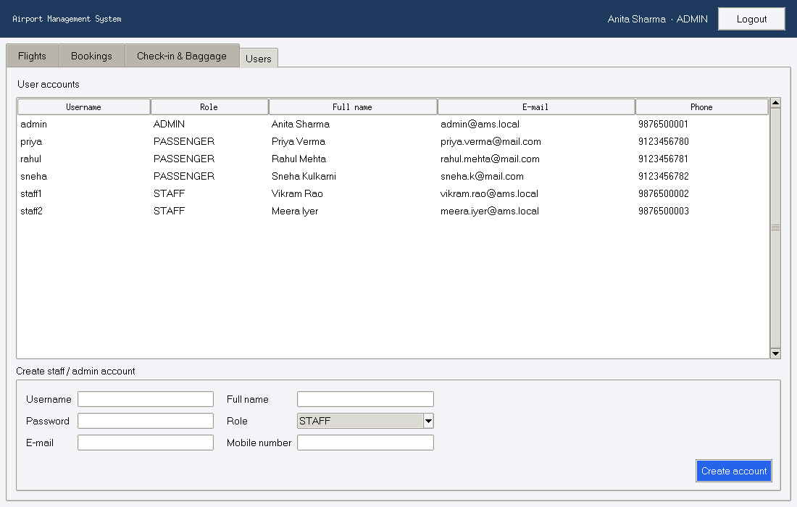
Figure 10.5: Administrator - Users tab (create staff/admin accounts)
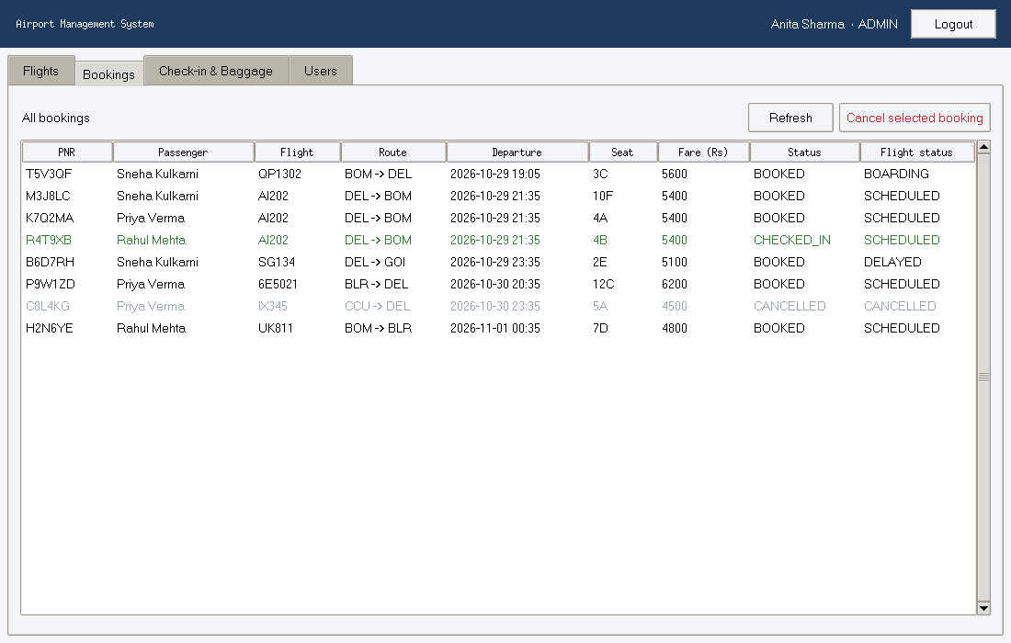
Figure 10.6: Administrator - all bookings, cancelled bookings greyed out
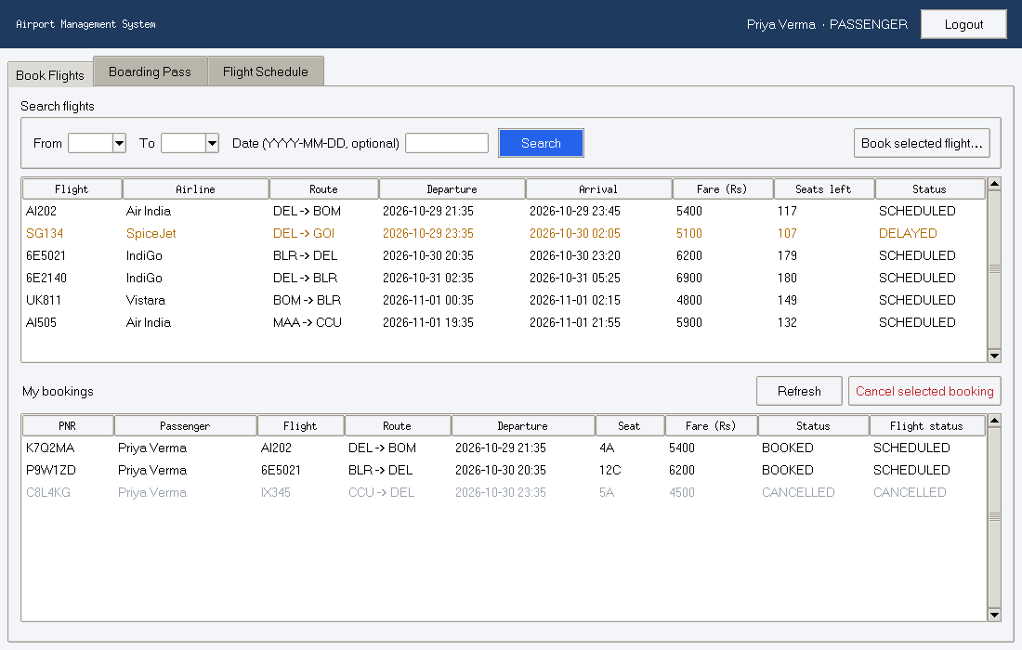
Figure 10.7: Passenger - search results (only bookable future flights) and own bookings
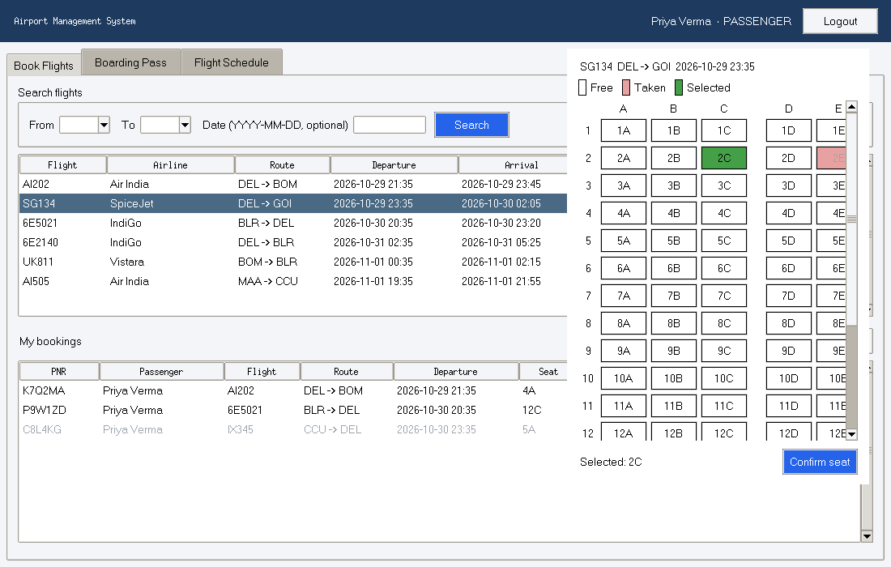
Figure 10.8: Passenger - seat map: taken seats disabled, selected seat green
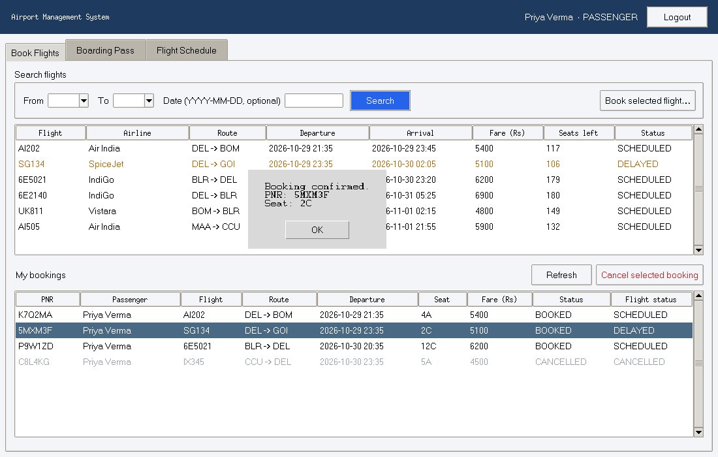
Figure 10.9: Booking confirmed with generated PNR
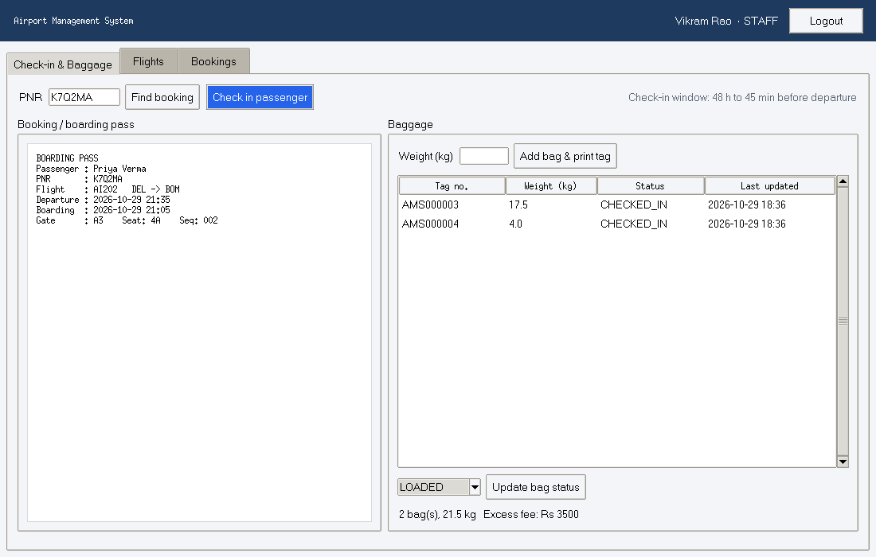
Figure 10.10: Check-in staff - boarding pass after check-in; two bags tagged, 21.5 kg, excess fee Rs 3500
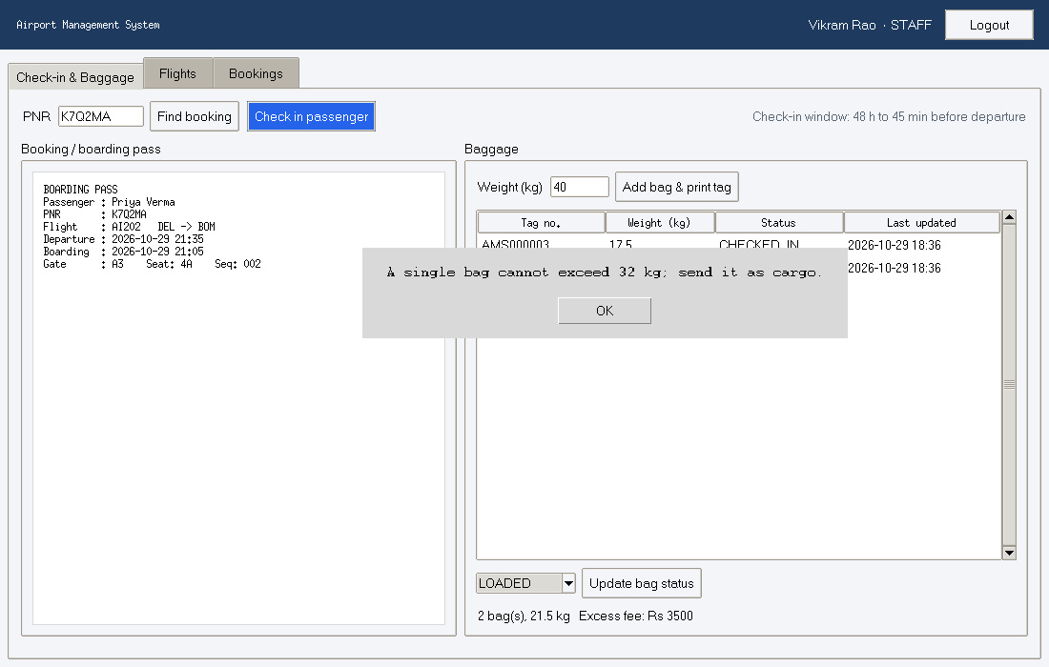
Figure 10.11: Bag heavier than 32 kg rejected with an explanatory message
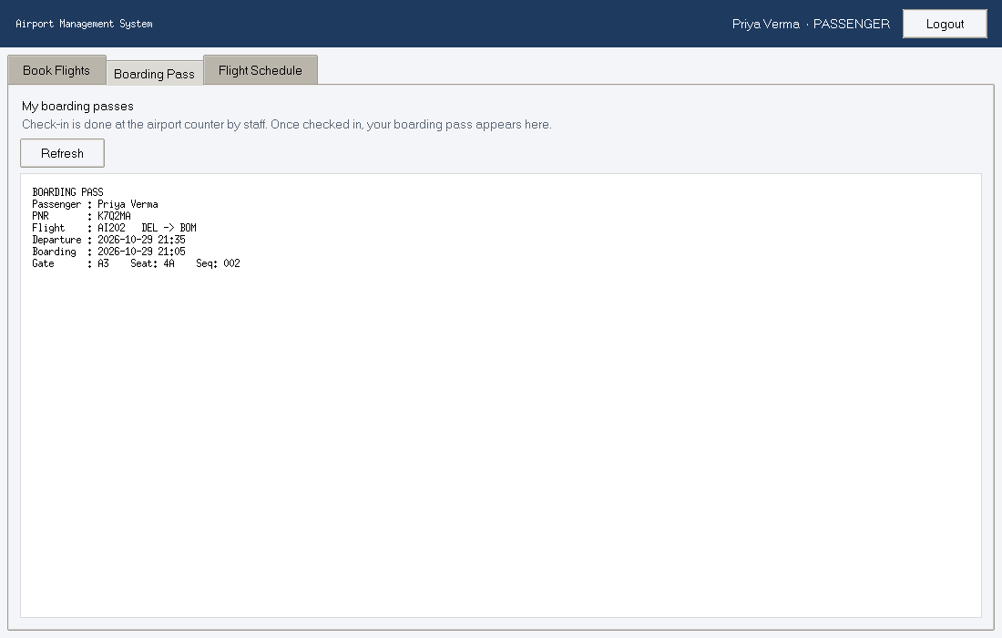
Figure 10.12: Passenger - own boarding pass after check-in

11. Software Testing

11.1 Testing Strategy
Testing was done at three levels on the real code: black-box testing of the functions' specified behaviour (the algorithmic rules), white-box testing of the source code paths, and unit testing of each service class. Black-box + white-box testing of individual units together form the unit testing of the system. All tests are automated with Python unittest and can be re-run with one command (Section 11.6). The results reported here are the actual output of that run (docs/test_results.txt).
To make tests repeatable, each test creates a fresh in-memory database seeded at a fixed time NOW = 2026-11-10 09:00 and passes that time explicitly to the services (the injectable clock described in NF8).

11.2 Black-Box Testing
Black-box test cases are designed from the specification only (SRS Sections 4.3 and 4.6), without looking at the code, using Equivalence Class Partitioning (ECP) - one test per valid and invalid class - and Boundary Value Analysis (BVA) - tests at, just inside and just outside each boundary.

11.2.1 Equivalence classes and boundaries
Table 11.1: Equivalence classes and boundary values
Input | Valid classes | Invalid classes | Boundary values tested
Seat (rows = 20) | row 1-20 and column A-F | row < 1; row > 20; column not A-F; wrong format/empty | 0, 1, 20, 21
Bag weight (kg) | 0 < w <= 32 | w <= 0; w > 32; non-numeric | 0, 0.1, 32, 32.1
Total baggage for fee | 0 <= w <= 15 (fee 0); w > 15 (fee > 0) | w < 0 | 0, 15.0, 15.1
Seat rows | 1-40 | < 1; > 40; non-integer | 0, 1, 40, 41
Fare (Rs) | 500-200000 | < 500; > 200000; non-integer | 499, 500, 200000, 200001
Gate | empty; A-D + 1-20 | letter E+; number 0 or > 20; wrong order | A0, D20, A21
Password length | 6-64 with letter + digit | < 6; no digit; no letter | length 4 and 6

11.2.2 Black-box test cases and results
Table 11.2: Black-box test cases (tests/test_blackbox.py)
ID | Unit | Technique | Input | Expected | Result
BB01 | parse_seat | ECP valid | '12C', rows=20 | '12C' | Pass
BB02 | parse_seat | ECP valid (case/space) | ' 7d ' | '7D' | Pass
BB03 | parse_seat | BVA min row | '1A' | '1A' | Pass
BB04 | parse_seat | BVA max row | '20F' | '20F' | Pass
BB05 | parse_seat | BVA min-1 | '0A' | ValidationError | Pass
BB06 | parse_seat | BVA max+1 | '21A' | ValidationError | Pass
BB07 | parse_seat | ECP invalid column | '5G' | ValidationError | Pass
BB08 | parse_seat | ECP invalid format | 'A5', '', '12', '1 2C', None | ValidationError | Pass
BB09 | validate_bag_weight | ECP valid | '18.5' | 18.5 | Pass
BB10 | validate_bag_weight | BVA max | '32' | 32.0 | Pass
BB11 | validate_bag_weight | BVA max+ | '32.1' | ValidationError | Pass
BB12 | validate_bag_weight | BVA min valid | '0.1' | 0.1 | Pass
BB13 | validate_bag_weight | BVA / ECP <= 0 | '0', '-5' | ValidationError | Pass
BB14 | validate_bag_weight | ECP non-numeric | 'heavy' | ValidationError | Pass
BB15 | compute_excess_fee | BVA 0 | 0 | 0 | Pass
BB16 | compute_excess_fee | BVA allowance | 15.0 | 0 | Pass
BB17 | compute_excess_fee | BVA allowance+ | 15.1 | 500 | Pass
BB18 | compute_excess_fee | ECP over | 20.0 | 2500 | Pass
BB19 | compute_excess_fee | ECP invalid | -1 | ValidationError | Pass
BB20 | validate_flight_no | ECP valid / invalid | 'ai202', '6E5021' / '22202', 'AI', 'AI20202', 'AI-202' | 'AI202', '6E5021' / ValidationError | Pass
BB21 | validate_route | ECP | DEL,BOM / DEL,DEL | ('DEL','BOM') / ValidationError | Pass
BB22 | validate_rows | BVA 1..40 | '1', '40' / '0', '41', 'ten' | 1, 40 / ValidationError | Pass
BB23 | validate_fare | BVA 500..200000 | '500', '200000' / '499', '200001', '12.5' | 500, 200000 / ValidationError | Pass
BB24 | validate_gate | ECP + BVA | '' , 'b7', 'D20' / 'E1', 'A0', 'A21', '7B' | None, 'B7', 'D20' / ValidationError | Pass
BB25 | validate_password | BVA length 6, ECP | 'abc123' / 'ab12', 'abcdefg', '1234567' | accepted / ValidationError | Pass
BB26 | validate_phone, validate_email | ECP | '98765 43210', 'Om@Example.com' / '5876543210', '987654321', 'om@example' | normalised / ValidationError | Pass

Defect found by black-box testing. In the first run, BB20 failed: the input 'A202' was accepted because the pattern allowed any two letters/digits as the airline code. The specification was clarified (the airline code must contain at least one letter, e.g. AI, 6E, G8), the validator in validators.py was corrected, and the ambiguous input was replaced by the clearly invalid '22202'. All black-box tests pass after the fix.

11.3 White-Box Testing
White-box test cases are derived from the source code. For each unit the control-flow graph (CFG) was drawn, its cyclomatic complexity V(G) computed in two ways (V(G) = E - N + 2 and V(G) = number of decision nodes + 1), and one test case written for each basis path (path coverage), plus boundary tests of the decisions. Yellow nodes are decisions, red boxes are raised exceptions, E is the exit.

11.3.1 Unit 1: CheckInService.check_in()
def check_in(self, actor: User, pnr, now: Optional[datetime] = None) -> BoardingPass:
"""Check a passenger in and return the boarding pass.
Check-in is open from 48 h until 45 min before departure."""
require_role(actor, Role.STAFF, Role.ADMIN)
now = now or datetime.now()
details = self.find_booking(pnr) # may raise NotFoundError
booking = details.booking
if booking.status == BookingStatus.CANCELLED:
raise BusinessRuleError(f"Booking {booking.pnr} is cancelled.")
if booking.status == BookingStatus.CHECKED_IN:
raise BusinessRuleError(f"Passenger {details.passenger_name} is already checked in.")
if details.flight_status in (FlightStatus.CANCELLED, FlightStatus.DEPARTED):
raise BusinessRuleError(f"Flight {details.flight_no} is {details.flight_status.value}.")
if now < details.departure - timedelta(hours=CHECKIN_OPENS_HOURS):
raise BusinessRuleError(f"Check-in opens {CHECKIN_OPENS_HOURS} hours before departure.")
if now > details.departure - timedelta(minutes=CHECKIN_CLOSES_MINUTES):
raise BusinessRuleError(f"Check-in closed {CHECKIN_CLOSES_MINUTES} minutes before departure.")
seq = self.conn.execute(
"SELECT COALESCE(MAX(boarding_seq), 0) + 1 FROM bookings WHERE flight_id = ?",
(booking.flight_id,)).fetchone()[0]
self.conn.execute(
"UPDATE bookings SET status = 'CHECKED_IN', checked_in_at = ?, boarding_seq = ?"
" WHERE booking_id = ?", (fmt_dt(now), seq, booking.booking_id))
self.conn.commit()
return self.get_boarding_pass(actor, booking.pnr)
Table 11.3: CFG node numbering for check_in()
Node | Statement / decision
1 | require_role(actor, STAFF, ADMIN) - role not allowed?
2 | find_booking(pnr) - booking not found (or bad PNR)?
3 | booking.status == CANCELLED?
4 | booking.status == CHECKED_IN?
5 | flight_status in (CANCELLED, DEPARTED)?
6 | now < departure - 48 h?
7 | now > departure - 45 min?
8 | compute seq; UPDATE booking; commit
9 | return get_boarding_pass(...)
R1-R7 | raise the corresponding error (T branch of nodes 1-7)
E | exit

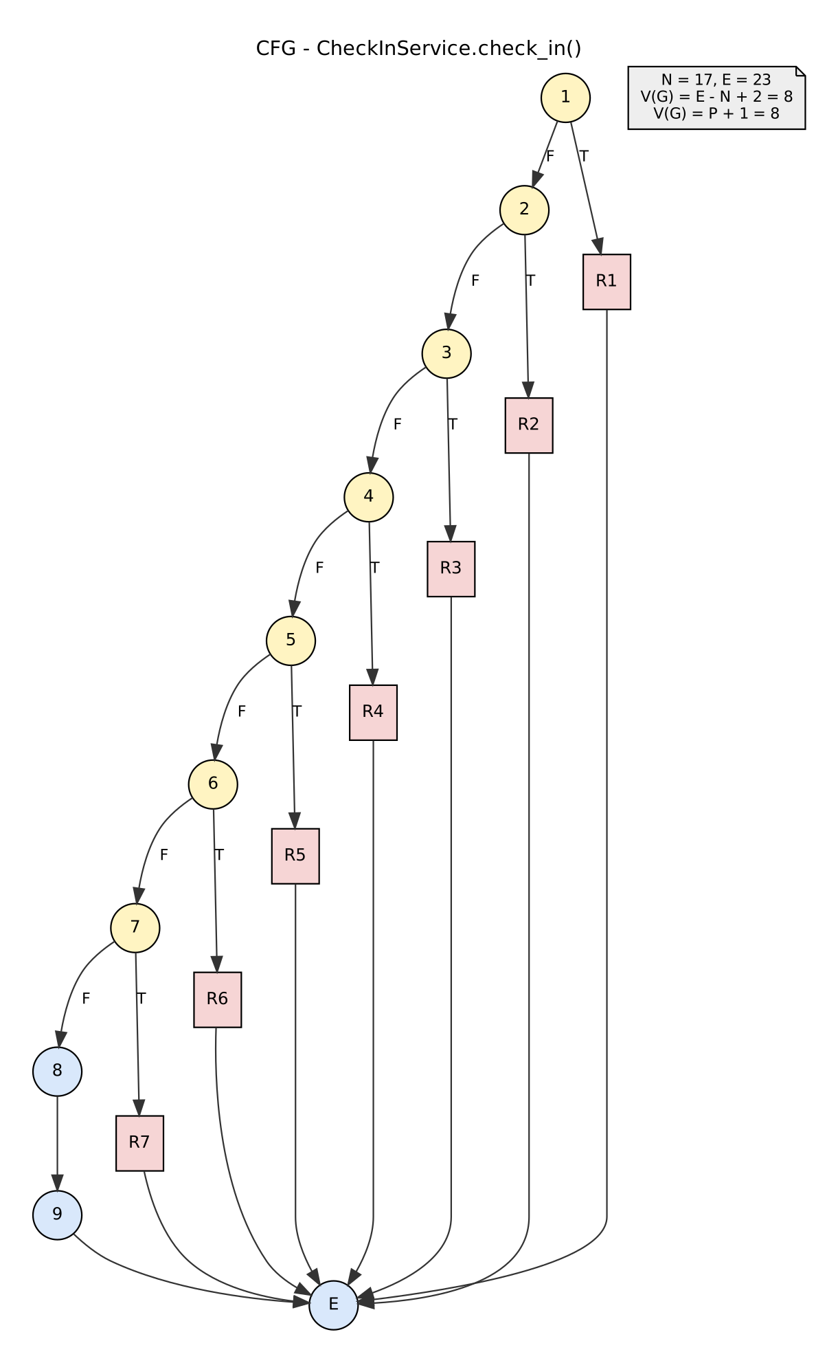
Figure 11.1: Control-flow graph of check_in(): N = 17, E = 23, V(G) = 8

11.3.2 Unit 2: FlightService.is_gate_available()
def is_gate_available(self, gate: Optional[str], departure: datetime,
exclude_flight_id: Optional[int] = None) -> bool:
"""A gate is free if no other active flight at it departs within the buffer."""
if gate is None:
return True
rows = self.conn.execute(
"SELECT flight_id, departure FROM flights WHERE gate = ? AND status IN (?,?,?)",
(gate, *[s.value for s in ACTIVE_STATUSES])).fetchall()
for row in rows:
if exclude_flight_id is not None and row["flight_id"] == exclude_flight_id:
continue
gap_minutes = abs((to_dt(row["departure"]) - departure).total_seconds()) / 60
if gap_minutes < GATE_BUFFER_MINUTES:
return False
return True
Nodes: 1 gate is None?, 2 query active flights at the gate, 3 loop for row in rows (next row / rows done), 4 row is the excluded flight?, 5 gap_minutes < 60?, 6 return False, 7 return True after the loop, E exit.
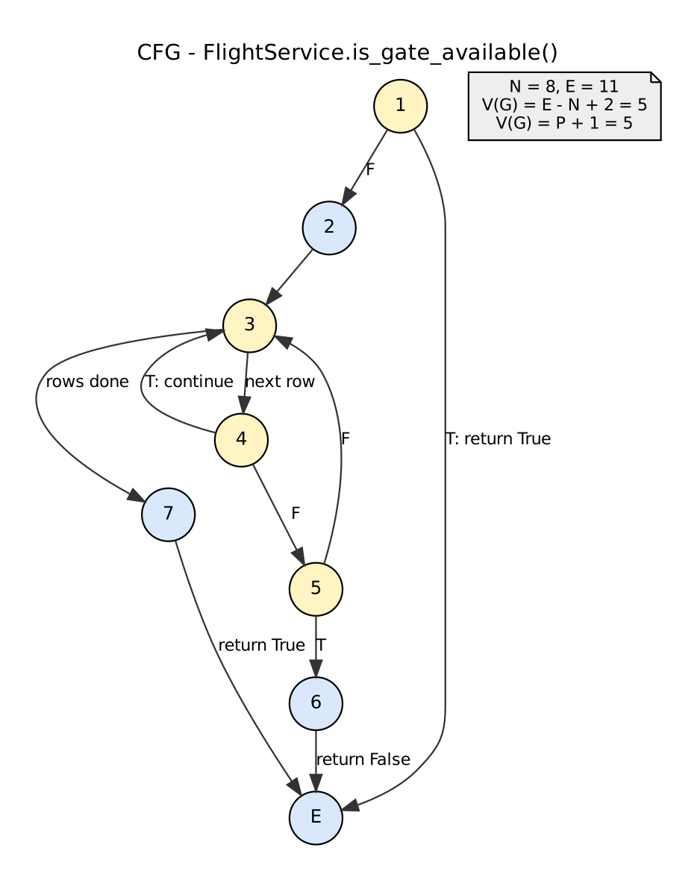
Figure 11.2: Control-flow graph of is_gate_available(): N = 8, E = 11, V(G) = 5

11.3.3 Unit 3: compute_excess_fee()
def compute_excess_fee(total_weight_kg: float) -> int:
"""Excess-baggage fee in INR: Rs 500 for every started kg above the 15 kg allowance."""
if total_weight_kg < 0:
raise ValidationError("Total baggage weight cannot be negative.")
excess = total_weight_kg - FREE_BAGGAGE_KG
if excess <= 0:
return 0
return math.ceil(round(excess, 1)) * EXCESS_RATE_PER_KG
Nodes: 1 total < 0?, R raise, 2 excess = total - 15, 3 excess <= 0?, 4 return 0, 5 return ceil(...) * 500, E exit.
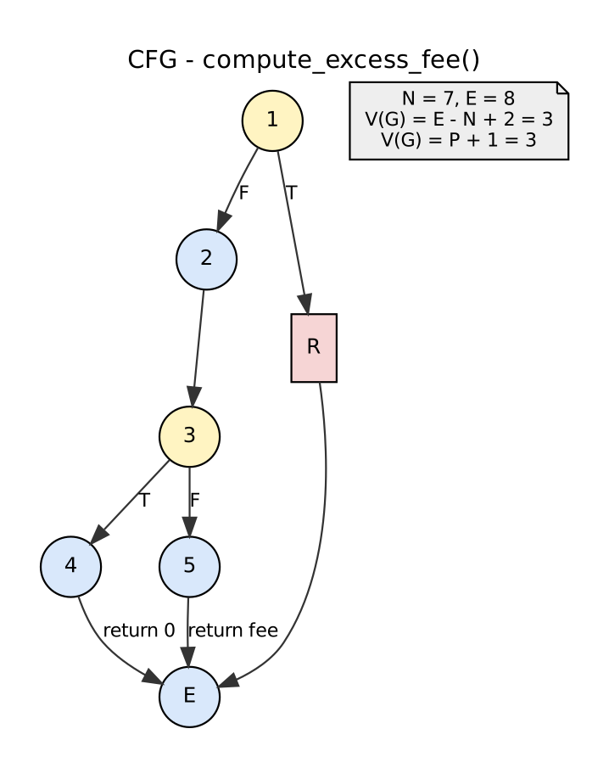
Figure 11.3: Control-flow graph of compute_excess_fee(): N = 7, E = 8, V(G) = 3

11.3.4 Basis paths, test cases and results
Table 11.4: Cyclomatic complexity and number of basis-path tests
Unit | V(G) | Independent paths needed | Tests written
check_in | 8 | 8 | WB01-WB08 (+ WB09 boundary)
is_gate_available | 5 | 5 | WB10-WB14
compute_excess_fee | 3 | 3 | WB15-WB17

Table 11.5: White-box test cases (tests/test_whitebox.py)
ID | Unit | Path | Test data | Expected | Result
WB01 | check_in | 1T-R1-E | role = PASSENGER | AuthorizationError | Pass
WB02 | check_in | 1F-2T-R2-E | PNR 'ZZZZZZ' (absent) | NotFoundError | Pass
WB03 | check_in | ...3T-R3-E | PNR C8L4KG (cancelled) | BusinessRuleError 'cancelled' | Pass
WB04 | check_in | ...4T-R4-E | PNR R4T9XB (already checked in) | BusinessRuleError 'already checked in' | Pass
WB05 | check_in | ...5T-R5-E | AI202 set DEPARTED, PNR K7Q2MA | BusinessRuleError 'DEPARTED' | Pass
WB06 | check_in | ...6T-R6-E | PNR H2N6YE, flight 54 h away | BusinessRuleError 'opens' | Pass
WB07 | check_in | ...7T-R7-E | PNR T5V3QF, flight 30 min away | BusinessRuleError 'closed' | Pass
WB08 | check_in | 1F-2F-...-7F-8-9-E | PNR K7Q2MA, 3 h before departure | Boarding pass: seat 4A, gate A3, seq 2, boarding = dep - 30 min | Pass
WB09 | check_in | boundary of node 7 | now = dep - 45 min / dep - 44 min | accepted / rejected | Pass
WB10 | is_gate_available | 1T-E | gate None | True | Pass
WB11 | is_gate_available | 1F-2-3-7-E (loop 0 times) | gate D20 (unused) | True | Pass
WB12 | is_gate_available | 1F-2-3-4F-5T-6-E | A3 at AI202 dep + 59 min | False | Pass
WB13 | is_gate_available | 1F-2-3-4F-5F-3-...-7-E | A3 at AI202 dep + 60 min | True | Pass
WB14 | is_gate_available | 1F-2-3-4T-3-...-7-E | A3 at AI202 dep, exclude AI202 | True | Pass
WB15 | compute_excess_fee | 1T-R-E | -0.5 | ValidationError | Pass
WB16 | compute_excess_fee | 1F-2-3T-4-E | 10 | 0 | Pass
WB17 | compute_excess_fee | 1F-2-3F-5-E | 21.5 | 3500 (ceil 6.5 = 7) | Pass

11.4 Unit Testing of Service Classes
Each service class was tested as a unit against an in-memory database, covering normal behaviour, every business rule and role check.
Table 11.6: Unit test cases (tests/test_services.py)
ID | Class | Scenario | Expected | Result
UT01 | AuthService | Login with 'ADMIN ' (case/space) and correct password | role ADMIN | Pass
UT02 | AuthService | Wrong password | AuthenticationError | Pass
UT03 | AuthService | Blank username and password | ValidationError | Pass
UT04 | AuthService | Register new passenger, then log in | role PASSENGER, same user_id | Pass
UT05 | AuthService | Register with existing username | 'already taken' | Pass
UT06 | AuthService | Staff tries to create staff; admin creates staff | AuthorizationError; then STAFF account | Pass
UT07 | AuthService | Stored hash does not contain the password | plain text absent | Pass
UT08 | FlightService | Add valid flight (15 rows) | SCHEDULED, capacity 90 | Pass
UT09 | FlightService | Staff adds a flight | AuthorizationError | Pass
UT10 | FlightService | Departure in the past | ValidationError 'future' | Pass
UT11 | FlightService | Second flight at same gate 30 min later | 'Gate C9' conflict | Pass
UT12 | FlightService | Same flight number same day | 'already scheduled' | Pass
UT13 | FlightService | Update rows/fare, then assign gate 'd11' | rows 20, fare 4500; gate D11 | Pass
UT14 | FlightService | Reduce AI202 to 8 rows (row 10 booked) | 'row 10' error | Pass
UT15 | FlightService | Cancel AI202 | 3 bookings cancelled, gate None, no taken seats | Pass
UT16 | FlightService | CANCELLED -> SCHEDULED; SCHEDULED -> DELAYED | error; DELAYED | Pass
UT17 | BookingService | Search from DEL | AI202, SG134, 6E2140; AI202 has 117 seats left | Pass
UT18 | BookingService | Search all | IX345 (cancelled) and QP1302 (boarding) excluded | Pass
UT19 | BookingService | Book UK811 seat '1a' (fixed PNR generator) | PNR TEST01, seat 1A, fare 4800, BOOKED | Pass
UT20 | BookingService | Book taken seat 7D | 'taken' | Pass
UT21 | BookingService | Book cancelled flight IX345 | 'CANCELLED' | Pass
UT22 | BookingService | Second booking on same flight | 'already hold' | Pass
UT23 | BookingService | Staff books | AuthorizationError | Pass
UT24 | BookingService | Cancel own booking P9W1ZD | seat 12C free | Pass
UT25 | BookingService | Cancel another passenger's booking | 'own' error | Pass
UT26 | BookingService | Cancel checked-in booking | 'checked in' error | Pass
UT27 | BookingService | List bookings as passenger / staff | own only / all 8 | Pass
UT28 | CheckInService | Add 12.4 kg bag | tag AMSnnnnnn, CHECKED_IN | Pass
UT29 | CheckInService | Add bag before check-in | error | Pass
UT30 | CheckInService | Fourth bag | 'at most 3' | Pass
UT31 | CheckInService | Bags 17.5 + 4 kg | (21.5, 3500) | Pass
UT32 | CheckInService | LOADED -> UNLOADED -> CLAIMED, then LOADED | CLAIMED; then error | Pass
UT33 | CheckInService | Passenger views own / other's boarding pass | seat 4A / 'own' error | Pass

11.5 Test Results Summary
Table 11.7: Test summary (unittest: "Ran 76 tests in 23.897s", result OK)
Suite | Test methods | Passed | Failed
Black-box (BB) | 26 | 26 | 0
White-box (WB) | 17 | 17 | 0
Unit (UT) | 33 | 33 | 0
Total | 76 | 76 | 0

Several test methods check more than one input using subTest (e.g. BB08 checks 5 malformed seats), so the number of individual checks is larger than the number of methods.
Statement coverage of the non-GUI code, measured with the coverage tool while running all tests:
Table 11.8: Statement coverage of the non-GUI code
File | Statements | Missed | Cover | Missed lines
ams/__init__.py | 1 | 0 | 100%
ams/access.py | 10 | 1 | 90% | 11
ams/config.py | 20 | 0 | 100%
ams/database.py | 56 | 2 | 96% | 78, 175
ams/errors.py | 6 | 0 | 100%
ams/models.py | 113 | 1 | 99% | 162
ams/security.py | 12 | 0 | 100%
ams/services/__init__.py | 5 | 0 | 100%
ams/services/auth_service.py | 51 | 8 | 84% | 41, 47-49, 72, 76-78
ams/services/booking_service.py | 96 | 14 | 85% | 24, 44-45, 48-49, 67, 72, 86-88, 97, 107, 113, 122
ams/services/checkin_service.py | 95 | 5 | 95% | 83, 108, 123, 132-133
ams/services/flight_service.py | 121 | 13 | 89% | 33, 39-41, 51-53, 84, 137, 159, 167-168, 173, 185
ams/validators.py | 134 | 14 | 90% | 34, 50, 79, 86, 101-102, 110-114, 121, 123, 174
TOTAL | 720 | 58 | 92%

The GUI layer is excluded from coverage because it is tested manually (system testing through the screenshots in Section 10.5). Most uncovered lines are secondary error branches (e.g. 'Unknown flight status', 'User not found') and the retry-exhausted branch of PNR generation.

11.6 How to Run the Tests
cd AirportMS
python -m unittest discover -s tests -t . -v

# optional coverage report
pip install coverage
python -m coverage run --source=ams --omit="ams/gui/*" -m unittest discover -s tests -t .
python -m coverage report -m

12. Limitations and Future Scope
Table 12.1: Limitations and future scope
Limitation (not implemented) | Possible extension
Payment is not processed; the fare is only recorded. | Integrate a payment gateway; add refunds on cancellation.
Boarding passes and bag tags are shown on screen, not printed. | Generate PDF passes with a barcode/QR code; print bag tags.
Single-user desktop application with one SQLite file. | Client-server version (web front end, PostgreSQL) for many counters.
One cabin class; fixed 6-abreast layout; fixed fare. | Seat classes, aircraft types with layouts, dynamic pricing.
No notifications. | E-mail/SMS on booking, gate change, delay and cancellation.
No password reset or account deactivation. | Self-service reset, admin deactivation, audit log of changes.
Local times only. | Time-zone aware schedules for international flights.
GUI tested manually. | Automated GUI tests.

13. Conclusion
The Airport Management System was analysed, designed, implemented and tested following the iterative waterfall model. The function-oriented design (context diagram, balanced Level 1-3 DFDs, a data dictionary covering every flow, and structure charts from transaction and transform analysis) and the object-oriented design (use case, class, activity, state chart, sequence and collaboration diagrams) describe the same system with the same names, and both map directly onto the code.
The working Tkinter + SQLite application implements all four modules with role-based access, input validation and clear error messages. Its layered structure gives high cohesion and low coupling, which made it possible to test every business rule without the GUI: 76 automated black-box, white-box and unit tests pass, with 92% statement coverage of the non-GUI code, and testing found and fixed one real defect in input validation.

14. References
- Rajib Mall, Fundamentals of Software Engineering, 5th ed., PHI Learning.
- Roger S. Pressman, Software Engineering: A Practitioner's Approach, McGraw-Hill.
- IEEE Std 830-1998, IEEE Recommended Practice for Software Requirements Specifications.
- Python Software Foundation, Python 3 documentation: tkinter, sqlite3, unittest, hashlib.
- SQLite documentation: partial indexes, CHECK and foreign-key constraints (sqlite.org).
- Object Management Group, UML 2.5 specification (diagram notation).

Appendix A. Requirements Traceability Matrix
Each functional requirement is traced to the DFD process that models it, the use case, the code that implements it and the tests that verify it.
Table A.1: Requirements traceability matrix
Req. | Name | DFD process | Use case | Code | Tests
R1.1 | Login | 1.3 | UC01 | AuthService.login | UT01, UT02, UT03, UT07
R1.2 | Register passenger | 1.1 | UC03 | AuthService.register_passenger | UT04, UT05, BB25, BB26
R1.3 | Create staff account | 1.2 | UC04 | AuthService.create_staff_account | UT06
R1.4 | View users | 1.4 | UC05 | AuthService.list_users | GUI screenshot 4 (manual)
R1.5 | Logout | - | UC02 | AirportApp.show_login | Manual GUI check
R1.6 | Role-based access | all | all | access.require_role, gui.app.ROLE_TABS | UT06, UT09, UT23, WB01
R2.1 | View flight schedule | 2.3 | UC17 | FlightService.list_flights | Used by all tests; GUI screenshot 2
R2.2 | Add flight | 2.1, 2.2, 2.3 | UC18, UC22 | FlightService.add_flight | UT08-UT12, BB20-BB24
R2.3 | Update flight | 2.1, 2.2, 2.3 | UC18 | FlightService.update_flight | UT13, UT14
R2.4 | Assign gate | 2.4, 2.2 | UC19, UC22 | FlightService.assign_gate, is_gate_available | UT13, WB10-WB14
R2.5 | Change flight status | 2.5 | UC20 | FlightService.change_status | UT16
R2.6 | Cancel flight | 2.6 | UC21 | FlightService.cancel_flight | UT15
R3.1 | Search flights | 3.1, 3.2, 3.3 | UC06 | BookingService.search_flights | UT17, UT18
R3.2 | Select seat | 4.1 | UC08 | BookingService.get_taken_seats, gui.SeatMap, validators.parse_seat | BB01-BB08, UT20
R3.3 | Book ticket | 4.2, 4.3, 4.4 | UC07 | BookingService.book_ticket | UT19-UT23
R3.4 | Cancel booking | 4.5 | UC09 | BookingService.cancel_booking | UT24-UT26
R3.5 | View bookings | 4.4 | UC10 | BookingService.list_bookings | UT27
R4.1 | Find booking by PNR | 5.1 | UC11 | CheckInService.find_booking | WB02
R4.2 | Check in passenger | 5.2, 5.3 | UC11 | CheckInService.check_in | WB01-WB09
R4.3 | Boarding pass | 5.4 | UC12, UC13 | CheckInService.get_boarding_pass | WB08, UT33
R4.4 | Add bag and tag | 6.1, 6.2 | UC14, UC15 | CheckInService.add_bag | UT28-UT30, BB09-BB14
R4.5 | Baggage summary and excess fee | 6.3 | UC14 | CheckInService.baggage_summary, compute_excess_fee | UT31, BB15-BB19, WB15-WB17
R4.6 | Update bag status | 6.4 | UC16 | CheckInService.update_bag_status | UT32

Appendix B. Setup and Run Instructions
- Install Python 3.9 or newer from python.org (Tkinter and SQLite are included). Nothing else is needed to run the program.
cd AirportMS
python run.py --reset # create fresh sample data and start
python run.py # start with the existing data
python init_db.py --reset # only (re)create the database
run.bat # Windows: double-click to start
Table A.2: Demo accounts
Role | Username | Password
Administrator | admin | admin123
Check-in staff | staff1 / staff2 | staff123
Passenger | priya / rahul / sneha | pass1234

Suggested demonstration (about 5 minutes)
- admin: Flights tab - add a flight with gate Z9 to show validation; add a valid one; assign a gate already in use to show the clash rule; set status DELAYED; cancel a flight and see its bookings cancelled.
- priya: search DEL, select a flight, pick a seat on the seat map, confirm and note the PNR; cancel a booking.
- staff1: Check-in tab - PNR K7Q2MA, check in (boarding pass), add bags of 17.5 and 4 kg (fee Rs 3500), try 40 kg (error), set a bag to LOADED. Try PNR H2N6YE to show 'check-in opens 48 hours before departure'.
- priya: Boarding Pass tab shows the pass.
- Run python -m unittest discover -s tests -t . -v to show 76 passing tests.

