Studio 1 and 2

Name and Student Id: Prakhar Pant: 33915350

Self-Evaluation High Distinction:

|  |  |  |  |  |  |
| --- | --- | --- | --- | --- | --- |
| Need Help | Work in Progress | Pass | Credit | Distinction | High Distinction |

Task Run VS Code community edition, Research and list 5 different IDEs currently used in Agile software development industry, discuss 5 core features of visual studio community edition:

VS code is a great piece of software for writing code as the name would suggest, here are some screenshots for the tutor’s perusal - 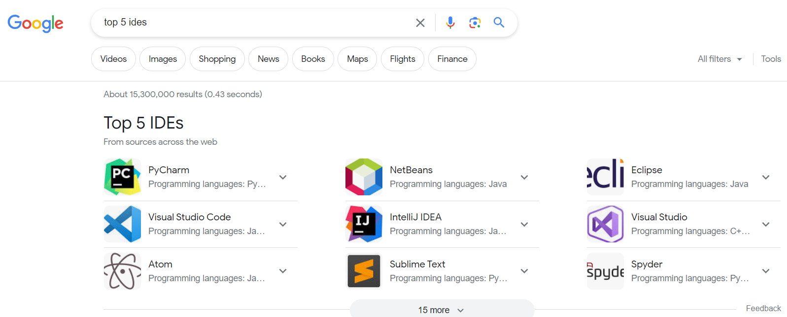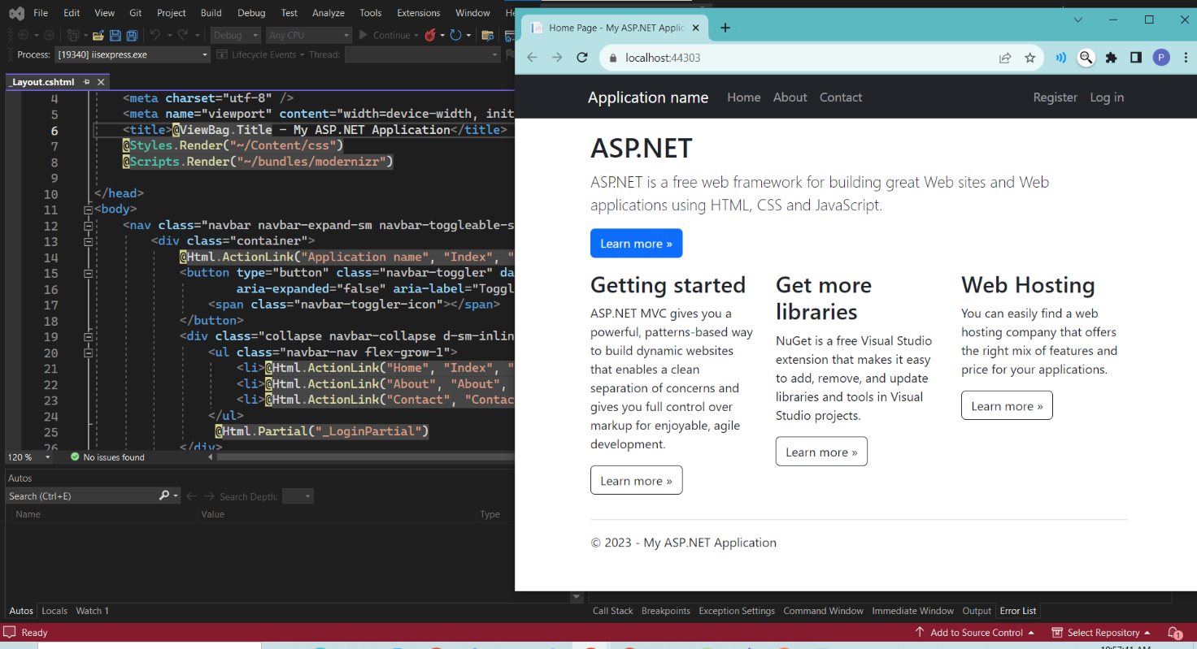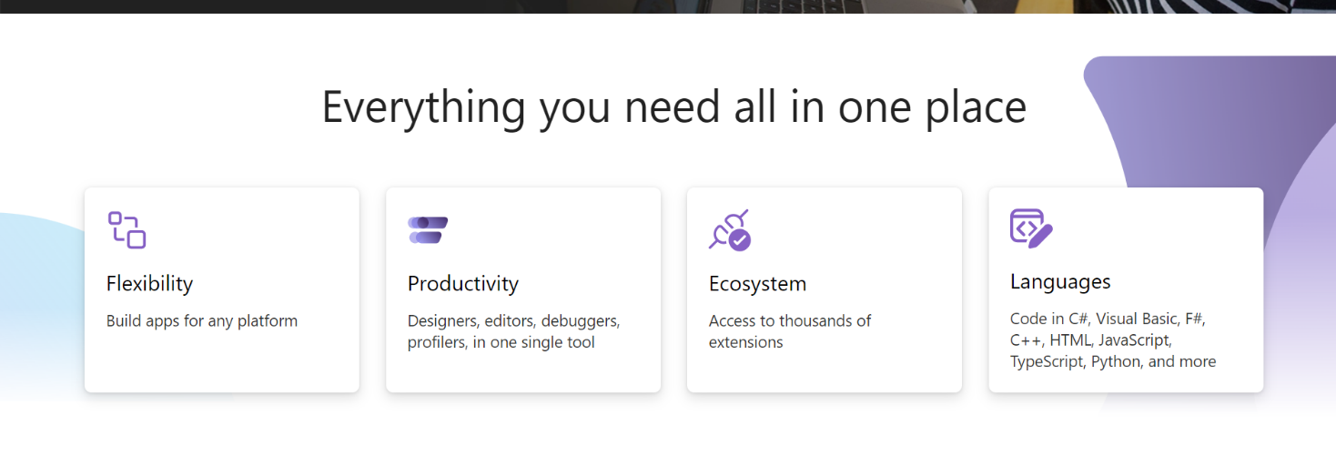

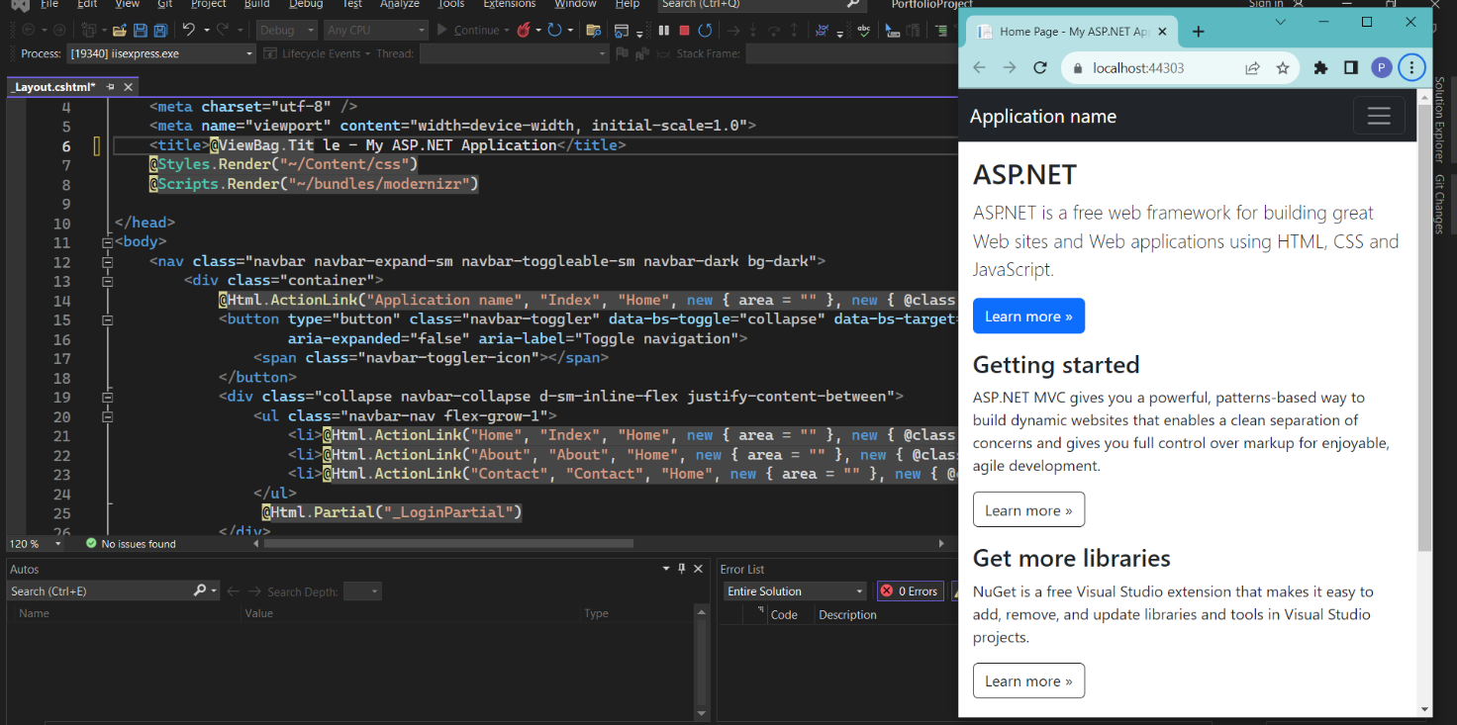

Link - https://github.com/prakspant/FIT5032.git

Task CSS Example, demonstrate responsiveness using Bootstrap, Database first development of ASP.NET MVC application using Visual Studio Scaffolding:

Cascading Style Sheets is a programming language to complement HTML webpages that can create stylings, animations, and other static and dynamic content for HTML web pages.  
Bootstrap is a CSS framework that enables us to speed up our development drastically with pre styled buttons navbars etc.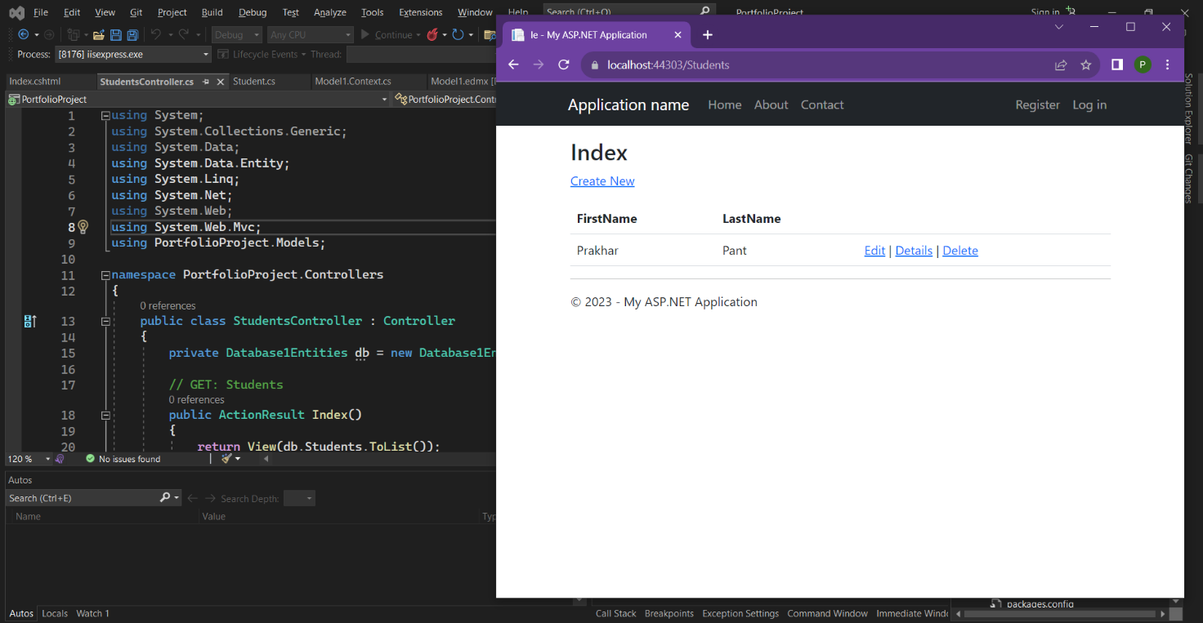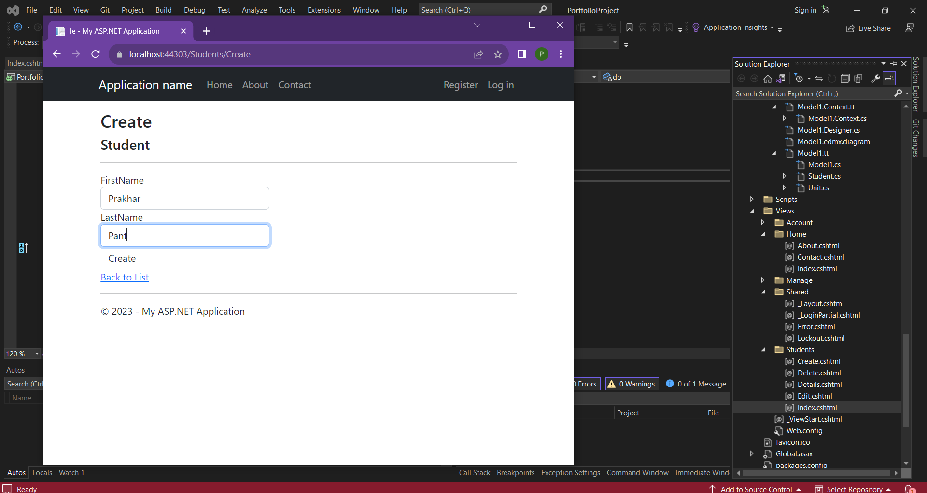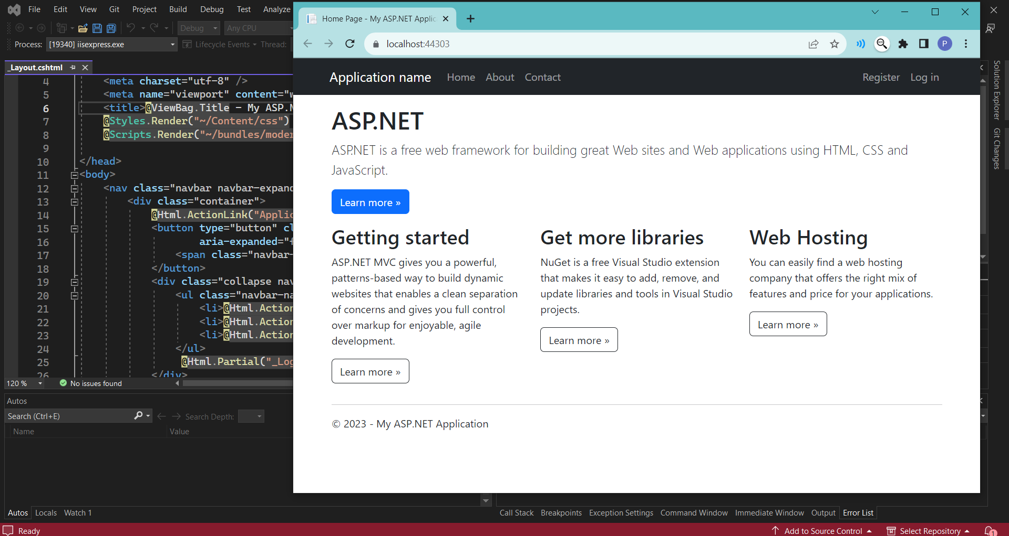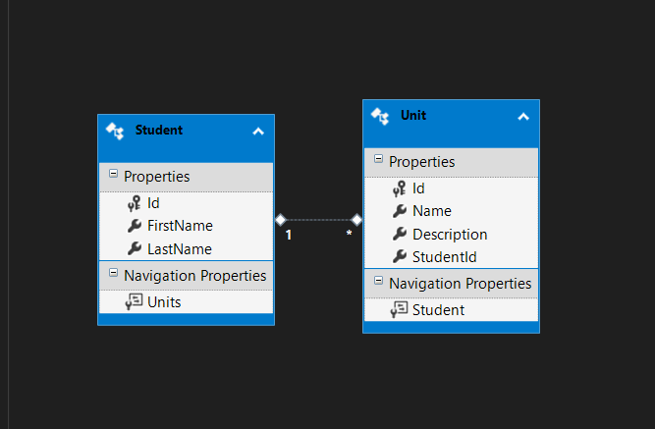

Link - https://github.com/prakspant/FIT5032.git