Fortnightly eFolio submission

Studio 3 & 4

Name and Student Id: Prakhar Pant: 33915350

Self-Evaluation HD:

|  |  |  |  |  |  |
| --- | --- | --- | --- | --- | --- |
| Need Help | Work in Progress | Pass | Credit | Distinction | High Distinction |

Task 3.1:

Following the steps in week 3’s introduction to C# activity. I have modified the viewbag message for the about page to display “Hello World!” by creating a new Hello.cs class in HelloWorld namespace with a method GetHello() that returns the string “Hello World!”.

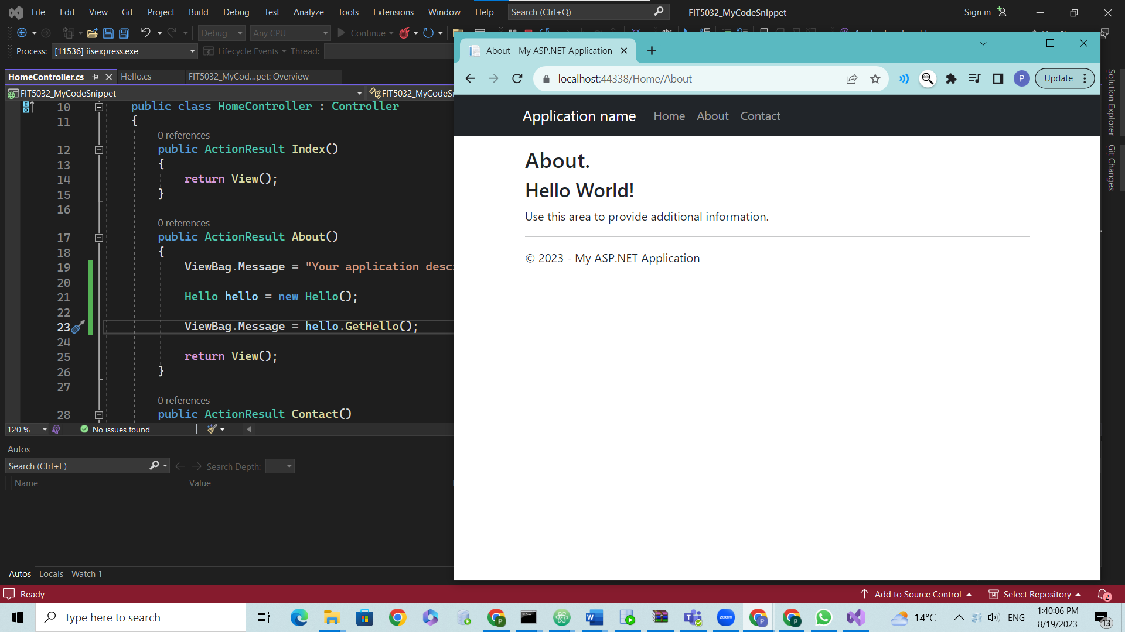

Link to GitHub repository - https://github.com/prakspant/FIT5032

Task 3.2:

I used a previously created GitHub account to create a repository for the project. The project is stored in that account in a public repository.

GitHub username - prakspant

Repository URL - <https://github.com/prakspant/FIT5032>

Task 4.1:

Following the steps provided in week 4s model first approach till the end –

Task 4.2:

Following screenshots provide a running application with the /Students and /Units page visible where we can perform CRUD operations on them, built using code first approach.–

