Course Code: CSA1557

Course Name: Cloud Computing and Big Data Analytics

S.Prakul 192210073

6) Create a simple cloud software application for Payroll Processing System using any Cloud Service Provider to demonstrate SaaS include the necessary fields such as Name of the employee, experience in present org , over all experience, basic pay, HRA, DA, TA, net pay, gross pay etc.

STEP 1:CREATE PAYROLL PROCESSING SYSTEM

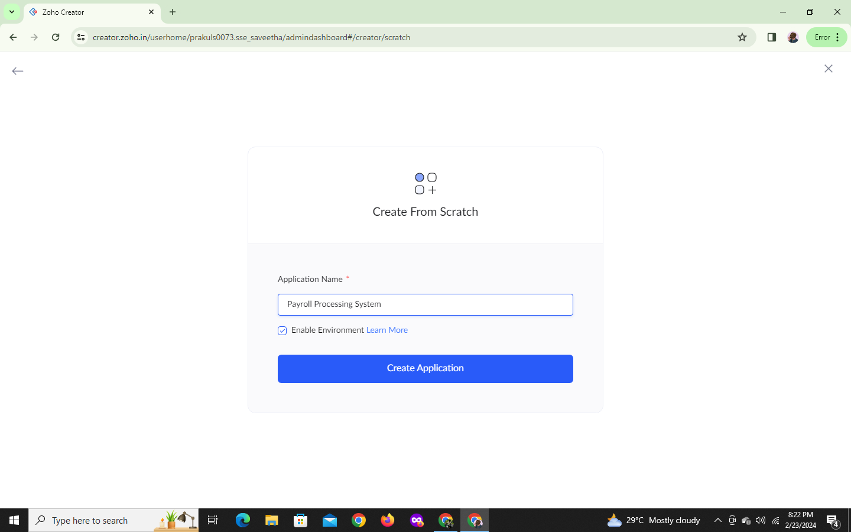

STEP 2:PAYROLL PROCESSING FORM WILL OPEN

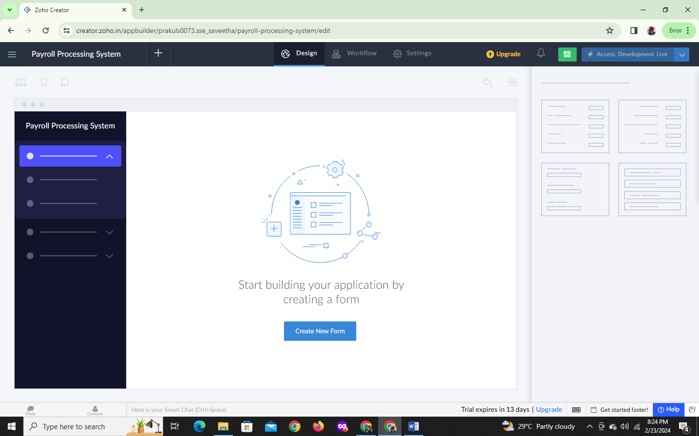

STEP 3:FROM STEP 2 CREATE A NEW FORM EMPLOYEE INFORMATION

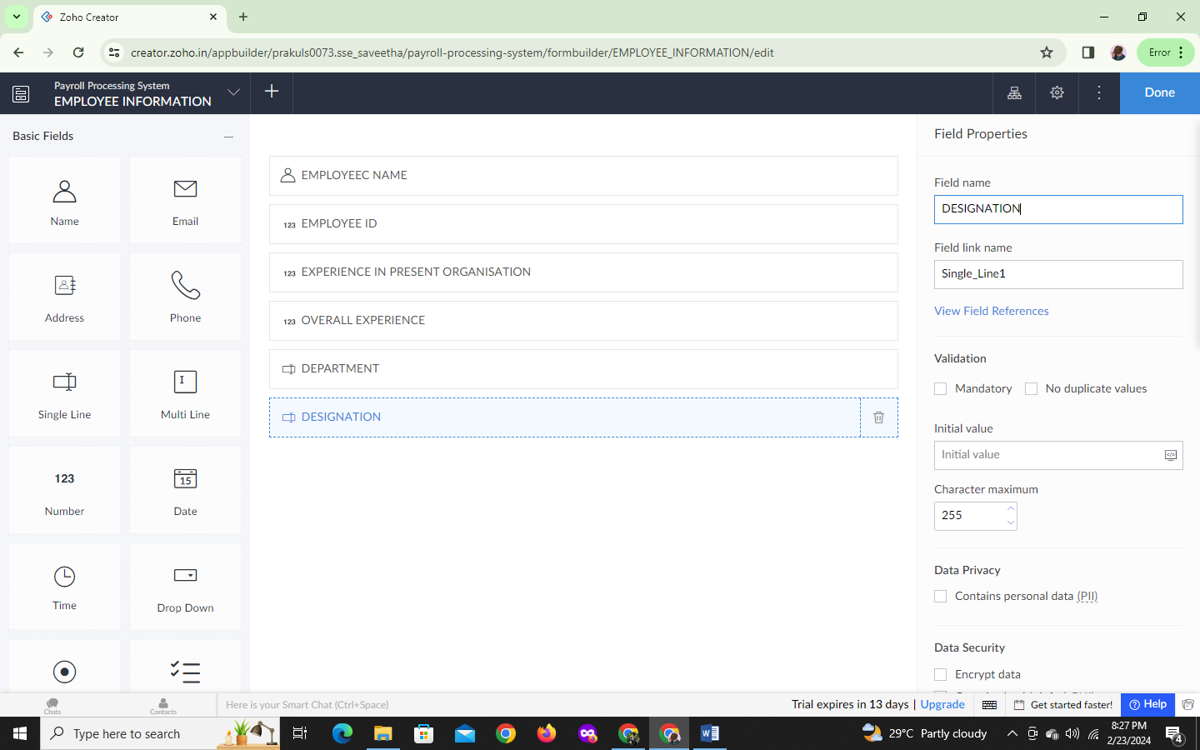

STEP4:FILL THE DETAILS

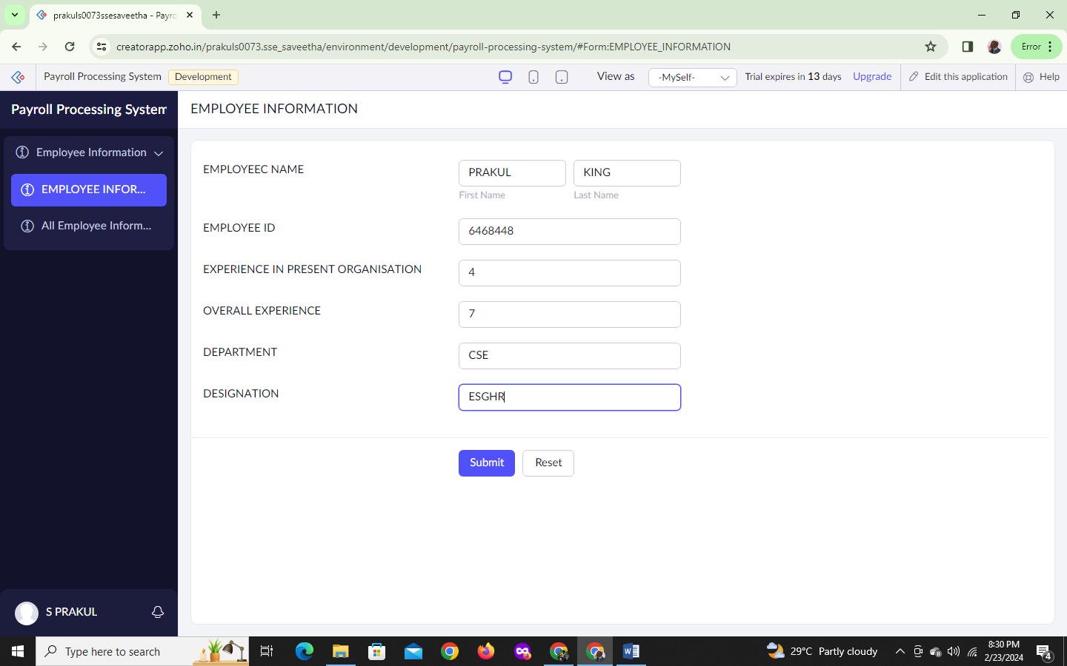

STEP 5:GIVEN EMPLOYEE INFORMATION REPORT

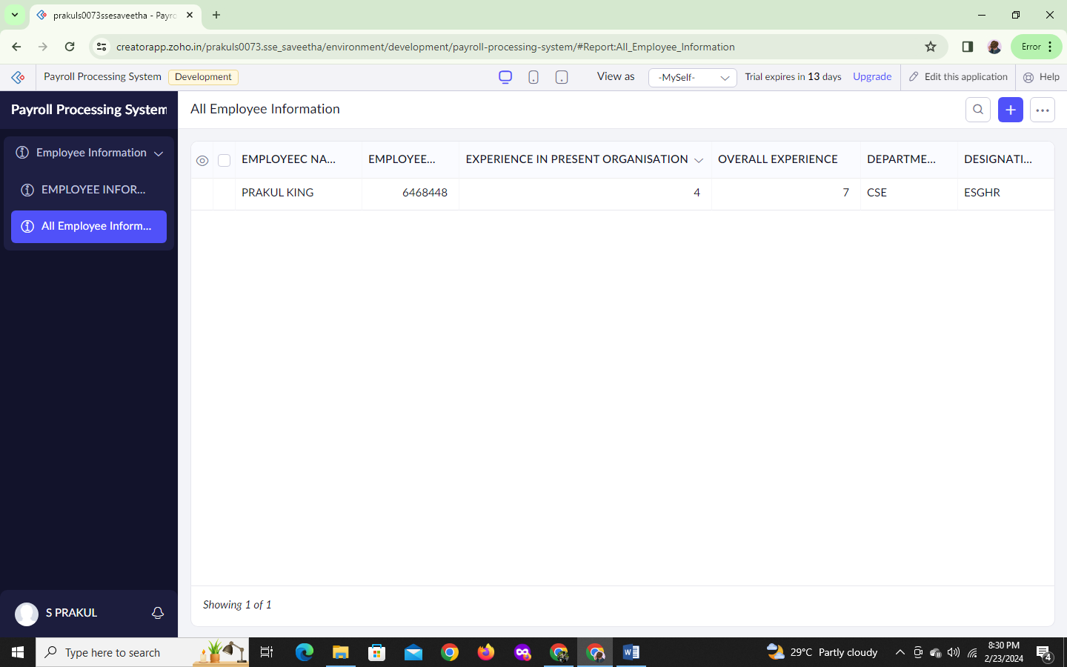

STEP 6:START A NEW FORM

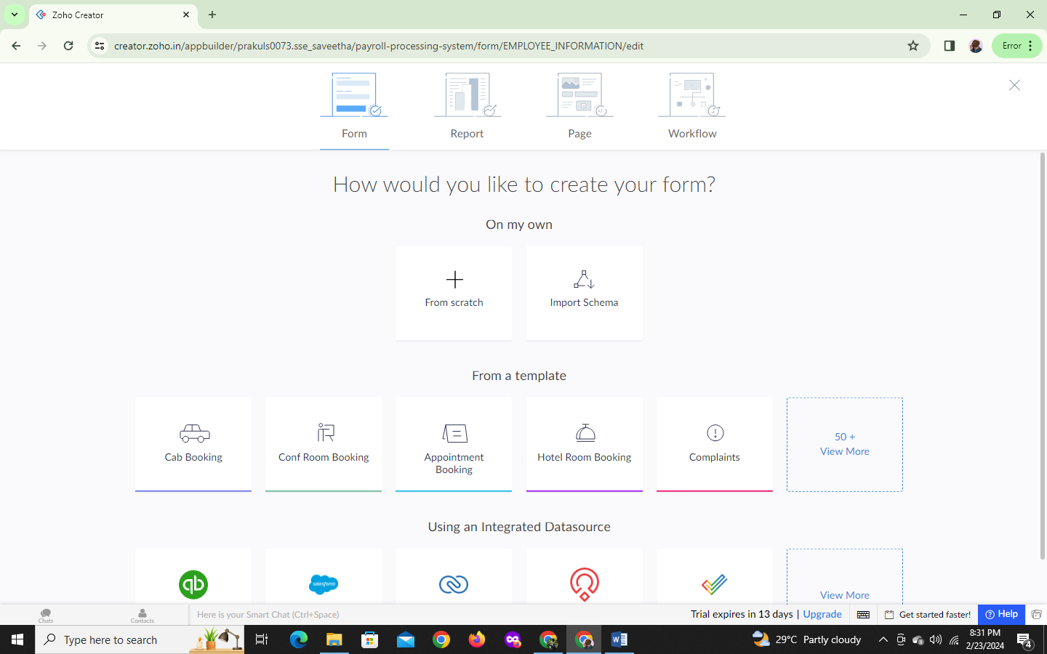

STEP 7:CREATE A TITLE AS SALARY INFORMATION

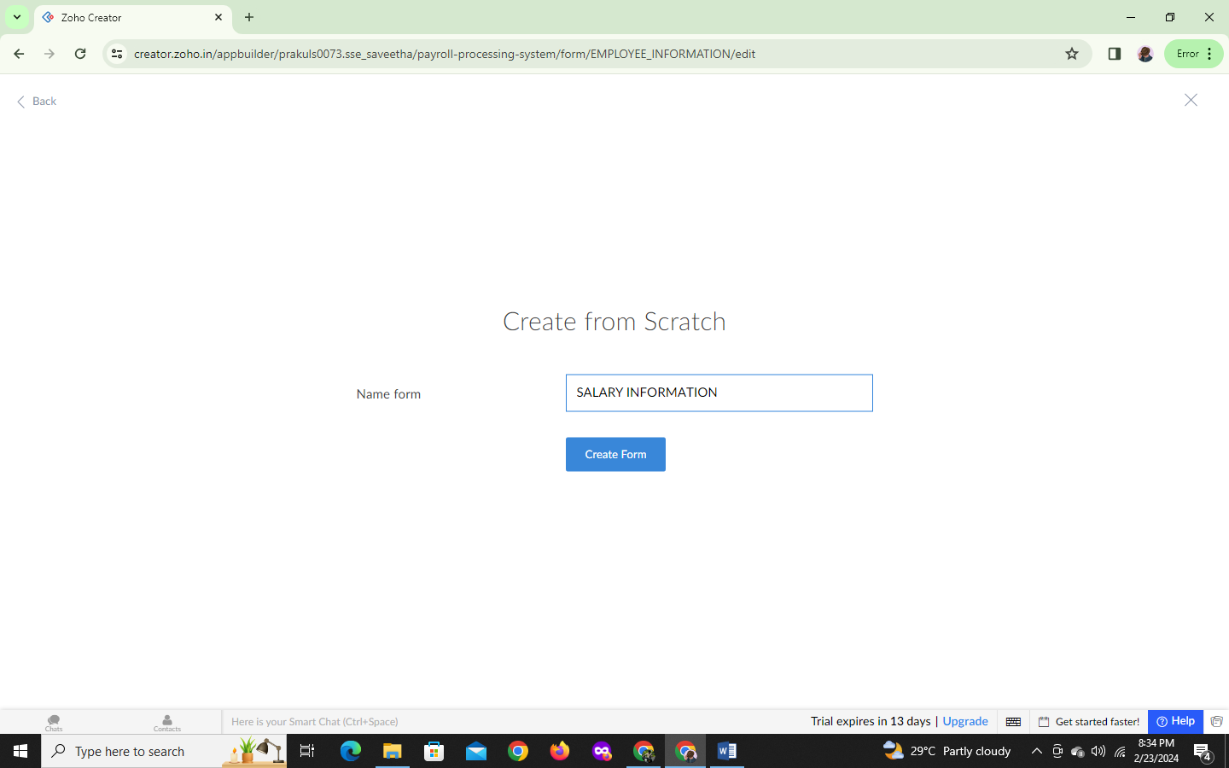

STEP 8:CREATE A FORM

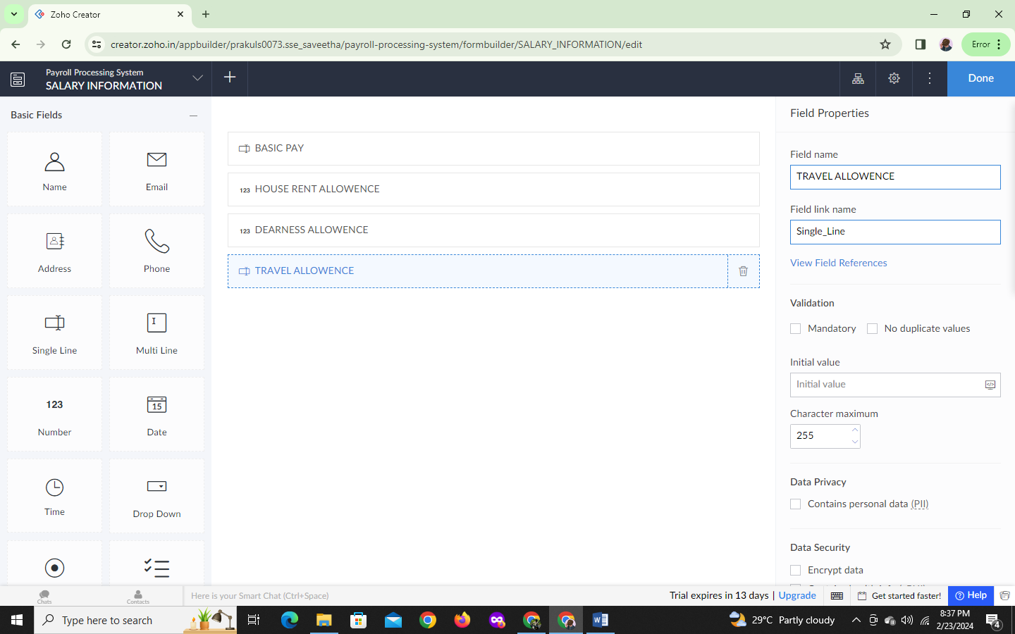

STEP 9:FILL THE DETAILS

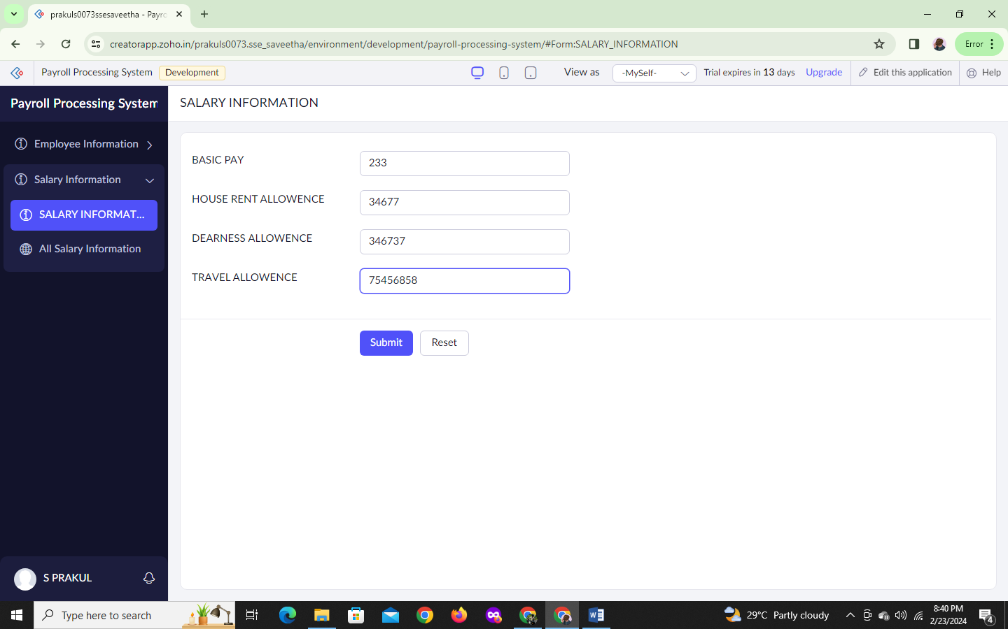

STEP 10:GIVEN SALARY INFROMATION REPORT

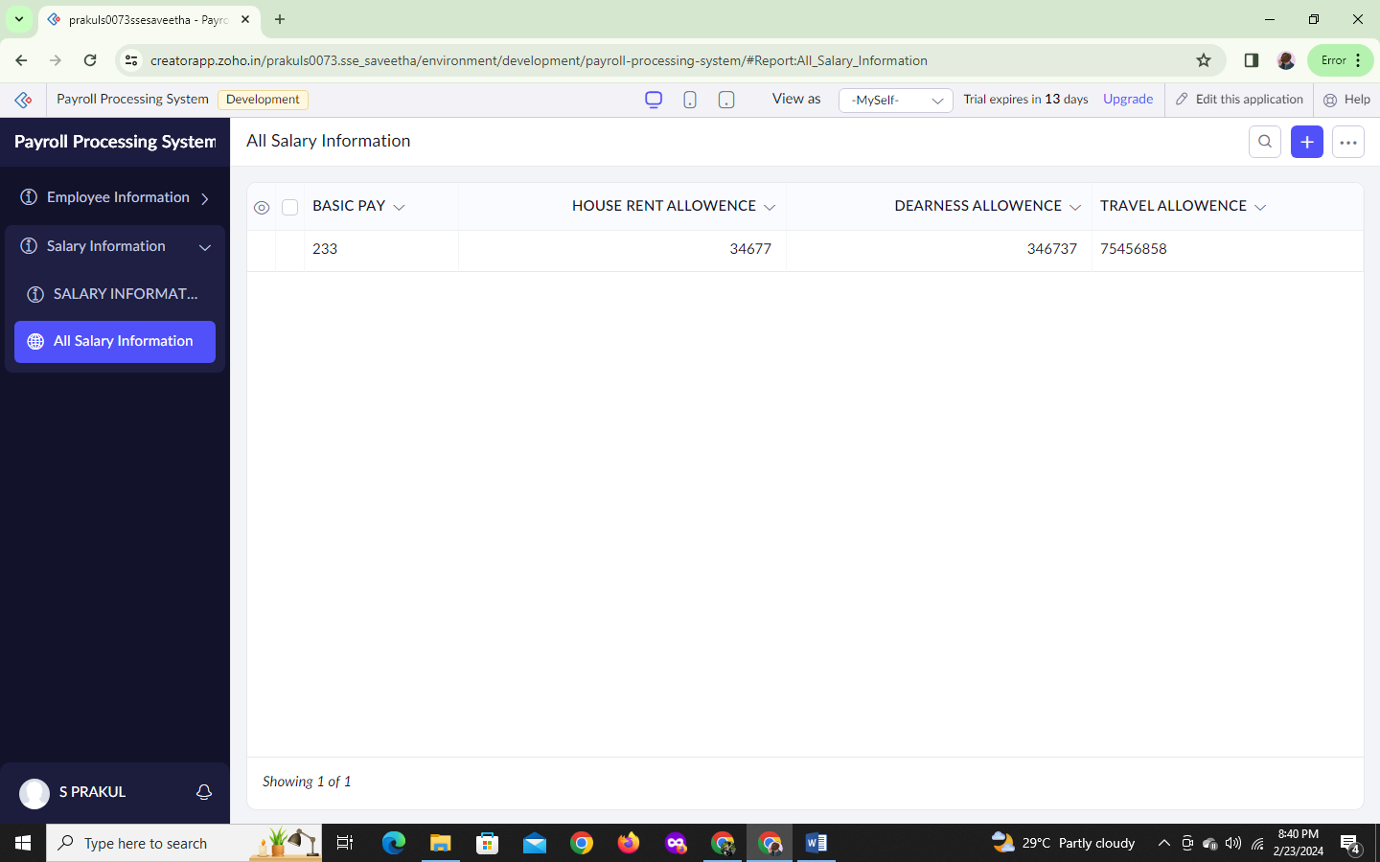

STEP 11:CREATE A NEW FORM SCRATCH TITLE AS TAX INFROMATION

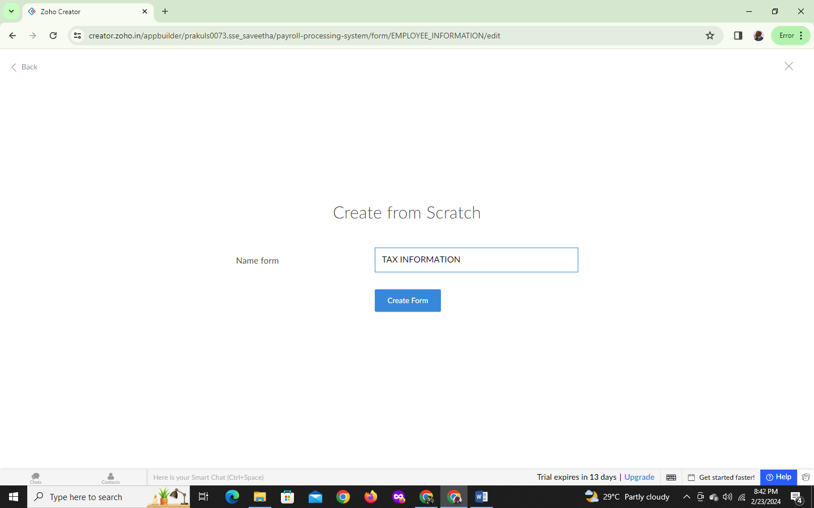

STEP 12:CREATE A FORM

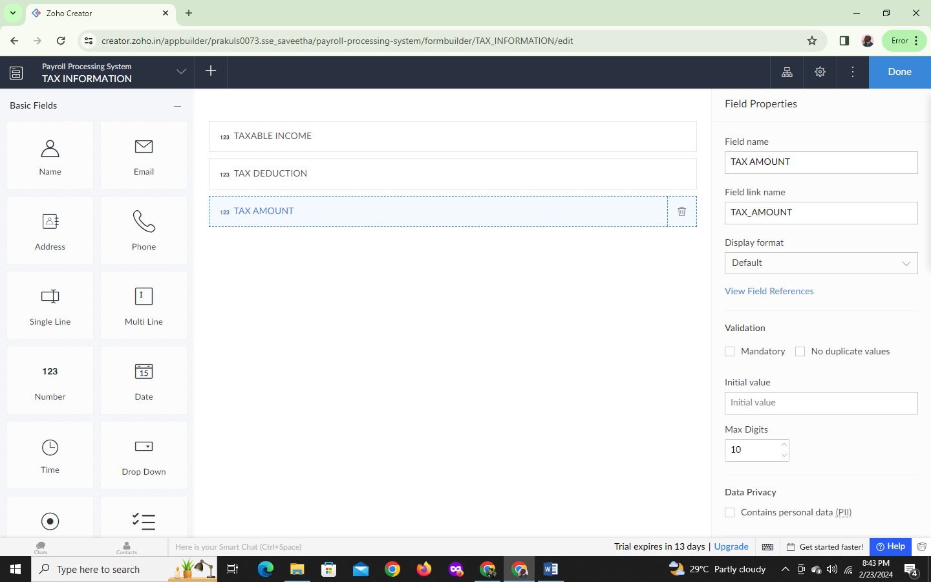

STEP 13:GIVE DETAILS

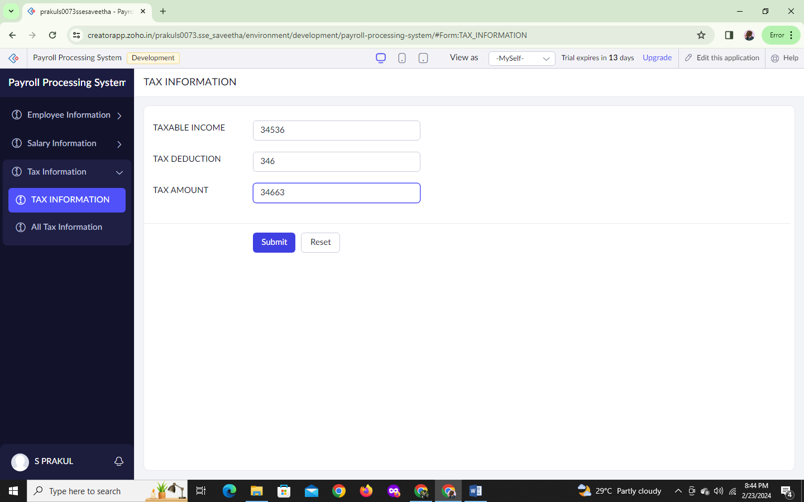

STEP 14:THESE TAX INFORMATION REPORT

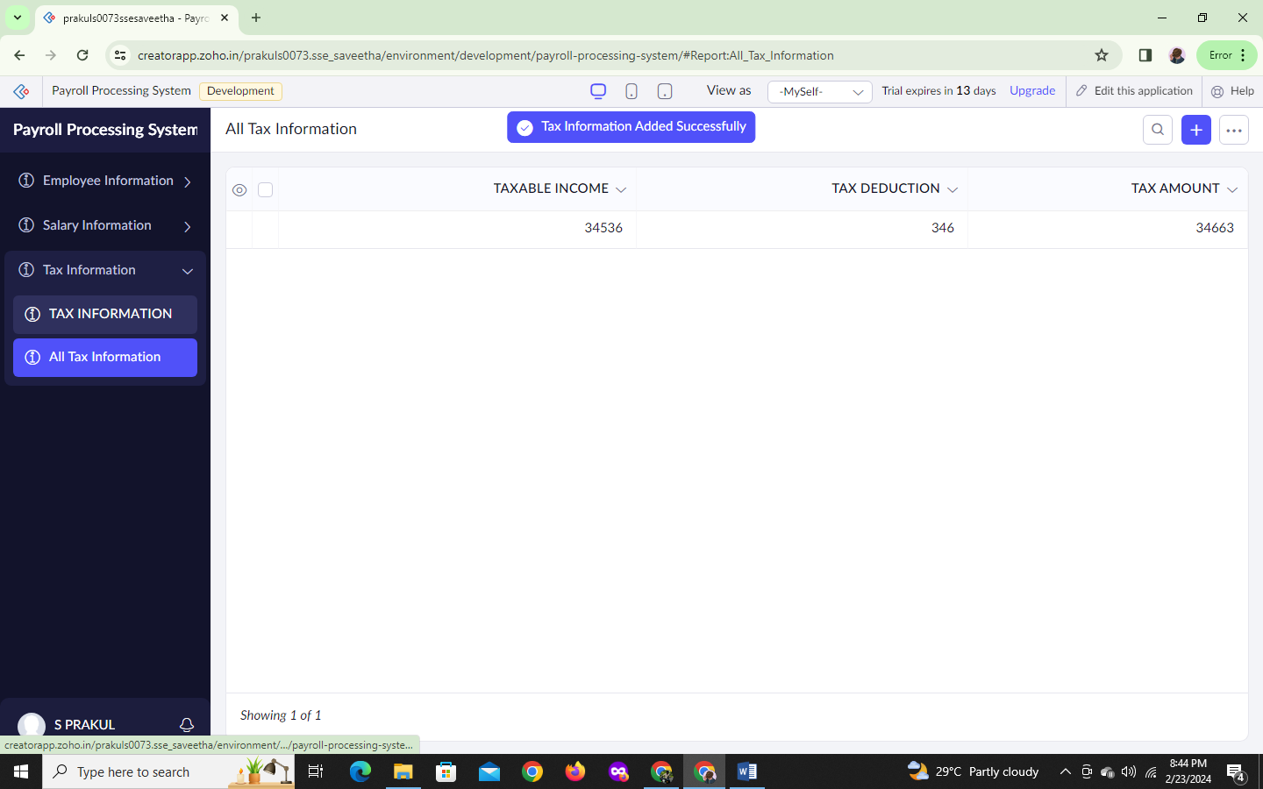

STEP15:CREATE A NEW FORM

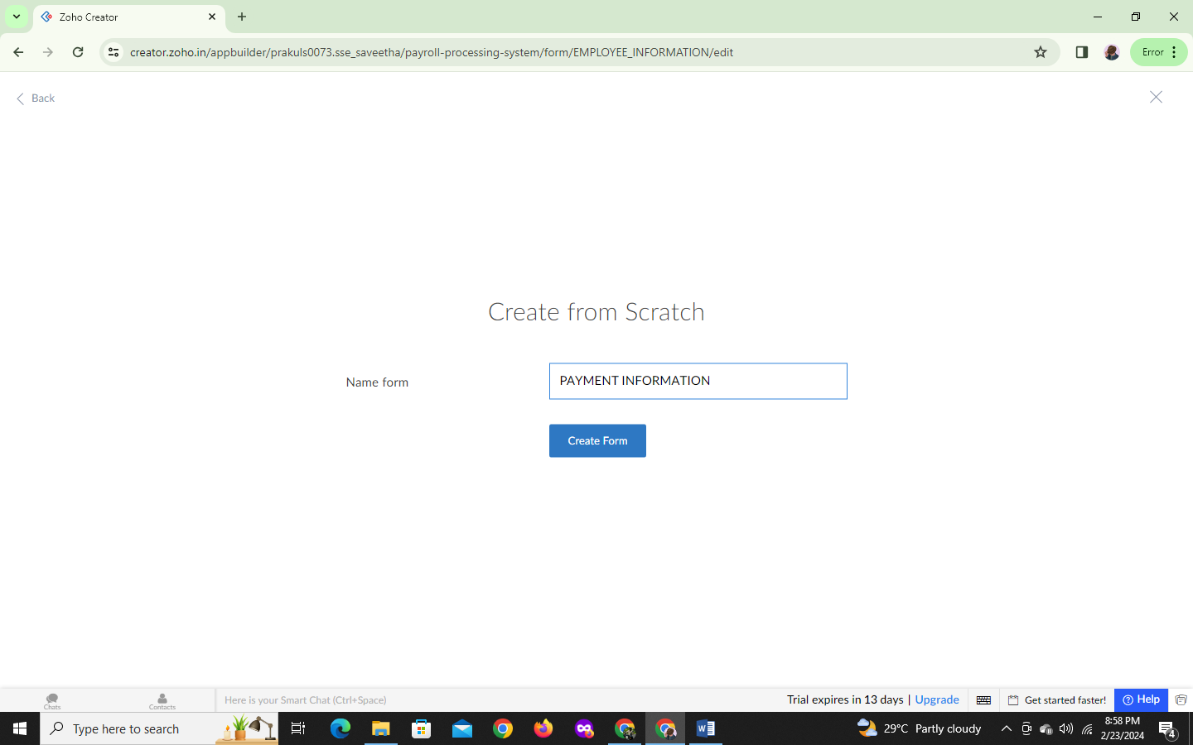

STEP 16:CREATE A FORM FOR PAYMENT INFORMATION

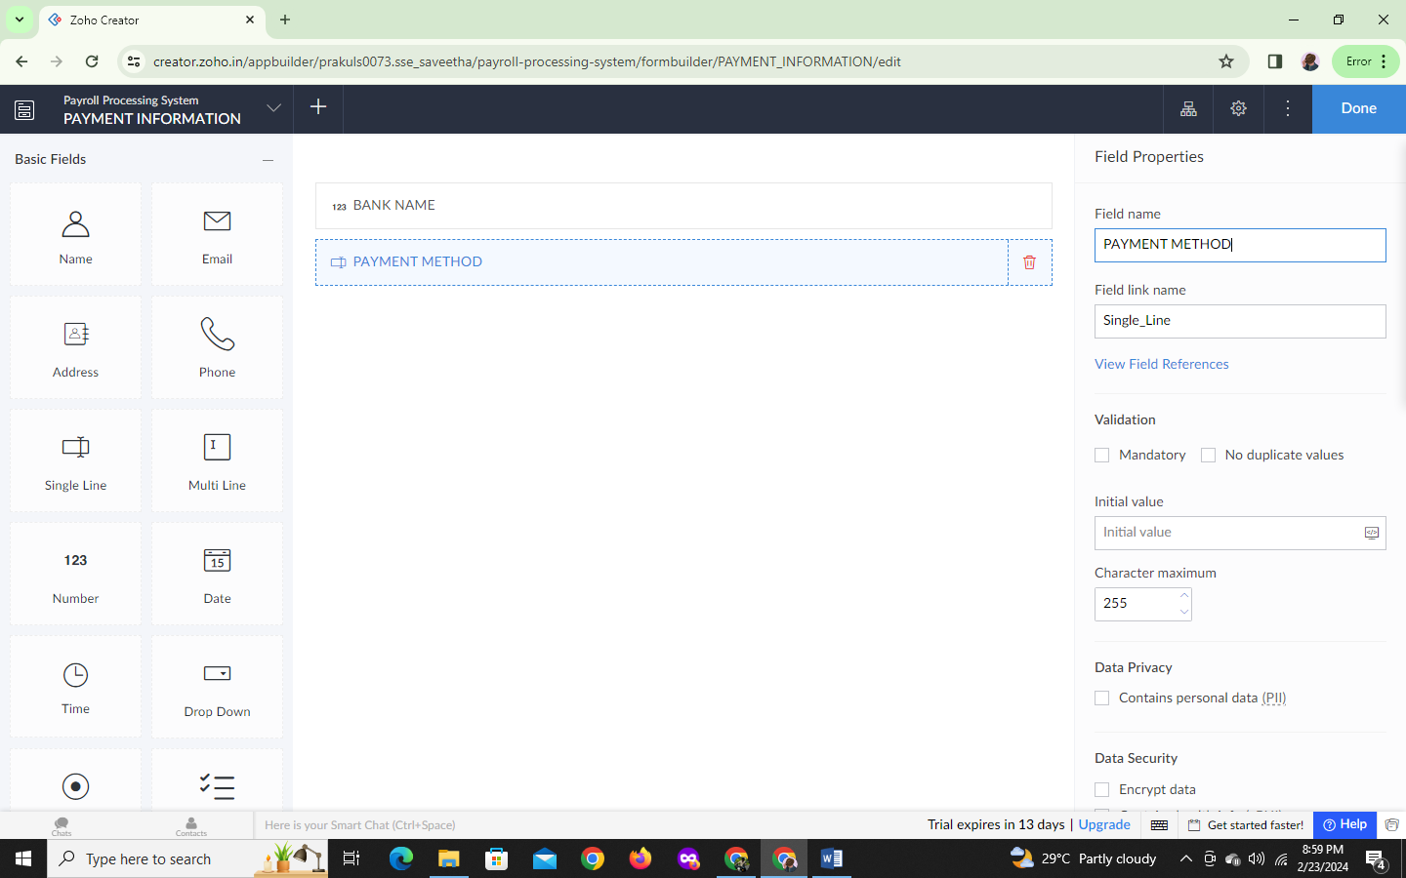

STEP 17:FILL PAYMENT INFORMATION DETAILS

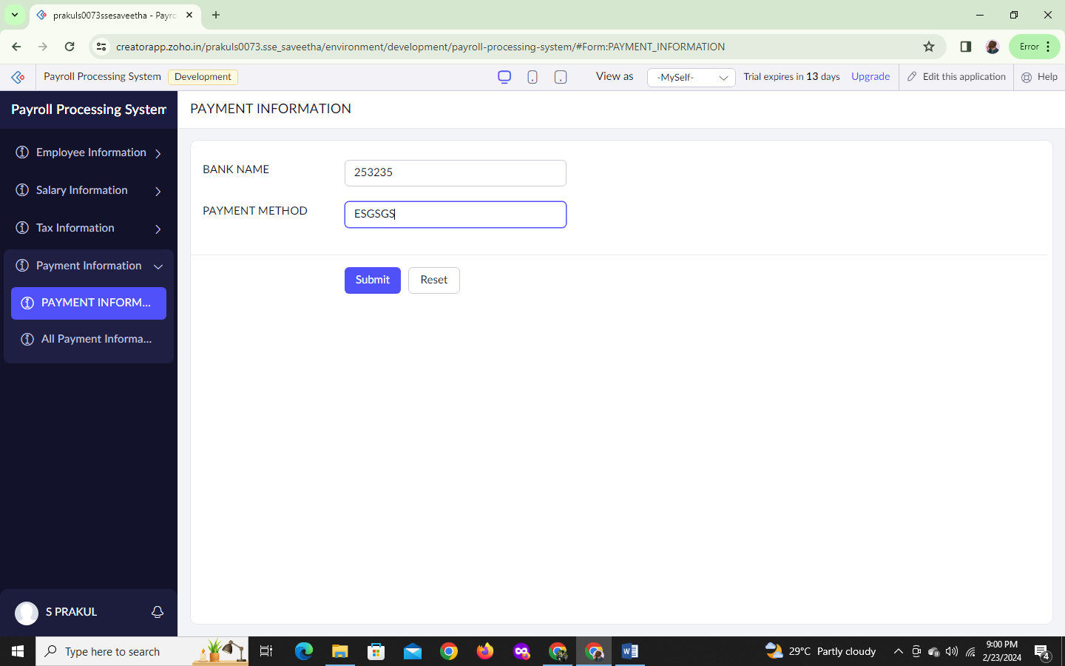

STEP 18:PAYMENT INFORMATION REPORT

