**Class:** Final Year (Computer Science and Engineering)

**Year:** 2021-22 **Semester:** 1

**Course:** High Performance Computing Lab

**Practical No. 4**

**Exam Seat No:2018BTECS00100**

1. Exam Seat Number – Prakash Singh

**Problem Statement 1:**

Analyse and implement a Parallel code for below programs using OpenMP

considering synchronization requirements. (Demonstrate the use of different clauses and constructs wherever applicable)

**Screenshot #:**

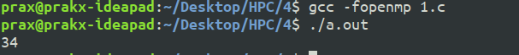

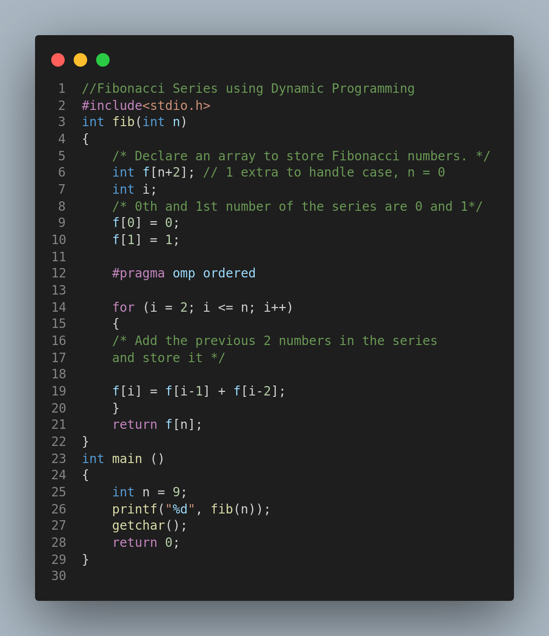

**Information #:**

**Used #pragma omp ordered**  to run to compute the fibonacci sum sequentially.

Problem Statement 1: Analyse and implement a Parallel code for below programs using OpenMP considering synchronization requirements. (Demonstrate the use of different clauses and constructs wherever applicable)

**Screenshot #:**

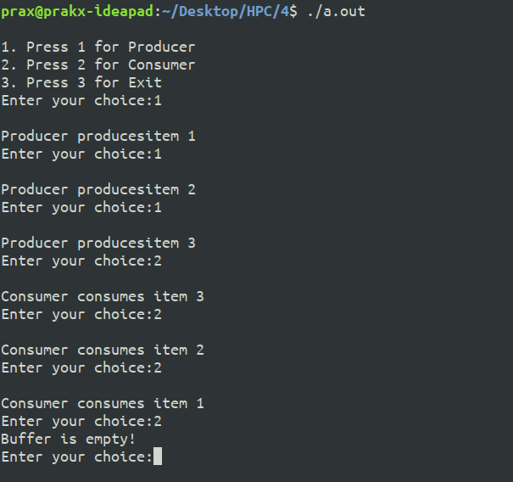

**Information #:**

**Using #pragma omp critical** , **we use the concept of parallel programming and Critical Section to implement the Producer-Consumer problem in C language using OpenMP.**

**Github Link:https://github.com/prakx1/HPC-LAB/tree/master/4**