**Class:** Final Year (Computer Science and Engineering)

**Year:** 2021-22 **Semester:** 1

**Course:** High Performance Computing Lab

**Practical No. 5**

**Exam Seat No:2018BTECS00100**

1. Exam Seat Number – Prakash Singh

**Problem Statement 1:**Implement blocking and non-blocking MPI send & receive to demonstrate Nearest neighbour exchange of data in a ring topology.

**Screenshot #1:**

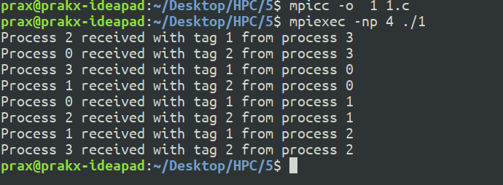

**Information #:**

Implemented blocking and non-blocking MPI send & receive to demonstrate Nearest neighbour exchange of data in a ring topology.



**Problem Statement 2:** Implement a MPI program to give an example of non-blocking send and receive between four processes.

**Screenshot #1:**

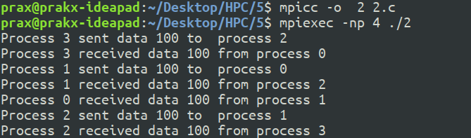

**Information :**

Implemented a MPI program to give an example of non-blocking send and receive between four processes.

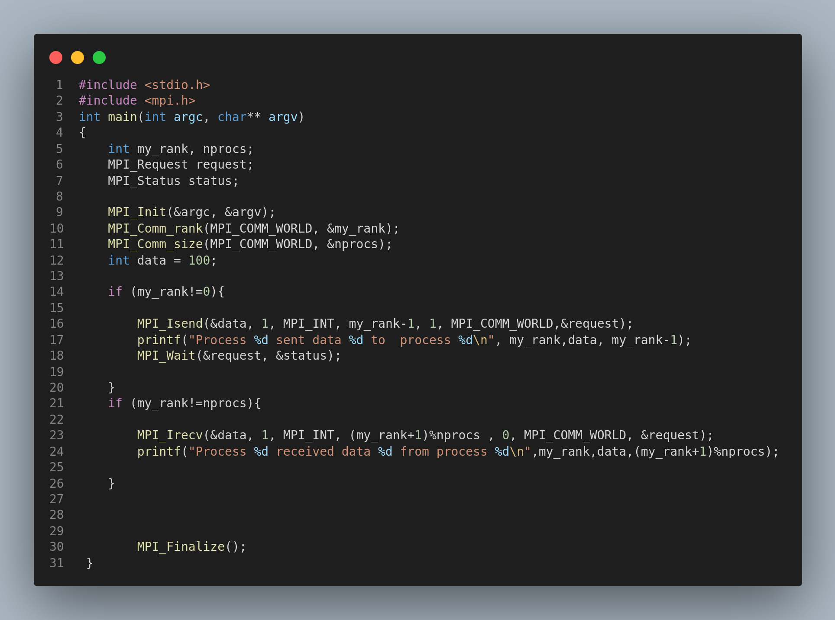

**­**

**Problem Statement 3:**Write a MPI program to find the product of all the elements of an array A of size n using m

number of processes. The two sums then are added to get the final result.

**Screenshot 1:**



**Information :**

A MPI program to find the product of all the elements of an array A of size 6 using 2 number of processes. The two sums then are added to get the final result by using MPI_REDUCE.

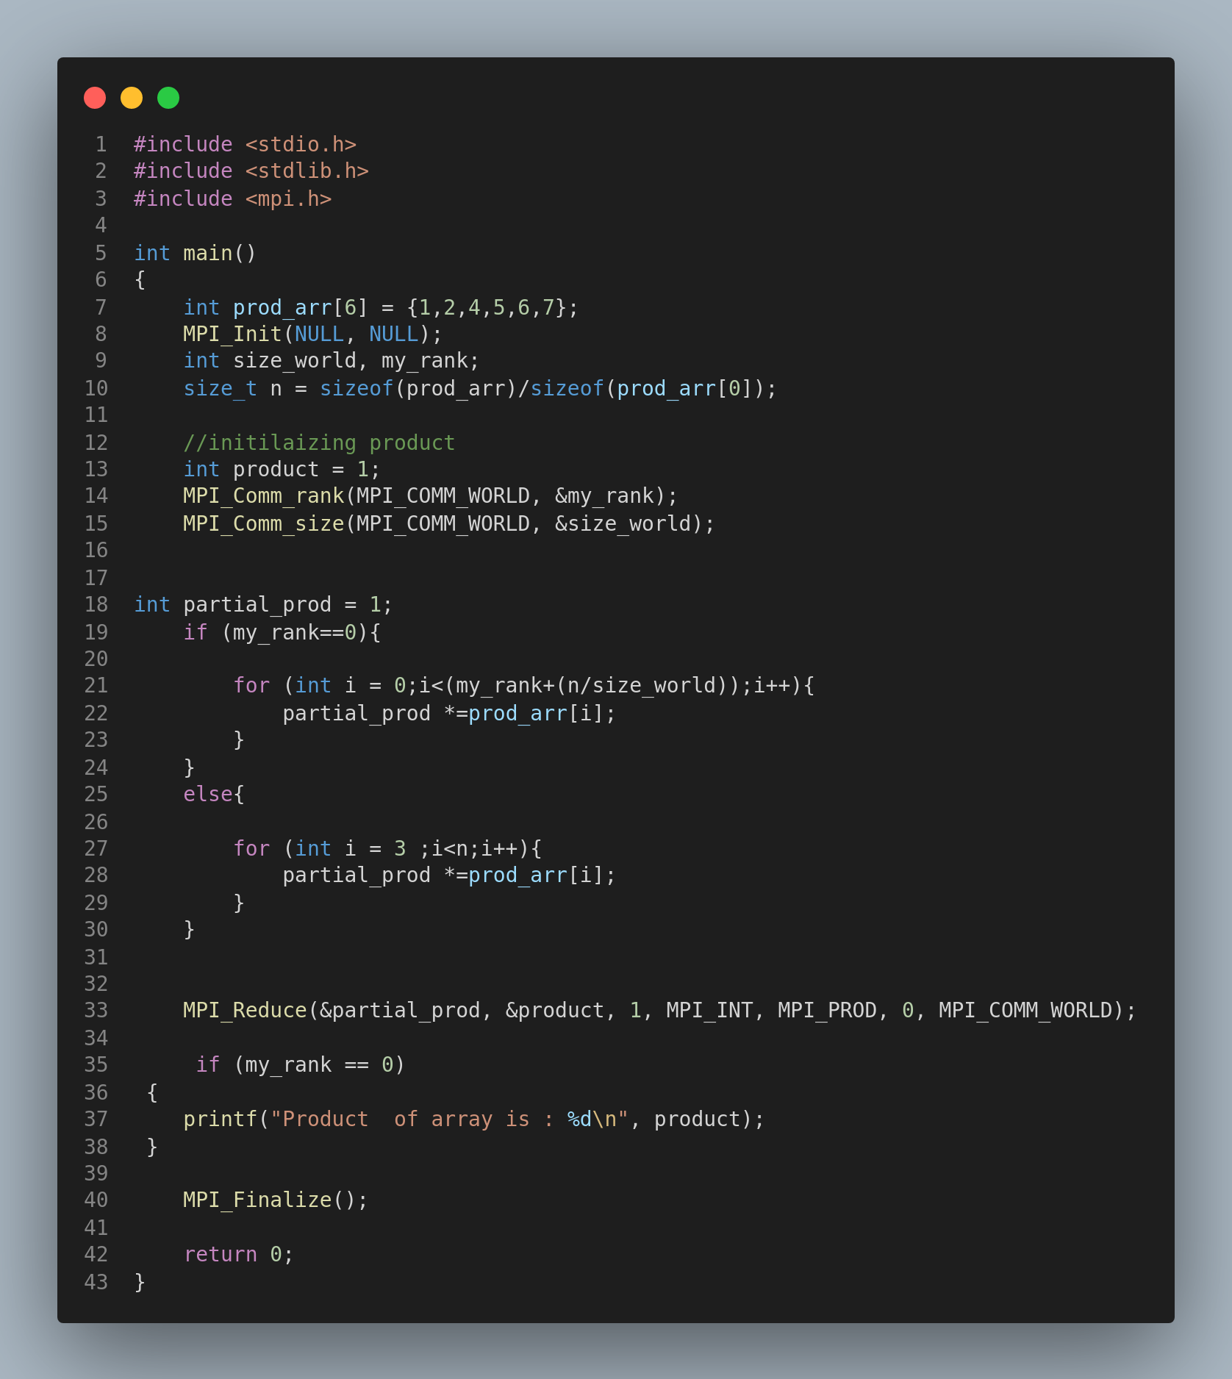

**Github Link: https://github.com/prakx1/HPC-LAB/tree/master/5**