**Class:** Final Year (Computer Science and Engineering)

**Year:** 2021-22 **Semester:** 1

**Course:** High Performance Computing Lab

**Practical No. 7**

**Exam Seat No:2018BTECS00100**

1. Exam Seat Number – Prakash Singh

**Problem Statement 1:** Setup the environment requirements, for execution of CUDA C programs.

**Screenshot #:**

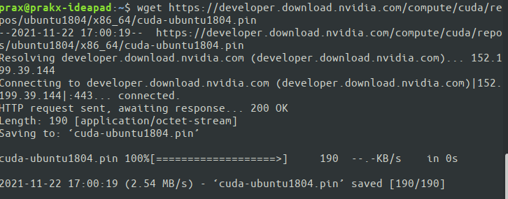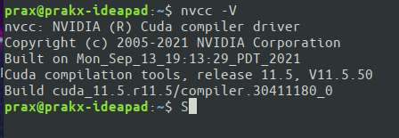

**Information #:** Installed CUDA 11.5 on ubuntu 18.04 LTS

**Problem Statement 2:**Execute the attached Program 1, and understand the output.

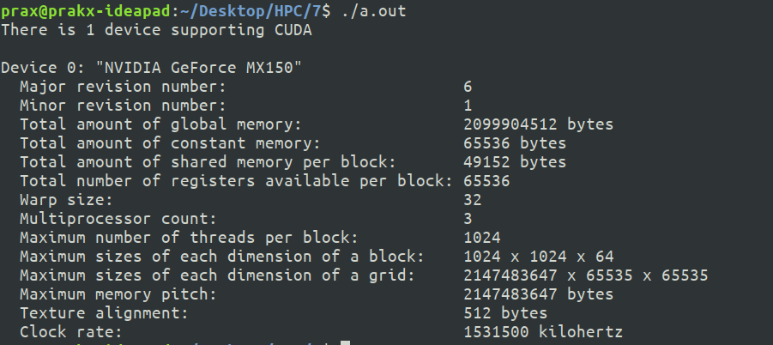**Screenshot #:**

**Information #:** The program gives device information (NVIDIA GeForce MX150) with global memory of 2GB.

**Problem Statement 3:** Write a CUDA C program to perform the addition of two vectors of arbitrary size

(Dynamic Array).

**Screenshot #:**

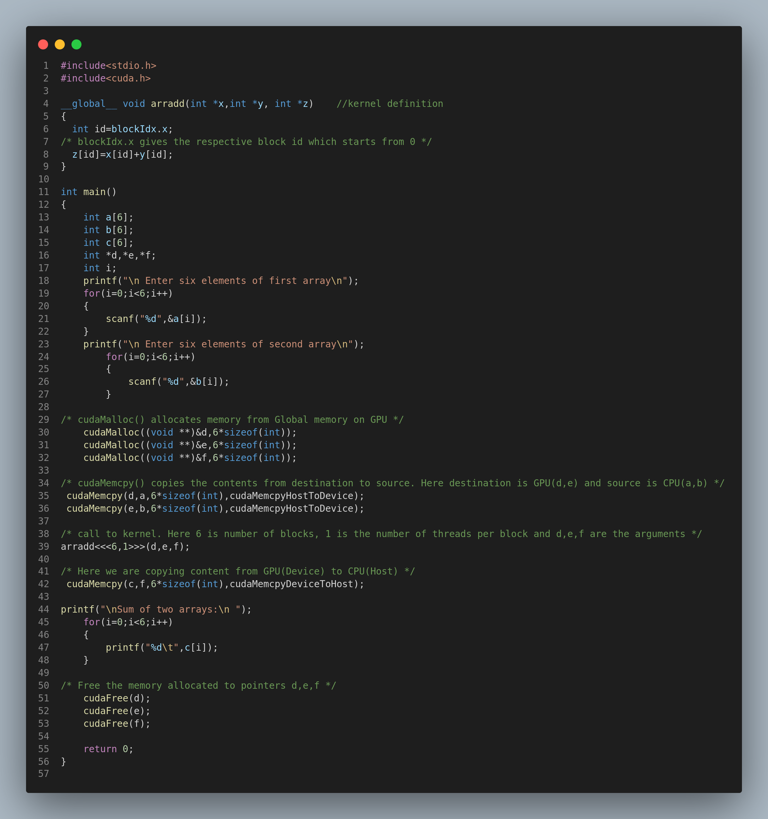

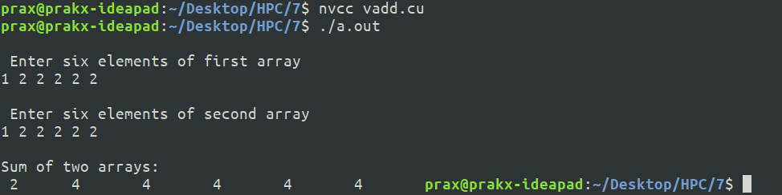

**Github Link:https://github.com/prakx1/HPC-LAB/tree/master/7**

**Note: (Remove this part)**

1. Upload only .pdf file on WCE Moodle.
2. Rename .pdf file with ExamSeatNumber_P#
3. Submit Document on moodle and code on Github in public repository.