**Class:** Final Year (Computer Science and Engineering)

**Year:** 2021-22 **Semester:** 1

**Course:** High Performance Computing Lab

**Practical No. 1**

**Exam Seat No:**

1. Exam Seat Number – 2018BTECS00100

**Problem Statement 1:**

**Screenshot #:**

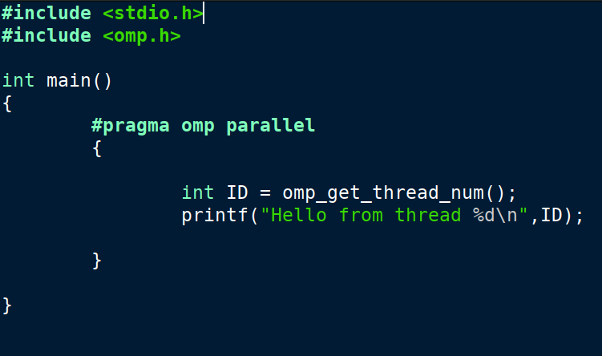

**Information #:**

**Code:**

**#include <stdio.h>**

**#include <omp.h>**

**int main()**

**{**

**#pragma omp parallel**

**{**

**int ID = omp_get_thread_num();**

**printf("Hello from thread %d\n",ID);**

**}**

**}**

**Screenshot #:**

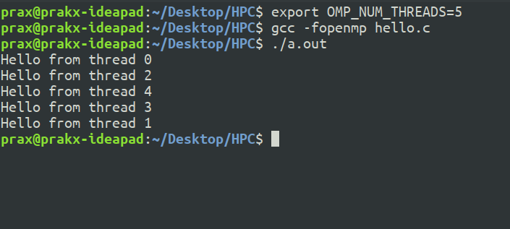

**Information #:**

**1)Setting number of threads to 5**

**2)Running the hello.c file using openmp in GNU compiler**

**Github Link: https://github.com/prakx1/HPC-LAB/tree/master/Practical1**