**Class:** Final Year (Computer Science and Engineering)

**Year:** 2021-22 **Semester:** 1

**Course:** High Performance Computing Lab

**Practical No. 2**

**Exam Seat No:**

1. Exam Seat Number – 2018BTECS00100

**Problem Statement 1:**

**Screenshot #:**

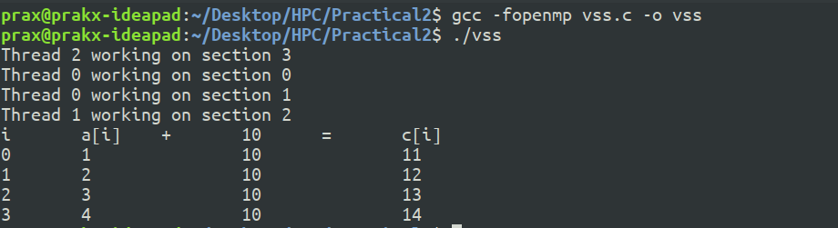

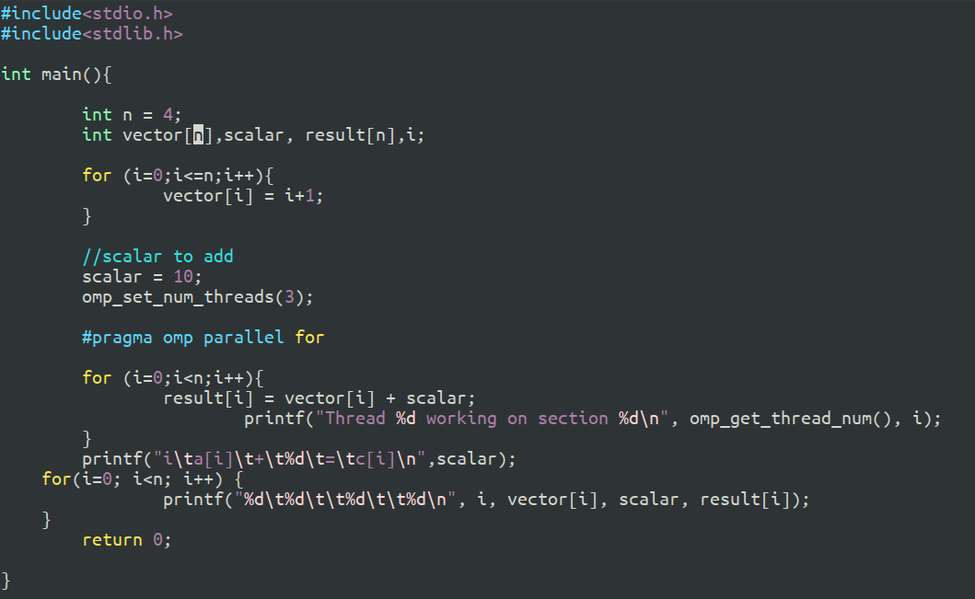**Information #:**

**Screenshot #:**

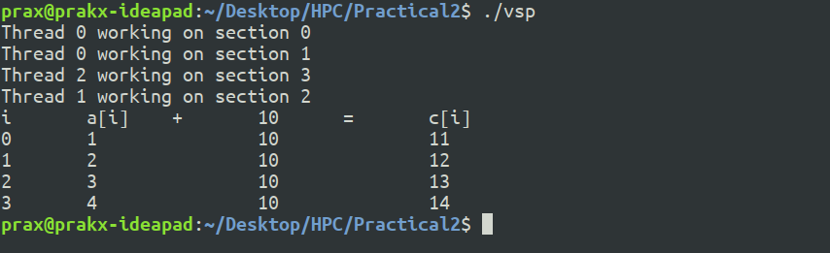

**Information #:**

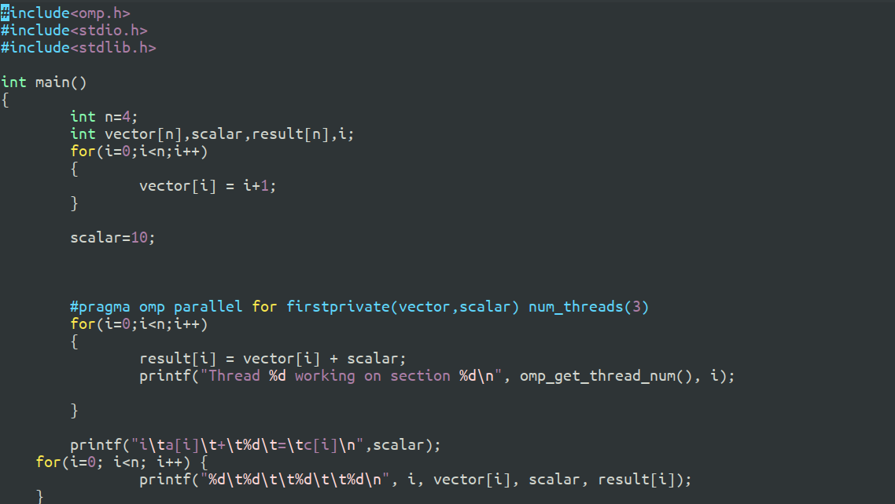

**Screenshot #:**

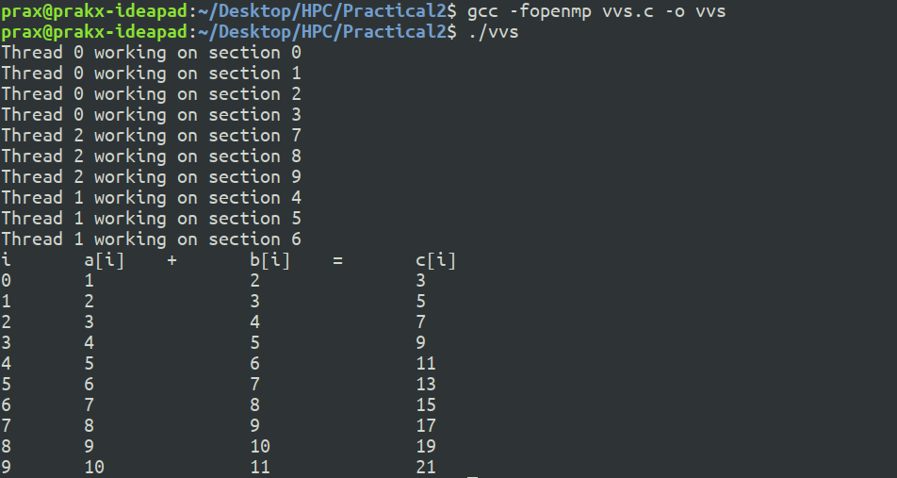

**Information #:**

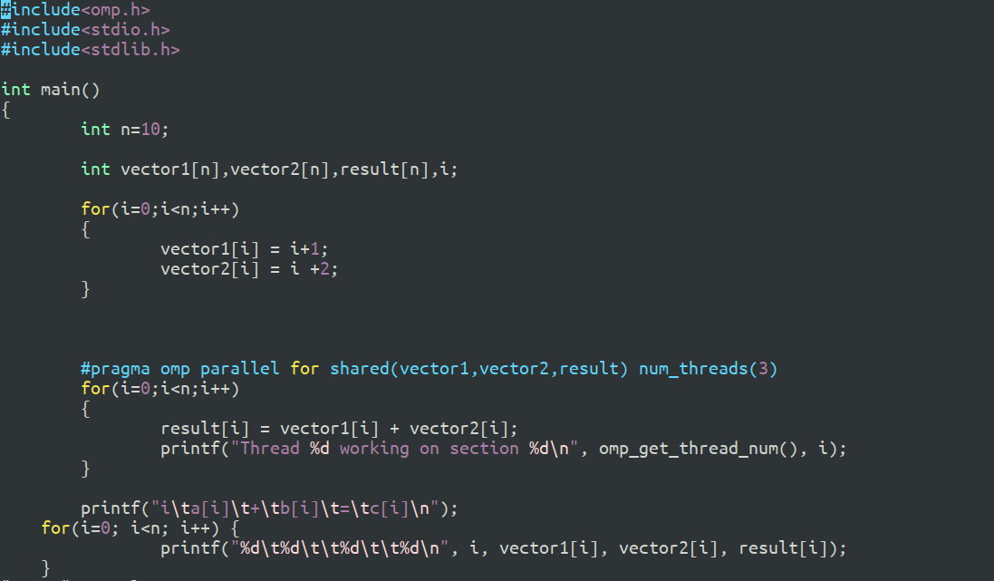

**Screenshot #:**

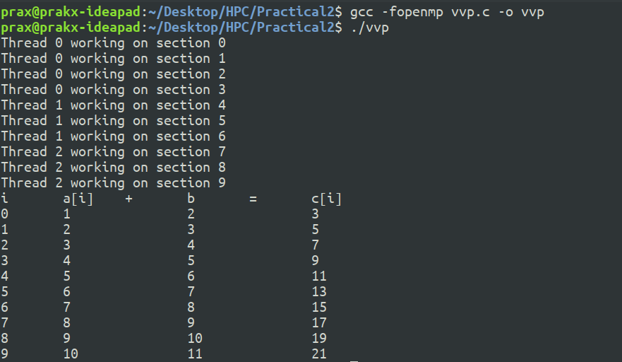

**Information #:**

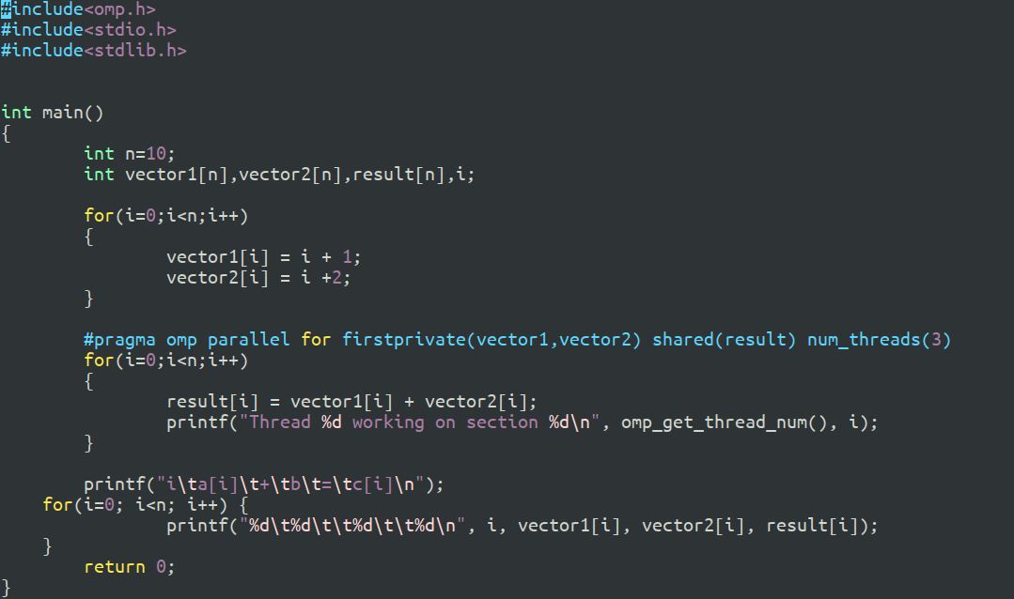

**1)Setting number of threads to 5**

**2)Running the hello.c file using openmp in GNU compiler**

**Github Link: https://github.com/prakx1/HPC-LAB/tree/master/Practical2**