Walchand College of Engineering, Sangli Department of Computer Science and Engineering

**Class:** Final Year (Computer Science and Engineering)

**Year:** 2021-22 **Semester:** 1

**Course:** High Performance Computing Lab

**Practical No. 3**

**Exam Seat No:**

1. Exam Seat Number - 2018BTECS00100

**Problem Statement 1:**

**Screenshot #:**

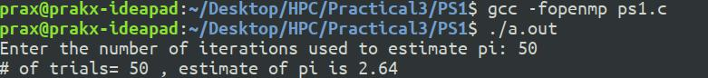

**Information #:**

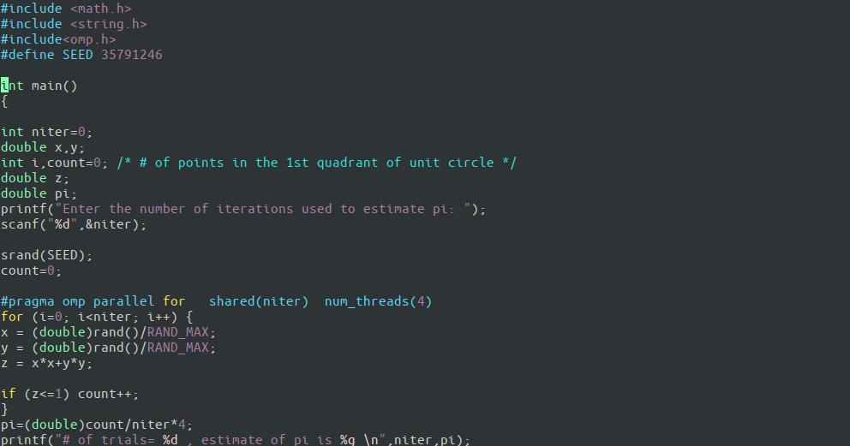

1 | P a g e



Final Year: High Performance Computing Lab

Walchand College of Engineering, Sangli Department of Computer Science and Engineering

**Problem Statement 2:**

**Screenshot #:**

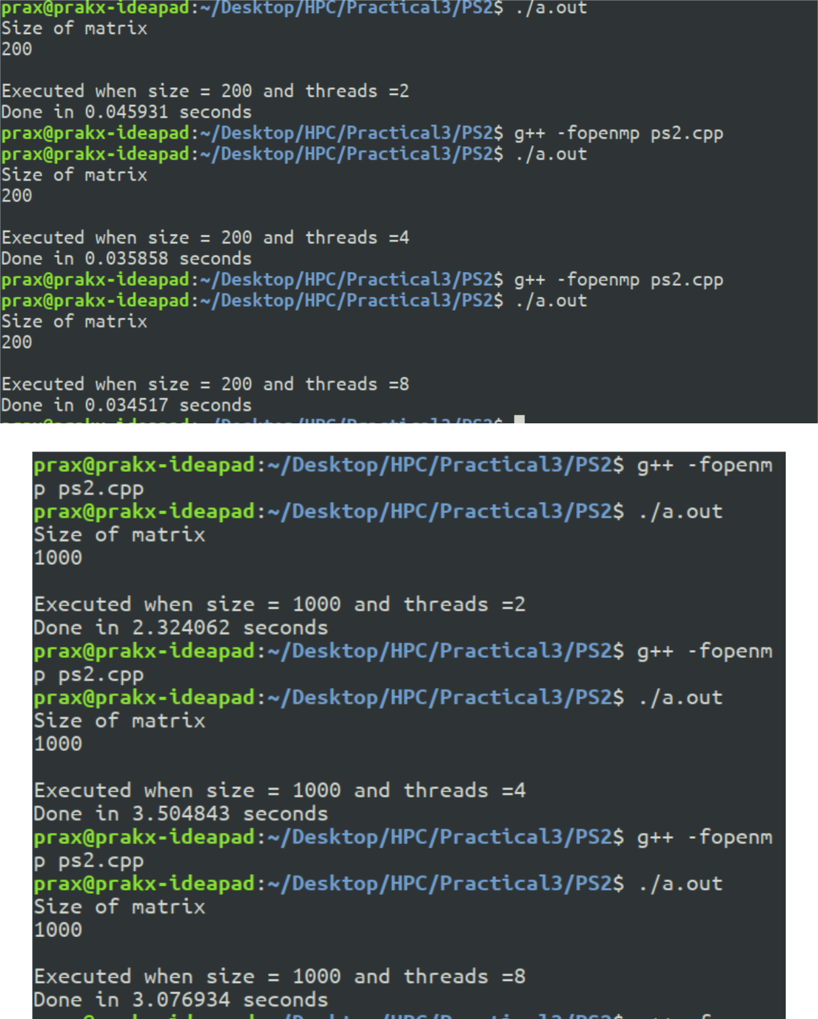

2 | P a g e



Final Year: High Performance Computing Lab

Walchand College of Engineering, Sangli Department of Computer Science and Engineering

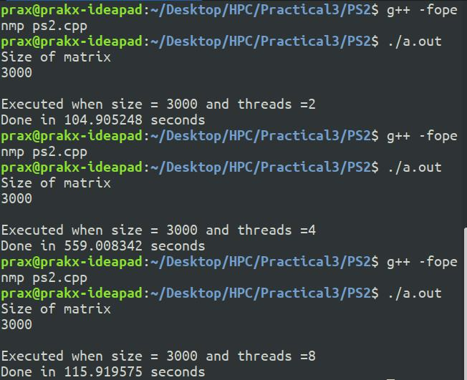

**Information #:**

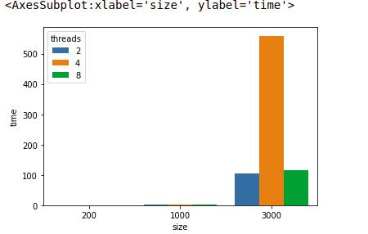

3 | P a g e



Final Year: High Performance Computing Lab

Walchand College of Engineering, Sangli Department of Computer Science and Engineering

**Problem Statement 3:**

**1) With static scheduling:**

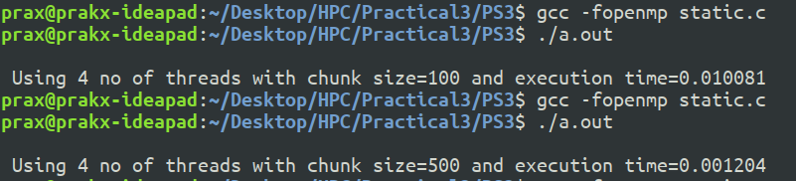

**Significant improvment in time as the chunk size in increased.**

**2)With dynamic scheduling:**

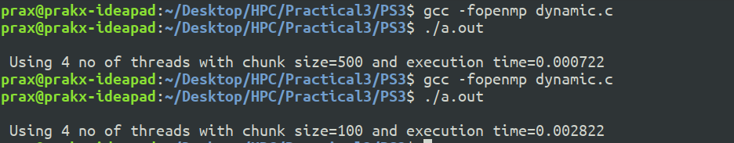

**3)With nowait**

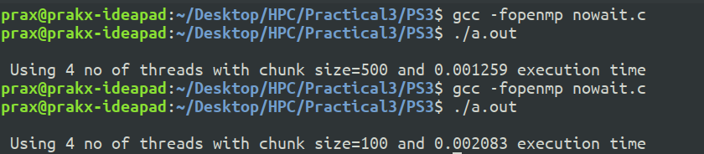

**Compairing all three:**

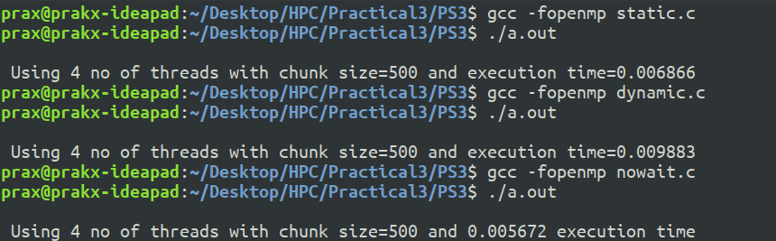

Conlusion: Significant improvment in time with nowait.

**Github Link:**

4 | P a g e



Final Year: High Performance Computing Lab