DAYANANDA SAGAR COLLEGE OF ENGINEERING
Department of Computer Science and Business Systems

AI-Based Wood Quality Assessment
Surface defect detection on sawn timber using YOLO11
7th Semester Major Project: 50% completion report

Team member | USN
Gurugubelli Gayatri | 1DS23CB014
Prakyat Pramod Shetty | 1DS23CB033
Saiprasad Rao | 1DS23CB041
Yasti Anil Kotak | 1DS23CB063

Guide | Mrs. Aparna H D, Assistant Professor, Department of CSBS, DSCE Bengaluru
Report date | 11 September 2026
Academic year | 2026-27

1. Abstract
Wood surface defects such as knots, cracks, resin pockets and pith lines reduce the usable portion of sawn timber, and manual grading is slow, subjective and hard to keep consistent at scale. This project builds an AI-based computer-vision system that detects, classifies and localises surface defects on timber boards from line-scan images, as the foundation for automated quality assessment and usable-area estimation. In the first half of the project we prepared a leakage-free dataset of 4,000 industrial board images with 8 defect classes, trained two YOLO11 detectors (YOLO11m as the proposed model and YOLO11s as a baseline) under identical, fully logged settings on Kaggle GPUs, and evaluated each once on 12 physically separate test boards. Both models reach 63 to 65 mAP50 and 33 to 34 mAP50-95 on the held-out boards, with the large knot classes above 85 mAP50, and run at 30 to 86 frames per second on a Tesla T4. A demonstration web application with bounding boxes, defect heatmaps, per-class statistics and a JSON report has been built for live testing. The remaining work covers recoverability estimation, image-enhancement experiments, architectural improvements and the final comparative study.

2. Introduction
- Visual grading of timber depends on human inspectors; fatigue and inter-inspector variation make results inconsistent, and throughput limits line speed.
- Defects differ in how much they matter: a live knot is cosmetic, a dead or missing knot weakens the board, a crack may make a section unusable. Any grading system therefore needs the defect type and its location, not only a yes/no answer.
- Modern one-stage detectors (the YOLO family) can find and classify small objects in real time, which makes them a natural fit for a conveyor-mounted camera.
- Our system takes a board image, returns every visible defect with its class, position, size and confidence, summarises defect coverage per board, and is designed to feed a recoverability estimate in the second half of the project.

3. Problem statement
Manual wood quality inspection is time-consuming and subjective, and available AI approaches mostly stop at detecting defects without a rigorous, leakage-free evaluation or a path to usable-area estimation. The project aims to develop an AI-based computer-vision system that detects, classifies and localises visible surface defects on timber boards, evaluates the detector honestly on boards it has never seen, and uses the detections to estimate the recoverable portion of each board.

4. Objectives and status at 50%
# | Objective (from synopsis) | Status | What has been done
1 | Develop a diverse, well-annotated dataset of good and defective wood under varying imaging conditions | Done (public data), enhancement pending | 4,000 annotated line-scan images (Kodytek et al. 2022 subset), 8 classes, 9,053 boxes after cleaning, split by physical board into train / val / test with zero board overlap. Imaging-condition variation (enhancement, low-light) is scheduled for the second half.
2 | Develop and evaluate a deep-learning framework for detecting and localising defects | Done | Reproducible pipeline: data preparation script, training script with logged configuration, evaluation script; YOLO11m and YOLO11s trained and evaluated on held-out boards.
3 | Estimate the recoverable / usable portion of each piece from detected defects | Started | Per-defect area and per-board defect coverage are computed and shown in the demo application. The grading rule that turns coverage and defect types into a recoverability figure is remaining work.
4 | Compare and evaluate models using precision, recall, mAP, F1 and inference time | Done for two models | Per-class P / R / F1 / mAP50 / mAP50-95 and ms per image on a T4 for YOLO11m vs YOLO11s at identical data and settings. Further variants (enhanced images, architectural changes) are remaining work.

5. Methodology as implemented
- Data acquisition and preparation: public industrial line-scan dataset; label cleaning; class mapping verified; board-level split (section 6).
- Input handling: the boards are 2800 x 1024 pixels (2.73:1). We train and infer at 1024 pixels with rectangular batches so the network sees 1024 x 384 without padding, keeping thin defects at usable resolution.
- Detection model: Ultralytics YOLO11, fine-tuned from COCO weights. YOLO11m is the proposed model; YOLO11s is trained with the identical recipe as the baseline.
- Grain-aware augmentation: horizontal flips, mild translation and scale, mild colour jitter; no rotation or vertical flip because the grain direction is fixed by the scanner; no random erasing of small regions.
- Training: AdamW, cosine learning-rate schedule, 100 epochs with early stopping on validation, seed 42, deterministic mode; every setting recorded in a configuration file per run.
- Evaluation protocol: model selection on the validation boards only; the test boards are evaluated exactly once per model with the Ultralytics validator (confidence 0.001, NMS IoU 0.6); metrics are Precision, Recall, F1, mAP50, mAP50-95 and inference time.
- Defect analysis and application: per-defect class, box, size and confidence; per-class counts and area share; defect coverage per board; confidence heatmap; JSON report; all exposed through a web application.

6. Dataset
Source: Kodytek, Bodzas and Bilik (2022), "A large-scale image dataset of wood surface defects for automated vision-based quality control processes", F1000Research 10:581. We use the 4,000-image Kaggle subset (2800 x 1024, YOLO-format boxes, CC BY 4.0). It is a sawn-timber dataset captured with an industrial line-scan camera under controlled lighting; it was chosen because no comparable public, annotated plywood dataset exists at this scale, and the defect taxonomy (knots, cracks, resin, pith) transfers directly to engineered wood surfaces.
Property | Value
Images / boxes | 4,000 / 9,053 after cleaning (158 zero-size export artefacts removed)
Background images | 388 (9.7%), kept to teach the model what clean wood looks like
Physical boards | 81, identified by the first four digits of the file name
Resolution | 2800 x 1024 (98.9%), a few slightly narrower; aspect ratio 2.73:1
Classes | 8: Quartzity, Live_Knot, Marrow, Resin, Dead_Knot, Knot_with_crack, Knot_missing, Crack
Imbalance | Live_Knot 44% and Dead_Knot 32% of boxes; Knot_missing 1.3%, Quartzity 1.9%, Marrow 2.2%

6.1 Classes
id | Class | Description | Share of boxes | Typical box shape
0 | Quartzity | faint streak along the grain | 1.9% | long, thin
1 | Live_Knot | healthy, intergrown knot | 44.2% | compact
2 | Marrow | pith line running along the grain | 2.2% | long, thin
3 | Resin | resin pocket, elongated dark patch | 7.1% | elongated
4 | Dead_Knot | dark, loose or encased knot | 31.9% | compact
5 | Knot_with_crack | knot with a radial crack | 5.9% | compact, larger
6 | Knot_missing | hole left by a fallen knot | 1.3% | compact
7 | Crack | long thin fissure along the grain | 5.6% | long, thin

The Kaggle labels are numeric. The mapping above was established from the dataset card and confirmed by the geometry of the boxes per id (for example, ids 0, 2 and 7 are long thin streaks; ids 1, 4, 5, 6 are compact) and by the class-frequency ranking reported in the source paper.

6.2 Board-level split
Consecutive images come from the same physical board and share grain, colour and lighting. A random per-image split would place tiles of the same board in both training and test and inflate the scores. We therefore split by board id with a group-stratified procedure (seed 42) that keeps every class present in every split, and the preparation script asserts that no board appears in more than one split.
Split | Boards | Images | Background | Quartzity | Live_Knot | Marrow | Resin | Dead_Knot | Knot_w_crack | Knot_missing | Crack
train | 52 | 2817 | 272 | 125 | 2899 | 94 | 489 | 2071 | 377 | 78 | 306
val | 17 | 714 | 71 | 20 | 713 | 64 | 88 | 482 | 98 | 15 | 111
test | 12 | 469 | 45 | 10 | 406 | 46 | 69 | 343 | 30 | 24 | 95

File names carry a seeded hash prefix so that rectangular-batch training, which iterates in sorted order, still mixes boards within every batch.

7. Implementation

7.1 Training configuration (identical for both models)
Setting | Value
Pretrained weights | COCO yolo11m.pt (20.0 M parameters, 68 GFLOPs) and yolo11s.pt (9.4 M, 21 GFLOPs)
Input | imgsz 1024, rectangular batches (effective 1024 x 384)
Optimiser / schedule | AdamW, lr0 0.001, lrf 0.01, cosine, 3 warm-up epochs, weight decay 5e-4
Batch / epochs / patience | 32 / 100 / 40
Loss gains | cls 1.0, box 7.5, dfl 1.5
Augmentation | hsv 0.01 / 0.3 / 0.2, translate 0.08, scale 0.3, fliplr 0.5, degrees 0, flipud 0, mosaic 0, mixup 0, erasing 0.05
Reproducibility | seed 42, deterministic; configuration and results logged per run
Selection / test | best.pt by validation fitness; test split evaluated once per model

The first YOLO11m run used batch 16 and lr0 0.002 and showed an unstable validation curve; batch 32 with lr0 0.001 and a longer patience removed the instability and improved every class on validation, so it was adopted as the final recipe for both models. This decision was made on validation results only.

7.2 Compute and tooling
- Training on Kaggle, one NVIDIA Tesla T4 (15 GB). Multi-GPU was tried and rejected because the framework disables rectangular batching under multi-GPU. A 100-epoch YOLO11m run takes about 2.6 GPU-hours; YOLO11s about 1.4. Total used so far: 6.8 of the weekly 30 hours.
- Software: Python 3.12, PyTorch 2.10 (GPU) / 2.14 (CPU demo), Ultralytics 8.4.142, OpenCV, Gradio 6.
- Repository layout: prepare_dataset.py (cleaning and board split), train_yolo11m.py (configuration, resume, overrides), evaluate.py (single-shot test evaluation and tables), app.py (demo), NOTES.md (decision log), docs/PROGRESS.md (results log), eval/ and runs_log/ (tables, curves, confusion matrices per run). Weights are stored on Kaggle.

8. Results

8.1 Training runs
Run | Model | Settings | Epochs / GPU time | Best epoch | Val mAP50 | Val mAP50-95
1 | YOLO11m | batch 16, lr0 0.002, patience 25 | 89 (early stop) / 2.54 h | 64 | 62.6 | 33.7
2 | YOLO11m | batch 32, lr0 0.001, patience 40 (adopted) | 100 / 2.64 h | 73 | 65.7 | 36.2
3 | YOLO11s | as run 2 | 90 (early stop) / 1.43 h | 50 | 65.3 | 36.0

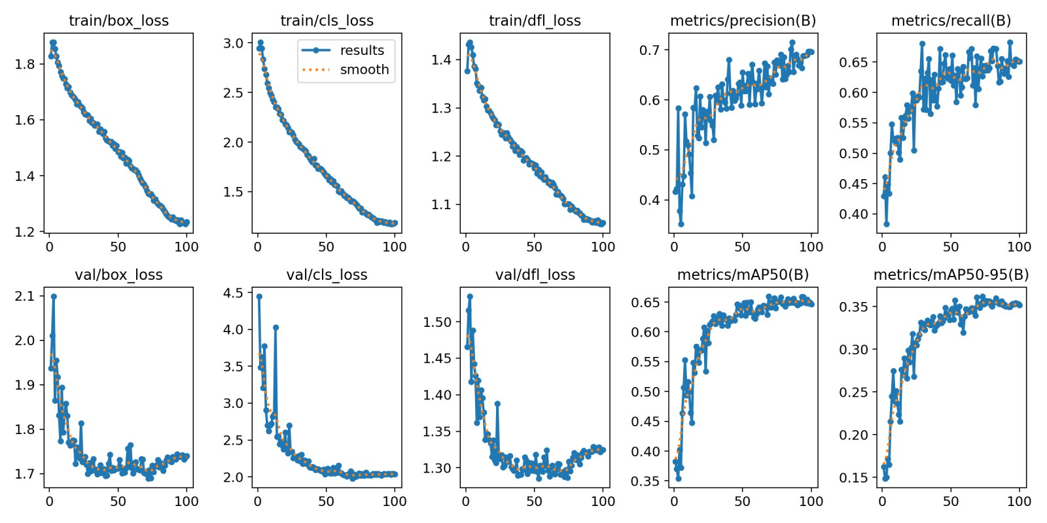
Figure 1. Training and validation curves, YOLO11m (adopted run).
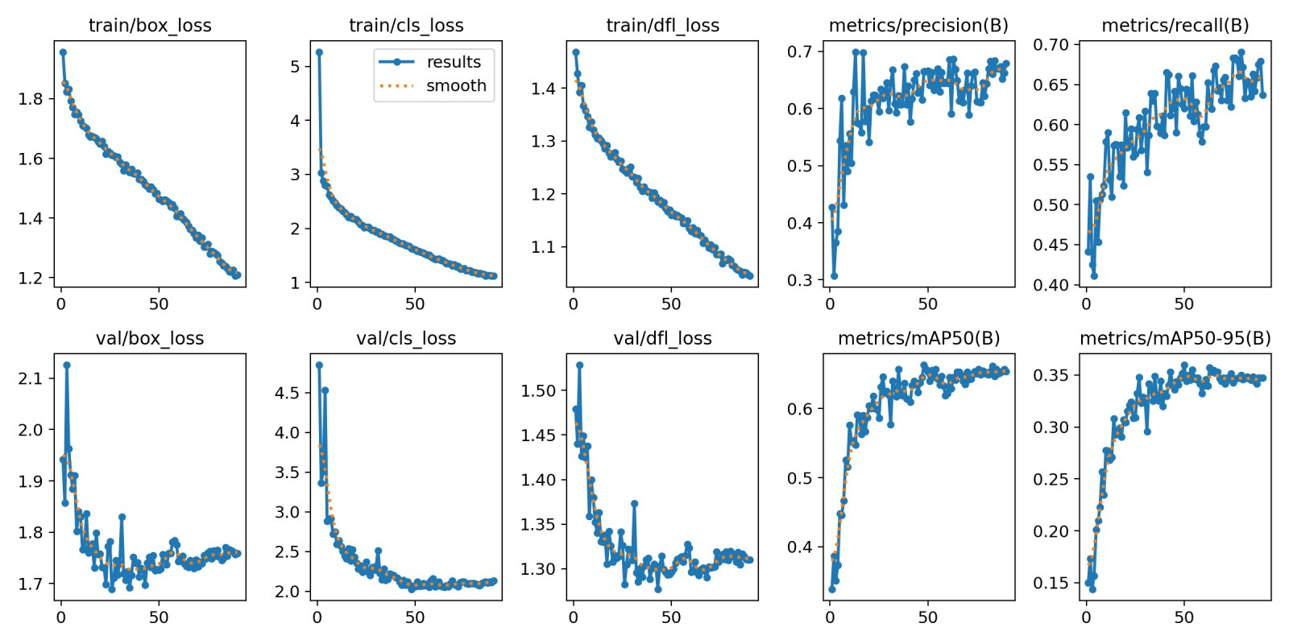
Figure 2. Training and validation curves, YOLO11s baseline.

8.2 Held-out test results
Test set: 12 boards, 469 images, 1,023 annotated defects, never used for training, validation, model selection or threshold choice. Each model was evaluated exactly once.
Model | Precision | Recall | F1 | mAP50 | mAP50-95 | ms / image (T4, batch 16) | FPS | Parameters
YOLO11m (proposed) | 63.4 | 66.2 | 64.7 | 63.0 | 34.0 | 33.2 | 30 | 20.0 M
YOLO11s (baseline) | 71.0 | 64.1 | 67.4 | 64.6 | 33.4 | 11.7 | 86 | 9.4 M

8.3 Per-class test results
Class | Test boxes | 11m P | 11m R | 11m F1 | 11m mAP50 | 11m mAP50-95 | 11s P | 11s R | 11s F1 | 11s mAP50 | 11s mAP50-95
Dead_Knot | 343 | 77.2 | 88.0 | 82.3 | 86.8 | 41.8 | 83.0 | 84.3 | 83.6 | 89.1 | 43.3
Marrow | 46 | 79.6 | 84.9 | 82.2 | 85.8 | 57.4 | 89.3 | 72.7 | 80.2 | 87.7 | 55.2
Live_Knot | 406 | 73.5 | 79.2 | 76.3 | 74.8 | 32.0 | 75.2 | 75.1 | 75.2 | 75.8 | 32.6
Knot_missing * | 24 | 57.9 | 62.5 | 60.1 | 62.7 | 35.7 | 80.8 | 70.8 | 75.5 | 69.6 | 34.1
Knot_with_crack | 30 | 63.2 | 63.3 | 63.3 | 61.7 | 38.4 | 80.9 | 63.3 | 71.1 | 67.5 | 42.8
Resin | 69 | 68.0 | 56.5 | 61.7 | 59.5 | 29.9 | 81.9 | 53.6 | 64.8 | 60.4 | 29.5
Crack | 95 | 56.8 | 72.6 | 63.7 | 57.7 | 31.0 | 60.5 | 63.2 | 61.8 | 53.0 | 26.3
Quartzity * | 10 | 30.7 | 22.3 | 25.8 | 15.4 | 5.7 | 16.7 | 30.0 | 21.5 | 13.4 | 3.0
ALL | 1023 | 63.4 | 66.2 | 64.7 | 63.0 | 34.0 | 71.0 | 64.1 | 67.4 | 64.6 | 33.4

* Fewer than 25 test boxes; indicative only.
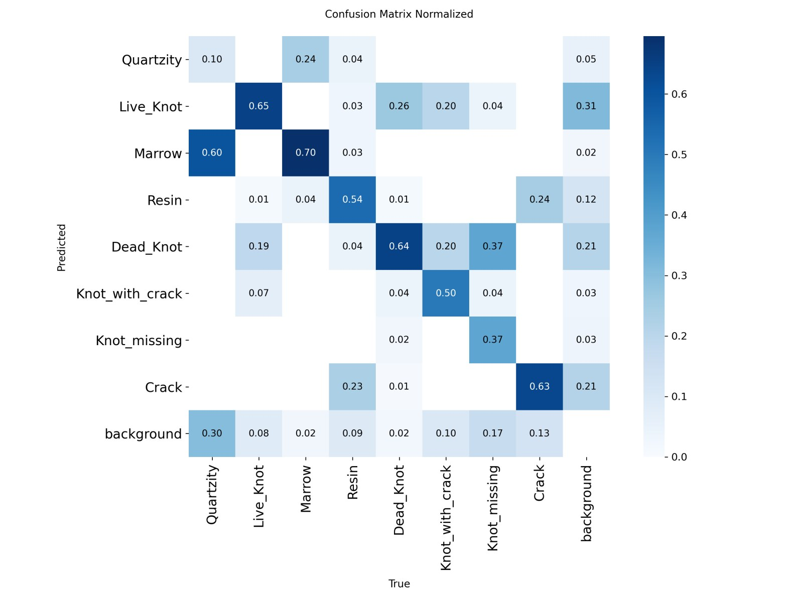
Figure 3. Normalised confusion matrix on the test boards, YOLO11m (columns: true class).
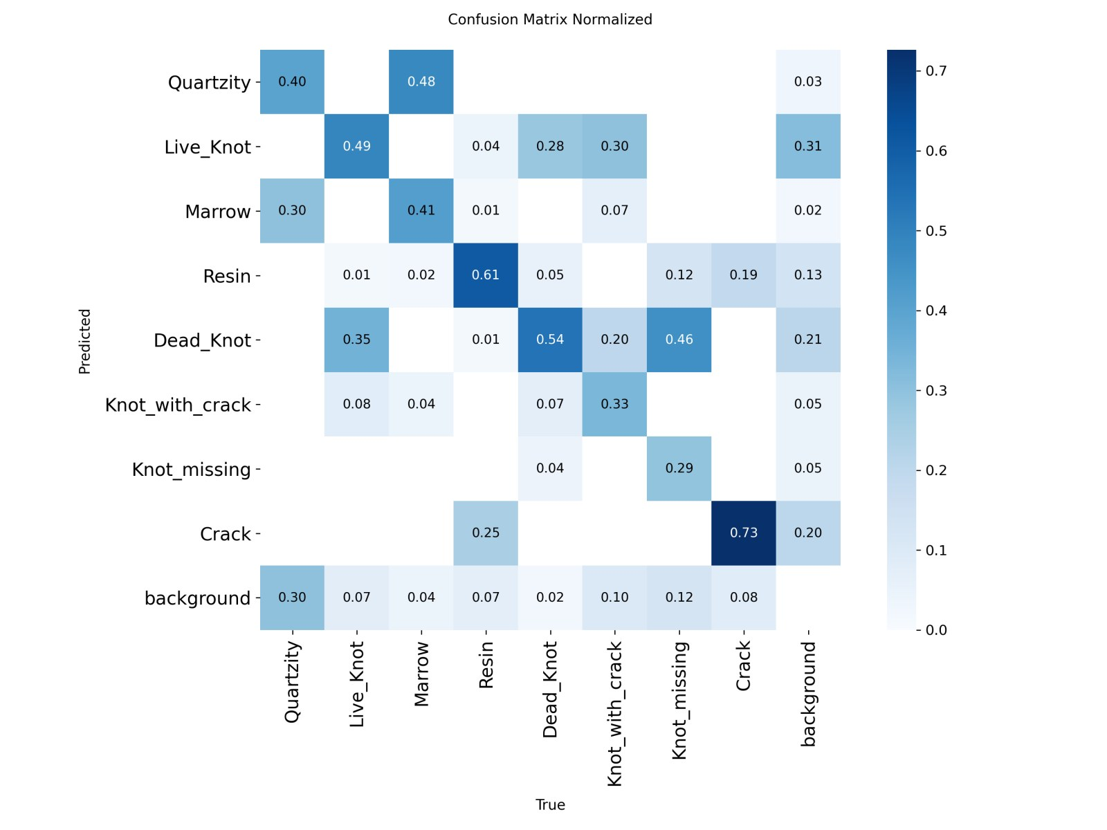
Figure 4. Normalised confusion matrix on the test boards, YOLO11s.
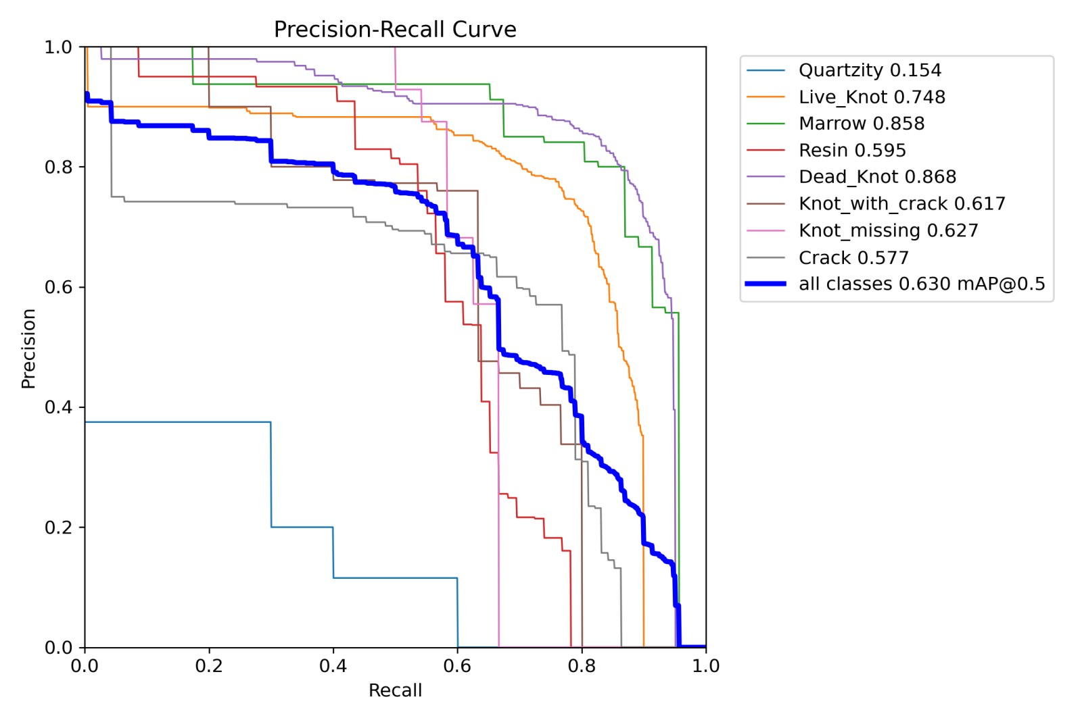
Figure 5. Precision-recall curves per class on the test boards, YOLO11m.
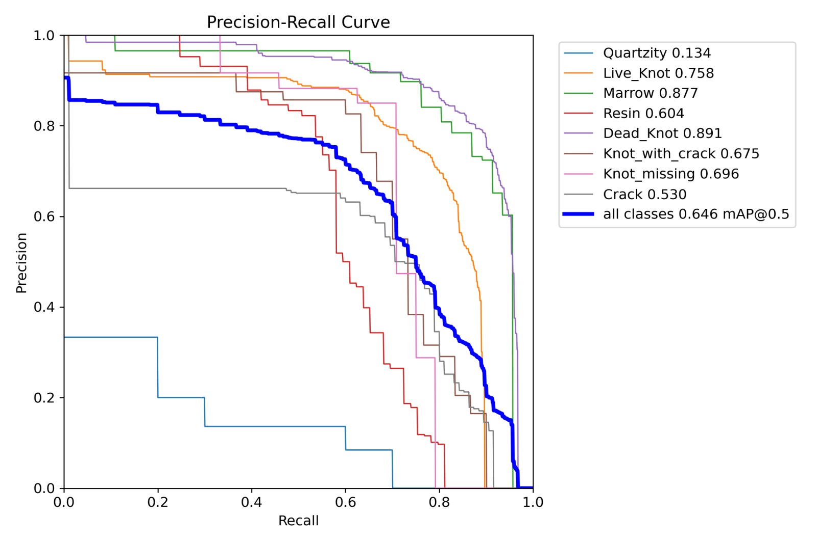
Figure 6. Precision-recall curves per class on the test boards, YOLO11s.

8.4 Reading the results
- Structural knot classes are detected reliably: Dead_Knot 87 to 89 mAP50 and Marrow 86 to 88 for both models; Live_Knot, the most frequent class, at about 75.
- Crack, a long thin structure, reaches 58 mAP50 with YOLO11m and 53 with YOLO11s; YOLO11m recalls 73% of cracks. The rectangular 1024 input is what keeps these thin defects resolvable.
- Quartzity is not learned by either model (13 to 15 mAP50). It is a faint grain-aligned streak with only 125 training examples and 10 test boxes; most instances are predicted as background or as Marrow.
- The remaining errors are between visually similar knot sub-types: about a quarter to a third of Knot_with_crack is predicted as Live_Knot and of Knot_missing as Dead_Knot.
- Validation and test scores agree (about 65 vs 63 to 65 mAP50), so there is no sign of over-fitting to the validation boards.

9. Model comparison: YOLO11m (proposed) vs YOLO11s (baseline)
Both models share the same data, split, seed and recipe, so the differences below are due to model size alone.
Aspect | YOLO11m | YOLO11s | Difference (m minus s) | Reading
mAP50 | 63.0 | 64.6 | -1.6 | tie within the noise of a 12-board test set
mAP50-95 | 34.0 | 33.4 | +0.6 | slightly tighter boxes; within noise
Precision | 63.4 | 71.0 | -7.6 | YOLO11m raises more low-confidence false alarms
Recall | 66.2 | 64.1 | +2.1 | YOLO11m finds slightly more defects
F1 | 64.7 | 67.4 | -2.7 | driven by the precision gap
Crack mAP50 / recall | 57.7 / 72.6 | 53.0 / 63.2 | +4.7 / +9.4 | largest gain for YOLO11m: the thin-defect class
Dead_Knot / Live_Knot mAP50 | 86.8 / 74.8 | 89.1 / 75.8 | -2.3 / -1.0 | dominant classes effectively equal
Inference, T4 (1024 rect) | 33.2 ms, 30 FPS | 11.7 ms, 86 FPS | 2.8x slower | both real-time for a conveyor camera; YOLO11s has far more headroom
Inference, laptop CPU | about 0.5-0.6 s | about 0.2-0.3 s | 2x slower | measured in the demo application
Training cost | 2.64 h | 1.43 h | 1.8x
Parameters | 20.0 M | 9.4 M | 2.1x

Interpretation. On this dataset the two detectors are tied in overall accuracy. YOLO11m trades precision for recall and is stronger on the thin Crack class; YOLO11s is more precise and almost three times faster. Model capacity is therefore not the limiting factor; the rare classes and the visually similar knot sub-types are. This directs the second half of the project towards data and input improvements (image enhancement, targeted augmentation for rare classes, higher input resolution for thin defects) rather than towards a larger backbone, and it makes YOLO11s the current candidate for deployment.

10. Qualitative results
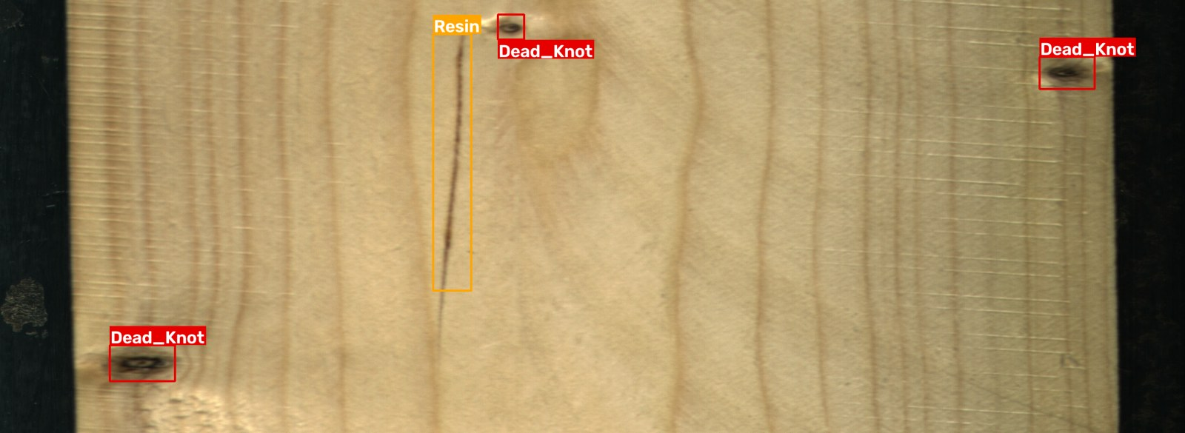
Figure 7. Held-out test board 9990: annotator's ground truth (Resin x1, Dead_Knot x3).
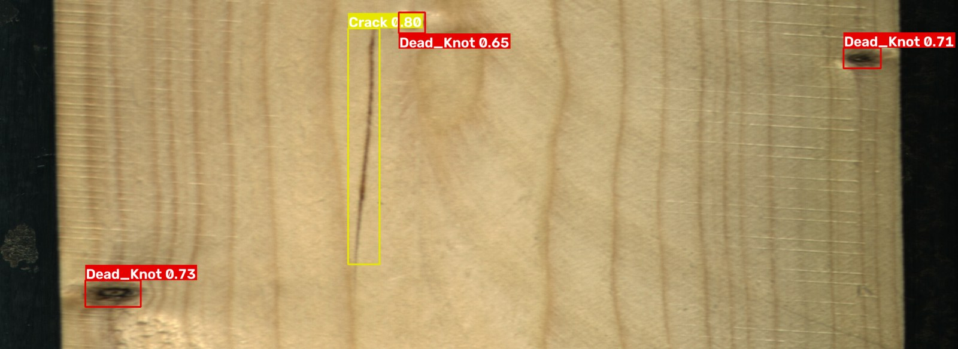
Figure 8. Same image, YOLO11m prediction at confidence 0.35: all three dead knots found; the resin streak is predicted as Crack (thin-streak confusion).
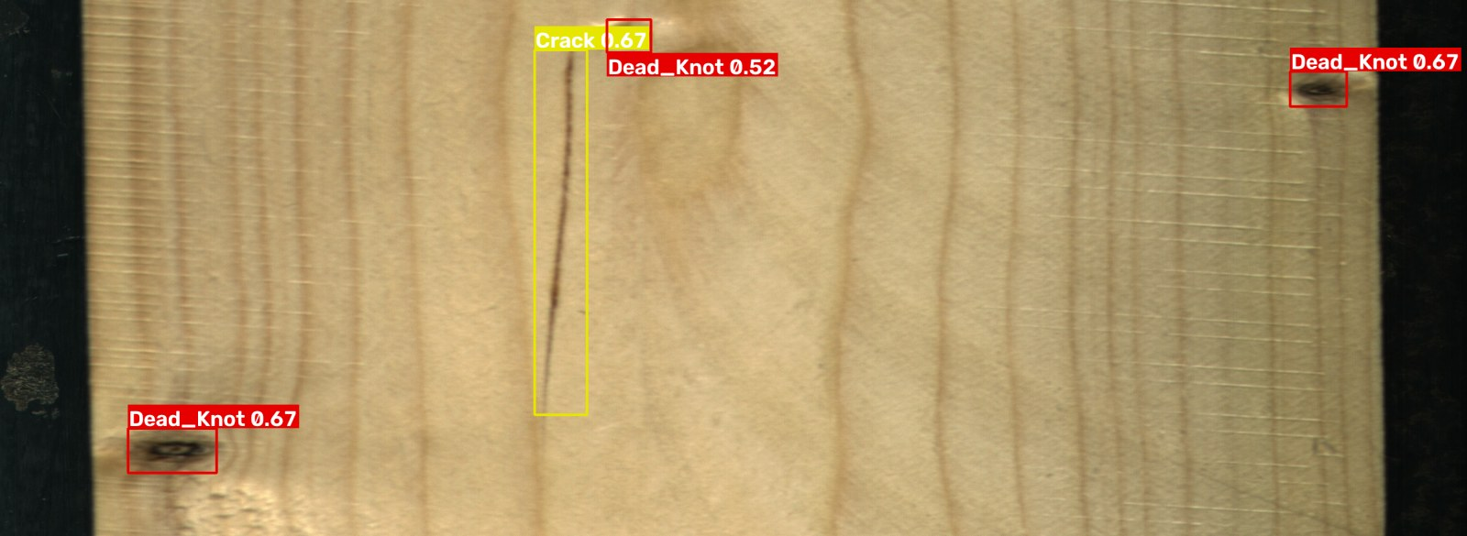
Figure 9. Same image, YOLO11s prediction at confidence 0.35.
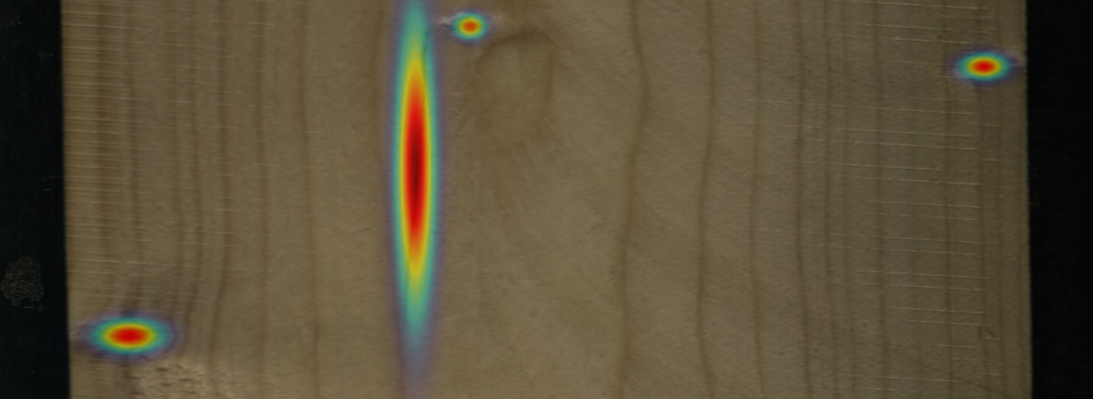
Figure 10. Confidence-weighted defect heatmap for the same board (YOLO11m), as shown in the application.
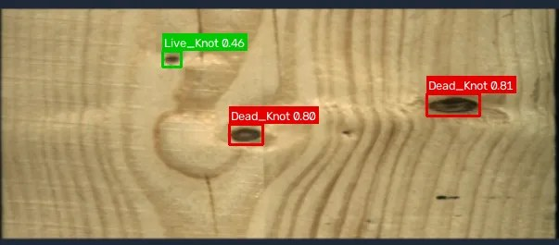
Figure 11. Application output on a downscaled board photo (600 px wide): two dead knots at 0.80 and 0.81 and a small live knot at 0.46.

11. Demonstration application
A web application (Gradio, Python) was built so that the models can be tested live and shown during the review. It runs on a CPU laptop and can be published on Hugging Face Spaces for access by URL.
Tab | Function
Detect on your image | Upload a board image; choose YOLO11m, YOLO11s or both side by side; set confidence and NMS thresholds; automatic input-size rule (full strips at 1024, small photos near native size). Output: colour-coded boxes, confidence heatmap, per-class count and area share, defect coverage of the surface, downloadable JSON report.
Test boards | Picks images from the 12 held-out boards and shows the annotator's boxes next to the model's prediction with identical colours, so detection quality on unseen boards can be judged directly.
Results | The tables in this report, confusion matrices and training curves.
Legend | Class descriptions and colours; definition of defect coverage as a transparent area heuristic.

Defect coverage (union of predicted boxes as a share of the image) is the first building block of recoverability estimation. A grading rule that combines coverage with defect type and position is part of the remaining work and will be defined with the guide before it is presented as a quality grade.

12. Progress against the plan of action
Plan step (synopsis) | Planned content | Status | Evidence
Step 1: project setup and data exploration | Collect and annotate images; organise train / val / test | Complete | Dataset audit, class mapping, cleaning, board-level split, Kaggle datasets, preparation script and log
Step 2: image processing and baseline model | Enhancement and augmentation; baseline detector | Baseline complete; enhancement pending | YOLO11s baseline trained and evaluated; grain-aware augmentation in place. CLAHE / denoising / brightness experiments not yet run
Step 3: advanced model and recoverability | Improved detector; defect analysis; recoverability | Partly complete | YOLO11m trained and evaluated; per-defect analysis and coverage implemented in the application. Architectural improvements and the recoverability rule remain
Step 4: evaluation and final assessment | P / R / mAP / F1; comparative and ablation analysis; unseen samples | Evaluation protocol complete; ablations pending | Single-shot held-out test per model with per-class tables, curves and confusion matrices; two-model comparison done

Overall: the data pipeline, training pipeline, evaluation protocol, two trained models with held-out results, and the demonstration application are complete. This corresponds to roughly half of the planned work.

13. Challenges faced and how they were solved
Challenge | Solution
Board leakage: consecutive tiles from the same board would appear in both train and test under a random split | Group-stratified split by board id with an automatic zero-overlap check
Very wide images: square inputs waste 63% of the tensor on padding and shrink thin defects | 1024-pixel rectangular training and inference (1024 x 384 effective)
No GPU on the team machine (YOLO11m would take about 2 hours per epoch on CPU) | Kaggle T4 GPUs; scripted, resumable notebook; about 100 s per epoch
Framework disables rectangular batching under multi-GPU and the default Kaggle GPU (P100) is unsupported by current PyTorch | Single T4 pinned in the notebook metadata; batch 32 fits in 13.9 GB
Unstable first training run (validation mAP50 dropping 10-15 points between epochs) | Batch 32, lr0 0.001, patience 40; curve became smooth and every class improved on validation
Zero-size annotation boxes in the source labels | 158 boxes removed after clipping; every removed box inspected
Small or downscaled photos produced spurious detections when upscaled to 1024 | Automatic input-size rule in the application; a caveat is shown for out-of-domain inputs

14. Advantages and current limitations
Advantages
- Leakage-free evaluation on physically separate boards; results are defensible.
- Fully reproducible: seed, configuration, logs, tables and curves are version-controlled; the test split is used once.
- Real-time capable: 30 to 86 FPS on a single T4 at 1024-pixel rectangular input; usable on a CPU laptop for demonstration.
- Per-defect class, position, size and confidence, which is what recoverability estimation needs.
- Working application with heatmaps, per-class statistics and machine-readable reports.
Limitations
- Small test set (12 boards); per-class numbers for Quartzity and Knot_missing are not reliable, and differences of 1-2 mAP points overall are within noise.
- Rare classes are under-represented (Quartzity 125 training boxes) and not yet learned.
- Knot sub-types are confused with one another; the visual difference is subtle and annotation is partly subjective.
- Trained on controlled line-scan imagery; phone photos and other imaging conditions are outside the domain until enhancement and additional data are added.
- Recoverability is not yet estimated; only defect coverage is computed.
- Each configuration has been trained with a single seed.

15. Remaining work (second half)
- Image enhancement study: CLAHE, denoising, brightness correction and low-light simulation as planned in the synopsis; measure the effect on validation before any test run.
- Rare-class and thin-defect improvements: targeted augmentation, 1280-pixel rectangular input, removal of the 99 sub-5-pixel boxes; multi-seed runs to quantify variance.
- Architectural improvement experiment in the spirit of CWB-YOLO (conditional convolution, attention, Wise-IoU) on top of the YOLO11 baseline, if the enhancement study leaves budget; ablation of each component on validation.
- Recoverability estimation: define a grading rule with the guide (defect coverage, counts of structural defects such as Crack and Knot_with_crack, position on the board), implement it in the application, and validate it against a small set of expert-graded boards.
- Final comparative evaluation: one additional test evaluation per final model, reporting the total number of test evaluations.
- Report and presentation: update the synopsis wording (sawn-timber dataset, YOLO11, dataset citation) and prepare the final document.

16. Conclusion
At the halfway point the project has a clean, leakage-free dataset with verified classes, a reproducible training and evaluation pipeline, two trained YOLO11 detectors evaluated once each on twelve unseen boards, and a working demonstration application. The detectors reach 63 to 65 mAP50 and 33 to 34 mAP50-95 overall, above 85 mAP50 on the structural knot classes and 53 to 58 on cracks, and run in real time on a single T4 GPU. The comparison between YOLO11m and YOLO11s shows that model size is not the bottleneck on this data, which focuses the second half on image enhancement, rare-class handling, targeted architectural changes and the recoverability estimate that completes the quality-assessment goal.

Appendix A. Suggested slide outline for the 50% presentation
Slide | Title | Content from this report
1 | Title | Team, USNs, guide, date
2 | Organisation of the presentation | Sections 1-16
3 | Abstract | Section 1, shortened to 5 bullets
4 | Introduction | Section 2
5 | Problem statement | Section 3
6 | Objectives and status | Section 4 table
7 | Methodology as implemented | Section 5 as a flow: data, split, rect input, YOLO11, evaluation, application
8 | Dataset | Section 6 property table and class table, one example image
9 | Board-level split | Section 6.2 table and the leakage explanation
10 | Implementation | Section 7.1 configuration table, compute
11 | Training runs | Section 8.1 table with Figure 1
12 | Test results: overall | Section 8.2 table, large-number callouts for mAP50 and FPS
13 | Test results: per class | Section 8.3 table, Figure 3
14 | Model comparison | Section 9 table and interpretation
15 | Qualitative results | Figures 7, 8 and 10
16 | Demonstration application | Section 11, one screenshot (Figure 11), live demo
17 | Progress against plan | Section 12 table
18 | Challenges and solutions | Section 13 table, top 4 rows
19 | Remaining work | Section 15
20 | Conclusion | Section 16
21-22 | References | Below

References
- P. Kodytek, A. Bodzas and P. Bilik, "A large-scale image dataset of wood surface defects for automated vision-based quality control processes," F1000Research, vol. 10, 581, 2022, doi:10.12688/f1000research.52903.2.
- Kaggle dataset: nomihsa965/large-scale-image-dataset-of-wood-surface-defects, 4,000-image subset at 2800 x 1024 with YOLO labels, CC BY 4.0.
- Ultralytics, "YOLO11," software version 8.4.142, https://docs.ultralytics.com.
- H. An, Z. Liang, M. Qin, Y. Huang, F. Xiong and G. Zeng, "Wood defect detection based on the CWB-YOLOv8 algorithm," Journal of Wood Science, vol. 70, art. 26, 2024, doi:10.1186/s10086-024-02139-z.
- J. Zheng, "IEL-YOLO: A low-light robust wood defect detection method based on YOLOv11," Proc. ETAE 2026, pp. 818-821, doi:10.1109/ETAE69474.2026.11496073.
- Y. Fang, Y. Ma, S. Gao and J. Chen, "Recent advances in wood surface defect inspection using deep learning (2021-2025)," BioResources, vol. 21, no. 3, 2026.
- L. P. Yi et al., "The prospect of artificial intelligence-based wood surface inspection: A review," IEEE Access, vol. 12, pp. 84706-84725, 2024, doi:10.1109/ACCESS.2024.3412928.

